RV Akademik Sergey Vavilov: Final Report of CFC sampling and measurement

Bremen, 07 June 2006

RV Akademik Sergey Vavilov cruise
GOOD HOPE
4.11.2004 – 8.12.2004
Cape Town – Cape Town

PI CFC measurements: Monika Rhein (mrhein@physik.uni-bremen.de)

IUP (Institut für Umweltphysik) - Abt. Ozeanographie
Universität Bremen, Fachbereich 1 (Physik)
Postfach 330 440
D-28334 Bremen, Germany

Phone: ++49 - 421 – 218 2408 or …4529 (secretary)
FAX: ++49 - 421 – 218 7018

Cruise participants: Martha Schattenhofer (mschatte@mpi-bremen.de), Jon-Olaf Krisponeit.

CFC measurement: Klaus Bulsiewicz (kbulsie@physik.uni-bremen.de)

Report Oliver Huhn (ohuhn@physik.uni-bremen.de)

1. Data file “vavilov.woc”

The attached file “vavilov.woc” is an ASCII written file with a header describing the following sequence of data columns:

T R A C E R - O C E A N O G R A P H Y - B R E M E N
-------------------------------------------------------------

vavilov - Freondata from the 6.6.2006

Quality byte: 1= --
2= Acceptable measurement
3= Questionable measurement
4= Bad measurement
5= --
6= Mean of replicate measurements
7= --
8= --
9= Sample not drawn for this measurment from this bottle

Quality byte: CFC-11/CFC-12
1 2

Stat Cast Botl Bedford Deep F-11 F-12 Qualit
[m] [pmol/kg]

CFC-11 and CFC-12 are both reported in [pmol/kg] and calibrated on SIO98 scale.

As the header describes, the file includes

column 6: 650 CFC-11 measurements [pmol/kg]
column 7: 651 CFC-12 measurements [pmol/kg]

combined with

column 1 station number (545-704, i.e. add 1000 to column 1 to get correct station number)
column 2 cast number
column 3 bottle number (1-24)
column 4 bedford number (not used here)
column 5 approx. depth of sample
column 8 quality flag

The quality flag digit 1 contains the flag for CFC- 11 and digit 2 the flag for CFC-12. Digits 3 and 4 are without meaning here.

flag = 2 = “good”
flag = 6 = mean from replicates (samples from the same bottle,
tapped directly after another)
flag = 3 = “questionable” (i.e. something suspicious during the measurement or
suspicious in compare to other samples)
flag = 4 = “bad” (i.e. obvious outliers, possibly contaminated, something very suspicious
during measurement or in compare to other samples or any other very strange thing –
however, these samples cannot be used!)

Altogether 688 samples have been analyzed for chlorofluorocarbon (CFC) components CFC-11 and CFC-12. Some are replicate samples (i.e. samples from same bottle), from which the mean was taken. This leads to a total number of 651 data points.

CFC-11 has 551 measurements flag = 2 (good), 22 measurements flag = 6 (“good” and mean replicates), 3 measurements flag = 7 (questionable), 71 measurements flag = 4 (bad, i.e. never use these, they are nonsense or have something very doubtful occurred during the measurement).

CFC-12 has 576 measurements flag = 2 (good), 33 measurements flag = 6 (“good” and mean from replicates), 3 measurements flag = 3 (questionable), 39 measurements flag = 4 (bad, i.e. never use these, they are nonsense or have something very doubtful occurred during the measurement).

2. Sampling on the ship

The CFC samples during the cruise were taken immediately after the rosette system was brought back to the ship and before anybody else used water from the Niskin bottles. They were tapped into 100 ml glass ampoules preventing any contact to atmospheric air and after flushing the ampoule several minutes (i.e. about 3 times completely). Under a flow of trace-gas-free nitrogen (N₂) the glass ampoules were flame-sealed. The amount of gas (CFC) in the headspace was accounted for later during the analysis/measurement procedure.

3. Measurement in the lab

The measurement was performed in March and April 2006 our lab in Bremen by Klaus Bulsiewicz. It was carried out in a gas chromatographic (GC) system on a capillary column and detected by an electron capture detector (ECD).

Only the gases in the water can be transferred into the GC/ECD system. Thus the CFC concentrations in the headspace and the volume of the headspace have to be determined.

- Volume of the headspace: Before the cruise, the empty ampoules had been individually weighted and tagged. After returning from sea, the full ampoules are weighted again. Once the glass ampoules are opened and the water sample analyzed, the headspace is determined by filling the ampoule with distilled water.
- CFC concentration in the headspace: In order to ascertain that the solubility equilibrium between the water and the headspace is achieved, the glass ampoules are brought in an ultrasonic water bath at a constant temperature (δT < 0.1°C) for 24 hours.
- CFC analysis: The determination of the chlorofluorocarbons CFC-11 and CFC-12 is accomplished by purge and trap sample pre-treatment followed by gas chromatographic separation on capillary column and electron capture detector (ECD). The system is calibrated by analyzing several different volumes of a known standard gas. Additionally the blank of the system has to be analyzed regularly.

A more detailed description of the analysis can be found at:

Bulsiewicz, K., H. Rose, O. Klatt, A. Putzka, W. Roether (1998): A capillary-column chromatographic system for efficient chlorofluoromethane measurement in ocean waters; Journal of Geophysical Research, Vol. 103, No. C8, 15959-15970

4. Error estimate

4.1. Precision or reproducibility (from replicate samples)

CFC-11 ±0.9% for values > 0.15 … 0.2 pmol/kg and
± 0.005 pmol/kg for values < 0.15 … 0.2 pmol/kg

CFC-12 ±0.7% for values > 0.1 pmol/kg and
± 0.004 pmol/kg for values < 0.1 pmol/kg

4.2. Accuracy (error over all, including error of headspace, calibration, sample volume, etc.)

CFC-11 ±2.0 … 2.5% for values > 0.15 … 0.2 pmol/kg and
± 0.005 pmol/kg for values < 0.15 … 0.2 pmol/kg

CFC-12 ±1.5% for values > 0.1 pmol/kg and
± 0.004 pmol/kg for values < 0.1 pmol/kg
5. Description and comments

In the following some plots of the Vavilov CFC data are presented and are briefly discussed. The CFC measurements are reported in pmol/kg or ppt = parts per trillion or partial pressure, using the solubility function from Warner and Weiss (1985) and the hydrographic data set (depth, temperature, and salinity) provided to us by Pierre Branellec in December 2005.

The surface water values (0 – 30m) are in saturation with southern hemisphere atmospheric partial pressure for 96 ± 13 % (CFC-11) and 98 ± 8 % (CFC-12).

The extraordinary high concentrations (particularly for CFC-11, pink circles in Fig. 3a) indicate problems with a possible CFC contamination of the ship environment. Fig. 3 suggests, that extraordinary high CFC concentrations might have contaminated some of the samples, and that this contamination decreased with the time of the cruise. All of these data point have quality flag = 4. Extraordinary high concentrations were more often measured for CFC-11 than for CFC-12. Even for some of the replicate measurements one of the CFC-11 measurements was good and one was bad, while both CFC-12 measurements were good.

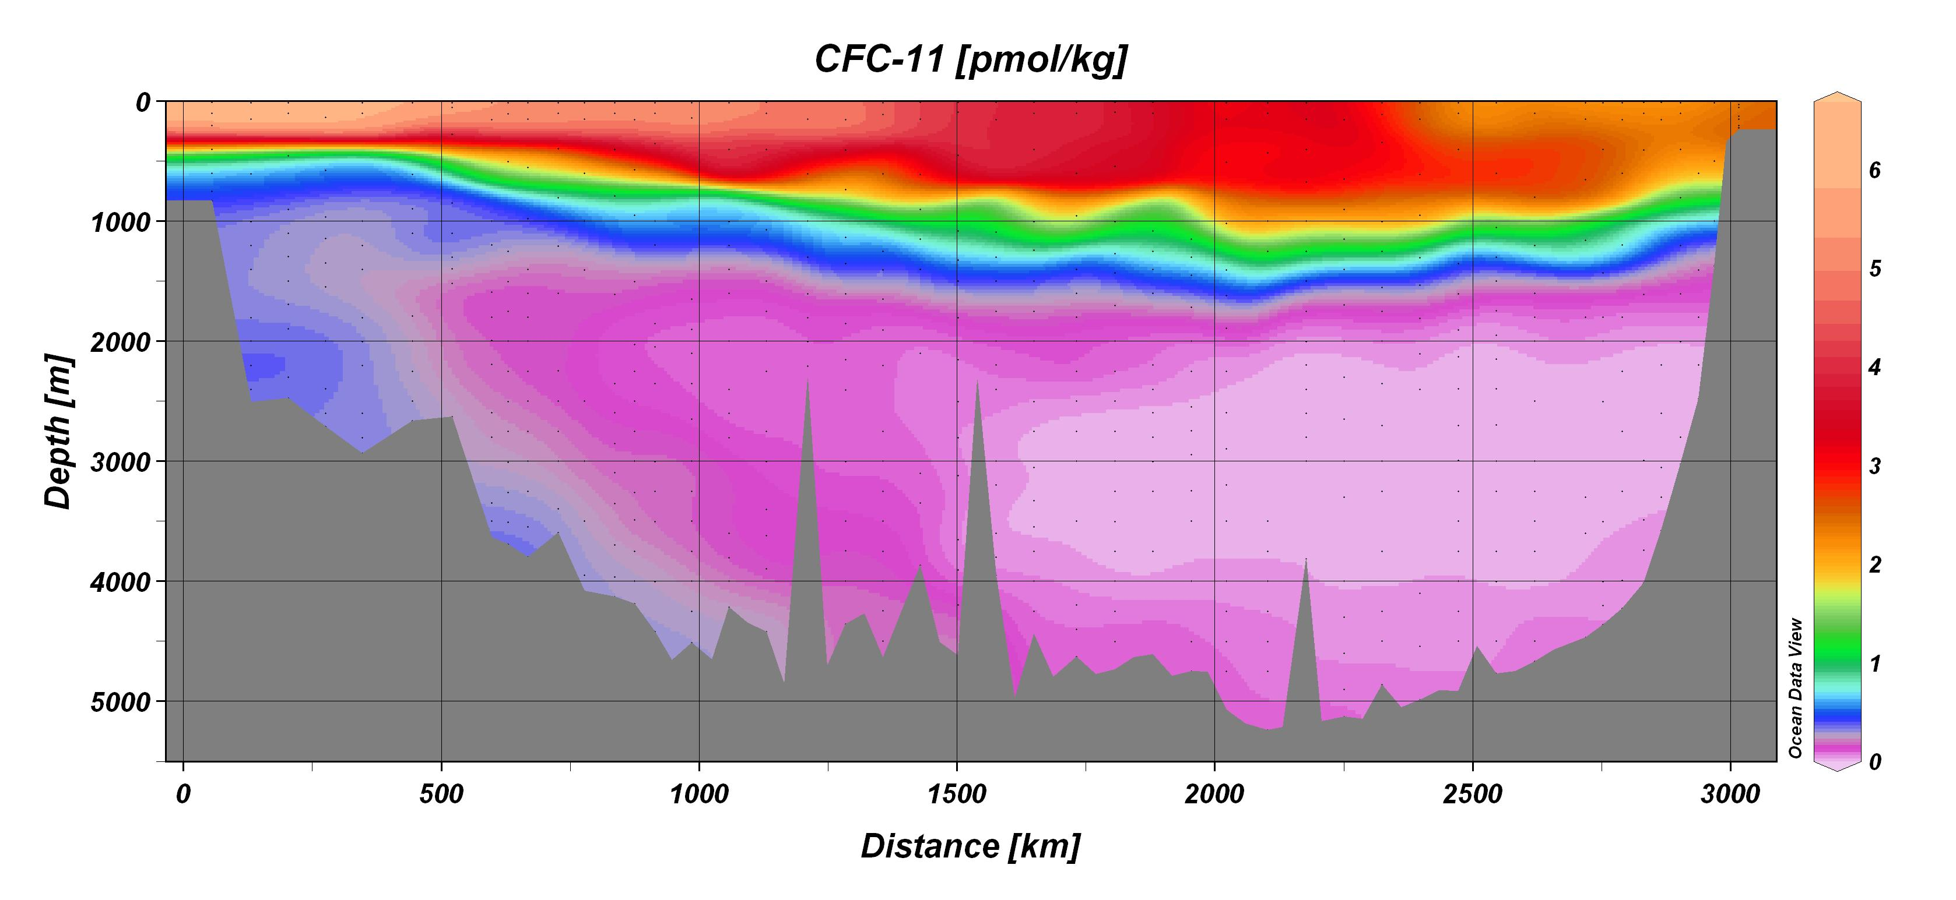

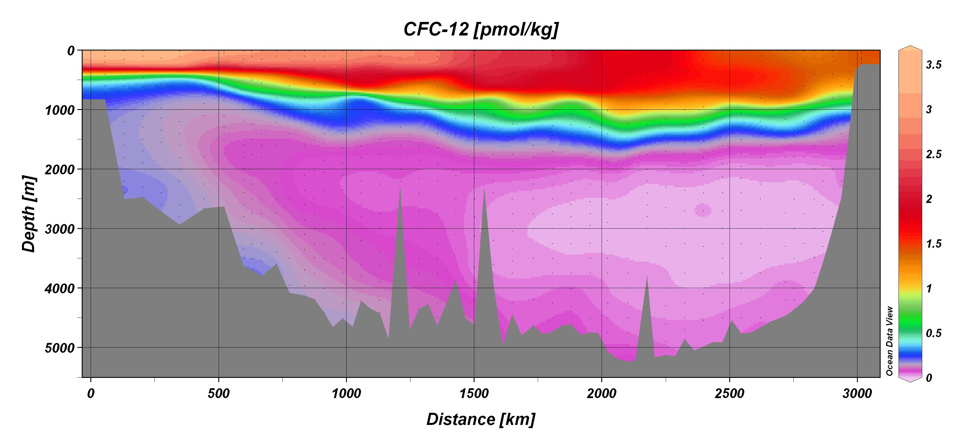

Fig. 1a and b: Contour plots of CFC-11 and CFC-12 along the cruise track of Vavilov. Left is the MAR, right the African continental slope. Only data points flags 2 (good) and 6 (mean from good replicates) had been used.

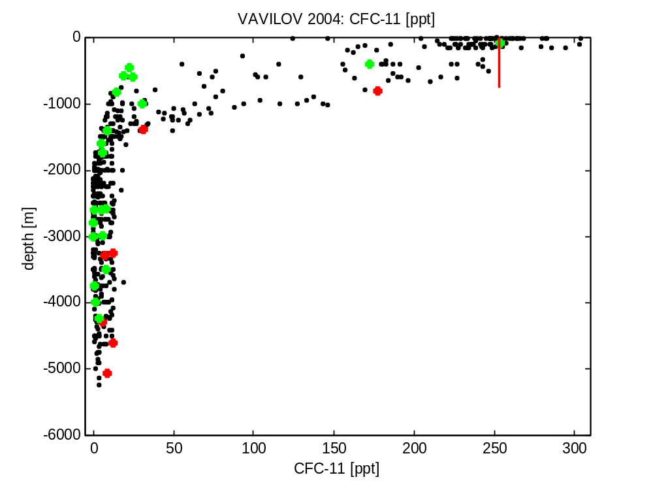

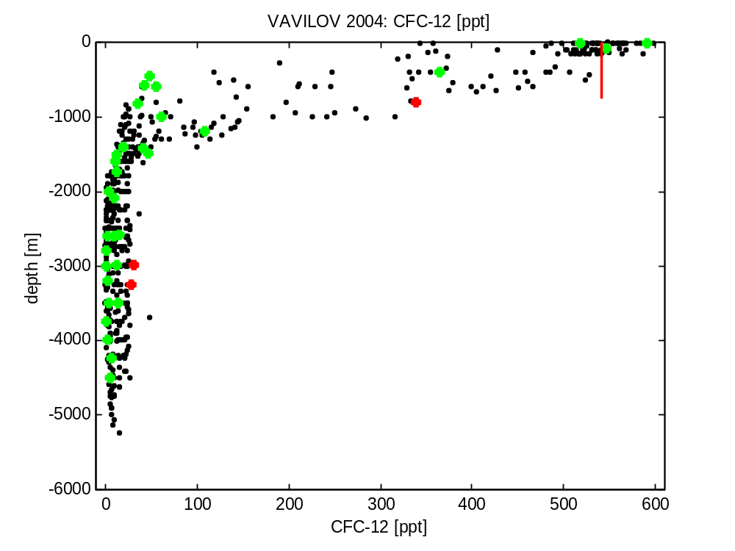
Figure 2a and b: CFC-11 and CFC-12 versus depth. Bad measurements (flag = 4) had been excluded, red dots are questionable (flag = 3) and green are replicates (flag = 6). The red line indicates the atmospheric partial pressure at the time of the sampling. The mean over all surface values (0 to 30 m) is in the order of 96 ± 13 % for CFC-11 and 98 ± 8 % for CFC-12. In mid depth the concentrations are close to zero.
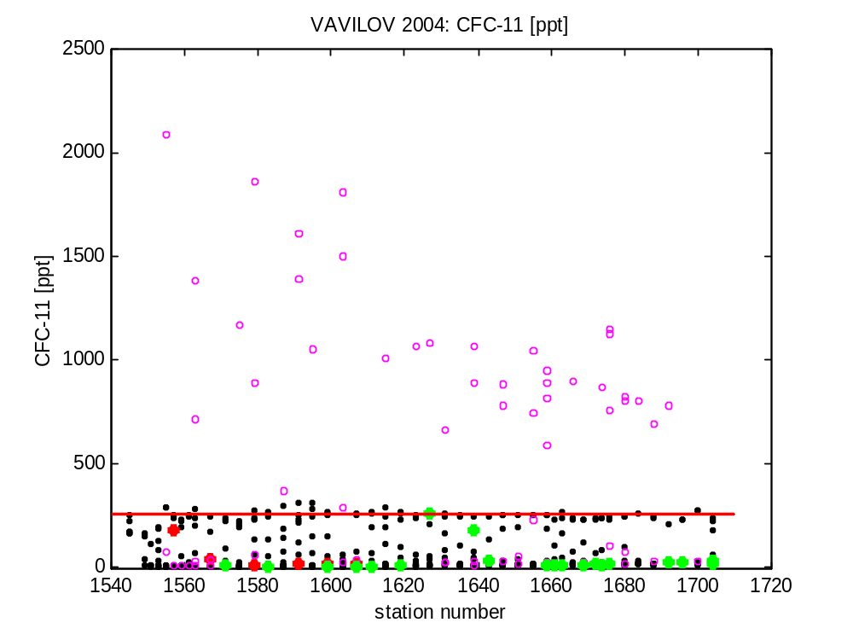

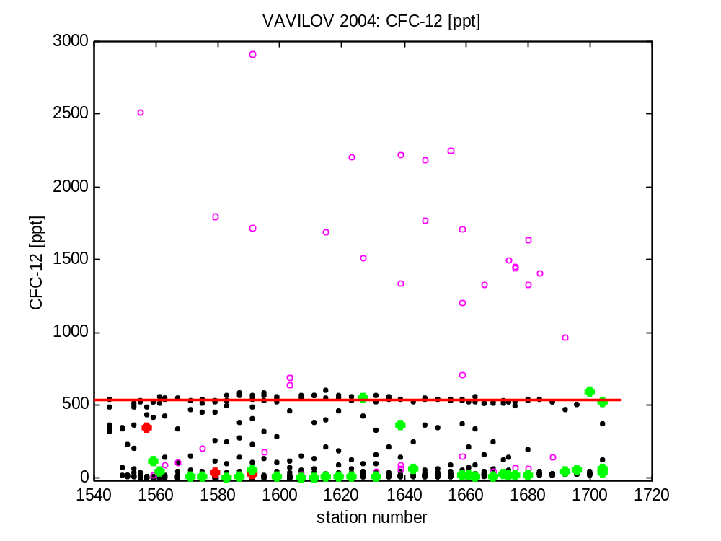

Figure 3a and b: CFC-11 and CFC-12 versus station number. Pink circles are bad (flag = 44), red dots are questionable (flag = 3) and green are replicates (flag = 6). The red line indicates the atmospheric partial pressure at the time of sampling. Note the “temporal decrease of the very, very high data points, particularly for CFC-11. That might indicate a decreasing contamination of the ship environment.
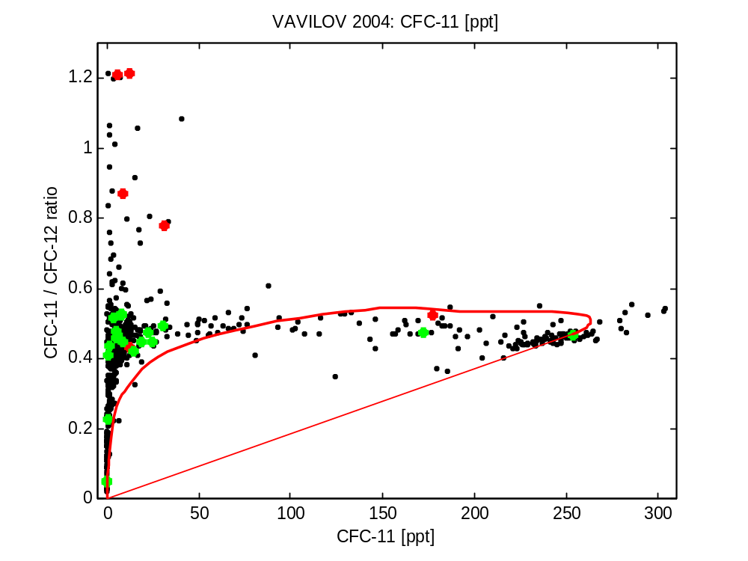

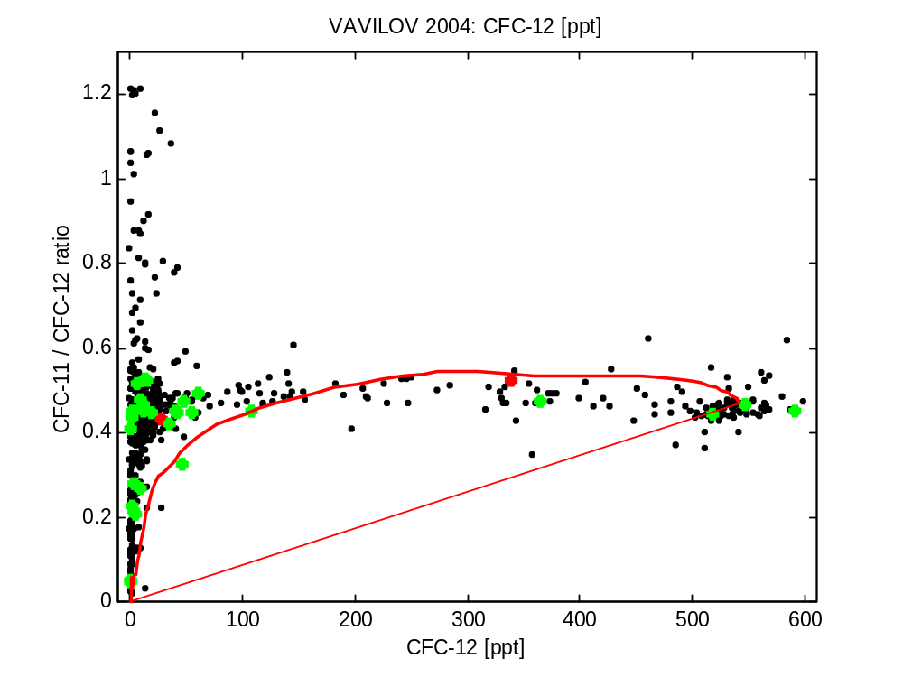

Figure 3a and b: CFC-11/CFC-12 ratio versus CFC-11 and CFC-12. Bad measurements had been excluded, red dots are questionable (flag = 3) and green are replicates (flag = 6). The thick red line indicates the temporal evolution of atmospheric partial pressure, the thin line is the mixing line between old and tracer free water and the atmospheric values at the time of the sampling. Note that for samples with small CFC concentrations the CFC ratios are highly sensitive for even small errors and become meaningless.

