C. Hydrographic Measurement Techniques and Calibration

CTDO₂ Measurements
27 March 2024

Personnel
TANAKA Kiyoshi
MURAKAMI Kiyoshi (RF2206, RF2207)
HIGASHI Yoshikazu (RF2206, RF2207)
WADA Kouichi (RF2205, RF2207)
SEGAWA Takahiro (RF2205, RF2207)
CHIBA Yasuomi (RF2205, RF2206)
TANAKA Hidekazu (RF2205, RF2206)

CTDO₂ measurement system

(Software: SEASAVEwin32 ver7.23.2)
Deck unit | Serial number | Station
SBE 11plus (SBE) | 11P35251 – 0683 | RF7040 – 7135
Under-water unit | Serial number | Station
SBE 9plus (SBE) | 09P69709 –1103  (Pressure : 123135) | RF7040 – 7135
Temperature | Serial number | Station
SBE 3plus (SBE)  SBE 35 (SBE) | 03P6159 (primary)  03P4321 (secondary)  0093 | RF7040 – 7135  RF7040 – 7135  RF7040 – 7135
Conductivity | Serial number | Station
SBE 4C (SBE) | 043697 (primary)  046059 (secondary) | RF7040 – 7135  RF7040 – 7135
Pump | Serial number | Station
SBE 5T (SBE) | 056552 (primary)  058892 (primary)  057934 (secondary)  059398 (secondary) | RF7040  RF7041 – 7135  RF7040 – 7134  RF7135
Oxygen | Serial number | Station
RINKO III (JFE) | 392 (foil number: 200633A)  356 (foil number:200633A) | RF7040 – 7135  RF7040 – 7135
Water sampler (36 position) | Serial number | Station
SBE 32 (SBE) | 32 – 1270 | RF7040 – 7135
Altimeter | Serial number | Station
VA500 (VA) | 69758 | RF7040 – 7135
Water sampling bottle |  | Station
Niskin Bottle (GO) |  | RF7040 – 7135
SBE: Sea- Bird Electronics, Inc., USA
JFE: JFE Advantech Co., Ltd., Japan
VA: VALEPORT, Inc., UK
GO: General Oceanics, Inc., USA

Pre-cruise calibration

(3.1) Pressure
S/N 09P 69709-1103(123135), 25 Feb. 2022
c₁ | = | -4.282684 × 10⁴ |  | t₁ | = | 3.006702 × 10
c₂ | = | 5.097742 × 10⁻¹ |  | t₂ | = | -8.607997 × 10⁻⁵
c₃ | = | 1.312000 × 10⁻² |  | t₃ | = | 3.727820 × 10⁻⁶
d₁ | = | 3.583800 × 10⁻² |  | t₄ | = | 3.699030 × 10⁻⁹
d₂ | = | 0.000000 |  | t₅ | = | 0.000000

Formula:
U (degrees Celsius) = M × (12-bit pressure temperature compensation word) + B
U: temperature in degrees Celsius
S/N 1103 coefficients in SEASOFT (configuration sheet dated on 25 Feb. 2022)
M = 1.28040 × 10⁻², B = –9.31868

Finally, pressure is computed as
t: pressure period (μsec)

The drift-corrected pressure is computed as
Slope = 0.99990, Offset = −0.5007

(3.2) Temperature (ITS-90): SBE 3plus

S/N 03P6159 (primary), 20 Oct. 2021
g | = | 4.32896843 × 10⁻³ |  | j | = | 2.03049914 × 10⁻⁶
h | = | 6.34331696 × 10⁻⁴ |  | f₀ | = | 1000.0
i | = | 2.16892784 × 10⁻⁵

S/N 03P4321 (secondary), 19 Jan. 2022
g | = | 4.39112463 × 10⁻³ |  | j | = | 1.95502273 × 10⁻⁶
h | = | 6.47351045 × 10⁻⁴ |  | f₀ | = | 1000.0
i | = | 2.30648901 × 10⁻⁵

Formula:
f: Instrument freq.[Hz]

(3.3) Deep Ocean Standards Thermometer Temperature (ITS-90): SBE 35
S/N 0093, 27 Oct. 2020
a₀ | = | 4.12756963 × 10⁻³ |  | a₃ | = | –9.36245277 × 10⁻⁶
a₁ | = | –1.08163464 × 10⁻³ |  | a₄ | = | 2.00979198 × 10⁻⁷
a₂ | = | 1.67453817 × 10⁻⁴
Formula:
n: instrument output

The slow time drift of the SBE 35
S/N 0093, 18 Noｖ. 2021 (2nd step: fixed point calibration)
Slope = 1.000003, Offset = -0.000148

Formula:

(3.4) Conductivity: SBE 4C
S/N 043697 (primary), 28 Jan. 2022
g | = | -9.71159477 |  | j | = | -2.55900486 × 10⁻⁵
h | = | 1.23873705 |  | CP_{cor} | = | –9.5700 × 10⁻⁸
i | = | 1.40974545 × 10⁻³ |  | CT_{cor} | = | 3.2500 × 10⁻⁶

S/N 046059 (secondary), 31 Mar. 2022
g | = | –1.02654717 × 10 |  | j | = | 2.24507825 × 10⁻⁴
h | = | 1.60537792 |  | CP_{cor} | = | –9.5700 × 10⁻⁸
i | = | –1.61160297 × 10⁻³ |  | CT_{cor} | = | 3.2500 × 10⁻⁶

Conductivity of a fluid in the cell is expressed as:
f: instrument frequency (kHz)
t: water temperature (degrees Celsius)
p: water pressure (dbar).

(3.5) Oxygen (RINKO III)
The RINKO III (JFE Advantech Co., Ltd., Japan) sensor is based on the ability of a selected substance to act as a dynamic fluorescence quencher. The RINKO III model is designed to be used with a CTD system that accepts an auxiliary analog sensor, and it is designed to operate down to 7000 m. The RINKO III output is expressed in voltage from 0 to 5 V.

Quality control and data correction during the cruise

(4.1) Temporal change of deck pressure
The post-cruise drift corrected pressure was computed as follows:
S/N 09P69709 –1103, 27 Feb. 2023
Slope = 1.00000，Offset = −0.2490
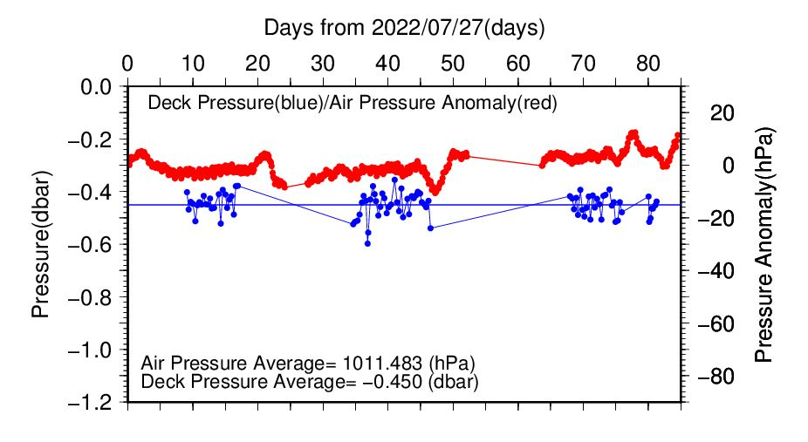
Figure C.1.1. Time series of the CTD deck pressure. Red line indicates atmospheric pressure anomaly. Blue line and dots indicate pre-cast deck pressure and average.

(4.2) Temperature sensor (SBE 3plus)
The practical corrections for the CTD temperature data can be made by using a SBE 35 and correcting the SBE 3plus so that it agrees with the SBE 35 (McTaggart et al., 2010; Uchida et al., 2007).

CTD temperature is corrected as follows:
$$Corrected temperature=T-(c_{0}+c_{1}×P+c_{2}×P^{2})$$
T: CTD temperature (degrees Celsius), P: pressure (dbar), and c₀, c₁, c₂: coefficients

Table C.1.1. Temperature correction summary (pressure ≥ 2000dbar). (Bold: accepted sensor)
S/N | Num | c₀(K) | c₁(K/dbar) | C₂(K/dbar²) | Stations
03P6159 | 230 | 6.406639 × 10⁻⁴ | 0.000000 | 0.000000 | RF7040 – 7064
03P6159 | 443 | 6.949485 × 10⁻⁴ | -8.851556 × 10⁻⁸ | 1.089389 × 10⁻¹¹ | RF7065  (※)  RF7066 – 7067  RF7068 – 7102
03P6159 | 369 | 5.199946 × 10⁻⁴ | 0.000000 | 0.000000 | RF7103 – 7135
03P4321 | 230 | 7.108319 × 10⁻⁴ | 0.000000 | 0.000000 | RF7040 – 7064
03P4321 | 415 | -4.949481 × 10⁻⁶ | 2.372874 × 10⁻⁷ | -1.249677 × 10⁻¹¹ | RF7065  (※)  RF7066 – 7067  RF7068 – 7102
03P4321 | 369 | -6.060353 × 10⁻⁵ | 2.505086 × 10⁻⁷ | -1.368830 × 10⁻¹¹ | RF7103 – 7135
※From station RF7066 to RF7067, S/N 03P6159 was accepted instead of S/N 03P4321 due to data failure. After RF7068, this data failure was resolved.

Table C.1.2. Temperature correction summary for S/N 03P 6159.
Stations | Pressure < 2000dbar |  |  | Pressure ≥ 2000 dbar
 | Num | Average  (K) | Std  (K) | Num | Average  (K) | Std  (K)
RF7040 – 7064 | 569 | – 0.0003 | 0.0093 | 230 | 0.0000 | 0.0002
RF7065 – 7102 | 828 | – 0.0001 | 0.0090 | 443 | 0.0000 | 0.0001
RF7103 – 7135 | 726 | – 0.0003 | 0.0078 | 369 | 0.0000 | 0.0001

Table C.1.3. Temperature correction summary for S/N 03P 4321.
Stations | Pressure < 2000dbar |  |  | Pressure ≥ 2000 dbar
 | Num | Average  (K) | Std  (K) | Num | Average  (K) | Std  (K)
RF7040 – 7064 | 569 | – 0.0009 | 0.0149 | 230 | 0.0000 | 0.0002
RF7065 – 7102 | 782 | – 0.0012 | 0.0078 | 415 | 0.0000 | 0.0001
RF7103 – 7135 | 726 | – 0.0008 | 0.0092 | 369 | 0.0000 | 0.0002

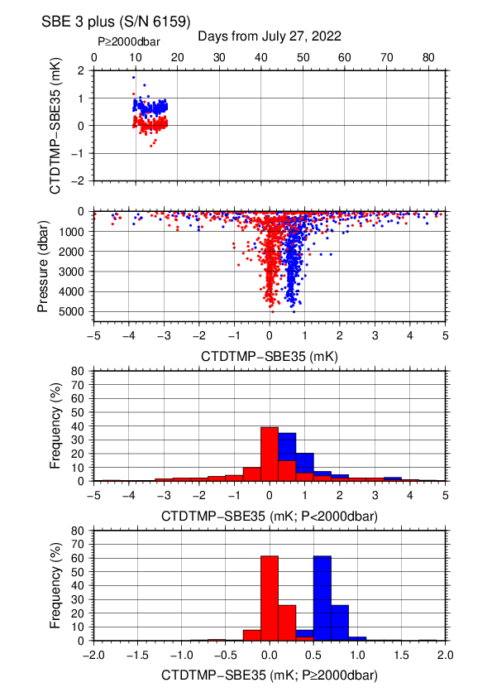
Figure C.1.2. Difference between the CTD temperature (S/N 03P 6159) and the Deep Ocean Standards thermometer (SBE 35) on RF22-05. Blue and red dots indicate before and after the correction using SBE 35 data, respectively. Lower two panels show histograms of the differences after correction.
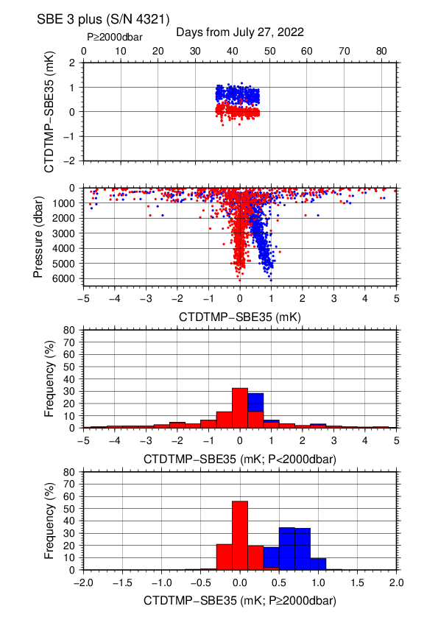
Figure C.1.3. Difference between the CTD temperature (S/N 03P 4321) and the Deep Ocean Standards thermometer (SBE 35) on RF22-06. Blue and red dots indicate before and after the correction using SBE 35 data, respectively. Lower two panels show histograms of the differences after correction.
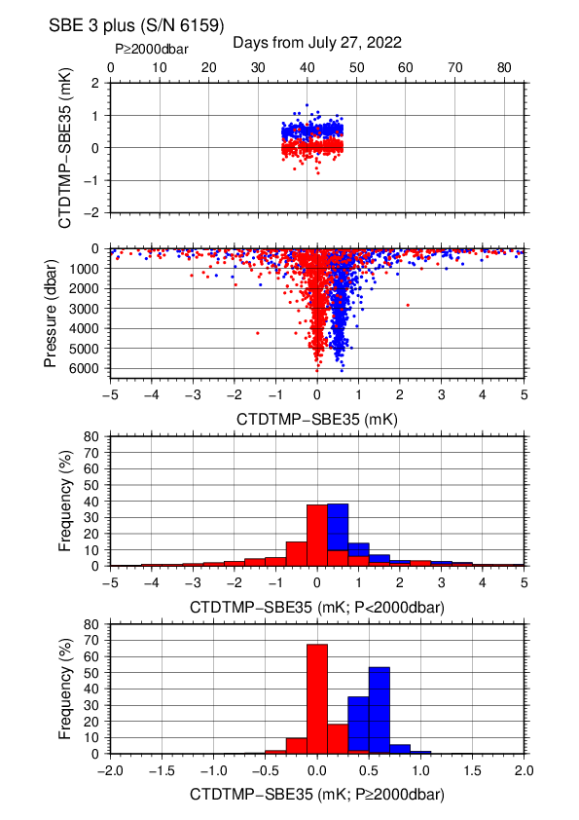
Figure C.1.4. Difference between the CTD temperature (S/N 03P 6159) and the Deep Ocean Standards thermometer (SBE 35) on RF22-06. Blue and red dots indicate before and after the correction using SBE 35 data, respectively. Lower two panels show histograms of the differences after correction.
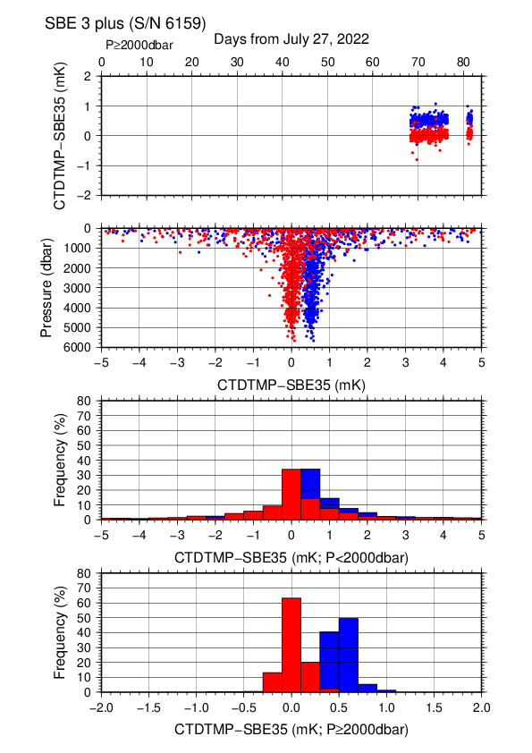
Figure C.1.5. Difference between the CTD temperature (S/N 03P 6159) and the Deep Ocean Standards thermometer (SBE 35) on RF22-07 Leg 1. Blue and red dots indicate before and after the correction using SBE 35 data, respectively. Lower two panels show histograms of the differences after correction.

(4.3) Conductivity sensor (SBE 4C)
The practical corrections for CTD conductivity data can be made by using bottle salinity data to correct the SBE 4C to agree with measured conductivity (McTaggart et al., 2010).

CTD conductivity was corrected as follows:
$$Corrected Conductivity=C-\left(\sum_{i=0}^{I}{c_{i}×C^{i}}+\sum_{j=1}^{J}{p_{j}×P^{j}}\right)$$
C: CTD conductivity, c_{i} and p_{j}: calibration coefficients
i, j: determined by use of the AIC (Akaike, 1974). In accord with McTaggart et al. (2010), the maximum of I and J are 2.

S/N | Num | c₀(S/m) | c₁ | c₂(m/S) | c₃(m/S²) | Stations
 |  |  | p₁(S/m/dbar) | p₂(S/m/dbar²) | p₃(S/m/dbar³)
043697 | 905 | -4.3479 × 10⁻³ | 1.8374 × 10⁻³ | -2.3936 × 10⁻⁴ | 0.0000 | RF7040 – 7064
 |  |  | 1.6941 × 10⁻⁷ | -2.3824 × 10⁻¹¹ | 0.0000
043697 | 1325 | -1.7159 × 10⁻³ | 7.7946× 10⁻⁴ | -1.5948 × 10⁻⁴ | 0.0000 | RF7065  (※)  RF7066 – 7067  RF7068 – 7102
 |  |  | 1.6297 × 10⁻⁸ | 0.0000 | 0.0000
043697 | 1193 | 4.7357 × 10⁻⁴ | -4.4053 × 10⁻⁴ | 0.0000 | 0.0000 | RF7103 – 7135
 |  |  | 2.3972 × 10⁻⁸ | 0.0000 | 0.0000
046059 | 896 | -2.8598 × 10⁻⁴ | 1.6159 × 10⁻⁴ | 0.0000 | 0.0000 | RF7040 – 7064
 |  |  | 0.0000 | 0.0000 | 0.0000
046059 | 1270 | -2.4270 × 10⁻³ | 1.1184 × 10⁻³ | -1.2363 × 10⁻⁴ | 0.0000 | RF7065  (※)  RF7066 – 7067  RF7068 – 7102
 |  |  | 1.5156 × 10⁻⁷ | -3.1434 × 10⁻¹¹ | 2.1157 × 10⁻¹⁵
046059 | 1111 | 5.2708 × 10⁻⁴ | –3.6327 × 10⁻⁴ | 6.6707 × 10⁻⁵ | 0.0000 | RF7103 – 7135
 |  |  | 2.7612 × 10⁻⁸ | 0.0000 | 0.0000
Table C.1.4. Conductivity correction coefficient summary. (Bold: accepted sensor)
※From station RF7066 to RF7067, S/N 043697 was accepted instead of S/N 046059 due to data failure. After RF7068, this data failure was resolved.

Table C.1.5. Conductivity correction and salinity correction summary for S/N 043697.
Stations | Pressure < 1900dbar
 | Conductivity |  |  | Salinity
 | Num | Average  (S/m) | Std  (S/m) | Num | Average | Std
RF7040 – 7064 | 621 | 0.0000 | 0.0011 | 621 | 0.0000 | 0.0075
RF7065 – 7102 | 849 | 0.0000 | 0.0007 | 849 | 0.0000 | 0.0051
RF7103 – 7135 | 749 | 0.0000 | 0.0008 | 749 | 0.0000 | 0.0062
Stations | Pressure ≥ 1900 dbar
 | Conductivity |  |  | Salinity
 | Num | Average  (S/m) | Std  (S/m) | Num | Average | Std
RF7040 – 7064 | 284 | 0.0000 | 0.0000 | 284 | 0.0000 | 0.0005
RF7065 – 7102 | 476 | 0.0000 | 0.0001 | 476 | 0.0000 | 0.0006
RF7103 – 7135 | 444 | 0.0000 | 0.0000 | 444 | 0.0000 | 0.0004

Table C.1.6. Conductivity correction and salinity correction summary for S/N 046059.
Stations | Pressure < 1900dbar
 | Conductivity |  |  | Salinity
 | Num | Average  (S/m) | Std  (S/m) | Num | Average | Std
RF7040 – 7064 | 618 | 0.0000 | 0.0011 | 618 | 0.0000 | 0.0081
RF7065 – 7102 | 818 | 0.0000 | 0.0007 | 818 | 0.0000 | 0.0050
RF7103 – 7135 | 691 | 0.0000 | 0.0008 | 691 | 0.0000 | 0.0059
Stations | Pressure ≥ 1900 dbar
 | Conductivity |  |  | Salinity
 | Num | Average  (S/m) | Std  (S/m) | Num | Average | Std
RF7040 – 7064 | 278 | 0.0000 | 0.0000 | 278 | 0.0000 | 0.0005
RF7065 – 7102 | 452 | 0.0000 | 0.0000 | 452 | 0.0000 | 0.0004
RF7103 – 7135 | 420 | 0.0000 | 0.0000 | 420 | 0.0000 | 0.0004

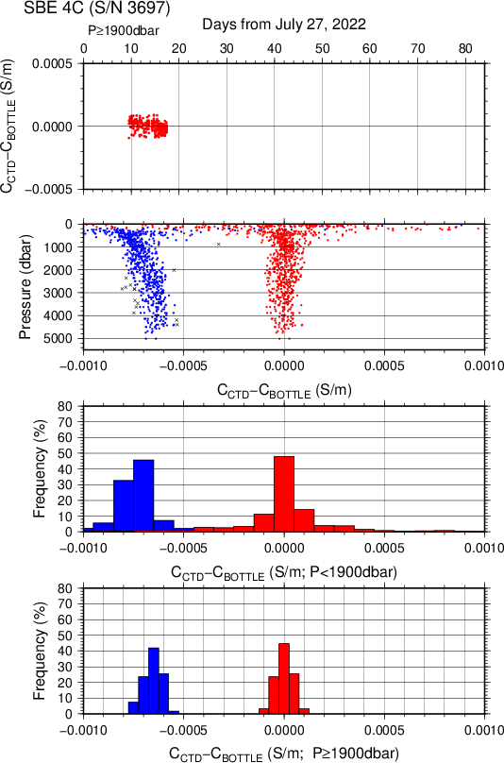
Figure C.1.6. Difference between the CTD conductivity (S/N 043697) and the bottle conductivity on RF22-05. Blue and red dots indicate before and after the calibration using bottle data, respectively. Lower two panels show histograms of the differences before and after calibration.

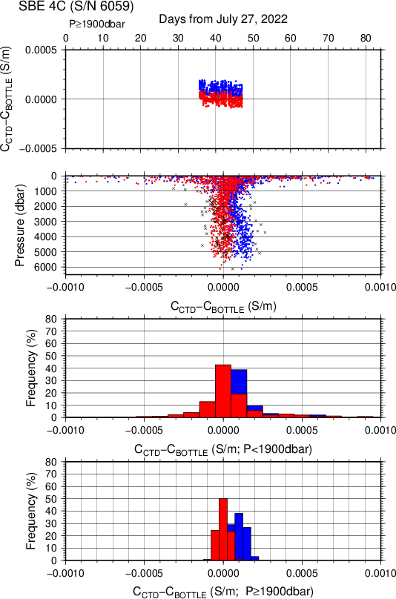
Figure C.1.7. Difference between the CTD conductivity (S/N 046059) and the bottle conductivity on RF22-06. Blue and red dots indicate before and after the calibration using bottle data, respectively. Lower two panels show histograms of the differences before and after calibration.

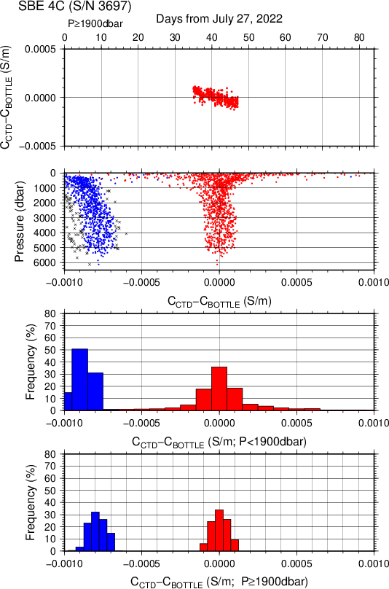
Figure C.1.8. Difference between the CTD conductivity (S/N 043697) and the bottle conductivity on RF22-06. Blue and red dots indicate before and after the calibration using bottle data, respectively. Lower two panels show histograms of the differences before and after calibration.
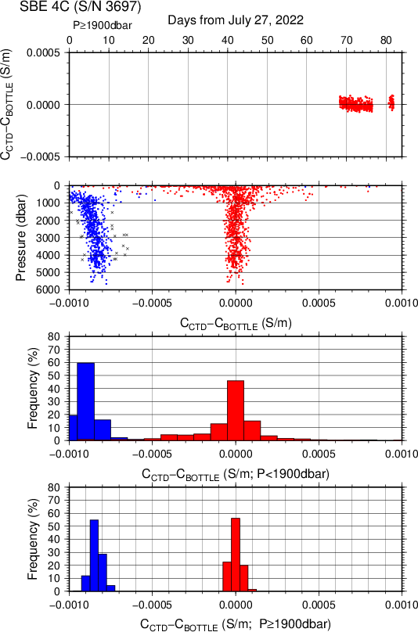
Figure C.1.9. Difference between the CTD conductivity (S/N 043697) and the bottle conductivity on RF22-07 Leg 1. Blue and red dots indicate before and after the calibration using bottle data, respectively. Lower two panels show histograms of the differences before and after calibration.

(4.4) Oxygen sensor (RINKO III)
The CTD oxygen concentration was calculated using the RINKO III output (voltage) with the Stern-Volmer equation in accord with the method of Uchida et al. (2008) and Uchida et al. (2010). The pressure hysteresis for the RINKO III output (voltage) was corrected in accord with Sea-bird Electronics (2009) and Uchida et al. (2010). The equations were as follows:
$$P_{0}=1.0+c_{4}×t$$
$$P_{c}=c_{5}{+c}_{6}×v+c_{7}×T+c_{8}×T×v$$
$$K_{sv}=c_{1}+c_{2}×t+c_{3}×t^{2}$$
$$coef={\left(1.0+c_{9}×P/{1000}\right)}^{1/3}$$
$$\left[O_{2}\right]=O_{2}^{sat}×\left\{{\left({P_{0}}/{P_{c}-1.0}\right)}/{K_{sv}×coef}\right\}$$
P: pressure (dbar), t: potential temperature, v: RINKO output voltage (volt)
T: elapsed time of the sensor from the beginning of first station in calculation group in day
O₂^{sat}: dissolved oxygen saturation by Garcìa and Gordon (1992) (μmol/kg)
[O₂]: dissolved oxygen concentration (μmol/kg)
c₁–c₉: determined by minimizing differences between CTD oxygen concentration and bottle dissolved oxygen concentration by quasi-newton method (Shanno, 1970).

S/N | Stations | c₁ | c₂ | c₃ | c₄ | c₅
 |  | c₆ | c₇ | c₈ | c₉
0392 | RF7040 – 7064 | 1.67544 | 1.52969 × 10⁻² | 1.29452 × 10⁻⁴ | -2.06723 × 10⁻³ | -1.10424 × 10⁻¹
 |  | 3.12593 × 10⁻¹ | 1.02224 × 10⁻³ | -1.46624 × 10⁻⁴ | 8.04862 × 10⁻²
0392 | RF7065 – 7102 | 1.72710 | 2.11986 × 10⁻² | 1.87955 × 10⁻⁴ | -9.01896 × 10⁻⁴ | -1.26917 × 10⁻¹
 |  | 3.17603 × 10⁻¹ | 2.45262 × 10⁻⁴ | 2.15964 × 10⁻⁴ | 7.99771 × 10⁻²
0392 | RF7103 – 7135 | 1.75666 | 2.04888 × 10⁻² | 2.50957 × 10⁻⁴ | -9.85855 × 10⁻⁴ | -1.31903 × 10⁻¹
 |  | 3.18994 × 10⁻¹ | -5.52313 × 10⁻⁴ | 5.46897 × 10⁻⁴ | 7.90762 × 10⁻²
0356 | RF7040 – 7064 | 1.76099 | 1.76869 × 10⁻² | 1.54020 × 10⁻⁴ | -1.72809 × 10⁻³ | -1.18853 × 10⁻¹
 |  | 3.14640 × 10⁻¹ | 1.11683 × 10⁻³ | -1.91344 × 10⁻⁴ | 7.98476 × 10⁻²
0356 | RF7065 – 7102 | 1.78055 | 2.84361 × 10⁻² | 1.55622 × 10⁻⁴ | 2.57797 × 10⁻⁴ | -1.31167 × 10⁻¹
 |  | 3.19775 × 10⁻¹ | 5.83281 × 10⁻⁵ | 1.92499 × 10⁻⁴ | 7.78531 × 10⁻²
0356 | RF7103 – 7135 | 1.76373 | 2.34709 × 10⁻² | 1.43849 × 10⁻⁴ | -5.85406 × 10⁻⁴ | -1.21666 × 10⁻¹
 |  | 3.17354 × 10⁻¹ | -3.38758 × 10⁻⁴ | 3.47439 × 10⁻⁴ | 7.85876 × 10⁻²
Table C.1.7. Dissolved oxygen correction coefficient summary. (Bold: accepted sensor)

Table C.1.8. Dissolved oxygen correction summary for S/N 0392.
Stations | Pressure < 950dbar |  |  | Pressure ≥ 950 dbar
 | Num | Average  (μmol/kg) | Std  (μmol/kg) | Num | Average  (μmol/kg) | Std  (μmol/kg)
RF7040 – 7064 | 449 | 0.04 | 1.02 | 372 | -0.00 | 0.27
RF7065 – 7102 | 634 | –0.00 | 0.82 | 640 | 0.00 | 0.31
RF7103 – 7135 | 538 | –0.06 | 0.71 | 555 | 0.00 | 0.30

Table C.1.9. Dissolved oxygen correction summary for S/N 0356.
Stations | Pressure < 950dbar |  |  | Pressure ≥ 950 dbar
 | Num | Average  (μmol/kg) | Std  (μmol/kg) | Num | Average  (μmol/kg) | Std  (μmol/kg)
RF7040 – 7064 | 449 | –0.01 | 0.94 | 372 | -0.00 | 0.24
RF7065 – 7102 | 634 | –0.04 | 0.79 | 640 | -0.00 | 0.26
RF7103 – 7135 | 538 | -0.02 | 0.55 | 555 | 0.00 | 0.22

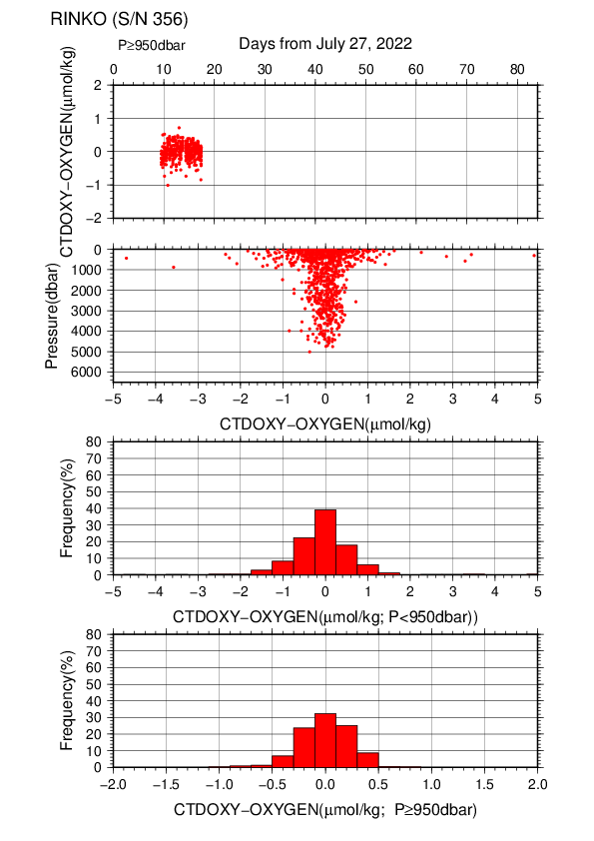
Figure C.1.10. Difference between the CTD oxygen (S/N 0356) and bottle dissolved oxygen at RF22-05. Red dots in upper two panels indicate the result of calibration. Lower two panels show histograms of the differences between calibrated oxygen concentration and bottle oxygen concentration.
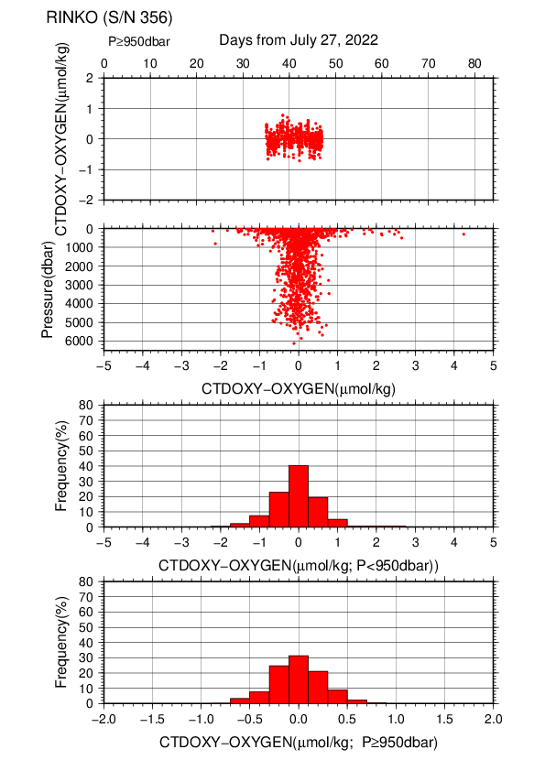
Figure C.1.11. Difference between the CTD oxygen (S/N 0356) and bottle dissolved oxygen at RF22-06. Red dots in upper two panels indicate the result of calibration. Lower two panels show histograms of the differences between calibrated oxygen concentration and bottle oxygen concentration.
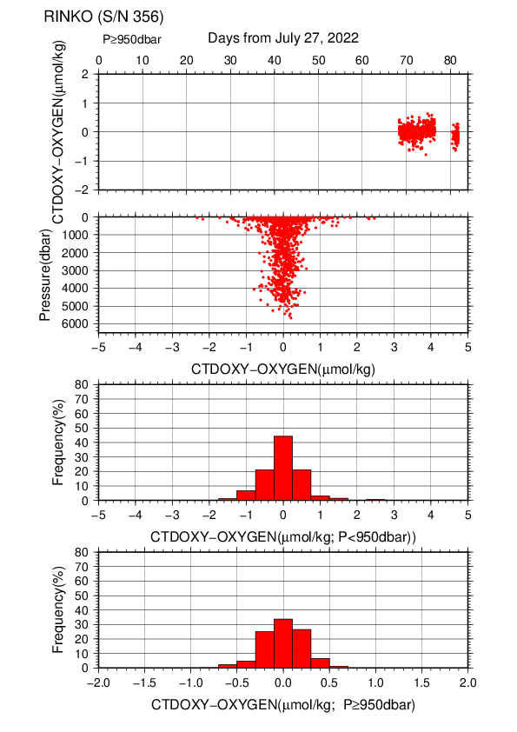
Figure C.1.12. Difference between the CTD oxygen (S/N 0356) and bottle dissolved oxygen at RF22-07 Leg1. Red dots in upper two panels indicate the result of calibration. Lower two panels show histograms of the differences between calibrated oxygen concentration and bottle oxygen concentration.

(4.5) Results of detection of sea floor by the altimeter (VA500)
The altimeter detected the sea floor at 91 of 93 stations and that of final detection of sea floor was 13.7 m. The summary of detection of VA500 was shown in Figure C.1.13.
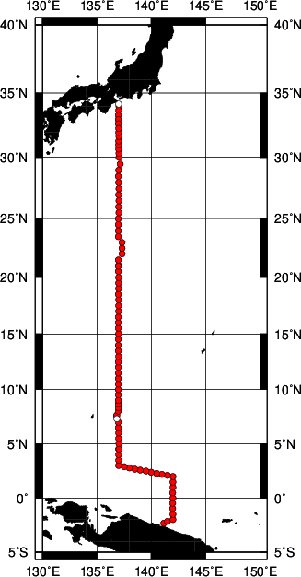
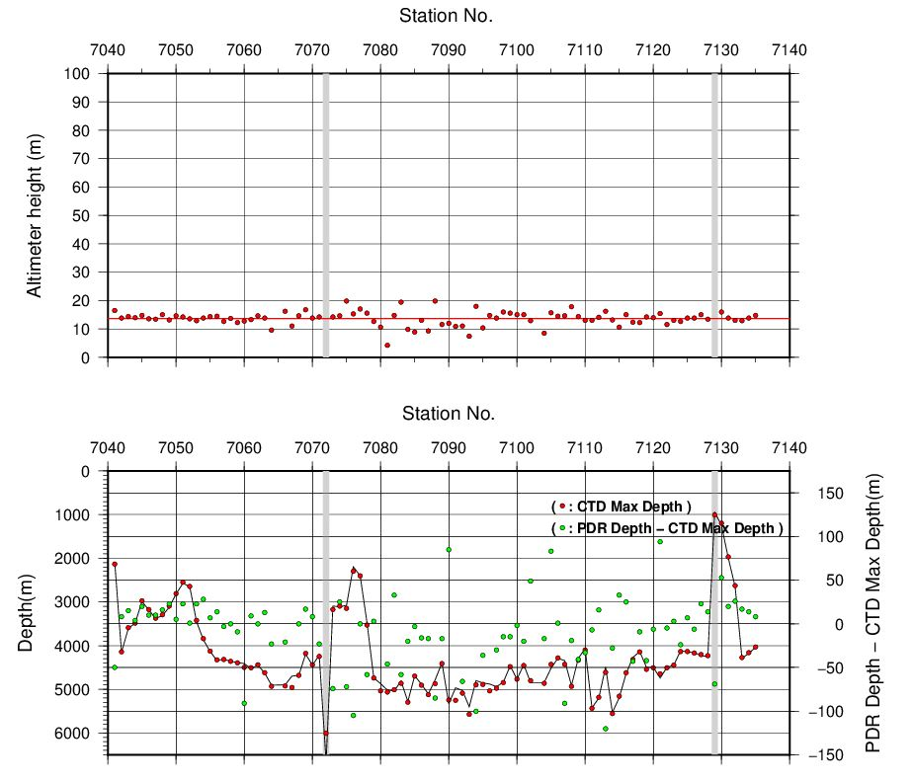

Figure C.1.13. The summary of detection of VA500. The left panel shows the stations of detection, the right panels shows the relationship among VA500, bathymetry（PDR Depth） and CTD depth. In the left panel, closed and open circles indicate react and no-react stations, respectively. In the right two panels, gray shade indicates no-react stations.

Post-cruise calibration
After the cruise, post-cruise calibration of sensors was performed by the manufacturer, as shown below. We confirmed that the calibration of these sensors did not change significantly during the cruise.

(5.1) Temperature (ITS-90): SBE 3plus

S/N 03P6159 (primary), 13 May. 2023
g | = | 4.31677996 × 10⁻³ |  | j | = | 2.00080133 × 10⁻⁶
h | = | 6.38544094 × 10⁻⁴ |  | f₀ | = | 1000.0
i | = | 2.17927463 × 10⁻⁵

S/N 03P4321 (secondary), 24 May. 2023
g | = | 4.34249577 × 10⁻³ |  | j | = | 2.09128339 × 10⁻⁶
h | = | 6.40268544 × 10⁻⁴ |  | f₀ | = | 1000.0
i | = | 2.24531711 × 10⁻⁵

(5.2) Deep Ocean Standards Thermometer Temperature (ITS-90): SBE 35
S/N 0093, 27 Oct. 2020
a₀ | = | 4.12756963 × 10⁻³ |  | a₃ | = | –9.36245277 × 10⁻⁶
a₁ | = | –1.08163464 × 10⁻³ |  | a₄ | = | 2.00979198 × 10⁻⁷
a₂ | = | 1.67453817 × 10⁻⁴
Formula:
n: instrument output

The slow time drift of the SBE 35
S/N 0093, 02 Feb. 2023 (2nd step: fixed point calibration)
Slope = 1.000007, Offset = –0.000205
Formula:

(5.3) Conductivity: SBE 4C
S/N 043697 (primary), 23 May. 2023
g | = | –9.79179904 |  | j | = | 2.71617766 × 10⁻⁴
h | = | 1.25556323 |  | CP_{cor} | = | –9.5700 × 10⁻⁸
i | = | –2.74297983 × 10⁻³ |  | CT_{cor} | = | 3.2500 × 10⁻⁶

S/N 046059 (secondary), 22 May. 2023
g | = | –1.02817639 × 10⁻¹ |  | j | = | 4.22955067 × 10⁻⁴
h | = | 1.61242457 |  | CP_{cor} | = | –9.5700 × 10⁻⁸
i | = | –3.91114555 × 10⁻³ |  | CT_{cor} | = | 3.2500 × 10⁻⁶

References
Akaike, H. (1974): A new look at the statistical model identification. IEEE Transactions on Automatic Control, 19:716–722.
Garcìa, H. E., and L. I. Gordon (1992): Oxygen solubility in seawater: Better fitting equations. Limnol. Oceanogr., 37, 1307–1312.
McTaggart, K. E., G. C. Johnson, M. C. Johnson, F. M. Delahoyde, and J. H. Swift (2010): The GO-SHIP Repeat Hydrography Manual: A Collection of Expert Reports and guidelines. IOCCP Report No 14, ICPO Publication Series No. 134, version 1, 2010.
Sea-Bird Electronics (2009): SBE 43 dissolved oxygen (DO) sensor – hysteresis corrections, Application note no. 64-3, 7 pp.
Shanno, David F. (1970): Conditioning of quasi-Newton methods for function minimization. Math. Comput. 24, 647–656. MR 42 #8905.
Uchida, H., G. C. Johnson, McTaggart, K. E. (2010): CTD oxygen sensor calibration procedures. In: The GO-SHIP repeat hydrography manual: A Collection of Expert Reports and guidelines. IOCCP Report No 14, ICPO Publication Series No. 134, version 1, 2010.
Uchida, H., K. Ohyama, S. Ozawa, and M. Fukasawa (2007): In-situ calibration of the Sea-Bird 9plus CTD thermometer. J. Atmos. Oceanic Technol., 24, 1961–1967.
Uchida, H., T. Kawano, I. Kaneko, and M. Fukasawa (2008): In-situ calibration of optode-based oxygen sensors. J. Atmos. Oceanic Technol., 25, 2271–2281.

Bottle Salinity
25 September 2023

Personnel
TANAKA Kiyoshi
MURAKAMI Kiyoshi (RF2206, RF2207)
HIGASHI Yoshikazu (RF2206, RF2207)
WADA Kouichi (RF2205, RF2207)
SEGAWA Takahiro (RF2205, RF2207)
CHIBA Yasuomi (RF2205, RF2206)
TANAKA Hidekazu (RF2205, RF2206)

Salinity measurement
Salinometer: AUTOSAL 8400B (Guildline Instruments Ltd., Canada ; S/N 73556 for stations between RF7096 and RF7102, S/N 72103 for stations between RF7103 and RF7128, and S/N 73239 for all other stations)
Thermometer: 1502A Tweener thermometer readout (to monitor ambient temperature and bath temperature) (Fluke calibration, USA)
IAPSO Standard Seawater: P165 (K15=0.99986)

Sampling and measurement
The measurement system was almost the same as the system described by Kawano (2010).
Algorithm for practical salinity scale, 1978 (PSS-78; UNESCO, 1981) was employed to convert the conductivity ratios to salinities.

Station occupied
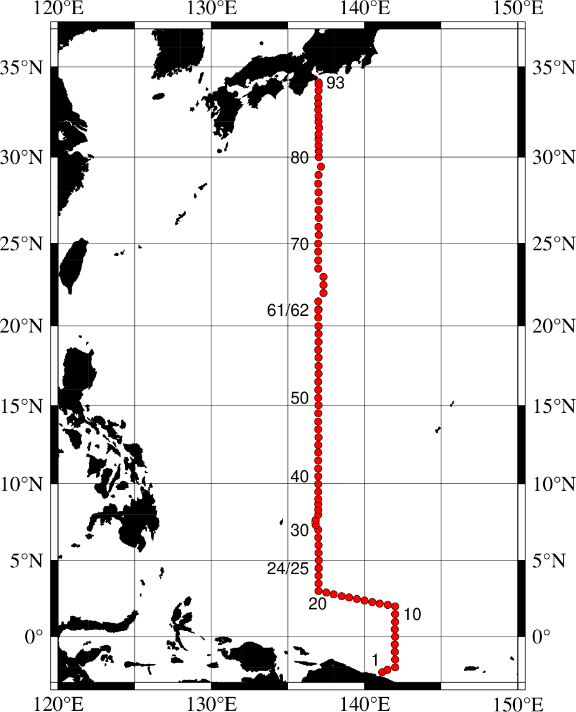
Figure C.2.1. Location of observation stations of bottle salinity.

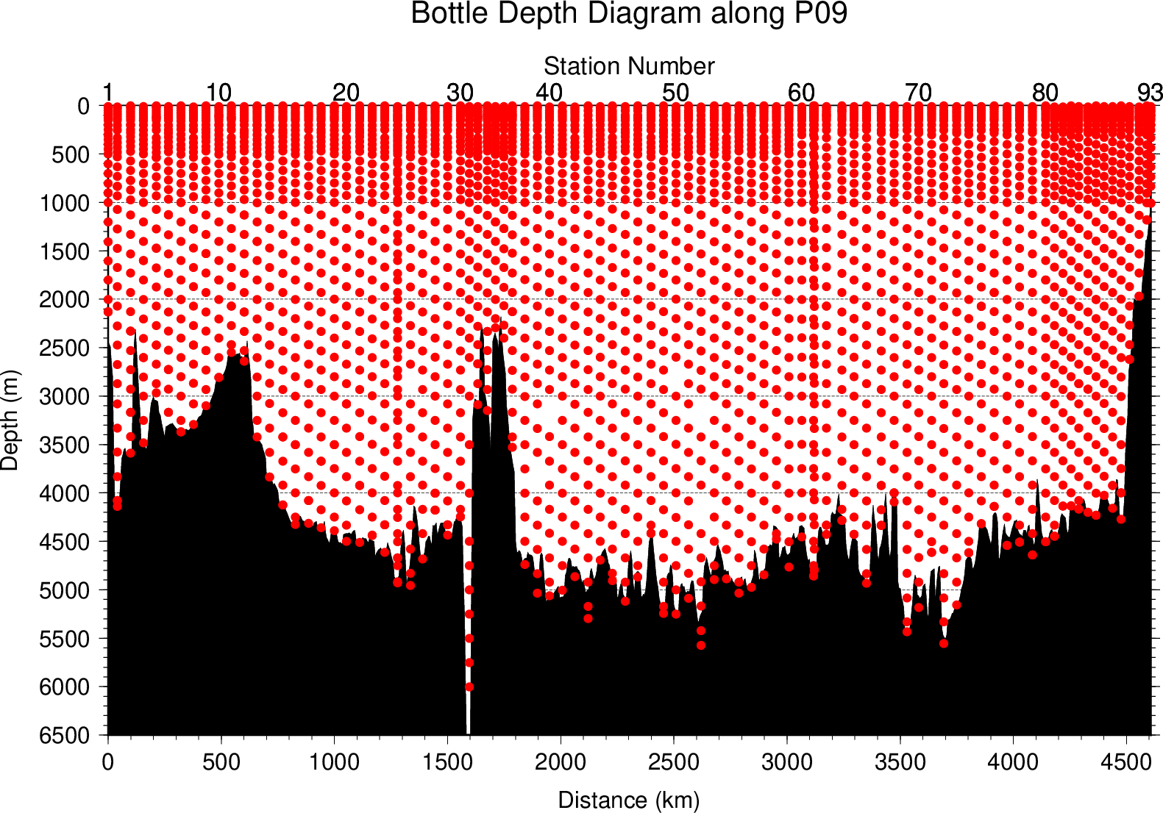
Figure C.2.2. Distance-depth distribution of sampling layers of bottle salinity.

Result

(5.1) Ambient temperature, bath temperature and Standard Seawater measurements
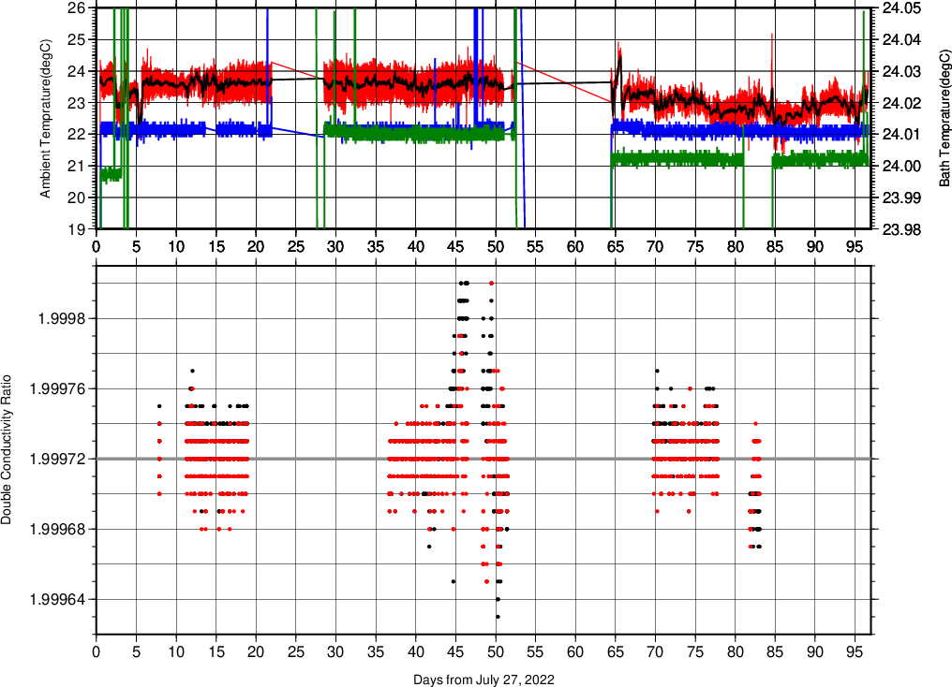
Figure C.2.3. The upper panel indicate time-series of ambient temperature and bath temperature during the cruise. (Red(black) line; ambient(average) temperature. Green line; bath temperature in Autosal S/N72103(RF2205,2207) and S/N73556(RF2206). Blue line; bath temperature in Autosal (S/N 73239) .
The lower panel, black dots, and red dots indicate raw and corrected time-series of the double conductivity ratio of the standard seawater (P165).

(5.2) Replicate and duplicate samples
We took replicate (pair of water samples taken from a single Niskin bottle) and duplicate (pair of water samples taken from different Niskin bottles closed at the same depth) samples for bottle salinity throughout the cruise. Table C.2.1 summarizes the results of the analyses. Figure C.2.4 shows details of the results. The calculation of the standard deviation from the difference of sets was based on a procedure (SOP 23) in DOE (1994).

Table C.2.1. Summary of replicate and duplicate salinity analyses.
Measurement | Average difference ± S.D.
Replicate sample | 0.0003 ± 0.0003 (N = 314)
Duplicate sample | 0.0009 ± 0.0018 (N = 171)
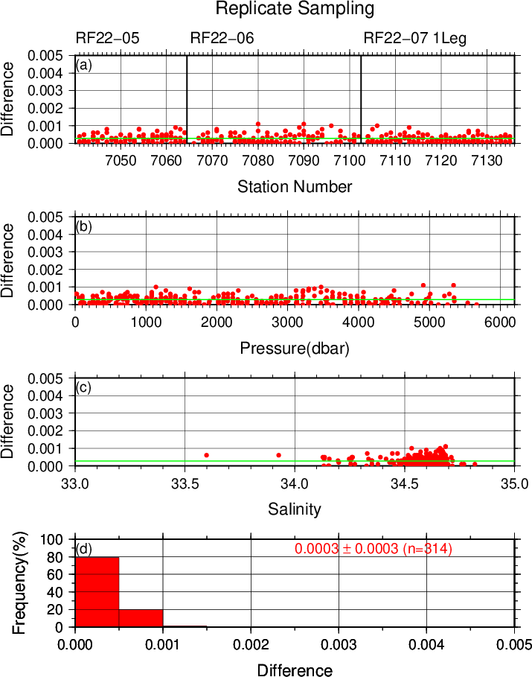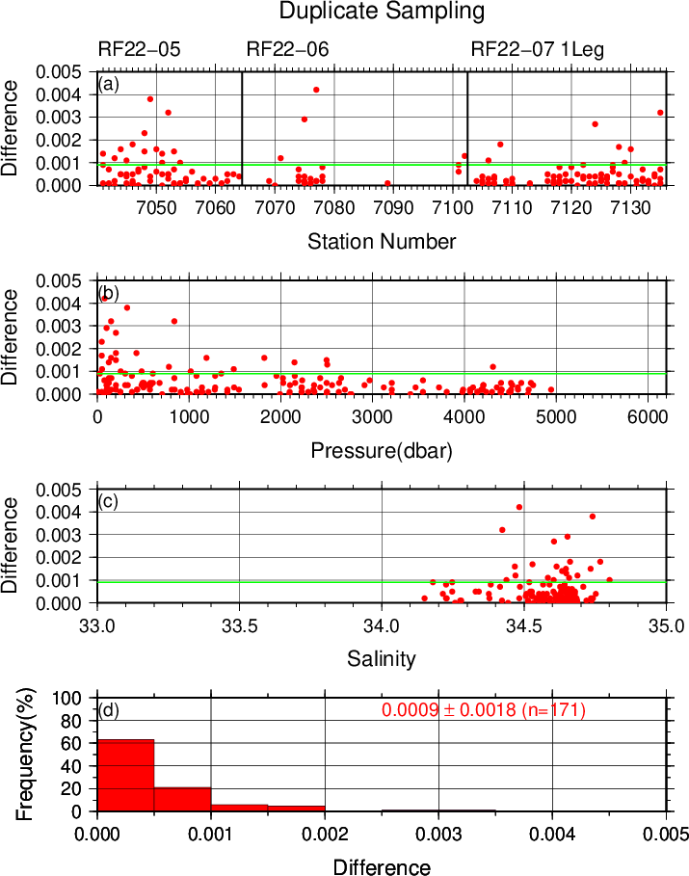
Figure C.2.4. Results of (left) replicate and (right) duplicate analyses during the cruise against (a) station number, (b) pressure, (c) salinity, and (d) histogram of the measurements. Green line indicates the mean of the differences of salinity of replicate/duplicate analyses.

(5.3) Summary of assigned quality control flags
Table C.2.2. Summary of assigned quality control flags
Flag | Definition | Number
2 | Good | 2826
3 | Questionable | 0
4 | Bad (Faulty) | 96
5 | Not reported | 4
6 | Replicate measurements | 319
Total number of samples |  | 3245
References
DOE (1994), Handbook of methods for the analysis of the various parameters of the carbon dioxide system in sea water; version 2. A. G. Dickson and C. Goyet (eds), ORNL/CDIAC-74.
Kawano (2010), The GO-SHIP Repeat Hydrography Manual: A Collection of Expert Reports and Guidelines. IOCCP Report No. 14, ICPO Publication Series No. 134, Version 1.
UNESCO (1981), Tenth report of the Joint Panel on Oceanographic Tables and Standards. UNESCO Tech. Papers in Mar. Sci., 36, 25 pp.

