Total Alkalinity (TA)

30 September 2023

Personnel
DEHARA Kohshiro
HAMANA Minoru
NAKAMURA Naoki

Station occupied
A total of 45 stations (RF21-06: 18, RF21-07: 15, RF21-08: 12) were occupied for total alkalinity (TA). Station location and sampling layers of them are shown in Figures C.7.1 and C.7.2, respectively.

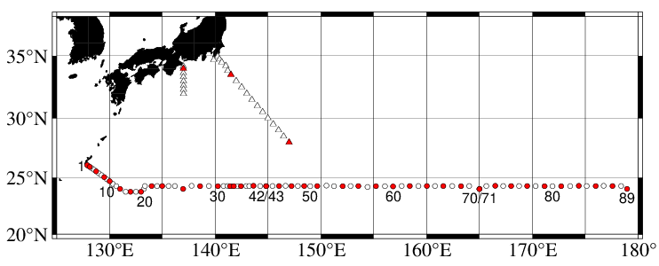
Figure C.7.1. Location of observation stations of TA. Closed and open circles indicate sampling and no-sampling stations, respectively. Triangles show sampling station which are not reported in the bottle data file, but the data at closed triangles are used for quality control of TA. These data are available from the JMA
(https://www.data.jma.go.jp/gmd/kaiyou/db/vessel_obs/data-report/html/ship/ship_e.php?year=2021&season=summer).

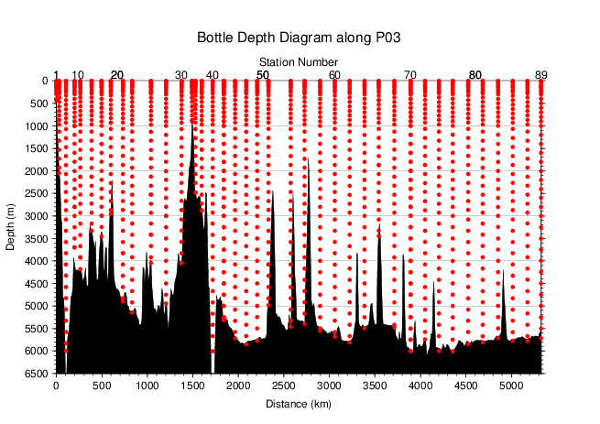
Figure C.7.2. Distance-depth distribution of sampling layers of TA.

Instrument
The measurement of TA was carried out with DIC/TA analyzers (Nihon ANS Co. Ltd., Japan). The methodology that these analyzers use is based on an open titration cell. We used two analyzers concurrently. These analyzers are designated as apparatus A and B.

Sampling and measurement
The procedure of seawater sampling of TA bottles and poisoning with mercury (II) chloride (HgCl₂) were based on the Standard Operating Procedure (SOP) described in PICES Special Publication 3 (Dickson et al., 2007). Details are shown in Appendix A1 in C.6.
TA measurement is based on a one-step volumetric addition of hydrochloric acid (HCl) to a known amount of sample seawater with prompt spectrophotometric measurement of excess acid using the sulfonephthalein indicator bromo cresol green sodium salt (BCG) (Breland and Byrne, 1993). We used a mixed solution of HCl, BCG, and sodium chloride (NaCl) as reagent. Details of measurement are shown in Appendix A1.

Calculation

(5.1) Volume of sample seawater
The volumes of pipette V_{S} using in apparatus A and B was calibrated gravimetrically in our laboratory. Table C.7.1 shows the summary.

Table C.7.1. Summary of sample volumes of seawater V_{S} for TA measurements.
Apparatus | Vs / mL
A | 42.8099
B | 41.4764

(5.2) pH_{T} calculation in spectrophotometric measurement
The data of absorbance A and pipette temperature T (in °C) were processed to calculate pH_{T} (in total hydrogen ion scale; details shown in Appendix A1 in C.8) and the concentration of excess acid [H⁺]_{T} (mol kg⁻¹) in the following equations (C7.1)–(C7.3) (Yao and Byrne, 1998),
pH_{T} = − log₁₀([H＋]_{T})
= 4.2699 + 0.02578 (35 − S) + log{(R₂₅ − 0.00131) / (2.3148 − 0.1299 R₂₅)}
− log(1 − 0.001005 S) (C7.1)
R₂₅ = R_{T} {1 + 0.00909 (25 − T)} (C7.2)
$R_{T}={\left(A_{616}^{SA}-A_{616}^{S}-A_{730}^{SA}+A_{730}^{S}\right)}/{\left(A_{444}^{SA}-A_{444}^{S}-A_{730}^{SA}+A_{730}^{S}\right)}$. (C7.3)
In the equation (C7.1), R_{T} is absorbance ratio at temperature T, R₂₅ is absorbance ratio at temperature 25 °C and S is salinity. $A_{λ}^{S}$ and $A_{λ}^{SA}$ denote absorbance of seawater before and after acidification, respectively, at wavelength λ nm.

(5.3) TA calculation
The calculated [H＋]_{T} was then combined with the volume of sample seawater V_{S}, the volume of titrant V_{A} added to the sample, and molarity of hydrochloric acid HCl_{A} (in mmol L⁻¹) in the titrant to determine to TA concentration A_{T} (in μmol kg⁻¹) as follows:
A_{T} = (−[H⁺]_{T} (V_{S} + V_{A}) ρ_{SA} + HCl_{A} V_{A}) / (V_{S} ρ_{S}) (C7.4)
ρ_{S} and ρ_{SA} denote the density of seawater sample before and after the addition of titrant, respectively. Here we assumed that ρ_{SA} is equal to ρ_{S}, since the density of titrant has been adjusted to that of seawater by adding NaCl and the volume of titrant (approx. 2.5 mL) is no more than approx. 6 % of seawater sample.
Finally, the value of A_{T} was multiplied by 1.00067 (= 300.2 / 300.0) to correct dilution effect in A_{T} induced by addition of HgCl₂ solution.

Standardization of HCl reagent
HCl reagents were prepared in our laboratory (Appendix A2) and divided into bottles (HCl batches). The determination of HCl_{A} was based on measurements of standard sea water (SSW) which was bottled in our laboratory at November 27th, 2019 (Appendix A2 in C.6). The SSWs show good homogeneity among bottles and good temporal stability of A_{T} at least 12 months. The determination of A_{T} of SSW was based on pre-cruise measurements at October 26th, 2020 using CRMs provided by Dr. Andrew G. Dickson of the Scripps Institution of Oceanography. The list of lot of the SSW and the batch of the CRMs is shown in Table C.7.2.

Table C.7.2. Assigned A_{T} and standard deviation of SSW and certified A_{T} and standard deviation of CRM. Unit of A_{T} is μmol kg^{–1}. More information about CRM is available at the NOAA web site (https://www.ncei.noaa.gov/access/ocean-carbon-acidification-data-system/oceans/Dickson_CRM/batches.html).
 | SSW | CRM
Lot/batch | AH | 187
A_{T} | 2266.99±0.64 | 2204.98±0.37
Salinity | 34.538 | 33.602

The apparent HCl_{A} of the titrant was determined from assigned SSW using equation (C7.4).
HCl_{A} was assigned for each HCl batches for each apparatus, as summarized in Table C.7.3 and detailed in Figure C.7.3.

Table C.7.3. Summary of assigned HCl_{A} for each HCl batches. The reported values are means and standard deviations. Unit is mmol L⁻¹.
Apparatus | Cruise | HCl Batch | HCl_{A}
A | RF21-06 | A_1 | 50.0806±0.0171 (N=18)
 |  | A_2 | 50.0986±0.0197 (N=19)
 | RF21-07 | A_3 | 50.0556±0.0230 (N=16)
 |  | A_4 | 50.1493±0.0411 (N=20)
 | RF21-08 | A_5 | 50.0384±0.0521 (N=6)
 |  | A_6 | 50.0386±0.0554 (N=4)
 |  | A_7 | 49.9667±0.0296 (N=6)
 |  | A_8 | 49.9409±0.0511 (N=6)
 |  | A_9 | 49.8942±0.0487 (N=6)
B | RF21-06 | B_1 | 50.0740±0.0341 (N=21)
 |  | B_2 | 50.1629±0.0304 (N=19)
 | RF21-07 | B_3 | 50.1984±0.0211 (N=17)
 |  | B_4 | 50.2224±0.0241 (N=12)
 | RF21-08 | B_5 | 50.1977±0.0215 (N=14)
 |  | B_6 | 50.1878±0.0207 (N=16)

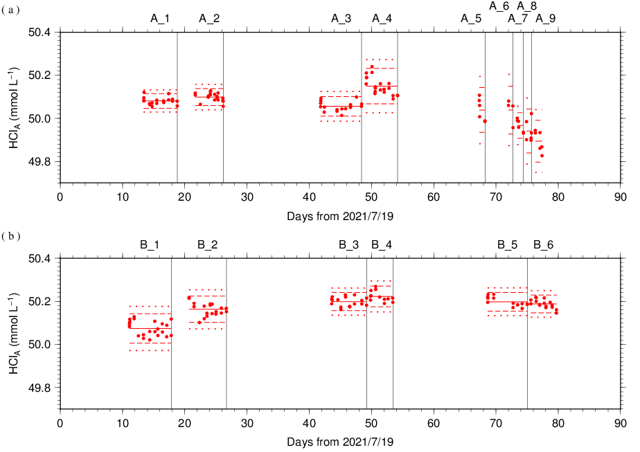
Figure C.7.3. Results of HCl_{A} measured by apparatus (a) A and (b) B. The HCl batch names are indicated at the top of each graph, and vertical lines denote the day when the HCl batch was switched. The red solid, dashed, and dotted lines denote the mean and the mean ± twice the S.D. and thrice the S.D. for each HCl batches, respectively.

The precisions of HCl_{A}, defined as the coefficient of variation (= S.D. / mean), were 0.0341–0.1107 % for apparatus A and 0.0412–0.0681 % for apparatus B. They correspond to 0.77–2.51 μmol kg⁻¹ and 0.94–1.54 μmol kg⁻¹ in A_{T} of SSW batch AH, respectively.

Quality Control

(7.1) Replicate and duplicate analyses
We took replicate (pair of water samples taken from a single Niskin bottle) and duplicate (pair of water samples taken from different Niskin bottles closed at the same depth) samples of TA throughout the cruise. Table C.7.4 summarizes the results of the measurements with each apparatus. Figures C.7.4–C.7.5 show details of the results. The calculation of the standard deviation from the difference of sets of measurements was based on a procedure (SOP 23) in DOE (1994).

Table C.7.4. Summary of replicate and duplicate measurements. Unit is μmol kg⁻¹.
 | Apparatus A | Apparatus B
Measurement | Average magnitude of difference ± S.D.
Replicate | 1.1±1.0 (N=63) | 0.9±0.8 (N=70)
Duplicate | 0.9±0.8 (N=22) | 0.9±0.9 (N=20)

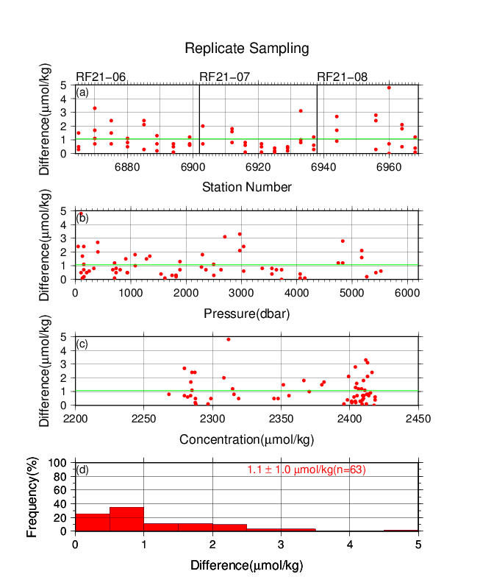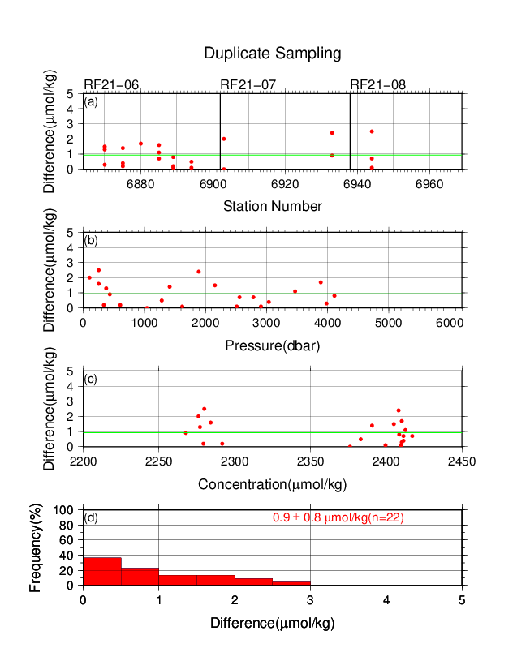
Figure C.7.4. Results of (left) replicate and (right) duplicate measurements during the cruise versus (a) station number, (b) pressure, and (c) A_{T} determined by apparatus A. The green lines denote the averages of the measurements. The bottom panels (d) show histograms of the measurements.

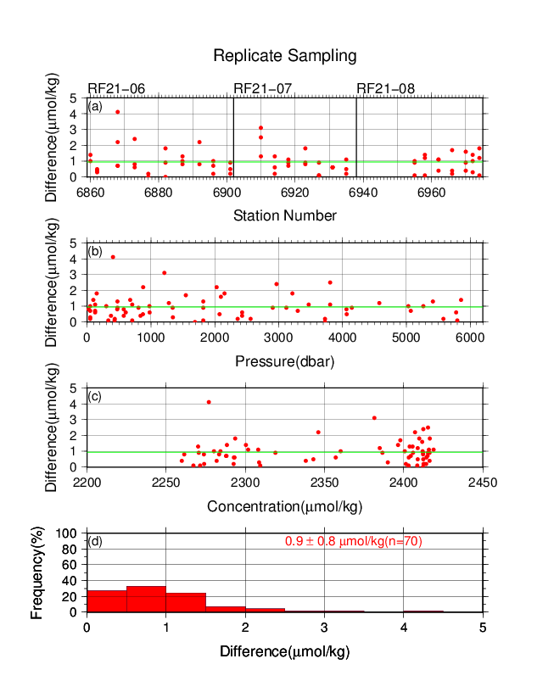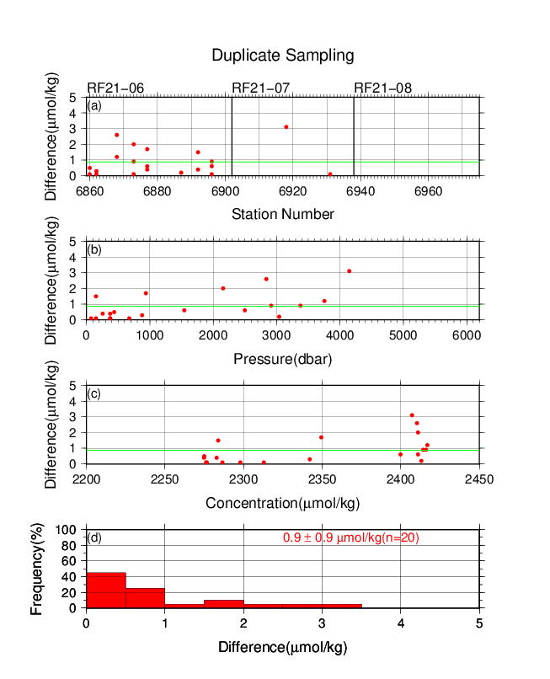
Figure C.7.5. Same as Figure C.7.4, but for apparatus B.

(7.2) Measurements of SSW and CRMs
At analysis of TA samples, we started by measurement of a SSW. If the condition of the measurement was good, measurements of seawater samples were started. As a set of analysis, we measured all seawater samples acquired from a single station. At the end of the sequence of measurements, we measured another SSW bottle to confirm condition of the measurement again. Additionally, we measured a CRM bottle every few stations to confirm a temporal stability of measurement through the cruise. In the cruise, the CRM batch 187 was used (Table C.7.2). SSW and CRM measurements were repeated at 2 and 3 times consecutively from the same bottle, respectively. Table C.7.5 summarizes the differences in the repeated measurements of the SSW and CRM and the mean A_{T} of the SSW and CRM measurements. Figures C.7.6–C.7.8 show detailed results.

Table C.7.5. Summary of difference and mean of A_{T} in the repeated measurements of SSW and CRM. These data are based on good measurements. Unit is μmol kg⁻¹.
Cruise | HCl Batch | Average  magnitude of  difference  ± S.D.  (SSW) | Average  magnitude of  difference  ± S.D.  (CRM) | Mean Ave.  ± S.D.  (SSW) | Mean Ave.  ± S.D.  (CRM)
RF21-06 | A_1 | 0.8±0.7  (N=9) | 1.0±0.7  (N=3) | 2267.0±0.7  (N=9) | 2204.0±1.4  (N=3)
 | A_2 | 0.6±0.6  (N=9) | 0.9±0.7  (N=2) | 2266.9±0.8  (N=9) | 2204.6±0.1  (N=2)
RF21-07 | A_3 | 0.8±0.6  (N=7) | 0.8±0.6  (N=3) | 2267.1±0.9  (N=7) | 2204.1±2.1  (N=3)
 | A_4 | 0.8±0.8  (N=10) | 0.7±0.6  (N=3) | 2267.0±1.9  (N=10) | 2204.7±2.4  (N=3)
RF21-08 | A_5 | 1.3±1.1  (N=3) | 1.4  (N=1) | 2267.0±2.6  (N=3) | 2206.4  (N=1)
 | A_6 | 2.8±2.4  (N=2) | – | 2267.0±2.1  (N=2) | –
 | A_7 | 0.7±0.6  (N=3) | 1.9  (N=1) | 2267.0±1.5  (N=3) | 2208.2  (N=1)
 | A_8 | 2.9±2.4  (N=3) | – | 2267.0±1.8  (N=3) | –
 | A_9 | 2.0±1.7  (N=3) | 1.3  (N=1) | 2267.0±2.2  (N=3) | 2207.0  (N=1)
RF21-06 | B_1 | 1.6±1.3  (N=10) | 0.6±0.4  (N=3) | 2266.9±1.3  (N=10) | 2204.9±0.8  (N=3)
 | B_2 | 1.0±0.9  (N=9) | 1.1±0.8  (N=4) | 2266.8±1.2  (N=9) | 2205.4±1.3  (N=4)
RF21-07 | B_3 | 0.9±0.8  (N=8) | 1.2±0.9  (N=2) | 2267.0±0.9  (N=8) | 2204.3±0.7  (N=2)
 | B_4 | 0.9±0.7  (N=5) | 1.4±1.1  (N=3) | 2266.9±1.2  (N=5) | 2205.3±0.8  (N=3)
RF21-08 | B_5 | 0.7±0.6  (N=7) | 1.5±1.2  (N=2) | 2267.0±1.0  (N=7) | 2205.2±1.7  (N=2)
 | B_6 | 0.6±0.5  (N=7) | 2.0±1.4  (N=2) | 2267.1±0.9  (N=7) | 2203.9±1.8  (N=2)

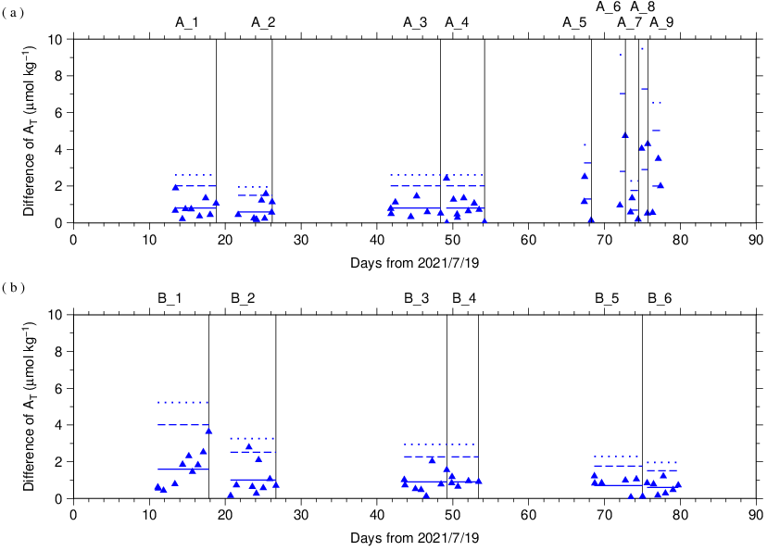
Figure C.7.6. The absolute difference (R) of A_{T} in repeated measurements of SSW determined by apparatus (a) A and (b) B. The solid line indicates the average of R ($\overline{R}$). The dashed and dotted lines denote the upper warning limit (2.512$\overline{R}$) and upper control limit (3.267$\overline{R}$), respectively (see Dickson et al., 2007). The labels at the top of the graph and vertical lines have the same meaning as in Figure C.7.3.

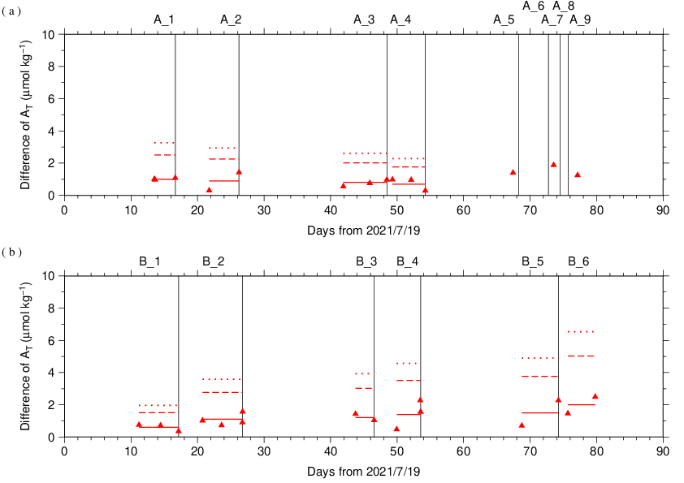
Figure C.7.7. Same as Figure C.7.6, but for CRM.

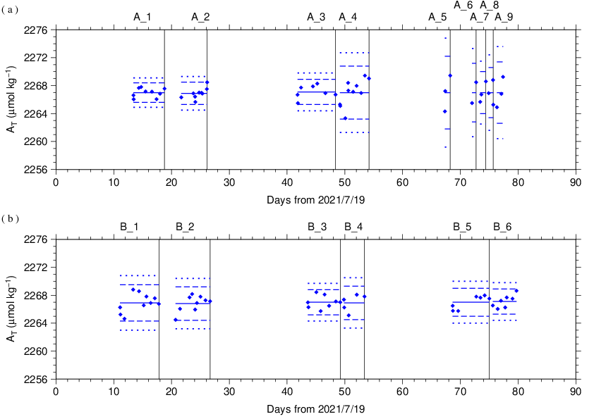
Figure C.7.8. The mean A_{T} of measurements of SSW. The panels show the results for apparatus (a) A and (b) B. The solid line indicates the mean of the measurements. The dashed and dotted lines denote the upper/lower warning limit (mean ± 2S.D.) and the upper/lower control limit (mean ± 3S.D.), respectively. The labels at the top of the graph and vertical lines have the same meaning as in Figure C.7.3.

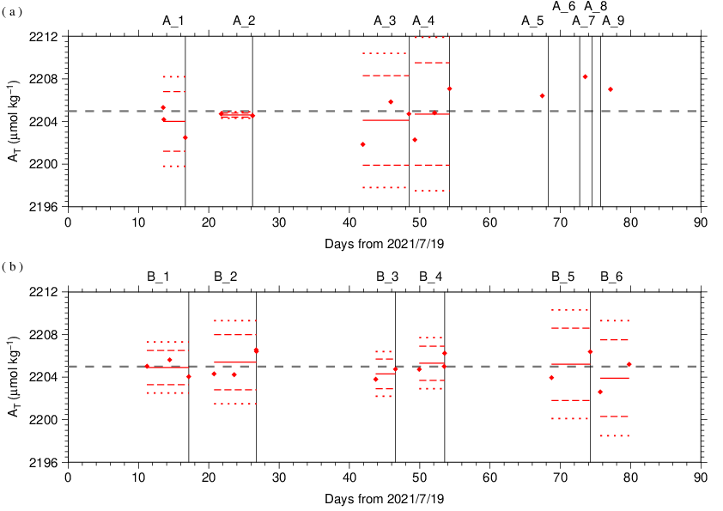
Figure C.7.9. Same as Figure C.7.8, but for CRM. The gray dashed line denotes certified A_{T} of CRM.

(7.3) Quality control flag assignment
A quality control flag value was assigned to the TA measurements (Table C.7.6) using the code defined in the IOCCP Report No.14 (Swift, 2010).

Table C.7.6. Summary of assigned quality control flags.
Flag | Definition | Number of samples
2 | Good | 1327
3 | Questionable | 7
4 | Bad (Faulty) | 4
5 | Not reported | 0
6 | Replicate measurements | 125
Total number of samples |  | 1463

Appendix
A1. Methods
(A1.1) Measurement
The unit for TA measurements in the coupled DIC/TA analyzer consists of sample treatment unit with a calibrated sample pipette and an open titration cell that are water-jacketed and connected to a thermostated water bath (25 °C), an auto syringe connected to reagent bottle of titrant stored at 25 °C, and a double-beam spectrophotometric system with two CCD image sensor spectrometers combined with a high power Xenon lamp. The mixture of 0.05 N HCl and 40 μmol L⁻¹ BCG in 0.65 M NaCl solution was used as reagent to automatically titrate the sample as follows:
(a) A portion of sample seawater was delivered into the sample pipette (approx. 42 mL) following sample delivery into the DIC unit for a measurement. After the temperature in the pipette was recorded, the sample was transferred into a cylindrical quartz cell.
(b) An absorption spectrum of sample seawater in the visible light domain was then measured, and the absorbances were recorded at wavelengths of 444 nm, 509 nm, 616 nm, and 730 nm as well as the temperature in the cell.
(c) The titrant that contains HCl was added to the sample seawater by the auto syringe so that pH of sample seawater altered in the range between 3.85 and 4.05.
(d) While the acidified sample was being stirred, the evolved CO₂ was purged with the stream of purified N₂ bubbled into the sample at approx. 200 mL min⁻¹ for 5 minutes.
(e) After the bubbled sample steadied down for 1 minute, the absorbance of BCG in the sample was measured in the same way as described in (b), and pH (in total hydrogen ion scale, pH_{T}) of the acidified seawater was precisely determined spectrophotometrically.

A2. HCl reagents recipes
0.05 N HCl and 40 μmol L⁻¹ BCG in 0.65 M NaCl solution
Dissolve 0.30 g of BCG and 190 g of NaCl in roughly 1.5 L of deionized water (DW) in a 5 L flask, and slowly add 200 mL concentrated HCl. After the powders completely dissolved, dilute with DW to a final volume of 5 L.

References
Breland II, J. A. and R. H. Byrne (1993), Spectrophotometric procedures for determination of sea water alkalinity using bromocresol green, Deep-Sea Res. I, 470, 629–641.
Dickson, A. G., C. L. Sabine, and J. R. Christian (Eds.) (2007), Guide to best practices for ocean CO₂ measurements. PICES Special Publication 3, 191 pp.
DOE (1994), Handbook of methods for the analysis of the various parameters of the carbon dioxide system in sea water; version 2. A. G. Dickson and C. Goyet (eds), ORNL/CDIAC-74.
Yao, W. and R. H. Byrne (1998), Simplified seawater alkalinity analysis: Use of linear array spectrometers. Deep-Sea Res. I, 45, 1383–1392.
Swift, J. H. (2010): Reference-quality water sample data, Notes on acquisition, record keeping, and evaluation. IOCCP Report No.14, ICPO Pub. 134, 2010 ver.1.

