Total Dissolved Inorganic Carbon (DIC)

30 September 2023

Personnel
DEHARA Kohshiro
HAMANA Minoru
NAKAMURA Naoki

Station occupied
A total of 45 stations (RF21-06: 18, RF21-07: 15, RF21-08: 12) were occupied for total dissolved inorganic carbon (DIC). Station location and sampling layers of them are shown in Figures C.6.1 and C.6.2, respectively.
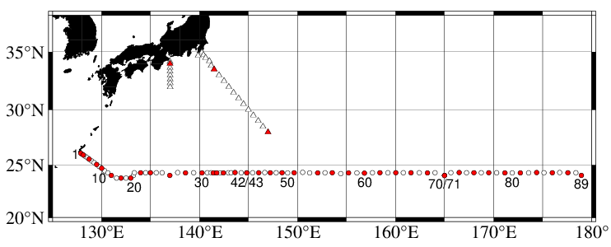
Figure C.6.1. Location of observation stations of DIC. Closed and open circles indicate sampling and no-sampling stations, respectively. Triangles show sampling station which are not reported in the bottle data file, but the data at closed triangles are used for quality control of DIC. These data are available from the JMA
(https://www.data.jma.go.jp/gmd/kaiyou/db/vessel_obs/data-report/html/ship/ship_e.php?year=2021&season=summer).

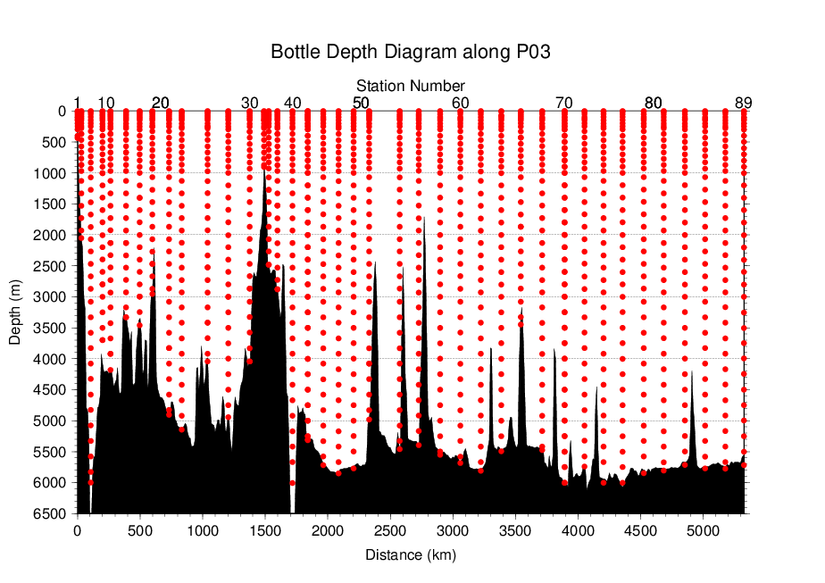
Figure C.6.2. Distance-depth distribution of sampling layers of DIC.

Instrument
The measurement of DIC was carried out with DIC/TA analyzers (Nihon ANS Co. Ltd, Japan). We used two analyzers concurrently. These analyzers are designated as apparatus A and B.

Sampling and measurement
Methods of seawater sampling, poisoning, measurement, and calculation of DIC concentrations were based on the Standard Operating Procedure (SOP) described in PICES Special Publication 3, SOP-2 (Dickson et al., 2007). DIC was determined by coulometric analysis (Johnson et al., 1985, 1987) using an automated CO₂ extraction unit and a coulometer. Details of sampling and measurement are shown in Appendix A1.

Calibration
The concentration of DIC (C_{T}) in moles per kilogram (mol kg⁻¹) of seawater was calculated from the following equation:
$C_{T}=N_{S}/ (cV ρ_{S})$ (C6.1)
where N_{S} is the counts of the coulometer (gC), cV is the calibration factor (gC (mol L⁻¹)⁻¹), and ρ_{S} is density of seawater (kg L⁻¹), which is calculated from the salinity of the sample and the water temperature of the water-jacket for the sample pipette.
The determination of values of cV was based on measurements of in-house standard sea water (SSW) which was bottled in our laboratory at November 27th, 2019 (Appendix A2). The SSW show good homogeneity among bottles and good temporal stability of C_{T} at least 12 months. The C_{T} of SSW was determined in pre-cruise measurements at October 26th, 2020 using Certified Reference Materials (CRMs; provided by Dr. Andrew G. Dickson of the Scripps Institution of Oceanography). The list of SSW and CRM is shown in Table C.6.1.
Through the each cruise, the SSW measurement was carried out used as working reference material at every stations as shown in Subsection (6.2). After the cruise, a value of cV was assigned to each apparatus (A, B) for each cruise. Table C.6.2 summarizes the cV values. Figure C.6.3 shows details.

Table C.6.1. Assigned C_{T} and standard deviation of SSW and certified C_{T} and standard deviation of CRM. Unit of C_{T} is μmol kg⁻¹. More information about CRM is available at the NOAA web site (https://www.ncei.noaa.gov/access/ocean-carbon-acidification-data-system/oceans/Dickson_CRM/batches.html).
 | SSW | CRM
Lot/batch | AH | 187
C_{T} | 2065.58±0.59 | 2002.85±0.40
Salinity | 34.538 | 33.602

Table C.6.2. Assigned cV and standard deviation for each apparatus during the cruise. Unit is gC (mol L⁻¹)⁻¹.
Apparatus | Cruise | cV
A | RF21-06 | 0.194080±0.000087 (N=16)
 | RF21-07 | 0.194066±0.000135 (N=19)
 | RF21-08 | 0.194194±0.000128 (N=13)
B | RF21-06 | 0.189809±0.000139 (N=21)
 | RF21-07 | 0.189884±0.000090 (N=16)
 | RF21-08 | 0.189939±0.000122 (N=16)

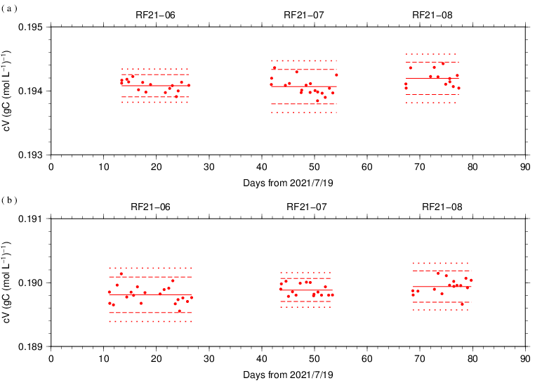
Figure C.6.3. Results of the cV at every stations for each cruise assigned for apparatus (a) A and (b) B. The solid, dashed, and dotted lines denote the mean, the mean ± 2S.D., and the mean ± 3S.D. for all measurements, respectively.

The precisions of the cV is equated to its coefficient of variation (= S.D. / mean). They were 0.045 % for apparatus A in RF21-06, 0.070 % for apparatus A in RF21-07, 0.066 % for apparatus A in RF21-08, 0.073 % for apparatus B in RF21-06, 0.047 % for apparatus B in RF21-07 and 0.064 % for apparatus B in RF21-08. They correspond to 0.93 μmol kg⁻¹, 1.44 μmol kg⁻¹, 1.36 μmol kg⁻¹, 1.51 μmol kg⁻¹, 0.98 μmol kg⁻¹ and 1.33 μmol kg⁻¹ in C_{T} of SSW batch AH, respectively.

Finally, the C_{T} was multiplied by 1.00067 (= 300.2 / 300.0) to correct dilution effect induced by addition of 0.2 mL of mercury (II) chloride (HgCl₂) solution in a sampling bottle with a volume of ~300 mL.

Quality Control

(6.1) Replicate and duplicate analyses
We took replicate (pair of water samples taken from a single Niskin bottle) and duplicate (pair of water samples taken from different Niskin bottles closed at the same depth) samples of DIC during the cruise. Table C.6.3 summarizes the results of the measurements with each apparatus (A, B). Figures C.6.4–C.6.5 show details of the results. The calculation of the standard deviation from the difference of sets of measurements was based on a procedure (SOP 23) in DOE (1994).

Table C.6.3. Summary of replicate and duplicate measurements. Unit is μmol kg⁻¹.
 | Apparatus A | Apparatus B
Measurement | Average magnitude of difference ± S.D.
Replicate | 2.1±2.0 (N=56) | 0.9±0.9 (N=70)
Duplicate | 1.9±1.9 (N=21) | 0.9±0.8 (N=20)

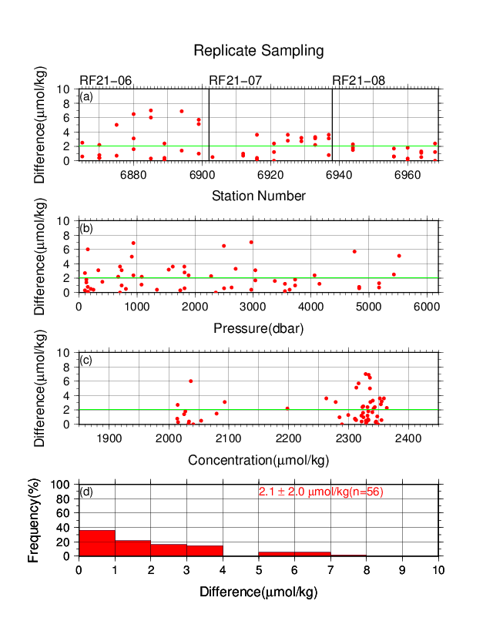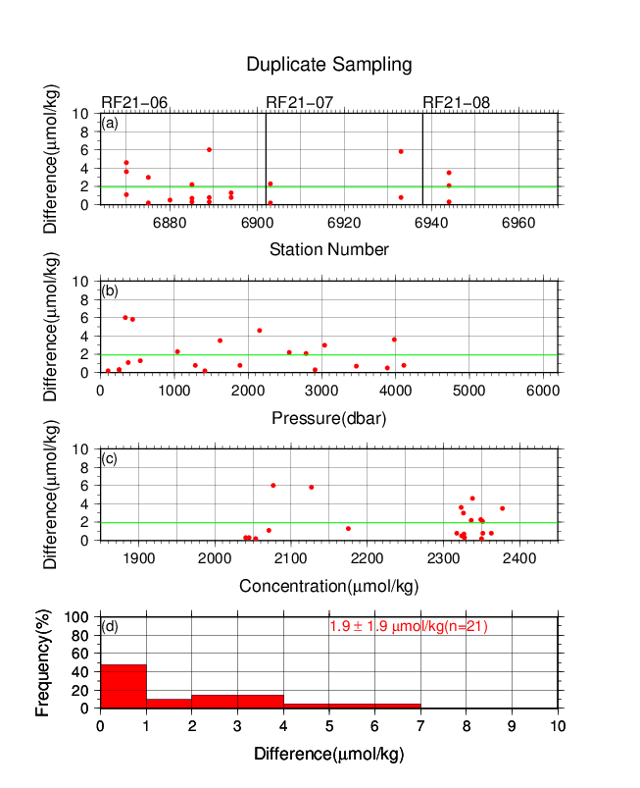
Figure C.6.4. Results of (left) replicate and (right) duplicate measurements during the cruise versus (a) station number, (b) pressure, and (c) C_{T} determined by apparatus A. The green lines denote the averages of the measurements. The bottom panels (d) show histograms of the measurements.

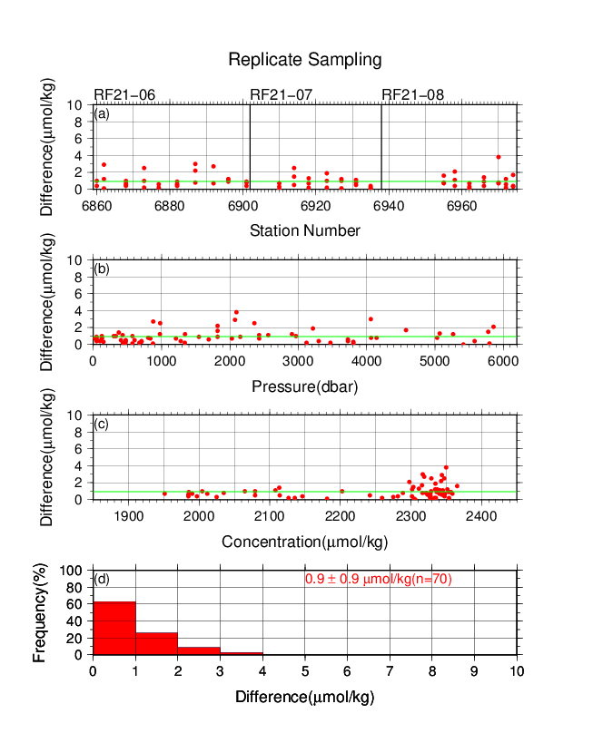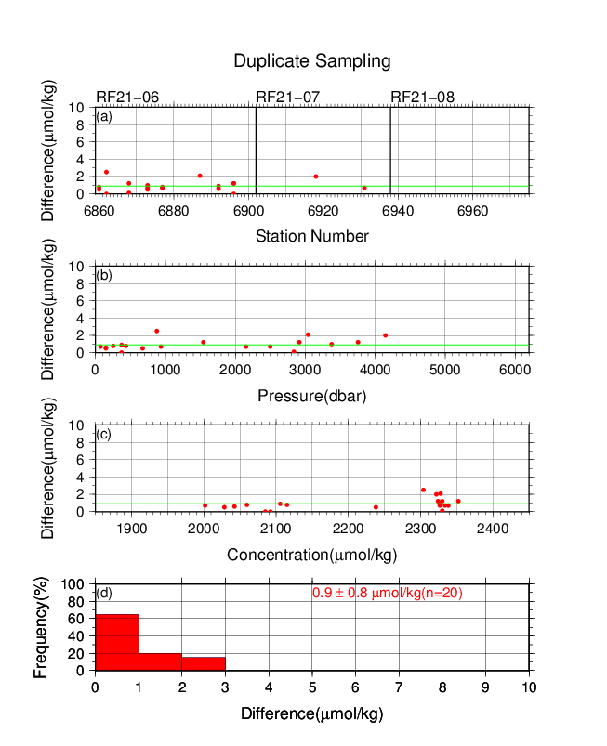
Figure C.6.5. Same as Figure C.6.4, but for apparatus B.

(6.2) Measurements of SSW and CRMs
The precision of the measurements was monitored by using SSW bottled in our laboratory (Appendix A2). At the beginning of the measurement of every station, we measured SSW as a working reference material. If the result were confirmed to be good, measurements of seawater samples were started. As a set of analysis, we measured all seawater samples acquired from a single station. At the end of the sequence of measurements, we measured another SSW bottle to confirm condition of the measurement again. Additionally, we measured a CRM bottle every few stations to confirm a temporal stability of measurement through the cruise. In the cruise, the CRM batch 187 was used (Table C.6.1). The CRM measurement was repeated twice consecutively from the same bottle. Table C.6.4 summarizes the mean C_{T} of SSW measurements, the differences and the mean C_{T} of the repeated measurements of the CRM. Figures C.6.6–C.6.8 show detailed results.

Table C.6.4. Summary of the mean C_{T} of SSW, the differences and the mean C_{T} of the repeated measurements of the CRM. These data are based on good measurements. Unit is μmol kg⁻¹.
Cruise | Apparatus | Mean Ave.  ± S.D.  (SSW) | Average  magnitude of  difference  ± S.D.  (CRM) | Mean Ave.  ± S.D.  (CRM)
RF21-06 | A | 2065.6±0.9  (N=16) | 1.5±1.3  (N=3) | 2004.4±0.1  (N=3)
 | B | 2065.6±1.5  (N=21) | 0.7±0.5  (N=5) | 2002.8±1.0  (N=5)
RF21-07 | A | 2065.6±1.4  (N=19) | 2.5±2.0  (N=6) | 2003.8±1.3  (N=6)
 | B | 2065.6±1.0  (N=16) | 0.5±0.4  (N=6) | 2002.8±1.1  (N=6)
RF21-08 | A | 2065.6±1.4  (N=13) | 1.1±0.8  (N=4) | 2003.4±1.1  (N=4)
 | B | 2065.6±1.3  (N=16) | 1.2±1.1  (N=3) | 2002.5±0.7  (N=3)

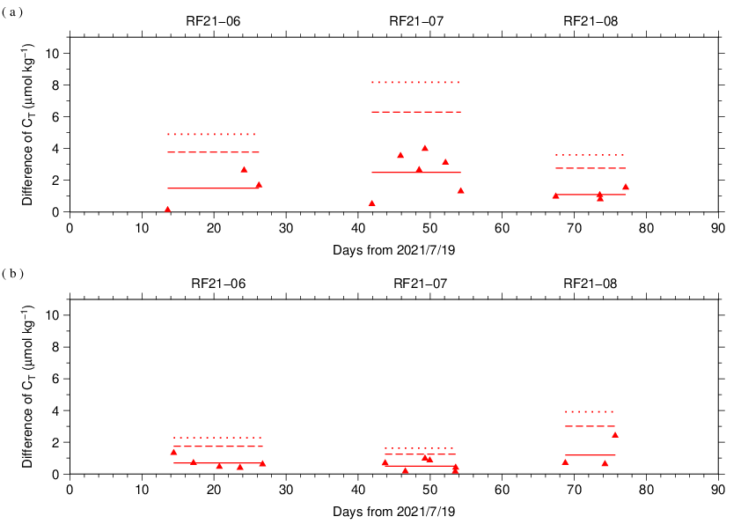
Figure C.6.6. The absolute difference (R) of C_{T} in repeated measurements of CRM determined by apparatus (a) A and (b) B. The solid line indicates the average of R ($\overline{R}$). The dashed and dotted lines denote the upper warning limit (2.512$\overline{R}$) and upper control limit (3.267$\overline{R}$), respectively (see Dickson et al., 2007).

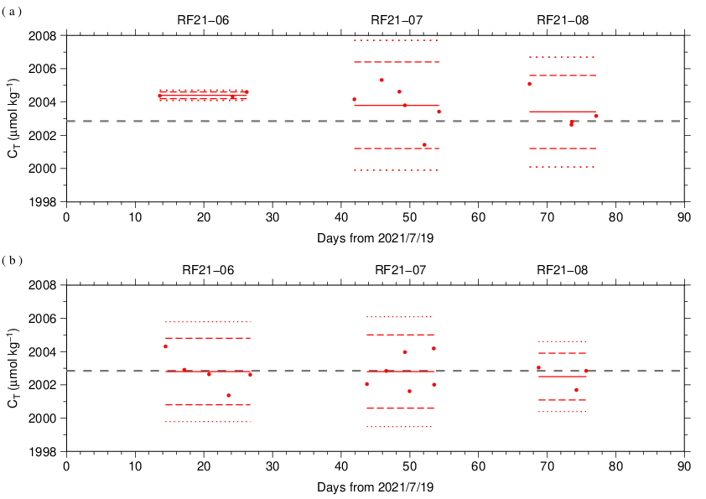
Figure C.6.7. The mean C_{T} of measurements of CRM. The panels show the results for apparatus (a) A and (b) B. The solid line indicates the mean of the measurements throughout the cruise. The dashed and dotted lines denote the upper/lower warning limit (mean ± 2S.D.) and the upper/lower control limit (mean ± 3S.D.), respectively. The gray dashed line denotes certified C_{T} of CRM.

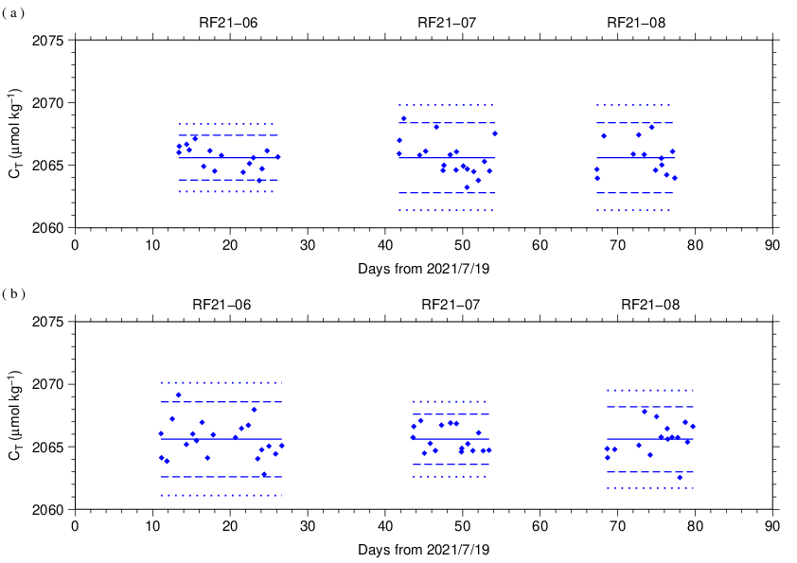
Figure C.6.8. C_{T} of SSW measured by apparatus (a) A and (b) B. The solid, dashed and dotted lines are the same as in Figure C.6.7.

(6.3) Quality control flag assignment
A quality control flag value was assigned to the DIC measurements (Table C.6.5) using the code defined in the IOCCP Report No.14 (Swift, 2010).

Table C.6.5. Summary of assigned quality control flags.
Flag | Definition | Number of samples
2 | Good | 1330
3 | Questionable | 11
4 | Bad (Faulty) | 3
5 | Not reported | 0
6 | Replicate measurements | 119
Total number of samples |  | 1463

Appendix
A1. Methods
(A1.1) Seawater sampling
Seawater samples were collected from 10-liters Niskin bottles mounted on CTD-system and a stainless steel bucket for the surface. Samples for DIC/TA were transferred to Schott Duran® glass bottles (screw top) using sample drawing tubes. Bottles were filled smoothly from the bottom after overflowing double a volume while taking care of not entraining any bubbles, and lid temporarily with inner polyethylene cover and screw cap.
After all sampling finished, 2 mL of sample is removed from each bottle to make a headspace to allow thermal expansion, and then samples were poisoned with 0.2 mL of saturated HgCl₂ solution and covered tight again.

(A1.2) Measurement
The unit for DIC measurement in the coupled DIC/TA analyzer consists of a coulometer with a quartz coulometric titration cell, a CO₂ extraction unit and a reference gas injection unit. The CO₂ extraction unit, which is connected to a bottle of 20 % v/v phosphoric acid and a carrier N₂ gas supply, includes a sample pipette (approx. 12 mL) and a CO₂ extraction chamber, two thermoelectric cooling units and switching valves. The coulometric titration cell and the sample pipette are water-jacketed and are connected to a thermostated (25 °C) water bath. The automated procedures of DIC analysis in seawater were as follows (Ishii et al., 1998):
(a) Approximately 2 mL of 20 % v/v phosphoric acid was injected to an “extraction chamber”, i.e., a glass tube with a course glass frit placed near the bottom. Purified N₂ was then allowed to flow through the extraction chamber to purge CO₂ and other volatile acids dissolved in the phosphoric acid.
(b) A portion of sample seawater was delivered from the sample bottle into the sample pipette of CO₂ extraction unit by pressurizing the headspace in the sample bottle. After temperature of the pipette was recorded, the sample seawater was transferred into the extraction chamber and mixed with phosphoric acid to convert all carbonate species to CO₂ (aq).
(c) The acidified sample seawater was then stripped of CO₂ with a stream of purified N₂. After being dehumidified in a series of two thermoelectric cooling units, the evolved CO₂ in the N₂ stream was introduced into the carbon cathode solution in the coulometric titration cell and then CO₂ was electrically titrated.

A2. Working reference material recipe
To produce in-house standard sea water (SSW) used as a working reference material, the surface seawater taken from the western North Pacific, and settled at least a half year in our laboratory. Before bottling, seawater was filtered by membrane filter (0.45 μm-mesh) using magnetic pump and was transferred into a large tank. Then, filtered seawater in the tank was processed in cycle filtration again for 3 hours and was agitated in clean condition air for 6 hours. On the next day, agitated 5 minutes to remove small bubbles on the tank and transfer to Schott Duran® glass bottles (about 300 mL) as the same method as samples (Appendix A1.1) except for overflowing a half of volume, not double. Created of headspace and poisoned with HgCl₂ was as the same as samples, finally, sealed by ground glass stoppers lubricated with Apiezon® grease (L).

References
Dickson, A. G., C. L. Sabine, and J. R. Christian (Eds.) (2007), Guide to best practices for ocean CO₂ measurements. PICES Special Publication 3, 191 pp.
DOE (1994), Handbook of methods for the analysis of the various parameters of the carbon dioxide system in sea water; version 2. A. G. Dickson and C. Goyet (eds), ORNL/CDIAC-74.
Ishii, M., H. Y. Inoue, H. Matsueda, and E. Tanoue (1998), Close coupling between seasonal biological production and dynamics of dissolved inorganic carbon in the Indian Ocean sector and the western Pacific Ocean sector of the Antarctic Ocean, Deep Sea Res. Part I, 45, 1187–1209, doi:10.1016/S0967-0637(98)00010-7.
Johnson, K. M., A. E. King and J. McN. Sieburth (1985), Coulometric TCO2 analyses for marine studies; an introduction. Marine Chemistry, 16, 61–82.
Johnson, K. M., J. M. Sieburth, P. J. L. Williams and L. Brändström (1987), Coulometric total carbon dioxide analysis for marine studies: Automation and calibration. Marine Chemistry, 21, 117–133.
Swift, J. H. (2010): Reference-quality water sample data, Notes on acquisition, record keeping, and evaluation. IOCCP Report No.14, ICPO Pub. 134, 2010 ver.1.

