Nutrients
31 March 2022

(1) Personnel
SHINODA Yoshihiro
HASHIMOTO Susumu
SASAKI Takuya
OKAJIMA Shingo (RF21-06)
FUJII Takuya (RF21-06, RF21-08)
IMAI Yoichi (RF21-07)
KAKUYA Keita (RF21-07, RF21-08)

Station occupied
A total of 81 stations (RF 21-06 Leg 2: 34, RF 21-07: 28, RF 21-08: 19) were occupied for nutrients measurements. Station location and sampling layers of nutrients are shown in Figures C.4.1 and C.4.2.
Figure C.4.1. Location of observation stations of nutrients. Closed and open circles indicate sampling and no-sampling stations, respectively. Triangle shows a sampling station which is not reported in the bottle data file but is included in data processing. These data are available from the JMA (https://www.data.jma.go.jp/gmd/kaiyou/db/vessel_obs/data-report/html/ship/ship_e.php?year=2021&season=summer).
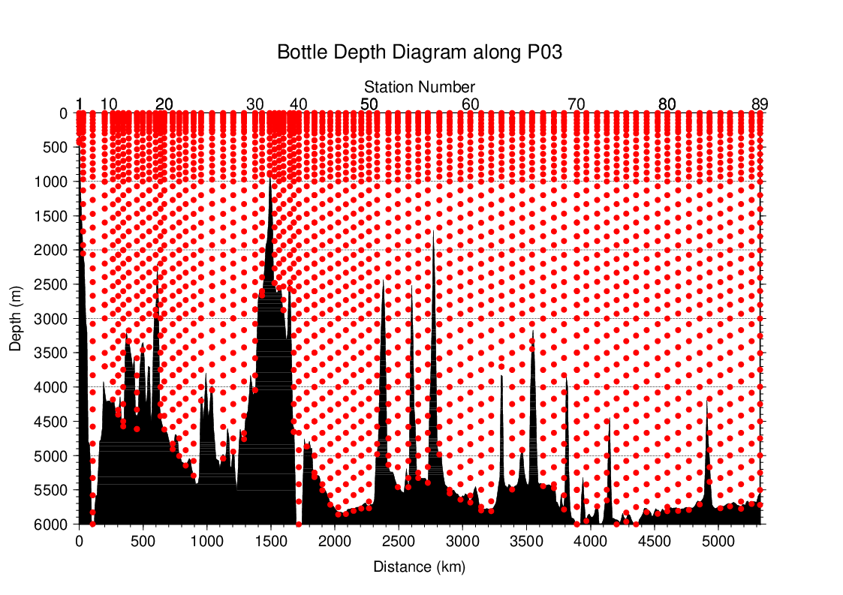
Figure C.4.2. Distance-depth distributions of sampling layers of nutrients.

Instrument
The nutrients analyses were carried out on a four-channel Auto Analyzer III (BL TEC K.K., Japan) for four nutrients nitrate+nitrite, nitrite, phosphate, and silicate.

Sampling and measurement
Methods of seawater sampling, measurement, and data processing of nutrient concentration were described in Appendixes A1, A2, and A3, respectively. The reagents for the measurement were prepared according to recipes shown in Appendix A4.

Nutrients standards

(5.1) Volumetric laboratory ware of in-house standards
All volumetric wares were gravimetrically calibrated. The weights obtained in the calibration weighing were corrected for the density of water and for air buoyancy. Polymethylpenten volumetric flasks were gravimetrically calibrated at the temperature of use within 4–6 °C. All pipettes have nominal calibration tolerances of 0.1 % or better. These were gravimetrically calibrated in order to verify and improve upon this nominal tolerance.

(5.2) Reagents of standard
The batches of the reagents used for standards are listed in Table C.4.1.
Table C.4.1. List of reagents for the standards used in the cruise.
 | Name | CAS No | Lot. No | Industries
Nitrate | Potassium nitrate 99.995 suprapur® | 7757-79-1 | B1706365 | Merck KGaA
Nitrite | Sodium nitrite GR for analysis ACS, Reag. Ph Eur | 7632-00-0 | A1611049 | Merck KGaA
Phosphate | Potassium dihydrogen phosphate anhydrous 99.995 suprapur® | 7778-77-0 | B1781408 | Merck KGaA
Silicate | Silicon standard solution 1000 mg/l Si* | - | HC01345036 | Merck KGaA
* Traceable to NIST-SRM3150

(5.3) Low nutrient seawater (LNSW)
Surface water with sufficiently low nutrient concentration was taken and filtered using 10 μm pore size membrane filter in our previous cruise. This water was stored in 15 liter flexible container with paper box.

(5.4) In-house standard solutions
Nutrient concentrations for A, B and C standards were set as shown in Table C.4.2. A and B standards were prepared with deionized water (DW). C standard (full scale of working standard) was mixture of B-1 and B-2 standards, and was prepared with LNSW. C-1 standard, whose concentrations of nutrient were nearly zero, was prepared as LNSW slightly added with DW to be equal with mixing ratio of LNSW and DW in C standard. The C-2 to -5 standards were prepared with mixture of C-1 and C standards in stages as 1/4, 2/4, 3/4, and 4/4 (i.e., pure “C standard”) concentration for full scale, respectively. The actual concentration of nutrients in each standard was calculated based on the solution temperature and factors of volumetric laboratory wares calibrated prior to use. Nominal zero concentration of nutrient was determined in measurement of DW after refraction error correction. The calibration curves for each run were obtained using 5 levels of C-1 to -5 standards. These standard solutions were periodically renewed as shown in Table C.4.3.

Table C.4.2. Nominal concentrations of nutrients for A, B, and C standards at 20 °C. Unit is μmol L⁻¹.
 | A | B | C
Nitrate | 27484 | 550 | 44.0
Nitrite | 12503 | 250 | 2.0
Phosphate | 2122 | 42.4 | 3.39
Silicate | 35606 | 2136 | 171

Table C.4.3. Schedule of renewal of in-house standards.
Standard | Renewal
A-1 std. (NO₃) | No renewal
A-2 std. (NO₂) | No renewal
A-3 std. (PO₄) | No renewal
A-4 std. (Si) | Commercial prepared solution
B-1 std. (mixture of A-1, A-3, and A-4 stds.) | Maximum 8 days
B-2 std. (diluted A-2 std.) | Maximum 15 days
C-std. (mixture of B-1 and B-2 stds.) | Every measurement
C-1 to -5 stds. | Every measurement

Certified reference material
Certified reference material for nutrients in seawater (hereafter CRM), which was prepared by the General Environmental Technos company (KANSO Technos, Japan), was used for every analysis at each hydrographic station. Use of CRMs for the analysis of seawater ensures stable comparability and uncertainty of data. CRMs used in the cruise are shown in Table C.4.4.

Table C.4.4. Certified concentration and uncertainty (k=2) of CRMs. Unit is μmol kg⁻¹.
 | Nitrate | Nitrite | Phosphate | Silicate
CRM-CK | 0.02±0.03* | 0.011±0.008* | 0.048±0.012 | 0.73±0.08*
CRM-CJ | 16.2±0.2 | 0.031±0.007 | 1.19±0.02 | 38.5±0.4
CRM-CM | 33.2±0.3 | 0.018±0.006* | 2.38±0.03 | 100.5±0.5
CRM-CN | 43.6±0.4 | 0.010±0.004* | 2.94±0.03 | 152.7±0.8
* Reference value because concentration is under limit of quantitation

The CRMs were analyzed every run but were newly opened every two runs. Although this usage of CRM might be less common, we have confirmed a stability of the opened CRM bottles to be tolerance in our observation. The CRM bottles were stored at a laboratory in the ship, where the temperature was maintained at around 25 °C.
It is noted that nutrient data in our report are calibrated not on CRM but on in-house standard solutions. Therefore, to calculate data based on CRM, it is necessary that values of nutrient concentration in our report are correlated with CRM values measured in the same analysis run. The result of CRM measurements is attached as 49UP20210719_P03W_nut_CRM_measurement.csv.

Quality Control

(7.1) Replicate and duplicate analyses
We took replicate (pair of water samples taken from a single Niskin bottle) and duplicate (pair of water samples taken from different Niskin bottles closed at the same depth) samples of nutrients throughout the cruise. Table C.4.5 summarizes the results of the analyses. Figures C.4.3–C.4.5 show details of the results. The calculation of the standard deviation from the difference of sets of samples was based on a procedure (SOP 23) in DOE (1994).

Table C.4.5. Average and standard deviation of difference of replicate and duplicate measurements throughout the cruise. Unit is μmol kg⁻¹.
Samples | Nitrate+nitrite | Phosphate | Silicate
Replicate | 0.026±0.024 (N=337) | 0.002±0.002 (N=337) | 0.130±0.125 (N=337)
Duplicate | 0.037±0.034 (N=96) | 0.003±0.002 (N=96) | 0.160±0.177 (N=96)
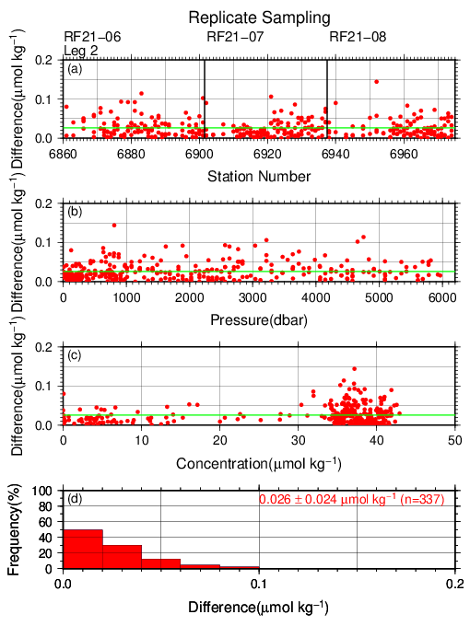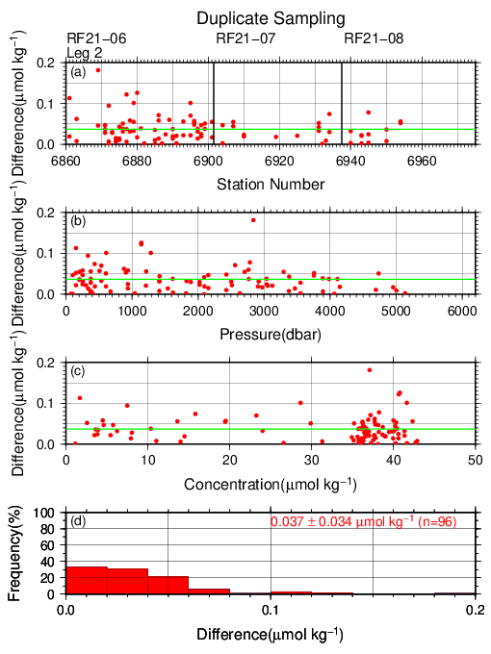

Figure C.4.3. Results of (left) replicate and (right) duplicate measurements of nitrate+nitrite throughout the cruise versus (a) station number, (b) sampling pressure, (c) concentration, and (d) histogram of the measurements. Green lines indicates the mean of the differences of concentrations based on replicate/duplicate analyses.

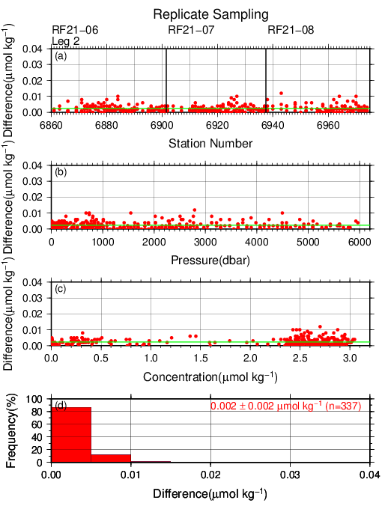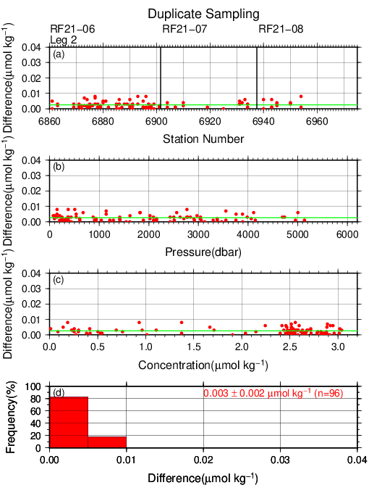
Figure C.4.4. Same as Figure C.4.3, but for phosphate.

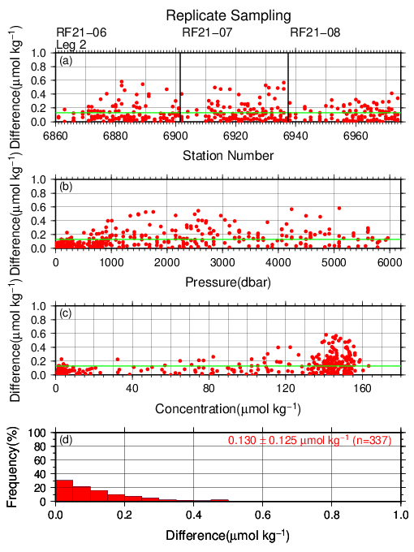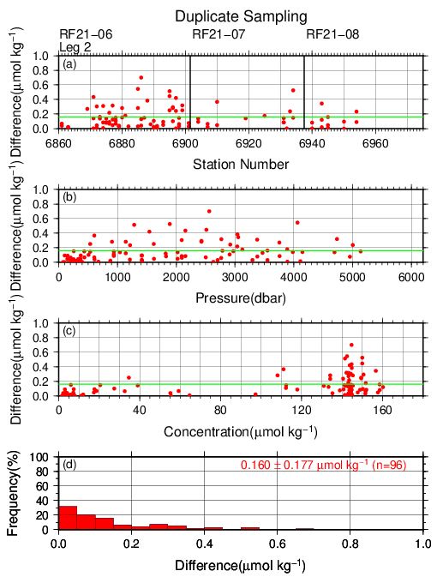
Figure C.4.5. Same as Figure C.4.3, but for silicate.

(7.2) Measurement of CRMs
Table C.4.6 summarizes the CRM measurements during the cruise. The CRM concentrations were assigned with in-house standard solutions. Figures C.4.6–C.4.9 show the measured concentrations of CRM-CN throughout the cruise.

Table C.4.6. Summary of (upper) mean concentration and its standard deviation (unit: μmol kg⁻¹), (middle) coefficient of variation (%), and (lower) total number of CRMs measurements throughout the cruise.
 | Nitrate+nitrite | Nitrite | Phosphate | Silicate
CRM-CK | 0.070±0.049  70.35 %  (N=136) | 0.039±0.002  4.65 %  (N=136) | 0.061±0.005  7.48 %  (N=134) | 0.81±0.14  16.86 %  (N=136)
CRM-CJ | 16.26±0.06  0.39 %  (N=136) | 0.047±0.002  3.35 %  (N=133) | 1.20±0.01  0.48 %  (N=134) | 38.88±0.17  0.43 %  (N=136)
CRM-CM | 33.25±0.08  0.25 %  (N=136) | 0.022±0.002  7.61 %  (N=135) | 2.39±0.01  0.28 %  (N=136) | 101.64±0.31  0.30 %  (N=136)
CRM-CN | 43.67±0.10  0.22 %  (N=137) | 0.013±0.002  14.87 %  (N=137) | 2.94±0.01  0.26 %  (N=135) | 154.52±0.39  0.26 %  (N=137)

Figure C.4.6. Time-series of measured concentration of nitrate+nitrite of CRM-CN throughout the cruise. Closed and open circles indicate the newly and previously opened bottle, respectively. Thick and dashed lines denote the mean and the mean ± twice the standard deviations of the measurements throughout the cruise, respectively. Gray shade indicates an observation period of a sampling station which is not reported in the bottle data file.

Figure C.4.7. Same as Figure C.4.6, but for nitrite.

Figure C.4.8. Same as Figure C.4.6, but for phosphate.
Figure C.4.9. Same as Figure C.4.6, but for silicate.

(7.3) Precision of analysis in a run
To monitor the precision of the analyses, the same samples were repeatedly measured in a sample array during a run. For this purpose, a C-5 standard solution was randomly inserted in every 2–10 samples as a “check standard” (the number of standards was about 8–9) in the run. The precision was estimated in terms of the coefficient of variation of the measurements. Table C.4.7 summarizes the results. The time series are shown in Figures C.4.10–C.4.13.

Figure C.4.10. Time-series of the coefficients of variation of “check standard” measurements of nitrate+nitrite throughout the cruise. Thick and dashed lines denote the mean and the mean ± twice the standard deviations of the measurements throughout the cruise, respectively. Gray shade indicates an observation period of a sampling station which is not reported in the bottle data file.

Figure C.4.11. Same as Figure C.4.10, but for nitrite.

Figure C.4.12. Same as Figure C.4.10, but for phosphate.

Figure C.4.13. Same as Figure C.4.10, but for silicate.

Table C.4.7. Summary of precisions of nutrient assays during the cruise.
 | Nitrate+nitrite | Nitrite | Phosphate | Silicate
Median | 0.11 % | 0.12 % | 0.11 % | 0.13 %
Mean | 0.12 % | 0.12 % | 0.12 % | 0.14 %
Minimum | 0.03 % | 0.01 % | 0.04 % | 0.03 %
Maximum | 0.57 % | 0.31 % | 0.29 % | 0.31 %
Number | 92 | 92 | 92 | 92

(7.4) Carryover
Carryover coefficients were determined during each analytical run. The C-5 standard (high standard) was followed by two C-1 standards (low standards). Figures C.4.14–17 show the time series of the carryover coefficients.

Figure C.4.14. Time-series of carryover coefficients in measurement of nitrate+nitrite throughout the cruise. Gray shade indicates an observation period of a sampling station which is not reported in the bottle data file.

Figure C.4.15. Same as Figure C.4.14, but for nitrite.

Figure C.4.16. Same as Figure C.4.14, but for phosphate.

Figure C.4.17. Same as Figure C.4.14, but for silicate.

(7.5) Limit of detection/quantitation of measurement
Limit of detection (LOD) and quantitation (LOQ) of nutrient measurement were estimated from standard deviation (σ) of repeated measurements of nutrients concentration in C-1 standard as 3σ and 10σ, respectively. Summary of LOD and LOQ are shown in Table C.4.8.

Table C.4.8. Limit of detection (LOD) and quantitation (LOQ) of nutrient measurement in the cruise. Unit is μmol kg⁻¹.
 | LOD | LOQ
Nitrate+nitrite | 0.049 | 0.165
Nitrite | 0.001 | 0.005
Phosphate | 0.009 | 0.031
Silicate | 0.170 | 0.567

(7.6) Quality control flag assignment
A quality flag value was assigned to nutriment measurements as shown in Table C.4.9, using the code defined in IOCCP Report No.14 (Swift, 2010).

Table C.4.9. Summary of assigned quality control flags.
Flag | Definition | Nitrate+nitrite | Nitrite | Phosphate | Silicate
2 | Good | 2566 | 2567 | 2564 | 2566
3 | Questionable | 0 | 0 | 0 | 0
4 | Bad (Faulty) | 2 | 1 | 4 | 2
5 | Not reported | 0 | 0 | 0 | 0
6 | Replicate measurements | 307 | 307 | 307 | 307
Total number of samples |  | 2875 | 2875 | 2875 | 2875

Uncertainty

(8.1) Uncertainty associated with concentration level: U_{c}
Generally, an uncertainty of nutrient measurement is expressed as a function of its concentration level which reflects that some components of uncertainty are relatively large in low concentration. Empirically, the uncertainty associated with concentrations level (U_{c}) can be expressed as follows;
$U_{c} (\%)=a+b∙(1/C_{x})+c∙{(1/C_{x})}^{2}$, (C4.1)
where C_{x} is the concentration of sample for parameter X.
Using the coefficients of variation of the CRM measurements throughout the cruise, uncertainty associated with concentrations of nitrate+nitrite, phosphate, and silicate were determined as follows:
$U_{c‐no3} (\%)=0.013+2.342∙(1/C_{no3})+0.002∙{(1/C_{no3})}^{2}$ (C4.2)
$U_{c‐po4} (\%)=-0.066+0.396∙(1/C_{po4})$ (C4.3)
$U_{c‐sil} (\%)=0.08+5.49∙(1/C_{sil})+1.10∙{(1/C_{sil})}^{2}$, (C4.4)
where C_{no3}, C_{po4}, and C_{sil} represent concentrations of nitrate+nitrite, phosphate, and silicate, respectively, in μmol kg⁻¹. Figures C.4.18–C.4.20 show the calculated uncertainty graphically.
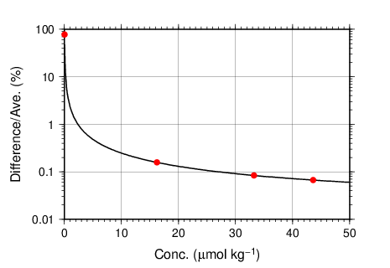
Figure C.4.18. Uncertainty of nitrate+nitrite associated with concentrations.

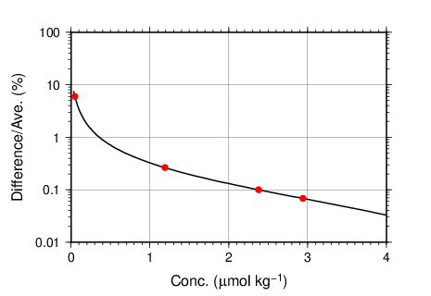
Figure C.4.19. Same as Figure C.4.18, but for phosphate.

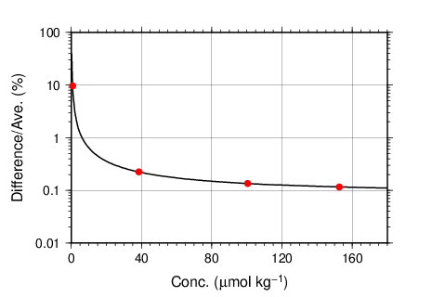
Figure C.4.20. Same as Figure C.4.18, but for silicate.

(8.2) Uncertainty of analysis between runs: U_{s}
Uncertainty of analysis among runs (U_{s}) was evaluated based on the coefficient of variation of measured concentrations of CRM-CN with the highest concentration among the CRM lots throughout the cruise, as shown in subsection (7.2). The reason for using the CRM lot to state U_{s} is to exclude the effect of uncertainty associated with lower concentration described previously. As is clear from the definition of U_{c}, U_{s} is equal to U_{c} at nutrients concentrations of the lot. It is important to note that U_{s} includes all of uncertainties during the measurements throughout stations, namely uncertainties of concentrations of in-house standard solutions prepared for each run, uncertainties of slopes and intercepts of the calibration curve in each run, precision of measurement in a run (U_{a}), and between-bottle homogeneity of the CRM.

(8.3) Uncertainty of analysis in a run: U_{a}
Uncertainty of analysis in a run (U_{a}) was evaluated based on the coefficient of variation of repeated measurements of the “check standard” solution, as shown in subsection (7.3). The U_{a} reflects the conditions associated with chemistry of colorimetric measurement of nutrients, and stability of electronic and optical parts of the instrument throughout a run. Under a well-controlled condition of the measurements, U_{a} might show Poisson distribution with a mean as shown in Figures C.4.10–C.4.13 and Table C.4.7 and treated as a precision of measurement. U_{a} is a part of U_{c} at the concentration as stated in a previous section for U_{c}.
However, U_{a} may show larger value which was not expected from Poisson distribution of U_{a} due to the malfunction of the instruments, larger ambient temperature change, human errors in handling samples and chemistries, and contaminations of samples in a run. In the cruise, we observed that U_{a} of our measurement was usually small and well-controlled in most runs as shown in Figures C.4.10–C.4.13 and Table C.4.7. However, in a few runs, U_{a} showed high values which were over the mean ± twice the standard deviations of U_{a}, suggesting that the measurement system might have some problems.

(8.4) Uncertainty of CRM concentration: U_{r}
In the certification of CRM, the uncertainty of CRM concentrations (U_{r}) was stated by the manufacturer (Table C.4.4) as expanded uncertainty at k=2. This expanded uncertainty reflects the uncertainty of the Japan Calibration Service System (JCSS) solutions, characterization in assignment, between-bottle homogeneity, and long term stability. We have ensured comparability between cruises by ensuring that at least two lots of CRMs overlap between cruises. In comparison of nutrient concentrations between cruises using KANSO CRMs in an organization, it was not necessary to include U_{r} in the conclusive uncertainty of concentration of measured samples because comparability of measurements was ensured in an organization as stated previously.

(8.5) Conclusive uncertainty of nutrient measurements of samples: U
To determine the conclusive uncertainty of nutrient measurements of samples (U), we use two functions depending on U_{a} value acquired at each run as follows:
When U_{a} was small and measurement was well-controlled condition, the conclusive uncertainty of nutrient measurements of samples, U, might be as below:
$U=U_{c}$. (C4.5)
When U_{a} was relative large and the measurement might have some problems, the conclusive uncertainty of nutrient measurements of samples, U, can be expanded as below:
$U=\sqrt{U_{c}^{2}+U_{a}^{2}}$. (C4.6)
When U_{a} was relative large and the measurement might have some problems, the equation of U is defined as to include U_{a} to evaluate U, although U_{a} partly overlaps with U_{c}. It means that the equation overestimates the conclusive uncertainty of samples. On the other hand, for low concentration there is a possibility that the equation not only overestimates but also underestimates the conclusive uncertainty because the functional shape of U_{c} in lower concentration might not be the same and cannot be verified. However, we believe that the applying the above function might be better way to evaluate the conclusive uncertainty of nutrient measurements of samples because we can do realistic evaluation of uncertainties of nutrient concentrations of samples which were obtained under relatively unstable conditions, larger U_{a} as well as the evaluation of them under normal and good conditions of measurements of nutrients.

Appendix
A1. Seawater sampling
Seawater samples were collected from 10-liters Niskin bottle attached CTD-system and a stainless steel bucket for the surface. Samples were drawn into 10 mL polymethylpenten vials using sample drawing tubes. The vials were rinsed three times before water filling and were capped immediately after the drawing.
No transfer was made and the vials were set on an auto sampler tray directly. Samples were analyzed immediately after collection.

A2. Measurement
(A2.1) General
Auto Analyzer III is based on Continuous Flow Analysis method and consists of sampler, pump, manifolds, and colorimeters. As a baseline, we used artificial seawater (ASW).

(A2.2) Nitrate+nitrite and nitrite
Nitrate+nitrite and nitrite were analyzed according to the modification method of Armstrong (1967). The sample nitrate was reduced to nitrite in a glass tube which was filled with granular cadmium coated with copper. The sample stream with its equivalent nitrite was treated with an acidic, sulfanilamide reagent and the nitrite forms nitrous acid which reacts with the sulfanilamide to produce a diazonium ion. N-1-naphthylethylene-diamine was added to the sample stream then coupled with the diazonium ion to produce a red, azo dye. With reduction of the nitrate to nitrite, sum of nitrate and nitrite were measured; without reduction, only nitrite was measured. Thus, for the nitrite analysis, no reduction was performed and the alkaline buffer was not necessary. The flow diagrams for each parameter are shown in Figures C.4.A1 and C.4.A2. If the reduction efficiency of the cadmium column became lower than 95 %, the column was replaced.
ORN/WHT N-1-naphtylethylene-diamine (0.23)
ORN/WHT sample or ASW (0.23)
5T
10T
20T
WHT/WHT debubble (0.60 cc min⁻¹)
YEL/YEL ammonium chloride (buffer) (1.20)
BLK/BLK air (0.32)
BLK/BLK air (0.32)
ORN/WHT sulfanilamide (0.23)
Waste
Waste
Colorimeter
1.5 mm (I.D.) × 15 mm flow cell
530 nm
Cd tube
10T
Waste
GRY/GRY waste (1.00)
Figure C.4.A1. Nitrate+nitrite (ch. 1) flow diagram.

GRY/GRY sample or ASW (1.00)
ORN/WHT sulfanilamide (0.23)

ORN/WHT N-1-naphtylethylene-diamine (0.23)

Waste
Colorimeter
1.5 mm (I.D.) × 50 mm flow cell
530 nm
10T
20T
10T
Waste
WHT/WHT waste (0.60)
Waste
BLK/BLK debubble (0.32)
BLK/BLK air (0.32 cc min⁻¹)
Figure C.4.A2. Nitrite (ch. 2) flow diagram.

(A2.3) Phosphate
The phosphate analysis was a modification of the procedure of Murphy and Riley (1962). Molybdic acid was added to the seawater sample to form phosphomolybdic acid which was in turn reduced to phosphomolybdous acid using L-ascorbic acid as the reductant. The flow diagram for phosphate is shown in Figure C.4.A3.
Waste
ORN/ORN debubble (0.42)
BLK/BLK ammonium molybdate (0.32)
YEL/BLU sample or ASW (1.40)
BLK/BLK air (0.32 cc min⁻¹)
ORN/WHT ascolbic acid (0.23)
Waste
Colorimeter
1.5 mm (I.D.) × 50 mm flow cell
880 nm
Heating bath
37°C
10T
Waste
RED/RED waste (0.80)
10T
Figure C.4.A3. Phosphate (ch. 3) flow diagram.

(A2.4) Silicate
The silicate was analyzed according to the modification method of Grasshoff et al. (1983), wherein silicomolybdic acid was first formed from the silicate in the sample and added molybdic acid, then the silicomolybdic acid was reduced to silicomolybdous acid, or "molybdenum blue," using L-ascorbic acid as the reductant. The flow diagram for silicate is shown in Figure C.4.A4.
WHT/WHT ammonium molybdate (0.60)
ORN/YEL sample or ASW (0.16)
BLK/BLK air (0.32 cc min⁻¹)
ORN/ORN oxalic acid (0.42)
Waste
Colorimeter
1.5 mm (I.D.) × 15 mm flow cell
820 nm
Heating bath
37°C
10T
Waste
GRY/GRY waste (1.00)
WHT/WHT ascolbic acid (0.60)

10T
10T
Figure C.4.A4. Silicate (ch. 4) flow diagram.

A3. Data processing
Raw data from Auto Analyzer III were recorded at 1-second interval and were treated as follows;
- Check the shape of each peak and position of peak values taken, and then change the positions of peak values taken if necessary.
- Baseline correction was done basically using linear regression.
- Reagent blank correction was done basically using linear regression.
- Carryover correction was applied to peak heights of each sample.
- Sensitivity correction was applied to peak heights of each sample.
- Refraction error correction was applied to peak heights of each seawater sample.
- Calibration curves to get nutrients concentration were assumed quadratic expression.
- Concentrations were converted from μmol L⁻¹ to μmol kg⁻¹ using seawater density.

A4. Reagents recipes
(A4.1) Nitrate+nitrite
Ammonium chloride (buffer), 0.7 μmol L⁻¹ (0.04 % w/v);
Dissolve 190 g ammonium chloride, NH₄Cl, in ca. 5 L of DW, add about 5 mL ammonia(aq) to adjust pH of 8.2–8.5.
Sulfanilamide, 0.06 μmol L ⁻¹ (1 % w/v);
Dissolve 5 g sulfanilamide, 4-NH₂C₆H₄SO₃H, in 430 mL DW, add 70 mL concentrated HCl. After mixing, add 1 mL Brij-35 (22 % w/w).
N-1-naphtylethylene-diamine dihydrochloride (NEDA), 0.004 μmol L ⁻¹ (0.1 % w/v);
Dissolve 0.5 g NEDA, C₁₀H₇NH₂CH₂CH₂NH₂·2HCl, in 500 mL DW.

(A4.2) Nitrite
Sulfanilamide, 0.06 μmol L ⁻¹ (1 % w/v); Shared from nitrate reagent.
N-1-naphtylethylene-diamine dihydrochloride (NEDA), 0.004 μmol L ⁻¹ (0.1 % w/v); Shared from nitrate reagent.

(A4.3) Phosphate
Ammonium molybdate, 0.005 μmol L⁻¹ (0.6 % w/v);
Dissolve 3 g ammonium molybdate(VI) tetrahydrate, (NH₄)₆Mo₇O₂₄·4H₂O, and 0.05 g potassium antimonyl tartrate, C₈H₄K₂O₁₂Sb₂·3H₂O, in 400 mL DW and add 40 mL concentrated H₂SO₄. After mixing, dilute the solution with DW to final volume of 500 mL and add 2 mL sodium dodecyl sulfate (15 % solution in water).
L(+)-ascorbic acid, 0.08 μmol L⁻¹ (1.5 % w/v);
Dissolve 4.5 g L(+)-ascorbic acid, C₆H₈O₆, in 300 mL DW. After mixing, add 10 mL acetone. This reagent was freshly prepared before every measurement.

(A4.4) Silicate
Ammonium molydate, 0.005 μmol L⁻¹ (0.6 % w/v);
Dissolve 3 g ammonium molybdate(VI) tetrahydrate, (NH₄)₆Mo₇O₂₄·4H₂O, in 500 mL DW and added concentrated 2 mL H₂SO₄. After mixing, add 2 mL sodium dodecyl sulfate (15 % solution in water).
Oxalic acid, 0.4 μmol L⁻¹ (5 % w/v);
Dissolve 25 g oxalic acid dihydrate, (COOH)₂·2H₂O, in 500 mL DW.
L(+)-ascorbic acid, 0.08 μmol L⁻¹ (1.5 % w/v); Shared from phosphate reagent.

(A4.5) Baseline
Artificial seawater (salinity is ~34.7);
Dissolve 160.6 g sodium chloride, NaCl, 35.6 g magnesium sulfate heptahydrate, MgSO₄·7H₂O, and 0.84 g sodium hydrogen carbonate, NaHCO₃, in 5 L DW.

References
Armstrong, F. A. J., C. R. Stearns and J. D. H. Strickland (1967), The measurement of upwelling and subsequent biological processes by means of the Technicon TM Autoanalyzer TM and associated equipment, Deep-Sea Res., 14(3), 381–389.
Grasshoff, K., Ehrhardt, M., Kremling K. et al. (1983), Methods of seawater analysis. 2nd rev, Weinheim: Verlag Chemie, Germany, West.
Murphy, J. and Riley, J.P. (1962), Analytica chimica Acta, 27, 31-36.
Swift, J. H. (2010), Reference-quality water sample data: Notes on acquisition, record keeping, and evaluation. IOCCP Report No.14, ICPO Pub. 134, 2010 ver.1.

