Bottle Oxygen
12 May 2022

Personnel
SHINODA Yoshihiro
HASHIMOTO Susumu
SASAKI Takuya
OKAJIMA Shingo (RF21-06)
FUJII Takuya (RF21-06, RF21-08)
IMAI Yoichi (RF21-07)
KAKUYA Keita (RF21-07, RF21-08)

Station occupied
A total of 81 stations (RF 21-06 Leg 2: 34, RF 21-07: 28, RF 21-08: 19) were occupied for dissolved oxygen measurements. Station location and sampling layers of bottle oxygen are shown in Figures C.3.1 and C.3.2, respectively.
Figure C.3.1. Location of observation stations of bottle oxygen. Closed and open circles indicate sampling and no-sampling stations, respectively. Closed triangle show sampling station which is not reported in the bottle data file but is used for quality control of dissolved oxygen. Open triangle shows no-sampling station which is not reported in the censor data. These data are available from the JMA (https://www.data.jma.go.jp/gmd/kaiyou/db/vessel_obs/data-report/html/ship/ship_e.php?year=2021&season=summer).

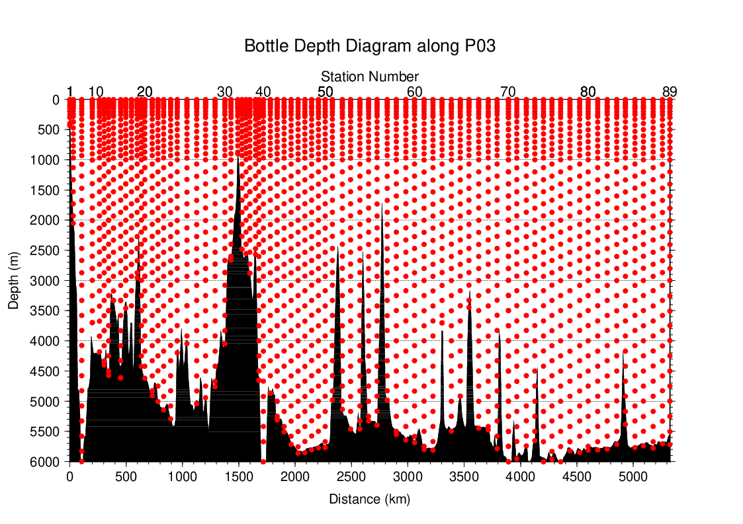Figure C.3.2. Distance-depth distribution of sampling layers of bottle oxygen.

Instrument
Detector: DOT-15X (KIMOTO ELECTRIC CO., LTD., Japan)
Burette: APB-610 (KYOTO ELECTRONICS MANUFACTURING CO., LTD., Japan)

Sampling and measurement
Methods of seawater sampling, measurement, and calculation of dissolved oxygen concentration were based on an IOCCP Report (Langdon, 2010). Details of the methods are shown in Appendix A1.
The reagents for the measurement were prepared according to recipes described in Appendix A2. Standard KIO₃ solutions were prepared gravimetrically using the highest purity standard substance KIO₃ (Lot. No. KCN5512, FUJIFILM Wako Pure Chemical Corporation, Japan). Table C.3.1 shows the batch list of prepared standard KIO₃ solutions.

Table C.3.1. Batch list of the standard KIO₃ solutions.
KIO₃ batch | Cruise | Concentration and uncertainty (k=2) at 20 °C. Unit is mol L⁻¹. | Purpose of use
20201012-1 | RF2106, RF2107, RF2108 | 0.0016670±0.0000007 | Standardization (main use)
20201012-2 | RF2106, RF2107 | 0.0016668±0.0000007 | Mutual comparison
20210319-1 | RF2108 | 0.0016664±0.0000007 | Mutual comparison

Standardization
The concentration of the Na₂S₂O₃ titrant was determined with the standard KIO₃ solution “20201012-1”, based on the methods of an IOCCP Report (Langdon, 2010). Figure C.3.3 shows the results of standardization during the cruise. The standard deviation of the concentration at 20 °C was determined through standardization and was used in the calculation of uncertainty.
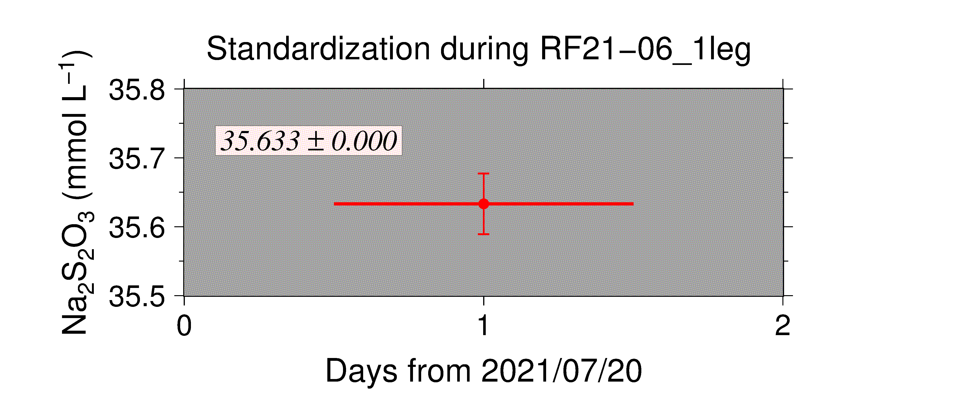
(a)
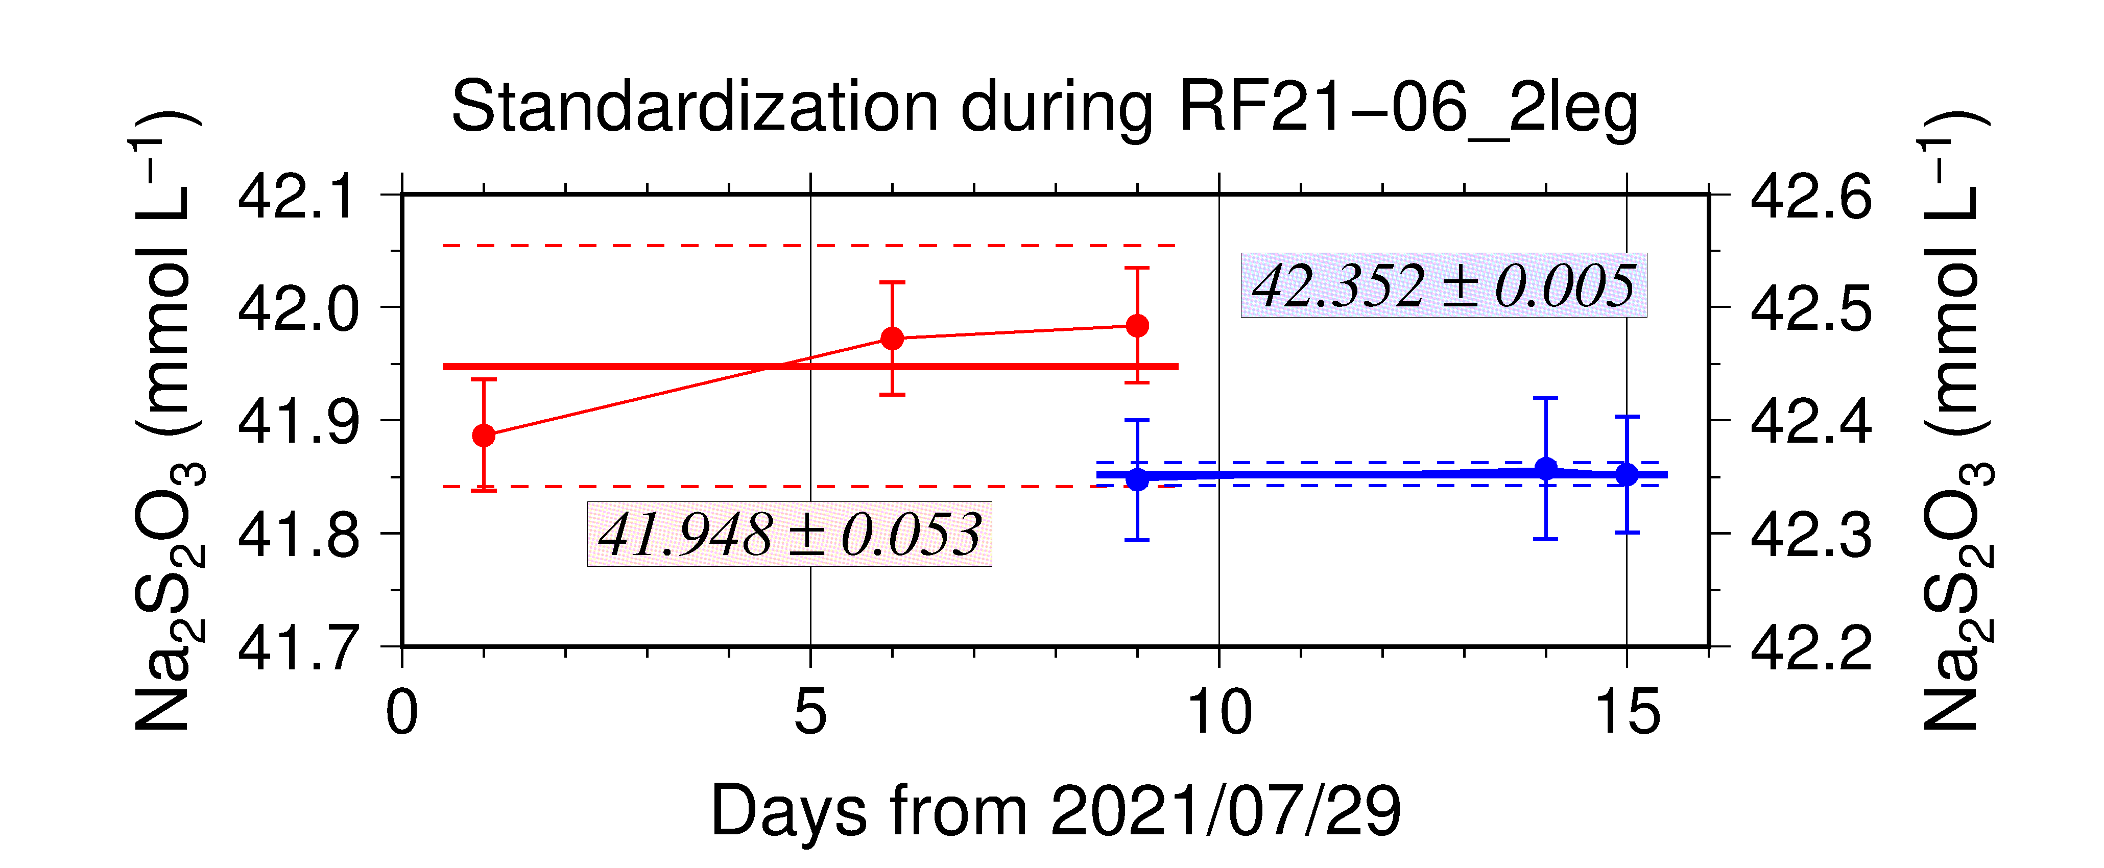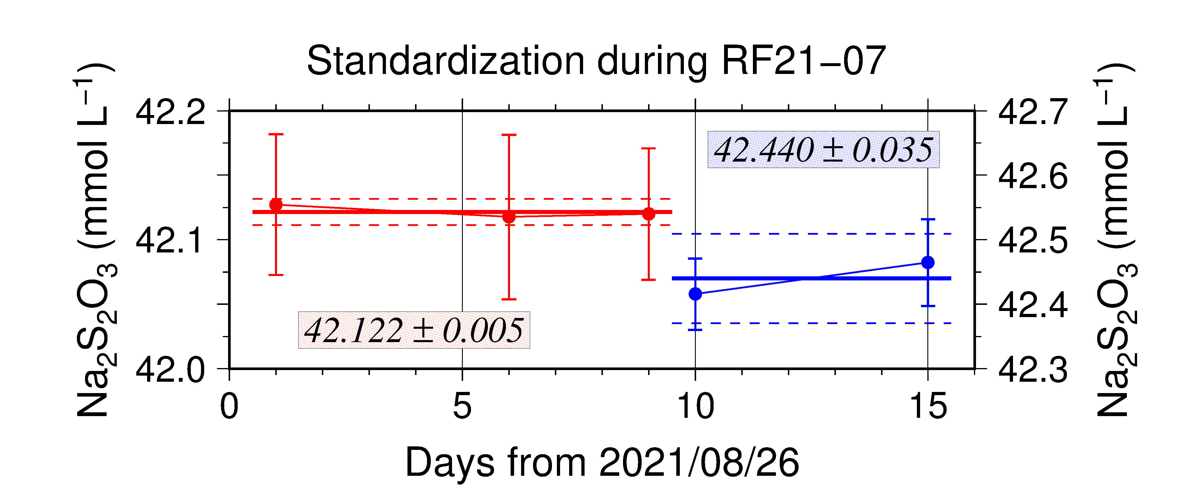
(c)
(b)
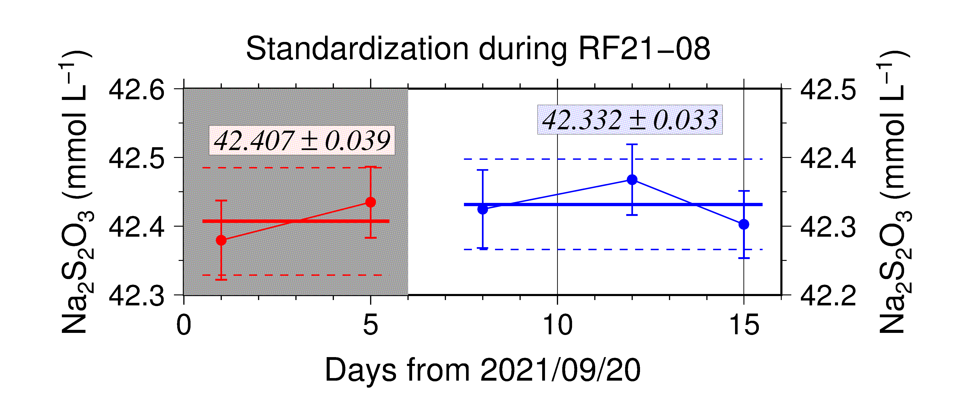
(d)
Figure C.3.3. Calculated concentration of Na₂S₂O₃ solution at 20 °C in standardization during (a) RF21-06 1leg and (b) RF21-06 2leg, (c) RF21-07, (d) RF21-08. Different colors of plots indicate different batches of Na₂S₂O₃ solution; red (blue) plots correspond to the left (right) y-axis. Error bars of plots show uncertainty of concentration of Na₂S₂O₃. Thick and dashed lines denote the mean and the mean ± twice the standard deviations for the batch measurements, respectively. The shaded regions indicate that the data in the regions are not used for calculations of measured data in P03 line.

Blank

(6.1) Reagent blank
The blank in an oxygen measurement (reagent blank in distilled water; V_{reg-blk}) was determined by the methods described in the IOCCP Report (Langdon, 2010) using pure water. The blank reflects not only the interfering substances (oxidants or reductants) in the reagents but also the differences between the measured end-point and the equivalence point due to unknown causes in the titrator. Figure C.3.4 shows details of the results.
Figure C.3.4. Reagent blank (V_{reg-blk}) determination during RF21-06 (top), RF21-07 and RF21-08 (bottom). Error bars of plots show standard deviations of the measurements. Thick and dashed lines denote the mean and the mean ± twice the standard deviation for the batch measurement, respectively. The shaded regions indicate that the data in the regions are not used for calculations of measured data in P03 line.

(6.2) Seawater blank
We also determined seawater blank (V_{sw-blk}) which reflects interfering substances in seawater. Although this blank is not included in determination of oxygen concentration, measurement of the blank would be necessary to improve traceability and comparability in dissolved oxygen concentration. Details are described in Appendix A3.

Quality Control

(7.1) Replicate and duplicate analyses
We took replicate (pair of water samples taken from a single Niskin bottle) and duplicate (pair of water samples taken from different Niskin bottles closed at the same depth) samples of dissolved oxygen throughout the cruise. Table C.3.2 summarizes the results of the analyses. Figure C.3.5 shows details of the results. The calculation of the standard deviation from the difference of sets was based on a procedure (SOP 23) in DOE (1994).

Table C.3.2. Summary of replicate and duplicate measurements.
Measurement | Ave. ± S.D. (μmol kg⁻¹)
Replicate | 0.20±0.18 (N=338)
Duplicate | 0.23±0.22 (N=96)

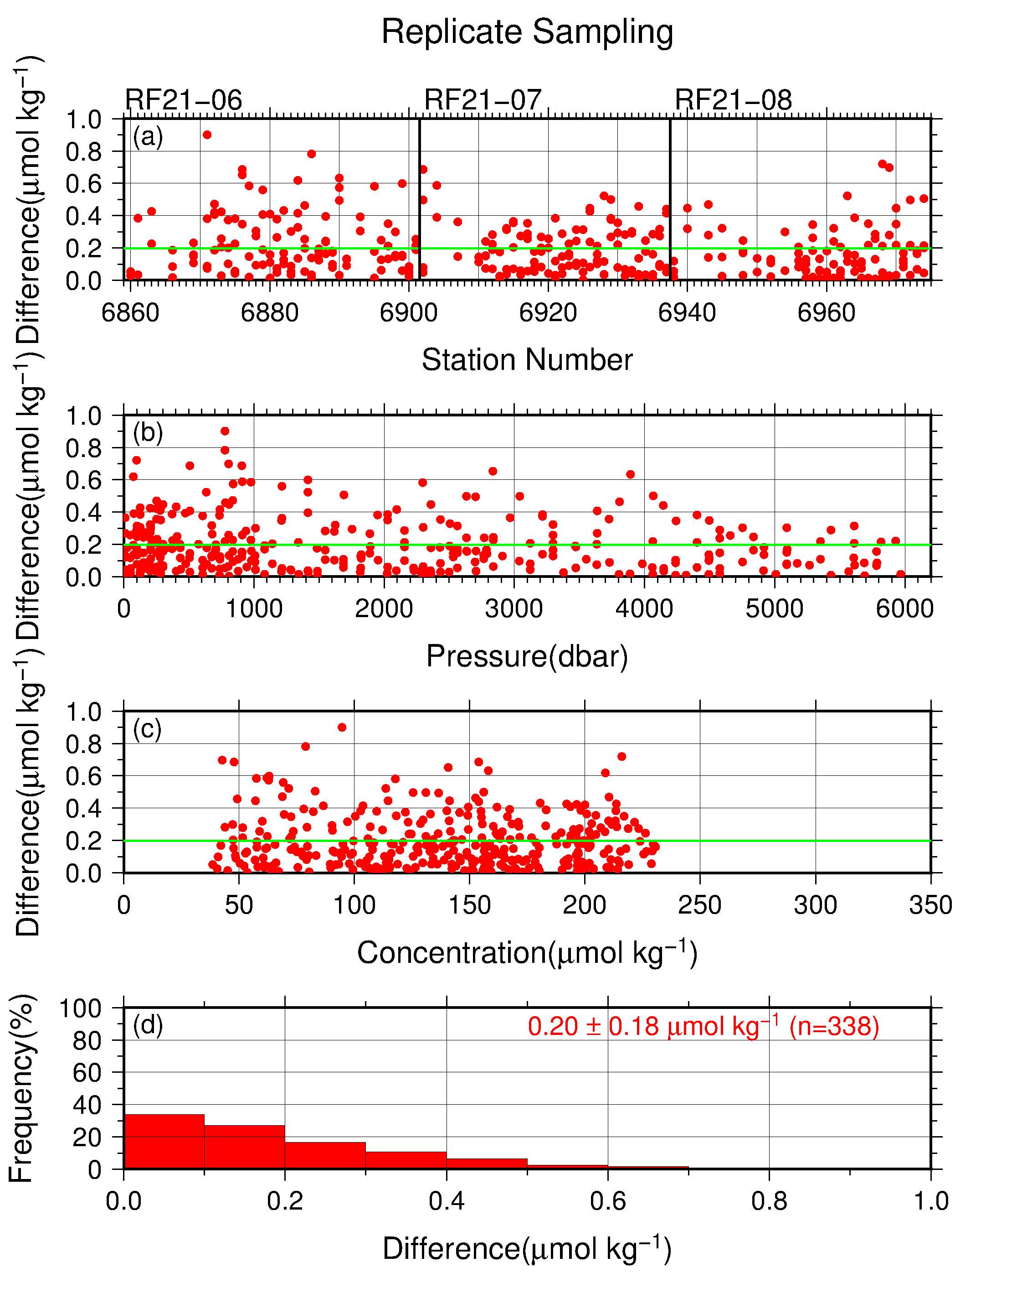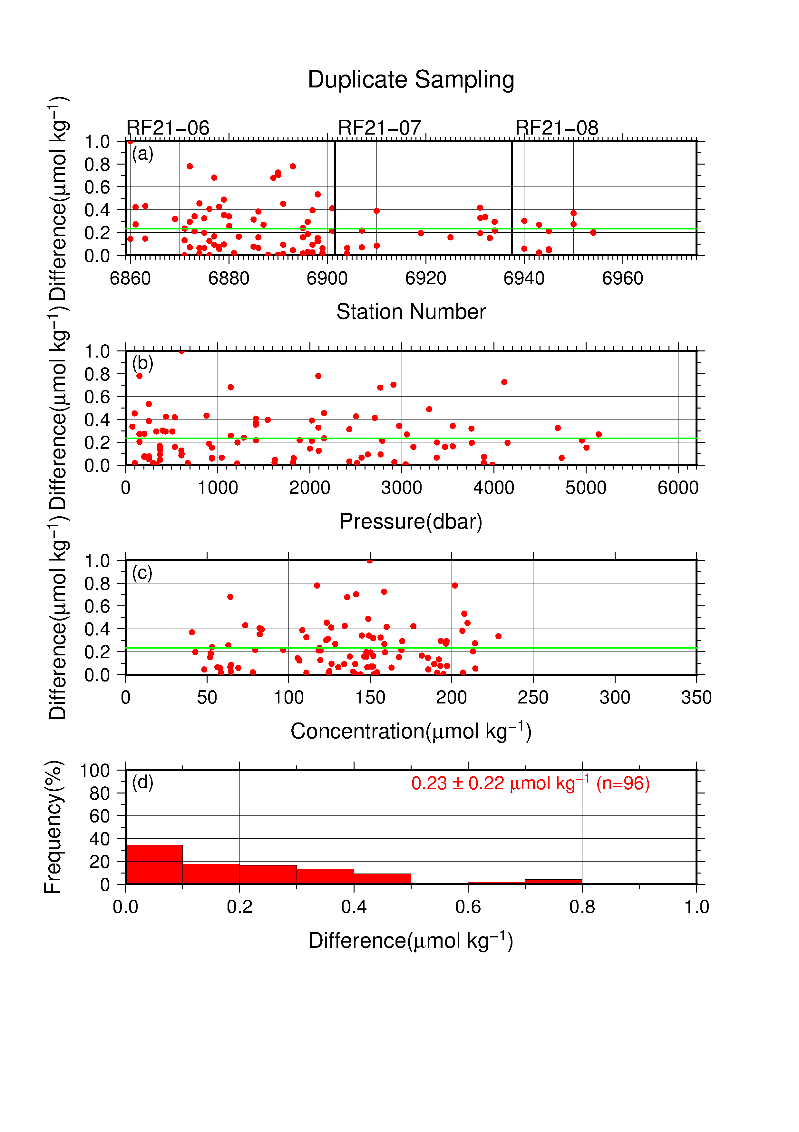
Figure C.3.5. Results of (left) replicate and (right) duplicate measurements during the cruise against (a) station number, (b) pressure, and (c) concentration of dissolved oxygen. Green lines denote the average of the measurements. Bottom panels (d) show histograms of the measurements.

(7.2) Comparisons between standard KIO₃ solutions
During the cruise, comparisons were made between different lots of standard KIO₃ solutions to confirm the accuracy of our oxygen measurements and the bias of a standard KIO₃ solution. A concentration of the standard KIO₃ solutions “20201012-2” and “20210319-1” was determined using Na₂S₂O₃ solution standardized with the KIO₃ solution “20201012-1”, and the difference between the measured value and the theoretical one. Good agreement between two standards confirmed that there was no systematic shift in oxygen measurements during the cruise (Figure C.3.6).
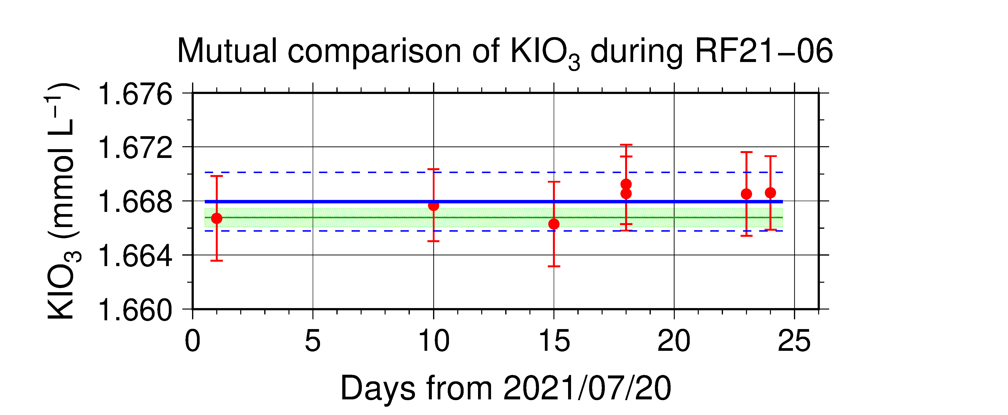
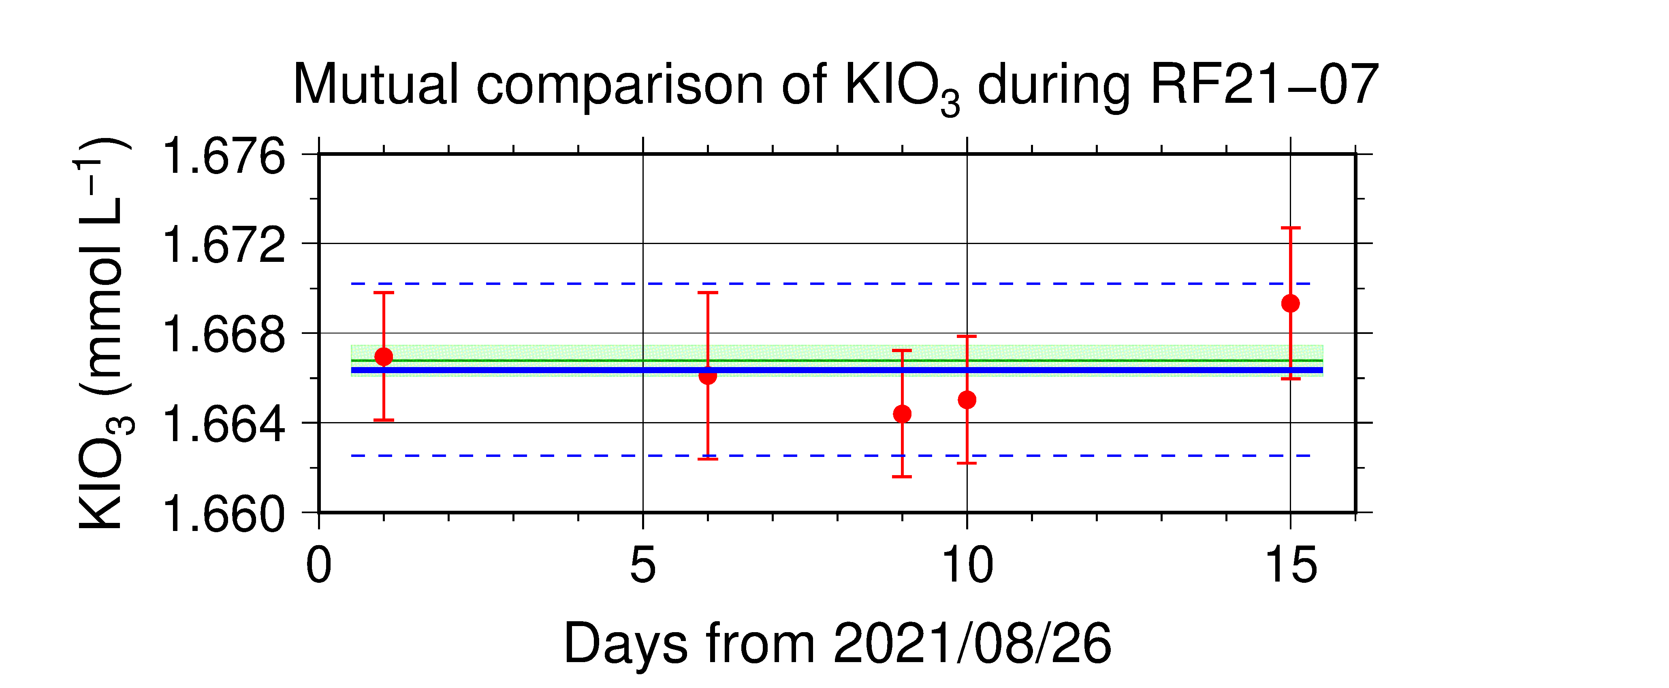

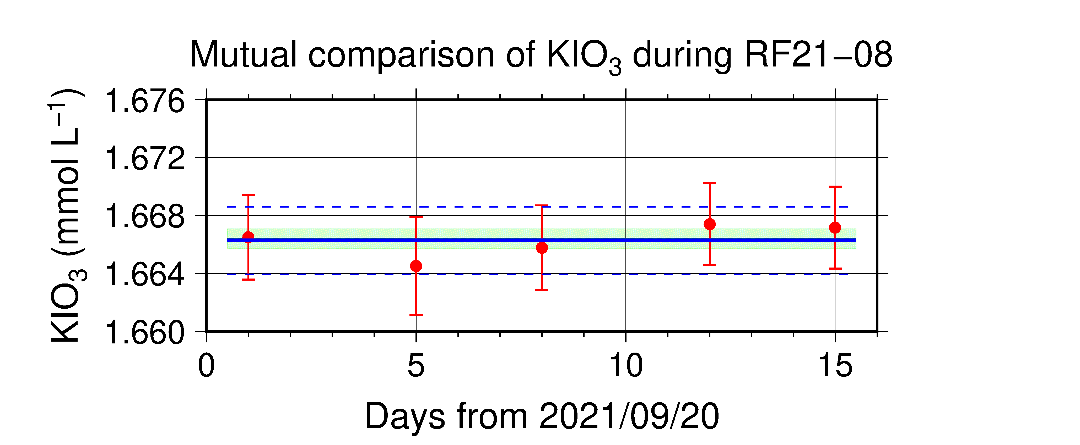
Figure C.3.6. Result of comparison of standard KIO₃ solutions during RF21-06 (top), RF21-07 (middle) and RF21-08 (bottom). Circles and error bars show mean of the measured value and its uncertainty (k=2), respectively. Thick and dashed lines in blue denote the mean and the mean ± twice the standard deviations, respectively, for the measurements throughout the cruise. Green thin line and light green thick line denote the nominal concentration and its uncertainty (k=2) of standard KIO₃ solutions “20201012-2” and “20210319-1”, for RF21-06, RF21-07 and RF21-08, respectively.

(7.3) Quality control flag assignment
A quality flag value was assigned to oxygen measurements, as shown in Table C.3.3, using the code defined in IOCCP Report No.14 (Swift, 2010).

Table C.3.3. Summary of assigned quality control flags.
Flag | Definition | Number of samples
2 | Good | 2545
3 | Questionable | 9
4 | Bad (Faulty) | 12
5 | Not reported | 3
6 | Replicate measurements | 306
Total number of samples |  | 2875

Uncertainty
Oxygen measurement involves various uncertainties; determination of glass bottles volume, repeatability and systematic error of burette discharge, repeatability of pickling reagent discharges, determination of reagent blank, standardization of Na₂S₂O₃ solution, and uncertainty of KIO₃ concentration. After taking into consideration the above uncertainties that could be evaluated, the expanded uncertainty of bottle oxygen concentrations (T=20, S=34.5) was estimated, as shown in Table C.3.4. However, it is difficult to determine a strict uncertainty for oxygen concentration because there is no reference material for oxygen measurement.

Table C.3.4. Expanded uncertainty (k=2) of bottle oxygen during the cruise.
O₂ conc. (μmol kg⁻¹) | Uncertainty (μmol kg⁻¹)
20 | 0.28
30 | 0.30
50 | 0.32
70 | 0.35
100 | 0.41
150 | 0.53
200 | 0.66
250 | 0.79
300 | 0.94
400 | 1.22

Appendix
A1. Methods
(A1.1) Seawater sampling
Following procedure is based on a determination method in IOCCP Report (Langdon, 2010). Seawater samples were collected from 10-liters Niskin bottles attached the CTD-system and a stainless steel bucket for the surface. Seawater for bottle oxygen measurement was transferred from the Niskin bottle and a stainless steel bucket to a volumetrically calibrated dry glass bottles. At least three times the glass volume water was overflowed. Then, pickling reagent-I 1 mL and reagent-II 1mL were added immediately, and sample temperature was measured using a thermometer. After a stopper was inserted carefully into the glass, it was shaken vigorously to mix the content and to disperse the precipitate finely. After the precipitate has settled at least halfway down the glass, the glass was shaken again. The sample glasses containing pickled samples were stored in a laboratory until they were titrated. To prevent air from entering the glass, deionized water (DW) was added to its neck after sampling.

(A1.2) Sample measurement
At least 15 minutes after the re-shaking, the samples were measured on board. Added 1 mL H₂SO₄ solution and a magnetic stirrer bar into the sample glass, samples were titrated with Na₂S₂O₃ solution whose molarity was determined with KIO₃ solution. During the titration, the absorbance of iodine in the solution was monitored using a detector. Also, temperature of Na₂S₂O₃ solution during the titration was recorded using a thermometer. Dissolved oxygen concentration (μmol kg⁻¹) was calculated from sample temperature at the fixation, CTD salinity, glass volume, and titrated volume of the Na₂S₂O₃ solution, and oxygen in the pickling reagents-I (1 mL) and II (1 mL) (7.6 × 10⁻⁸ mol; Murray et al., 1968).

A2. Reagents recipes
Pickling reagent-I; Manganous chloride solution (3 mol L⁻¹)
Dissolve 600 g of MnCl₂·4H₂O in DW, then dilute the solution with DW to a final volume of 1 L.
Pickling reagent-II; Sodium hydroxide (8 mol L⁻¹) / sodium iodide solution (4 mol L⁻¹)
Dissolve 320 g of NaOH in about 500 mL of DW, allow to cool, then add 600 g NaI and dilute with DW to a final volume of 1 L.
H₂SO₄ solution; Sulfuric acid solution (5 mol L⁻¹)
Slowly add 280 mL concentrated H₂SO₄ to roughly 500 mL of DW. After cooling the final volume should be 1 L.
Na₂S₂O₃ solution; Sodium thiosulfate solution (0.04 mol L⁻¹)
Dissolve 50 g of Na₂S₂O₃·5H₂O and 0.4 g of Na₂CO₃ in DW, then dilute the solution with DW to a final volume of 5 L.
KIO₃ solution; Potassium iodate solution (0.001667 mol L⁻¹)
Dry high purity KIO₃ for two hours in an oven at 130 °C. After weight out accurately KIO₃, dissolve it in DW in a 5 L flask. Concentration of potassium iodate is determined by a gravimetric method.

A3. Seawater blank
Blank due to redox species other than oxygen in seawater (V_{sw-blk}) can be a potential source of measurement error. Total blank (V_{tot-blk}) in seawater measurement can be represented as follows;
V_{tot-blk,} = V_{reg-blk} + V_{sw-blk}. (C3.A1)
Because the reagent blank (V_{reg-blk}) determined for pure water is expected to be equal to that in seawater, the difference between blanks for seawater (V_{tot-blk}) and for pure water gives the V_{sw-blk}.
Here, V_{sw-blk} was determined by following procedure. Seawater was collected in the calibrated volumetric glass without the pickling solution. Then 1 mL of the standard KIO₃ solution, H₂SO₄ solution, and reagent solution-II and I each were added in sequence into the glass. After that, the sample was titrated to the end-point by Na₂S₂O₃ solution. Similarly, a glass contained 100 mL of DW added with 1 mL of the standard KIO₃ solution, H₂SO₄ solution, pickling reagent solution-II and I were titrated with Na₂S₂O₃ solution. The difference of the titrant volume of the seawater and DW glasses gave V_{sw-blk}.
The seawater blank has been reported from 0.4 to 0.8 μmol kg⁻¹ in the previous study (Culberson et al., 1991). Additionally, these errors are expected to be the same to all investigators and not to affect the comparison of results from different investigators (Culberson, 1994). However, the magnitude and variability of the seawater blank have not yet been documented. Understanding of the magnitude and variability is important to improve traceability and comparability in oxygen concentration. The determined seawater blanks are shown in Table C.3.A1.

Table C.3.A1. Results of seawater blank determinations.
Station: RF6890  24°-15′N/140°-48′E |  |  | Station: RF6937  24°-01′N/164°-59′E |  |  | Station: RF6974  24°-00′N/178°-57′E
Depth | Blank |  | Depth | Blank |  | Depth | Blank
(m) | (μmol kg⁻¹) |  | (m) | (μmol kg⁻¹) |  | (m) | (μmol kg⁻¹)
50 | 0.88 |  | 48 | 0.48 |  | 48 | 0.59
252 | 0.86 |  | 201 | 0.65 |  | 126 | 0.49
400 | 0.77 |  | 201 | 0.70 |  | 249 | 0.71
502 | 0.83 |  | 400 | 0.70 |  | 249 | 0.74
701 | 0.79 |  | 799 | 0.69 |  | 402 | 0.73
1000 | 0.82 |  | 1401 | 0.70 |  | 900 | 0.72
1401 | 0.79 |  | 2200 | 0.75 |  | 1202 | 0.70
2399 | 0.86 |  | 2998 | 0.73 |  | 2405 | 0.77
2664 | 0.80 |  | 3997 | 0.68 |  | 3002 | 0.74
2664 | 0.84 |  | 4998 | 0.81 |  | 3995 | 0.77
 |  |  | 6001 | 0.70 |  | 3995 | 0.70
 |  |  | 6001 | 0.60 |  | 5502 | 0.75

Reference
Culberson, A.H. (1994), Dissolved oxygen, in WHPO Pub. 91-1 Rev. 1, November 1994, Woods Hole, Mass., USA.
Culberson, A.H., G. Knapp, M.C. Stalcup, R.T. Williams, and F. Zemlyak (1991), A comparison of methods for the determination of dissolved oxygen in seawater, WHPO Pub. 91-2, August 1991, Woods Hole, Mass., USA.
Langdon, C. (2010), Determination of dissolved oxygen in seawater by Winkler titration using the amperometric technique, IOCCP Report No.14, ICPO Pub. 134, 2010 ver.1
Murray, C. N., J. P. Riley and T. R. S. Wilson (1968), The solubility of oxygen in Winkler reagents used for the determination of dissolved oxygen. Deep-Sea Res. 15, 237–238.
Swift, J. H. (2010), Reference-quality water sample data: Notes on acquisition, record keeping, and evaluation. IOCCP Report No.14, ICPO Pub. 134, 2010 ver.1.

