C. Hydrographic Measurement Techniques and Calibration

CTDO₂ Measurements
25 November 2021

Personnel
WADA Kouichi (JMA)
ETO Tetsuhiro (JMA)
IDA Togo (JMA)
TSUZUKI Takato (JMA、RF2106)
OE Mitsuho (JMA、RF2106)
CHIBA Yasuomi (JMA、RF2107, RF2108)
HATANAKA Kenichiro (JMA、RF2107, RF2108)

CTDO₂ measurement system
(Software: SEASAVEwin32 ver7.23.2)
Deck unit | Serial number | Station
SBE 11plus (SBE) | 11P35251 – 0683 | RF6860 – 6974
Under-water unit | Serial number | Station
SBE 9plus (SBE) | 09P35251 – 0761  (Pressure : 91530) | RF6860 – 6974
Temperature | Serial number | Station
SBE 3plus (SBE)  SBE 35 (SBE) | 03P4436 (primary)  03P5632 (secondary)  0093 | RF6860 – 6974  RF6860 – 6974  RF6860 – 6974
Conductivity | Serial number | Station
SBE 4C (SBE) | 042987 (primary)  043682 (secondary) | RF6860 – 6974  RF6860 – 6974
Pump | Serial number | Station
SBE 5T (SBE) | 056552 (primary)  057934 (secondary) | RF6860 – 6974  RF6860 – 6974
Oxygen | Serial number | Station
RINKO III (JFE) | 392 (foil number:193028A)  356 (foil number:193028A) | RF6860 – 6974  RF6860 – 6974
Water sampler (36 position) | Serial number | Station
SBE 32 (SBE) | 32 – 1270 | RF6860 – 6974
Altimeter | Serial number | Station
VA500 (VA) | 69758 | RF6860 – 6974
Water sampling bottle |  | Station
Niskin Bottle (GO) |  | RF6860 – 6974
SBE: Sea- Bird Electronics, Inc., USA JFE: JFE Advantech Co., Ltd., Japan
VA: VALEPORT, Inc., UK GO: General Oceanics, Inc., USA

Pre-cruise calibration

(3.1) Pressure
S/N 0761, 15 Jan. 2021
c₁ | = | –4.651547 × 10⁴ |  | t₁ | = | 3.020363 × 10
c₂ | = | 9.130672 × 10⁻² |  | t₂ | = | –2.641135 × 10⁻⁴
c₃ | = | 1.439800 × 10⁻² |  | t₃ | = | 4.172110 × 10⁻⁶
d₁ | = | 3.778300 × 10⁻² |  | t₄ | = | 3.125100 × 10⁻⁹
d₂ | = | 0.000000 |  | t₅ | = | 0.000000

Formula:
U (degrees Celsius) = M × (12-bit pressure temperature compensation word) + B
U: temperature in degrees Celsius
S/N 0761 coefficients in SEASOFT (configuration sheet dated on 15 Jan. 2021)
M = 1.28617 × 10⁻², B = –8.41688

Finally, pressure is computed as
t: pressure period (μsec)

The drift-corrected pressure is computed as
Slope = 0.99990, Offset = −0.5234

(3.2) Temperature (ITS-90): SBE 3plus

S/N 03P4436 (primary), 01 Dec. 2020
g | = | 4.33671540 × 10⁻³ |  | j | = | 1.84135076 × 10⁻⁶
h | = | 6.38168848 × 10⁻⁴ |  | f₀ | = | 1000.0
i | = | 2.12668822 × 10⁻⁵

S/N 03P5632 (secondary), 04 Dec. 2020
g | = | 4.34077936 × 10⁻³ |  | j | = | 1.39823691 × 10⁻⁶
h | = | 6.28182709 × 10⁻⁴ |  | f₀ | = | 1000.0
i | = | 1.94913513 × 10⁻⁵

Formula:
f: Instrument freq.[Hz]

(3.3) Deep Ocean Standards Thermometer Temperature (ITS-90): SBE 35
S/N 0093, 27 Oct. 2020
a₀ | = | 4.12756963 × 10⁻³ |  | a₃ | = | –9.36245277 × 10⁻⁶
a₁ | = | –1.08163464 × 10⁻³ |  | a₄ | = | 2.00979198 × 10⁻⁷
a₂ | = | 1.67453817 × 10⁻⁴
Formula:
n: instrument output

The slow time drift of the SBE 35
S/N 0093, 2 Nov. 2020 (2nd step: fixed point calibration)
Slope = 1.000004, Offset = -0.000188
Formula:

(3.4) Conductivity: SBE 4C
S/N 042987 (primary), 28 Jan. 2021
g | = | –9.90116802 |  | j | = | -3.76254718 × 10⁻⁵
h | = | 1.35606673 |  | CP_{cor} | = | –9.5700 × 10⁻⁸
i | = | 1.99815553 × 10⁻³ |  | CT_{cor} | = | 3.2500 × 10⁻⁶

S/N 043682 (secondary), 24 Nov. 2020
g | = | –1.00118599 × 10 |  | j | = | 3.15601132 × 10⁻⁴
h | = | 1.43233438 |  | CP_{cor} | = | –9.5700 × 10⁻⁸
i | = | –2.92529308 × 10⁻³ |  | CT_{cor} | = | 3.2500 × 10⁻⁶

Conductivity of a fluid in the cell is expressed as:
f: instrument frequency (kHz)
t: water temperature (degrees Celsius)
p: water pressure (dbar).

(3.5) Oxygen (RINKO III)
The RINKO III (JFE Advantech Co., Ltd., Japan) sensor is based on the ability of a selected substance to act as a dynamic fluorescence quencher. The RINKO III model is designed to be used with a CTD system that accepts an auxiliary analog sensor, and it is designed to operate down to 7000 m. The RINKO III output is expressed in voltage from 0 to 5 V.

Quality control and data correction during the cruise

(4.1) Temporal change of deck pressure
The post-cruise drift corrected pressure was computed as follows:
S/N 09P35251 – 0761, 11 Mar. 2022
Slope = 0.99982，Offset = −1.4530
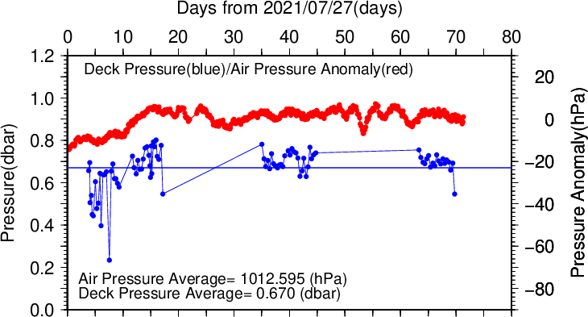
Figure C.1.1. Time series of the CTD deck pressure. Red line indicates atmospheric pressure anomaly. Blue line and dots indicate pre-cast deck pressure and average.

(4.2) Temperature sensor (SBE 3plus)
The practical corrections for the CTD temperature data can be made by using a SBE 35 and correcting the SBE 3plus so that it agrees with the SBE 35 (McTaggart et al., 2010; Uchida et al., 2007).

CTD temperature is corrected as follows:
$$Corrected temperature=T-(c_{0}+c_{1}×P+c_{2}×P^{2})$$
T: CTD temperature (degrees Celsius), P: pressure (dbar), and c₀, c₁, c₂: coefficients

Table C.1.1. Temperature correction summary (pressure ≥ 2000dbar). (Bold: accepted sensor)
S/N | Num | c₀(K) | c₁(K/dbar) | C₂(K/dbar²) | Stations
03P4436 | 372 | 5.437328 × 10⁻⁴ | 1.098702 × 10⁻⁷ | 0.000000 | RF6860 – 6901
03P4436 | 446 | 6.992947 × 10⁻⁴ | -1.149782 × 10⁻⁷ | 3.185994 × 10⁻¹¹ | RF6902 – 6931  RF6932 (※)  RF6933 - 6937
03P4436 | 384 | 7.489255 × 10⁻⁴ | -1.149898 × 10⁻⁷ | 2.979558 × 10⁻¹¹ | RF6938 – 6974
03P5632 | 372 | 3.653535 × 10⁻⁴ | -2.615938 × 10⁻⁷ | 5.289684 × 10⁻¹¹ | RF6860 – 6901
03P5632 | 446 | 7.466208 × 10⁻⁴ | -5.704204 × 10⁻⁷ | 8.808326 × 10⁻¹¹ | RF6902 – 6931  RF6932 (※)  RF6933 - 6937
03P5632 | 384 | 8.837996 × 10⁻⁴ | -6.324936 × 10⁻⁷ | 9.389582 × 10⁻¹¹ | RF6938 – 6974
※ For station RF6932, the S/N 03P5632 was accepted instead of the S/N 03P4436 due to data shift. This shift was not determined except for RF6932.

Table C.1.2. Temperature correction summary for S/N 03P4436.
Stations | Pressure < 2000dbar |  |  | Pressure ≥ 2000 dbar
 | Num | Average  (K) | Std  (K) | Num | Average  (K) | Std  (K)
RF6860 – 6901 | 737 | – 0.0002 | 0.0080 | 372 | 0.0000 | 0.0002
RF6902 – 6937 | 620 | – 0.0008 | 0.0080 | 446 | 0.0000 | 0.0001
RF6938 – 6974 | 537 | – 0.0002 | 0.0056 | 384 | 0.0000 | 0.0002

Table C.1.3. Temperature correction summary for S/N 03P5632.
Stations | Pressure < 2000dbar |  |  | Pressure ≥ 2000 dbar
 | Num | Average  (K) | Std  (K) | Num | Average  (K) | Std  (K)
RF6860 – 6901 | 737 | – 0.0002 | 0.0092 | 372 | 0.0000 | 0.0002
RF6902 – 6937 | 620 | – 0.0007 | 0.0074 | 446 | 0.0000 | 0.0001
RF6938 – 6974 | 537 | – 0.0007 | 0.0059 | 384 | 0.0000 | 0.0001

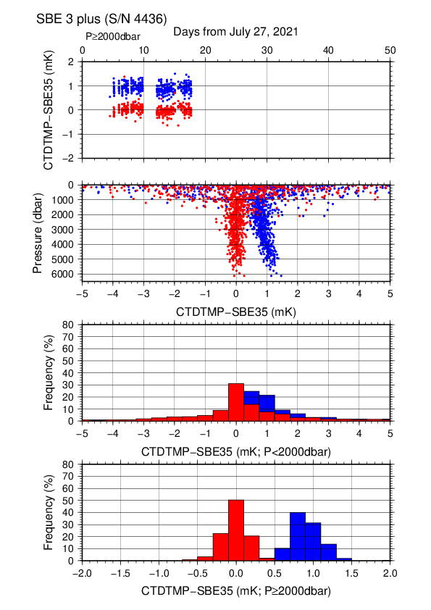
Figure C.1.2. Difference between the CTD temperature (S/N 03P4436) and the Deep Ocean Standards thermometer (SBE 35) on RF21-06 Leg 2. Blue and red dots indicate before and after the correction using SBE 35 data, respectively. Lower two panels show histograms of the differences after correction.

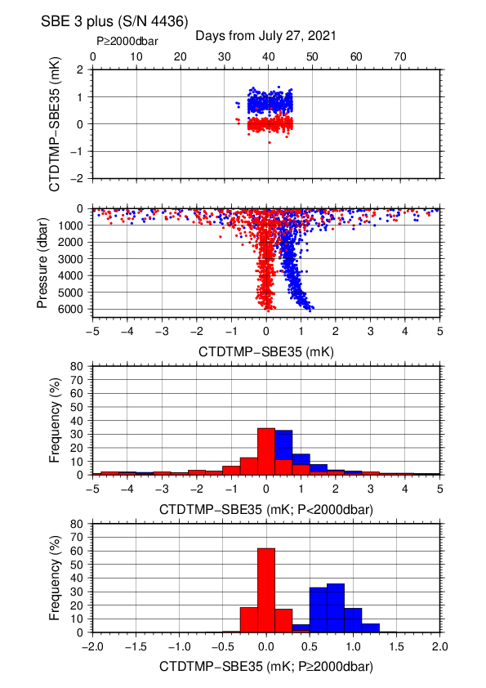
Figure C.1.3. Difference between the CTD temperature (S/N 03P4436) and the Deep Ocean Standards thermometer (SBE 35) on RF21-07. Blue and red dots indicate before and after the correction using SBE 35 data, respectively. Lower two panels show histograms of the differences after correction.

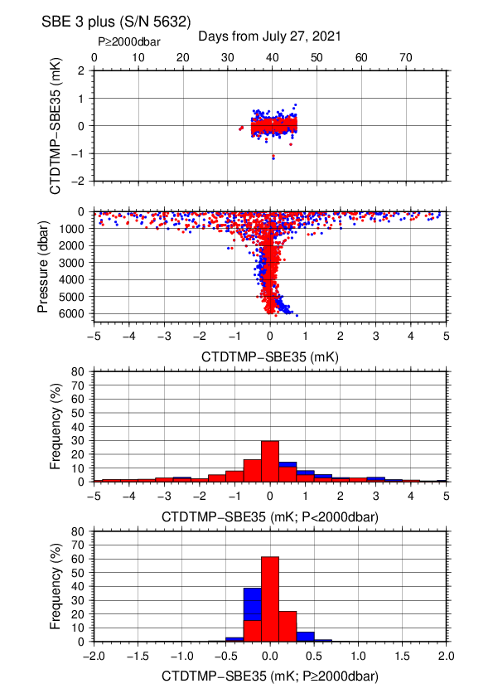
Figure C.1.4. Difference between the CTD temperature (S/N 03P5632) and the Deep Ocean Standards thermometer (SBE 35) on RF21-07. Blue and red dots indicate before and after the correction using SBE 35 data, respectively. Lower two panels show histograms of the differences after correction.

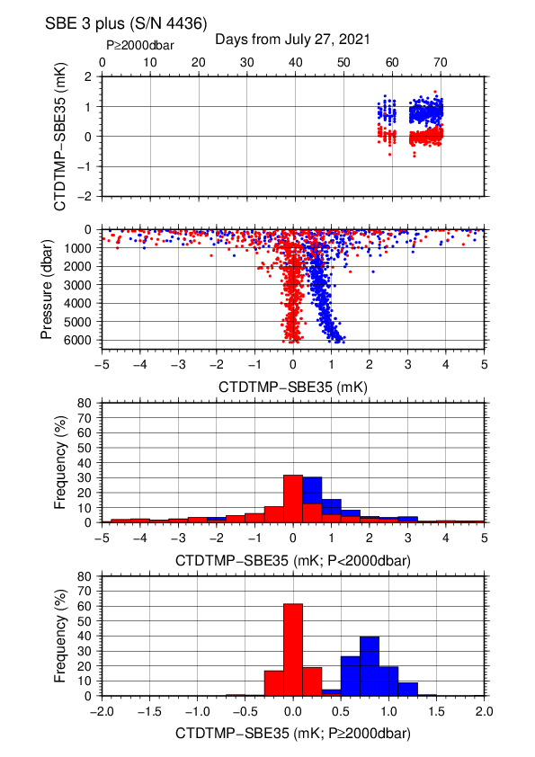
Figure C.1.5. Difference between the CTD temperature (S/N 03P4436) and the Deep Ocean Standards thermometer (SBE 35) on RF21-08. Blue and red dots indicate before and after the correction using SBE 35 data, respectively. Lower two panels show histograms of the differences after correction.

(4.3) Conductivity sensor (SBE 4C)
The practical corrections for CTD conductivity data can be made by using bottle salinity data to correct the SBE 4C to agree with measured conductivity (McTaggart et al., 2010).

CTD conductivity was corrected as follows:
$$Corrected Conductivity=C-\left(\sum_{i=0}^{I}{c_{i}×C^{i}}+\sum_{j=1}^{J}{p_{j}×P^{j}}\right)$$
C: CTD conductivity, c_{i} and p_{j}: calibration coefficients
i, j: determined by use of the AIC (Akaike, 1974). In accord with McTaggart et al. (2010), the maximum of I and J are 2.

Table C.1.4. Conductivity correction coefficient summary. (Bold: accepted sensor)
S/N | Num | c₀(S/m) | c₁ | c₂(m/S) | Stations
 |  |  | p₁(S/m/dbar) | p₂(S/m/dbar²)
042987 | 576 | -7.8668 × 10⁻⁴ | –4.8018 × 10⁻⁶ | 6.9212 × 10⁻⁵ | RF6860 – 6901
 |  |  | 3.5637 × 10⁻⁸ | 0.0000
042987 | 564 | -8.7024 × 10⁻⁴ | 8.2765 × 10⁻⁵ | 6.0423 × 10⁻⁵ | RF6902 – 6931  RF6932 (※)  RF6933 - 6937
 |  |  | 4.5645 × 10⁻⁸ | –3.0751 × 10⁻¹²
042987 | 542 | - 4.0535 × 10⁻⁴ | –1.5552 × 10⁻⁴ | 9.1640 × 10⁻⁵ | RF6938 – 6974
 |  |  | 5.9684 × 10⁻⁸ | -4.8822 × 10⁻¹²
043682 | 576 | 1.4895 × 10⁻³ | –9.8482 × 10⁻⁴ | 1.7983 × 10⁻⁴ | RF6860 – 6901
 |  |  | 1.4452 × 10⁻⁸ | 0.0000
043682 | 568 | 2.1282 × 10⁻³ | –1.2598 × 10⁻³ | 2.1145 × 10⁻⁴ | RF6902 – 6931  RF6932 (※)  RF6933 - 6937
 |  |  | 0.0000 | 0.0000
043682 | 542 | 2.5221 × 10⁻³ | –1.4789 × 10⁻³ | 2.3924 × 10⁻⁴ | RF6938 – 6974
 |  |  | 2.2088 × 10⁻⁸ | –3.3332 × 10⁻¹²
※ For station RF6932, the S/N 043682 was accepted instead of the S/N 042987 due to data shift. This shift was not determined except for RF6932.

Table C.1.5. Conductivity correction and salinity correction summary for S/N 042987.
Stations | Pressure < 1900dbar
 | Conductivity |  |  | Salinity
 | Num | Average  (S/m) | Std  (S/m) | Num | Average | Std
RF6860 – 6901 | 391 | 0.0000 | 0.0002 | 391 | 0.0000 | 0.0013
RF6902 – 6937 | 346 | 0.0000 | 0.0002 | 346 | 0.0000 | 0.0019
RF6938 – 6974 | 313 | 0.0000 | 0.0002 | 313 | 0.0000 | 0.0015
Stations | Pressure ≥ 1900 dbar
 | Conductivity |  |  | Salinity
 | Num | Average  (S/m) | Std  (S/m) | Num | Average | Std
RF6860 – 6901 | 185 | 0.0000 | 0.0000 | 185 | 0.0000 | 0.0005
RF6902 – 6937 | 218 | 0.0000 | 0.0000 | 218 | 0.0000 | 0.0003
RF6938 – 6974 | 229 | 0.0000 | 0.0000 | 229 | 0.0000 | 0.0004

Table C.1.6. Conductivity correction and salinity correction summary for S/N 043682.
Stations | Pressure < 1900dbar
 | Conductivity |  |  | Salinity
 | Num | Average  (S/m) | Std  (S/m) | Num | Average | Std
RF6860 – 6901 | 391 | 0.0000 | 0.0002 | 391 | 0.0000 | 0.0016
RF6902 – 6937 | 345 | 0.0000 | 0.0002 | 345 | 0.0000 | 0.0019
RF6938 – 6974 | 313 | 0.0000 | 0.0002 | 313 | 0.0000 | 0.0015
Stations | Pressure ≥ 1900 dbar
 | Conductivity |  |  | Salinity
 | Num | Average  (S/m) | Std  (S/m) | Num | Average | Std
RF6860 – 6901 | 185 | 0.0000 | 0.0000 | 185 | 0.0000 | 0.0005
RF6902 – 6937 | 223 | 0.0000 | 0.0000 | 223 | 0.0000 | 0.0003
RF6938 – 6974 | 229 | 0.0000 | 0.0000 | 229 | 0.0000 | 0.0003

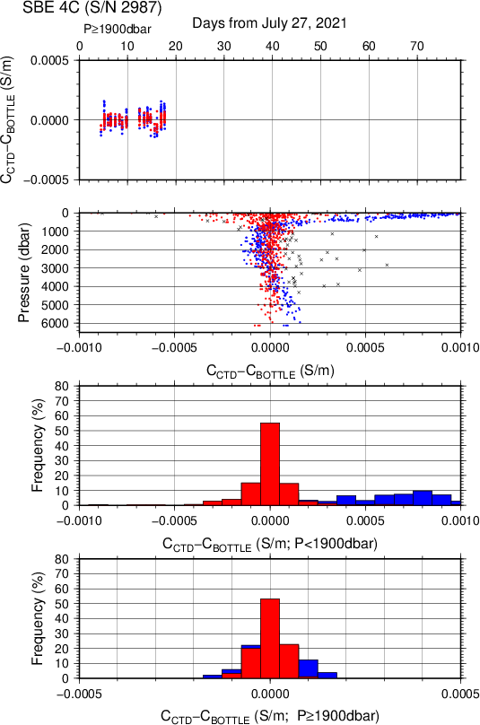
Figure C.1.6. Difference between the CTD conductivity (S/N 042987) and the bottle conductivity on RF21-06 Leg 2. Blue and red dots indicate before and after the calibration using bottle data, respectively. Lower two panels show histograms of the differences before and after calibration.

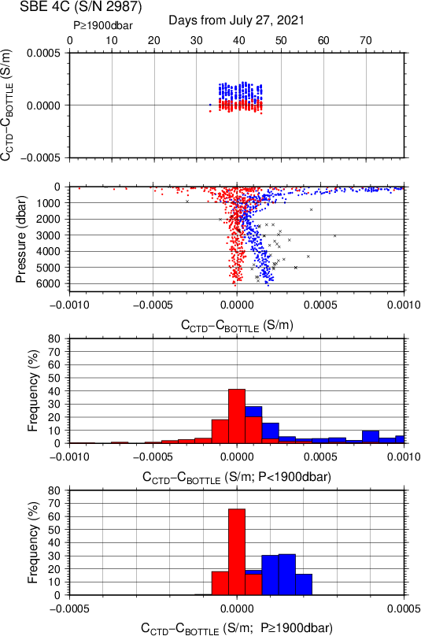
Figure C.1.7. Difference between the CTD conductivity (S/N 042987) and the bottle conductivity on RF21-07. Blue and red dots indicate before and after the calibration using bottle data, respectively. Lower two panels show histograms of the differences before and after calibration.

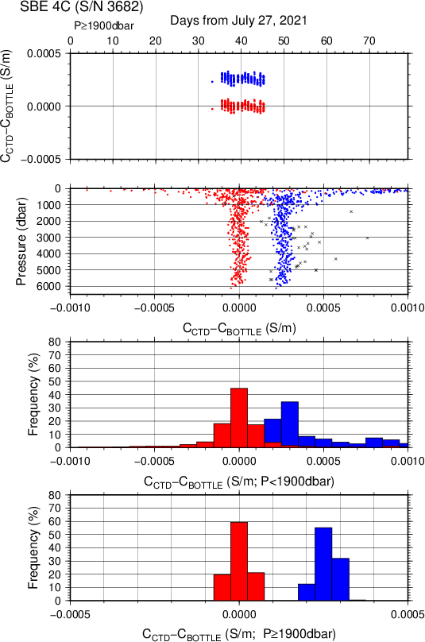
Figure C.1.8. Difference between the CTD conductivity (S/N 043682) and the bottle conductivity on RF21-07. Blue and red dots indicate before and after the calibration using bottle data, respectively. Lower two panels show histograms of the differences before and after calibration.
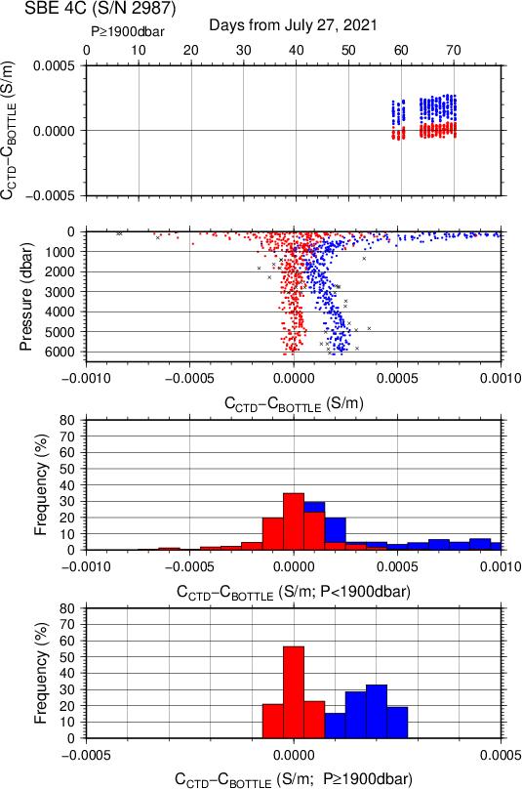
Figure C.1.9. Difference between the CTD conductivity (S/N 042987) and the bottle conductivity on RF21-08. Blue and red dots indicate before and after the calibration using bottle data, respectively. Lower two panels show histograms of the differences before and after calibration.

(4.4) Oxygen sensor (RINKO III)
The CTD oxygen concentration was calculated using the RINKO III output (voltage) with the Stern-Volmer equation in accord with the method of Uchida et al. (2008) and Uchida et al. (2010). The pressure hysteresis for the RINKO III output (voltage) was corrected in accord with Sea-bird Electronics (2009) and Uchida et al. (2010). The equations were as follows:
$$P_{0}=1.0+c_{4}×t$$
$$P_{c}=c_{5}{+c}_{6}×v+c_{7}×T+c_{8}×T×v$$
$$K_{sv}=c_{1}+c_{2}×t+c_{3}×t^{2}$$
$$coef={\left(1.0+c_{9}×P/{1000}\right)}^{1/3}$$
$$\left[O_{2}\right]=O_{2}^{sat}×\left\{{\left({P_{0}}/{P_{c}-1.0}\right)}/{K_{sv}×coef}\right\}$$
P: pressure (dbar), t: potential temperature, v: RINKO output voltage (volt)
T: elapsed time of the sensor from the beginning of first station in calculation group in day
O₂^{sat}: dissolved oxygen saturation by Garcìa and Gordon (1992) (μmol/kg)
[O₂]: dissolved oxygen concentration (μmol/kg)
c₁–c₉: determined by minimizing differences between CTD oxygen concentration and bottle dissolved oxygen concentration by quasi-newton method (Shanno, 1970).

Table C.1.7. Dissolved oxygen correction coefficient summary. (Bold: accepted sensor)
S/N | Stations | c₁ | c₂ | c₃ | c₄ | c₅
 |  | c₆ | c₇ | c₈ | c₉
0392 | RF6860 – 6901 | 1.71748 | 2.32914 × 10⁻² | 2.77573 × 10⁻⁴ | -1.68331 × 10⁻⁴ | -1.43710 × 10⁻¹
 |  | 3.08753 × 10⁻¹ | 2.64411 × 10⁻⁴ | 1.87630 × 10⁻⁴ | 8.62170 × 10⁻²
0392 | RF6902 – 6937 | 1.69381 | 1.94596 × 10⁻² | 2.46605 × 10⁻⁴ | -7.33923 × 10⁻⁴ | -1.29783 × 10⁻¹
 |  | 3.06309 × 10⁻¹ | 1.34390 × 10⁻⁴ | 1.53219 × 10⁻⁴ | 8.97566 × 10⁻²
0392 | RF6938 – 6974 | 1.71884 | 2.41620 × 10⁻² | 2.58729 × 10⁻⁴ | -1.67454 × 10⁻⁴ | -1.43759 × 10⁻¹
 |  | 3.10902 × 10⁻¹ | 2.06382 × 10⁻⁵ | 1.46204 × 10⁻⁴ | 8.39368 × 10⁻²
0356 | RF6860 – 6901 | 1.72686 | 2.73896 × 10⁻² | 1.58460 × 10⁻⁴ | 5.30533 × 10⁻⁴ | -1.34605 × 10⁻¹
 |  | 3.10240 × 10⁻¹ | 5.35585 × 10⁻⁴ | -3.80529 × 10⁻⁵ | 8.51756 × 10⁻²
0356 | RF6902 – 6937 | 1.70374 | 2.30838 × 10⁻² | 1.33419 × 10⁻⁴ | -2.28257 × 10⁻⁴ | -1.20650 × 10⁻¹
 |  | 3.06966 × 10⁻¹ | 1.00118 × 10⁻⁴ | 8.07451 × 10⁻⁵ | 8.70983 × 10⁻²
0356 | RF6938 – 6974 | 1.71839 | 2.56171 × 10⁻² | 1.28693 × 10⁻⁴ | -1.81806 × 10⁻⁵ | -1.29483 × 10⁻¹
 |  | 3.09772 × 10⁻¹ | 3.28179 × 10⁻⁴ | -3.03434 × 10⁻⁵ | 8.32957 × 10⁻²

Table C.1.8. Dissolved oxygen correction summary for S/N 0392.
Stations | Pressure < 950dbar |  |  | Pressure ≥ 950 dbar
 | Num | Average  (μmol/kg) | Std  (μmol/kg) | Num | Average  (μmol/kg) | Std  (μmol/kg)
RF6860 – 6901 | 555 | 0.04 | 0.72 | 542 | -0.00 | 0.34
RF6902 – 6937 | 455 | –0.03 | 0.56 | 603 | 0.01 | 0.26
RF6938 – 6974 | 390 | –0.00 | 0.60 | 527 | 0.00 | 0.23

Table C.1.9. Dissolved oxygen correction summary for S/N 0356.
Stations | Pressure < 950dbar |  |  | Pressure ≥ 950 dbar
 | Num | Average  (μmol/kg) | Std  (μmol/kg) | Num | Average  (μmol/kg) | Std  (μmol/kg)
RF6860 – 6901 | 555 | –0.01 | 0.62 | 542 | -0.00 | 0.34
RF6902 – 6937 | 455 | –0.03 | 0.49 | 603 | 0.00 | 0.25
RF6938 – 6974 | 390 | -0.03 | 0.53 | 527 | 0.00 | 0.23

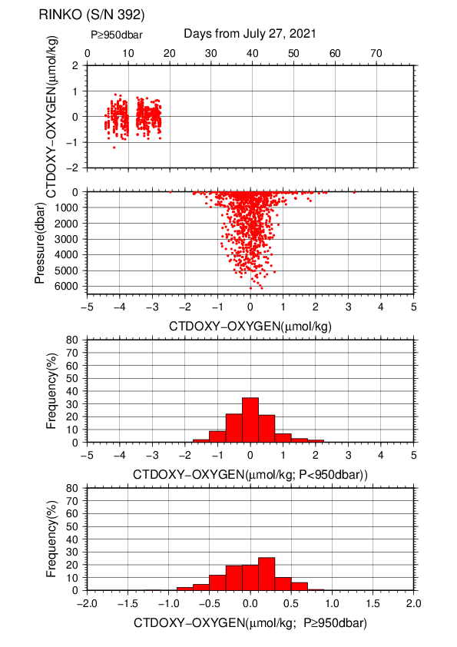
Figure C.1.10. Difference between the CTD oxygen (S/N 0392) and bottle dissolved oxygen on RF21-06 Leg 2. Red dots in upper two panels indicate the result of calibration. Lower two panels show histograms of the differences between calibrated oxygen concentration and bottle oxygen concentration.
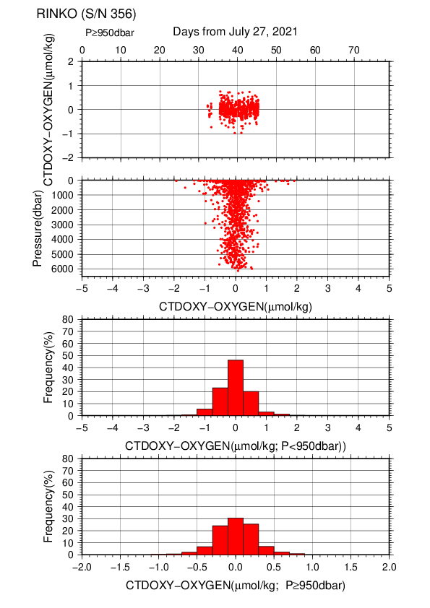
Figure C.1.11. Difference between the CTD oxygen (S/N 0356) and bottle dissolved oxygen on RF21-07. Red dots in upper two panels indicate the result of calibration. Lower two panels show histograms of the differences between calibrated oxygen concentration and bottle oxygen concentration.
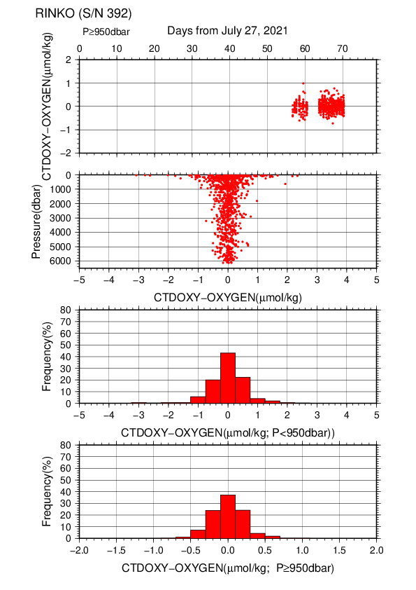
Figure C.1.12. Difference between the CTD oxygen (S/N 0392) and bottle dissolved oxygen on RF21-08. Red dots in upper two panels indicate the result of calibration. Lower two panels show histograms of the differences between calibrated oxygen concentration and bottle oxygen concentration.

(4.5) Results of detection of sea floor by the altimeter (VA500)
The altimeter detected the sea floor at 80 of 89 stations and that of final detection of sea floor was 14.6 m. The summary of detection of VA500 was shown in Figure C.1. 13.
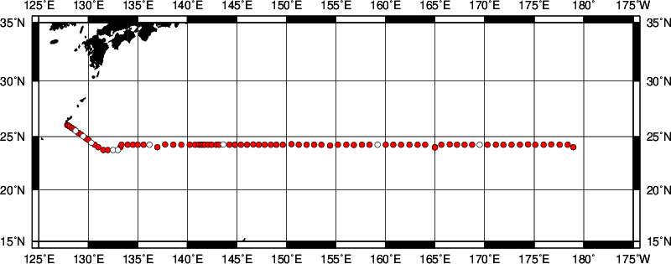
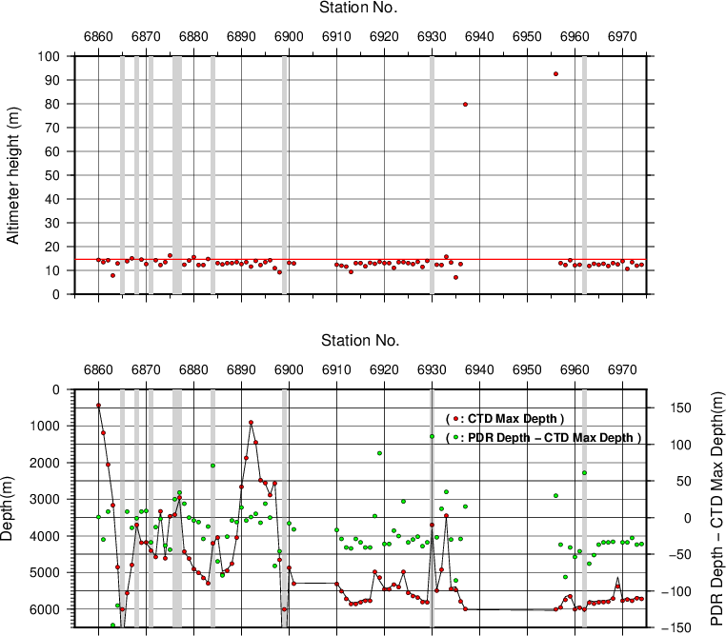

Figure C.1.13. The upper panel shows the stations of the detection along the P3 section. The middle panel shows altimeter height of VA500 in the stations. The lower panel shows maximum depth of CTD observation (left Y-axis) and difference between bathymetry (PDR depth) and the CTD depth (right Y-axis) in the stations. Open circles (the upper panel) and gray shade (the other two panels) indicate stations where the sea floor cannot detected.

Post-cruise calibration
After the cruise, post-cruise calibration of sensors was performed by the manufacturer, as shown below. We confirmed that the calibration of these sensors did not change significantly during the cruise.

(5.1) Temperature (ITS-90): SBE 3plus

S/N 03P4436 (primary), 21 Dec. 2021
g | = | 4.33657874 × 10⁻³ |  | j | = | 1.78510112 × 10⁻⁶
h | = | 6.37856931 × 10⁻⁴ |  | f₀ | = | 1000.0
i | = | 2.10338369 × 10⁻⁵

S/N 03P5632 (secondary), 21 Dec. 2021
g | = | 4.34073662 × 10⁻³ |  | j | = | 1.38437092 × 10⁻⁶
h | = | 6.28102586 × 10⁻⁴ |  | f₀ | = | 1000.0
i | = | 1.94331032 × 10⁻⁵

(5.2) Deep Ocean Standards Thermometer Temperature (ITS-90): SBE 35
S/N 0093, 27 Oct. 2020
a₀ | = | 4.12756963 × 10⁻³ |  | a₃ | = | –9.36245277 × 10⁻⁶
a₁ | = | –1.08163464 × 10⁻³ |  | a₄ | = | 2.00979198 × 10⁻⁷
a₂ | = | 1.67453817 × 10⁻⁴
Formula:
n: instrument output

The slow time drift of the SBE 35
S/N 0093, 18 Nov. 2021 (2nd step: fixed point calibration)
Slope = 1.000003, Offset = –0.000148
Formula:

(5.3) Conductivity: SBE 4C
S/N 042987 (primary), 13 Jan. 2022
g | = | –9.91933438 |  | j | = | 4.88610842 × 10⁻⁵
h | = | 1.36181919 |  | CP_{cor} | = | –9.5700 × 10⁻⁸
i | = | 5.85689368 × 10⁻⁴ |  | CT_{cor} | = | 3.2500 × 10⁻⁶

S/N 043682 (secondary), 07 Dec. 2021
g | = | –9.97135316 |  | j | = | 3.91068913 × 10⁻⁵
h | = | 1.41854121 |  | CP_{cor} | = | –9.5700 × 10⁻⁸
i | = | 8.23390530 × 10⁻⁴ |  | CT_{cor} | = | 3.2500 × 10⁻⁶

References
Akaike, H. (1974): A new look at the statistical model identification. IEEE Transactions on Automatic Control, 19:716–722.
Garcìa, H. E., and L. I. Gordon (1992): Oxygen solubility in seawater: Better fitting equations. Limnol. Oceanogr., 37, 1307–1312.
McTaggart, K. E., G. C. Johnson, M. C. Johnson, F. M. Delahoyde, and J. H. Swift (2010): The GO-SHIP Repeat Hydrography Manual: A Collection of Expert Reports and guidelines. IOCCP Report No 14, ICPO Publication Series No. 134, version 1, 2010.
Sea-Bird Electronics (2009): SBE 43 dissolved oxygen (DO) sensor – hysteresis corrections, Application note no. 64-3, 7 pp.
Shanno, David F. (1970): Conditioning of quasi-Newton methods for function minimization. Math. Comput. 24, 647–656. MR 42 #8905.
Uchida, H., G. C. Johnson, McTaggart, K. E. (2010): CTD oxygen sensor calibration procedures. In: The GO-SHIP repeat hydrography manual: A Collection of Expert Reports and guidelines. IOCCP Report No 14, ICPO Publication Series No. 134, version 1, 2010.
Uchida, H., K. Ohyama, S. Ozawa, and M. Fukasawa (2007): In-situ calibration of the Sea-Bird 9plus CTD thermometer. J. Atmos. Oceanic Technol., 24, 1961–1967.
Uchida, H., T. Kawano, I. Kaneko, and M. Fukasawa (2008): In-situ calibration of optode-based oxygen sensors. J. Atmos. Oceanic Technol., 25, 2271–2281.

Bottle Salinity
25 November 2021

Personnel
WADA Kouichi (JMA)
ETO Tetsuhiro (JMA)
IDA Togo (JMA)
TSUZUKI Takato (JMA、RF2106)
OE Mitsuho (JMA、RF2106)
CHIBA Yasuomi (JMA、RF2107, RF2108)
HATANAKA Kenichiro (JMA、RF2107, RF2108)

Salinity measurement
Salinometer: AUTOSAL 8400B (Guildline Instruments Ltd., Canada ; S/N 72103, 73556)
Thermometer: 1502A Tweener thermometer readout (to monitor ambient temperature and bath temperature) (Fluke calibration, USA)
IAPSO Standard Seawater: P164 (K15=0.99985)

Sampling and measurement
The measurement system was almost the same as the system described by Kawano (2010).
Algorithm for practical salinity scale, 1978 (PSS-78; UNESCO, 1981) was employed to convert the conductivity ratios to salinities.

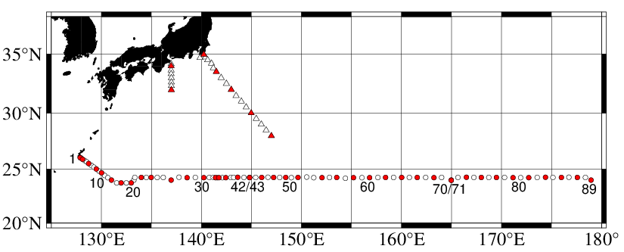
Station occupied
Figure C.2.1. Location of observation stations of bottle salinity. Closed and open circles indicate sampling and no-sampling station, respectively. Triangle shows a sampling station which is not reported in the bottle data file but is included in data processing. These data are available from the JMA web site
(https://www.data.jma.go.jp/gmd/kaiyou/db/vessel_obs/datareport/html/ship/ship_e.php?year=2021&season=summer).

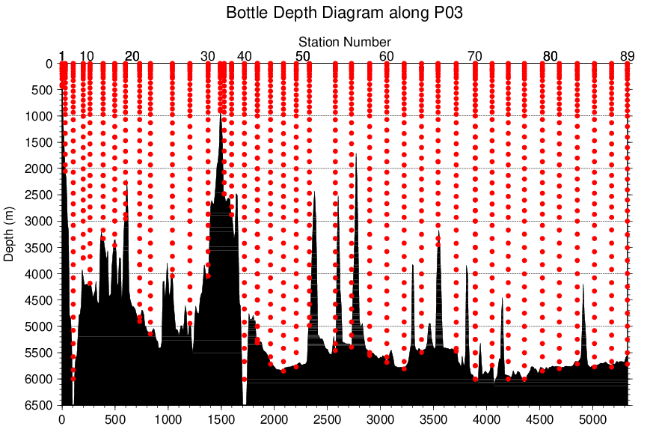
Figure C.2.2. Distance-depth distribution of sampling layers of bottle salinity.

Result

(5.1) Ambient temperature, bath temperature and Standard Seawater measurements
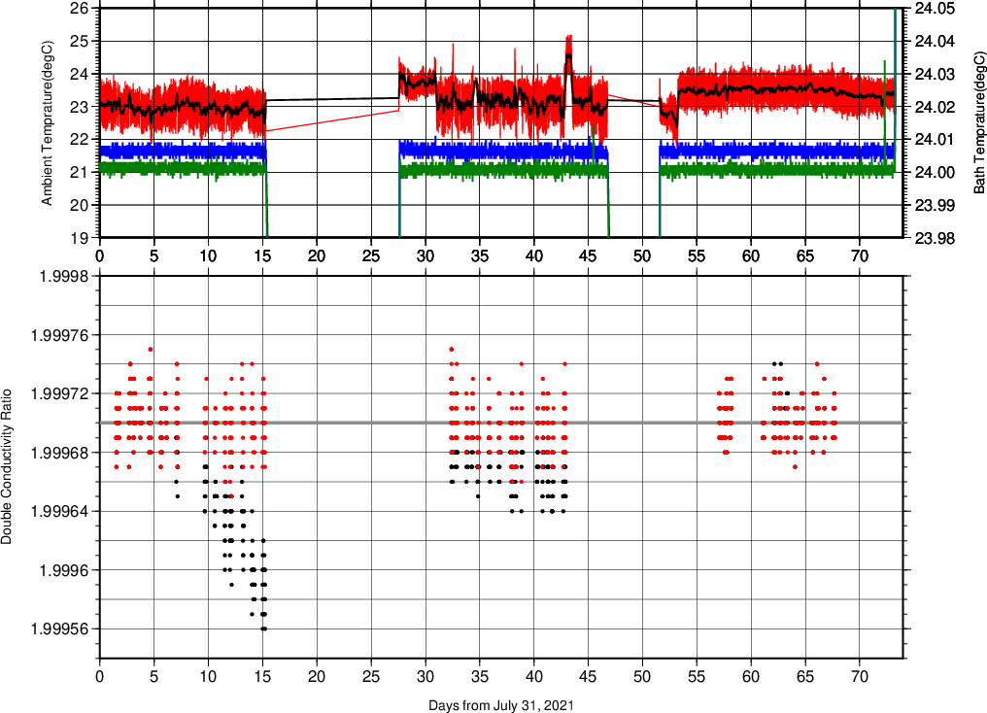
Figure C.2.3. The upper panel, red line, black line, green line, and blue line indicate time-series of ambient temperature, average ambient temperature, and bath temperature (green: Autosal S/N 72103, blue: S/N 73556) during cruise. The lower panel, black dots, and red dots indicate raw and corrected time-series of the double conductivity ratio of the standard seawater (P164).

(5.2) Replicate and duplicate samples
We took replicate (pair of water samples taken from a single Niskin bottle) and duplicate (pair of water samples taken from different Niskin bottles closed at the same depth) samples for bottle salinity throughout the cruise. Table C.2.1 summarizes the results of the analyses. Figure C.2.4 shows details of the results. The calculation of the standard deviation from the difference of sets was based on a procedure (SOP 23) in DOE (1994).

Table C.2.1. Summary of replicate and duplicate salinity analyses.
Measurement | Average difference ± S.D.
Replicate sample | 0.0002 ± 0.0002 (N = 170)
Duplicate sample | 0.0005 ± 0.0006 (N = 32)

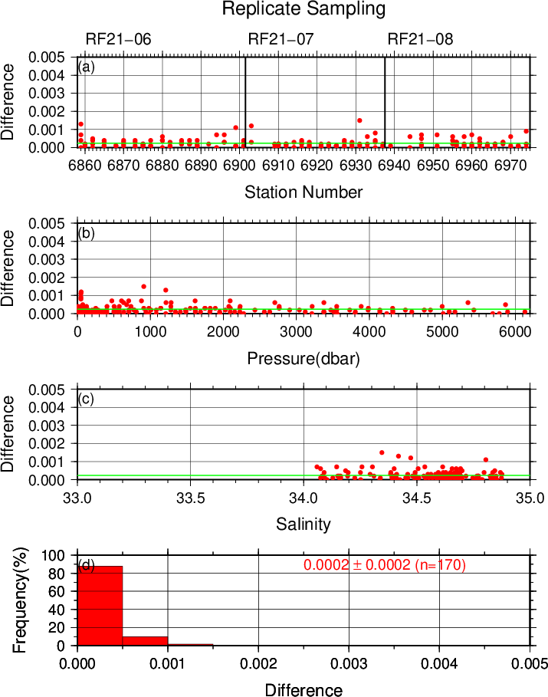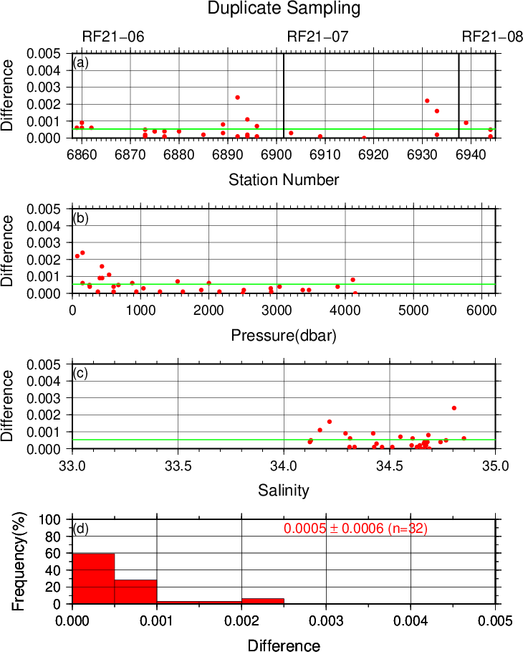

Figure C.2.4. Results of (left) replicate and (right) duplicate analyses during the cruise against (a) station number, (b) pressure, (c) salinity, and (d) histogram of the measurements. Green line indicates the mean of the differences of salinity of replicate/duplicate analyses. These data are available from the JMA web site(https://www.data.jma.go.jp/gmd/kaiyou/db/vessel_obs/data-report/html/ship/ship_e.php?year=2021&season=summer).

(5.3) Summary of assigned quality control flags
Table C.2.2. Summary of assigned quality control flags
Flag | Definition | Number
2 | Good | 1215
3 | Questionable | 0
4 | Bad (Faulty) | 95
5 | Not reported | 1
6 | Replicate measurements | 152
Total number of samples |  | 1463

References
DOE (1994), Handbook of methods for the analysis of the various parameters of the carbon dioxide system in sea water; version 2. A. G. Dickson and C. Goyet (eds), ORNL/CDIAC-74.
Kawano (2010), The GO-SHIP Repeat Hydrography Manual: A Collection of Expert Reports and Guidelines. IOCCP Report No. 14, ICPO Publication Series No. 134, Version 1.
UNESCO (1981), Tenth report of the Joint Panel on Oceanographic Tables and Standards. UNESCO Tech. Papers in Mar. Sci., 36, 25 pp.

