Acoustic Doppler Current Profiler
25 November 2021

Personnel
CHIBA Yasuomi (JMA)
WADA Koichi (JMA)

Instruments and Methods
Current direction and speed were measured by the hull-mounted 38 kHz Ocean Surveyor ADCP (Teledyne RD Instruments, Inc., USA; hereafter TRDI). The transducer of the system was installed in a dome at 3 m left of center and 13 m aft of the bow at the water line. The firmware version was 23.17 and the data acquisition software was TRDI/VMDAS Version. 1.49. The instrument was used in water-tracking mode during the operations, and was recording each ping raw data in 20 m × 60 bin from about 36 m to 1200 m in depth. Sampling interval was variable as short as possible and typically 6.4 seconds. GPS navigation data and ship’s gyrocompass data were recorded with the ADCP data. In addition to the raw data, 60 seconds and 300 seconds averaged data were stored as short term average (STA) and long term average (LTA) data, respectively. Current field based on the gyrocompass was used to check the operation and the performance on board.

Performance and quick view of the ADCP data on board
The performance of the ADCP instrument was almost good throughout the cruise, and current profiles were usually reached about 1000 m. We monitored the current profiles based on LTA data in this cruise on board.

Data Processing
LTA data were processed by CODAS (Common Oceanographic Data Access System) software, developed at the University of Hawaii
(https://currents.soest.hawaii.edu/docs/adcp_doc/index.html). We used a standard CODAS processing including a PC time correction, a sound-speed correction based on the thermistor temperature at the transducers, and an amplitude and phase calibration constant applied to the measured velocities.

Calibration constants to be applied were evaluated for each leg using the water track data. The values of amplitude and phase applied to each leg are listed in Table B.7.1. Figure B.7.1 shows surface current at the depth of 36 m during the cruise.

Table B.7.1. The values of amplitude and phase applied to each leg (cruise).
 | Amplitude | Phase
RF2106 Leg2 | 1.0039 | 0.3015
RF2107 | 1.0054 | -0.2846
RF2108 | 1.0050 | -0.3587

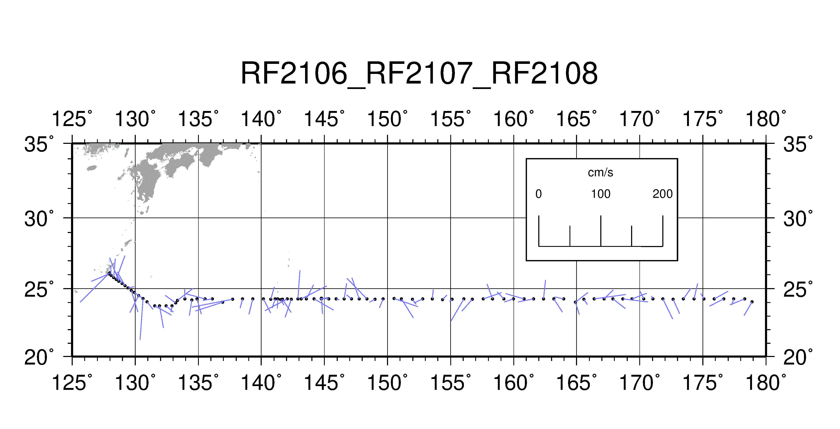
Figure B.7.1. Surface current at the depth of 36 m.

Reference
Joyce, T. M. (1988), On in-situ “calibration” of shipboard ADCPs. J. Atmos. Oceanic Technol., 6, 169172.

