B. Underway measurements

Navigation
25 November 2021

Personnel
NAGAI Naoki (JMA)
CHIBA Yasuomi (JMA)

Overview of the equipment
The ship's position was measured by navigation system manufactured by FURUNO ELECTRIC CO., LTD., Japan. The system has three 12-channels GPS receivers (GP-150, GP-170, JLR-7800).
GPS antennas were installed on the compass deck. We switched the receivers to choose better receiving state if the number of received GPS satellites was small or HDOP was large. The GPS data, gyro heading data and log speed data were integrated and delivered to two workstations. These workstations work as the primary and secondary NTP (Network Time Protocol) servers.
The navigation data were obtained approximately every one second and one minute data were extracted from one second data. These one minute data were recorded as "LOG data (GPS data)".

Data Period
05:00, 19 Jul. 2021 to 01:00, 24 Jul. 2021 (UTC).
05:00, 28 Jul. 2021 to 01:00, 17 Aug. 2021 (UTC).
05:00, 27 Aug. 2021 to 00:00, 16 Sep. 2021 (UTC).
05:00, 20 Sep. 2021 to 00:00, 14 Oct. 2021 (UTC).

Bathymetry
25 November 2021

Personnel
CHIBA Yasuomi (JMA)
WADA Koichi (JMA)

Overview of the equipment
R/V Ryofu Maru equipped a single beam echo sounder, EA 600 (Kongsberg Maritime, Norway). The main objective of the survey is to collect continuous bathymetry data along the ship's track.
The sound speed to correct depth data was set to 1500 m/s during the cruise. Data interval was about 10 seconds in the measurement for 7500 m depth.

System Configuration and Performance
System: | Kongsberg EA 600
Frequency: | 12 kHz
Transmit power: | 2 kW
Transmit pulse interval: | Within 20 seconds
Depth range: | 5–15,000 m
Depth resolution: | 1 cm
Depth accuracy (Assuming correct sound velocity, transducer depth and shortest pulse length): | Within 20 cm

Data Period
05:00, 19 Jul. 2021 to 01:00, 24 Jul. 2021 (UTC).
05:00, 28 Jul. 2021 to 01:00, 17 Aug. 2021 (UTC).
05:00, 27 Aug. 2021 to 00:00, 16 Sep. 2021 (UTC).
05:00, 20 Sep. 2021 to 00:00, 14 Oct. 2021 (UTC).

Maritime Meteorological Observations
25 November 2021

Personnel
NAGAI Naoki (JMA)
CHIBA Yasuomi (JMA)

Data Period

05:00, 19 Jul. 2021 to 01:00, 24 Jul. 2021 (UTC).
05:00, 28 Jul. 2021 to 01:00, 17 Aug. 2021 (UTC).
05:00, 27 Aug. 2021 to 00:00, 16 Sep. 2021 (UTC).
05:00, 20 Sep. 2021 to 00:00, 14 Oct. 2021 (UTC).

Methods
The maritime meteorological observation system on R/V Ryofu Maru is Ryofu Maru maritime meteorological measurement station (RMET). Instruments of RMET are listed in Table B.3.1. All RMET data were collected and processed by KOAC-7800 weather data processor made by KOSHIN DENKI KOGYO CO., LTD., Japan. The result of Maritime meteorological observation data were shown in Figures B.3.1 and B.3.2.

Table B.3.1. Instruments and locations of RMET.
Sensor | Parameter | Type (Manufacture) | Location
 |  |  | (Height from maximum load line)
Thermometer | Air Temperature | R005-341  (CHINO CORPORATION) | Compass deck  (13.3 m)
Hygrometer | Relative humidity | HMT3303JM (Vaisala) | Compass deck  (13.3 m)
Thermometer | Sea surface  temperature | RFN1-0  (CHINO CORPORATION) | Engine Room  (−4.7 m)
Aerovane | Wind Speed  Wind Direction | KVS-400-J  (KOSHIN DENKI KOGYO CO., LTD.) | Mast top  (19.8 m)
Wave gauge | Wave Height  Wave period | Micro Wave WM-2  (Tsrumi-Seiki Co., Ltd.) | Ship front  (6.5 m)
Barometer | Air pressure | PTB-220 (Vaisala) | Observation room  (2.8 m)
Note that there are two sets of a thermometer and a hygrometer at the starboard and the port sides.
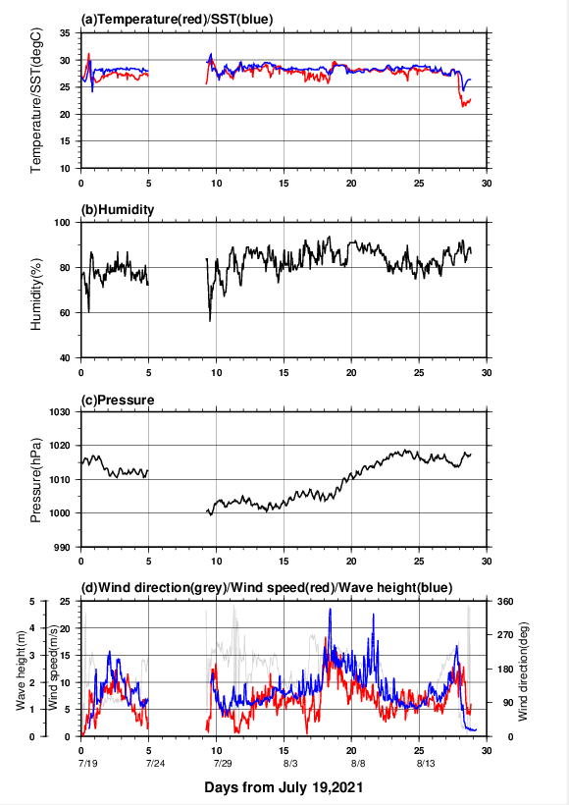
Figure B.3.1.1 Time series of (a) air temperature and sea surface temperature (SST), (b) relative humidity, (c) sea-level pressure, and (d) wind direction, wind speed and wave height. The light blue line in (d) panel shows the instrumental observation of wave height. Day 0 corresponds to July 19, 2021 (JST).
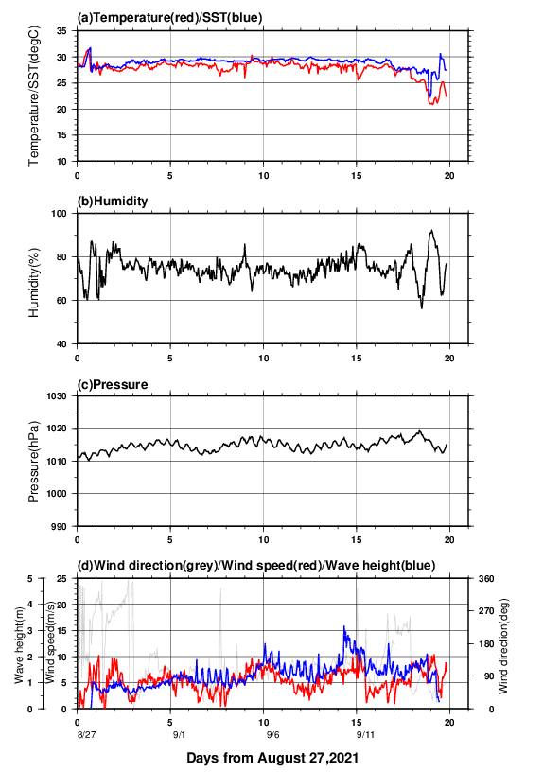
Figure B.3.1.2 Same as Fig. B.3.1.1, but day 0 corresponds to August 27, 2021 (JST).

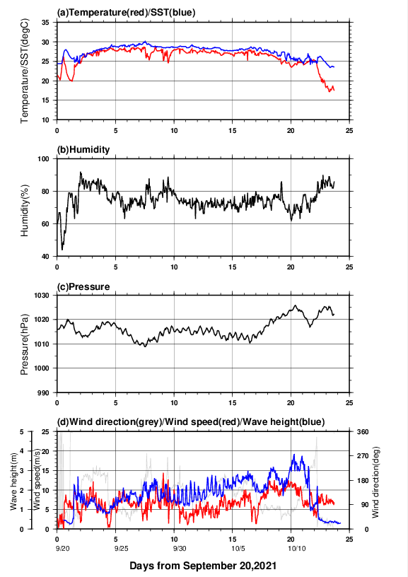
Figure B.3.1.3. Same as Fig. B3.1.1, but day 0 corresponds to September 20, 2021 (JST).

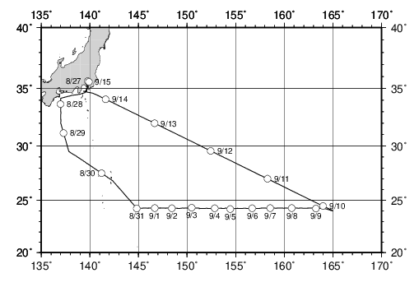
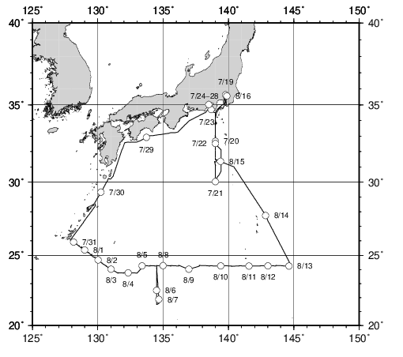
Figure B.3.2.1 Cruise track from July 19, 2021 to August 17, 2021 (UTC). Circles indicate all noon positions (JST) along the cruise track.
Figure B.3.2.2 Cruise track from August 27, 2021 to September 16, 2021 (UTC). Circles indicate all noon positions (JST) along the cruise track.

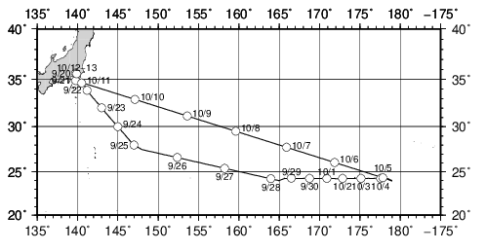
Figure B.3.2.3 Cruise track from September 20, 2021 to October 14, 2021 (UTC). Circles indicate all noon positions (JST) along the cruise track.

Data processing and Data format
All raw data were recorded in every 6-seconds. The values of 1-minute and 10-minute data were averaged from 6-seconds raw data. The 10-minute data in every three hours are available from JMA web site (https://www.data.jma.go.jp/kaiyou/db/vessel_obs/data-report/html/ship/cruisedata_e.php?id=RF2106). (https://www.data.jma.go.jp/kaiyou/db/vessel_obs/data-report/html/ship/cruisedata_e.php?id=RF2107).
(https://www.data.jma.go.jp/kaiyou/db/vessel_obs/data-report/html/ship/cruisedata_e.php?id=RF2108).

Because the thermometers and the hygrometers are equipped on the both starboard/port sides on the compass deck, we used air temperature/relative humidity data taken at upwind side at difference time. Dew point temperature was calculated from relative humidity and air temperature.

Pressure data was corrected to sea level pressure. During the cruise, fixed value +0.5 hPa (for the height of the observation room) was used for the correction. Data were stored in ASCII format and representative parameters are as follows; time in UTC, longitude (E), latitude (N), ship speed (knot), ship direction (degrees), sea-level pressure (hPa), air temperature (degrees Celsius), dew point temperature (degrees Celsius), relative humidity (%), sea surface temperature (degrees Celsius), wind direction (degree) and wind speed (m/sec).

Wave height and period were observed twice in an hour. The measurement period was 20 minutes and each measurement started at 5 minutes and 35 minutes after the hour. In addition to those data, ship’s position and observation time were recorded in ASCII format.

Data quality
To confirm the data quality, each sensor was checked as follows.

Temperature/Relative humidity sensor:
The temperature and relative humidity (T/RH) sensors on the both sides of the ship were checked by the manufacturer before delivering and, they were also checked by the calibrated Assmann psychrometer before and after the cruise. The discrepancy between T/RH sensors and Assmann psychrometer were within ± 0.4 degrees Celsius and ± 4 %, respectively.

Thermometer (Sea surface temperature):
The sea temperature sensor was calibrated once a year by the manufacturer. Certificated accuracy of the sensor is better than ± 0.4 degrees Celsius. At the start of the cruise, the values are also compared with temperature of water, taken from sea surface using a bucket, which was measured by a calibrated mercury thermometer (Yoshino Keisoku S-441, accuracy is better than ± 0.1 degrees Celsius).

Pressure sensor:
Using calibrated portable barometer (Vaisala 765-16B, certificated accuracy is better than ± 0.1 hPa), pressure sensor was checked before the cruise. Mean difference of RMET pressure sensor and portable sensor is less than 0.7 hPa.

Aerovane:
Aerovane was checked once per year by the manufacturer, and once per five years by the Meteorological Instrument Center, JMA.

Ship’s weather observation
Non-instrumental observations such as weather, cloud, visibility, wave direction and wave height were made by the ship crews every three hours. We sent those data together with the RMET data to the Global Collecting Centre for Marine Climatological Data in IMMT (International Maritime Meteorological Tape) -V format. The RMET data are available from JMA web site.
(https://www.data.jma.go.jp/kaiyou/db/vessel_obs/data-report/html/ship/cruisedata_e.php?id=RF2106).
(https://www.data.jma.go.jp/kaiyou/db/vessel_obs/data-report/html/ship/cruisedata_e.php?id=RF2107). (https://www.data.jma.go.jp/kaiyou/db/vessel_obs/data-report/html/ship/cruisedata_e.php?id=RF2108).

