Total Dissolved Inorganic Carbon (DIC)

30 September 2023

Personnel
SAKAMOTO Naoaki
TANI Masanobu
TANIZAKI Chiho

Station occupied
A total of 38 stations (Leg 1: 24, Leg 2: 14) were occupied for total dissolved inorganic carbon (DIC). Station location and sampling layers of them are shown in Figures C.6.1 and C.6.2, respectively.

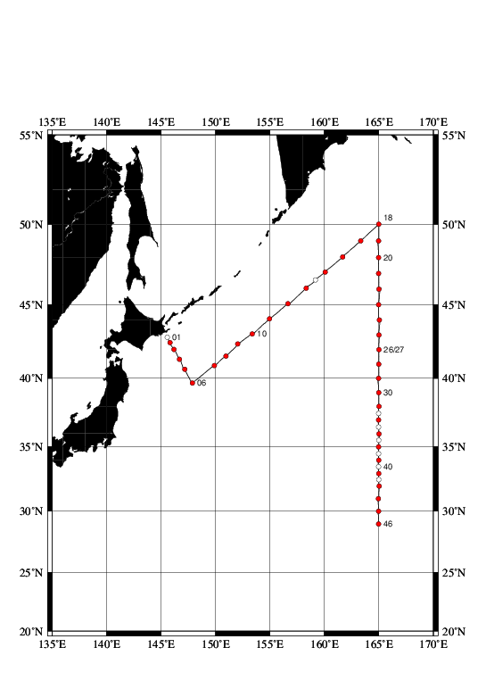
Figure C.6.1. Location of observation stations of DIC. Closed and open circles indicate sampling and no-sampling stations, respectively.
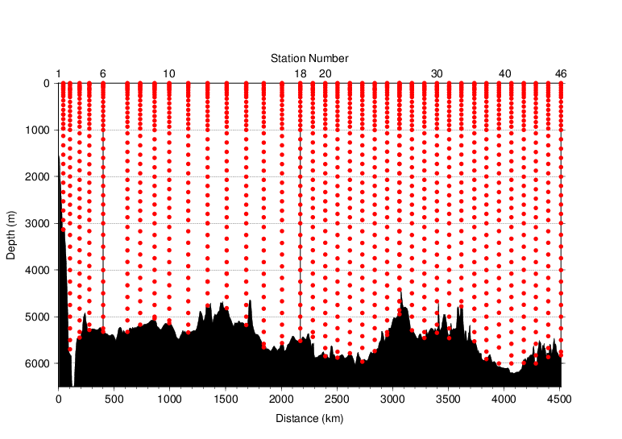
Figure C.6.2. Distance-depth distribution of sampling layers of DIC.

Instrument
The measurement of DIC was carried out with DIC/TA analyzers (Nihon ANS Co. Ltd, Japan). We used two analyzers concurrently. These analyzers are designated as apparatus A and B.

Sampling and measurement
Methods of seawater sampling, poisoning, measurement, and calculation of DIC concentrations were based on the Standard Operating Procedure (SOP) described in PICES Special Publication 3, SOP-2 (Dickson et al., 2007). DIC was determined by coulometric analysis (Johnson et al., 1985, 1987) using an automated CO₂ extraction unit and a coulometer. Details of sampling and measurement are shown in Appendix A1.

Calibration
The concentration of DIC (C_{T}) in moles per kilogram (mol kg⁻¹) of seawater was calculated from the following equation:
$C_{T}=N_{S}/ (cV ρ_{S})$ (C6.1)
where N_{S} is the counts of the coulometer (gC), cV is the calibration factor (gC (mol L⁻¹)⁻¹), and ρ_{S} is density of seawater (kg L⁻¹), which is calculated from the salinity of the sample and the water temperature of the water-jacket for the sample pipette.
The values of cV were determined by measurements of Certified Reference Materials (CRMs) that were provided by Dr. Andrew G. Dickson of the Scripps Institution of Oceanography. Table C.6.1 provides information about the CRM batches used in this cruise.
Table C.6.1. Certified C_{T} and standard deviation of CRM. Unit of C_{T} is μmol kg⁻¹. More information is available at the NOAA web site (https://www.ncei.noaa.gov/access/ocean-carbon-acidification-data-system/oceans/Dickson_CRM/batches.html).
Batch number | 160
C_{T} | 2030.39±0.36
Salinity | 33.414

The CRM measurement was carried out at every station. After the cruise, a value of cV was assigned to each apparatus (A, B). Table C.6.2 summarizes the cV values. Figure C.6.3 shows details.

Table C.6.2. Assigned cV and its standard deviation for each apparatus during the cruise. Unit is gC (mol L⁻¹)⁻¹.
Apparatus |  | cV
A | Leg 1 | 0.191105±0.000355 (N=53)
 | Leg 2 | 0.191011±0.000227 (N=27)
B | Leg 1 | 0.197065±0.000269 (N=49)
 | Leg 2 | 0.197229±0.000185 (N=27)

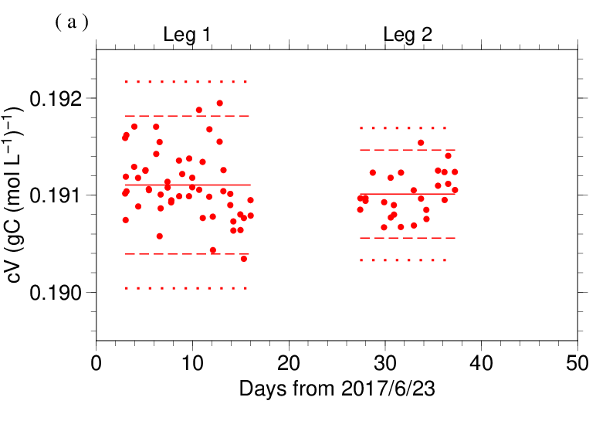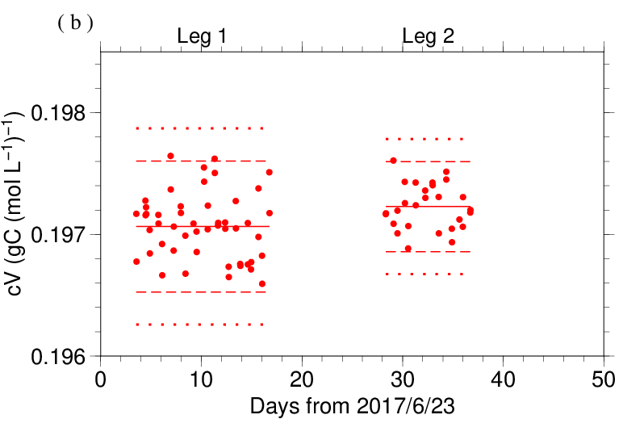
Figure C.6.3. Results of the cV at each station assigned for apparatus (a) A and (b) B. The solid, dashed, and dotted lines denote the mean, the mean ± twice the S.D., and the mean ± thrice the S.D. for all measurements, respectively.

The precisions of the cV is equated to its coefficient of variation (= S.D. / mean). They were 0.186 % for apparatus A in Leg 1, 0.119 % for apparatus A in Leg 2, 0.137 % for apparatus B in Leg 1 and 0.094 % for apparatus B in Leg 2. They correspond to 3.77 μmol kg⁻¹, 2.41 μmol kg⁻¹, 2.77 μmol kg⁻¹ and 1.90 μmol kg⁻¹ in C_{T} of CRM batch 160, respectively.
Finally, the value of C_{T} was multiplied by 1.00067 (= 300.2 / 300.0) to correct dilution effect induced by addition of 0.2 mL of mercury (II) chloride (HgCl₂) solution in a sampling bottle with a volume of ~300 mL.

Quality Control

(6.1) Replicate and duplicate analyses
We took replicate (pair of water samples taken from a single Niskin bottle) and duplicate (pair of water samples taken from different Niskin bottles closed at the same depth) samples of DIC throughout the cruise. Table C.6.3 summarizes the results of the measurements with each apparatus. Figures C.6.4–C.6.5 show details of the results. The calculation of the standard deviation from the difference of sets of measurements was based on a procedure (SOP 23) in DOE (1994).

Table C.6.3. Summary of replicate and duplicate measurements. Unit is μmol kg⁻¹.
 | Apparatus A | Apparatus B
Measurement | Average magnitude of difference ± S.D.
Replicate | 3.5±3.0 (N=47) | 2.1±1.9 (N=56)
Duplicate | 1.7±1.4 (N=4) | 1.7±1.3 (N=4)

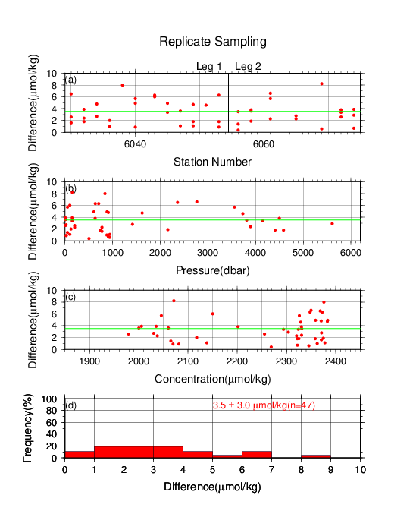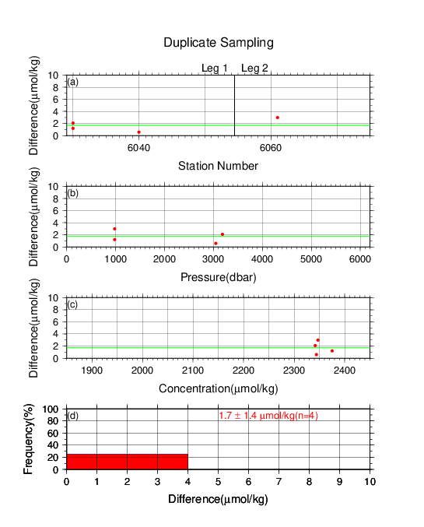
Figure C.6.4. Results of (left) replicate and (right) duplicate measurements during the cruise versus (a) station number, (b) pressure, and (c) C_{T} determined by apparatus A. The green lines denote the averages of the measurements. The bottom panels (d) show histograms of the measurements.

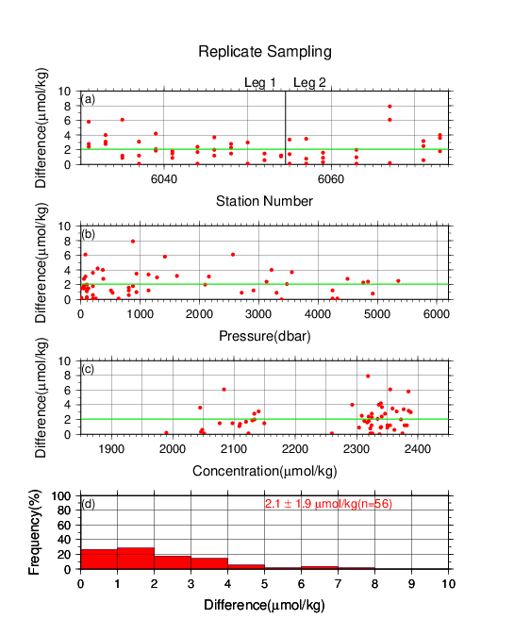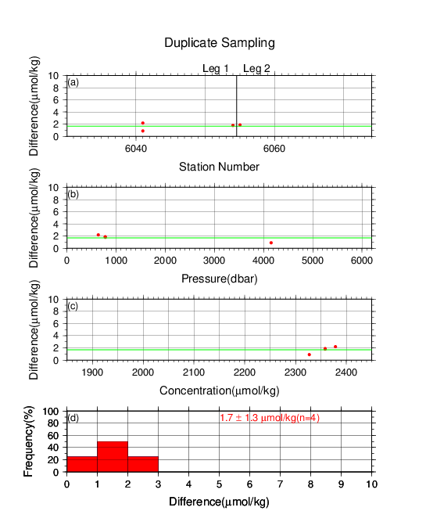
Figure C.6.5. Same as Figure C.6.4, but for apparatus B.

(6.2) Measurements of CRM and working reference materials
The precision of the measurements was monitored by using the CRMs and working reference materials bottled in our laboratory (Appendix A2). The CRM (batch 160) and working reference material measurements were carried out at every station. At the beginning of the measurement of each station, we measured a working reference material and a CRM. If the results of these measurements were confirmed to be good, measurements on seawater samples were begun. At the end of a sequence of measurements at a station, another CRM bottle was measured. A CRM measurement was repeated twice from the same bottle. Table C.6.4 summarizes the differences in the repeated measurements of the CRMs, the mean C_{T} of the CRM measurements, and the mean C_{T} of the working reference material measurements. Figures C.6.6–C.6.8 show detailed results.

Table C.6.4. Summary of difference and mean of C_{T} in the repeated measurements of CRM and the mean C_{T} of the working reference material. These data are based on good measurements. Unit is μmol kg⁻¹.
 | CRM |  | Working reference material
Apparatus | Average magnitude of  difference ± S.D. | Mean  Ave. ± S.D. | Mean  Ave. ± S.D.
A | 3.3±2.9 (N=39) | 2030.3±2.7 (N=39) | 2077.9±3.1 (N=20)
B | 1.8±1.5 (N=37) | 2030.4±2.3 (N=37) | 2077.6±2.2 (N=20)
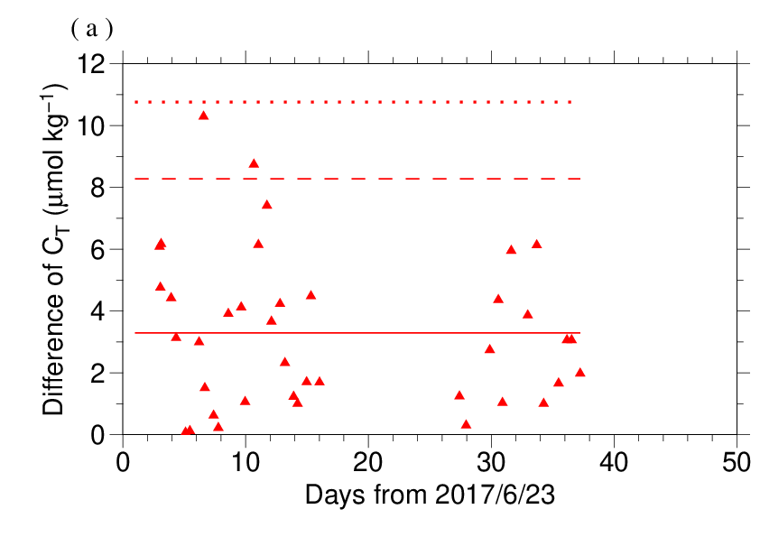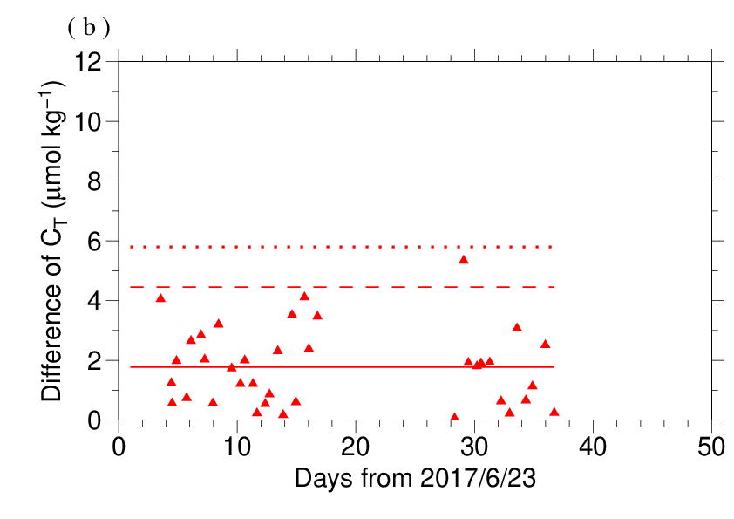
Figure C.6.6. The absolute difference (R) of C_{T} in repeated measurements of CRM determined by apparatus (a) A and (b) B. The solid line indicates the average of R ($\overline{R}$). The dashed and dotted lines denote the upper warning limit (2.512$\overline{R}$) and upper control limit (3.267$\overline{R}$), respectively (see Dickson et al., 2007).

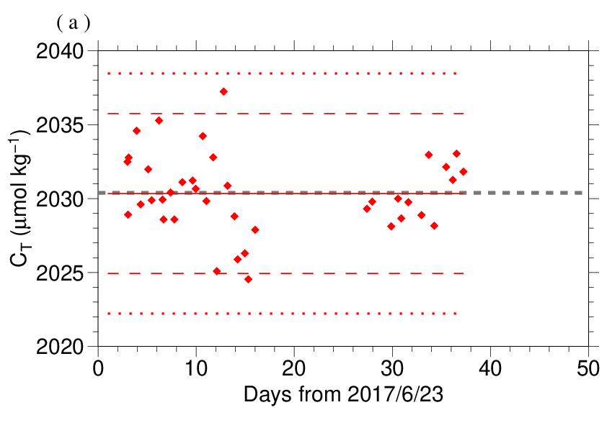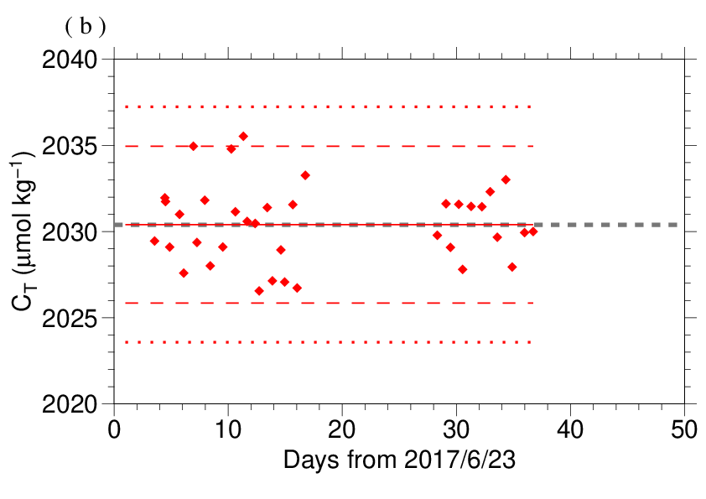
Figure C.6.7. The mean C_{T} of measurements of CRM. The panels show the results for apparatus (a) A and (b) B. The solid line indicates the mean of the measurements throughout the cruise. The dashed and dotted lines denote the upper/lower warning limit (mean ± 2S.D.) and the upper/lower control limit (mean ± 3S.D.), respectively. The gray dashed line denotes certified C_{T} of CRM.

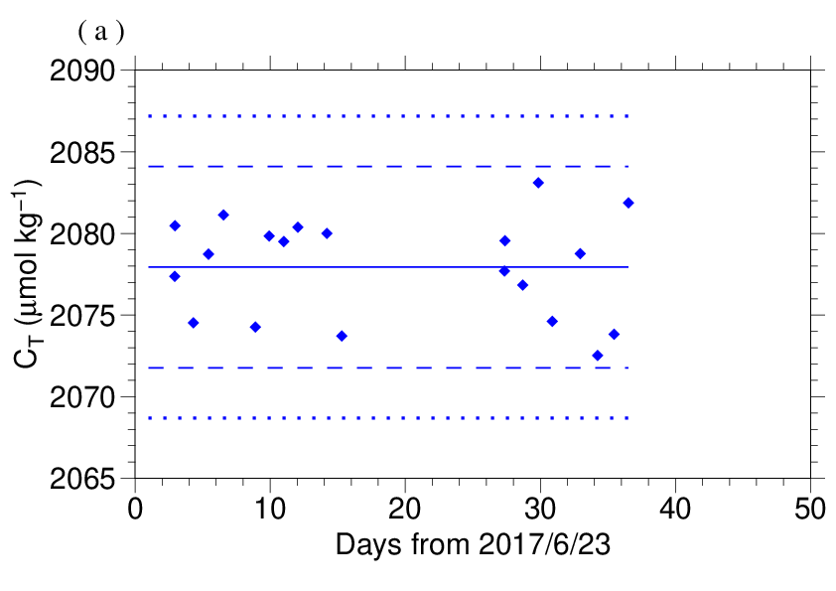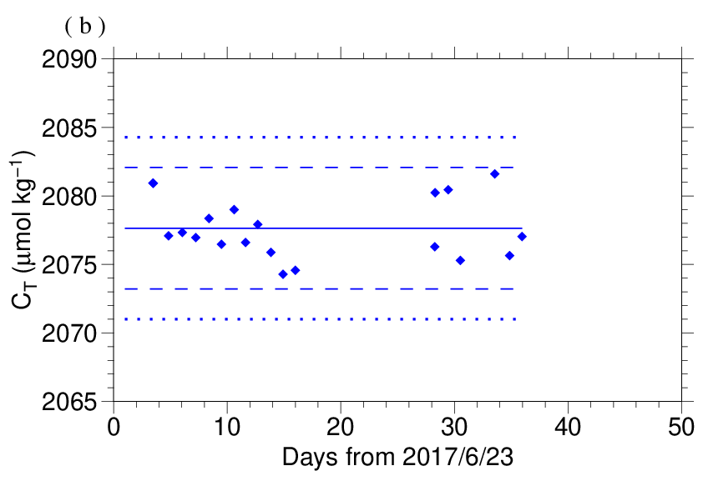
Figure C.6.8. Calculated C_{T} of working reference material measured by apparatus (a) A and (b) B. The solid, dashed and dotted lines are the same as in Figure C.6.7.

(6.3) Comparisons with other CRM batches
At every few stations, other CRM batches (155 and 157) were measured to provide comparisons with batch 160 to confirm the determination of C_{T} in our measurements. For these CRM measurements, C_{T} was calculated from the cV determined from batch 160 measurement. Figures C.6.9 show the differences between the calculated and certified C_{T}.

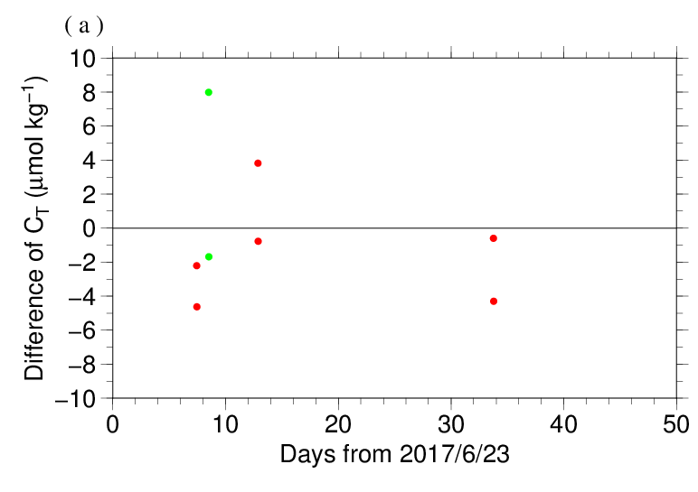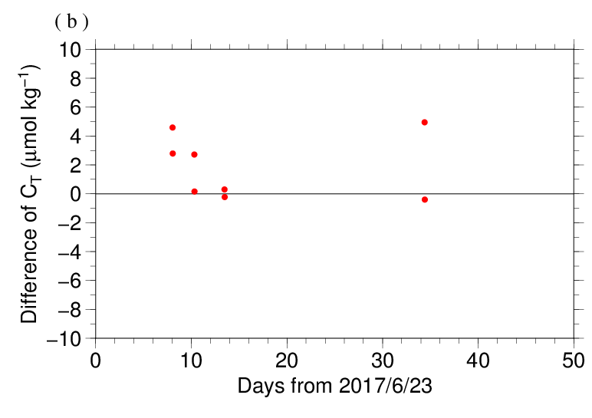
Figure C.6.9. The differences between the calculated C_{T} from batch 160 measurements and the certified C_{T}. The panels show the results for apparatus (a) A and (b) B. Colors indicate CRM batches; red: 155 and green: 157

(6.4) Quality control flag assignment
A quality control flag value was assigned to the DIC measurements (Table C.6.5) using the code defined in the IOCCP Report No.14 (Swift, 2010).

Table C.6.5. Summary of assigned quality control flags.
Flag | Definition | Number of samples
2 | Good | 1256
3 | Questionable | 38
4 | Bad (Faulty) | 4
5 | Not reported | 0
6 | Replicate measurements | 103
Total number of samples |  | 1401

Appendix
A1. Methods
(A1.1) Seawater sampling
Seawater samples were collected from 10-liters Niskin bottles mounted on CTD-system and a stainless steel bucket for the surface. Samples for DIC/TA were transferred to Schott Duran® glass bottles (screw top) using sample drawing tubes. Bottles were filled smoothly from the bottom after overflowing double a volume while taking care of not entraining any bubbles, and lid temporarily with inner polyethylene cover and screw cap.
After all sampling finished, 2 mL of sample is removed from each bottle to make a headspace to allow thermal expansion, and then samples were poisoned with 0.2 mL of saturated HgCl₂ solution and covered tight again.

(A1.2) Measurement
The unit for DIC measurement in the coupled DIC/TA analyzer consists of a coulometer with a quartz coulometric titration cell, a CO₂ extraction unit and a reference gas injection unit. The CO₂ extraction unit, which is connected to a bottle of 20 % v/v phosphoric acid and a carrier N₂ gas supply, includes a sample pipette (approx. 12 mL) and a CO₂ extraction chamber, two thermoelectric cooling units and switching valves. The coulometric titration cell and the sample pipette are water-jacketed and are connected to a thermostated (25 °C) water bath. The automated procedures of DIC analysis in seawater were as follows (Ishii et al., 1998):
(a) Approximately 2 mL of 20 % v/v phosphoric acid was injected to an “extraction chamber”, i.e., a glass tube with a course glass frit placed near the bottom. Purified N₂ was then allowed to flow through the extraction chamber to purge CO₂ and other volatile acids dissolved in the phosphoric acid.
(b) A portion of sample seawater was delivered from the sample bottle into the sample pipette of CO₂ extraction unit by pressurizing the headspace in the sample bottle. After temperature of the pipette was recorded, the sample seawater was transferred into the extraction chamber and mixed with phosphoric acid to convert all carbonate species to CO₂ (aq).
(c) The acidified sample seawater was then stripped of CO₂ with a stream of purified N₂. After being dehumidified in a series of two thermoelectric cooling units, the evolved CO₂ in the N₂ stream was introduced into the carbon cathode solution in the coulometric titration cell and then CO₂ was electrically titrated.

A2. Working reference material recipe
The surface seawater in the western North Pacific was taken until at least a half year ago. Seawater was firstly filtered by membrane filter (0.45 μm-mesh) using magnetic pump and transfer into large tank. After first filtration finished, corrected seawater in the tank was processed in cycle filtration again for 3 hours and agitated in clean condition air for 6 hours. On the next day, agitated 5 minutes to remove small bubbles on the tank and transfer to Schott Duran® glass bottles as same method as samples (Appendix A1.1) except for overflowing a half of volume, not double. Created of headspace and poisoned with HgCl₂ was as same as samples, finally, sealed by ground glass stoppers lubricated with Apiezon® grease (L).

References
Dickson, A. G., C. L. Sabine, and J. R. Christian (Eds.) (2007), Guide to best practices for ocean CO₂ measurements. PICES Special Publication 3, 191 pp.
DOE (1994), Handbook of methods for the analysis of the various parameters of the carbon dioxide system in sea water; version 2. A. G. Dickson and C. Goyet (eds), ORNL/CDIAC-74.
Ishii, M., H. Y. Inoue, H. Matsueda, and E. Tanoue (1998), Close coupling between seasonal biological production and dynamics of dissolved inorganic carbon in the Indian Ocean sector and the western Pacific Ocean sector of the Antarctic Ocean, Deep Sea Res. Part I, 45, 1187–1209, doi:10.1016/S0967-0637(98)00010-7.
Johnson, K. M., A. E. King and J. McN. Sieburth (1985), Coulometric TCO2 analyses for marine studies; an introduction. Marine Chemistry, 16, 61–82.
Johnson, K. M., J. M. Sieburth, P. J. L. Williams and L. Brändström (1987), Coulometric total carbon dioxide analysis for marine studies: Automation and calibration. Marine Chemistry, 21, 117–133.
Swift, J. H. (2010): Reference-quality water sample data, Notes on acquisition, record keeping, and evaluation. IOCCP Report No.14, ICPO Pub. 134, 2010 ver.1.

