pH

30 September 2023

Personnel
HAMANA Minoru (RF18-05)
HORI Kasumi (RF18-05)
NAKAMURA Naoki (RF18-05)
AKAMATSU Mio (RF18-06)
MARUO Tetsuya (RF18-06)
TANIZAKI Chiho (RF18-06)

Station occupied
A total of 78 stations (RF18-05 Leg 1: 19, RF18-05 Leg 2: 11, RF18-06 Leg 1: 30, RF18-06 Leg 2: 18) were occupied for pH. Station location and sampling layers of them are shown in Figures C.8.1 and C.8.2, respectively.

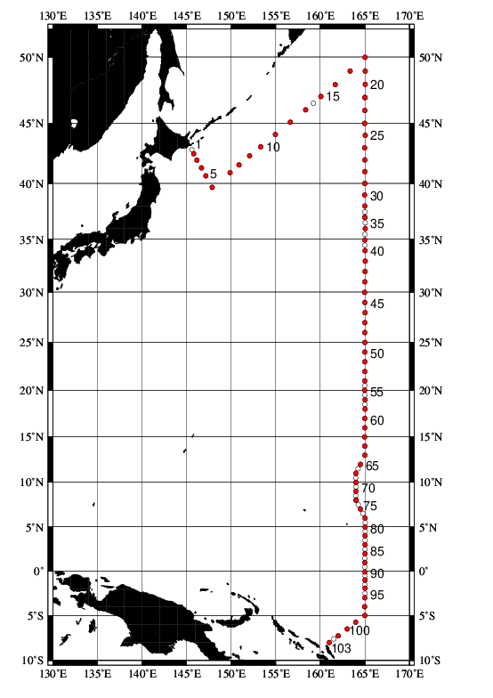
Figure C.8.1. Location of observation stations of pH. Closed and open circles indicate sampling and no-sampling stations, respectively.
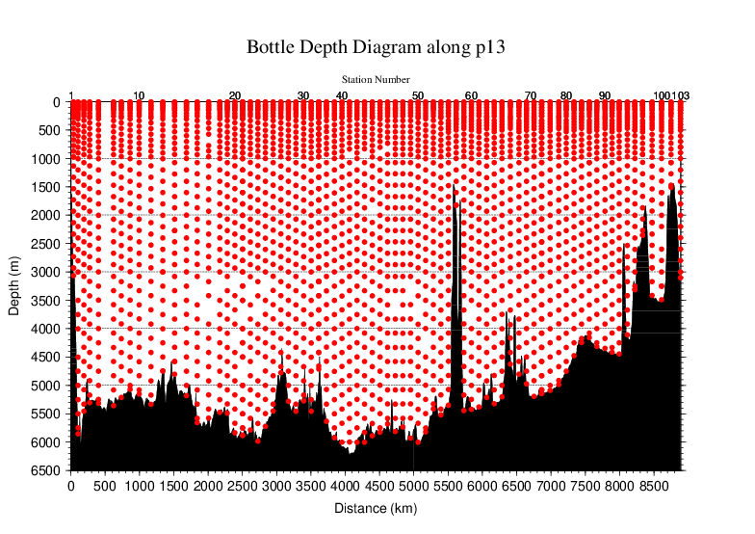
Figure C.8.2. Distance-depth distribution of sampling layers of pH.

Instrument
The measurement of pH was carried out with a pH analyzer (Nihon ANS Co. Ltd, Japan).

Sampling and measurement
Methods of seawater sampling, poisoning, spectrophotometric measurements using the indicator dye m-cresol purple (hereafter mCP) and calculation of pH_{T} (on the total hydrogen ion scale; Appendix A1) were based on Saito et al. (2008). The pH_{T} is calculated from absorbance ratio (R) with the following equations,
${pH}_{T}=pK_{2}+\log_{10}\left\{{\left(R-0.0069\right)}/{\left(2.222-0.1331 R\right)}\right\}$ (C8.1)
$R={\left(A_{578}^{SD}-A_{578}^{S}-A_{730}^{SD}+A_{730}^{S}\right)}/{\left(A_{434}^{SD}-A_{434}^{S}-A_{730}^{SD}+A_{730}^{S}\right)}$ (C8.2)
where pK₂ is the acid dissociation constant of mCP,
$pK_{2}={1245.69}/T+3.8322+0.00211 \left(35-S\right)$ (C8.3)
(293 K ≤ T ≤ 303 K, 30 ≤ S ≤ 37).
$A_{λ}^{S}$ and $A_{λ}^{SD}$ in equation (C8.2) are absorbance of seawater itself and dye plus seawater, respectively, at wavelength λ (nm). The value of pK₂ in equation (C8.3) is expressed as a function of temperature T (in Kelvin) and salinity S (in psu). Finally, pH_{T} is reported as the value at temperature of 25 °C. Details are shown in Appendix A1.

pH perturbation caused by addition of m-cresol purple solution
The mCP solution using as indicator dye was prepared in our laboratory (Appendix A2) and was subdivided into some bottles (mCP batches) that attached to the apparatus. The injection of mCP solution perturbs the sample pH_{T} slightly because the acid-base equilibrium of the seawater is disrupted by the addition of the dye acid-base pair (Dickson et al., 2007).
Before applying R to the equation (C8.1), the measured R in the sample was corrected to that value expected to be unperturbed by the addition of the dye (Dickson et al., 2007; Clayton and Byrne, 1993). The magnitude of the perturbation (ΔR) was calculated empirically from that by the second addition of the dye and absorbance ratio measurement as follows:
ΔR = R₂ − R₁, (C8.4)
where R₁ and R₂ are the absorbance ratio after the initial addition of dye solution in the sample measurement and after the second addition in the experimental measurement, respectively. Because the value of ΔR depends on the pH_{T} of sample, we expressed ΔR as a quadratic function of R₁ based on experimental ΔR measurement obtained at this cruise as follows:
$∆R=C_{2}{×R}_{1}^{2}+C_{1}×R_{1}+C_{0}$. (C8.5)
In each measurement for a station, ΔR was measured for about 10 samples from various depths to obtain wide range of R₁ and experimental ΔR data. For each mCP batch bottle, coefficients (C₀, C₁ and C₂) were calculated by equation (C8.5), and ΔR was evaluated for each R₁. The coefficients for each mCP batch are showed in Table C.8.1. The plots and function curves are illustrated in Figure C.8.3.

Table C.8.1. Summary of coefficients; C_{2,} C₁ and C₀ in $∆R=C_{2}{×R}_{1}^{2}+C_{1}×R_{1}+C_{0}$.
Stations | mCP batch | C₂ | C₁ | C₀
2–21 | 1 | −7.25669E−03 | −4.10134E−03 | 9.57174E−03
22–33 | 2 | −2.58107E−03 | −9.14504E−03 | 1.01108E−02
34–64 | 3 | −5.40236E−04 | −1.51472E−02 | 1.51998E−02
65–103 | 4 | 7.18411E−05 | −1.79396E−02 | 1.59564E−02

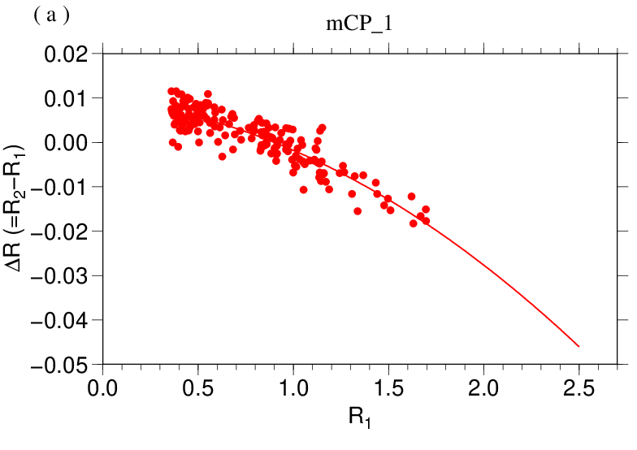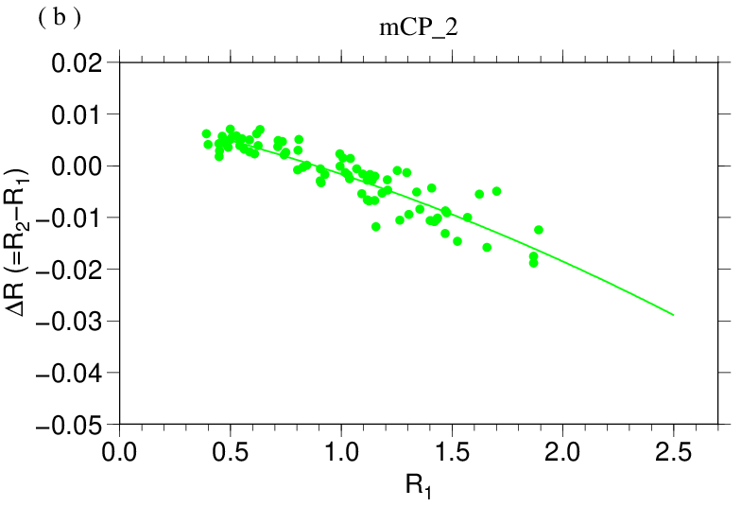
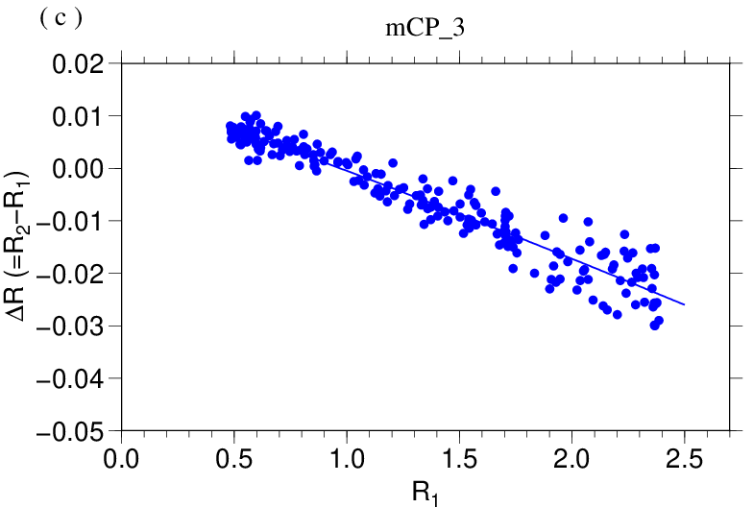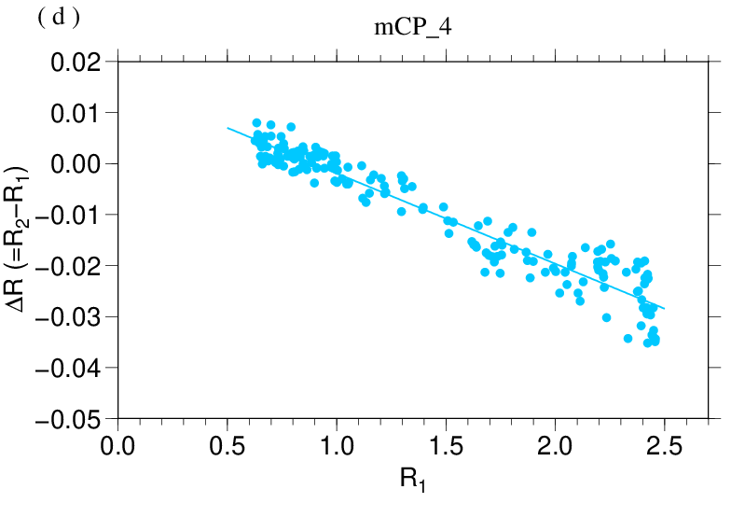
Figure C.8.3. The function curve of the ΔR (= R₂ − R₁) vs R₁ for (a) first, (b) second, (c) third and (d) fourth mCP batch of solution shown in Table C.8.1.

Quality Control
(6.1) Replicate and duplicate analyses
We took replicate (pair of water samples taken from a single Niskin bottle) and duplicate (pair of water samples taken from different Niskin bottles closed at the same depth) samples for pH_{T} determination throughout the cruise. Table C.8.2 summarizes the results of the measurements. Figure C.8.4 shows details of the results. The calculation of the standard deviation from the difference of sets of measurements was based on a procedure (SOP 23) in DOE (1994).

Table C.8.2. Summary of replicate and duplicate measurements of pH_{T}.
Measurement | Average magnitude of difference ± S.D.
Replicate | 0.0017±0.0015 (N=220)
Duplicate | 0.0018±0.0015 (N=30)

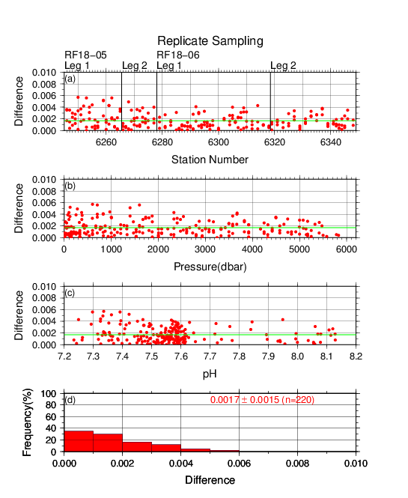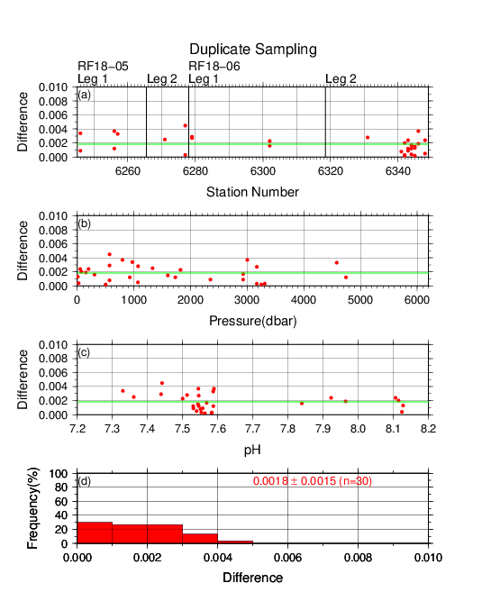
Figure C.8.4. Results of (left) replicate and (right) duplicate measurements during the cruise versus (a) station number, (b) pressure and (c) pH_{T}. The green lines denote the averages of the measurements. The bottom panels (d) show histograms of the measurements.

(6.2) Measurements of CRM and working reference materials
The precision of the measurements was monitored by using the CRMs and working reference materials bottled in our laboratory (Appendix A2 in C.6). Although the pH_{T} value of the CRM was not assigned, it could be calculated from certified parameters of DIC and TA (https://www.ncei.noaa.gov/access/ocean-carbon-acidification-data-system/oceans/Dickson_CRM/batches.html) based on the chemical equilibrium of the carbonate system (Lueker et al., 2000). The pH_{T} of the CRMs (batch 168 and 174) were calculated to be 7.7359 and 7.8002. Working reference material measurements were carried out first at every station. If the results of the measurements were confirmed to be good, measurements on seawater samples were begun. CRM (batch 168 in RF18-05 and 174 in RF18-06) measurements were done at every few (about 3) stations. The measurement for seawater sample and working reference material was made once for a single bottle, and that for CRM was made twice. Table C.8.3 summarizes the means of difference of pH_{T} between two measurements and pH_{T} values for a CRM bottle and the means of the pH_{T} value for a working reference material for each mCP batch. Figures C.8.5–C.8.7 show detailed results.

Table C.8.3. Summary of difference and means of the pH_{T} values for two measurements for a CRM bottle, and mean of pH_{T} for a working reference material, which was calculated with data with good measurements.
Cruise | mCP Batch | Magnitude of  difference  Ave. ± S.D.  (CRM) | Mean Ave. ± S.D.  (CRM) | Mean Ave. ± S.D.  (Working reference material)
RF18-05 | 1 | 0.0013±0.0010  (N=7) | 7.7309±0.0032  (N=7) | 7.9191±0.0023  (N=21)
 | 2 | 0.0017±0.0016  (N=2) | 7.7356±0.0050  (N=2) | 7.9213±0.0029  (N=13)
RF18-06 | 3 | 0.0013±0.0011  (N=9) | 7.7985±0.0020  (N=9) | 7.9182±0.0013  (N=23)
 | 4 | 0.0020±0.0016  (N=9) | 7.7998±0.0019  (N=9) | 7.9190±0.0013  (N=26)

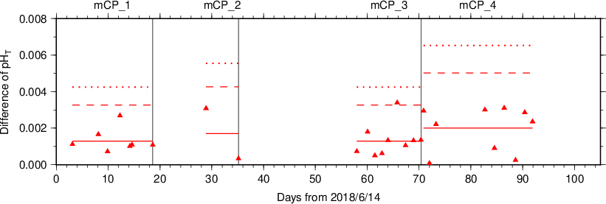
Figure C.8.5. The absolute difference (R) of pH_{T} between two measurements of a CRM bottle. The mCP batch names are shown above the graph, and vertical lines denote the day mCP batches were changed. The solid, dashed and dotted lines denote the average range ($\overline{R}$), upper warning limit (2.512$\overline{R}$) and upper control limit (3.267$\overline{R}$) for each mCP batch bottle, respectively (see Dickson et al., 2007).

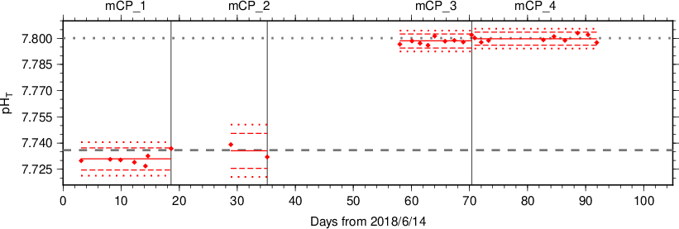
Figure C.8.6. The mean of pH_{T} values between two measurements of a CRM bottle. The mCP batch names are shown above the graph, and vertical lines denote the day when the mCP batch was changed. The solid, dashed, and dotted lines denote the mean of measurements, upper/lower warning limit (mean ± 2S.D.), and upper/lower control limit (mean ± 3S.D.) for each mCP batch bottle, respectively (see Dickson et al., 2007). The gray dashed and dotted lines denote pH_{T} of CRM batch 168 and 174 calculated from certified parameters.

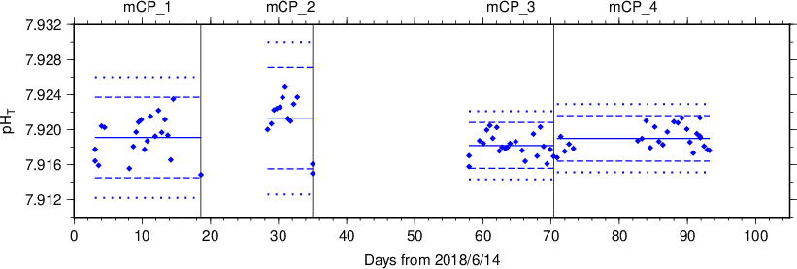
Figure C.8.7. Same as C.8.6, but for working reference material.

(6.3) Quality control flag assignment
A quality control flag value was assigned to the pH measurements (Table C.8.4) using the code defined in the IOCCP Report No.14 (Swift, 2010).

Table C.8.4. Summary of assigned quality control flags.
Flag | Definition | Number of samples
2 | Good | 2575
3 | Questionable | 7
4 | Bad (Faulty) | 2
5 | Not reported | 0
6 | Replicate measurements | 220
Total number of samples |  | 2804

(6.4) Comparison at cross-stations during the cruise
There were cross-stations during the cruise located at 47˚N/165˚E (in RF18-05), 37˚N/165˚E (in RF18-05 and RF18-06) and 8˚N/164˚E (in RF18-06). At these points, hydrocast sampling for pH_{T} was conducted two times at interval of 14 days (Stns.21 and 22), 25 days (Stns.33 and 34) and 9 days (Stns.73 and 74). These profiles are shown in Figure C.8.8.

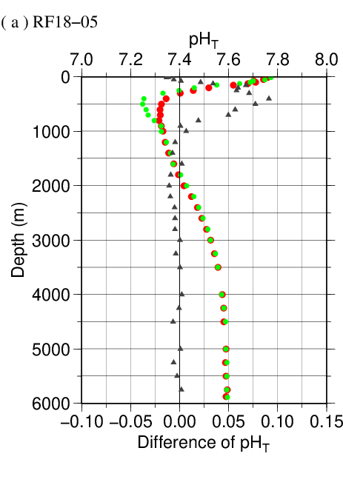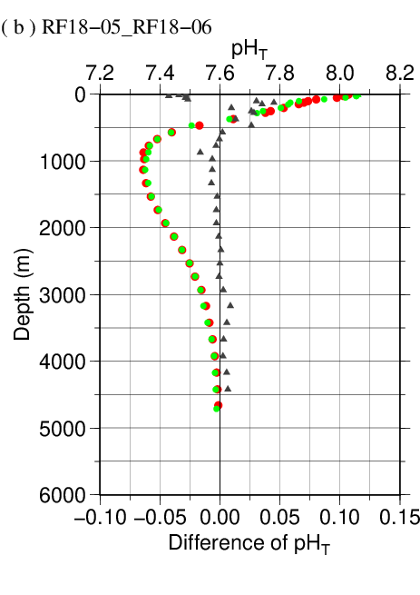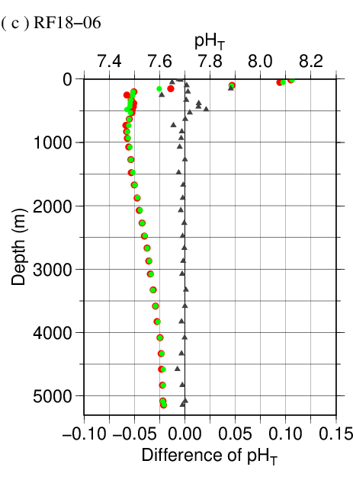
Figure C.8.8. Comparison of pH_{T} observed at same location in different legs of the cruise: (a) 47˚N/165˚E (in RF18-05), (b) 37˚N/165˚E (in RF18-05 and RF18-06) and (c) 8˚N/164˚E (in RF18-06). The red and green circles denote former (Stns.21, 33, and 73) and latter (Stns.22, 34, and 74) stations, respectively. Triangles denote the difference in pH_{T} measured at same depth in different legs.

(6.5) Comparison at cross-stations of WHP cruises
We compared pH_{T} data of this cruise and other WHP cruises by JMA, Japan Agency for Marine-Earth Science and Technology (JAMSTEC) and Scripps Institution of Oceanography (SIO) at cross points. Summary of the comparisons are shown in Figure C.8.9(a) for cross point with WHP-P4 line (around 9˚N/164˚E), Figure C.8.9(b) for cross point with WHP-P3 line (around 24˚N/165˚E), Figure C.8.9(c) for cross point with WHP-P2 line (around 30˚N/165˚E), Figure C.8.9(d) for cross point with WHP-40N line (around 40˚N/165˚E) and Figure C.8.9(e) for cross point with WHP-P1 line (around 47˚N/160˚E). Data of other cruises are downloaded from the CCHDO web site (https://cchdo.ucsd.edu).

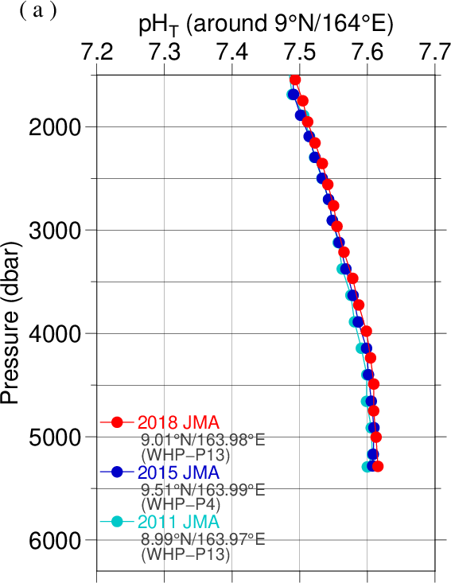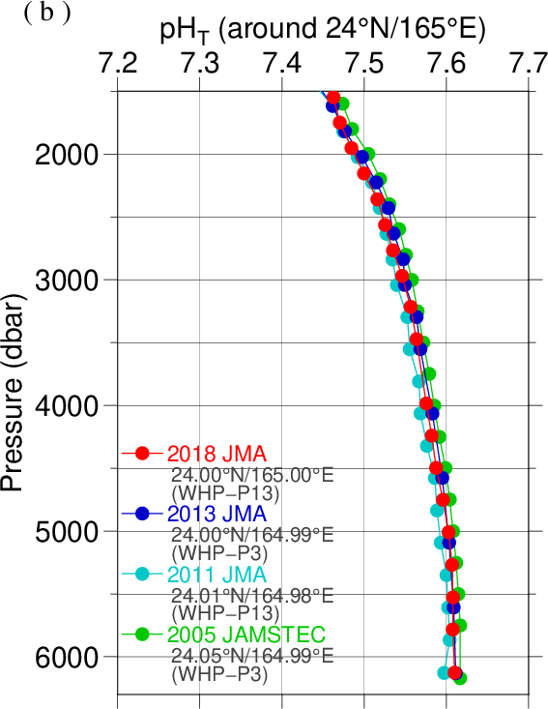
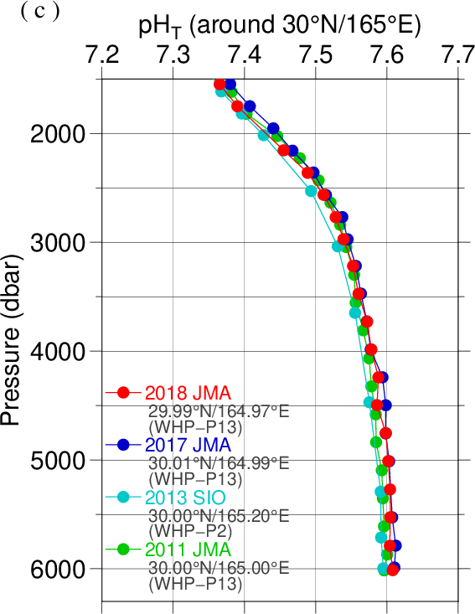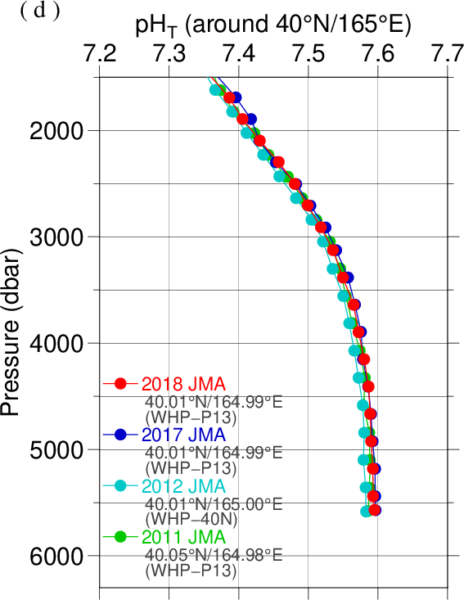

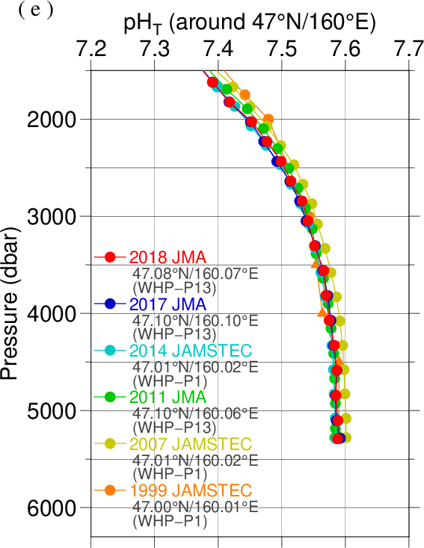
Figure C.8.9. Comparison of pH_{T} profiles at (a) 9˚N/165˚E (cross point with WHP-P4 line), (b) 24˚N/165˚E (cross point with WHP-P3 line), (c) 30˚N/165˚E (cross point with WHP-P2 line), (d) 40˚N/165˚E (cross point with WHP-40N line) and (e) 47˚N/160˚E (cross point with WHP-P1 line). Circles and triangles denote good and questionable values, respectively. The red ones show this cruise.

Appendix
A1. Methods
(A1.1) Seawater sampling
Seawater samples were collected from 10-liters Niskin bottles mounted on CTD-system and a stainless steel bucket for the surface. Samples for pH were transferred to Schott Duran® glass bottles using sample drawing tubes. Bottles were filled smoothly from the bottom after overflowing double a volume while taking care of not entraining any bubbles, and lid temporarily with ground glass stoppers.
After all sampling finished, 2 mL of sample is removed from each bottle to make a headspace to allow thermal expansion. Although the procedure is differed from Standard Operating Procedure (SOP) described in PICES Special Publication 3, SOP-2 (Dickson, 2007), poisoned with 0.2 mL of saturated HgCl₂ solution to prevent change in pH_{T} caused by biological activity. Finally, samples were sealed with ground glass stoppers lubricated with Apiezon® grease (L).

(A1.2) Measurement
Custom-made pH analyzer (2009 model; Nihon ANS) was prepared and operated in the cruise. The analyzer comprised of a sample dispensing unit, a pre-treatment unit combined with an automated syringe, and two (sample and reference) spectrophotometers combined with a high power xenon light source. Spectrophotometric cell was made of quartz tube that has figure of “U”. This cell was covered with stainless bellows tube to keep the external surface dry and for total light to reflect in the tube. The temperature of the cell was regulated to 25.0 ± 0.1 °C by means of immersing the cell into the thermostat bath, where the both ends of bellows tube located above the water surface of the bath. Spectrophotometer, cell and light source were connected with optical fiber.
The analysis procedure was as follows:
a) Seawater was ejected from a sample loop.
b) A portion of sample was introduced into a sample loop including spectrophotometric cell. The spectrophotometric cell was flushed two times with sample in order to remove air bubbles.
c) An absorption spectrum of seawater in the visible light range was measured. Absorbance at wavelengths of 434 nm, 488 nm, 578 nm and 730 nm as well as cell temperature were recorded. To eject air bubbles from the cell, the sample was moved four times and the absorbance was recorded at each stop.
d) 10 μl of indicator mCP was injected to the loop.
e) Circulating 2 minutes 40 seconds through the loop tube, seawater sample and indicator dye was mixed together.
f) Absorbance of mCP plus seawater was measured in the same way described above (c).

(A1.3) Calculation
In order to state clearly the scale of pH, we mention “pH_{T}” that is defined by equation (C8.A1.3.1),
${pH}_{T}=-\log_{10}\left({{[H^{+}]}_{T}}/{C^{0}}\right)$ (C8.A1.3.1)
where [H⁺]_{T} denotes the concentration of hydrogen ion expressed in the total hydrogen ion scale. ${[H^{+}]}_{T}={[H^{+}]}_{F}\left(1+{{[{SO}_{4}]}_{T}}/{K_{{HSO}_{4}^{-}}}\right)$, where [H⁺]_{F} is the concentration of free hydrogen ion, [SO₄]_{T} is the total concentration of sulphate ion and $K_{{HSO}_{4}^{-}}$ is acid dissociation constant of hydrogen sulphate ion (Dickson, 1990). C⁰ is the standard value of concentration (1 mole per kilogram of seawater, mol kg⁻¹). The pH_{T} was reported as the value at temperature of 25 °C in “total hydrogen ion scale”.

pH_{T} was calculated from the measured absorbance (A) based on the following equations (C8.A1.3.2) and (C8.A1.3.3), which are the same as (C8.1) and (C8.2), respectively.
$${pH}_{T}=pK_{2}+\log_{10}\left({[I^{2-}]}/{[{HI}^{-}]}\right)$$
$=pK_{2}+\log_{10}\left\{{\left(R-0.0069\right)}/{\left(2.222-0.1331 R\right)}\right\}$ (C8.A1.3.2)
$R={\left(A_{578}^{SD}-A_{578}^{S}-A_{730}^{SD}+A_{730}^{S}\right)}/{\left(A_{434}^{SD}-A_{434}^{S}-A_{730}^{SD}+A_{730}^{S}\right)}$ (C8.A1.3.3)
where pK₂ is the acid dissociation constant of mCP. [I²⁻] / [HI⁻] is the ratio of mCP base form (I²⁻) concentration over acid form (HI⁻) concentration which is calculated from the corrected absorbance ratio (R) shown in the section 8(5) and the ratios of extinction coefficients (Clayton and Byrne, 1993). $A_{λ}^{S}$ and $A_{λ}^{SD}$ in equation (C8.A1.3.3) are absorbance of seawater itself and dye plus seawater, respectively, at wavelength λ (nm). The value of pK₂ (${=-log}_{10}\left({K_{2}}/{k^{0}}\right)$, k⁰ = 1 mol kg⁻¹) had also been expressed as a function of temperature T (in Kelvin) and salinity S (in psu) by Clayton and Byrne (1993), but the calculated value has been subsequently corrected by 0.0047 on the basis of a reported pH_{T} value accounting for “tris” buffer (DelValls and Dickson, 1998):

$$pK_{2}=pK_{2}\left(Clayton \& Byrne, 1993\right)+0.0047$$
$={1245.69}/T+3.8322+0.00211 \left(35-S\right)$. (C8.A1.3.4)
(293 K ≤ T ≤ 303 K, 30 ≤ S ≤ 37)
Finally, pH_{T} determined at a temperature t (pH_{T}(t), with t in °C) was corrected to the pH_{T} at 25.00 °C (pH_{T}(25)) with the following equation (Saito et al., 2008).
$${(pH}_{T}\left(t\right)-{pH}_{T}(25))/(t-25.00)$$
$=(2.00170-0.735594 {pH}_{T}\left(25\right)+{0.0896112 {pH}_{T}\left(25\right)}^{2}-{0.00364656 {pH}_{T}\left(25\right)}^{3})$.
(C8.A1.3.5)
A2. pH indicator
Indicator m-cresol purple (mCP) solution
Add 0.67 g mCP to 500 mL deionized water (DW) in a borosilicate glass flask. Pour DW slowly into flask to weight of 1 kg (mCP + DW), and mix well to dissolve mCP. Regulate the pH (free hydrogen ion scale) of indicator solution to 7.9±0.1 by small amount of diluted NaOH solution (approx. 0.25 mol L⁻¹) if the pH was out of the range. The pH of indicator solution was monitored using glass electrode pH meter. The reagent had not been refining.

References
Clayton T.D. and R.H. Byrne 1993. Spectrophotometric seawater pH measurements: total hydrogen ion concentration scale calibration of m-cresol purple and at-sea results. Deep-Sea Res. I, 40, 2115–2129.
DelValls, T. A and A. G. Dickson, 1998. The pH of buffers based on 2-amino-2-hydroxymethyl-1,3-propanediol (‘tris’) in synthetic sea water. Deep-Sea Res. I, 45, 1541-1554.
Dickson, A.G. 1990. Standard potential of the reaction: AgCl(s) + 1/2 H2(g) = Ag(s) + HCl(aq), and the standard acidity constant of the ion HSO₄⁻ in synthetic sea water from 273.15 to 318.15 K. J. Chem. Thermodynamics, 22, 113–127.
Dickson, A.G., Sabine, C.L. and Christian, J.R. (Eds.) 2007. Guide to best practices for ocean CO₂ measurements. PICES Special Publication 3, 191 pp.
Lueker, T.J, A.G. Dickson and C.D. Keeling, 2000. Ocean pCO₂ calculated from dissolved inorganic carbon, alkalinity, and equations for K₁ and K₂: validation based on laboratory measurements of CO₂ in gas and seawater at equilibrium. Marine Chem., 70, 105-119.
Saito, S., M. Ishii, T. Midorikawa and H.Y. Inoue 2008. Precise Spectrophotometric Measurement of Seawater pH_{T} with an Automated Apparatus using a Flow Cell in a Closed Circuit. Technical Reports of Meteorological Research Institute, 57, 1–28.
Swift, J. H. (2010): Reference-quality water sample data, Notes on acquisition, record keeping, and evaluation. IOCCP Report No.14, ICPO Pub. 134, 2010 ver.1

