## Bottle Oxygen

*Updated 1 September 2023*

### Personnel

Chihiro KAWAMURA (GEMD/JMA)

Atsushi KOJIMA (GEMD/JMA)

Misaki YAKAWA (GEMD/JMA)

### Station occupied

A total of 66 stations (Leg 1: 31, Leg 2: 35) were occupied for dissolved oxygen measurements. Station location and sampling layers of bottle oxygen are shown in Figures C.3.1 and C.3.2, respectively.

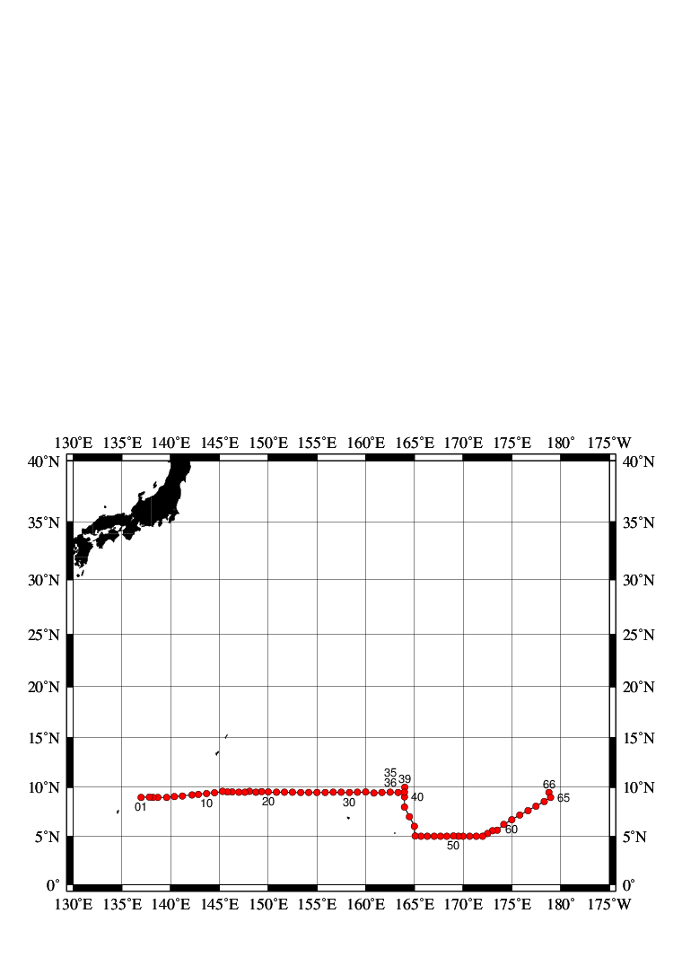

Figure C.3.1. Location of observation stations of bottle oxygen. Closed and open circles indicate sampling and no-sampling stations, respectively.

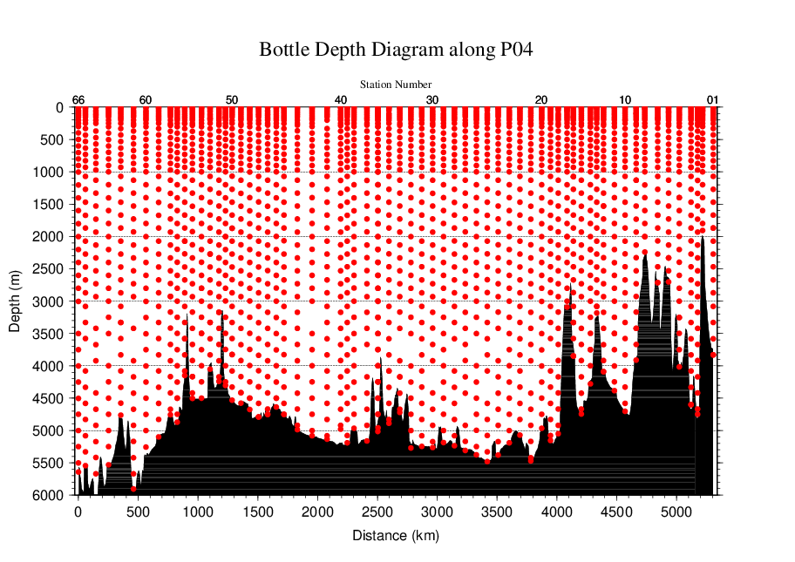

Figure C.3.2. Distance-depth distribution of sampling layers of bottle oxygen.

### Instrument

Detector: DOT-01X (Kimoto Electronic, Japan)

Burette: APB-510 (Kyoto Electronic, Japan)

### Sampling and measurement

Methods of seawater sampling, measurement, and calculation of dissolved oxygen concentration were based on IOCCP Report (Langdon, 2010). Details of the methods are shown in Appendix A1.

The reagents for the measurement were prepared according to recipes described in Appendix A2. It is noted that standard KIO3 solutions were prepared gravimetrically using the highest purity standard substance KIO3 (Lot. No. TLG0272, Wako Pure Chemical, Japan). Batch list of prepared standard KIO3 solutions is shown in Table C.3.1.

Table C.3.1. Batch list of the standard KIO3 solutions.

|  |  |  |
| --- | --- | --- |
| **KIO3 batch** | **Concentration and uncertainty (k=2) at 20 °C. Unit is normality (N).** | **Purpose of use** |
| 20150501-2 | 0.010003±0.000004 | Standardization (main use) |
| 20150611-2 | 0.010000±0.000004 | Mutual comparison |

### Standardization

Concentration of Na2S2O3 titrant was determined with the standard KIO3 solution “20150501-2”, based on the methods of IOCCP Report (Langdon, 2010). The results of standardization during the cruise are shown in Figure C.3.3. Standard deviation of its concentration at 20 °C determined through standardization was used in calculation of an uncertainty.

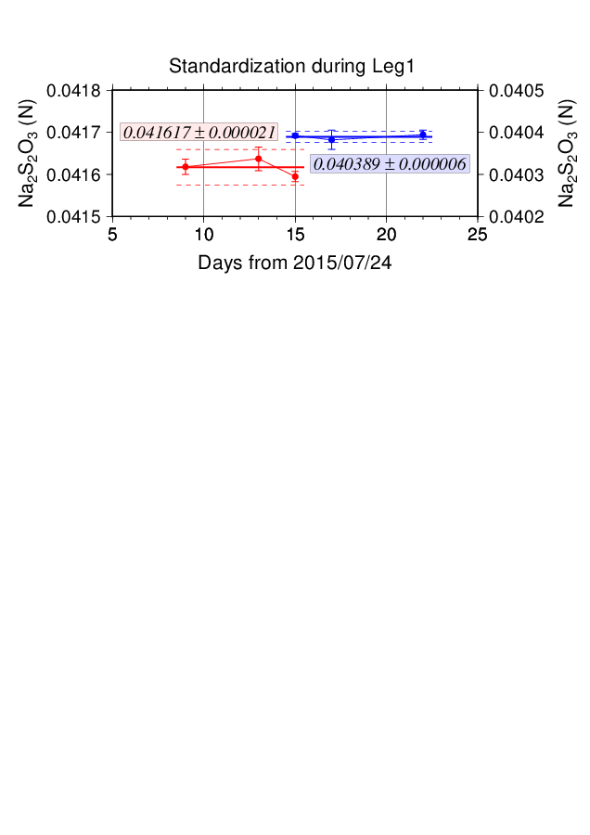

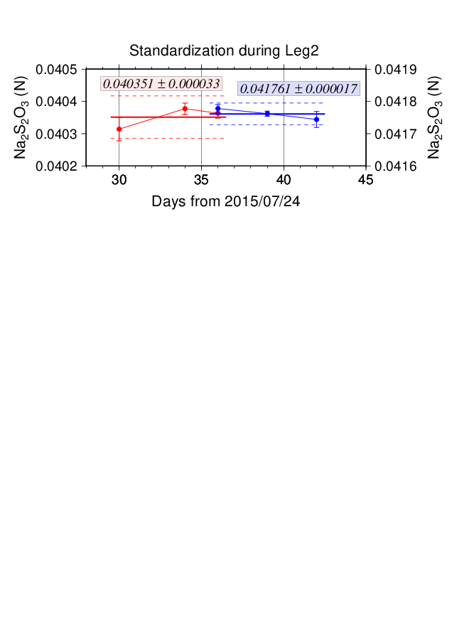

Figure C.3.3. Calculated concentration of Na2S2O3 solution at 20 °C in standardization during Leg 1 (top) and Leg 2 (bottom). Different colors of plots indicate different batches of Na2S2O3 solution; red (blue) plots correspond to the left (right) y-axis. Error bars of plots show standard deviation of concentration of Na2S2O3 in the measurement. Thick and dashed lines denote the mean and 2 times of standard deviations for the batch measurements, respectively.

### Blank

#### (6.1) Reagent blank

Blank in oxygen measurement (reagent blank; Vblk, dw) can be represented as follows;

Vblk, dw = Vblk, ep + Vblk, reg (C3.1)

where Vblk, ep represents a blank due to differences between the measured end-point and the equivalence point, and Vblk, reg a blank associated with oxidants or reductants in the reagent. The reagent blank Vblk, dw was determined by the methods described in IOCCP Report (Langdon, 2010). Because we used two sets (set A and B) of pickling reagent-I and -II, the blanks in each set were determined (Figure C.3.4).

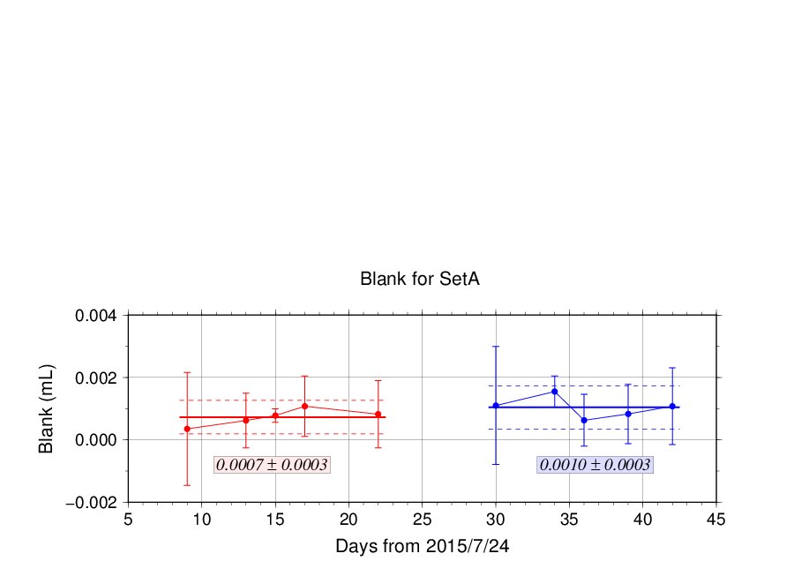

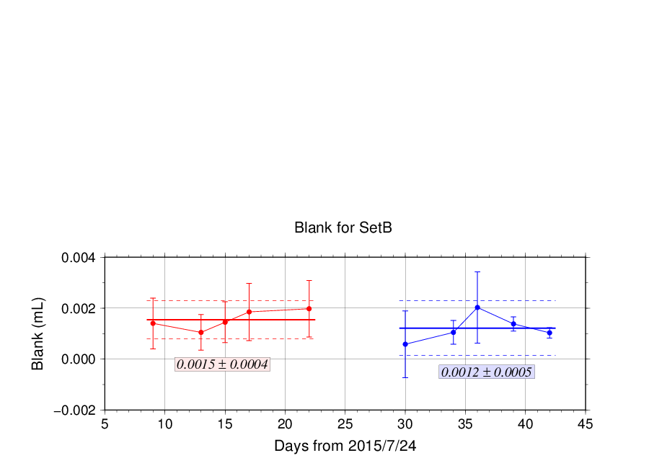

Figure C.3.4. Reagent blank (Vblk, dw) determination for set A (top) and set B (bottom). Error bars of plots show standard deviation of the measurement. Thick and dashed lines denote the mean and 2 times of standard deviations for the batch measurement, respectively.

#### (6.2) Other blanks

We also determined two other blanks related to oxygen measurement; the blank Vblk, reg and the seawater blank (Vblk, sw). Details are described in Appendix A3.

### Quality Control

#### (7.1) Replicate and duplicate analyses

We took replicate (pair of water samples taken from a single Niskin bottle) and duplicate (pair of water samples taken from different Niskin bottles closed at the same depth) samples of dissolved oxygen through the cruise. Results of the analyses are summarized in Table C.3.2. Detailed results of them are shown in Figure C.3.5. The calculation of the standard deviation from the difference of sets was based on a procedure (SOP 23) in DOE (1994).

Table C.3.2. Summary of replicate and duplicate measurements.

|  |  |
| --- | --- |
| **Measurement** | **Ave. ± S.D. (mol kg−1)** |
| Replicate | 0.16±0.15 (N=251) |
| Duplicate | 0.21±0.19 (N=71) |

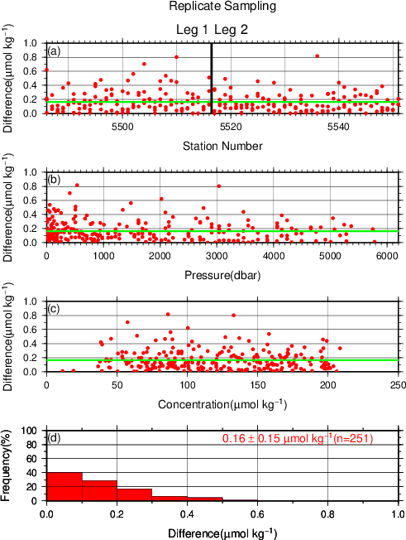 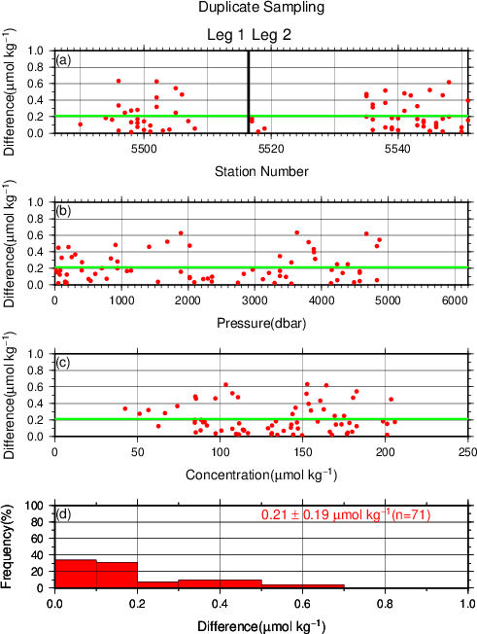

Figure C.3.5. Results of (left) replicate and (right) duplicate measurements during the cruise against (a) station number, (b) pressure and (c) concentration of dissolved oxygen. Green line denotes the average of the measurements. Bottom panels (d) show histogram of the measurements.

#### (7.2) Mutual comparison between each standard KIO3 solution

During the cruise, mutual comparison between different lots of standard KIO3 solution was performed to confirm the accuracy of our oxygen measurement and the bias of a standard KIO3 solution. A concentration of the standard KIO3 solution “20150501-2” was determined using Na2S2O3 solution standardized with the KIO3 solution “20150611-2”, and the difference between measurement value and theoretical one. A good agreement among two standards confirmed that there was no systematic shift in our oxygen measurements during the cruise (Figure C.3.6).

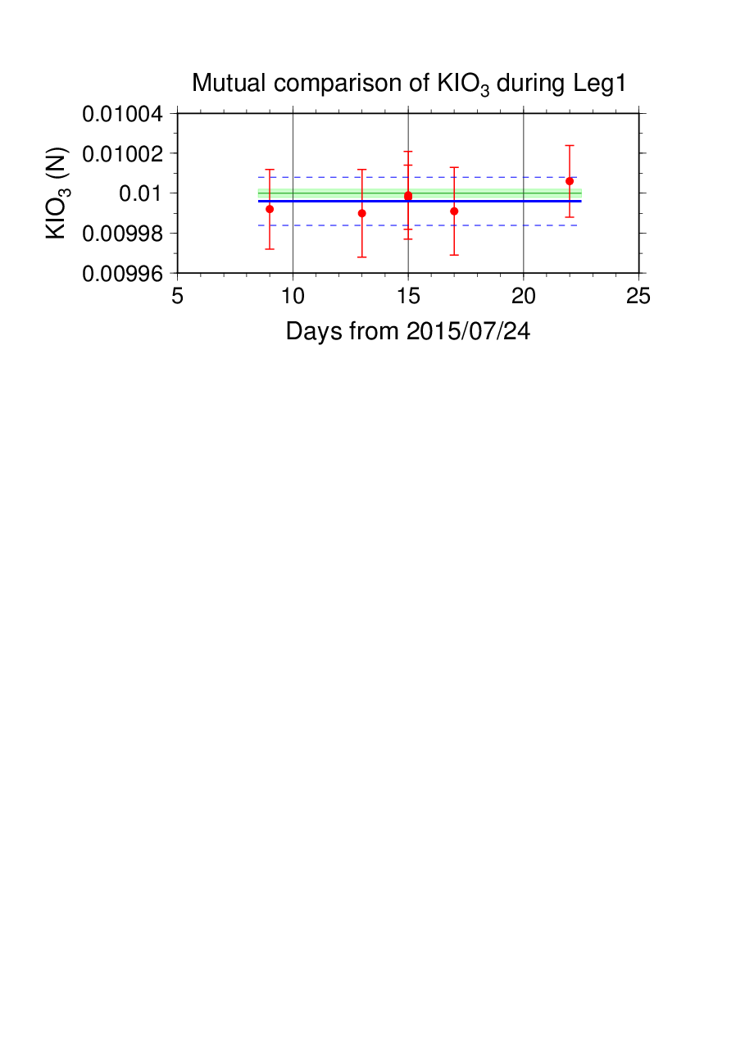

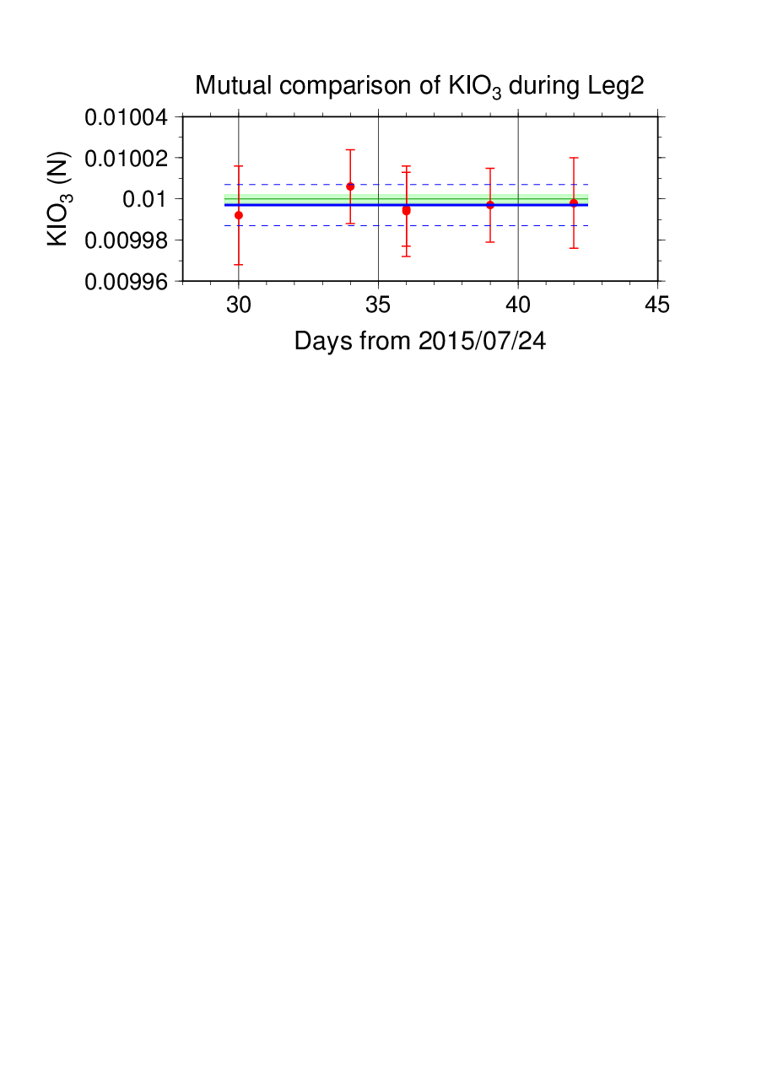

Figure C.3.6. Result of mutual comparison of standard KIO3 solutions. Circles and error bars show mean of the measurement value and its uncertainty (k=2), respectively. Thick and dashed lines in blue denote the mean and 2 times of standard deviations, respectively, for the measurement through the leg. Green thin line and light green thick line denote nominal concentration and its uncertainty (k=2) of standard KIO3 solution “20150501-2”.

#### (7.3) Quality control flag assignment

Quality flag value was assigned to oxygen measurements as shown in Table C.3.3, using the code defined in IOCCP Report No.14 (Swift, 2010).

Table C.3.3. Summary of assigned quality control flags.

|  |  |  |
| --- | --- | --- |
| Flag | Definition | Number of samples |
| 2 | Good | 2120 |
| 3 | Questionable | 11 |
| 4 | Bad (Faulty) | 10 |
| 5 | Not reported | 0 |
| 6 | Replicate measurements | 251 |
| Total number of samples | | 2392 |

### Uncertainty

Oxygen measurement involves various uncertainties; determination of glass bottles volume, repeatability and systematic error of burette discharge, repeatability of pickling reagents discharge, determination of reagent blank, standardization of Na2S2O3 solution, and uncertainty of KIO3 concentration. Considering evaluable uncertainties as above, expanded uncertainty of bottle oxygen concentration (*T*=20, *S*=34.5) was estimated as shown in Table C.3.4. However, it is difficult to determine a strict uncertainty for oxygen concentration because there is no reference material for oxygen measurement.

Table C.3.4 Expanded uncertainty (k=2) of bottle oxygen in the cruise.

|  |  |
| --- | --- |
| O2 conc. (mol kg−1) | Uncertainty (mol kg−1) |
| 20 | 0.35 |
| 30 | 0.36 |
| 50 | 0.38 |
| 70 | 0.40 |
| 100 | 0.45 |
| 150 | 0.55 |
| 200 | 0.67 |
| 250 | 0.80 |
| 300 | 0.93 |
| 400 | 1.20 |

### Appendix

**A1. Methods**

**(A1.1) Seawater sampling**

Following procedure is based on a determination method in IOCCP Report (Langdon, 2010). Seawater samples were collected from 10-liters Niskin bottles attached the CTD-system and a stainless steel bucket for the surface. Seawater for bottle oxygen measurement was transferred from the Niskin bottle and a stainless steel bucket to a volumetrically calibrated dry glass bottles. At least three times the glass volume water was overflowed. Then, pickling reagent-I 1 mL and reagent-II 1mL were added immediately, and sample temperature was measured using a thermometer. After a stopper was inserted carefully into the glass, it was shaken vigorously to mix the content and to disperse the precipitate finely. After the precipitate has settled at least halfway down the glass, the glass was shaken again. The sample glasses containing pickled samples were stored in a laboratory until they were titrated. To prevent air from entering the glass, deionized water (DW) was added to its neck after sampling.

**(A1.2) Sample measurement**

At least 15 minutes after the re-shaking, the samples were measured on board. Added 1 mL H2SO4 solution and a magnetic stirrer bar into the sample glass, samples were titrated with Na2S2O3 solution whose molarity was determined with KIO3 solution. During the titration, the absorbance of iodine in the solution was monitored using a detector. Also, temperature of Na2S2O3 solution during the titration was recorded using a thermometer. Dissolved oxygen concentration (mol kg−1) was calculated from sample temperature at the fixation, CTD salinity, glass volume, and titrated volume of the Na2S2O3 solution, and oxygen in the pickling reagents-I (1 mL) and II (1 mL) (7.6 × 10−8 mol; Murray *et al.*, 1968).

**A2. Reagents recipes**

Pickling reagent-I; Manganous chloride solution (3 molL−1)

Dissolve 600 g of MnCl2·4H2O in DW, then dilute the solution with DW to a final volume of 1 L.

Pickling reagent-II; Sodium hydroxide (8 molL−1) / sodium iodide solution (4 molL−1)

Dissolve 320 g of NaOH in about 500 mL of DW, allow to cool, then add 600 g NaI and dilute with DW to a final volume of 1 L.

H2SO4 solution; Sulfuric acid solution (5 molL−1)

Slowly add 280 mL concentrated H2SO4 to roughly 500 mL of DW. After cooling the final volume should be 1 L.

Na2S2O3 solution; Sodium thiosulfate solution (0.04 molL−1)

Dissolve 50 g of Na2S2O3·5H2O and 0.4 g of Na2CO3 in DW, then dilute the solution with DW to a final volume of 5 L.

KIO3 solution; Potassium iodate solution (0.001667 mol L−1)

Dry high purity KIO3 for two hours in an oven at 130 °C. After weight out accurately KIO3, dissolve it in DW in a 5 L flask. Concentration of potassium iodate is determined by a gravimetric method.

**A3. Other blanks in oxygen measurement**

**(A3.1) Blank associated with oxidants or reductants in the reagents**

The blank Vblk, reg, associated with oxidants or reductants in the reagent, was determined as follows. Using a calibrated pipette, 1 mL of the standard KIO3 solution and 100 mL of DW were added to two glasses each. Then, 1 mL H2SO4 solution, 1 mL of pickling reagent-II and 1 mL reagent-I were added in sequence into the first glass. Next, added two times volume of the reagents (2 mL of H2SO4 solution, pickling reagent-II and I each) into the second one. After that, the sample was titrated to the end-point with Na2S2O3 solution. Vblk, reg was determined with difference of titrated volume of Na2S2O3 between the first (total reagents volume is 3 mL) and the second (total reagents volume is 6 mL) one, also, experiments for three times and four times volume of them were carried out. The results are shown in Figure C.3.A1.

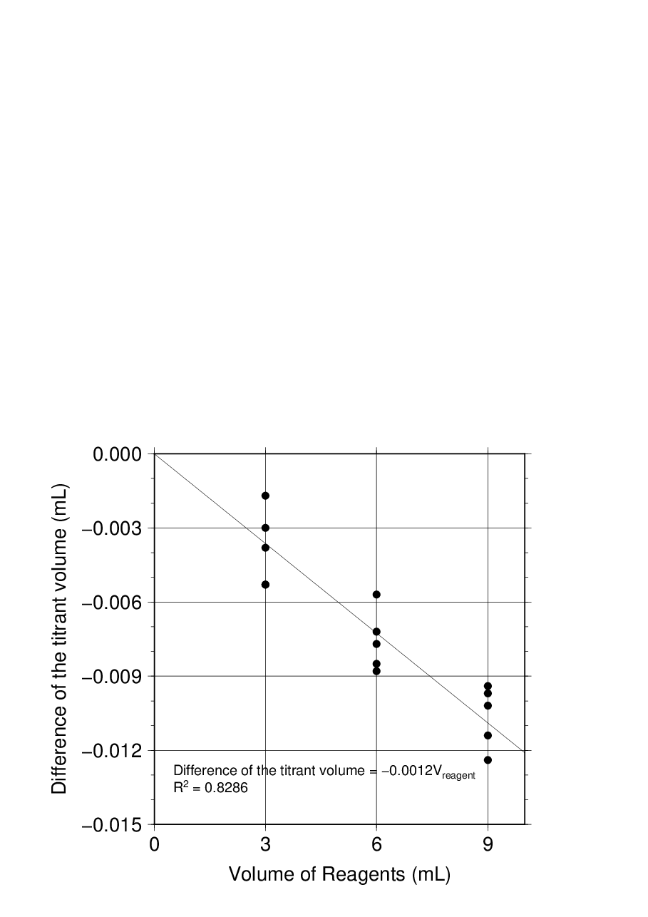

Figure C.3.A1. Blank (mL) due to redox species other than oxygen in the reagents.

The relation between difference of the titrant volume and the reagents of the volume (Vreg) is expressed as follows;

Difference of the titrant volume = –0.0012 Vreg. (C3.A1)

Therefore, Vblk, reg was estimated to be +0.004 mL.

**(A3.2) Sample blank (Vblk, spl)**

Blank due to redox species other than oxygen in the sample (Vblk, spl) can be a potential source of measurement error. Total blank during seawater measurement, seawater blank (Vblk, sw), can be represented as follows;

Vblk, sw = Vblk, spl + Vblk, dw.(C3.A2)

If the Vblk, dw determined in eq. (C3.1) is identical both in seawater and in pure water, the difference between the seawater and reagent blanks gives the Vblk, spl.

Here, Vblk, spl was determined by following procedure. Seawater was collected in the calibrated volumetric glass without the pickling solution. Then 1 mL of the standard KIO3 solution, H2SO4 solution, and reagent solution-II and I each were added in sequence into the glass. After that, the sample was titrated to the end-point by Na2S2O3 solution. Similarly, a glass contained 100 mL of DW added with 1 mL of the standard KIO3 solution, H2SO4 solution, pickling reagent solution-II and I were titrated with Na2S2O3 solution. The difference of the titrant volume of the seawater and DW glasses gave Vblk, spl.

The sample blank has been reported from 0.4 to 0.8 molkg−1 in the previous study (Culberson *et al*., 1991). Additionally, these errors are expected to be the same to all investigators and not to affect the comparison of results from different investigators (Culberson, 1994). However, the magnitude and variability of the seawater blank have not yet been documented. We believe that understanding of the magnitude and variability may be important to evaluate comparability of computed oxygen concentrations with other groups. The determined sample blanks are shown in Table C.3.A1.

Table C.3.A1. Results of the sample blank determinations.

|  |  |  |  |  |  |  |  |  |  |  |
| --- | --- | --- | --- | --- | --- | --- | --- | --- | --- | --- |
| Station: RF5487  9°-00′N/137°-00′E | |  | Station: RF5495  8°-59′N/139°-35′E | |  | Station: RF5547  5°-35′N/173°-00′E | |  | Station: RF5551  8°-59′N/178°-58′E | |
| Pres. | Blank |  | Pres. | Blank |  | Pres. | Blank |  | Pres. | Blank |
| (dbar) | (mol kg−1) |  | (dbar) | (mol kg−1) |  | (dbar) | (mol kg−1) |  | (dbar) | (mol kg−1) |
| 2.6 | 0.42 |  | 25.6 | 0.95 |  | 50.8 | 0.41 |  | 10.8 | 0.61 |
| 10.6 | 0.29 |  | 78.3 | 1.21 |  | 75.4 | 0.38 |  | 50.1 | 0.50 |
| 25.1 | 0.38 |  | 78.3 | 0.80 |  | 100.7 | 0.48 |  | 50.1 | 0.41 |
| 50.9 | 0.42 |  | 252.1 | 0.70 |  | 100.7 | 0.50 |  | 125.2 | 0.58 |
| 77.9 | 0.50 |  | 806.8 | 0.62 |  | 126.1 | 0.84 |  | 251.9 | 0.68 |
| 77.9 | 0.49 |  | 1412.5 | 1.44 |  | 151.7 | 0.48 |  | 534.3 | 0.72 |
| 102.0 | 0.55 |  | 2021.4 | 0.65 |  | 176.9 | 0.55 |  | 736.3 | 0.78 |
| 151.8 | 0.71 |  | 2427.0 | 0.91 |  | 202.8 | 0.67 |  | 1080.9 | 0.72 |
| 201.7 | 0.72 |  | 2835.4 | 0.65 |  | 606.3 | 0.58 |  | 2297.1 | 0.81 |
| 433.3 | 0.71 |  | 3295.6 | 0.69 |  | 1211.2 | 0.50 |  | 3375.6 | 0.58 |
| 938.3 | 0.63 |  | 3295.6 | 0.72 |  | 1818.0 | 0.61 |  | 3375.6 | 0.72 |
| 1484.3 | 0.66 |  | 4077.6 | 0.54 |  | 2631.1 | 0.53 |  | 4913.8 | 0.76 |
| 2296.0 | 0.76 |  |  |  |  | 3293.4 | 0.56 |  |  |  |
| 2907.1 | 0.65 |  |  |  |  | 4061.6 | 0.62 |  |  |  |
| 3889.4 | 0.71 |  |  |  |  | 4955.6 | 0.68 |  |  |  |
| 3889.4 | 0.71 |  |  |  |  | 4955.6 | 0.84 |  |  |  |

***Reference***

Culberson, A.H. (1994) Dissolved oxygen, in WHPO Pub. 91-1 Rev. 1, November 1994, Woods Hole, Mass., USA.

Culberson, A.H., G. Knapp, M.C. Stalcup, R.T. Williams, and F. Zemlyak (1991) A comparison of methods for the determination of dissolved oxygen in seawater, WHPO Pub. 91-2, August 1991, Woods Hole, Mass., USA.

DOE (1994), Handbook of methods for the analysis of the various parameters of the carbon dioxide system in sea water; version 2. *A.G. Dickson and C. Goyet (eds), ORNL/CDIAC-74*.

Langdon, C. (2010), Determination of dissolved oxygen in seawater by Winkler titration using the amperometric technique, *IOCCP Report No.14, ICPO Pub. 134, 2010 ver.1*

Murray, C. N., J. P. Riley and T. R. S. Wilson (1968), The solubility of oxygen in Winkler reagents used for the determination of dissolved oxygen. *Deep-Sea Res*. 15, 237–238.

Swift, J. H. (2010), Reference-quality water sample data: Notes on acquisition, record keeping, and evaluation. *IOCCP Report No.14, ICPO Pub. 134, 2010 ver.1*.