A. Cruise narrative

Highlights
Cruise designation: RF22-05, RF22-06, RF22-07 (WHP-P09 revisit)

a. EXPOCODE: RF22-05 49UP20220727
RF22-06 49UP20220824
RF22-07 49UP20220929

b. Chief scientist: NAGAI Naoki
Atmospheric Environment and Ocean Division
Atmosphere and Ocean Department
Japan Meteorological Agency (JMA)

c. Ship name: R/V Ryofu Maru

d. Ports of call: RF22-05: Tokyo (Japan) – Tokyo (Japan)
RF22-06: Tokyo (Japan) – Tokyo (Japan)
RF22-07: Leg 1: Tokyo (Japan) – Kochi (Japan)
Leg 2: Kochi (Japan) – Tokyo (Japan)

e. Cruise dates (JST): RF22-05: 27 July 2022 – 20 August 2022
RF22-06: 24 August 2022 – 17 September 2022
RF22-07: Leg 1: 29 September 2022 – 19 October 2022
Leg 2: 23 October 2022 – 2 November 2022

f. Principal Investigator (Contact person):
HIBINO Sho
Atmospheric Environment and Ocean Division
Atmosphere and Ocean Department
Japan Meteorological Agency (JMA)
3-6-9, Toranomon, Minato-ku, Tokyo 105-8431, JAPAN
Phone: +81-3-6758-3900 Ext. 4617
FAX: +81-3-3434-9125
E-mail: seadata@met.kishou.go.jp

Cruise Summary
RF22-05, RF22-06 and RF22-07 cruises were carried out during the period from July 27 to November 2, 2022. The cruises started from the north of Papua New Guinea, and sailed towards north along approximately 137°E meridian. This line (WHP-P09) was observed by JMA in 1994 as WOCE (World Ocean Circulation Experiment) Hydrographic Programme and in 2010 and 2016 as CLIVAR (Climate Variability and Predictability Project) / GO-SHIP (Global Ocean Ship-based Hydrographic Investigations Program).
A total of 93 stations were occupied using a Sea-Bird Electronics (SBE) 36 position carousel equipped with 10-liter Niskin water sample bottles, a CTD system (SBE911plus) equipped with SBE35 deep ocean standards thermometer, JFE Advantech oxygen sensor (RINKO III), Valeport altimeter (VA500), and Teledyne RD Instruments L-ADCP (300kHz). To examine consistency of data, we carried out the observation repeatedly twice at stations of 4°30’N, 137°00’E (Stns.24 and 25) and 21°00’N, 137°00’E (Stns.61 and 62) at the cross points of each cruise. Station location and cruise track are shown in Figure A.1 (except Leg 2 at RF22-07).
At almost all station, full-depth CTDO₂ (temperature, conductivity (salinity) and dissolved oxygen) profile were taken, and up to 36 water samples were taken and analyzed. Water samples were obtained from 10 dbar to approximately 10 m above the bottom. In addition, surface water was sampled by a stainless steel bucket at each station. Sampling layer is designed as so-called staggered mesh as shown in Table A.1 (Swift, 2010). The bottle depth diagram is shown in Figure A.2.
Water samples were analyzed for salinity, dissolved oxygen, nutrients, dissolved inorganic carbon (DIC), total alkalinity (TA), pH, CFCs (CFC-11, CFC-12, and CFC-113), SF₆ and phytopigments (chlorophyll-a and phaeopigment). Underway measurements of partial pressure of carbon dioxide (pCO₂), temperature, salinity, chlorophyll-a, subsurface current, bathymetry and meteorological parameters were conducted along the cruise track.
At RF22-05, R/V Ryofu Maru departed from Tokyo (Japan) on July 27, 2022. The hydrographic cast of CTDO₂ was started at the first station (Stn.1 (2°20’S, 141°10’E; RF7041)) in the north of Papua New Guinea on August 5. RF22-05 consisted of 24 stations from Stn.1 to Stn.24 (4°30’N, 137°00’E; RF7064). Observation at Stn.24 was finished on August 13. She returned at Tokyo on August 20.
At RF22-06, she departed from Tokyo on August 24. The hydrographic cast of CTDO₂ restarted at the same station (Stn.25 (4°30’N, 137°00’E; RF7066)) with the RF22-05 last station on August 30. RF22-06 consisted of 37 stations from Stn.25 to Stn.61 (21°00’N, 137°00’E; RF7102). Observation at Stn.61 was finished on September 12. She returned at Tokyo on September 17.
At RF22-07, she departed from Tokyo on September 29. The hydrographic cast of CTDO₂ restarted at same station (Stn.62 (21°00’N, 137°00’E; RF7104)) with the RF22-06 last station on October 3. Observations from Stn.62 to Stn.86 (32°00’N, 137°00’E; RF7128) were carried out in order from the south. After observation at Stn.86, she evacuated to Suruga Bay in Shizuoka (Japan) for avoiding high waves expected in the observation area. She restarted from Stn.93 (34°10’N, 137°00’E; RF7129) on the coast of Japan on October 15 and observed southward to Stn.87 (32°20’N, 137°00’E; RF7136). Observation at Stn.87 was finished on October 16. RF22-07 consisted of 32 stations from Stn.62 to Stn.93. She entered at Kochi on October 19 (Leg 1). At Leg 2, she departed from Kochi on October 23, and observed the pCO2 and the surface layer temperature in the south of Japan, returned at Tokyo on November 2. Location data of stations is shown in Table A.2.
Five Argo floats were deployed along the cruise track. The information of deployed the float is listed in Table A.3.

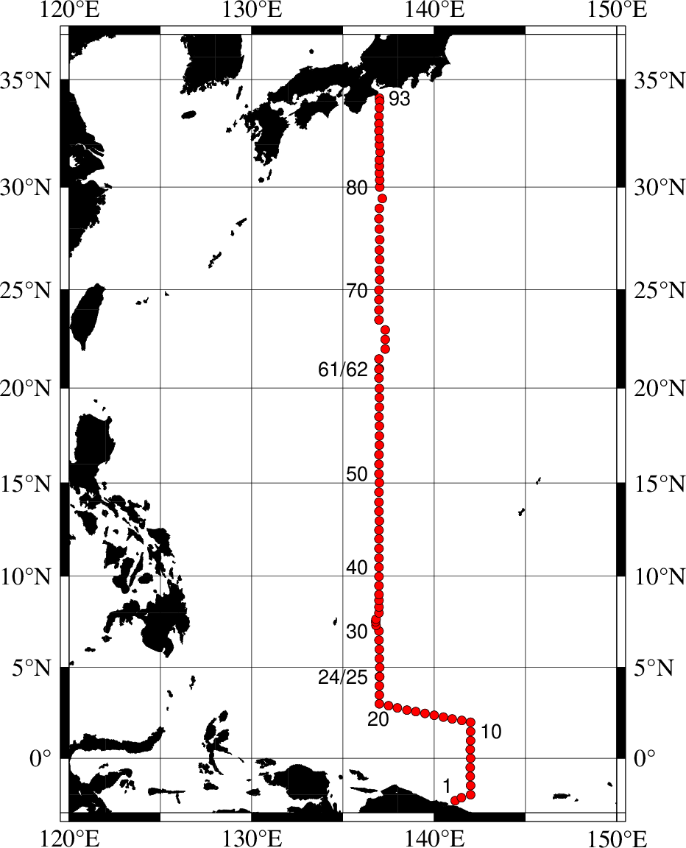
Figure A.1. Location of hydrographic stations and cruise track of RF22-05, RF22-06 and RF22-07. Circles indicate stations along WHP-09.

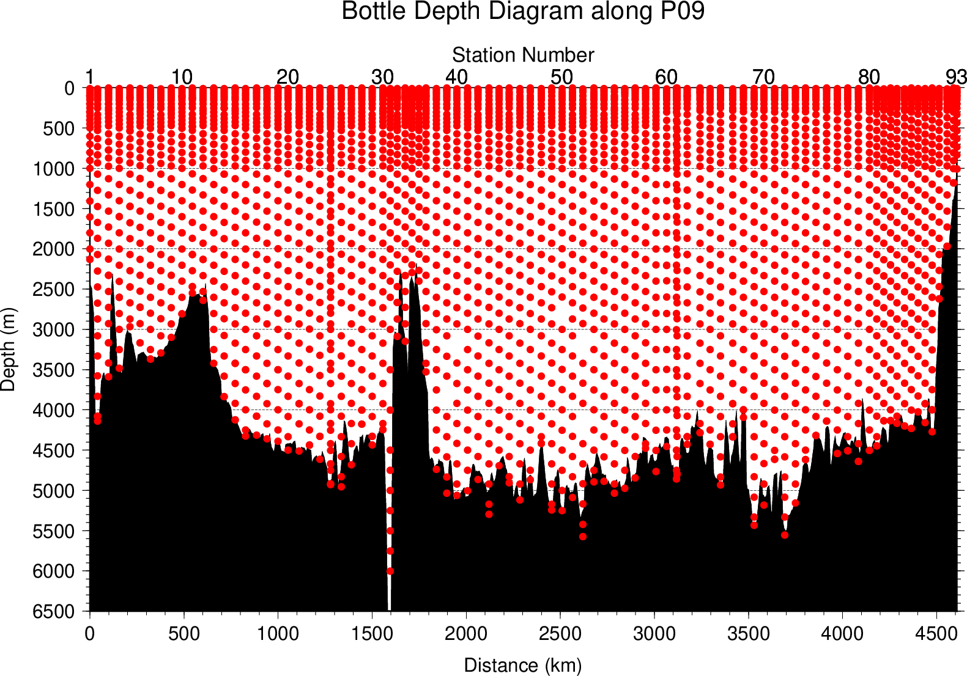
Figure A.2. The bottle depth diagram for WHP-P09 revisit.

Table A.1. The scheme of sampling layer in meters.
 | North of 20°N (Stn.60–Stn.93) |  |  | South of 20°N (Stn.1–Stn.59)
Bottle count | Scheme 1 | Scheme 2 | Scheme 3 | Scheme 4 | Scheme 5 | Scheme 6
1 | 10 | 10 | 10 | 10 | 10 | 10
2 | 25  50  75  100  125  150  200  250  300  400  500  600  700  800  900  1000  1200  1400  160050 | 25 | 25 | 25 | 25 | 25
3 | 50 | 50 | 50 | 50 | 50 | 50
4 | 75 | 75 | 75 | 75 | 75 | 75
5 | 100 | 100 | 100 | 100 | 100 | 100
6 | 125 | 125 | 125 | 125 | 125 | 125
7 | 150 | 150 | 150 | 150 | 150 | 150
8 | 200 | 200 | 200 | 200 | 200 | 200
9 | 250 | 250 | 250 | 250 | 250 | 250
10 | 300 | 330 | 280 | 300 | 330 | 280
11 | 400 | 430 | 370 | 350 | 380 | 320
12 | 500 | 530 | 470 | 400 | 430 | 370
13 | 600 | 630 | 570 | 450 | 480 | 420
14 | 700 | 730 | 670 | 500 | 530 | 470
15 | 800 | 830 | 770 | 600 | 630 | 570
16 | 900 | 930 | 870 | 700 | 730 | 670
17 | 1000 | 1070 | 970 | 800 | 830 | 770
18 | 1200 | 1270 | 1130 | 900 | 930 | 870
19 | 1400 | 1470 | 1330 | 1000 | 1070 | 970
20 | 1600 | 1670 | 1530 | 1200 | 1270 | 1130
21 | 1800 | 1870 | 1730 | 1400 | 1470 | 1330
22 | 2000 | 2070 | 1930 | 1600 | 1670 | 1530
23 | 2200 | 2270 | 2130 | 1800 | 1870 | 1730
24 | 2400 | 2470 | 2330 | 2000 | 2070 | 1930
25 | 2600 | 2670 | 2530 | 2200 | 2270 | 2130
26 | 2800 | 2870 | 2730 | 2400 | 2470 | 2330
27 | 3000 | 3080 | 2930 | 2600 | 2670 | 2530
28 | 3250 | 3330 | 3170 | 2800 | 2870 | 2730
29 | 3500 | 3580 | 3420 | 3000 | 3080 | 2930
30 | 3750 | 3830 | 3670 | 3250 | 3330 | 3170
31 | 4000 | 4080 | 3920 | 3500 | 3580 | 3420
32 | 4250 | 4330 | 4170 | 3750 | 3830 | 3670
33 | 4500 | 4580 | 4420 | 4000 | 4080 | 3920
34 | 4750 | 4830 | 4670 | 4250 | 4330 | 4170
35 | 5000 | 5080 | 4920 | 4500 | 4580 | 4420
36 | 5250 | 5330 | 5170 | 4750 | 4830 | 4670
37 | 5500 | 5580 | 5420 | 5000 | 5080 | 4920
38 | 5750 | 5830 | 5670 | 5250 | 5330 | 5170
39 | 6000 | 6000 | 6000 | 5500 | 5580 | 5420
40 |  |  |  | 5750 | 5830 | 5670
41 |  |  |  | 6000 | 6000 | 6000
Scheme 1 to Scheme 3 are applied to the area north of 20°N, while Scheme 4 to Scheme 6 are applied to the area south of 20°N. At some deep stations over 36 layers, some layers shown in italic may be skipped.
Table A.2(a). Station lists of RF22-05 cruise. The ‘RF’ column indicates the JMA station identification number.
Station |  | Location |  |  | Station |  | Location
Stn. | RF | Latitude | Longitude |  | Stn. | RF | Latitude | Longitude
1 | 7041 | 02-20.13 S | 141-09.15 E |  | 13 | 7053 | 02-11.50 N | 140-59.64 E
2 | 7042 | 02-10.14 S | 141-29.08 E |  | 14 | 7054 | 02-16.10 N | 140-30.17 E
3 | 7043 | 02-00.64 S | 141-59.04 E |  | 15 | 7055 | 02-23.44 N | 140-00.04 E
4 | 7044 | 01-30.13 S | 141-59.32 E |  | 16 | 7056 | 02-29.21 N | 139-30.50 E
5 | 7045 | 00-59.65 S | 141-58.62 E |  | 17 | 7057 | 02-35.79 N | 138-59.40 E
6 | 7046 | 00-30.32 S | 141-58.70 E |  | 18 | 7058 | 02-40.99 N | 138-30.23 E
7 | 7047 | 00-00.31 S | 141-59.37 E |  | 19 | 7059 | 02-47.67 N | 137-59.50 E
8 | 7048 | 00-29.19 N | 141-58.95 E |  | 20 | 7060 | 02-54.57 N | 137-30.73 E
9 | 7049 | 00-59.43 N | 141-59.48 E |  | 21 | 7061 | 03-00.56 N | 137-00.19 E
10 | 7050 | 01-29.76 N | 141-59.82 E |  | 22 | 7062 | 03-30.53 N | 137-00.96 E
11 | 7051 | 01-59.40 N | 142-00.44 E |  | 23 | 7063 | 04-00.55 N | 137-00.86 E
12 | 7052 | 02-05.54 N | 141-30.24 E |  | 24 | 7064 | 04-30.80 N | 137-00.95 E

Table A.2(b). Same as Table A.2(a) but for RF22-06 cruise.
Station |  | Location |  |  | Station |  | Location
Stn. | RF | Latitude | Longitude |  | Stn. | RF | Latitude | Longitude
25 | 7066 | 04-30.84 N | 137-01.30 E |  | 44 | 7085 | 12-29.79 N | 136-59.62E
26 | 7067 | 05-01.47 N | 137-01.08 E |  | 45 | 7086 | 12-59.13 N | 137-00.42 E
27 | 7068 | 05-30.42 N | 137-00.06 E |  | 46 | 7087 | 13-29.59 N | 136-59.71 E
28 | 7069 | 06-00.32 N | 137-00.56 E |  | 47 | 7088 | 13-59.76 N | 136-59.36 E
29 | 7070 | 06-30.58 N | 136-59.24 E |  | 48 | 7089 | 14-31.00 N | 136-59.91 E
30 | 7071 | 07-00.63 N | 136-58.86 E |  | 49 | 7090 | 15-01.07 N | 137-00.41 E
31 | 7072 | 07-19.80 N | 136-49.15 E |  | 50 | 7091 | 15-30.54 N | 136-59.32 E
32 | 7073 | 07-30.13 N | 136-48.76 E |  | 51 | 7092 | 16-00.19 N | 136-58.59 E
33 | 7074 | 07-39.71 N | 136-49.44 E |  | 52 | 7093 | 16-30.50 N | 136-58.55 E
34 | 7075 | 08-00.18 N | 136-58.93 E |  | 53 | 7094 | 17-01.83 N | 137-00.22 E
35 | 7076 | 08-19.91 N | 136-59.77 E |  | 54 | 7095 | 17-30.97 N | 137-00.14 E
36 | 7077 | 08-40.49 N | 136-59.19 E |  | 55 | 7096 | 18-01.11 N | 137-00.10 E
37 | 7078 | 09-00.28 N | 136-59.51 E |  | 56 | 7097 | 18-30.24 N | 136-59.50 E
38 | 7079 | 09-29.99 N | 136-59.32 E |  | 57 | 7098 | 19-00.30 N | 137-00.14 E
39 | 7080 | 09-59.93 N | 136-59.43 E |  | 58 | 7099 | 19-30.01 N | 137-00.87 E
40 | 7081 | 10-29.14 N | 136-59.68 E |  | 59 | 7100 | 19-59.90 N | 137-00.62 E
41 | 7082 | 10-59.88 N | 136-58.72 E |  | 60 | 7101 | 20-30.45 N | 136-59.92 E
42 | 7083 | 11-29.81 N | 136-59.23 E |  | 61 | 7102 | 21-00.13 N | 137-00.88 E
43 | 7084 | 12-00.68 N | 136-59.21 E

Table A.2(c). Same as Table A.2(a) but for RF22-07 cruise.
Station |  | Location |  |  | Station |  | Location
Stn. | RF | Latitude | Longitude |  | Stn. | RF | Latitude | Longitude
62 | 7104 | 20-58.77 N | 136-59.83 E |  | 78 | 7120 | 28-59.50 N | 137-00.25 E
63 | 7105 | 21-29.28 N | 136-59.23 E |  | 79 | 7121 | 29-28.73 N | 137-09.88 E
64 | 7106 | 22-00.24 N | 137-19.80 E |  | 80 | 7122 | 30-00.02 N | 137-01.17 E
65 | 7107 | 22-29.79 N | 137-19.12 E |  | 81 | 7123 | 30-20.41 N | 137-01.66 E
66 | 7108 | 22-59.46 N | 137-19.00 E |  | 82 | 7124 | 30-40.80 N | 137-00.92 E
67 | 7109 | 23-29.33 N | 136-59.47 E |  | 83 | 7125 | 31-00.60 N | 137-00.89 E
68 | 7110 | 23-59.83 N | 136-59.22 E |  | 84 | 7126 | 31-18.37 N | 137-00.51 E
69 | 7111 | 24-30.90 N | 136-59.26 E |  | 85 | 7127 | 31-40.52 N | 137-02.13 E
70 | 7112 | 24-59.01 N | 136-59.41 E |  | 86 | 7128 | 31-59.88 N | 137-00.27 E
71 | 7113 | 25-29.33 N | 137-01.01 E |  | 87 | 7135 | 32-18.85 N | 137-00.19 E
72 | 7114 | 25-58.35 N | 137-00.90 E |  | 88 | 7134 | 32-39.22 N | 136-59.16 E
73 | 7115 | 26-29.23 N | 137-01.76 E |  | 89 | 7133 | 32-59.08 N | 136-58.87 E
74 | 7116 | 26-58.04 N | 137-00.96 E |  | 90 | 7132 | 33-19.81 N | 136-58.23 E
75 | 7117 | 27-28.52 N | 137-01.12 E |  | 91 | 7131 | 33-42.00 N | 137-00.05 E
76 | 7118 | 27-59.29 N | 137-00.39 E |  | 92 | 7130 | 34-00.51 N | 137-01.03 E
77 | 7119 | 28-29.67 N | 136-59.61 E |  | 93 | 7129 | 34-10.07 N | 137-00.78 E

Table A.3. Information of deployed float.
Float | Date and Time | Position of deployment |  | PI | Manufacturer
WMO number | of Deployment (UTC) | Latitude | Longitude
5905872 | September 4, 2022  00:27 | 9-59.83 N | 136-58.85 E | JAMSTEC | APEX
2903708 | September 11, 2022  02:18 | 20-01.60 N | 137-03.39 E | JMA | ARVOR
2903712 | October 7, 2022  10:31 | 27-57.75 N | 137-00.04 E | JMA | ARVOR
2903714 | October 9, 2022  06:37 | 30-00.04 N | 137-02.38 E | JMA | ARVOR
2903716 | October 11, 2022  03:38 | 31-59.68 N | 137-01.45 E | JMA | ARVOR
ARVOR: NKE Instrumentation (France)
APEX: Teledyne Webb Research (USA)

List of Principal Investigators for Measurements
The principal investigators for each parameter are listed in Table A.4.

Table A.4. List of principal investigators for each parameter.
Hydrography | CTDO₂ | MURAKAMI Kiyoshi
 | Salinity | MURAKAMI Kiyoshi
 | Dissolve oxygen | KITAGAWA Takahiro
 | Nutrients | KITAGAWA Takahiro
 | Phytopigments | KITAGAWA Takahiro
 | DIC | ENYO Kazutaka
 | TA | ENYO Kazutaka
 | pH | ENYO Kazutaka
 | CFCs | ENYO Kazutaka
 | SF₆ | ENYO Kazutaka
 | LADCP | MURAKAMI Kiyoshi
Underway | Meteorology | NAGAI Naoki
 | Thermo-Salinograph | ENYO Kazutaka
 | pCO₂ | ENYO Kazutaka
 | Chlorophyll a | KITAGAWA Takahiro
 | ADCP | MURAKAMI Kiyoshi
 | Bathymetry | MURAKAMI Kiyoshi
Float | JMA | NAKAMURA Tetsuya
 | JAMSTEC | HOSODA Shigeki

Reference
Swift, J. H. (2010): Reference-quality water sample data: Notes on acquisition, record keeping, and evaluation. IOCCP Report No.14, ICPO Pub. 134, 2010 ver.1

