9. Lowered Acoustic Doppler Current Profiler

(1) Personnel
CHIBA Yasuomi (JMA)
WADA Koichi (JMA)

(2) Instrument and measurement
Direct flow measurement from sea surface to sea bed was carried out using a Lowered Acoustic Doppler Current Profiler (LADCP). The instrument, RDI Workhorse Monitor 300 kHz (S/N 16468, 14108; Teledyne RD Instruments, USA), was attached on the CTD frame, orientating downward. The CPU firmware version was 50.41.

One ping raw data were recorded. Settings for the collecting data were as listed in Table C.9.1. A total of 76 operations were made with the CTD observations. The performance of the LADCP (S/N 16468) was good between Stn.1 (RF6860) and Stn.57 (RF6924). After Stn.58 (RF6925), data from Stn.58 (RF6925) to Stn.70 (RF6937) is missing due to a bulkhead connector failure. Using LADCP (S/N 14108) from stn.71 (RF6956), it was good.

Table C9.1. Setting for the correcting data.
Bin length | 8 m
Bin number | 25
Error Threshold | 2000 mm/s
Ping interval | 1.0 sec

(3) Data process and result
Vertical profiles of absolute velocity are obtained by the inversion method (Visbeck, 2002). Both the up and down casts were used for the calculation. Because the first bin from LADCP is influenced by the turbulence generated by CTD frame, the weighted mean coefficient for the calculation was set to 0.1. The GPS navigation data were used in the calculation of the reference velocities and the bottom-track data were used for the correction of the reference velocities. Shipboard ADCP (SADCP) data averaged for 5 minutes were also included in the calculation. The CTD data were used for the sound speed and depth calculation. IGRF (International Geomagnetic Reference Field) 11th generation data were used for calculating magnetic deviation to correct the direction of velocity. In the calculation processing, we used Matlab routines (version 8b: 5 April 2004) provided by M. Visbeck and G. Krahmann. Because the uncertainty of velocity observed by SADCP is about 10 cm/s, we regard the error velocity from LADCP upper 1000 dbar as about 10 cm/s. Figures C.9.1 and C.9.2 show the results of the zonal velocity (eastward is positive) and the meridional velocity (northward is positive), respectively. Figure C.9.3 shows measurement errors of velocity estimated by the inversion method.

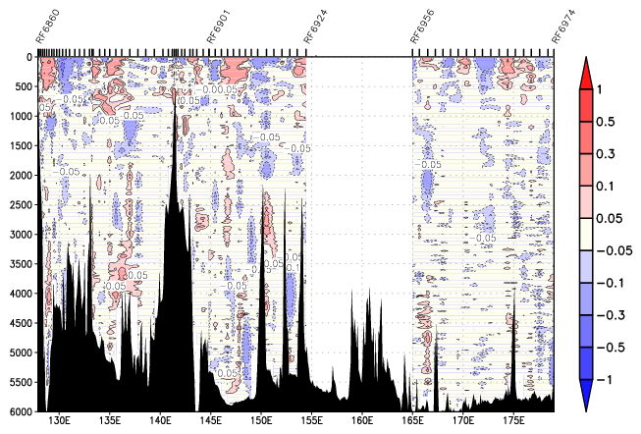
Figure C.9.1. The cross-section of zonal velocity (m/s, eastward is positive). Blanks are missing data from stn.58 to stn.71.
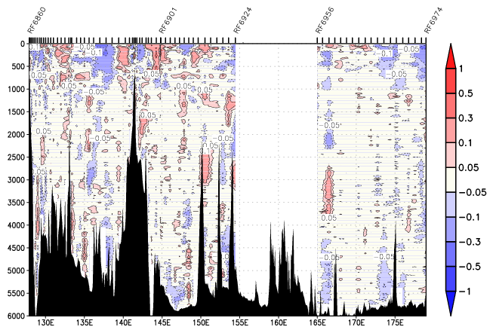

Figure C.9.2 The cross-section of meridional velocity (m/s, northward is positive). Blanks are missing data from stn.58 to stn.71.

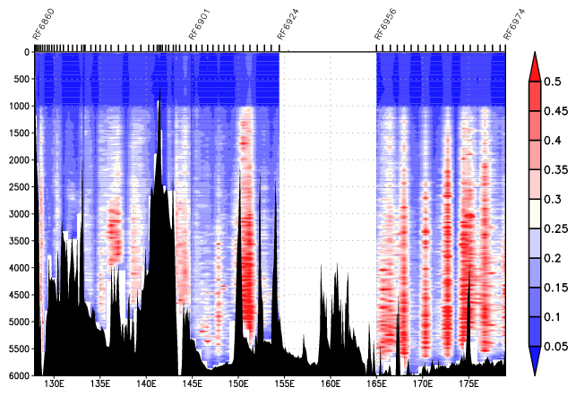
Figure C.9.3. Cross-section of measurement error in velocity (m/s) estimated by the inversion method. Blanks are missing data from stn.58 to stn.71.

Reference
Visbeck, M. (2002): Deep velocity profiling using Lowered Acoustic Doppler Current Profilers: Bottom track and inverse solutions. J. Atmos. Oceanic Technol., 19, 794-807.

