Phytopigments (chlorophyll-a and phaeopigment)

(1) Personnel
SHINODA Yoshihiro
HASHIMOTO Susumu
SASAKI Takuya
OKAJIMA Shingo (RF21-06)
FUJII Takuya (RF21-06, RF21-08)
IMAI Yoichi (RF21-07)
KAKUYA Keita (RF21-07, RF21-08)

Station occupied
A total of 42 stations (RF 21-06 Leg 2: 18, RF 21-07: 14, RF21-08: 10) were occupied for phytopigment measurements. Station location and sampling layers of phytopigment are shown in Figures C.5.1 and C.5.2.

Figure C.5.1. Location of observation stations of chlorophyll-a. Closed and open circles indicate sampling and no-sampling stations, respectively.

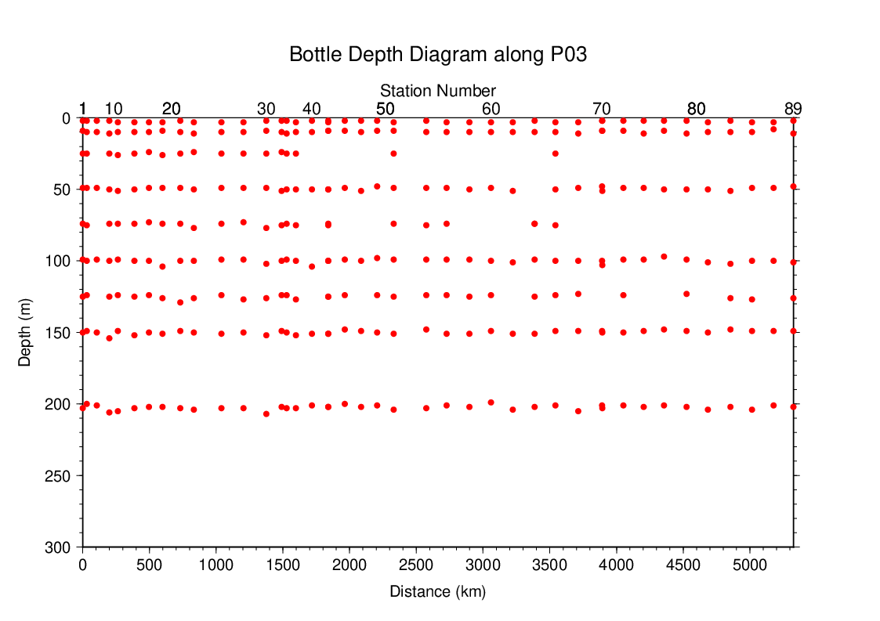
Figure C.5.2. Distance-depth distribution of sampling layers of chlorophyll-a.

Reagents
N,N-dimethylformamide (DMF)
Hydrochloric acid (HCl), 0.5 mol L⁻¹
Chlorophyll-a standard from Anacystis nidulans algae (Sigma-Aldrich, United States)
Rhodamine WT (Turner Designs, United States)

Instruments
Fluorometer: 10-AU (Turner Designs, United States)
Spectrophotometer: UV-1800 (Shimadzu, Japan)

Standardization

(5.1) Determination of chlorophyll-a concentration of standard solution
To prepare the pure chlorophyll-a standard solution, reagent powder of chlorophyll-a standard was dissolved in DMF. A concentration of the chlorophyll-a solution was determined with the spectrophotometer as follows:
chl. a concentration (μg mL⁻¹) = A_{chl} / a*_{phy} (C5.1)
where A_{chl} is the difference between absorbance at 663.8 nm and 750 nm, and a*_{phy} is specific absorption coefficient (UNESCO, 1994). The specific absorption coefficient is 88.74 L g⁻¹ cm⁻¹ (Porra et al., 1989).

(5.2) Determination of R and f_{ph}
Before measurements, sensitivity of the fluorometer was calibrated with pure DMF and a rhodamine 1 ppm solution (diluted with deionized water).
The chlorophyll-a standard solution, whose concentration was precisely determined in subsection (5.1), was measured with the fluorometer, and after acidified with 1–2 drops 0.5 mol L⁻¹ HCl the solution was also measured. The acidification coefficient (R) of the fluorometer was also calculated as the ratio of the unacidified and acidified readings of chlorophyll-a standard solution. The linear calibration factor (f_{ph}) of the fluorometer was calculated as the slope of the acidified reading against chlorophyll-a concentration. The R and f_{ph} in the cruise are shown in Table C.9.1.

Table C.5.1. R and f_{ph} in the cruises.
Cruises number | RF21-06 | RF21-07 | RF21-08
Acidification coefficient (R) | 2.0040 | 2.0015 | 1.9919
Linear calibration factor (f_{ph}) | 6.0970 | 6.1172 | 5.3501

Seawater sampling and measurement
Water samples were collected from 10-liters Niskin bottle attached the CTD-system and a stainless steel bucket for the surface. A 200 mL seawater sample was immediately filtered through 25 mm GF/F filters by low vacuum pressure below 15 cmHg, the particulate matter collected on the filter. Phytopigments were extracted in vial with 9 mL of DMF. The extracts were stored for 24 hours in the refrigerator at −30 °C until analysis.
After the extracts were put on the room temperature for at least one hour in the dark, the extracts were decanted from the vial to the cuvette. Fluorometer readings for each cuvette were taken before and after acidification with 1–2 drops 0.5 mol L⁻¹ HCl. Chlorophyll-a and phaeopigment concentrations (μg mL⁻¹) in the sample are calculated as follows:
(C5.2)
(C5.3)

F₀: reading before acidification
F_{a}: reading after acidification
R: acidification coefficient (F₀/F_{a}) for pure chlorophyll-a
f_{ph}: linear calibration factor
v: extraction volume
V: sample volume.

Quality control flag assignment
Quality flag value was assigned to oxygen measurements as shown in Table C.5.2, using the code defined in IOCCP Report No.14 (Swift, 2010).

Table C.5.2 Summary of assigned quality control flags.
Flag | Definition | Chl. a | Phaeo.
2 | Good | 329 | 329
3 | Questionable | 0 | 0
4 | Bad (Faulty) | 2 | 2
5 | Not reported | 0 | 0
Total number |  | 331 | 331

References
Porra, R. J., W. A. Thompson and P. E. Kriedemann (1989), Determination of accurate coefficients and simultaneous equations for assaying chlorophylls a and b extracted with four different solvents: verification of the concentration of chlorophyll standards by atomic absotption spectroscopy. Biochem. Biophy. Acta, 975, 384-394.
Swift, J. H. (2010), Reference-quality water sample data: Notes on acquisition, record keeping, and evaluation. IOCCP Report No.14, ICPO Pub. 134, 2010 ver.1.
UNESCO (1994), Protocols for the joint global ocean flux study (JGOFS) core measurements: Measurement of chlorophyll a and phaeopigments by fluorometric analysis, IOC manuals and guides 29, Chapter 14.

