A. Cruise narrative

Highlights
Cruise designation: RF21-06, RF21-07, RF21-08 (WHP-P03 revisit)

a. EXPOCODE: RF21-06 49UP20210719
RF21-07 49UP20210827
RF21-08 49UP20210920

b. Chief scientist: NAGAI Naoki
Atmospheric Environment and Ocean Division
Atmosphere and Ocean Department
Japan Meteorological Agency (JMA)

c. Ship name: R/V Ryofu Maru

d. Ports of call: RF21-06: Leg 1: Tokyo (Japan) – Shimizu (Japan)
Leg 2: Shimizu (Japan) – Tokyo (Japan)
RF21-07: Tokyo (Japan) –Tokyo (Japan)
RF21-08: Tokyo (Japan) – Tokyo (Japan)

e. Cruise dates (JST): RF21-06: Leg 1: 19 July 2021 – 24 July 2021
Leg 2: 28 July 2021 – 17 August 2021
RF21-07: 27 August 2021 – 16 September 2021
RF21-08: 20 September 2021 – 14 October 2021

f. Principal Investigator (Contact person):
SASANO Daisuke
Atmospheric Environment and Ocean Division
Atmosphere and Ocean Department
Japan Meteorological Agency (JMA)
3-6-9, Toranomon, Minato-ku, Tokyo 105-8431, JAPAN
Phone: +81-3-6758-3900 Ext. 4678
FAX: +81-3-3434-9125
E-mail: seadata@met.kishou.go.jp

Cruise Summary
RF21-06, RF21-07 and RF21-08 cruises were carried out during the period from July 19 to October 14, 2021. The cruises started from the east of Okinawa Island, Japan, and sailed eastern, thereafter to 179°E along approximately 24°N. This line (WHP-P03) was observed by JMA in 2013 as CLIVER (Climate Variability and Predictability Project) / GO-SHIP (Global Ocean Ship-based Hydrographic Investigations Program). In the cruises, we also conducted hydrographic observation along other sections (see Figure A.1). For some parameters, we included these data to determine coefficients to calculate data and to evaluate data quality. These data were not reported here, but available from the JMA (https://www.data.jma.go.jp/gmd/kaiyou/db/vessel_obs/data-report/html/ship/ship_e.php?year
=2021&season=summer).
A total of 89 stations were occupied using a Sea-Bird Electronics (SBE) 36 position carousel equipped with 10-liter Niskin water sample bottles, a CTD system (SBE911plus) equipped with SBE35 deep ocean standards thermometer, JFE Advantech oxygen sensor (RINKO III), Teledyne Benthos altimeter (PSA-916D), and Teledyne RD Instruments L-ADCP (300kHz). To examine consistency of data, we carried out the observation repeatedly twice at stations of 24°15’N, 144°50’E (Stns.42 and 43) and 24°00’N, 165°00’E (Stns.70 and 71) at the cross points of each cruise. Station location and cruise track are shown in Figure A.1.
At almost all station, full-depth CTDO₂ (temperature, conductivity (salinity) and dissolved oxygen) profile were taken, and up to 36 water samples were taken and analyzed. Water samples were obtained from 10 dbar to approximately 10 m above the bottom. In addition, surface water was sampled by a stainless steel bucket at each station. Sampling layer is designed as so-called staggered mesh as shown in Table A.1 (Swift, 2010). The bottle depth diagram is shown in Figure A.2.
Water samples were analyzed for salinity, dissolved oxygen, nutrients, dissolved inorganic carbon (DIC), total alkalinity (TA), pH, CFCs (CFC-11, CFC-12, and CFC-113), SF₆ and phytopigments (chlorophyll-a and phaeopigment). Underway measurements of partial pressure of carbon dioxide (pCO₂), temperature, salinity, chlorophyll-a, subsurface current, bathymetry and meteorological parameters were conducted along the cruise track.
At RF21-06, R/V Ryofu Maru departed from Tokyo (Japan) on July 19, 2021. We deployed an underwater glider of Meteorological Research Institute (MRI) in the south of Honshu, thereafter she called for Shimizu (Japan) on July 24 (Leg 1). She left Shimizu on July 28. After X-BT observation was conducted along Tokara Channel (JMA-Line), the hydrographic cast of CTDO₂ was started at the first station (Stn.1 (26°04’N, 127°54’E; RF6860)) in the east of Okinawa Island on July 31. RF21-06 consisted of 42 stations from Stn.1 to Stn.42 (24°15’N, 144°50’E; RF6901). Observation at Stn.42 was finished on August 13. She returned at Tokyo on August 17 (Leg 2).
At RF21-07, she departed from Tokyo on August 27. After the hydrographic cast of CTDO₂ was observed in north of 32°N along 137°E meridian (JMA-Line), restarted at the same station (Stn.43 (24°15’N, 144°50’E; RF6910)) with the RF21-06 last station on August 31. RF21-07 consisted of 28 stations from Stn.43 to Stn.70 (40°00’N, 165°00’E; RF6937). Observation at Stn.70 was finished on September 10. She returned at Tokyo on September 16.
At RF21-08, she departed from Tokyo on September 20. After the hydrographic cast of CTDO₂ was observed off the Boso Peninsula (JMA-Line), restarted at same station (Stn.71 (24°00’N, 165°00’E; RF6956)) with the RF21-07 last station on September 28. RF21-08 consisted of 19 stations from Stn.71 to Stn.89 (24°00’N, 179°00’E; RF6974). Observation at Stn.89 was finished on October 5. She returned at Tokyo on October 14. Location data of stations is shown in Table A.2.
Seven Argo floats were deployed along the cruise track. The information of deployed the float is listed in Table A.3.
Figure A.1. Location of hydrographic stations and cruise track of RF21-06, RF21-07 and RF21-08. Circles indicate stations along WHP-03. Triangles show stations along other sections. These data are available from the JMA (https://www.data.jma.go.jp/gmd/kaiyou/db/vessel_obs/data-report/html/ship/ship_e.php?year=2021&season=summer).

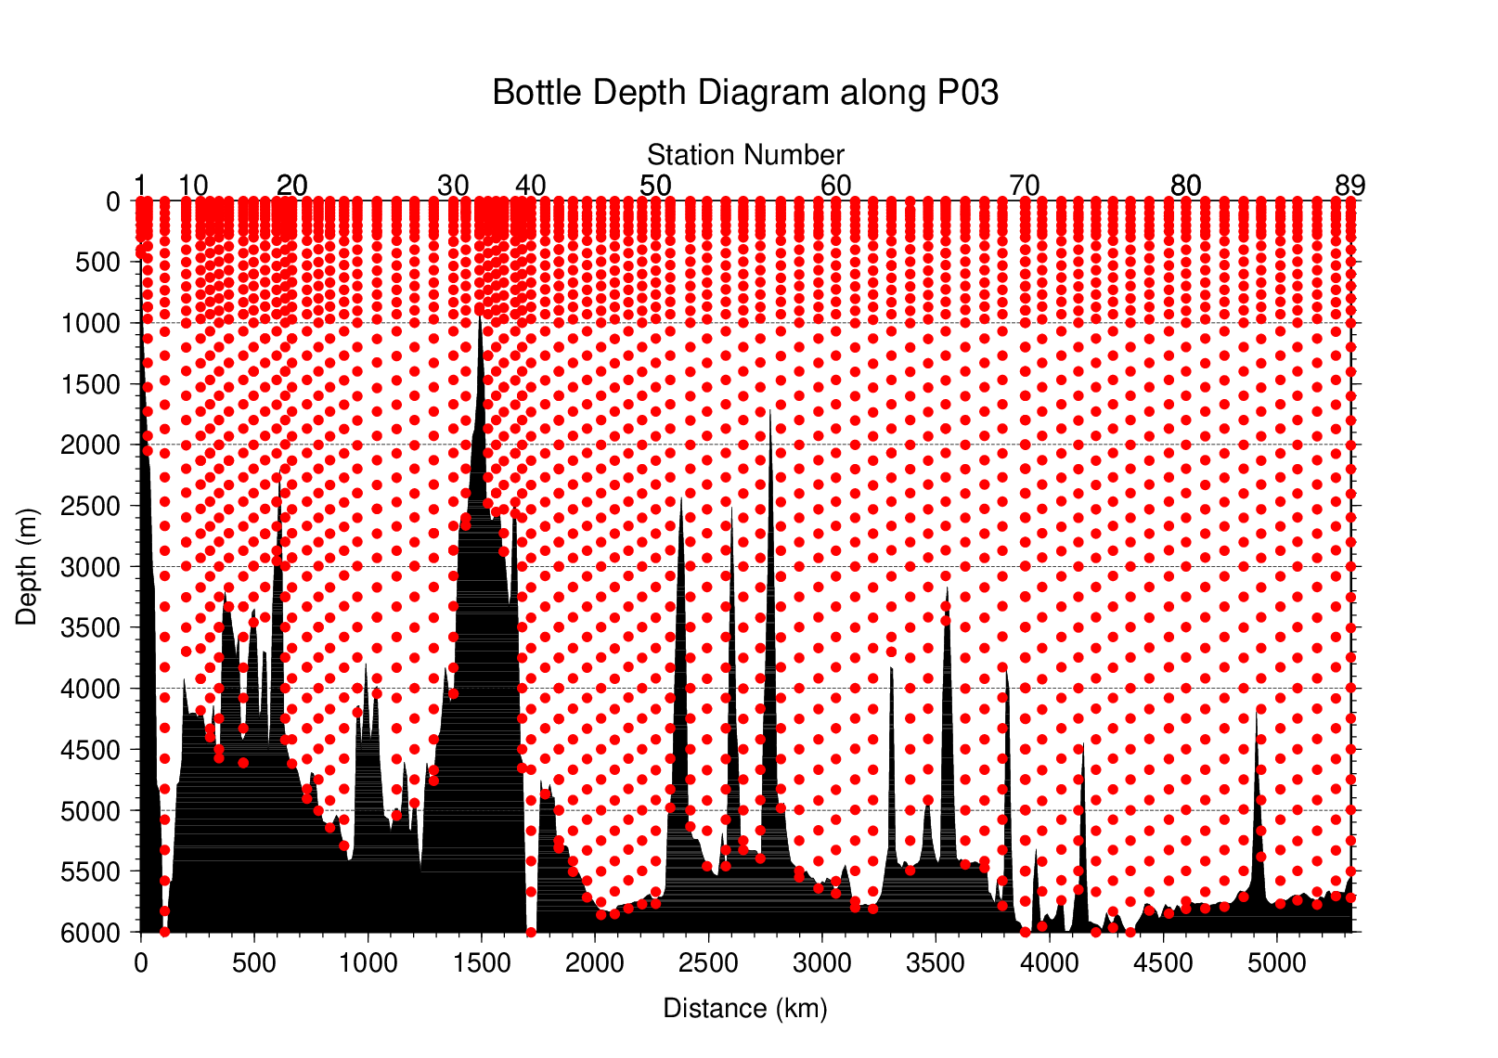
Figure A.2. The bottle depth diagram for WHP-P03 revisit.

Table A.1. The scheme of sampling layer in meters.
Bottle  count | Scheme 1 | Scheme 2 | Scheme 3
1 | 10 | 10 | 10
2 | 25  50  75  100  125  150  200  250  300  400  500  600  700  800  900  1000  1200  1400  160050 | 25 | 25
3 | 50 | 50 | 50
4 | 75 | 75 | 75
5 | 100 | 100 | 100
6 | 125 | 125 | 125
7 | 150 | 150 | 150
8 | 200 | 200 | 200
9 | 250 | 250 | 250
10 | 300 | 330 | 280
11 | 400 | 430 | 370
12 | 500 | 530 | 470
13 | 600 | 630 | 570
14 | 700 | 730 | 670
15 | 800 | 830 | 770
16 | 900 | 930 | 870
17 | 1000 | 1070 | 970
18 | 1200 | 1270 | 1130
19 | 1400 | 1470 | 1330
20 | 1600 | 1670 | 1530
21 | 1800 | 1870 | 1730
22 | 2000 | 2070 | 1930
23 | 2200 | 2270 | 2130
24 | 2400 | 2470 | 2330
25 | 2600 | 2670 | 2530
26 | 2800 | 2870 | 2730
27 | 3000 | 3080 | 2930
28 | 3250 | 3330 | 3170
29 | 3500 | 3580 | 3420
30 | 3750 | 3830 | 3670
31 | 4000 | 4080 | 3920
32 | 4250 | 4330 | 4170
33 | 4500 | 4580 | 4420
34 | 4750 | 4830 | 4670
35 | 5000 | 5080 | 4920
36 | 5250 | 5330 | 5170
37 | 5500 | 5580 | 5420
38 | 5750 | 5830 | 5670
39 | 6000 | 6000 | 6000
At some deep stations over 36 layers, some layers shown in italic may be skipped.
Table A.2(a). Station lists of RF21-06 cruise. The ‘RF’ column indicates the JMA station identification number.
Station |  | Location |  |  | Station |  | Location
Stn. | RF | Latitude | Longitude |  | Stn. | RF | Latitude | Longitude
1 | 6860 | 26-03.90 N | 127-53.90 E |  | 22 | 6881 | 24-15.17 N | 134-30.04 E
2 | 6861 | 25-59.98 N | 127-59.72 E |  | 23 | 6882 | 24-14.75 N | 135-00.08 E
3 | 6862 | 25-54.10 N | 128-08.83 E |  | 24 | 6883 | 24-15.01 N | 135-36.90 E
4 | 6863 | 25-46.45 N | 128-20.85 E |  | 25 | 6884 | 24-15.10 N | 136-11.81 E
5 | 6864 | 25-38.14 N | 128-32.74 E |  | 26 | 6885 | 24-00.04 N | 136-59.82 E
6 | 6865 | 25-30.20 N | 128-44.77 E |  | 27 | 6886 | 24-15.07 N | 137-47.76 E
7 | 6866 | 25-20.14 N | 128-59.86 E |  | 28 | 6887 | 24-14.83 N | 138-34.74 E
8 | 6867 | 25-10.18 N | 129-15.11 E |  | 29 | 6888 | 24-14.85 N | 139-24.96 E
9 | 6868 | 25-00.13 N | 129-29.84 E |  | 30 | 6889 | 24-14.76 N | 140-16.00 E
10 | 6869 | 24-50.19 N | 129-45.10 E |  | 31 | 6890 | 24-14.97 N | 140-47.95 E
11 | 6870 | 24-39.93 N | 130-00.22 E |  | 32 | 6891 | 24-15.00 N | 141-11.78 E
12 | 6871 | 24-26.92 N | 130-19.88 E |  | 33 | 6892 | 24-14.92 N | 141-24.02 E
13 | 6872 | 24-15.01 N | 130-39.86 E |  | 34 | 6893 | 24-14.90 N | 141-34.13 E
14 | 6873 | 23-59.90 N | 131-00.01 E |  | 35 | 6894 | 24-14.86 N | 141-46.03 E
15 | 6874 | 23-45.01 N | 131-32.94 E |  | 36 | 6895 | 24-14.98 N | 142-06.96 E
16 | 6875 | 23-45.10 N | 131-59.84 E |  | 37 | 6896 | 24-14.88 N | 142-26.86 E
17 | 6876 | 23-44.95 N | 132-29.96 E |  | 38 | 6897 | 24-14.89 N | 142-57.16 E
18 | 6877 | 23-45.08 N | 133-00.07 E |  | 39 | 6898 | 24-15.11 N | 143-14.01 E
19 | 6878 | 24-00.15 N | 133-15.02 E |  | 40 | 6899 | 24-15.19 N | 143-37.94 E
20 | 6879 | 24-15.08 N | 133-21.93 E |  | 41 | 6900 | 24-14.99 N | 144-15.03 E
21 | 6880 | 24-15.14 N | 134-00.02 E |  | 42 | 6901 | 24-14.98 N | 144-50.05 E

Table A.2(b). Same as Table A.2(a) but for RF21-07 cruise.
Station |  | Location |  |  | Station |  | Location
Stn. | RF | Latitude | Longitude |  | Stn. | RF | Latitude | Longitude
43 | 6910 | 24-14.78 N | 144-50.00 E |  | 57 | 6924 | 24-10.81 N | 154-26.73 E
44 | 6911 | 24-15.11 N | 145-26.81 E |  | 58 | 6925 | 24-15.09 N | 155-13.86 E
45 | 6912 | 24-14.81 N | 146-02.93 E |  | 59 | 6926 | 24-14.92 N | 156-03.88 E
46 | 6913 | 24-15.03 N | 146-40.09 E |  | 60 | 6927 | 24-14.81 N | 156-49.67 E
47 | 6914 | 24-15.14 N | 147-14.89 E |  | 61 | 6928 | 24-14.88 N | 157-39.82 E
48 | 6915 | 24-14.87 N | 147-50.69 E |  | 62 | 6929 | 24-15.11 N | 158-26.83 E
49 | 6916 | 24-15.01 N | 148-26.77 E |  | 63 | 6930 | 24-15.48 N | 159-13.96 E
50 | 6917 | 24-14.68 N | 149-01.31 E |  | 64 | 6931 | 24-14.87 N | 160-02.89 E
51 | 6918 | 24-15.60 N | 149-39.81 E |  | 65 | 6932 | 24-15.23 N | 160-49.31 E
52 | 6919 | 24-17.72 N | 150-31.21 E |  | 66 | 6933 | 24-15.18 N | 161-35.27 E
53 | 6920 | 24-14.88 N | 151-15.01 E |  | 67 | 6934 | 24-15.07 N | 162-26.71 E
54 | 6921 | 24-14.87 N | 152-03.97 E |  | 68 | 6935 | 24-14.75 N | 163-15.97 E
55 | 6922 | 24-14.84 N | 152-49.86 E |  | 69 | 6936 | 24-15.16 N | 164-02.68 E
56 | 6923 | 24-14.96 N | 153-33.80 E |  | 70 | 6937 | 24-00.15 N | 164-59.83 E

Table A.2(c). Same as Table A.2(a) but for RF21-08 cruise.
Station |  | Location |  |  | Station |  | Location
Stn. | RF | Latitude | Longitude |  | Stn. | RF | Latitude | Longitude
71 | 6956 | 23-59.86 N | 164-59.97 E |  | 81 | 6966 | 24-14.81 N | 172-44.88 E
72 | 6957 | 24-14.86 N | 165-39.84 E |  | 82 | 6967 | 24-15.01 N | 173-34.91 E
73 | 6958 | 24-14.90 N | 166-29.97 E |  | 83 | 6968 | 24-15.05 N | 174-24.87 E
74 | 6959 | 24-15.07 N | 167-14.91 E |  | 84 | 6969 | 24-14.94 N | 175-10.02 E
75 | 6960 | 24-15.06 N | 167-59.83 E |  | 85 | 6970 | 24-15.06 N | 175-59.99 E
76 | 6961 | 24-14.86 N | 168-44.95 E |  | 86 | 6971 | 24-14.98 N | 176-44.72 E
77 | 6962 | 24-15.06 N | 169-30.04 E |  | 87 | 6972 | 24-14.74 N | 177-34.95 E
78 | 6963 | 24-15.19 N | 170-19.50 E |  | 88 | 6973 | 24-15.03 N | 178-24.76 E
79 | 6964 | 24-14.78 N | 171-10.02 E |  | 89 | 6974 | 23-59.83 N | 178-59.81 E
80 | 6965 | 24-14.89 N | 171-55.00 E

Table A.3. Information of deployed float and buoy.
Float | Date and Time | Position of deployment |  | PI | Manufacturer
WMO number | of Deployment (UTC) | Latitude | Longitude
2903684 | July 21, 2021  02:30 | 30-00.12 N | 138-58.76 E | JMA | ARVOR
2903686 | August 1, 2021  18:50 | 25-00.07 N | 129-29.98 E | JMA | ARVOR
2903687 | August 9, 2021  03:40 | 24-01.10 N | 136-57.35 E | JMA | ARVOR
2903688 | August 11, 2021  07:35 | 24-14.46 N | 141-43.86 E | JMA | ARVOR
2903691 | August 28, 2021  22:53 | 31-59.28 N | 137-00.83 E | JMA | ARVOR
2903664 | October 1, 2021  00:32 | 24-17.32 N | 170-17.53 E | JAMSTEC | APEX
2903665 | October 3, 2021  03:59 | 24-16.74 N | 175-06.94 E | JAMSTEC | APEX
ARVOR: NKE Instrumentation (France)
APEX: Teledyne Webb Research (USA)

List of Principal Investigators for Measurements
The principal investigators for each parameter are listed in Table A.4.

Table A.4. List of principal investigators for each parameter.
Hydrography | CTDO₂ | CHIBA Yasuomi
 | Salinity | WADA Koichi
 | Dissolve oxygen | KAKUYA Keita
 | Nutrients | KAKUYA Keita
 | Phytopigments | KAKUYA Keita
 | DIC | ENYO Kazutaka
 | TA | ENYO Kazutaka
 | pH | ENYO Kazutaka
 | CFCs | ENYO Kazutaka
 | SF₆ | ENYO Kazutaka
 | LADCP | CHIBA Yasuomi
Underway | Meteorology | NAGAI Naoki
 | Thermo-Salinograph | ENYO Kazutaka
 | pCO₂ | ENYO Kazutaka
 | Chlorophyll a | KAKUYA Keita
 | ADCP | CHIBA Yasuomi
 | Bathymetry | CHIBA Yasuomi
Float | JMA | NAKAMURA Tetsuya
 | JAMSTEC | HOSODA Shigeki

Reference
Swift, J. H. (2010): Reference-quality water sample data: Notes on acquisition, record keeping, and evaluation. IOCCP Report No.14, ICPO Pub. 134, 2010 ver.1

