METEOR-Cruise 37/2
Cruise Report

Abstract
Leg 37/2 was performed within two major projects of basic marine research. CANIGO (Canary Islands Azores Gibraltar Observations) is a multinational project funded by the European Union to investigate by field experiments and modelling the circulation and watermasses in the subtropical eastern North Atlantic and to determine the distribution and the fluxes of a diversity of parameters in this region. ESTOC is a European time series station that has been set up since 1994 in a joint effort of four institutes from Spain and Germany 60 nm north of Gran Canaria and Tenerife, and that serves as a background station for CANIGO. The aim of leg 37/2 was to exchange and set moorings with current meters and sediment traps at selected positions at which currents and vertical particle fluxes are to be measured directly for several months. These moorings are part of a closed box of 45 stations north of the Canary Islands from which balanced fluxes will be calculated in using geostrophic currents adjusted to absolute profiles of ADCP measurements.

Zusammenfassung
Der Fahrtabschnitt M37/2 war Teil von zwei großen Projekten in der marinen Grundlagenforschung. Die Europäische Union fördert das multinationale Projekt CANIGO (Canary Islands Azores Observations). Hauptziel ist es, Zirkulation und Wassermassentransporte im subtropischen östlichen Nordatlantik und die damit zusammenhängenden Flüsse mehrerer bio-geochemischer Parameter mit Hilfe von direkten Beobachtungen und von Modellen zu bestimmen. Im einem spanisch-deutschen Projekt wird seit 1994 die Zeitserienstation ESTOC etwa 100 Km nördlich von Gran Canaria und Teneriffa betrieben. Während M37/2 sollten verankerte Strömungsmesser und Partikelfallen an ausgewählten Positionen erstmals ausgesetzt bzw ausgetauscht werden. Mit ihnen werden die vertikale Struktur von Strömung und Sedimentationsraten bestimmt. Die Verankerungspositionen waren gleichzeitig Teil einer geschlossenen Box von 45 Stationen nördlich der Kanrischen Inseln und östlich von Madeira. Ziel ist es, Balancen von Flüssen verschiedener Parameter zu berechnen. Dabei werden gestrophisch berechnete Strömungsprofile mit Hilfe von direkten Strömungen aus ADCP-Messungen an absolute Profile angepaßt.

Compiled by Thomas J. Müller
Institut für Meereskunde an der Universität Kiel
Düsternbrooker Weg 20
24105 KIEL, Germany

Phone : ++431 597 3799
Fax : ++431 597 3981
e-mail : tmueller@ifm.uni-kiel.de

Contents
Page
1 Research Objectives leg M37/2 3

2 Participants leg M37/2 4

3 Research Programme leg M37/2 6

4 Narrative of the Cruise leg M37/2 7

5 Preliminary Results leg M37/2 9
5.1 Physical and Chemical Oceanography 9
5.2 Particle flux process studies at ESTOC 10
5.3 Trace metal measurements at ESTOC, EBC and LP1 12
5.4 Measurements of Foraminifera during M37/2a 13
5.5 Bio-Optical mesurements on the CANIGO box 15
5.6 Measurements of Al and other trace metals on the CANIGO box 17
5.7 Measurements of CO₂ parameters on the CANIGO box 19
5.8 Measurements of DOC on the CANIGO box 19
5.9 Measurements of Cocolithophores and Foraminifera on the CANIGO box 20
5.10 Zooplankton as tracers in intermediate waters off Morocco at 29°N and 32°N 21

6 Ship’s Meteorological Station leg M37/2 24

7 Lists 25
7.1 METEOR 37/2 station and sample log 25

References 29

Figure captions 30

Figures 31

1 Research objectives leg M37/2
The area north of the Canary Islands and until the latitude of Madeira is characterized in the upper layers by recirculating branches of the North Atlantic’s subtropical gyre that feed the Canary Current and that are influenced by upwelling events off the African coast. This leg of Meteor cruise 37 was aimed at studying the circulation and transports of water masses, the associated fluxes of bio-geochemical parameters in the water column and through the air sea surface in this area and their variability in space and time. The work was embedded mainly in two major interdisciplinary and multinational projects: the European funded marine science and technology project CANIGO (Canary Islands Azores Gibraltar Observations) and the Spanish German ocean time series station ESTOC 100 Km north of Gran Canaria.
Methods included to use moored current meters and sediment traps to study the vertical structure of the eastern boundary current and sedimentation rates of a diversity of bio-chemical parameters at three key sites (Fig. 1, upper panel): (i) in an array of 5 moorings (EBC) east of Fuerteventura / Lanzarote, an area that is strongly influenced bay upwelling, (ii) at the open ocean time series station ESTOC which serves also as a background station for CANIGO, and (iii) at the more oligothophic station LP1 north of La Palma.
To estimate the spatial structure and variability of fluxes in the recirculation regime, a hydrographic box of 45 stations was obtained north of the Canary Islands (Fig. 1, lower panel) to estimate transports of waters masses and bio-chemical parameters. Classic hydrography along with direct current measurenments from lowered and ship mounted ADCP was used. Samling included also CO₂ parameters, DOC, Al and other trace metals, coccolithophores and diatoms, and zooplankton and fish larvae.

2 Participants leg M37/2
For logistic reasons, the leg had two parts:
Leg 37/2a: Las Palmas-Las Palmas, 28.12.1996-05.01.1997
37/2b: Las Palams-Las Palmas, 06.01.1997-22.01.1997
Leg M37/2
a b
-------------------------------------------------------------------------------------------
Müller, Thomas J. Dr. IFMK Chief Sc. ---------------
Beining, Peter Dr. IFMK Phys. Oc. ------
Busse, Markus Stud. IFMK Phys. Oc. ---------------
Cisneros-A., Jesus MSc. ULPGC Phys. Oz. ------
Garcia-R., Carlos MSc. IEO Phys. Oz. ------
Hernandez-G., Alonso Dr. ULPGC Phys. Oc. ------
Kipping, Antonius TA IFMK Moorings ------
Koy, Uwe TA IFMK CTD, floats ----------------
Lopez.-L., Federico MSc IEO Phys. Oc. ------
Meyer, Peter Dipl-Ing IFMK Moorings, CTD---------------
Rose, Henning Dipl-Phys UBT Tracer Oc. ------
Schuster, Connie TA IFMK Phys. Oc. ------

Neuer, Susanne, Dr. GeoB Part. flux ------
Kemle-v. Mücke, S. Dr. GeoB Foraminifera ------
Darling, Kate Dr. UoE Foraminifera ------
Stewart Ian Stud. UoE Foraminifera ------

Otto, Sabine Dr. UBMCh Trace metals ------
Deeken, Aloys A UBMCh Trace metals ------
Kukolka, Florian Stud. UBMCh Trace metals ------

Correira, Antonio TA UL Diatomees ------
Bollmann, Jörg Dr. ETH Cocolithoph. ------

Barth, Hans Dr. UO Marine optics ------
Zielinski, Oliver Dipl-Phys UO Marine optics ------
Loquay, Klaus TA UO Marine optics ------

Hernandez-B., Joaquin Dr. ULPGC Trace metals ------
Gelado C., Maria MSc. ULPGC Trace metals ------
Munoz, Francisco Stud. ULPGC Trace metals ------

Mintrop, Ludger Dr. GeoB CO2 ------
Gonzalez-D, Melchior Dr. ULPGC ph, Alkalin. ------
Perez, Fiz Dr. CIMV CO2 ------
Friis, Karten Stud. IFMK CO₂ ------

Cianca-A, Andres MSc. ICCM Marine chem. ------
Godoy, Juana MSc. ICCM Marine chem. ------
Perez-M., Francisco MSc ICCM Marine chem. ------
Villagarcia, Maria Dr.. ICCM Marine chem. ------

Fengler, Günther Dr. IBGM DOC ------

John, Hans-Christian Dr. BAH Zooplankton ------
Zelck, Clementine Dipl.-Biol. BAH Zooplankton ------

Participating Institutions
IFMK Institut für Meerekunde an der Universität Kiel, Germany

CIMV Consejo Superior de Investigaciones, Instituto de Investigaciones Marinas, Vigo, Spain

BAH Biologische Anstalt Helgoland, Hamburg, Germany

GeoB FB5 Geowissenschaften, Universität Bremen, Germany

IBGM Institut für Biogeochemie und Meereschemie der Universität Hamburg, Germany

ICCM Instituto Canario de Ciencias Marinas, Telde, GC, Spain

IEO Instituto Espanol de Oceanografia, Sta. Cruz, TF, Spain

UBMCh FB2 Biologie/Chemie - Meereschemie-, Universität Bremen, Germany

UBT FB1 Physik, Universität Bremen, Germany

UL Instituto de Oceanografia, Unversidade de Lisboa, Portugal

ULPGC Universidad de Las Palmas de Gran Canaria, Las Palmas, GC, Spain

UO Universität Oldenburg, FB Physik, Germany

UoE University of Edinburgh, Scotland, United Kingdom

3 Research programme leg M37/2
Along the CANIGO and ESTOC scientific goals, METEOR cruise M37/2 was aimed at providing a data base for studying the circulation and water mass transports in the subtropical eastern North Atlantic north and east of the Canary Islands. The region encompasses the eastern boundary current system. Determining the variability of the circulation and associated bio-geochemical fluxes on time scales from days to annual and longer, and on spatial scales that include the mesoscale (30 Km) up to basin scale is included. The flow field, the water mass transports and the associated bio-geochemical fluxes in the region are strongly influenced by both, the recirculation of the subtropical gyre that feeds the Canary Current and the seasonally varying trade wind field with its impact on the upwelling system and the eastern boundary current system off Marocco.
To attack the problem, basicly two methods are used. First, at selected positions the vertical structure of currents and the vertical transport of particles are measured for a period of ca 18 months from January 1997 on to cover more than one season. The sites chosen (see Fig. 1) are the ESTOC position, an array of five moorings in the eastern boundary current sytem (EBC) east of Lanzarote and Fuerteventura that will be influenced strongly by upwelling events, and a more oligithrophic open ocean position north of La Palma (LP1). Current meters and sediment traps will be moored, with a service of instruments scheduled for autumn 1997 from the German reserach vessel POSEIDON. During the first part of M37/2, it was planned to
- exchange the ESTOC current meter mooring (IFMK)
- to set the five moorings array EBC (IFMK, IEO, ULPGC, GeoB)
- to set a mooring at site LP1 (GeoB, IFMK)
- to measure the vertical particle flux in the upper 200 m near ESTOC and at the same time to perform incubation experiments (GeoB)
- to measure the concentraions and vertical fluxes of certain trace metals at the ESTOC, EBC and LP1 sites (UBMCh)
- to take samples for CFCs as reference for the time varying input function at ESTOC (UBT)
- to determine the near surface distribution of foraminifera (GeoB, UoE)

Second, a closed box north and east of the Canary Islands is designed with 45 hydrographic stations spaced between 7 nm on and close to the shelf, and 40 nm in the deep basin. On each station, bottom deep CTD and lowered ADCP measurements and water sampling for dissolved oxygen, nutrients and chlorophyll analysis build the basic hydrographic measurements to determine the flow field and the water mass distribution. Enroute, the upper ocean current profiles down to 200 m and the sea surface temperature and salinity are measured using a vessel mounted ADCP and a thermosalinograph in combimation with GPS positioning. These basic measurements on the box will be repeated in in autumn 1997 and spring 1998 with POSEIDON, and in summer 1998 with METEOR. During the second part of M37/2 these and additional samples were taken and measurements were made to
- to determine the absolute flow field and with a CTD/rosette/ADCP system and with shipborne ADCP (IFMK)
- to provide water mass information from oxygen, nutrient and chlorophyll (ICCM)
- to use optical sensors attached to a CTD for biological interpretations (UO)
- to measure parameters of the CO₂ system in the water column and at the air sea interface (IFMK, CIMV, ULPCG)
- to take samples for dissolved organic carbon DOC (IBGM)
- to take samples for coccolithophores and diatomees (ETH, UL)
- to measure aluminum and other metals in the water column (ULPGC)
- to detect fish larvae as tracers for intermediate water masses (BAH)

4 Narrative leg M37/2
For logistic reasons, this leg was divided into two parts. After loading of scientific equipment and embarking of the scientific party, METEOR sailed from Las Palmas on the 28 December 1996 in the afternoon. This first part, leg M37/2a, was aimed at mooring and station work near the centre of the CANIGO array in the eastern boundary current system (EBC), at the ESTOC station and at the more oligotrophic CANIGO position LP1 north of the island of La Palma. Here, special water sampling was performed for trace metal analysis. Near ESTOC, an experiment was designed to determine the vertical flux of particles in the surface layer. On station, plankton was caught from near the surface using pumps and handhold nets. Additional CTD stations between the mooring positions completed the hydrographic work. En route, meteorological data, sea surface temperature and salinity were measured almost continuously from the ship-borne thermosalinograph. Unfortunately, we could not measure the vertical current profiles due to a failure of the ADCP mounted on the ship’s hull. A spare was available only later for leg M37/2b.
About 4 hours after sailing for legM37/2a, we successfully performed a test station with a CTD/rosette sytem. Attached to the CTD/rosette were two acoustic releases of IFMK to test for later use in moorings.
Early in the morning next day, we arrived at the ESTOC station position at nominally 29°10’N, 15°30’W and 3610 m water depth. Here, after a CTD/rosette cast, the first two of five casts with special bottles and pumps for trace metal sampling were obtained to achieve a densely sampled profile throughout the the water column. Between these casts, at a position some 10 nm northeast of ESTOC a drifting sediment trap was deployed to measure for a few days the particle flux in the upper 200 m layer.
We then steamed to the position of the first of five CANIGO moorings that we deployed in the eastern boundary current array EBC on the 30 Dec and 31 Dec 1996 during day time. The five moorings all reach up to 150 m below the surface and carry a total of 23 current meters and 2 sediment traps. During the night and between the moooring work, five CTD stations near the mooring positions and three hydrocasts for a trace metal profile near mooring EBC3 were obtained. The CTD stations form a section across the channel between Lanzarote/Fuerteventura and the Moroccian shelf.
While steaming again to the ESTOC station, we celebrated New Year’s Eve with a mixture of German and Spanish traditions. On New Year’s Day morning, the third of five trace metal casts and a shallow CTD/rosette profile for water sampling at the ESTOC position was obtained. We then searched successfully for the drifting sediment trap for recovery. After almost immediate redeployement of the trap, another shallow CTD/rosette was taken to supply water for the incubation experiment that runs while the trap is drifting. In the afternoon, the ESTOC current meter mooring was successfully recovered after 15 months. All meters have worked. The fourth and fifth trace metal cast and a CTD/rosette cast close to the bottom with CFC sampling were obtained during the night.
We then steamed towards the position LP1 north of the island of La Palma at nominally 29°45’N, 18°00’W. We reached that position on 02 Jan 1997, performed another test with an acoustic release attached to the CTD/rosette, took the first two of three trace metal casts and a deep CTD/rosette cast. On 03 Jan 1997 we deployed CANIGO mooring LP1 with two sediment traps and three current meters. The final trace metal cast completed the work at this position..
Heading again for the ESTOC position, we took four CTD stations down to 2000 m below the Mediterranean outflow water to achieve additional information on the thermocline circulation north of the Canary Islands. The ESTOC current meter mooring was set and the drifting sediment trap successfully recovered on 04 Jan 1997. Five CTD stations towards Lanzarote/Fuerteventura completed a section that starts at the African shelf, passes the current meter array EBC and the ESTOC position and reaches to the mooring position LP1.
METEOR called port of Las Palmas on 05 Jan 1997 for personnel exchange. The groups from the IEO, ULPGC, GeoB, UBMCh, UBT and UoE involved in mooring work, trace metals, CFC and foraminifera disembarked. Embarking were groups from eight institutes from four nations.
METEOR sailed from Las Palmas for Leg M37/2b on 06 Jan 1997 in the evening. In port, a spare ADCP had been mounted in the ship’s moon pool for enroute upper ocean direct curent measurements. Leg M37/2b was aimed to measure and sample important hydrographic, chemical and bilogical parameters on a closed box north of the Canary Islands for balance and flux calculations. In addition to the upper ocean enroute current profile and sea surface temperature and salinity, pCO2 was measured by pumping water from the pool.
After a test station late in the evening on the same day, station work started on 07 Jan 1997 east of Lanzarote and Fuerteventura on the shelf at 100 m water depth with a station spacing of 7 nm that was increased to 20 nm towards the ESTOC position. Each station consisted of a bottom deep CTD/rosette cast with sampling for dissolved oxygen, nutrients and chlorophyll. Attached to the CTD/rosette was an ADCP to measure the absolute current profile in the whole water column. Also on each station, another CTD with optical sensors attached took casts down to 2000 m. Samples for the CO2 sytem, dissolved organic carbon, aluminum, coccolithophores and plankton were taken from the rosette bottles on roughly every other station. Deep plankton net hauls down to 1000 m and on some stations down to 2000 m were restricted to the continental shelf break and the adjacent deep basin.
The box basicly consists of three CTD/rosette sections: the first runs almost zonally along mooring array EBC towards ESTOC and then to a position north of La Palma at 29°10’N, 18°00’W, the second meridionally towards Madeira until 32°15’ N, the third then zonally onto the shelf until the 100 m bottom contour. A total of 45 stations were obtained on these three sections. The box was then completed with enroute ADCP measurements that ran soutwestward and almost parallel to and on the shelf break towards the EBC array.
The routine station work was interrupted by several events. First, on the westbound section a helicopter from the regional Canary Islands rescue basis supplied with a chemical that was essential for the oxygen standardization. The chemical that had been brought onboard in port had turned out not to fulfill its specifications. Next, on the southwest corner of the box, we had to interrupt the station work for several hours due to gale winds. On the northbound section, two RAFOS floats were launched to 1000 m nominal depth within the EU funded EUROFLOAT programme. Three further floats were launched on the northern eastbound section, the third one of these (No. 214) was positioned as to be caught by Meddy ‘Jani’ that was detected by CTD measurements on station 63 at 32°15’N, 12°10.1’W. Also, a sound source (SQ4/V379) was moored on this section at 32°16’ N, 13°12’ W to improve tracking of RAFOS floats that drift towards the Canary islands within the CANIGO and EUROFLOAT projects.
After having completed a final ADCP section that closed the box along the 200 m depth contour off Morocco, METEOR again headed towards the ESTOC position to obtain an XBT section with six launches from here towards Gran Canaria. This section is part of the regular monthly ESTOC station work performed by the ICCM. Leg M37/2b was completed in Las Palmas on 22 Jan 1997 early in the morning.

5 Preliminary results leg M37/2

5.1 Physical Oceanography
(T.J. Müller, P. Beining, M. Busse, A. Cianca, J. Godoy, J. Perez, J. Reppin, M. Villagarcia)

Moorings
All moorings but the ESTOC current meter mooring V367200 were set for the first time period. Therefore, data from these will be available only after instrument service in autumn 1997. Mooring V367200 was the second recovery of IFMK’s current meter mooring at the ESTOC position. The data return was good. Calibration of Aanderaa current meters RCM8 and that of the ADCP follow the manufacturer’s instructions (RDI, 1989; Aanderaa, 1995). The pressure record in the uppermost instrument shows that mooring motion was low (less 20 dbar). Salinity was derived from measured temperature and conductivity, and nominal pressure (instrument depth). All temperature measurements and the derived salinities were checked against CTD temperature profiles taken before laying and after rcovery. Linear corrections were applied where necessary. After calibration, the time series were low pass filtered with a cut off period of 36 h and then averaged to daily values.
Displayed in Figure 2 are the combined series of currents from the two settings which start in autumn 1994. No clear signal of a steady southward flowing Canary Current can be detected in the upper layers. Instead, the signals in the whole water column are dominated by mesoscale activity, some with a strong baratropic component. Note, that during the 27 month period, at least two meddies passed the ESTOC position.

Hydrography
A Neil Brown MKIIIB CTD (IFMK internal code NB2) was used to obtain continous profiles of temperature and salinity. Attached to the CTD was also an oxygen sensor. This sensor did not have an internal temperature which makes absolute calibration of this sensor difficult. On some stations, also a fluorometer was attached (see 7.1). Also attached on most of the stations was a (lowered) lADCP.
The CTD’s pressure and temperature sensors were calibrated in the laboratory to WOCE standards (better 2 mK, 3 dbar at 6000 dbar). The conductivity sensor was calibrated by comparison with the in-situ conductivity of bottle samples taken during the up profile with the rosette. CTD data processing and removal of typical nonlinear effects in sensor responses followed Müller et al. (1995). The samples were analysed with a Guildline AUTOSAL salinometer to better 0.002 psu for single samples, with a few outliers being ignored. The resulting deviations of calibrated CTD salinity from bottle salinity in up profiles is shown in figure 3. The expected error of salinity in CTD profiles is expected to be less 0.002 psu.
On the CANIGO box, nearly all bottle samples were analysed for oxygen and nutrients. Analysis for dissolved oxygen used the Winkler method with improvements to WOCE standards (WOCE Operations Manual, 1994). Samples for nutrient analysis were frozen at -20°C and then analysed at the ICCM following the WOCE standards (WOCE, 1994). For details see the first ESTOC time series report (Llinas et al., 1997).
As a first result, we display the distribution of potential temperature and salinity along the three sides of the CANIGO box (Fig. 3). Between Lanzarote and the African shelf and centered at about 800 m depth below the North Atlantic Central Water, we identify the Antarctic Intermediate Water with its salinity minimum and silicate maximum (not shown here). It probably is transported northwards with a poleward undercurrent and cannot be identified in salinity further north at 32°N. The Mediterranean Water with the salinity maximum at 1100 dbar to 1200 dbar is most pronounced in Meddy ‘Jani’ observed on the 32°N section. Outside this Meddy, the salinity maximum generally deceases to the south and west.

Direct shipborne current measurements
Attached to the CTD/rosette sytem was a 150 Khz ADCP. Lowered during CTD casts (lADCP), it measures currents relative to the vessel from which together with GPS positioning absolute currents in the water column can be derived (Fischer and Visbeck, 1993).
Another 150 Khz ADCP was mounted in the ship’s moonpool (vADCP) to continously measure current profiles in the upper 300 m. In figure 5, we display the current distribution in the upper levels. Again, no clear Canary Current can be detected, probably because the tides have not yet been removed from the signal.

5.2 Particle fluxes
(S. Neuer)

Process studies near ESTOC with drifting near surface traps
Particle flux in the ESTOC (European Station for Time-series in the Ocean, Canary Islands) region is subject to seasonal and short-term variability due to varying productivity and hydrographic conditions. Experiments with moored particle traps at the ESTOC station show that a large portion of deep particle flux originates laterally. Thus it is important to determine particulate carbon flux directly below the euphotic zone. Ideally, these sinking flux determinations need to be coupled with measurements of the standing stock and production rates of the plankton community in the euphotic zone.
To study particle flux below the euphotic zone, two types of surface-tethered particle interceptor traps (PIT) were deployed in 200 and 220 m (Fig. 6) during two mooring periods, one beginning on 29.Dec. 1996 and ending 1. Jan. 1997 and the second one starting on 1. Jan. 1997 and ending on 4. Jan. 1997. The first array was deployed northeast of the ESTOC station and drifted 26.7 km south-west at 20.7 cm/s, the second one was deployed at the recovery position and continued 32.8 km on the south-west course at 22.2 cm/s (see Tab. 1). The traps were attached to a surface spar buoy with an ARGOS transmitter, flash and a Radar reflector. The main buoyancy was located at about 30 m depth to minimize the influence of the wind-driven EKMAN layer. Several positions per day were obtained for the traps using the CLS ARGOS location service in Toulouse/France.
To quantify the plankton community in the euphotic zone during the trap deployments, samples were taken for chlorophyll, taxonomically characteristic pigments (analysed with High Pressure Liquid Chromatography, HPLC)and POC (Particulate organic carbon). All of the water samples were filtered on GF/F filters. While chlorophyll a was analysed onboard ship as an acetone extract using a Turner AU 10 fluorometer (supplied by the group of O. Llinas, ICCM Telde), POC and HPLC samples were kept frozen until analysis onshore.
During the deployment of the particle trap, I conducted 3 dilution experiments to determine phytoplankton growth and microzooplankton grazing rates onboard close to in-situ conditions. Dilution experiments were carried out mostly with water from 25 m and 50 m depth collected at the beginning of the deployment period of the particle trap. The incubations were carrried out in an on-deck incubator with neutral density screens to simulate in-situ light conditions.

Tab. 1: Inventory of GeoB activities during M37/2a, 28 Dec 1996 - 05 Jan 1997, Canary Islands
Date | Stat | GeoB | Lat N  Long W | Depth m | Start time  UTC | Chl  (depth/m) | HPLC  (depth/m) | POC  (depth/m) | Dil-Exp  (depth/m) | Mooring | Drifting  Trap
29.12 | 457 | 4245 | 29°10 15°30 | 3613 | 02:10 | 10,25,50,  75,100,150,200 | 10,25,  50,  75,100 | 10,25,50,  75,100,  150,200, 400,600,  800,1000,2000,3000 | 25,50 |  | water  for trap
29.12 | 459 | 4246 | 29°19.8  15°28.3 | 3603 | 12:35 |  |  |  |  |  | into water 200,  220m
30.12 | 463 | 4247 | 28°44.5  13°18.0 | 1197 | 12:48 |  |  |  |  | EBC 3
31.12 | 470 | 4248 | 28°40.0  12°57.0 | 498 | 4:45 |  |  |  | 25
31.12 | 471 | 4249 | 28°42.5  13°09.3 | 996 | 9:11 |  |  |  |  | EBC 2
01.01. | 2 | 4250 | 29°05.7  15°31.5 | 3608 | 12:57 |  |  |  |  |  | Recovery
01.01. | 3 | 4251 | 29°05.6  15°31.7 | 3608 | 13:03 |  |  |  |  |  | into water 200,  220m
01.01. | 4 | 4252 | 29°05.2  15°32.3 | 3612 | 13:42 | 10,25,50,  75,100,150,200 | 10,25,  50,  75,100,200 | 10,25,50,  75,100,  150,200
02.01 | 7 | 4253 | 29°03.6  15°31.0 | 3608 | 14:08 |  |  |  | 25,50
03.01 | 14 | 4254 | 28°48.2  17°57.3 | 4327 | 9:33 |  |  |  |  | LP 1
04.01 | 22 | 4255 | 28°48.2  15°35.4 | 3586 | 18:10 |  |  |  |  |  | Recover
04.01 | 23 | 4256 | 28°47.9  15°34.7 | 3585 | 18:51 | 10,50,  75,100,150 | 10,50,  75,100,150

Particle collection with moored particle traps
During M 37/2a, one particle trap each was attached to each of the Kiel current meter moorings EBC 2 and EBC 3 in the Eastern Boundary Current at 700 m depth. In addition, EBC 3 had one INFLUX current meter (group of G. Krause, AWI) attached 20 m below the particle trap. INFLUX current meters carry a fluorometer and a transmissometer in addition to CTD sensors and can thus record episodic particle sedimentation events at depth. All traps were programmed for 20x 14 days sampling intervals starting January 6, 1997.

On January 3, mooring LP 1 was deployed as the westernmost particle trap mooring in the CANIGO mooring line which covers the horizontal productivity gradient from the coastal upwelling zone to the open ocean. In this mooring line, the ESTOC mooring CI which was exchanged on M37/1 is located on about the midpoint and the particle traps in the EBC2 and EBC3 arrays are located on the eastern end of the gradient.
Mooring LP 1 is equipped with two particle traps in 1028 m and 3780 m and one INFLUX current meter in 1048 m depth (Table 2 ). All traps were programmed for 20 x 14 days sampling intervals starting January 6, 1997.

Tab. 2: Instruments used and deployment depths on mooring LP 1
Mooring Position Water Sampling Instrument Depth Intervals
depth interval (m)

LP1 29°45,73 4327 6.01.1997- RCM 5 850
13.10.1997 SMT 234 1028 20x14 days
INFLUX 1048
RCM 5 1570
SMT 230 3780 20x14 days

Instruments:
S/MT 234, Particle trap, Aquatec Meerestechnik , Kiel
S/MT 230 Particle trap, Sazgitter Electronik , Kiel
INFLUX INFLUX current meter (group G. Krause, AWI) with CTD, fluorometer, transmissometer
RCM 5 Aanderaa current meter

5.3 Trace metal measurements at ESTOC, EBC and LP1
(A. Deeken, F. Kukolka, S. Otto)
The interaction of particles and water is a key process for the biogeochemical cycling of chemical elements in the ocean. Uptake onto particulate matter and subsequent sinking mechanisms (scavenging) is the major control on the chemical composition of seawater and maintains the concentrations of many elements in seawater rather low. The particulate matter itself consists of (i) suspended particulate matter (SPM) which is supposed to consist of almost non-sinkable biogenic and terrestrial detritus with a large surface area and (ii) the relative fast sinking particles found in sediment traps, responsible for the vertical transport to the sediments. The comparison of the trace element composition and distribution in these three different phases (dissolved, SPM and particulate trap material) are excepted to provide important clues on transport and sorption mechanisms as well as on the general geochemical behavior of these elements in the ocean.

Our task during this cruise was to examine the vertical distribution of trace metals in dissolved and suspended form in the water column. For this purpose, we investigated three different mooring locations, reaching from the eutrophic coast-near region off Africa towards the more oligotrophic open ocean. Samples of dissolved trace metals and suspended particulate matter were collected from the entire water column by means of GoFlo bottles and in situ filtration using special in situ pumps. Bottle casts combined with in situ SPM collections were performed at station EBC 3 (east of the islands Lanzarote and Fuerteventura), at the ESTOC station and at station LP (north of La Palma). The positions occupied were sampled with a high vertical resolution (sixteen to twenty-nine sampling depths). All samples were collected rigorously applying clean sampling techniques to avoid contamination as far as possible. GoFlo bottles and in situ pumps were attached to a non-metallic wire and sample processing was done inside a clean bench. Dissolved trace element samples were pressure-filtered with nitrogen gas through pre-cleaned 0.4 µm polycarbonate membranes directly from the sampling bottles, whereas SPM was sampled onto filters of identical material.
Due to technical problems with the new generation of in situ pumps used, sampling of SPM was reduced at all positions. At the ESTOC station, SPM samples from nine depths, at EBC 3 six samples and at LP two SPM samples were obtained.
Besides trace metal sampling, water samples were analyzed for nutrients as well as for oxygen. The nutrients nitrate, phosphate and silicate were determined according to standard photometric procedures. Oxygen was analyzed through titration using the Winkler method. The only trace metal to be determined onboard was total dissolvable Aluminium by a fluorescence method. All other dissolved trace metals will be analyzed onshore, as well as the filters from the in situ pumps.

5.4 Foraminifera

Net Sampling for Planktic Foraminifera
(S. Kemle-von Mücke)
Plankton samples were collected from about 5 m water depth using the shipboard fire pump system. The sea water was filtered through a plankton net with a mesh size of 70 microns each day. The aim was to collect planktic foraminifera to investigate the species assemblage and abundance for later comparison with temperature, salinity, chlorophyll a content and nutrient concentration in the surface water. Apart from the first two samples, the planktic foraminifera were picked out from the plankton sample and oxidized with 3,8 % NaOCl buffered with NadiBorat to obtain clean foraminifera shells. The foraminifera were rinsed with distilled water and 96 % ethanol and stored in fema cells. Site locations of the sampling are listed in Table 3. The temperature and salinity data given in the table originate from the ship thermosalinometer.
Only very few foraminifera were found in all the samples and these foraminifera were so small that it was often difficult to accurately identify the species. The dominant species was Turborotalita. humilis followed by Globigerinella siphonifera, (Globigerinella calida), Globigerinita glutinata, Globigerinoides ruber. Other species found were Globorotalia crassaformis, Globorotalia inflata, Globigerina bulloides,(may be Globigerina falconensis or Orbulina universa), Turborotalita quinqueloba. By far the most common zooplankton were the copepods. In addition, various zooplankton were present: euphausides, pteropods, some ostracodes, radiolarian, dinoflagellates and diatoms.

Tab. 3: Planktic foraminifera net sampling data.
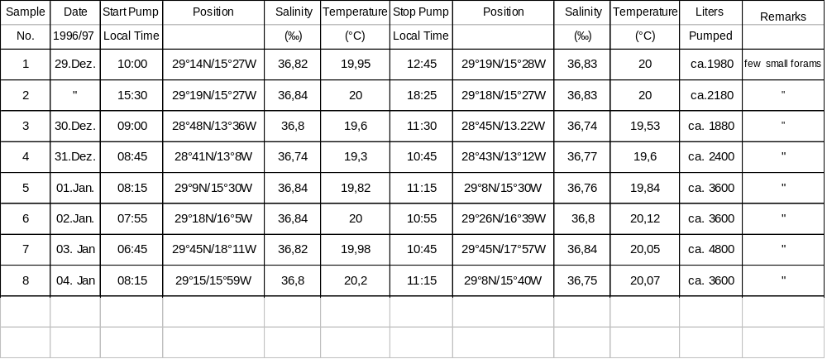

Collection of Planktic Foraminifera for DNA Analysis
(K. Darling, I. Stewart)
The foraminifera were collected by pumping sea water through a 70 micron mesh net as described in the preceding paragraph. The plankton net was also deployed approximately four metres below the water surface for two periods of ten minutes. Little difference was found between the two collection methods. As the collection was made for DNA analysis, it was not necessary to quantitatively estimate the foraminiferal assemblage per volume of water. Pumping was therefore continuous, with serial samples being taken at short time intervals to maximise the viability of the living cells and to allow time for species identification. The sampling details are outlined in Table 4. Following selection of individual specimens, they were crushed into 30µl of buffer to protect the DNA from enzymatic activity. The samples were then individually labelled and stored at -20°C.
Foraminifers were scarce in the surface waters and positive identification of individual species proved difficult, as the foraminifers throughout the whole of the collection period were immature. It is therefore not possible to provide an accurate species list at this stage. We found Turborotalita humilis, Globigerinella siphonifera (which possibly includes Type I and Type II forms of G. siphonifera and G. calida), Globigerinita glutinata, Globigerinoides ruber (pink and white forms). In addition we found five specimens of Neogloboquadrina (intergrade) and single specimens of Globigerinoides sacculifer and Globorotalia truncatulinoides. Other species found were possibly Globigerina bulloides / Globigerina falconensis and Orbulina universa. DNA analysis will provide a more accurate species list when sequence alignment can be made against known species within the DNA database. A total of 123 individual specimens were taken for analysis.

Table 4. Sampling data for the collection of planktic foraminifers for DNA analysis.
Sample day | Date | Pump start time | Position | Salinity °/oo | Temp. °C | Pump stop time | Position | Salinity °/oo | Temp. °C | Litres pumped
1 | 29.12.96 | 13.00 | 29°20N/15°28W | 36.83 | 19.9 | 15.00 | 29°20N/ 15°28W | 36.84 | 20.0 | 1400
2 | 30.12.96 | 11.30 | 28°45N/13°22W | 36.74 | 19.5 | 15.30 | 28°45N/ 13°19W | 36.74 | 19.4 | 2800
3 | 31.12.96 | 11.00 | 28°41N/13°09W | 36.77 | 19.2 | 12.30 | 28°41N/ 13°09W | 36.76 | 19.2 | 1050
4 | 1.1.97 | 12.00 | 29°05N/15°32W | 36.76 | 19.7 | 16.00 | 29°05N/ 15°32W | 36.84 | 19.7 | 4800
5 | 2.1.97 | 11.00 | 29°31N/17°02W | 36.80 | 19.8 | 16.00 | 29°37N/ 17°27W | 36.87 | 19.8 | 7000
6 | 3.1.97 | 10.45 | 29°45N/17°57W | 36.84 | 19.7 | 18.30 | 29°44N/ 17°58W | 36.80 | 19.7 | 9300
7 | 4.1.97 | 11.15 | 29°09N/15°40W | 36.75 | 19.7 | 18.00 | 28°47N/  15°34W | 36.75 | 19.5 | 8100

5.5 Bio-optical measurements on the CANIGO box
(Hans Barth, Klaus Loquay, Oliver Zielinski)

Introduction
The main element in the flow of dissolved and particulate organic matter and of living organisms is carbon. Calculations which include only chemical and physical properties of the ocean for the exchange of carbon lead to wrong predictions. Only the inclusion of biological activities can fill this gap in understanding the carbon cycle. In January and February the hydrographic conditions of the Canary Island region are characterised by coastal upwelling of intermediate water to the surface and by an increase in phytoplankton growth. One of the main objectives is to study the carbon assimilation and transport mechanisms by biological activities to understand and quantify the amount of carbon which is transported to deep waters by mixing and sinking.
Dissolved and particulate substances in seawater can be sensitively characterised by optical methods. The method is very fast since it does need any preparation of samples. Gelbstoff as a major compound of marine DOM, chlorophyll a and other phytoplankton pigments like phycoerythrin, fucoxanthin and fucocyanin, and the aromatic amino acid tryptophan can be measured with fluorescence methods. The attenuation coefficient is an optical parameter which depends sensitively on suspended and dissolved substances. Its measurement is of interest not only for the understanding of optical conditions in water, but it also allows for a fast determination of absorbing and scattering matter in the form of depth profiles, which can hardly be obtained with other methods in realtime.

Optical parameters have met the interest of oceanographers and limnologists for a long time. Devices which measure optical data are utilised to classify water masses on the basis of optical properties and to obtain information on particulate matter or dissolved organic substances. The most prominent instruments of that kind used in the present study are the following:

Laboratory Instruments: | In situ Instruments:
Spectrofluorometer | Multi Channel Fluorometer
Spectrophotometer | Polychromatic Transmissometer
 | Radiometer

For hydrographic parameters a CTD is added to the in situ probes. All of these instruments are connected by a central underwater unit to obtain simultaneous data sets from the water column (down to 3000m).

Methods
The following instruments were used throughout the campaign (Fig. 7, 8):

Spectrophotometer:

Type: Perkin Elmer, Lambda-18
Measurements: Absorption of filtrated (Whatman GF/F) and unfiltrated samples in the range from 189.6 to 700 nm. Yellow substance concentration can be derived by interpretation of the spectra.

Spectrofluorometer:
Type: Perkin Elmer, LS-50
Measurements: Five different excitation scans were used

Scan | Excitation  wavelength [nm] | Ramanpeak [nm] | detected substance with  relevant wavelength [nm]
A | 530 | 646.5 | Chlorophyll a at 680 nm
B | 420 | 490.0 | Chlorophyll a at 680 nm
H | 308 | 344.0 | Tryptophan at 340 nm  Gelbstoff at 420 nm
J | 270 | 397.3 | Tryptophan at 340 nm  Gelbstoff at 440 nm
N | 230 | 249.5 | Tyrosine at 300 nm  Tryptophan at 340 nm  Gelbstoff at 420 nm

Multi Channel Fluorometer:

Type: Prototype
Measurements: Using two excitation wavelengths (270 nm and 420 nm) from a Xe-flashlamp spectrum via optical filters, the following substances are detected:
Raman at 397.3 nm and 490.0 nm, Chlorophyll, yellow substance, Tryptophan, Phycoerythrin and Fucoxanthin.

Polychromatic Transmissometer:

Type: Prototype
Measurements: Attenuation coefficient in the range of 370 nm to 730 nm at 134 wavelengths. The optical pathlength is adjustable to different turbidity situations.

Radiometer:

Type: Prototype
Measurements: Underwater light field (vectorial irradiance), upwelling and downwelling in the range of 370 nm to 730 nm at 67 wavelengths.

CTD:

Type: Meerestechnik Elektronik, OTS 1500
Measurements: Pressure, conductivity and temperature. Calculated components include salinity and sound speed.

Data sampling
Water samples from the Niskin Sampler were taken (if available) at every station from the CTD/rosette following this scheme: 10m, 25m, 50m, 75m, 100m, 125m, 300m, 1000m, 1250m, 1500m depth and 20m above seafloor. The optical sensors were used at every station down to a depth of 1500m. Station 38 was probed down to 2070m, station 63 where the Meddy ‘Jani’ was observed (Fig. 9) down to 1800m. Underwater light field measurements were carried out only at daytime starting with station 56.
.

5.6 Measurements of Al and other trace metals on the CANIGO box
(M.D. Gelado-Caballero, F.J. Martin- Muñoz and J.J.Hernández-Brito)

Introduction
Aluminium distributions in Canary Islands (Central East Atlantic Waters) show a great variability [Gelado-Caballero et al. , 1996]. The area possesses major features that could affect the aluminium biogeochemical behaviour, such as elevated aeolian (dust) inputs from the Sahara desert, proximity to areas of upwelling (150-200 Km) and mesoscale features induced by the effect islands on the course of the Canary Current. The aluminium distributions show a marked latitudinal gradient from East to West. The study of the Al variations along these gradients and at a fixed station could give a better knowledge of the physical and biogeochemical processes controlling mesoescale distribution of aluminium in the area.

Al determinations
The HPACSV (High Performance Adsorptive Cathodic Stripping Voltametry) method (Hernández-Brito et al., 1994a) was used to measure on board dissolved aluminium in seawater. Samples are prepared in Teflon cups of polarographic cell, containing 10 ml of water, 2·10-6 M DASA and 0.01 M BES. The solution is purged using nitrogen (3 minutes) to remove dissolved oxygen. The adsorption potential (-0.9 V) is applied to the working electrode, while the solution is stirred. After 40s accumulation time, the stirring is stopped and 5 s is allowed for the solution to became quiescent. The scanning is started at -0.9 V and terminated at -1.4 V. The scan is made using staircase modulation with a scan rate of 30 V/s and a pulse height of 5 mV. The DASA-Al peak appears at ca. -1.25 V. A standard addition procedure is used to quantify the aluminium concentration of the sample. Determinations were carried out in a flow bench class-100 to avoid contamination of the sample by dust particles.
The electrochemical system used has been designed to measure the instantaneous currents at short times with a low noise level (Hernandez-Brito et al., 1994b). Thus, the analytical time required for each sample is substantially reduced, allowing an increase of measurements on board. A PAR- 303A electrochemical cell with hanging mercury drop electrode (HMDE) was connected to a specially made computer-controlled potentiostat.

The reproducibility of the method was less than 4% for a 21 nM Al concentration based on seven replicates sampled at 2000 m (28°25.40´ N 15° 24.70´W). A detection limit of 2.5 nM was calculated using these results.

The water sampling was carried out using Niskin bottles provided with silicone rubber and stain steel springs. Replicated samples taken at the same depth showed no significant contamination from the springs (less than 4%). The possible contamination by the rosette frame was tested by comparison with seawater sampled using a rubber boat. Aluminium values using both devices showed differences within the experimental error (4%). Samples were taken and manipulated wearing plastic gloves to avoid contamination. Additional samples were frozen at polyethylene bottles to carry out analysis at the land-based laboratory. Every container has been previously cleaned using conventional procedures in the trace metal assay.

Preliminary results
More than 500 samples were analysed on board. Preliminary results shows that aluminium distribution in the water columns appears to be related with the physical and biogeochemical processes in the area sampled. Aluminium distribution in the surface waters shows a winter mixed surface layer without the maximum concentrations found during previous cruises at summer and fall at the area. Mid-depth aluminium distributions seem to be related to the water masses. Low Al values have been found (800 m) in the channel between Lanzarote and the African continental slope. Low salinity waters have been measured at the same depth. Stations located west of Lanzarote show higher aluminium concentrations and no salinity minimum at this deepness. An aluminium maximum appears at intermediate waters (1000-1300 m) and it seems to be related with the intrusion of Mediterranean waters. A minimum in the aluminium distributions occurs below the Mediterranean waters. The aluminium concentrations increase again below 2500m. Stations close to the continental slope show higher aluminium near the bottom layer. It could be an indication of sediment dissolution or lateral transport of sediment at the deep layers. The profiles in the western most stations show no significant alterations near the bottom.

5.7 Measurements of CO2 on the CANIGO box
(L. Mintrop, M. Gonzalez-Davila, F.F. Perez)

A total of 351 samples were drawn and immediately analyzed for total dissolved inorganic carbon (C_{T}). 18 further samples were drawn from 6 sample bottles (3 each), which had been closed at 3 different depth ( 10, 3799, 1100m ) at stations 59, 62, 64, and 65. These samples served for an alkalinity intercalibration between the 3 different CO₂ - workgroups and were measured after the cruise. The analytical methods involved are a coulometric titration technique for C_{T} (SOMMA-system, Johnson et al., 1994; DOE, 1994) and potentiometric titration for A_{T}, basically according to Millero et al. (1993), but carried out in an open vessel (VINDTA-system, Mintrop, 1996, unpubl.). Alkalinity was calculated from the titration curve by a curve fitting procedure (Millero and Campbell, 1994). The coulometric system was calibrated with pure CO₂ (gas calibration) and tested by running different batches of certified reference material (CRM, provided by A. Dickson, SIO, La Jolla, CA, U.S.A.). The same CRMs were also used to monitor alkalinity titrations. For the VINDTA system, the pipette volume was determined by filling with distilled water and weighting, the acid used was prepared in a batch, and the acid factor of the batch was determined coulometrically (A. Dickson, pers. comm.). The precision (between-bottle reproducibility) as judged from regular measurements of duplicate samples was 0.5 µmol.kg⁻¹ for C_{T} and 0.5 µmol.kg⁻¹ for A_{T}. Accuracy of the data has been estimated to be about 1.5 µmol.kg⁻¹ for C_{T} and 2.0 µmol.kg⁻¹ for A_{T}.

The alkalinity intercomparison gave a very close agreement of the results for the three groups involved within the precision of the method (within ± 1 µmol.kg⁻¹ ) thus allowing perfect data exchange within the groups for the future. The determination of dissolved inorganic carbon gave distinct differences in the depth distribution for the northern and southern zonal transects. We hope to be able to calculate carbon transport with the help of hydrogaphical data and estimates for water transport rates resulting from the investigations of the physical oceanography work groups. Figure 10 shows an isoplot along the southern transect towards east, the meridional transect northbound and the zonal continuation along the northern transect back to the African coast. Outstanding feature is the maximum at 1000-1500m depth, indicating the Mediterranean outflow; higher values at depth in the southern transect in comparison to the northern transect indicate the prevalence of southern component water here.

5.8 Measurements of DOC on the CANIGO box
(G. Fengler)

Introduction
Dissolved organic carbon (DOC) in the ocean contain a total mass of carbon comparable to that in the atmosphere (Hedges, 1992). Consequently small changes in the cycling of DOC have a potentially large impact on the global carbon cycle. Despite this importance, DOC still continues to be the least understood pool of carbon. Many recent studies have addressed the question of the nature of DOC and the problems involved in its measurements (e.g. Sugimura & Suzuki, 1988; Suzuki 1993; Hedges & Lee, 1993; Sharp, 1993; Cauwet, 1994).
The objective of this study is, to determine the spatial distribution of DOC within the research area.

Methods
Ultra-clean sampling and filtration techniques were employed on samples recovered from CTD-Hydro-casts (see 7.1). DOC is operationally defined here as all organic carbon passing a glass fibre filter (GF/F, Whatman precombusted at 4500 C for 5h). Quantitative analyses of DOC will be performed within the laboratories of the Institute of Biogeochemistry and Marine Chemistry at the University of Hamburg by using the high-temperature oxidation (HTCO) method in which a home-made DOC-analyser will be used. After carbonate removal by acidification to a pH of 2 with 50% H3PO4 and subsequent purging (10 min with CO2 free oxygen), 100 µl samples will be injected directly onto the pure platinum catalyst (Ionics, Inc.) and oxidise at 8000 C. The effluent from the furnace passes through a water separator, a mossy tintrap to remove HCl gas, through a cold trap at 10 C, a MgClO4 trap, a particle filter (Balston Type 9900-05-BK DFU) and finally into an IR analyser (Licor 6252). Oxygen will be used as the carrier gas at 130 ml/min. Peak areas will be determined with an Hewlett Packard 3396A integrator. The calibration of the DOC-Analyser will be done with a series of potassium hydrogenophtalate standard solutions.

5.9 Measurements of cocolithophores and diatomes on the CANIGO box

Coccolithophores
(J. Bollmann)
Coccolithophore sampling during cruise M37/2B is part of CANIGO Subproject 3. The scientific goals are (a) to obtain a better understanding of the seasonal and interannual interaction between coccolithophores and the physical environment and (b) to compare this interaction with the long-term variability of coccolith composition and flux into the sedimentary archives.
During cruise M37/2b, water casts of 10 litres were taken at 23 stations and the following water depth levels were sampled: 0, 10, 25, 50, 75, 100, 125, 150, 200, 250, 300 meters. 13 stations were sampled along a zonal transect from the African coast to La Palma, 2 stations were sampled during the meridional transect from La Palma to Madeira and 8 stations during the zonal transect from Madeira towards the African coast (Fig.. 1, see also 7.1).
Carboys were rinsed twice (about 0.5 litres) with tap water and up to 8 litres of water were transferred from the Niskin bottles for each depth level into carboys. Within one hour the water was filtered onboard through Nucleopore PC filters (0.8µm, 47 mm diameter) using a low-vacuum filteration device. Filtration was terminated if the filter became clogged up and the amount of remaining water was measured and noted. After filtration the filters were rinsed with 50ml of distilled water to eliminate all traces of sea salt, to which 1-2 drops of NH4OH per litre were added to obtain a pH of about 8.5 to prevent carbonate dissolution. Rinsed filters were transferred to labelled petri-dishes, dried immediately in an oven at 55 ° and stored in a refrigerator.
In subsequent analyses using a Scanning Electron Microscope cell density (#/l) and taxonomic composition of the coccolithophore populations will be determined. In addition morphological features of Gephyrocapsa sp. and Calcidiscus leptoporus will be analysed.

Diatoms
(J. Bollmann, Antonio Correira)
Diatom sampling during cruise M37/2b is part of the CANIGO Subproject 3.
The scientific goals are (a) to determine diatom standing stock and assemblage compostion at distinct water depth levels and (b) to construct transfer functions between diatom abundances and assemblages and environmental parameters and (c) to compare the results of these analyses with long-term variability of diatom compositions in sediments and diatom flux into the sedimentary archives.
During cruise M37/2b water casts of 10 litres were taken at 11 stations along a zonal transect from the African coast to La Palma and the following water depth levels were sampled: 0, 10, 25, 50, 75, 100, 125, 150, 200, 250, 300 meters. 200 ml water were transfered from Niskin bottles into plastic bottles and Formol and Hexamethyl-Tetramine was added.
At 25 stations a plankton net with 63 µm mesh size was used to sample diatoms within the upper 100 m water column (intergrated sampling). The net was released to 100m water depth and was pulled with 0.3 m/s back to the surface. Subsequently the net was rinsed with sea water and the catch was tranfered into a plastic bottle and Glutardialdehyde was added.
In subsequent analyses using a light microscope and if necessary a Scanning Electron Microscope, diatom standing stock and assemblage composition will be determined.

5.10 Zooplankton as tracers in intermediate waters off Morocco at 29°N and 32°N
(H.-Ch. John, C. Zelck)

Purpose
It is intended to analyse the intermediate meridional plankton transports along the Moroccan continental slope. It is presumed that some tropical planktonic species reach Morocco by means of a narrow poleward undercurrent located at about 400 to 800 m depth, whilst other, more northern species drift southwards in a zonally broader band influenced by the Mediterranean Outflow Water (MOW), located at broadly 1000 m depth. The bottom topography of the Canary Archipelago is likely to disturb both flows at least locally.

Sampling
Mesozooplankton of the 300 µm size fraction was sampled by vertical tows with a multiple-opening-closing net (MUV). The MUV had an integrated CTD-system with real-time data transfer to the lab. Sampling was generally done between 1000 m and the surface, separated into 5 strata 200 m wide each, unless shallower bottom depths interfered. In these cases narrower strata were sampled. Six additional deep stepwise tows down to 2000 m were also made on identical positions. Details on the tows and vertical resolution are listed in Table 5, haul positions are listed in Section 7.1.
All stations yielded succesful tows, except that three malfunctions of the sampler resulted in integrations of two depth strata each (Table 5). One stratum was completely lost due to a torn net. Some of the CTD-files show spikes, for which the reasons are still unknown, but the data can be recovered.
The stations ran broadly zonal and cross-slope along the transects at approoximately 29°N and 32°N, except for test station no. 1. The station spacing was from the shelf edge across the continental slope approximately 5-6 nautical miles (n.m.), but increased from 10 to 60 n.m. in the open ocean.

Tab. 5: MUV-tows obtained during leg 2 of „Meteor“ cruise 37. Listed are ship station versus haul numbers, the depth strata sampled and the abundance of fish larvae (as far as analysed during the cruise).
Sta Haul Net 1 Net 2 Net 3 Net 4 Net 5 N Fish
# # (m) (m) (m) (m) (m) /1m²
26 1 1000-800 800-600 600-400 400-200 200-0 92
29 2 240-200 200-150 150-100 100-50 50-0 64
30 3 350-300 300-200 200-100 100-50 50-0 88
31 4 575-400 400-300 300-200 200-100 100-0 32
32 5 795-600 600-400 400-200 200-100 100-0 48
33 6 1000-800 800-600 600-400 - 400-0 56
34 7 1000-800 800-600 600-400 400-200 200-0 28
35 8 1000-800 800-600 600-400 400-200 200-0 60
36 9 800-600 600-400 400-200 200-100 100-0 124
37 10 985-800 800-600 600-400 400-200 200-0 60
38 11 2000-1600 1600-1400 1400-1200 1200-1000 1000-0 28
38 12 1000-800 800-600 600-400 400-200 200-0 0
39 13 1000-800 800-600 600-400 400-200 200-0 52
39 14 2000-1600 1600-1400 1400-1200 1200-1000 1000-0
40 15 1000-800 800-600 600-400 400-200 200-0
42 16 1000-600 600-400 400-200 200-100 100-0
44 17 1000-800 800-600 600-400 400-200 200-0
46 18 1000-800 800-600 600-400 400-200 200-0
49 19 1000-800 800-600 600-400 - 400-0
62 20 1000-800 800-600 600-400 400-200 200-0
62 21 2000-1600 1600-1400 1400-1200 1200-1000 1000-0
63 22 1000-800 800-600 600-400 400-200 200-0
64 23 1000-800 800-600 600-400 400-200 200-0
65 24 1000-800 800-600 600-400 400-200 200-0

65 25 2000-1600 1600-1400 1400-1200 1200-1000 1000-0
66 26 1000-800 800-600 600-400 400-200 200-0

66 27 2000-1600 1600-1400 1400-1200 1200-1000 1000-0
67 28 1000-800 800-600 600-400 400-200 200-0

67 29 2000-1600 1600-1400 1400-1200 1200-1000 1000-0
68 30 1000-800 800-600 600-400 400-200 200-0
69 31 1000-800 800-600 600-400 400-200 200-0
70 32 500-400 400-300 300-200 200-100 100-0

Results
On board, only the first 12 hauls could be coarsely analysed. The fish larvae abundances (included in Table 5) are perhaps slight underestimates due to both, the quick check and the ical tows. The material is generally in excellent conditions.

Ichthyology
We obtained a developmental series from early larvae to transforming specimens of lanternfish Lobianchia dofleini. Such series are known to science and are adequately described, but larvae of this species have previously not been caught by us and were missing from the collections of „Zoologisches Museum Hamburg“.
We identified a transforming specimen of deep-sea smelt Bathylagus greyae. The larval development of B. greyae was previously unknown, contrary to most other Atlantic bathylagids. We caught also two early bathylagid larvae. These lacked meristic features for identification, but they showed a similar basic pigment pattern as the transforming B. greyae, and they definitely not belonged to any of the known species.
We caught in one of the deep hauls a transforming larva of the bathypelagic family Searsiidae. The specimen is by meristic characters and postopercular pores with a high degree of certainty referable to Normichthys operosus. The ontogeny of Searsiidae seems to be completely unknown in spite of being a large family with 31 species.
The remaining fish species are well known to us. The ichthyocoenosis appears to have by diversity and some indicator species (Vinciguerria nimbaria, Engraulis encrasicolus, no Clupeidae) a warm-water character both near-shore and offshore. Within the archipelago neritic and oceanic species co-occurred. The highest abundances were found at the slopes (table 1).

Invertebrates
We caught in two hauls two bathypelagic Nemertini which have to be handed to experts. They appear to us laymen remarkable in that one seems to deviate from normal organisation by a dorsal insertion of the lateral nerves. The other, less transparent one is an egg-bearing female folding its sides ventrally to form a „marsupium“ and shoowing „leg-like“ appendages in front and behind the marsupium.
The upwelling-systems copepod Calanoides carinatus was almost absent from the samples. Only two specimens were so far found within the Canary Archipelago.

Meridional plankton drift
Potential indicators for the poleward intermediate undercurrent were found only within the archipelago itself, but not at the Moroccan slope. The flow there may have been weak or non-existent during the warm conditions. The tropical mesopelagic fish Cyclothone livida seems to be frequent and to coincide in depth with a poleward flow passing through the archipelago. It needs further analysis to establish its offshore boundaries.
No species indicating the MOW (Cyclothone pygmaea, Ceratoscopelus maderensis) have so far been found, but the majority of deep tows has yet to be analysed.

6. Ship’s Meteorological Station

Cruise, course and weather
At 16:00 UTC of December 28th, 1996 METEOR cruised out of Las Palmas. Being north of the Canary Islands we were situated at the edge of a low west of Portugal. There we mostly had moderate westerly winds, only when we were passed by cold fronts we experienced Bft 6 to 7 with showersqualls, even a few thunderthorms were observed.
After the interruption of the cruise at Las Palmas at January 5th and 6th, 1997 a low moved eastwards far north of the Canary Islands. Thus, there were some showers but only southwesterly winds Bft 4 to 5. Lateron we were infuenced by a high pressure cell with only light to moderate winds. From January 12th to 14th an intense low was situated in the area of Madeira. Being north of La Palma we had some spells with Bft 8 and heavy showers and thunderstorms. While cruising the hydrographic box the low was filling on our way to Madeira and the windspeed decreased. From January 15th to 18th we were steaming eastwards at roughly 32øN. At those days we were situated north of a high with southwesterly winds Bft 4 to 5. At the last days of the cruise near the Moroccan coast we were influenced by a low moving from the Biscay towards the Canary Islands. Thus, we experienced some periods with Bft 6 and heavy showers. In the morning hours of January 22th METEOR reached Las Palmas again.

Activities of the ship’s weather watch
Two written weather reports were generated daily for the scientific and nautical crew. These reports were explained verbally in greater detail. Except for some observations from the ship’s weather station, the basis for the forecasts were synoptic weather charts which were produced twice a day using the 6:00 and 12:00 UTC meteorological observations from islands and ships of the northern Atlantic and land stations of western Europe. Additionnally, forecast charts of the DWD (Deutscher Wetterdienst), the ECMF (European Centre of Middle Range Weather Forecasts) and the English weather service in Bracknell were used. Eight weather observations per day were generated, six of them with cloud and sea observations. These were transferred into the international observation network via the DCP (Data Collecting Platform). At last, many meteorological parameters (wind direction and speed, moisture, precipitation rates, radiation, temperature of air and water) were continually measured and recorded.
7. Lists

7.1 METEOR cruise 37/2 station and sample log
Status: 30 Oct 1997

Last changes:
Station 68, profile 93, positon to 32 04.850, 010 05.868
CFCs sampled at station 7, profile 11

List of abbreviations:
St : Station no.
Pr : CTD profile no., monotonically increasing during the cruise
Wd : Waterdepth
Instr : Type of instrumentation or mooring or equipment
NBX : Neil Brown CTD probe no X with 21x10 l bottle rosette
RXXX : RAFOS float no. XXX
VXXX : Mooring no XXX
DTRAP: Drifting sediment traps
TRACE: Cast for trace elements with GoFlo bottles and in-situ
pumps on Kevlaer rope
XBTJJ : XBT type T7, profile no JJ

Parameter list for CTD/rosette:
1 Ctd with optic sensors ahead or after CTD/rosette
2 lowered ADCP (LADCP) on CTD/rosette
3 rosette
4 oxygen
5 carbon dioxide system components
6 dissolved organic carbon (DOC)
7 aluminium
8 nutrients
9 chlorophyll
10 salt
11 optics
12 coccolitho...
13 plankton samples from rosette
14 plankton net after or ahead of CTD/rosette
15 multiple closing net after or ahead of CTD/rosette

From stations 456 to 473, 1 to 4 and 66 to 72, a fluorometer was attached to the CTD.

Parameter no
-----------------------------
Date Time St Pr Latitude Longitude Wd Inst 1 2 3 4 5 6 7 8 9 10 11 12 13 14 15
UTC UTC North West 0 not sampled
MMDD hhmm GG MM.MM GG MM.MM [m] 1 sampled
1996/97
---------------------------------------------------------------------------------
1228 1624 Sail from Las Palmas, begin of M37/2
1228 2025 456 1 28 25.40 15 24.70 3350 NB2 Test acoustic release
1229 0215 457 2 29 10.00 15 30.00 3600 NB2
1229 1045 458 3 29 14.50 15 27.90 3600 TRACE
1229 1236 469 -9 29 19.8 15 28.3 3603 DTRAP Drifting sediment trap deployed
1229 1406 460 -9 29 19.3 15 27.3 3605 TRACE
1230 0744 461 -9 28 48.39 13 38.83 1044 VEBC5 CANIGO mooring EBC5 deployed
1230 0755 462 4 28 48.30 13 39.30 1030 NB2
1230 1049 463 -9 28 46.39 13 28.02 1281 VEBC4 CANIGO mooring EBC4 deployed
1230 1406 464 -9 28 44.49 13 17.96 1180 V3771 CANIGO mooring EBC3/377100 deployed
1230 1523 465 -9 28 45.0 13 19.8 1276 TRACE
1230 1925 466 5 28 46.50 13 29.10 1280 NB2
1230 2129 467 -9 28 46.3 13 29.0 1279 TRACE
1231 0015 468 6 28 44.90 13 19.80 1240 NB2
1231 0230 469 7 28 41.90 13 06.00 850 NB2
1231 0455 470 8 28 40.00 12 57.00 500 NB2
1231 0735 471 -9 28 39.89 12 56.83 490 VEBC1 CANIGO mooring EBC1 deployed
1231 1045 472 -9 28 42.49 13 09.34 996 V3781 CANIGO mooring EBC2/378100 deployed
1231 1134 473 -9 28 44.4 13 15.6 1138 TRACE
0101 0800 1 -9 29 09.7 15 30.1 3609 TRACE
0101 1000 1 9 29 09.40 15 30.17 3608 NB2
0101 1230 2 -9 29 06.4 15 31.5 3608 DTRAP Drifting sediment trap recovered
0101 1323 3 -9 29 05.57 15 31.67 3609 DTRAP Drifting sediment trap deployed
0101 1345 4 10 29 05.20 15 32.30 3610 NB2
0101 1606 5 -9 29 09.75 15 40.15 3624 V3672 ESTOC mooring V367200 recovered
0101 2015 6 -9 29 10.0 15 30.1 3608 TRACE
0101 2257 7 11 29 03.50 15 31.00 3600 NB2 ESTOC: CFCs sampled from rosette
0102 0325 8 -9 29 10.00 15 30.00 3600 TRACE
0102 1910 9 12 29 45.00 17 59.90 4350 NB2 Test acoustic release
0102 2059 10 -9 29 45.9 18 02.9 4366 TRACE
0102 2319 11 13 29 45.00 17 59.90 4355 NB2
0103 0306 12 -9 29 46.0 18 03.0 4366 TRACE
0103 0635 13 14 29 48.00 18 11.50 4403 NB2
0103 1202 14 -9 29 45.73 17 57.26 4327 VLP1 CANIGO mooring LP1 deployed
0103 1247 15 -9 29 45.9 18 03.0 4365 TRACE
0103 2100 16 15 29 37.56 17 29.81 4201 NB2
0104 0110 17 16 29 29.99 16 55.97 3800 NB2
0104 0553 18 17 29 20.96 16 23.93 3704 NB2
0104 0803 19 18 29 15.05 15 59.95 3633 NB2
0104 1435 20 -9 29 9.0 15 40.0 3616 V3673 ESTOC mooring V376300 deployed
0104 1455 21 19 29 9.08 15 40.95 3617 NB2
0104 1810 22 -9 28 48.2 15 35.4 3586 DTRAP Drifting sediment trap recovered
0104 1850 22 20 28 47.91 15 34.72 3586 NB2
0104 1927 22 21 28 47.76 15 34.76 3500 NB2
0104 2250 23 22 29 06.09 15 6.51 3576 NB2
0105 0235 24 23 28 58.00 14 33.00 3300 NB2
0105 0500 25 24 28 54.40 14 15.20 2962 NB2
0105 1412 Call port of Las Palmas, end of M37/2a

0106 1900 Sail from Las Palmas, begin of M37/2b
0106 2300 26 25 28 14.22 15 08.38 2716 NB2 Test Station
0107 1435 27 26 28 33.49 12 31.97 100 NB2 1 0 1 1 1 1 1 1 1 0 1 1 1 0 0
0107 1708 28 27 28 36.39 12 43.38 171 NB2 1 0 1 0 1 1 1 1 0 0 1 0 0 0 0
0107 1917 29 28 28 37.03 12 48.88 248 NB2 1 1 1 1 1 0 1 1 1 0 0 1 1 1 0
0107 2058 29 29 28 37.12 12 48.62 247 NB2 1 1 1 1 1 1 1 1 1 0 1 1 1 0 1
0107 2253 30 30 28 37.81 12 54.35 357 NB2 1 0 1 0 1 1 1 1 0 1 1 0 0 0 1
0108 0145 31 31 28 39.49 13 00.23 587 NB2 1 1 1 1 1 0 1 1 1 1 1 1 1 1 1
0108 0515 32 32 28 40.44 13 06.00 799 NB2 1 1 1 0 1 0 1 1 0 1 1 0 0 0 1
0108 0859 33 33 28 42.28 13 12.22 1059 NB2 1 1 1 1 1 1 1 1 1 1 1 1 1 1 1
0108 1315 34 34 28 44.14 13 22.05 1300 NB2 1 1 1 0 1 1 1 1 0 1 1 0 0 0 1
0108 1905 35 35 28 45.96 13 33.64 1197 NB2 1 1 1 1 1 1 1 1 1 0 1 1 1 0 1
0108 2323 36 36 28 48.31 13 42.65 848 NB2 1 1 1 1 1 1 1 1 1 1 1 0 0 0 1
0109 0330 37 37 28 51.21 13 56.34 1130 NB2 1 1 1 1 1 0 1 1 1 1 1 0 0 0 1
0109 0557 37 38 28 50.97 13 56.06 1030 NB2 1 0 1 0 0 0 0 0 0 0 0 1 0 1 1
0109 0935 38 39 28 52.50 14 06.39 2100 NB2 1 1 1 1 1 1 1 1 1 1 1 0 1 0 1
0109 1325 38 40 28 52.50 14 06.22 2100 NB2 1 0 1 0 0 0 0 0 0 0 0 1 0 1 0
0109 1747 39 41 28 56.37 14 22.42 2945 NB2 1 1 1 1 0 1 1 1 1 1 1 0 0 0 1
Parameter no
-----------------------------
Date Time St Pr Latitude Longitude Wd Inst 1 2 3 4 5 6 7 8 9 10 11 12 13 14 15
UTC UTC North West 0 not sampled
MMDD hhmm GG MM.MM GG MM.MM [m] 1 sampled
1996/97
---------------------------------------------------------------------------------
0110 0155 40 42 29 01.03 14 43.93 3517 NB2 1 1 1 1 1 0 1 1 1 1 1 0 0 0 0
0110 0548 40 43 29 00.98 14 44.02 3515 NB2 1 0 1 1 1 0 1 1 1 0 0 1 0 0 1
0110 0913 41 44 29 05.71 15 06.69 3581 NB2 1 1 1 1 1 1 1 1 1 1 1 0 0 0 0
0110 1518 42 45 29 09.97 15 29.98 3615 NB2 1 1 1 1 1 1 1 0 0 1 1 0 0 0 0
0110 1945 42 46 29 10.09 15 30.08 3615 NB2 1 0 1 0 0 0 0 0 0 0 0 1 1 0 1
0110 2300 43 47 29 10.23 15 50.07 3629 NB2 1 1 1 1 0 1 1 1 1 1 1 0 0 0 0
0111 0505 44 48 29 09.91 16 11.84 3660 NB2 1 1 1 1 0 0 1 1 1 1 1 0 0 0 0
0111 0852 44 49 29 09.10 16 12.02 3707 NB2 1 0 1 0 0 0 0 0 0 0 0 1 0 1 1
0111 1124 45 50 29 09.90 16 33.99 3707 NB2 1 1 1 1 1 0 0 1 0 1 1 0 0 0 0
0111 1531 45 51 29 09.94 16 34.00 3708 NB2 1 0 1 1 1 0 1 1 1 0 1 0 0 0 0
0111 1755 46 52 29 09.96 16 54.91 3839 NB2 1 1 1 1 0 1 1 1 0 1 1 0 0 0 0
0111 2305 46 53 29 09.88 16 54.67 3837 NB2 1 0 1 1 0 1 1 1 1 0 1 1 1 1 1
0112 0137 47 54 29 10.00 17 17.04 3916 NB2 1 1 1 1 1 0 1 1 0 1 1 0 0 0 0
0112 1026 48 55 29 09.89 17 39.13 3741 NB2 1 1 1 1 0 1 1 1 0 1 1 0 0 0 0
0112 1500 48 56 29 09.87 17 38.71 3736 NB2 1 0 1 1 0 1 1 1 1 0 1 1 0 0 0
0112 1753 49 57 29 09.94 17 59.99 3694 NB2 1 1 1 1 1 1 1 1 0 1 1 0 0 0 1
0112 2304 49 58 29 09.76 18 00.11 3693 NB2 1 0 1 1 1 1 1 1 1 0 1 1 0 1 0
0113 0318 50 59 29 47.02 17 59.90 4373 NB2 1 1 1 1 0 0 1 1 0 1 1 0 0 0 0
0113 0800 50 60 29 46.94 18 00.09 4370 NB2 1 0 1 1 0 0 1 1 1 0 1 1 1 0 0
0113 1616 51 61 30 14.91 18 00.17 4492 NB2 1 1 1 1 1 1 1 1 0 1 1 0 0 0 0
0113 2050 51 62 30 14.82 18 00.57 4492 NB2 1 0 1 1 1 1 1 1 1 0 1 0 0 0 0
0114 0024 52 63 30 44.99 17 59.98 4542 NB2 1 1 1 1 0 0 1 1 0 1 1 0 0 0 0
0114 0510 52 64 30 44.99 18 00.10 4543 NB2 1 1 1 1 0 0 1 1 1 0 1 0 0 0 0
0114 1055 53 65 31 14.95 18 00.01 4576 NB2 1 0 1 1 1 1 1 1 1 0 1 0 0 0 0
0114 1208 53 66 31 14.98 18 00.00 4574 NB2 1 1 1 1 0 1 1 1 0 1 1 0 0 0 0
0114 1529 53 -9 31 14.98 17 59.99 4573 R209 RAFOS float 209
0114 1855 54 67 31 44.98 17 59.97 4553 NB2 1 1 1 1 0 1 1 1 0 1 1 0 0 0 0
0114 2318 54 68 31 45.05 18 00.34 4553 NB2 1 0 1 1 0 1 1 1 1 1 1 0 0 0 0
0114 2347 54 -9 31 44.99 18 00.35 4553 R211 RAFOS float 211
0115 0303 55 69 32 14.96 17 59.89 4427 NB2 1 1 1 1 0 1 1 1 0 1 1 0 0 0 0
0115 0740 55 70 32 15.18 18 00.24 4426 NB2 1 1 1 1 1 1 1 1 1 0 1 1 0 1 0
0115 1124 56 71 32 15.07 17 24.89 4222 NB2 1 1 1 1 1 1 1 1 0 1 1 0 0 0 0
0115 1603 56 72 32 14.98 17 25.01 4221 NB2 1 0 1 1 1 1 1 1 1 0 1 0 0 1 0
0115 1932 57 73 32 14.98 16 49.92 3582 NB2 1 1 1 1 1 1 1 1 0 1 1 0 0 0 0
0115 2340 57 74 32 14.99 16 50.12 3570 NB2 1 0 1 1 0 1 1 1 1 0 0 0 0 1 0
0116 0309 58 75 32 14.94 16 09.95 4300 NB2 1 1 1 1 0 0 1 1 0 1 1 0 0 0 0
0116 0751 58 76 32 15.08 16 09.95 4303 NB2 1 0 1 1 0 0 1 1 1 0 1 1 0 1 0
0116 1246 59 77 32 14.92 15 09.98 4367 NB2 1 1 1 1 0 1 1 1 0 1 1 0 0 0 0
0116 1715 59 78 32 14.93 15 09.98 4368 NB2 1 0 1 1 1 1 1 1 1 0 1 0 0 0 0
0116 1752 59 78 32 14.86 15 09.97 4368 R212 RAFOS float 212
0116 2245 60 79 32 14.98 14 10.06 4336 NB2 1 1 1 1 1 0 1 1 0 1 1 0 0 0 0
0117 0309 60 80 32 14.98 14 10.15 4335 NB2 1 0 1 1 1 0 1 1 1 0 1 1 0 0 0
0117 0830 61 -9 32 16.00 13 12.40 4020 V3791 CANIGO sound source mooring
SQ4/V379100 deployed
0117 1045 62 81 32 14.88 13 09.82 3995 NB2 1 0 1 1 1 1 1 1 1 0 1 0 0 0 0
0117 1408 62 82 32 15.00 13 09.96 3998 NB2 1 1 1 1 1 1 1 0 0 1 1 0 0 1 1
0117 1848 62 -9 32 15.06 13 09.88 4000 R213 RAFOS float 213
0118 0420 63 83 32 14.94 12 09.92 3379 NB2 1 1 1 1 0 0 1 1 0 1 1 0 0 0 0
0118 0935 63 84 32 14.95 12 09.72 3378 NB2 1 0 1 1 1 0 1 1 1 0 1 1 0 1 1
0118 1104 -9 -9 32 14.87 11 58.24 -9 R214 RAFOS float 214
0118 1335 64 85 32 15.02 11 24.91 3337 NB2 1 1 1 1 1 1 1 1 0 1 1 0 0 0 0
0118 1850 64 86 32 14.94 11 24.90 3334 NB2 1 0 1 1 0 1 1 1 1 0 1 0 0 1 1
0118 2203 65 87 32 15.95 10 50.06 3240 NB2 1 1 1 1 0 1 1 1 0 1 1 0 0 0 1
0119 0430 65 88 32 15.06 10 50.00 3233 NB2 1 0 1 1 0 1 1 1 1 0 1 1 0 1 1
0119 0648 66 89 32 10.07 10 31.88 3001 NB2 1 1 1 1 1 0 1 1 0 0 1 0 0 0 1
0119 1305 66 90 32 09.98 10 31.88 2986 NB2 1 0 1 1 1 0 1 1 1 0 0 0 0 1 1
0119 1452 67 91 32 07.19 10 14.83 2074 NB2 1 1 1 1 0 1 1 1 0 0 1 0 0 0 1
0119 2037 67 92 32 06.76 10 14.90 2011 NB2 1 0 1 1 0 1 0 1 1 0 1 1 0 1 1
0119 2203 68 93 32 04.85 10 05.87 1219 NB2 1 1 1 1 1 1 1 1 0 0 1 0 0 0 1
0120 0220 69 94 32 02.71 09 55.42 908 NB2 1 0 1 1 0 0 1 1 1 0 1 0 0 0 0
0120 0555 69 95 32 02.55 09 55.45 1026 NB2 1 0 1 0 0 0 0 0 0 0 0 1 0 1 1
0120 0705 70 96 32 02.72 09 54.60 501 NB2 1 1 1 1 1 1 1 1 1 0 1 0 0 0 1
0120 0922 71 97 32 02.21 09 53.90 265 NB2 1 0 1 1 1 1 1 1 1 0 1 1 0 1 0
0120 1137 72 98 32 01.94 09 51.87 107 NB2 1 0 1 1 1 1 0 1 1 0 0 1 0 1 0
0121 2356 -9 -9 29 06.4 15 13.6 3592 XBT01
0122 0037 -9 -9 29 00.0 15 14.6 3598 XBT02
0122 0136 -9 -9 28 50.0 15 16.2 3594 XBT03
Parameter no
-----------------------------
Date Time St Pr Latitude Longitude Wd Inst 1 2 3 4 5 6 7 8 9 10 11 12 13 14 15
UTC UTC North West 0 not sampled
MMDD hhmm GG MM.MM GG MM.MM [m] 1 sampled
1996/97
---------------------------------------------------------------------------------
0122 0246 -9 -9 28 40.0 15 17.7 3584 XBT04
0122 0400 -9 -9 28 30.0 15 19.2 3472 XBT05
0122 0510 -9 -9 28 20.0 15 29.9 3148 XBT06
0122 0630 Call port of Las Palmas, end of M37/2

References

Aanderaa (1995): Operating Manual RCM 7 & 8. Techn. Descr. No. 159. Aanderaa Instruments, Bergen, Norway,

Cauwet, G (1994): HTCO method for dissolved organic carbon analysis in seawater: influence of catalyst on blank estimation. Mar. Chem. 47. 55-64.

Doe (1994). Handbook of methods for the analysis of the various parameters of the carbon-dioxide system in sea water, Version 2, A.G. Dickson and C. Goyet (eds.), ORNL/CDIAC-74.

Fischer, J. and M. Visbeck (1993): Deep Velocity Profiling with Self-contained ADCPs. Journ. Atm. Oc. Techn., Vol. 10, 764 - 773.

Gelado-Caballero,M.D., J.J. Hernández-Brito, M.E. Torres-Padrón, J.A. Herrera-Melian and J. Pérez-Peña (1996): Aluminium distributions in Central East Atlantic Waters (Canary Islands). Mar. Chem, 51, 4, 359-372.

Hedges, J. I. (1992): Global biogeochemical cycles: progress and problems. Mar. Chem. 39. 67-93.

Hedges, J. I. & C. Lee, (eds.) (1993): Measurement of dissolved organic carbon and nitrogen in natural waters. Proceedings of NSF/NOAA/DOE Workshop, Seattle, WA, USA. 290 pp.

Hernández-Brito, J.J., M.D. Gelado-Caballero, J. Pérez-Peña and J.A. Herrera-Melián (1994): Fast Determination of Aluminum Reactive to 1,2-Dihydroxyanthra-quinone-3-sulfonic Acid in Sea-water. Analyst, 119, 1593-1597..

Hernández-Brito, J.J., P. Cardona-Castellano, V. siruela-Matos and J. Pérez-Peña (1994): A High-Speed Computerized Polarographic System for Cathodic Stripping Voltammetry in Seawater. Electroanalysis, 6, 1141-1146.

Johnson, K.M, K.D. Wills, D.B. Butler, W.K. Johnson and C.S. Wong (1993). Coulometric total carbon dioxide analysis for marine studies: automation and calibration. Mar. Chem., 44, 167-187.

Llinas, O. A. Rodriguez de Leon, G. Siedler, G. Wefer (editors,): ESTOC data reprot. Inf. Tech. del Inst. Can. C. Mar., Nu. 3, Telde de Gran Canaria, 1997.

Millero, F. J., J.- Z. Zhang, K. Lee, D. M. Campbell (1993). Titration alkalinity of seawater. Mar. Chem., 44, 153-165.

Mintrop, L., The VINDTA manual, Version 2.0 (June 1996, unpubl.).

Müller, T.J., J. Holfort, F. Delahoyde, and R. Williams (1995): MKIIIB-CTD: improving its system output. Deep-Sea Res I, Vol. 42, No. 11/12, 2113-2126.

RDI (1989): Acoustic Doppler Current Profilers - Principles of Operation: A Practical Primer. RD Instruments, 36 pp.

Sharp, J., (1993): The dissolved organic carbon controversy: An update. Oceanography. 6. Nr. 2, 45-50.Sugimura, Y. & Y. Suzuki (1988): A high-temperature catalytic oxidation method for the determination of non-volatile dissolved organic carbon in seawater by direct injection of a liquid sample. Mar. Chem. 24. 105-131.

Suzuki, Y. (1993): On the measurement of DOC and DON in seawater. Mar. Cem. 41. 287-288.

WOCE (1994): WOCE Operations Manual, Vol. 3, Sect. 3.1, Part 3.1.3: WHP Operations and Methods. Rev. 1, Nov. 1994. Woods Hole, Mass. USA.

Figures
Fig 1: Station Map M37/2a (upper panel) and M37/2b (lower panel) with positions of CTD casts (o), moorings (*), and launched floats (x) and XBTs (+).

Fig. 2: Currents at the ESTOC position, starting in September 1994; moorings V367100 and V367200. Upward is north.

Fig. 3: Residuals of the salinity calibration of the MKIIIB CTD (IFMK internal code NB2).

Fig. 4: Distribution of potential temperature and salinity along 29°N (Fig. 4a, b), 18°W (Fig. 4c, d), and 32°N (Fig. 4e, f).

Fig. 5: Near surface currents as measured with the vessel mounted ADCP

Fig. 6: Design of the GeoB drifting trap mooring.

Fig. 7: Coupling of the optical sensors.

Fig. 8: Information which can be obtained by measuring optical parameters.

Fig. 9: Distribution of temperature, salinity, chlorphyll and gelbstoff at the Meddy ‘Jani’ station 63.

Fig. 10: Distribution of total Carbon along the 29°N, 18°W and the 32°N sections. The view onto the sections is from the east.
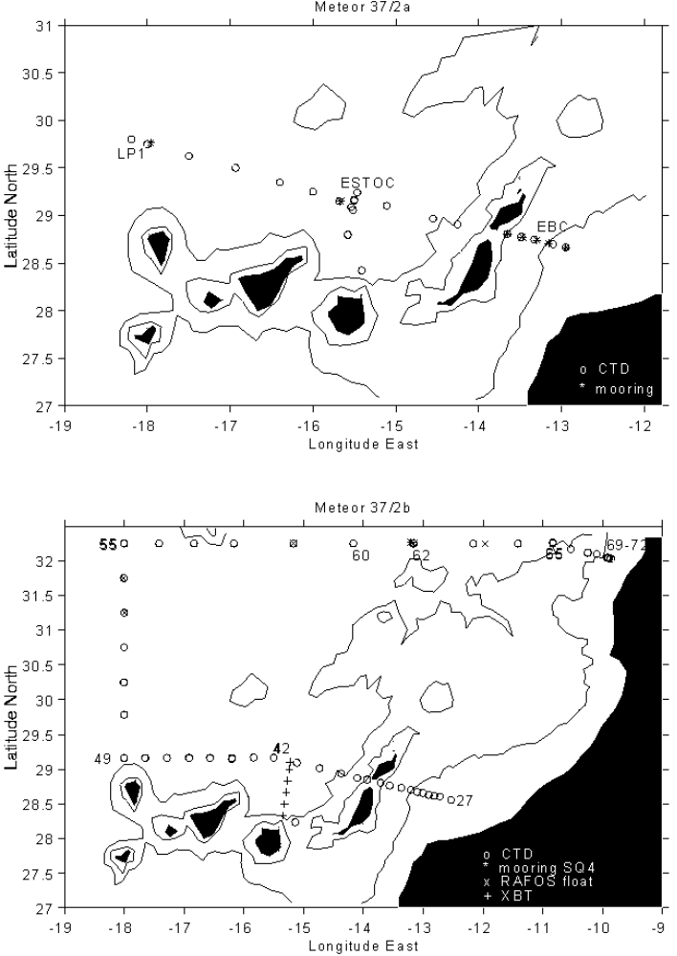
Fig 1: Station Map M37/2a (upper panel) and M37/2b (lower panel) with positions of CTD casts (o), moorings (*), and launched floats (x) and XBTs (+).

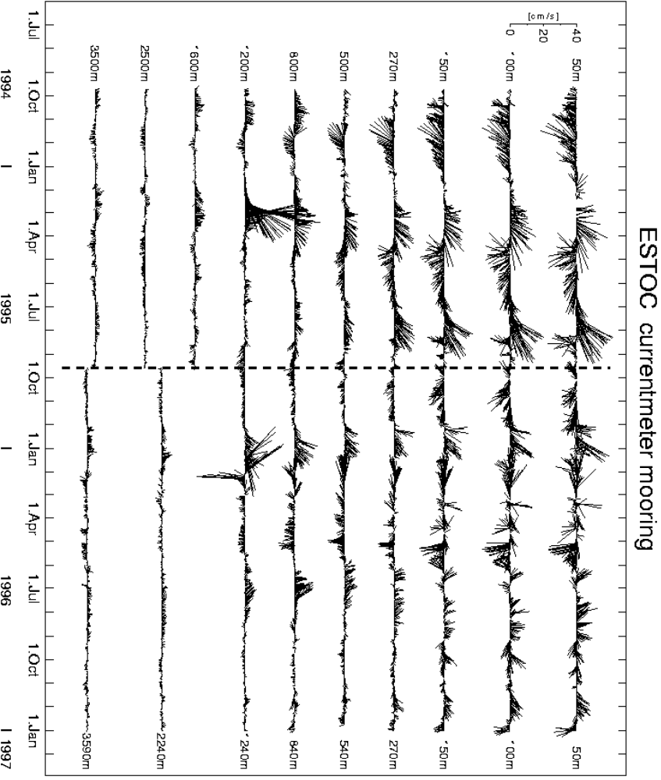

Fig. 2: Currents at the ESTOC position, starting in September 1994; moorings V367100 and V367200. Upward is north.

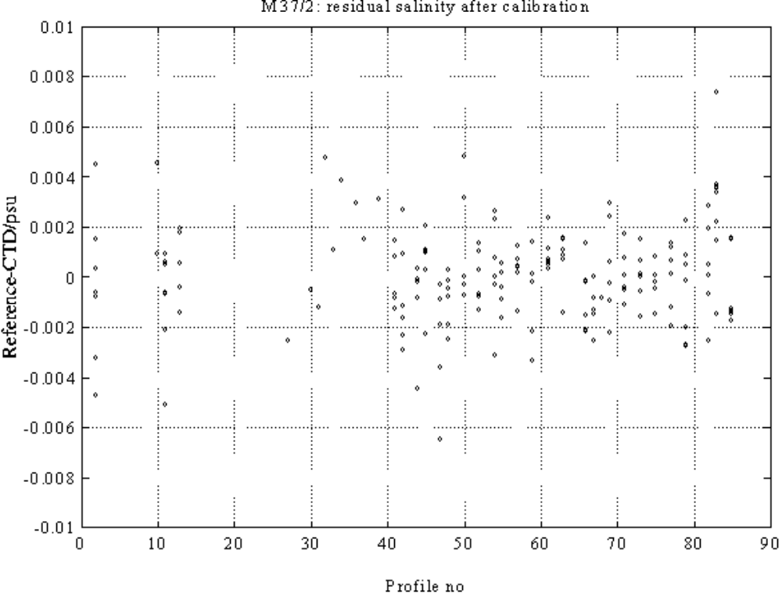
Fig. 3: Residuals of the salinity calibration of the MKIIIB CTD (IFMK internal code NB2).
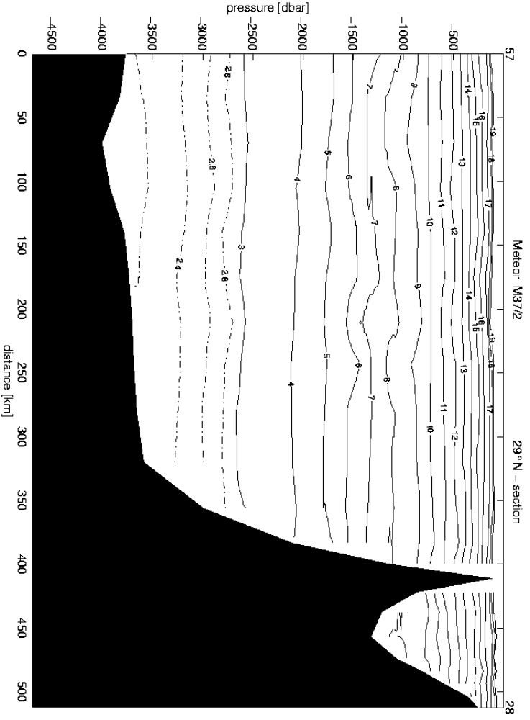
Fig. 4a: Distribution of potential temperature along 29°N.
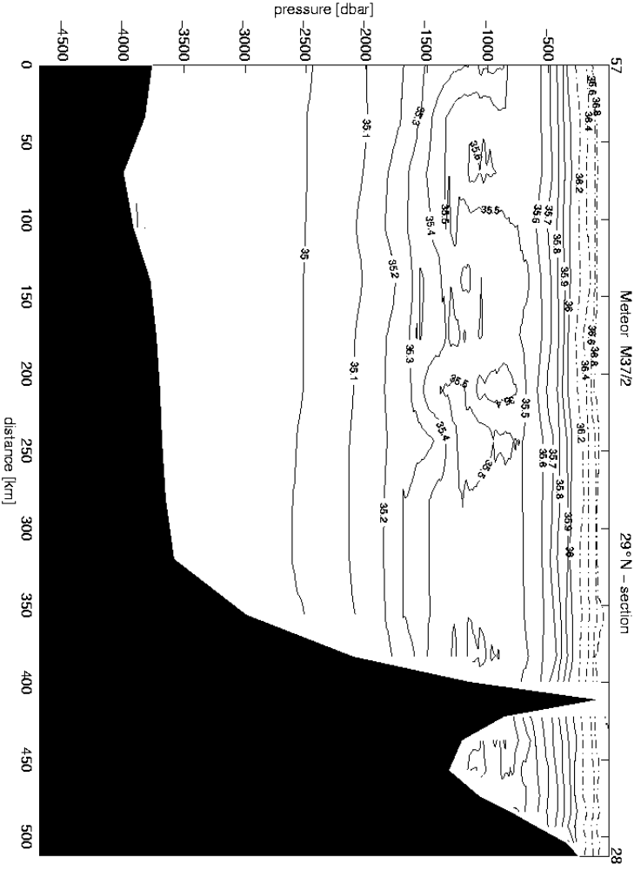
Fig. 4b: Distribution of salinity along 29°N.
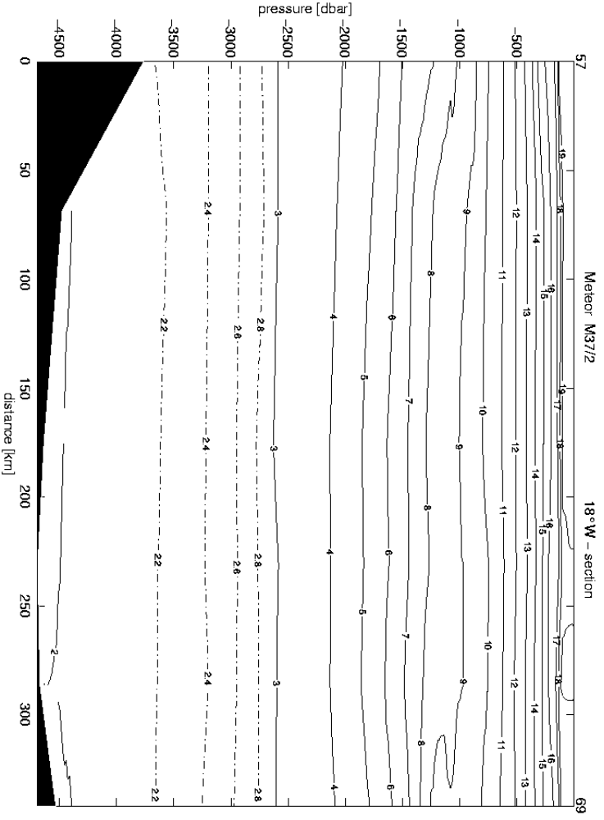
Fig. 4c: Distribution of potential temperature along18°W.
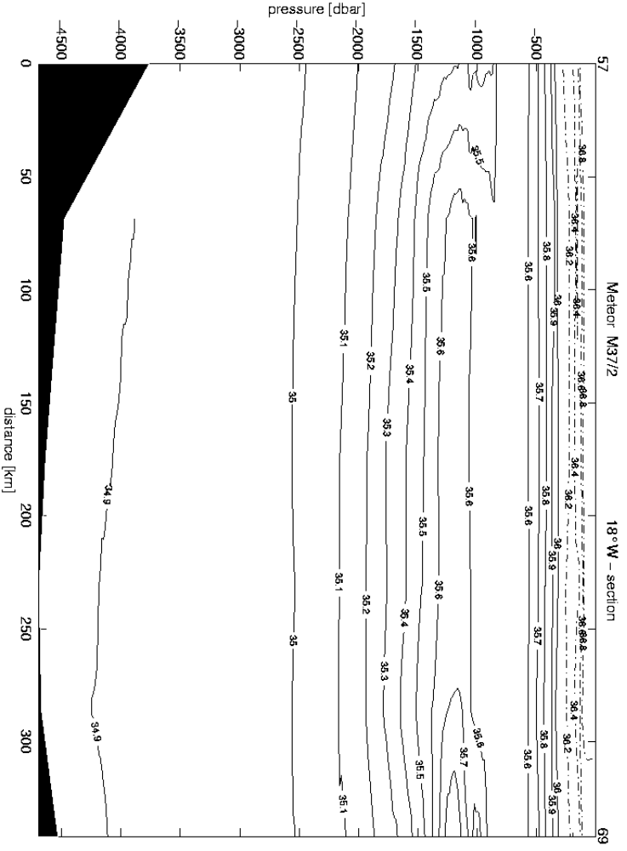
Fig. 4d: Distribution of salinity along18°W.
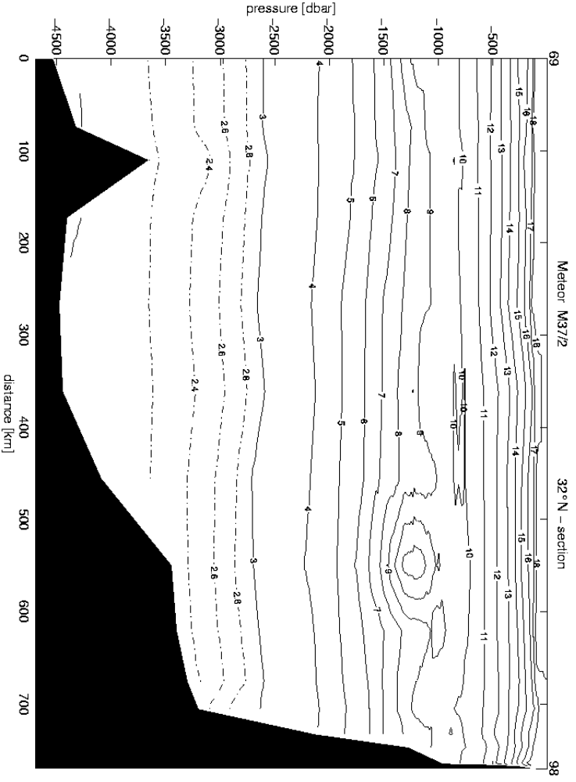
Fig. 4e: Distribution of potential temperature along 32°N.
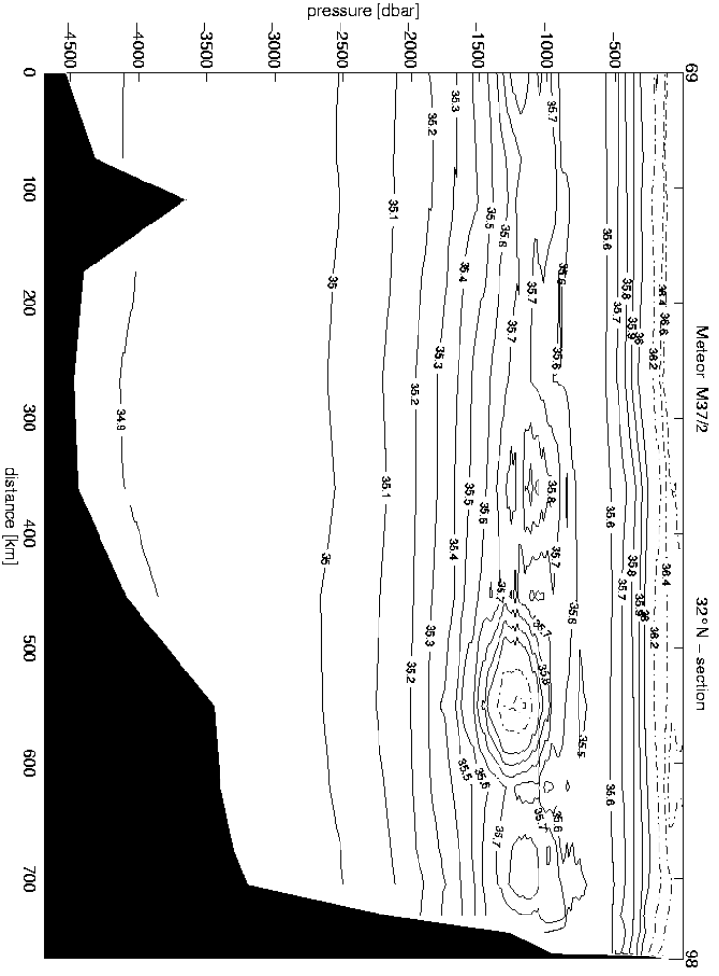
Fig. 4f: Distribution of salinity along 32°N.

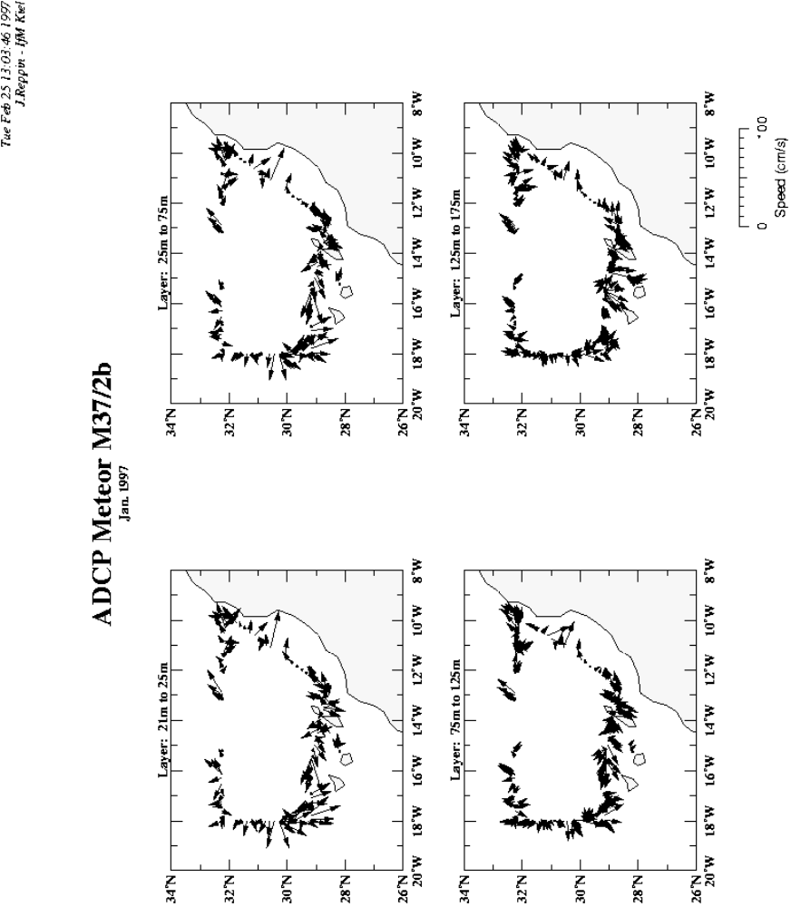

Fig. 5a: Currents between 21 m and 175 m as measured with the vessel mounted ADCP

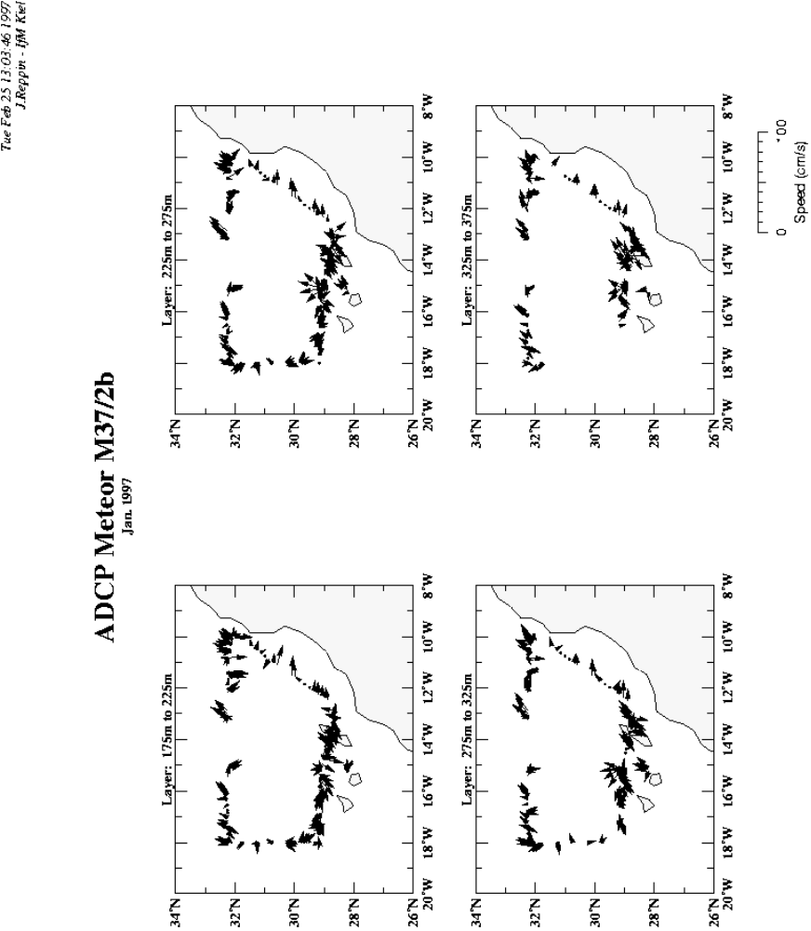

Fig. 5b: Currents between 175 m and 375 m as measured with the vessel mounted ADCP

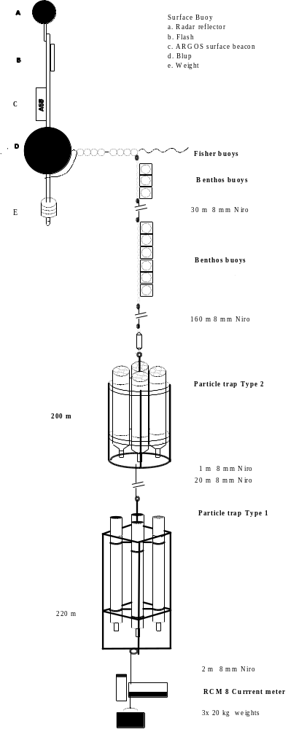

Fig. 6: Design of the GeoB drifting trap mooring
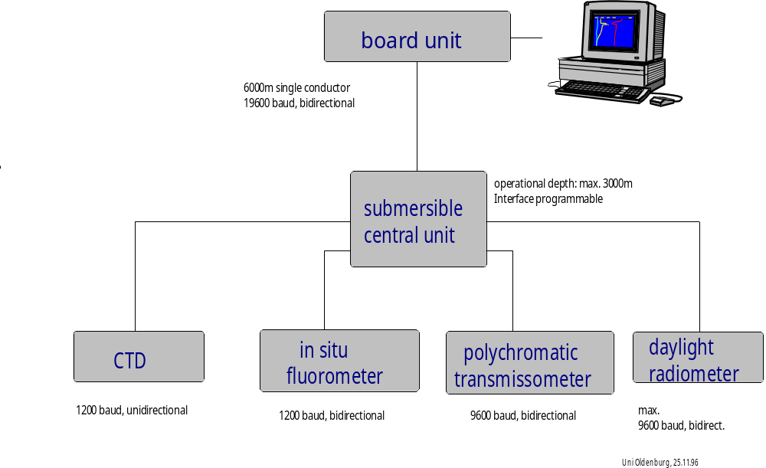

Fig. 7: Coupling of the optical sensors

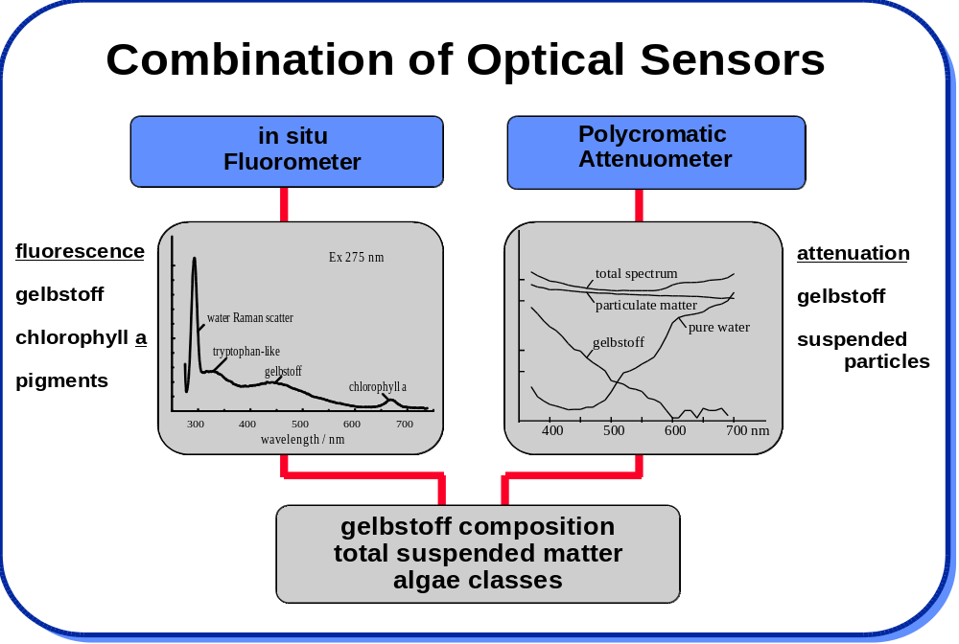

Fig. 8: Information which can be obtained by measuring optical parameters.

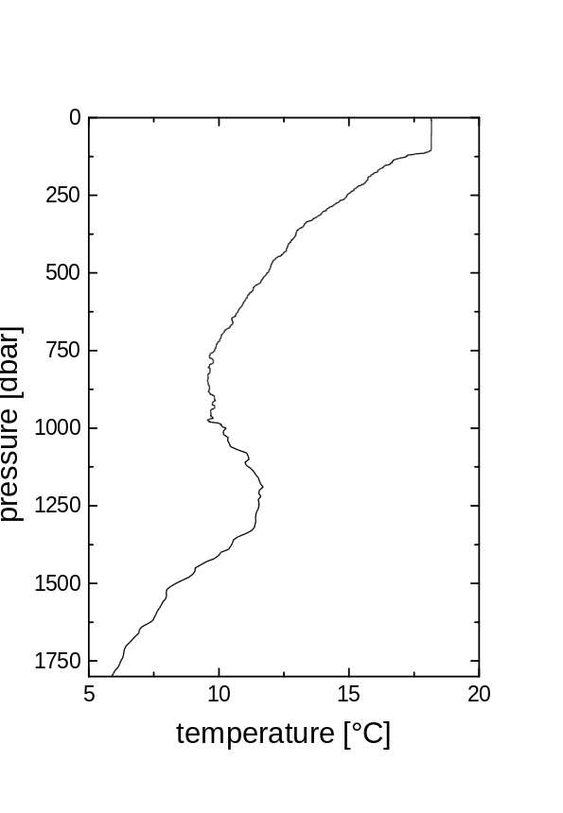 | 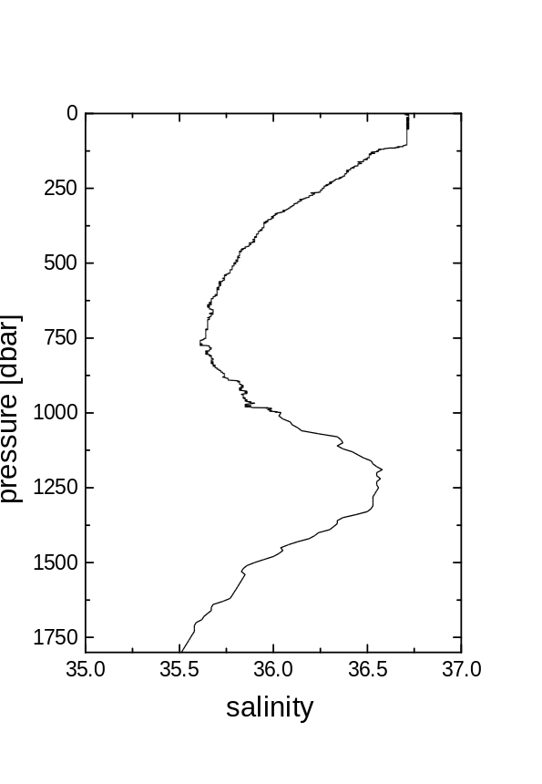
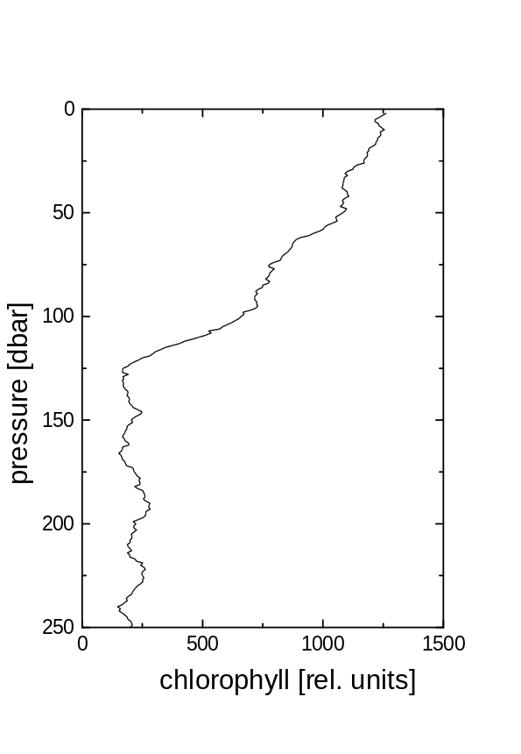 |  | 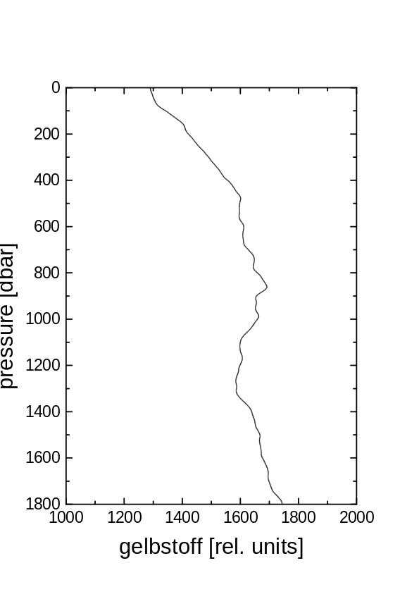

Fig. 9: Distribution of temperature, salinity, chlorphyll and gelbstoff at the Meddy ‘Jani’ station
63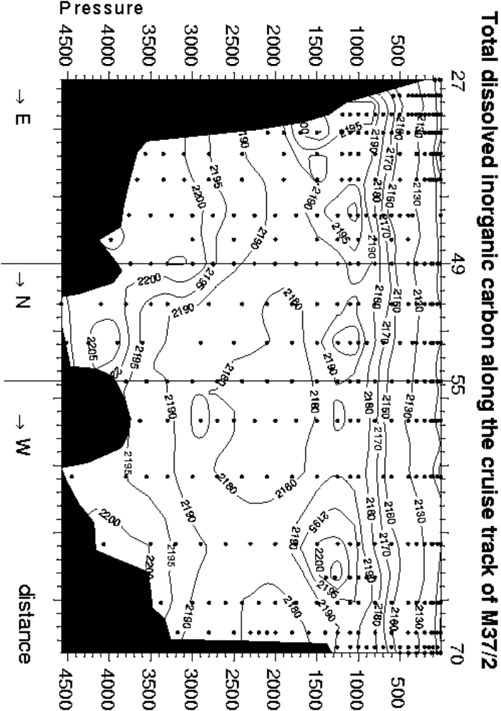

Fig 10: Distribution of total Carbon along the 29°N, 18°W and the 32°N sections. The view is onto the sections from the east.

