A. Cruise narrative

Highlights
Cruise designation: RF19-05 (40N revisit)

- EXPOCODE: RF19-05 49UP20190612

- Chief scientist: Shinji MASUDA
Marine Division
Global Environment and Marine Department
Japan Meteorological Agency (JMA)

- Ship name: R/V Ryofu Maru

- Ports of call: Leg 1: Tokyo (Japan) – Hakodate (Japan)
Leg 2: Hakodate (Japan) – Tokyo (Japan)

- Cruise dates (JST): Leg 1: 12 June 2019 – 6 July 2019
Leg 2: 10 July 2019 – 3 August 2019

- Floats and drifters deployed: 7 floats
1 drifter

- Principal Investigator (Contact person):
Daisuke SASANO
Marine Division
Global Environment and Marine Department
Japan Meteorological Agency (JMA)
1-3-4, Otemachi, Chiyoda-ku, Tokyo 100-8122, JAPAN
Phone: +81-3-3212-8341 Ext. 5132
E-mail: seadata@met.kishou.go.jp

Cruise Summary
RF19-05 cruise was carried out during the period from June 12 to August 3, 2019. The cruise started from the east of Honshu, Japan, and sailed towards east along 40°N. This line was observed by JMA in 2012 as CLIVER (Climate Variability and Predictability Project) / GO-SHIP (Global Ocean Ship-based Hydrographic Investigations Program).

A total of 70 stations were occupied using a Sea-Bird Electronics (SBE) 36 position carousel equipped with 10-liter Niskin water sample bottles, a CTD system (SBE911plus) equipped with SBE35 deep ocean standards thermometer, JFE Advantech oxygen sensor (RINKO III), Teledyne Benthos altimeter (PSA-916D), and Teledyne RD Instruments L-ADCP (300 kHz). To examine consistency of data, we carried out the observation repeatedly twice at stations of 40°N, 160°20'E (Stn.32 and 33) and 40°N, 165°E (Stn.40 and 70). Cruise track and station location are shown in Figure A.1.

At each station, full-depth CTDO₂ (temperature, conductivity (salinity) and dissolved oxygen) profile were taken, and up to 36 water samples were taken and analyzed. Water samples were obtained from 10 dbar to approximately 10 m above the bottom. In addition, surface water was sampled by a stainless steel bucket at each station. Sampling layer is designed as so-called staggered mesh as shown in Table A.1 (Swift, 2010). The bottle depth diagram is shown in Figure A.2.

Water samples were analyzed for salinity, dissolved oxygen, nutrients, dissolved inorganic carbon (DIC), total alkalinity (TA), pH, CFCs (CFC-11, CFC-12, and CFC-113), SF₆ and phytopigments (chlorophyll-a and phaeopigment). Underway measurements of partial pressure of carbon dioxide (pCO₂), temperature, salinity, chlorophyll-a, subsurface current, bathymetry and meteorological parameters were conducted along the cruise track.

R/V Ryofu Maru departed Tokyo (Japan) on June 12, 2019. Before the observation at the first station, all watch standers were drilled in the method of sample drawing and CTD operations off Boso Peninsula (34°42’N, 139°52’E). The hydrographic cast of CTDO₂ was started at the first station (Stn.1 (40°00’N, 142°20’E; RF6502)) on June 13. Leg 1 consisted of 32 stations from Stn.1 to Stn.32 (40°00’N, 160°20’E; RF6533). The observation at Stn.32 was finished on June 30. She called for Hakodate (Japan) on July 6 (Leg 1). She left Hakodate on July 10, 2019. The hydrographic cast of CTDO₂ was restarted at the last station (Stn.33 (40°00’N, 160°20’E; RF6534)) on July 13. Leg 2 consisted of 38 stations from Stn.33 to Stn.70 (40°00’N, 165°00’E; RF6571). The observation at Stn.70 was finished on July 26. She arrived at Tokyo on August 3, 2019 (Leg 2). Location data of stations is shown in Table A.2.

Seven Argo floats and one drifting ocean data buoy were deployed along the cruise track. The information of deployed the float and the buoy are listed in Table A.3.
Figure A.1. Location of hydrographic stations of the cruise.

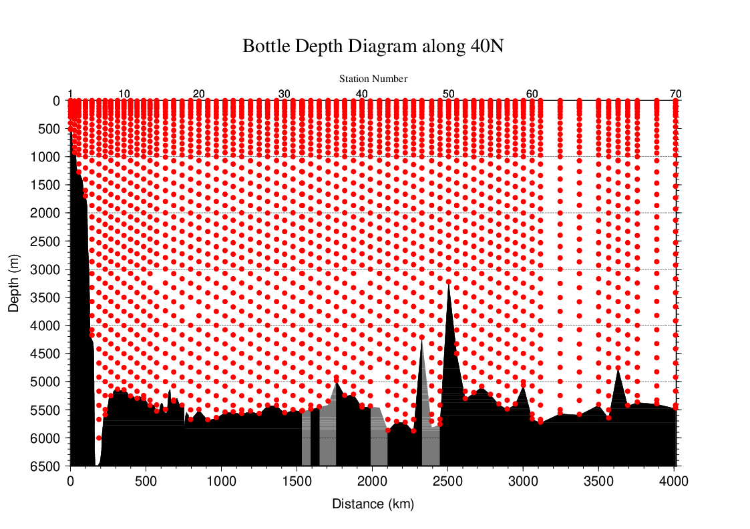
Figure A.2. The bottle depth diagram for the cruise. Seafloor filled with black before RF6520 station indicates data measured continuously by a single beam echo sounder, and after RF6521 station indicates data estimated by CTD observation with altimeter measurement. Seafloor filled with gray indicates data missing station during this cruise and is referred from our previous cruise in 2012.
Table A.1. The schemes of sampling layers in meters.
Bottle count | Scheme 1 | Scheme 2 | Scheme 3
1 | 10 | 10 | 10
2 | 25  50  75  100  125  150  200  250  300  400  500  600  700  800  900  1000  1200  1400  160050 | 25 | 25
3 | 50 | 50 | 50
4 | 75 | 75 | 75
5 | 100 | 100 | 100
6 | 125 | 125 | 125
7 | 150 | 150 | 150
8 | 200 | 200 | 200
9 | 250 | 250 | 250
10 | 300 | 330 | 280
11 | 400 | 430 | 370
12 | 500 | 530 | 470
13 | 600 | 630 | 570
14 | 700 | 730 | 670
15 | 800 | 830 | 770
16 | 900 | 930 | 870
17 | 1000 | 1070 | 970
18 | 1200 | 1270 | 1130
19 | 1400 | 1470 | 1330
20 | 1600 | 1670 | 1530
21 | 1800 | 1870 | 1730
22 | 2000 | 2070 | 1930
23 | 2200 | 2270 | 2130
24 | 2400 | 2470 | 2330
25 | 2600 | 2670 | 2530
26 | 2800 | 2870 | 2730
27 | 3000 | 3080 | 2930
28 | 3250 | 3330 | 3170
29 | 3500 | 3580 | 3420
30 | 3750 | 3830 | 3670
31 | 4000 | 4080 | 3920
32 | 4250 | 4330 | 4170
33 | 4500 | 4580 | 4420
34 | 4750 | 4830 | 4670
35 | 5000 | 5080 | 4920
36 | 5250 | 5330 | 5170
37 | 5500 | 5580 | 5420
38 | 5750 | 5830 | 5670
39 | 6000 | 6000 | 6000
At some deep stations over 36 layers, some layers shown in italic may be skipped.
Table A.2. Station lists of the cruise. The ‘RF’ column indicates original station number of JMA.
Leg | Station |  | Location |  |  | Leg | Station |  | Location
 | Stn. | RF | Latitude | Longitude |  |  | Stn. | RF | Latitude | Longitude
1 | 1 | 6502 | 40-00.03 N | 142-19.72 E |  | 2 | 36 | 6537 | 39-59.52 N | 162-21.25 E
1 | 2 | 6503 | 39-59.81 N | 142-39.05 E |  | 2 | 37 | 6538 | 39-59.62 N | 163-00.58 E
1 | 3 | 6504 | 39-59.92 N | 142-59.12 E |  | 2 | 38 | 6539 | 39-59.41 N | 163-39.70 E
1 | 4 | 6505 | 39-59.78 N | 143-29.27 E |  | 2 | 39 | 6540 | 40-00.24 N | 164-20.81 E
1 | 5 | 6506 | 40-00.62 N | 143-59.99 E |  | 2 | 40 | 6541 | 39-59.71 N | 165-00.12 E
1 | 6 | 6507 | 40-00.71 N | 144-32.35 E |  | 2 | 41 | 6542 | 39-59.47 N | 165-39.57 E
1 | 7 | 6508 | 40-01.67 N | 145-01.90 E |  | 2 | 42 | 6543 | 40-00.03 N | 166-21.86 E
1 | 8 | 6509 | 40-01.41 N | 145-28.85 E |  | 2 | 43 | 6544 | 39-59.69 N | 167-01.01 E
1 | 9 | 6510 | 40-00.47 N | 145-59.63 E |  | 2 | 44 | 6545 | 39-58.78 N | 167-41.05 E
1 | 10 | 6511 | 39-58.13 N | 146-29.31 E |  | 2 | 45 | 6546 | 39-59.56 N | 168-21.88 E
1 | 11 | 6512 | 39-59.27 N | 146-59.91 E |  | 2 | 46 | 6547 | 39-59.84 N | 169-00.55 E
1 | 12 | 6513 | 40-01.10 N | 147-29.59 E |  | 2 | 47 | 6548 | 40-00.57 N | 169-40.17 E
1 | 13 | 6514 | 40-00.95 N | 148-00.42 E |  | 2 | 48 | 6549 | 39-29.36 N | 170-00.83 E
1 | 14 | 6515 | 39-58.92 N | 148-30.32 E |  | 2 | 49 | 6550 | 38-59.54 N | 169-59.99 E
1 | 15 | 6516 | 39-59.58 N | 149-01.48 E |  | 2 | 50 | 6551 | 38-29.35 N | 169-59.95 E
1 | 16 | 6517 | 39-59.68 N | 149-42.52 E |  | 2 | 51 | 6552 | 38-00.11 N | 170-01.52 E
1 | 17 | 6518 | 40-00.26 N | 150-21.58 E |  | 2 | 52 | 6553 | 37-29.68 N | 169-59.80 E
1 | 18 | 6519 | 39-59.66 N | 150-59.90 E |  | 2 | 53 | 6554 | 36-59.22 N | 170-00.92 E
1 | 19 | 6520 | 39-59.82 N | 151-40.28 E |  | 2 | 54 | 6555 | 36-30.90 N | 170-01.74 E
1 | 20 | 6521 | 39-59.77 N | 152-19.58 E |  | 2 | 55 | 6556 | 35-59.41 N | 170-00.74 E
1 | 21 | 6522 | 40-00.99 N | 153-00.37 E |  | 2 | 56 | 6557 | 35-29.53 N | 169-59.85 E
1 | 22 | 6523 | 39-59.98 N | 153-40.22 E |  | 2 | 57 | 6558 | 34-59.90 N | 169-59.67 E
1 | 23 | 6524 | 40-00.59 N | 154-20.51 E |  | 2 | 58 | 6559 | 34-30.47 N | 169-59.44 E
1 | 24 | 6525 | 40-00.52 N | 154-59.18 E |  | 2 | 59 | 6560 | 34-01.14 N | 169-59.72 E
1 | 25 | 6526 | 40-00.24 N | 155-38.91 E |  | 2 | 60 | 6561 | 33-30.21 N | 169-59.22 E
1 | 26 | 6527 | 40-00.61 N | 156-20.11 E |  | 2 | 61 | 6562 | 33-00.50 N | 169-59.41 E
1 | 27 | 6528 | 40-00.63 N | 157-00.64 E |  | 2 | 62 | 6563 | 34-01.18 N | 169-16.89 E
1 | 28 | 6529 | 40-00.97 N | 157-39.76 E |  | 2 | 63 | 6564 | 35-00.26 N | 168-32.52 E
1 | 29 | 6530 | 40-00.59 N | 158-21.28 E |  | 2 | 64 | 6565 | 36-00.60 N | 167-52.13 E
1 | 30 | 6531 | 40-00.23 N | 158-59.71 E |  | 2 | 65 | 6566 | 36-31.43 N | 167-29.23 E
1 | 31 | 6532 | 40-00.51 N | 159-38.64 E |  | 2 | 66 | 6567 | 37-00.04 N | 167-08.55 E
1 | 32 | 6533 | 40-00.62 N | 160-19.65 E |  | 2 | 67 | 6568 | 37-30.20 N | 166-47.50 E
2 | 33 | 6534 | 39-59.42 N | 160-21.46 E |  | 2 | 68 | 6569 | 38-00.38 N | 166-24.97 E
2 | 34 | 6535 | 39-59.39 N | 161-00.90 E |  | 2 | 69 | 6570 | 39-01.05 N | 165-41.91 E
2 | 35 | 6536 | 40-00.34 N | 161-41.08 E |  | 2 | 70 | 6571 | 40-00.74 N | 165-01.32 E

Table A.3. Information of deployed float and buoy.
Float | Date and Time | Position of deployment |  | PI
WMO number | of Deployment (UTC) | Latitude | Longitude
2903373 | 2019 June 14  23:23 | 40-00.09 N | 143-59.93 E | JMA | APEX
2903374 | 2019 June 18  13:19 | 39-59.96 N | 145-28.46 E | JMA | APEX
2903375 | 2019 June 19  11:58 | 39-59.94 N | 146-58.53 E | JMA | APEX
2903405 | 2019 July. 17  13:28 | 40-00.44 N | 169-39.01 E | JAMSTEC | APEX
2903407 | 2019 July. 21  5:47 | 35-01.11 N | 169-59.79 E | JAMSTEC | APEX
2903406 | 2019 July 17  13:32 | 40-00.33 N | 169-38.81 E | JAMSTEC | DeepAPEX
2903408 | 2019 July 21  5:55 | 35-00.94 N | 169-59.39 E | JAMSTEC | DeepAPEX
Buoy | Date and Time | Position of deployment |  | PI
WMO number | of Deployment (UTC) | Latitude | Longitude
11143 | 2019 June 18  4:20 | 40-00.16 N | 144-58.61 E | JMA | YTSS-2100
APEX: Teledyne Webb Research (USA)
YTSS-2100: JVC KENWOOD Co., Japan

List of Principal Investigators for Measurements
The principal investigators for each parameter are listed in Table A.4.

Table A.4. List of principal investigators for each parameter.
Hydrography | CTDO₂ | Keita KAKUYA
 | Salinity | Noriyuki OKUNO
 | Dissolve oxygen | Hiroyuki HATAKEYAMA
 | Nutrients | Hiroyuki HATAKEYAMA
 | Phytopigments | Hiroyuki HATAKEYAMA
 | DIC | Kazutaka ENYO
 | TA | Kazutaka ENYO
 | pH | Kazutaka ENYO
 | CFCs | Kazutaka ENYO
 | LADCP | Keita KAKUYA
Underway | Meteorology | Shinji MASUDA
 | Thermo-Salinograph | Kazutaka ENYO
 | pCO₂ | Kazutaka ENYO
 | Chlorophyll a | Hiroyuki HATAKEYAMA
 | ADCP | Keita KAKUYA
 | Bathymetry | Keita KAKUYA
Float | JMA | Tetsuya NAKAMURA
 | JAMSTEC APEX | Shigeki HOSODA
 | JAMSTEC DeepAPEX | Shigeki HOSODA
Buoy | JMA | Shoji SHIRAISHI

Major Problems
The Precision Depth Recorder (Kongsberg Maritime EA600) was broken down on the way from Stn.19 (RF6520) to Stn.20 (RF6521) at June 26. After this failure, bathymetry cannot be measured.

Reference
Swift, J. H. (2010): Reference-quality water sample data: Notes on acquisition, record keeping, and evaluation. IOCCP Report No.14, ICPO Pub. 134, 2010 ver.1

