A. Cruise narrative

Highlights
Cruise designation: RF18-05, RF18-06 (WHP-P13 revisit)

- EXPOCODE: RF18-05 49UP20180614
RF18-06 49UP20180806

- Chief scientist: Keizo SAKURAI
Marine Division
Global Environment and Marine Department
Japan Meteorological Agency (JMA)

- Ship name: R/V Ryofu Maru

- Ports of call: RF18-05: Leg 1: Tokyo (Japan) – Hakodate (Japan)
Leg 2: Hakodate (Japan) – Tokyo (Japan)
RF18-06: Leg 1: Tokyo (Japan) – Pohnpei (FSM)
Leg 2: Pohnpei (FSM) – Tokyo (Japan)
*FSM: Federated States of Micronesia

- Cruise dates (JST): RF18-05: Leg 1: 14 June 2018 – 4 July 2018
Leg 2: 8 July 2018 – 22 July 2018
RF18-06: Leg 1: 6 August 2018 – 30 August 2018
Leg 2: 3 September 2018 – 27 September 2018

- Principal Investigator (Contact person):
Toshiya NAKANO
Marine Division
Global Environment and Marine Department
Japan Meteorological Agency (JMA)
1-3-4, Otemachi, Chiyoda-ku, Tokyo 100-8122, JAPAN
Phone: +81-3-3212-8341 Ext. 5131
E-mail: seadata@met.kishou.go.jp

Cruise Summary
RF18-05 and RF18-06 cruises were carried out during the period from June 14 to September 27, 2018. The cruise started from the south of Hokkaido, Japan, and sailed southeastern line along the Kuril Islands, thereafter from 50°N to 8°S along approximately 165°E meridian. This line (WHP-P13) was observed by JMA in 2011 as CLIVER (Climate Variability and Predictability Project) / GO-SHIP (Global Ocean Ship-based Hydrographic Investigations Program).

A total of 103 stations were occupied using a Sea-Bird Electronics (SBE) 36 position carousel equipped with 10-liter Niskin water sample bottles, a CTD system (SBE911plus) equipped with SBE35 deep ocean standards thermometer, JFE Advantech oxygen sensor (RINKO III), Teledyne Benthos altimeter (PSA-916D), and Teledyne RD Instruments L-ADCP (300kHz). To examine consistency of data, we carried out the observation repeatedly twice at stations of 47°N, 165°E (Stn.21 and 22), 37°N, 165°E (Stn.33 and 34) and 8°N, 165°E (Stn.73 and 74). Cruise track and station location are shown in Figure A.1.

At each station, full-depth CTDO₂ (temperature, conductivity (salinity) and dissolved oxygen) profile were taken, and up to 36 water samples were taken and analyzed. Water samples were obtained from 10 dbar to approximately 10 m above the bottom. In addition, surface water was sampled by a stainless steel bucket at each station. Sampling layer is designed as so-called staggered mesh as shown in Table A.1 (Swift, 2010). The bottle depth diagram is shown in Figure A.2.

Water samples were analyzed for salinity, dissolved oxygen, nutrients, dissolved inorganic carbon (DIC), total alkalinity (TA), pH, CFCs (CFC-11, CFC-12, and CFC-113) and phytopigments (chlorophyll-a and phaeopigment). Underway measurements of partial pressure of carbon dioxide (pCO₂), temperature, salinity, chlorophyll-a, subsurface current, bathymetry and meteorological parameters were conducted along the cruise track.
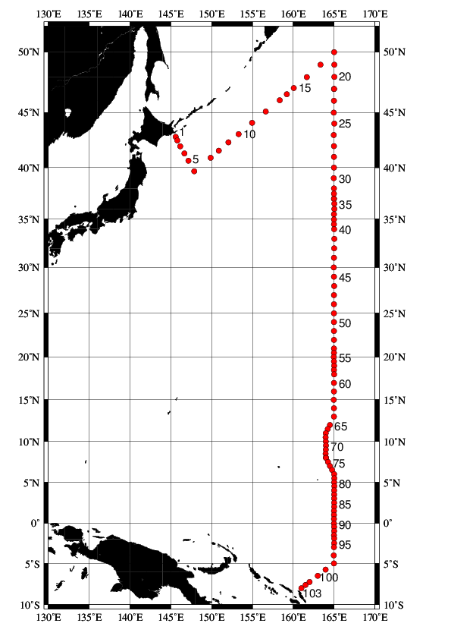
Figure A.1. Location of hydrographic stations of RF18-05 and RF18-06.
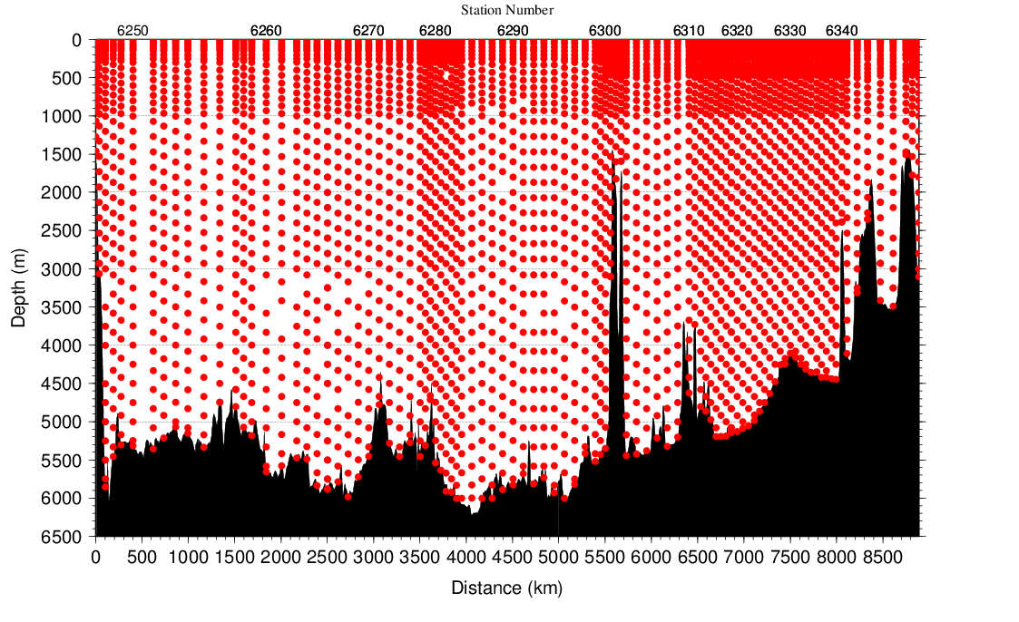
Figure A.2. The bottle depth diagram for WHP-P13 revisit.
Table A.1. The scheme of sampling layer in meters.
Bottle count | Scheme 1 | Scheme 2 | Scheme 3 | Scheme 4 | Scheme 5 | Scheme 6
1 | 10 | 10 | 10 | 10 | 10 | 10
2 | 25  50  75  100  125  150  200  250  300  400  500  600  700  800  900  1000  1200  1400  160050 | 25 | 25 | 25 | 25 | 25
3 | 50 | 50 | 50 | 50 | 50 | 50
4 | 75 | 75 | 75 | 75 | 75 | 75
5 | 100 | 100 | 100 | 100 | 100 | 100
6 | 125 | 125 | 125 | 125 | 125 | 125
7 | 150 | 150 | 150 | 150 | 150 | 150
8 | 200 | 200 | 200 | 200 | 200 | 200
9 | 250 | 250 | 250 | 250 | 250 | 250
10 | 300 | 330 | 280 | 300 | 330 | 280
11 | 400 | 430 | 370 | 350 | 380 | 320
12 | 500 | 530 | 470 | 400 | 430 | 370
13 | 600 | 630 | 570 | 450 | 480 | 420
14 | 700 | 730 | 670 | 500 | 530 | 470
15 | 800 | 830 | 770 | 600 | 630 | 570
16 | 900 | 930 | 870 | 700 | 730 | 670
17 | 1000 | 1070 | 970 | 800 | 830 | 770
18 | 1200 | 1270 | 1130 | 900 | 930 | 870
19 | 1400 | 1470 | 1330 | 1000 | 1070 | 970
20 | 1600 | 1670 | 1530 | 1200 | 1270 | 1130
21 | 1800 | 1870 | 1730 | 1400 | 1470 | 1330
22 | 2000 | 2070 | 1930 | 1600 | 1670 | 1530
23 | 2200 | 2270 | 2130 | 1800 | 1870 | 1730
24 | 2400 | 2470 | 2330 | 2000 | 2070 | 1930
25 | 2600 | 2670 | 2530 | 2200 | 2270 | 2130
26 | 2800 | 2870 | 2730 | 2400 | 2470 | 2330
27 | 3000 | 3080 | 2930 | 2600 | 2670 | 2530
28 | 3250 | 3330 | 3170 | 2800 | 2870 | 2730
29 | 3500 | 3580 | 3420 | 3000 | 3080 | 2930
30 | 3750 | 3830 | 3670 | 3250 | 3330 | 3170
31 | 4000 | 4080 | 3920 | 3500 | 3580 | 3420
32 | 4250 | 4330 | 4170 | 3750 | 3830 | 3670
33 | 4500 | 4580 | 4420 | 4000 | 4080 | 3920
34 | 4750 | 4830 | 4670 | 4250 | 4330 | 4170
35 | 5000 | 5080 | 4920 | 4500 | 4580 | 4420
36 | 5250 | 5330 | 5170 | 4750 | 4830 | 4670
37 | 5500 | 5580 | 5420 | 5000 | 5080 | 4920
38 | 5750 | 5830 | 5670 | 5250 | 5330 | 5170
39 | 6000 | 6000 | 6000 | 5500 | 5580 | 5420
40 |  |  |  | 5750 | 5830 | 5670
41 |  |  |  | 6000 | 6000 | 6000
Scheme 1 to Scheme 3 are applied to the area north of 20°N, while Scheme 4 to Scheme 6 are applied to the area south of 20°N. At some deep stations over 36 layers, some layers shown in italic may be skipped.
Table A.2(a). Station lists of RF18-05 cruise. The ‘RF’ column indicates the JMA station identification number.
Leg | Station |  | Location |  |  | Leg | Station |  | Location
 | Stn. | RF | Latitude | Longitude |  |  | Stn. | RF | Latitude | Longitude
1 | 1 | 6245 | 42-50.18 N | 145-36.48 E |  | 1 | 18 | 6262 | 49-59.35 N | 165-00.16 E
1 | 2 | 6246 | 42-30.93 N | 145-48.32 E |  | 1 | 19 | 6263 | 48-59.63 N | 165-01.21 E
1 | 3 | 6247 | 41-59.72 N | 146-09.29 E |  | 1 | 20 | 6264 | 48-00.63 N | 165-01.01 E
1 | 4 | 6248 | 41-20.12 N | 146-40.60 E |  | 1 | 21 | 6265 | 47-00.05 N | 164-59.97 E
1 | 5 | 6249 | 40-39.71 N | 147-09.18 E |  | 2 | 22 | 6266 | 47-00.27 N | 165-00.42 E
1 | 6 | 6250 | 39-39.35 N | 147-52.95 E |  | 2 | 23 | 6267 | 46-00.05 N | 164-59.38 E
1 | 7 | 6251 | 40-55.78 N | 149-52.16 E |  | 2 | 24 | 6268 | 44-59.99 N | 164-58.23 E
1 | 8 | 6252 | 41-35.03 N | 150-52.31 E |  | 2 | 25 | 6269 | 44-01.34 N | 165-01.00 E
1 | 9 | 6253 | 42-20.57 N | 152-04.61 E |  | 2 | 26 | 6270 | 43-00.88 N | 164-58.46 E
1 | 10 | 6254 | 43-05.28 N | 153-19.20 E |  | 2 | 27 | 6271 | 42-00.07 N | 164-59.10 E
1 | 11 | 6255 | 44-05.06 N | 154-57.09 E |  | 2 | 28 | 6272 | 41-00.30 N | 164-59.99 E
1 | 12 | 6256 | 45-04.97 N | 156-38.26 E |  | 2 | 29 | 6273 | 40-00.45 N | 164-59.62 E
1 | 13 | 6257 | 46-03.67 N | 158-20.28 E |  | 2 | 30 | 6274 | 39-00.60 N | 164-58.51 E
1 | 14 | 6258 | 46-33.33 N | 159-12.29 E |  | 2 | 31 | 6275 | 38-01.41 N | 164-59.87 E
1 | 15 | 6259 | 47-04.83 N | 160-04.44 E |  | 2 | 32 | 6276 | 37-30.89 N | 164-59.08 E
1 | 16 | 6260 | 47-59.29 N | 161-39.94 E |  | 2 | 33 | 6277 | 37-01.36 N | 164-59.17 E
1 | 17 | 6261 | 48-59.67 N | 163-20.29 E

Table A.2(b). Station lists of RF18-06 cruise.
Leg | Station |  | Location |  |  | Leg | Station |  | Location
 | Stn. | RF | Latitude | Longitude |  |  | Stn. | RF | Latitude | Longitude
1 | 34 | 6279 | 37-01.10 N | 164-59.37 E |  | 1 | 69 | 6314 | 9-59.43 N | 163-59.60 E
1 | 35 | 6280 | 36-31.46 N | 165-02.19 E |  | 1 | 70 | 6315 | 9-29.76 N | 164-00.44 E
1 | 36 | 6281 | 36-00.82 N | 165-02.64 E |  | 1 | 71 | 6316 | 9-00.61N | 163-59.05 E
1 | 37 | 6282 | 35-29.80 N | 164-59.61 E |  | 1 | 72 | 6317 | 8-29.99 N | 163-58.81 E
1 | 38 | 6283 | 34-57.76 N | 164-59.29 E |  | 1 | 73 | 6318 | 8-01.13 N | 164-00.75 E
1 | 39 | 6284 | 34-28.57 N | 164-59.41 E |  | 2 | 74 | 6319 | 7-59.79 N | 164-00.79 E
1 | 40 | 6285 | 33-58.88 N | 165-00.20 E |  | 2 | 75 | 6320 | 7-30.04 N | 164-15.50 E
1 | 41 | 6286 | 32-59.67 N | 165-01.43 E |  | 2 | 76 | 6321 | 7-00.04 N | 164-30.19 E
1 | 42 | 6287 | 32-00.36 N | 165-00.79 E |  | 2 | 77 | 6322 | 6-30.33 N | 164-45.50 E
1 | 43 | 6288 | 31-00.64 N | 164-59.94 E |  | 2 | 78 | 6323 | 6-00.75 N | 165-00.92 E
1 | 44 | 6289 | 29-59.62 N | 164-58.36 E |  | 2 | 79 | 6324 | 5-29.47 N | 165-01.23 E
1 | 45 | 6290 | 28-59.54 N | 164-59.41 E |  | 2 | 80 | 6325 | 5-00.37 N | 165-00.81 E
1 | 46 | 6291 | 27-59.85 N | 165-00.41 E |  | 2 | 81 | 6326 | 4-31.00 N | 165-01.17 E
1 | 47 | 6292 | 26-59.58 N | 164-59.01 E |  | 2 | 82 | 6327 | 4-00.80 N | 165-00.88 E
1 | 48 | 6293 | 25-59.32 N | 164-59.49 E |  | 2 | 83 | 6328 | 3-30.31 N | 165-00.81 E
1 | 49 | 6294 | 24-59.17 N | 164-59.86 E |  | 2 | 84 | 6329 | 3-00.18 N | 165-00.54 E
1 | 50 | 6295 | 24-00.22 N | 164-59.80 E |  | 2 | 85 | 6330 | 2-29.86 N | 165-00.30 E
1 | 51 | 6296 | 22-59.72 N | 164-59.23 E |  | 2 | 86 | 6331 | 1-59.65 N | 165-00.06 E
1 | 52 | 6297 | 21-59.24 N | 164-59.56 E |  | 2 | 87 | 6332 | 1-29.73 N | 164-59.08 E
1 | 53 | 6298 | 20-59.43 N | 164-59.39 E |  | 2 | 88 | 6333 | 0-59.75 N | 164-59.58 E
1 | 54 | 6299 | 20-29.87 N | 164-59.51 E |  | 2 | 89 | 6334 | 0-29.57 N | 164-59.58 E
1 | 55 | 6300 | 20-00.28 N | 164-58.05 E |  | 2 | 90 | 6335 | 0-04.44 S | 164-59.83 E
1 | 56 | 6301 | 19-30.08 N | 164-59.05 E |  | 2 | 91 | 6336 | 0-30.66 S | 165-00.40 E
1 | 57 | 6302 | 19-00.14 N | 165-00.08 E |  | 2 | 92 | 6337 | 1-00.02 S | 165-00.42 E
1 | 58 | 6303 | 18-30.12 N | 164-59.52 E |  | 2 | 93 | 6338 | 1-30.10 S | 164-59.89 E
1 | 59 | 6304 | 17-59.46 N | 165-00.31 E |  | 2 | 94 | 6339 | 1-55.60 S | 165-00.83 E
1 | 60 | 6305 | 16-59.60 N | 164-59.83 E |  | 2 | 95 | 6340 | 2-29.73 S | 165-00.00 E
1 | 61 | 6306 | 15-59.92 N | 164-59.51 E |  | 2 | 96 | 6341 | 2-59.05 S | 164-59.92 E
1 | 62 | 6307 | 14-59.39 N | 164-58.80 E |  | 2 | 97 | 6342 | 3-59.50 S | 164-58.84 E
1 | 63 | 6308 | 13-59.54 N | 164-59.68 E |  | 2 | 98 | 6343 | 4-59.62 S | 164-59.62 E
1 | 64 | 6309 | 12-59.46 N | 164-59.51 E |  | 2 | 99 | 6344 | 5-44.17 S | 163-58.36 E
1 | 65 | 6310 | 11-59.28 N | 164-29.83 E |  | 2 | 100 | 6345 | 6-30.64 S | 163-00.11 E
1 | 66 | 6311 | 11-29.56 N | 164-14.31 E |  | 2 | 101 | 6348 | 7-15.47 S | 162-00.13 E
1 | 67 | 6312 | 10-59.71 N | 163-59.29 E |  | 2 | 102 | 6347 | 7-37.42 S | 161-30.45 E
1 | 68 | 6313 | 10-29.44 N | 163-58.69 E |  | 2 | 103 | 6346 | 8-00.17 S | 160-59.70 E

List of Principal Investigators for Measurements
The principal investigators for each parameter are listed in Table A.3.

Table A.3. List of principal investigators for each parameter.
Hydrography | CTDO₂ | Keizo SHUTTA
 | Salinity | Keizo SHUTTA
 | Dissolve oxygen | Kazuhiro SAITO
 | Nutrients | Kazuhiro SAITO
 | Phytopigments | Kazuhiro SAITO
 | DIC | Kazutaka ENYO
 | TA | Kazutaka ENYO
 | pH | Kazutaka ENYO
 | CFCs | Kazutaka ENYO
 | LADCP | Keizo SHUTTA
Underway | Meteorology | Keizo SAKURAI
 | Thermo-Salinograph | Kazutaka ENYO
 | pCO₂ | Kazutaka ENYO
 | Chlorophyll a | Kazuhiro SAITO
 | ADCP | Keizo SHUTTA
 | Bathymetry | Keizo SHUTTA

Reference
Swift, J. H. (2010): Reference-quality water sample data: Notes on acquisition, record keeping, and evaluation. IOCCP Report No.14, ICPO Pub. 134, 2010 ver.1

