- Cruise narrative
- Highlights
Cruise designation: RF17-07（WHP-P13N revisit）
- EXPOCODE: 49UP20170623
- Chief scientist: Naoki NAGAI
Marine Division
Global Environment and Marine Department
Japan Meteorological Agency (JMA)
- Ship name: R/V Ryofu Maru
- Ports of call: Leg 1: Tokyo – Hakodate, Leg 2: Hakodate – Tokyo
- Cruise dates (JST): Leg 1: 23 June 2017 – 13 July 2017
Leg 2: 17 July 2017 – 7 August 2017
- Principal Investigator (Contact person):
Toshiya NAKANO
Marine Division
Global Environment and Marine Department
Japan Meteorological Agency (JMA)
1-3-4, Otemachi, Chiyoda-ku, Tokyo 100-8122, JAPAN
Phone: +81-3-3212-8341 Ext. 5131
E-mail: seadata@met.kishou.go.jp
- Cruise Summary Information
RF17-07 cruise was carried out during the period from June 23 to August 7, 2017. The cruise started from the south of Hokkaido, Japan, and sailed southeastern line along the Kuril Islands, thereafter from 50°N to 29°N along approximately 165°E meridian. This line (WHP-P13) was observed by JMA in 2011 as CLIVER (Climate Variability and Predictability Project) / GO-SHIP (Global Ocean Ship-based Hydrographic Investigations Program).

A total of 46 stations was occupied using a Sea-Bird Electronics (SBE) 36 position carousel equipped with 10-liter Niskin water sample bottles, a CTD system (SBE911plus) equipped with SBE35 deep ocean standards thermometer, JFE Advantech oxygen sensor (RINKO III), Teledyne Benthos altimeter (PSA-916D), and Teledyne RD Instruments L-ADCP (300kHz). To examine consistency of data, we carried out the observation twice at 42°N, 165°E (Stn.26 and 27). Cruise track and station location are shown in Figure A.1.

At each station, full-depth CTDO₂ (temperature, conductivity (salinity) and dissolved oxygen) profile were taken, and up to 36 water samples were taken and analyzed. Water samples were obtained from 10 dbar to approximately 10 m above the bottom. In addition, surface water was sampled by a stainless steel bucket at each station. Sampling layer is designed as so-called staggered mesh as shown in Table A.1 (Swift, 2010). The bottle depth diagram is shown in Figure A.2.

Water samples were analyzed for salinity, dissolved oxygen, nutrients, dissolved inorganic carbon (DIC), total alkalinity (TA), pH, CFC-11, CFC-12, CFC-113 and phytopigment (chlorophyll-a and phaeopigmens). Underway measurements of partial pressure of carbon dioxide (pCO₂), temperature, salinity, chlorophyll-a, subsurface current, bathymetry and meteorological parameters were conducted along the cruise track.

R/V Ryofu Maru departed Tokyo (Japan) on June 23, 2017. The hydrographic cast of CTDO₂ was started at the first station (Stn.1 (42°50’N, 145°37’E; RF6029)) on June 25. Leg 1 consisted of 26 stations from Stn.1 to Stn.26 (42°N, 165°E; RF6054). The observation at Stn.26 was finished on July 7. She called for Hakodate (Japan) on July 13 (Leg 1). She left Hakodate on July 17, 2017. The hydrographic cast of CTDO₂ was restarted at the station (Stn.27 (42°N, 165°E; RF6055)) on July 20. Leg 2 consisted of 20 stations from Stn.27 to Stn.46 (29°N, 165°E; RF6074). Stn.46 was finished on July 29. She arrived at Tokyo (Japan) on August 7, 2017 (Leg 2).
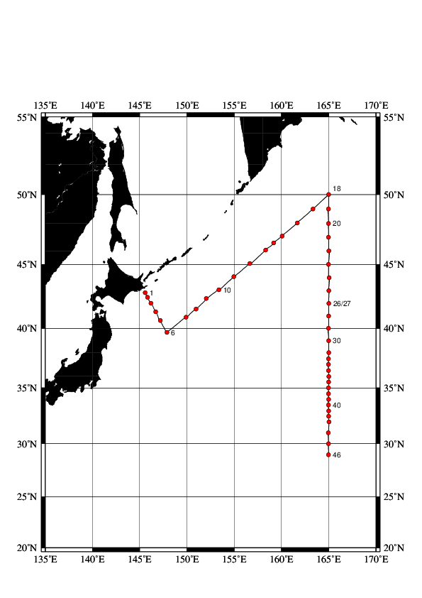
Figure A.1. The track and the station location of the cruise.
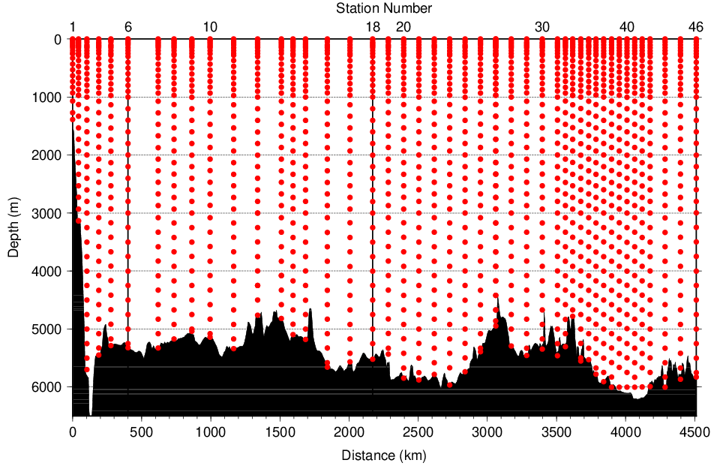
Figure A.2. The bottle depth diagram for the cruise.
Table A.1. The scheme of sampling layer in meters.
Bottle count | scheme1 | scheme2 | scheme3 |  | Bottle count | scheme1 | scheme2 | scheme3
1 | 10 | 10 | 10 |  | 21 | 1800 | 1870 | 1730
2 | 25 | 25 | 25 |  | 22 | 2000 | 2070 | 1930
3 | 50 | 50 | 50 |  | 23 | 2200 | 2270 | 2130
4 | 75 | 75 | 75 |  | 24 | 2400 | 2470 | 2330
5 | 100 | 100 | 100 |  | 25 | 2600 | 2670 | 2530
6 | 125 | 125 | 125 |  | 26 | 2800 | 2870 | 2730
7 | 150 | 150 | 150 |  | 27 | 3000 | 3080 | 2930
8 | 200 | 200 | 200 |  | 28 | 3250 | 3330 | 3170
9 | 250 | 250 | 250 |  | 29 | 3500 | 3580 | 3420
10 | 300 | 330 | 280 |  | 30 | 3750 | 3830 | 3670
11 | 400 | 430 | 370 |  | 31 | 4000 | 4080 | 3920
12 | 500 | 530 | 470 |  | 32 | 4250 | 4330 | 4170
13 | 600 | 630 | 570 |  | 33 | 4500 | 4580 | 4420
14 | 700 | 730 | 670 |  | 34 | 4750 | 4830 | 4670
15 | 800 | 830 | 770 |  | 35 | 5000 | 5080 | 4920
16 | 900 | 930 | 870 |  | 36 | 5250 | 5330 | 5170
17 | 1000 | 1070 | 970 |  | 37 | 5500 | 5580 | 5420
18 | 1200 | 1270 | 1130 |  | 38 | 5750 | 5830 | 5670
19 | 1400 | 1470 | 1330 |  | 39 | 6000 | 6000 | 6000
20 | 1600 | 1670 | 1530

At several deep stations over 36 layers, some layers were removed.
Table A.2. Station data of the cruise. The ‘RF’ column indicates the JMA station identification number.
Leg | Station |  | Position |  |  | Leg | Station |  | Position
 | Stn. | RF | Latitude | Longitude |  |  | Stn. | RF | Latitude | Longitude
1 | 1 | 6029 | 42-50.27 N | 145-35.84 E |  | 1 | 24 | 6052 | 44-00.46 N | 165-03.43 E
1 | 2 | 6030 | 42-29.67 N | 145-50.82 E |  | 1 | 25 | 6053 | 43-00.59 N | 165-01.20 E
1 | 3 | 6031 | 42-01.03 N | 146-11.86 E |  | 1 | 26 | 6054 | 42-00.82 N | 165-01.40 E
1 | 4 | 6032 | 41-20.87 N | 146-41.88 E |  | 2 | 27 | 6055 | 42-00.91 N | 165-00.50 E
1 | 5 | 6033 | 40-38.82 N | 147-11.06 E |  | 2 | 28 | 6056 | 41-00.78 N | 165-00.14 E
1 | 6 | 6034 | 39-40.49 N | 147-53.67 E |  | 2 | 29 | 6057 | 40-00.41 N | 164-59.19 E
1 | 7 | 6035 | 40-54.97 N | 149-54.06 E |  | 2 | 30 | 6058 | 38-59.26 N | 165-00.67 E
1 | 8 | 6036 | 41-33.54 N | 150-58.19 E |  | 2 | 31 | 6059 | 38-00.20 N | 165-01.09 E
1 | 9 | 6037 | 42-23.14 N | 152-03.59 E |  | 2 | 32 | 6060 | 37-29.89 N | 164-59.14 E
1 | 10 | 6038 | 43-04.88 N | 153-22.00 E |  | 2 | 33 | 6061 | 37-00.86 N | 164-59.42 E
1 | 11 | 6039 | 44-04.70 N | 154-58.50 E |  | 2 | 34 | 6062 | 36-29.56 N | 164-59.71 E
1 | 12 | 6040 | 45-04.66 N | 156-39.98 E |  | 2 | 35 | 6063 | 35-58.33 N | 165-01.95 E
1 | 13 | 6041 | 46-04.99 N | 158-20.45 E |  | 2 | 36 | 6064 | 35-30.41 N | 165-00.45 E
1 | 14 | 6042 | 46-35.10 N | 159-10.61 E |  | 2 | 37 | 6065 | 35-00.36 N | 164-59.14 E
1 | 15 | 6043 | 47-05.88 N | 160-05.76 E |  | 2 | 38 | 6066 | 34-29.01 N | 164-58.84 E
1 | 16 | 6044 | 48-01.49 N | 161-41.17 E |  | 2 | 39 | 6067 | 33-59.02 N | 165-00.04 E
1 | 17 | 6045 | 49-00.57 N | 163-20.57 E |  | 2 | 40 | 6068 | 33-29.29 N | 164-58.59 E
1 | 18 | 6046 | 50-00.97 N | 165-00.60 E |  | 2 | 41 | 6069 | 32-58.78 N | 165-00.17 E
1 | 19 | 6047 | 49-00.06 N | 164-59.01 E |  | 2 | 42 | 6070 | 32-29.44 N | 165-00.78 E
1 | 20 | 6048 | 47-59.80 N | 164-58.52 E |  | 2 | 43 | 6071 | 31-59.10 N | 165-02.18 E
1 | 21 | 6049 | 47-00.37 N | 164-59.40 E |  | 2 | 44 | 6072 | 31-00.73 N | 164-57.35 E
1 | 22 | 6050 | 46-00.65 N | 165-01.63 E |  | 2 | 45 | 6073 | 30-00.81 N | 164-59.59 E
1 | 23 | 6051 | 45-00.67 N | 164-59.63 E |  | 2 | 46 | 6074 | 28-58.96 N | 164-59.84 E
- List of Principal Investigators for Measurements
The principal investigators for each parameter are listed in Table A.3.

Table A.3. List of principal investigators for each parameter.
Hydrography | CTDO₂ / LADCP | Keizo SHUTTA
 | Salinity | Keizo SHUTTA
 | Dissolve oxygen | Hiroyuki HATAKEYAMA
 | Nutrients | Hiroyuki HATAKEYAMA
 | Phytopigments | Hiroyuki HATAKEYAMA
 | DIC | Shinji MASUDA
 | TA | Shinji MASUDA
 | pH | Shinji MASUDA
 | CFCs | Yoshihiro SHINODA
 | LADCP | Keizo SHUTTA
Underway | Meteorology | Naoki NAGAI
 | Thermo-Salinograph | Shinji MASUDA
 | pCO₂ | Shinji MASUDA
 | Chlorophyll a | Hiroyuki HATAKEYAMA
 | ADCP | Keizo SHUTTA
 | Bathymetry | Keizo SHUTTA

Reference
Swift, J. H. (2010): Reference-quality water sample data: Notes on acquisition, record keeping, and evaluation. IOCCP Report No.14, ICPO Pub. 134, 2010 ver.1

