C. Hydrographic Measurement Techniques and Calibration

CTDO₂ Measurements

Personnel
Nobumi KATO (GEMD/JMA)
Koichi WADA (GEMD/JMA)
Yutaka KOBASHIGAWA (GEMD/JMA)
Jinya MIURA (GEMD/JMA)
Toshiyuki AMAZAWA (GEMD/JMA)

CTDO₂ measurement system
(Software : SEASAVEwin32 ver7.23.2)
Deck unit | Serial Number | Station
SBE 11plus (SBE) | 0683 | RF5486 – 5551
Under water unit | Serial Number | Station
SBE 9plus (SBE) | 69709 (Pressure: 1103) | RF5486 – 5551
Temperature | Serial Number | Station
SBE 3plus (SBE)  SBE 35 (SBE) | 4321 (primary)  5511 (secondary)  0069 | RF5486 – 5551  RF5486 – 5551  RF5486 – 5551
Conductivity | Serial Number | Station
SBE 4C (SBE) | 2988 (primary)  4316 (secondary) | RF5486 – 5551  RF5486 – 5551
Pump | Serial Number | Station
SBE 5T (SBE) | 5420 (primary)  5501 (secondary) | RF5486 – 5551  RF5486 – 5551
Oxygen | Serial Number | Station
RINKO III (JFE) | 025 (foil number:141303B)  008 (foil numner:141304B) | RF5486 – 5551  RF5486 – 5551
Water sampler (36 position) | Serial Number | Station
SBE 32 (SBE) | 0734 | RF5486 – 5551
Altimeter | Serial Number | Station
PSA-916D (TB) | 47830  43854 | RF5486 – 5538  RF5539 – 5551
Water Sampling Bottle |  | Station
Niskin Bottle (GO) |  | RF5486 – 5551
SBE: Sea- Bird Electronics, Inc., USA JFE: JFE Advantech Co., Ltd., Japan
TB: Teledyne Benthos, Inc., USA GO: General Oceanics, Inc., USA

Pre-cruise calibration

(3.1) Pressure
S/N 1103, 04 May 2015
c₁ | = | –4.282684e+004 |  | t₁ | = | 3.006702e+001
c₂ | = | 5.097742e–001 |  | t₂ | = | –8.607997e–005
c₃ | = | 1.312000e–002 |  | t₃ | = | 3.727820e–006
d₁ | = | 3.583800e–002 |  | t₄ | = | 3.699030e–009
d₂ | = | 0.000000e+000 |  | t₅ | = | 0.000000e+000

Formula:

U (degrees Celsius) = M × (12-bit pressure temperature compensation word) + B
U: temperature in degrees Celsius
S/N 1103 coefficients in SEASOFT (configuration sheet dated on 04 May 2015)
M = 1.28040e–002, B = –9.31868e+000

Finally, pressure is computed as
t: pressure period (μsec)

The drift–corrected pressure is computed as
Slope = 1.00004, Offset = 0.0463

(3.2) Temperature (ITS-90): SBE 3plus
S/N 4321(primary), 01 May 2015
g | = | 4.39121739e–003 |  | j | = | 1.97139836e–006
h | = | 6.47466739e–004 |  | f₀ | = | 1000.0
i | = | 2.31450429e–005

S/N 5511(secondary), 24 Jan. 2015
g | = | 4.36821681e–003 |  | j | = | 1.35703648e–006
h | = | 6.31058826e–004 |  | f₀ | = | 1000.0
i | = | 1.95507287e–005
Formula:
f : Instrument freq.[Hz]

(3.3) Deep Ocean Standards Thermometer Temperature (ITS-90): SBE 35
S/N 0069, 23 Oct. 2006
a₀ | = | 4.96812728e–003 |  | a₃ | = | –1.14827915e–005
a₁ | = | –1.39341438e–003 |  | a₄ | = | 2.44200422e–007
a₂ | = | 2.06596098e–004
Formula:
n: instrument output

The slow time drift of the SBE 35
S/N 0069, 17 Oct. 2014 (2nd step: fixed point calibration)
Slope = 1.000012, Offset = –0.000550
Formula:

(3.4) Conductivity: SBE 4C
S/N 2988(primary), 01 May 2015
g | = | –9.85278832e+000 |  | j | = | 4.34181802e–005
h | = | 1.34626692e+000 |  | CP_{cor} | = | –9.5700e–008
i | = | 3.51383646e–004 |  | CT_{cor} | = | 3.2500e–006

S/N 4316(secondary), 01 May 2015
g | = | –9.87013372e+000 |  | j | = | 2.39767065e–004
h | = | 1.29110437e+000 |  | CP_{cor} | = | –9.5700e–008
i | = | –2.58121723e–003 |  | CT_{cor} | = | 3.2500e–006

Conductivity of a fluid in the cell is expressed as:
f: instrument frequency (kHz)
t: water temperature (degrees Celsius)
p: water pressure (dbar).

(3.5) Oxygen (RINKO III)
RINKO III (JFE Advantech Co., Ltd., Japan) is based on the ability of selected substance to act as dynamic fluorescence quenchers. RINKO III model is designed to use with a CTD system which accept an auxiliary analog sensor, and is designed to operate down to 7000 m.

RINKOIII output is expressed in voltage from 0 to 5 V.

Data correction and Post-cruise calibration

(4.1) Temporal change of deck pressure and Post-cruise calibration
The drift–corrected pressure of post-cruise is computed as
S/N 1103, 16 Oct. 2015
Slope = 1.00003，Offset = 0.0239
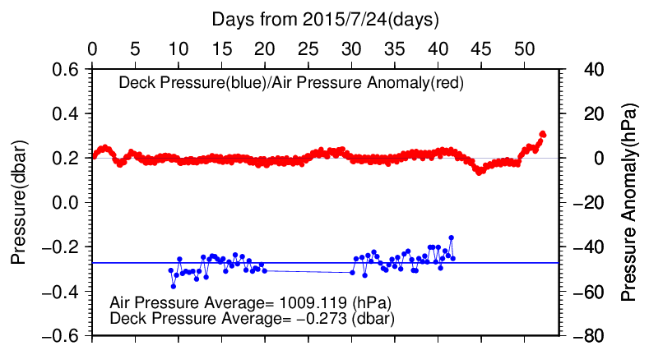
Figure C.1.1. Time series of the CTD deck pressure. Red line indicates atmospheric pressure anomaly. Blue line and dots indicate pre-cast deck pressure and average.

(4.2) Temperature sensor (SBE 3plus)
The practical corrections for CTD temperature data can be made by using a SBE 35, correcting the SBE 3plus to agree with the SBE 35 (McTaggart et al., 2010; Uchida et al., 2007).

CTD temperature is corrected as
T : the CTD temperature (degrees Celsius), P: pressure (dbar) and c₀, c₁, c₂ : coefficients

Table C.1.1. Temperature correction summary (Pressure ≥ 2000dbar). (Bold : selected sensor)
S/N | Num | c₀(K) | c₁(K/dbar) | C₂(K/dbar²) | Stations
4321 | 433 | 2.3754287e–4 | 7.1430481e–8 | 0.0000000e+0 | RF5486 – 5516
4321 | 416 | 2.6076840e–4 | 5.5049546e–8 | 0.0000000e+0 | RF5517 – 5551
5511 | 435 | -3.1366487e–6 | -2.4213192e–7 | 3.4909460e-11 | RF5486 – 5516
5511 | 416 | 3.3597151e–4 | -4.7346361e–7 | 6.2970873e-11 | RF5517 – 5551

Table C.1.2. Temperature correction summary for S/N 4321.
Stations | Pressure < 2000dbar |  |  | Pressure ≥ 2000dbar
 | Num | Average  (K) | Std  (K) | Num | Average  (K) | Std  (K)
RF5517 – 5551 | 680 | –0.0018 | 0.0132 | 433 | 0.0000 | 0.0002
RF5486 – 5516 | 793 | –0.0006 | 0.0145 | 416 | 0.0000 | 0.0002

Table C.1.3. Temperature correction summary for S/N 5511.
Stations | Pressure < 2000dbar |  |  | Pressure ≥ 2000 dbar
 | Num | Average  (K) | Std  (K) | Num | Average  (K) | Std  (K)
RF5486 – 5516 | 680 | –0.0006 | 0.0175 | 435 | 0.0000 | 0.0002
RF5517 – 5551 | 793 | –0.0010 | 0.0165 | 416 | 0.0000 | 0.0002

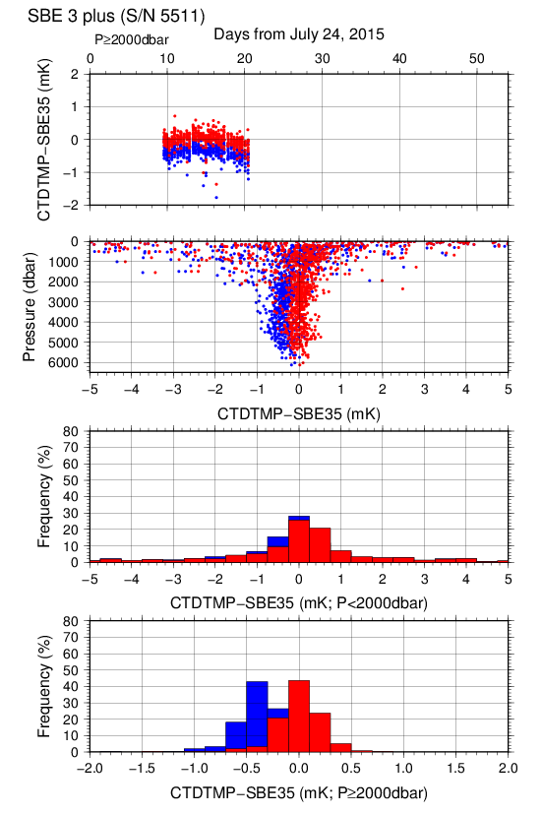
Figure C.1.2. Difference between the CTD temperature (S/N 5511) and the Deep Ocean Standards thermometer (SBE 35) at Leg 1. Blue and red dots indicate before and after the correction using SBE 35 data respectively. Lower two panels show histogram of the difference after correction.

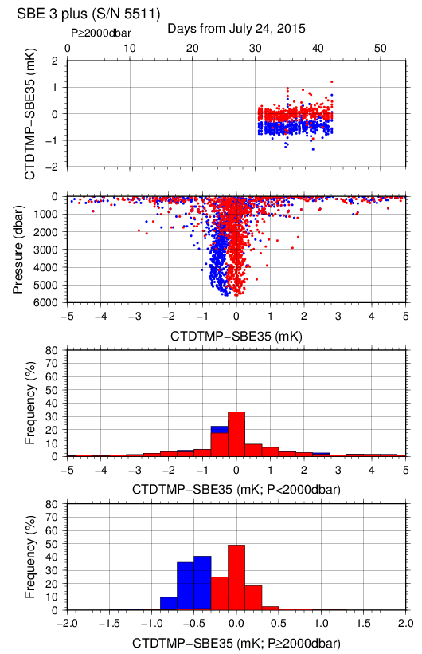
Figure C.1.3. Difference between the CTD temperature (S/N 5511) and the Deep Ocean Standards thermometer (SBE 35) at Leg 2. Blue and red dots indicate before and after the correction using SBE 35 data respectively. Lower two panels show histogram of the difference after correction.

Post–cruise sensor calibration for the SBE 3plus
S/N 4321(primary), 16 Oct. 2015
g | = | 4.39122630e–003 |  | j | = | 1.97996371e–006
h | = | 6.47501491e–004 |  | f₀ | = | 1000.0
i | = | 2.31753528e–005

S/N 5511(secondary), 16 Oct. 2015
g | = | 4.36816775e–003 |  | j | = | 1.34328201e–006
h | = | 6.30960365e–004 |  | f₀ | = | 1000.0
i | = | 1.94873151e–005
Formula:
f : Instrument freq.[Hz]

Post–cruise sensor calibration for the SBE 35
S/N 0069, 22 Oct. 2015 (2nd step: fixed point calibration)
Slope = 1.000004, Offset = 0.000683
Formula:

(4.3) Conductivity sensor (SBE 4C)
The practical corrections for CTD conductivity data can be made by using a bottle salinity data, correcting the SBE 4C to agree with measured conductivity (McTaggart et al., 2010).

CTD conductivity is corrected
C: CTD conductivity, c_{i} and p_{j} : calibration coefficients
i, j: determined by referring to AIC (Akaike, 1974). According to McTaggart et al. (2010), maximum of I and J are 2.

Table C.1.4. Conductivity correction coefficient summary. (Bold : selected sensor)
S/N | Num | c₀(S/m) | c₁ | c₂(m/S) | Stations
 |  |  | p₁(S/m/dbar) | p₂(S/m/dbar²)
2988 | 1142 | 1.6861e–4 | 0.0000e+0 | 0.0000e+0 | RF5486 – 5516
 |  |  | 8.6189e–8 | –8.7748e–12
2988 | 1318 | 1.9913e–4 | 5.0992e–5 | 0.0000e+0 | RF5517 – 5551
 |  |  | 3.3650e–8 | 0.0000e–0
4316 | 1144 | 4.2129e–4 | -1.2155e–4 | 0.0000e+0 | RF5486 – 5516
 |  |  | 8.9017e–8 | –5.2210e–12
4316 | 1315 | 1.7825e–6 | 0.0000e–0 | 0.0000e+0 | RF5517 – 5551
 |  |  | 1.2325e–7 | –1.0345e–11

Table C.1.5. Conductivity correction and salinity correction summary for S/N 2988.
Stations | Pressure < 1900dbar
 | Conductivity |  |  | Salinity
 | Num | Average  (S/m) | Std  (S/m) | Num | Average | Std
RF5486 – 5516 | 672 | 0.0000 | 0.0003 | 672 | 0.0001 | 0.0024
RF5517 – 5551 | 841 | 0.0000 | 0.0005 | 841 | 0.0000 | 0.0041
Stations | Pressure ≥ 1900 dbar
 | Conductivity |  |  | Salinity
 | Num | Average  (S/m) | Std  (S/m) | Num | Average | Std
RF5486 – 5516 | 470 | 0.0000 | 0.0000 | 470 | 0.0000 | 0.0005
RF5517 – 5551 | 477 | 0.0000 | 0.0001 | 477 | 0.0001 | 0.0007

Table C.1.6. Conductivity correction and salinity correction summary for S/N 4316.
Stations | Pressure < 1900dbar
 | Conductivity |  |  | Salinity
 | Num | Average  (S/m) | Std  (S/m) | Num | Average | Std
RF5486 – 5516 | 669 | 0.0000 | 0.0003 | 669 | 0.0000 | 0.0024
RF5517 – 5551 | 839 | 0.0000 | 0.0005 | 839 | 0.0000 | 0.0040
Stations | Pressure ≥ 1900 dbar
 | Conductivity |  |  | Salinity
 | Num | Average  (S/m) | Std  (S/m) | Num | Average | Std
RF5486 – 5516 | 475 | 0.0000 | 0.0000 | 475 | 0.0000 | 0.0005
RF5517 – 5551 | 476 | 0.0000 | 0.0000 | 476 | 0.0000 | 0.0005

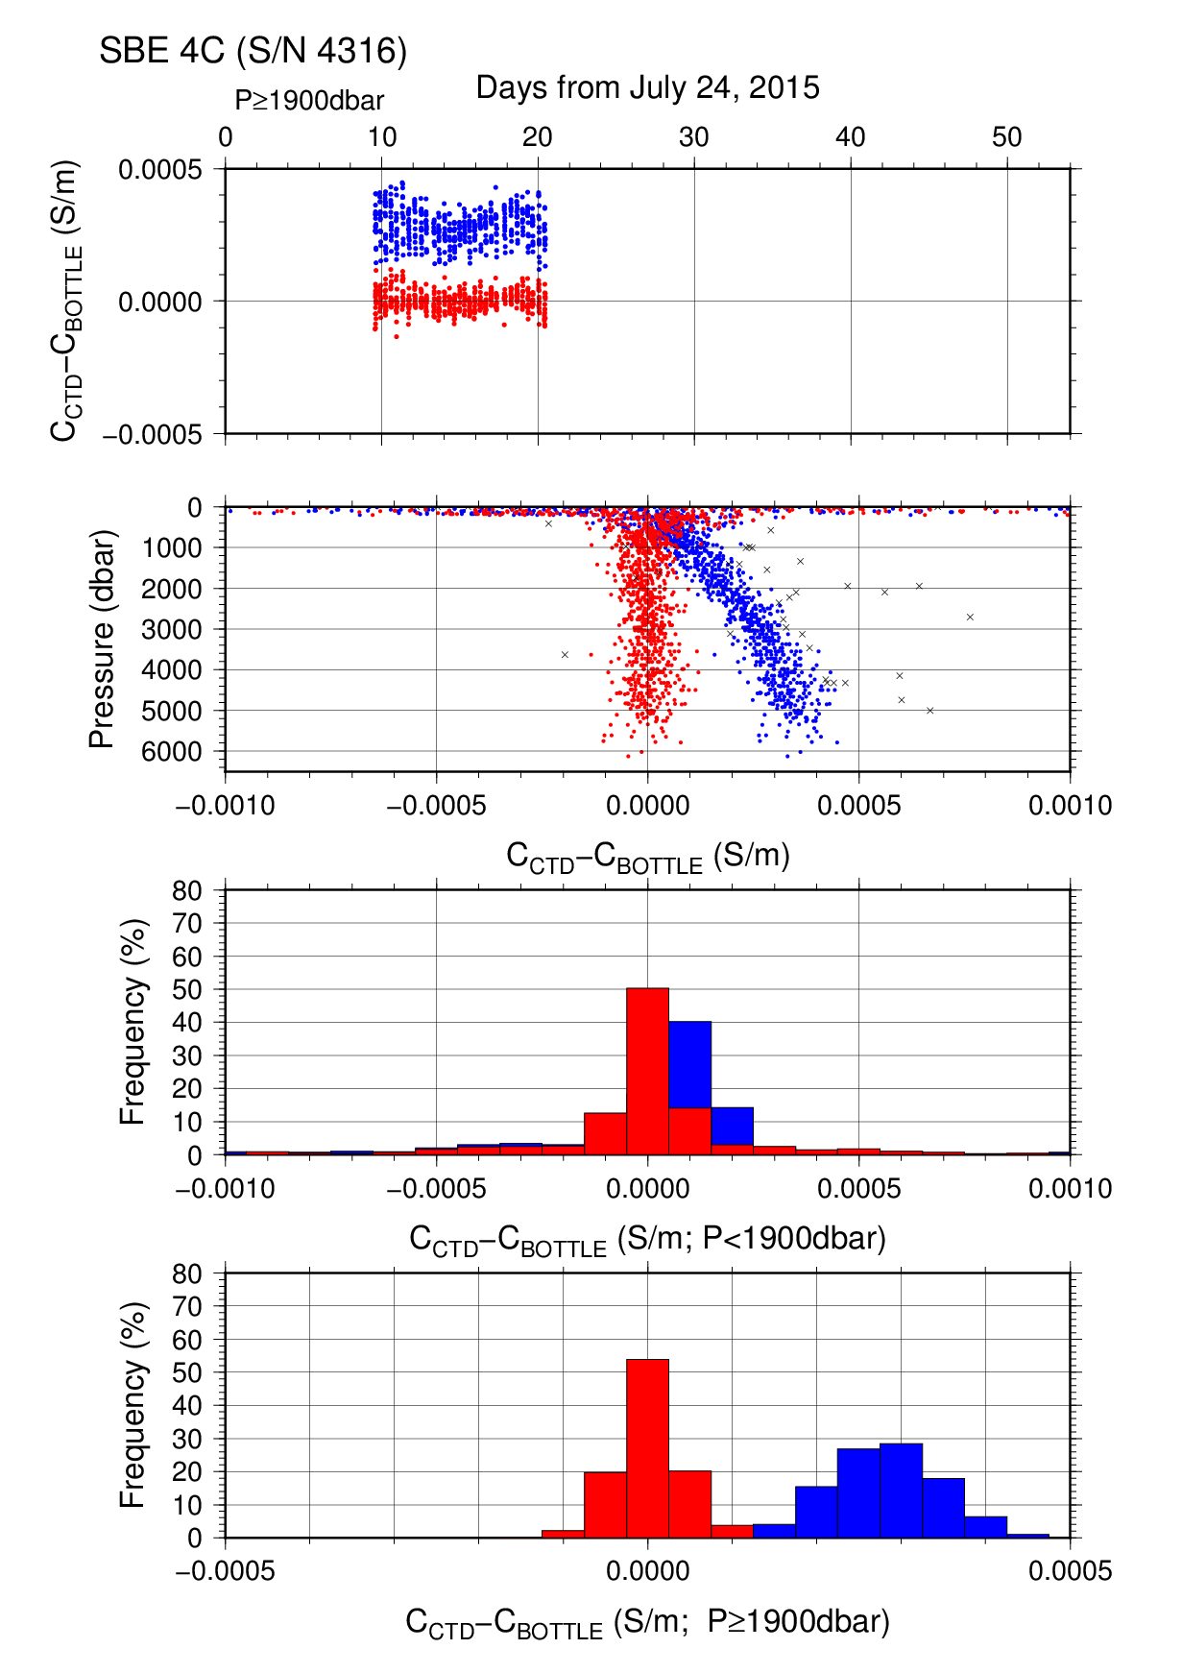
Figure C.1.4. Difference between the CTD conductivity (S/N 4316) and the bottle conductivity at Leg 1. Blue and red dots indicate before and after the calibration using bottle data respectively. Lower two panels show histogram of the difference before and after calibration.
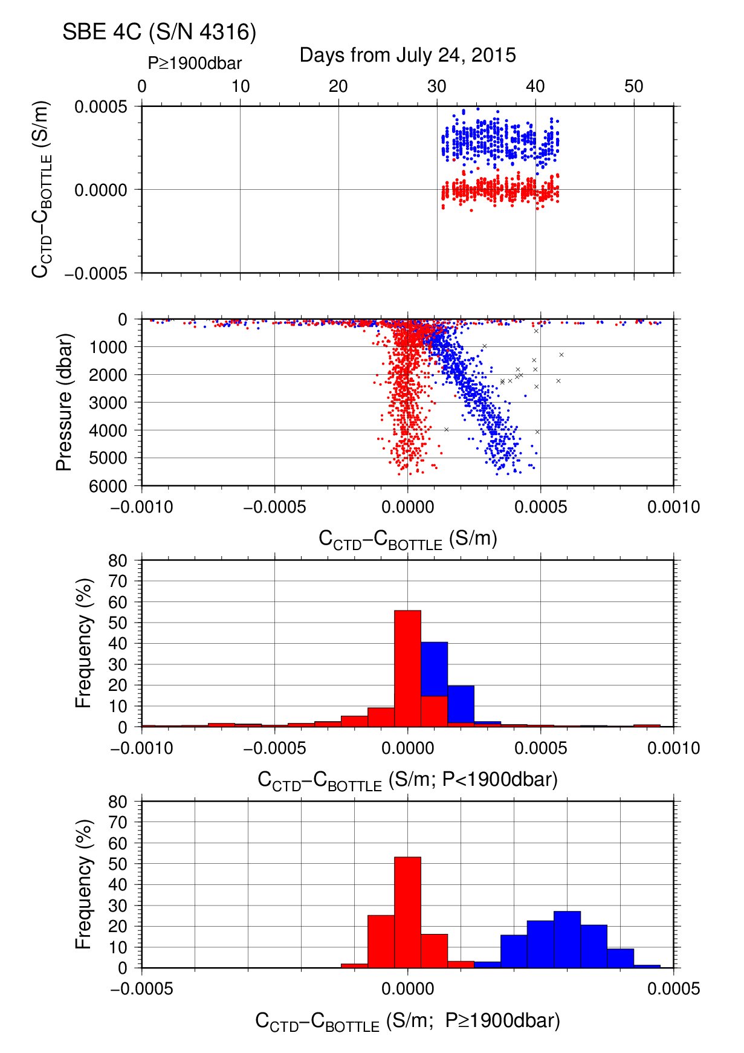

Figure C.1.5. Difference between the CTD conductivity (S/N 4316) and the bottle conductivity at Leg 2. Blue and red dots indicate before and after the calibration using bottle data respectively. Lower two panels show histogram of the difference before and after calibration.

Post–cruise sensor calibration for the SBE 4C
S/N 2988(primary), 16 Oct. 2015
g | = | –9.85203889e+000 |  |  | j | = | 4.61136788e–005
h | = |  | 1.34620761e+000 |  | CP_{cor} | = | –9.5700e–008
i | = |  | 3.29757340e–004 |  | CT_{cor} | = | 3.2500e–006

S/N 4316(secondary), 16 Oct. 2015
g | = | –9.87076057e+000 |  | j | = | 2.45401575e–004
h | = | 1.29126815e+000 |  | CP_{cor} | = | –9.5700e–008
i | = | –2.63568263e–003 |  | CT_{cor} | = | 3.2500e–006

Conductivity of a fluid in the cell is expressed as:
f: instrument frequency (kHz)
t: water temperature (degrees Celsius)
p: water pressure (dbar).

(4.4) Oxygen sensor (RINKO III)
The CTD oxygen is calculated using RINKO III output (voltage) by the Stern-Volmer equation, according to a method by Uchida et al. (2008) and Uchida et al. (2010). The pressure hysteresis for the RINKO III output (voltage) is corrected according to a method by Sea-bird Electornics (2009) and Uchida et al. (2010). The formulas are as follows:
$$P_{0}=1.0+c_{4}×t$$
$$P_{c}=c_{5}{+c}_{6}×v+c_{7}×T+c_{8}×T×v$$
$$K_{sv}=c_{1}+c_{2}×t+c_{3}×t^{2}$$
$$coef={\left(1.0+c_{9}×P/{1000}\right)}^{1/3}$$
$$\left[O_{2}\right]=O_{2}^{sat}×\left\{{\left({P_{0}}/{P_{c}-1.0}\right)}/{K_{sv}×coef}\right\}$$
P: pressure (dbar), t: potential temperature, v: RINKO output voltage (volt)
T: elapsed time of the sensor from the beginning of first station in calculation group in day
O₂^{sat}: dissolved oxygen saturation by Garcìa and Gordon (1992) (μmol/kg)
[O₂]: dissolved oxygen concentration (μmol/kg)
c₁–c₉: determined by minimizing difference between CTD oxygen and bottle dissolved oxygen by quasi-newton method (Shanno, 1970).

Table C.1.7. Dissolved oxygen correction coefficient summary. (Bold : selected sensor)
S/N | Stations | c₁ | c₂ | c₃ | c₄ | c₅
 |  | c₆ | c₇ | c₈ | c₉
025 | RF5521 – 5551 | 1.77941e+0 | 2.30304e–2 | 1.20674e–4 | –1.17375e–3 | –1.18870e–1
 |  | 3.03798e–1 | 2.58797e–4 | 5.18761e–4 | 9.91309e–2
025 | RF5486 – 5520 | 1.78556e+0 | 2.89718e–2 | 2.21929e–4 | –1.84584e–4 | –1.33767e–1
 |  | 3.08384e–1 | –4.86350e–4 | 7.43793e–4 | 8.31758e–2
008 | RF5521 – 5551 | 1.80537e+0 | 2.37545e–2 | 1.39951e–4 | –8.37342e–4 | –1.24338e–1
 |  | 2.84432e–1 | 2.32233e–4 | 7.58759e–4 | 1.07596e–1
008 | RF5486 – 5520 | 1.81772e+0 | 3.16183e–2 | 2.80953e–4 | 4.88528e–4 | –1.46188e–1
 |  | 2.90917e–1 | –4.48620e–4 | 9.04550e–4 | 8.80134e–2

Table C.1.8. Dissolved oxygen correction summary for S/N 025.
Stations | Pressure < 950dbar |  |  | Pressure ≥ 950dbar
 | Num | Average  (μmol/kg) | Std  (μmol/kg) | Num | Average  (μmol/kg) | Std  (μmol/kg)
RF5521 – 5551 | 510 | 0.11 | 1.33 | 566 | –0.01 | 0.33
RF5486 – 5520 | 598 | 0.03 | 1.02 | 593 | 0.00 | 0.22

Table C.1.9. Dissolved oxygen correction summary for S/N 008.
Stations | Pressure < 950dbar |  |  | Pressure ≥ 950dbar
 | Num | Average  (μmol/kg) | Std  (μmol/kg) | Num | Average  (μmol/kg) | Std  (μmol/kg)
RF5521 – 5551 | 510 | 0.09 | 1.31 | 566 | –0.01 | 0.35
RF5486 – 5520 | 598 | 0.00 | 1.03 | 593 | 0.00 | 0.22

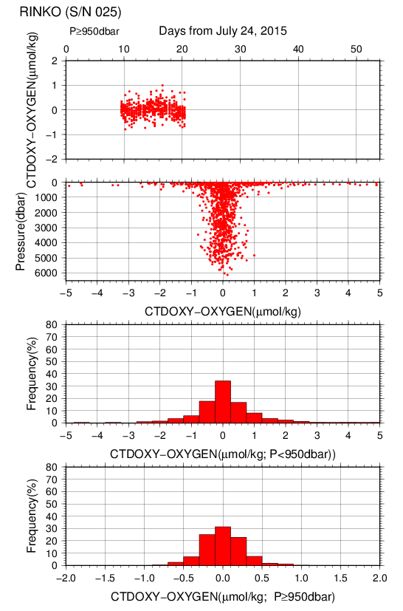
Figure C.1.6. Difference between the CTD oxygen (S/N 025) and bottle dissolved oxygen at Leg 1. Red dots in upper two panels indicate the result of calibration. Lower two panels show histogram of the difference between calibrated oxygen and bottle oxygen.

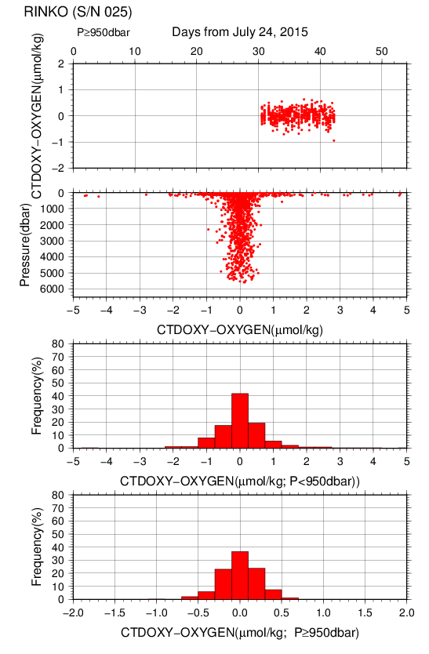
Figure C.1.7. Difference between the CTD oxygen (S/N 025) and bottle dissolved oxygen at Leg 2. Red dots in upper two panels indicate the result of calibration. Lower two panels show histogram of the difference between calibrated oxygen and bottle oxygen.

(4.5) Results of detection of sea floor by the altimeter (PSA-916D)
The altimeter detected the sea floor at 58 of 66 stations, the average distance of beginning detecting the sea floor was 35.0m, and that of final detection of sea floor was 12.9m. The summary of detection of PSA-916D was shown in Figure C.1.8.
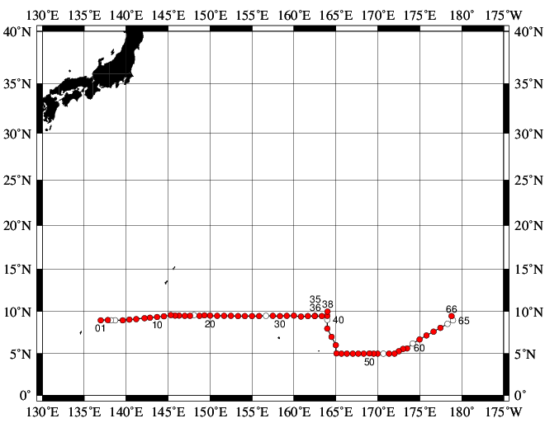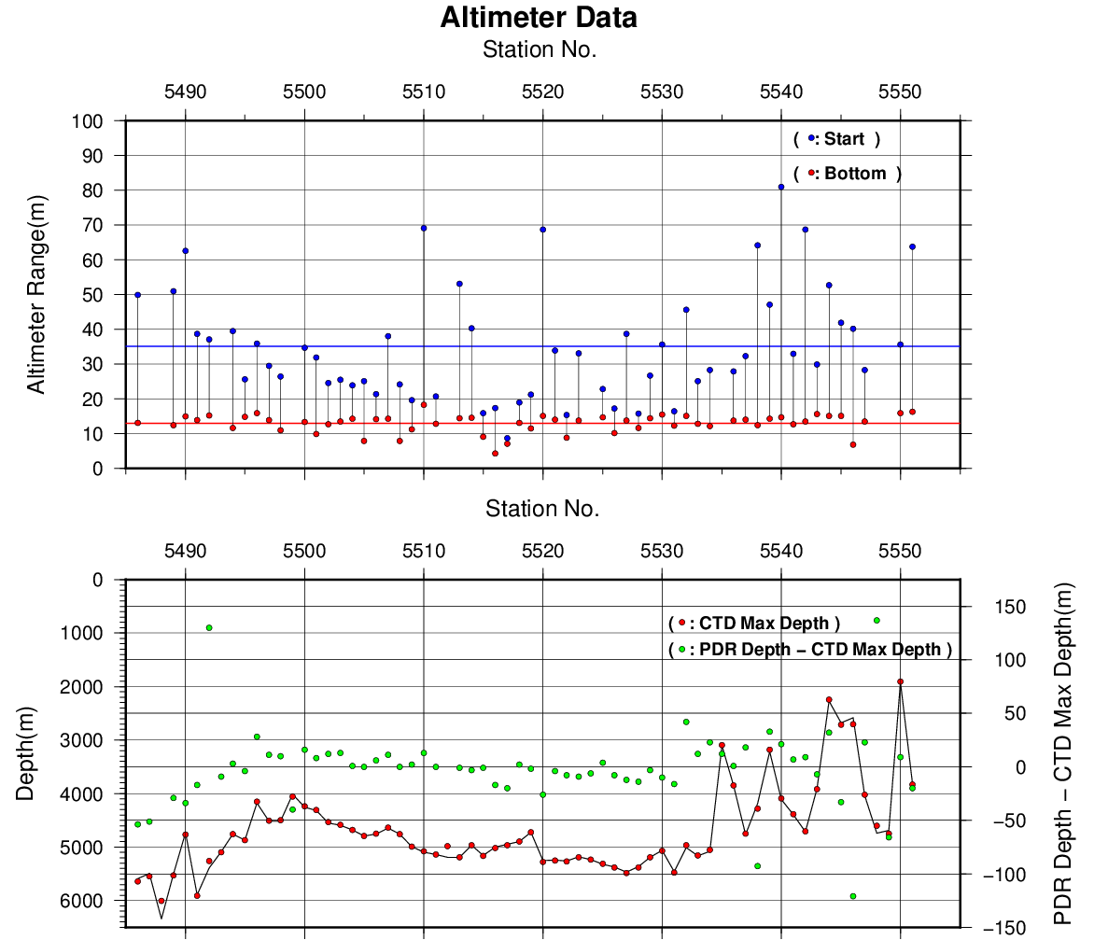

Figure C.1.8. The summary of detection of PSA-916D. The left panel shows the stations of detection, the right panel shows the relationship among PSA-916D, bathymetry and CTD depth. In the left panel, closed and open circles indicate react and no-react stations, respectively.

References
Akaike, H. (1974): A new look at the statistical model identification. IEEE Transactions on Automatic Control, 19:716–722.
Garcìa, H. E., and L. I. Gordon (1992): Oxygen solubility in seawater: Better fitting equations. Limnol. Oceanogr., 37, 1307–1312.
McTaggart, K. E., G. C. Johnson, M. C. Johnson, F. M. Delahoyde, and J. H. Swift (2010): The GO-SHIP Repeat Hydrography Manual: A Collection of Expert Reports and guidelines. IOCCP Report No 14, ICPO Publication Series No. 134, version 1, 2010.
Sea-Bird Electronics (2009): SBE 43 dissolved oxygen (DO) sensor – hysteresis corrections, Application note no. 64-3, 7 pp.
Shanno, David F. (1970): Conditioning of quasi-Newton methods for function minimization. Math. Comput. 24, 647–656. MR 42 #8905.
Uchida, H., G. C. Johnson, McTaggart, K. E. (2010): CTD oxygen sensor calibration procedures. In: The GO-SHIP repeat hydrography manual: A Collection of Expert Reports and guidelines. IOCCP Report No 14, ICPO Publication Series No. 134, version 1, 2010.
Uchida, H., K. Ohyama, S. Ozawa, and M. Fukasawa (2007): In-situ calibration of the Sea-Bird 9plus CTD thermometer. J. Atmos. Oceanic Technol., 24, 1961–1967.
Uchida, H., T. Kawano, I. Kaneko, and M. Fukasawa (2008): In-situ calibration of optode-based oxygen sensors. J. Atmos. Oceanic Technol., 25, 2271–2281.

Salinity

Personnel
Nobumi KATO (GEMD/JMA)
Koichi WADA (GEMD/JMA)
Yutaka KOBASHIGAWA (GEMD/JMA)
Jinya MIURA (GEMD/JMA)
Toshiyuki AMAZAWA (GEMD/JMA)

Salinity measurement
Salinometer: AUTOSAL 8400B (S/N696774; Guildline Instruments Ltd., Canada)
Thermometer: Guildline platinum thermometers model 9450 (to monitor an ambient temperature and bath temperature)
IAPSO Standard Sea Water: P157 (K15=0.99985)

Sampling and measurement
The measurement system was almost same as Kawano (2010).
Algorithm for practical salinity scale, 1978 (UNESCO, 1981) was employed to convert the conductivity ratios to salinities.

Station occupied
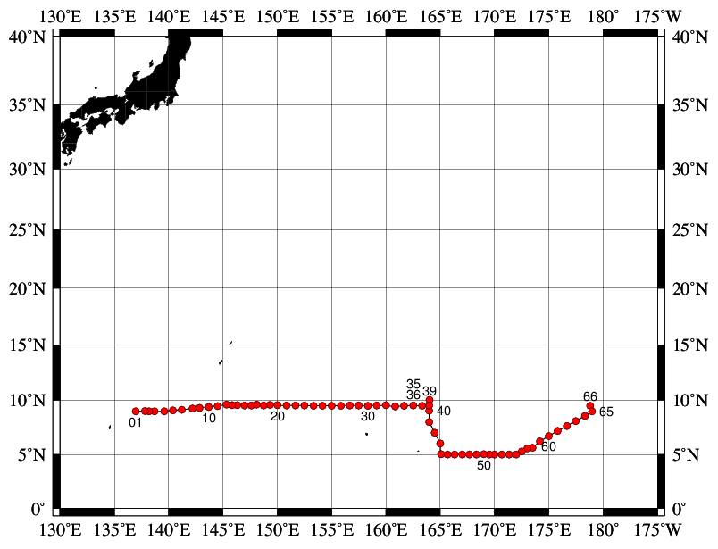
Figure C.2.1. Location of observation stations of bottle salinity. Closed and open circles indicate sampling and no-sampling station, respectively.
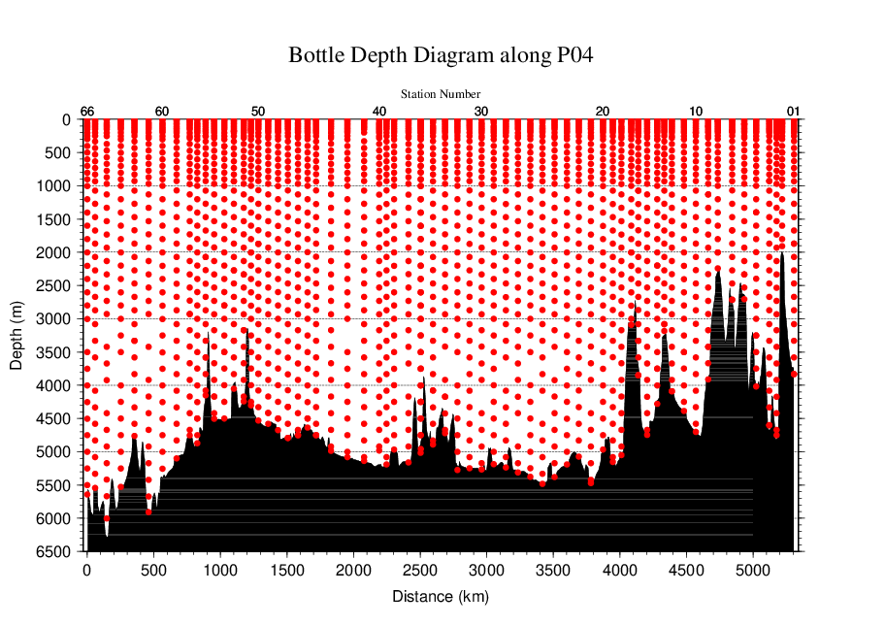
Figure C.2.2. Distance-depth distribution of sampling layers of bottle salinity.

Result

(5.1) Ambient temperature, bath temperature and SSW measurements
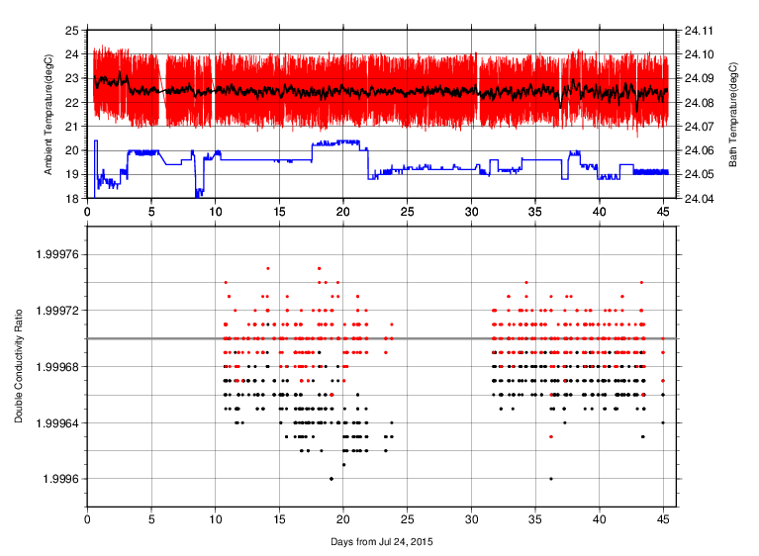
Figure C.2.3. The upper panel, red line, black line and blue line indicate time-series of ambient temperature, ambient temperature average and bath temperature during cruise. The lower panel, black dots and red dots indicate raw and corrected time-series of the double conductivity ratio of the standard sea water (P157).

(5.2) Replicate and Duplicate Samples
We took replicate (pair of water samples taken from a single Niskin bottle) and duplicate (pair of water samples taken from different Niskin bottles closed at the same depth) samples of bottle salinity through the cruise. Results of the analyses are summarized in Table C.2.1. Detailed results of them are shown in Figure C.2.4. The calculation of the standard deviation from the difference of sets was based on a procedure (SOP 23) in DOE (1994).

Table C.2.1. Summary of replicate and duplicate analyses.
Measurement | Ave. ± S.D.
Replicate | 0.0003±0.0004 (N=267)
Duplicate | 0.0007±0.0012 (N=64)

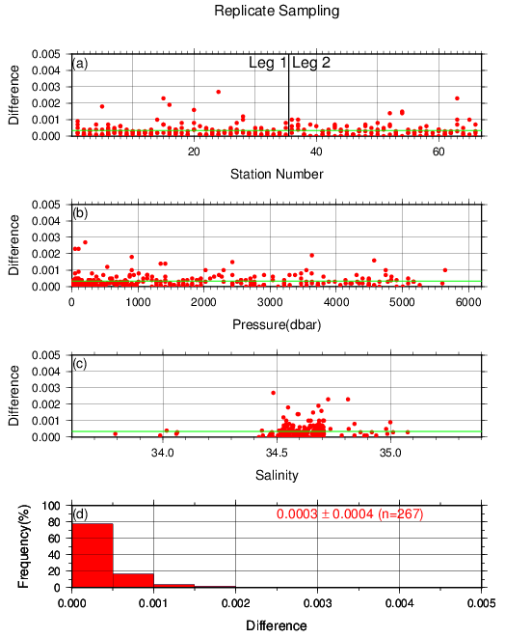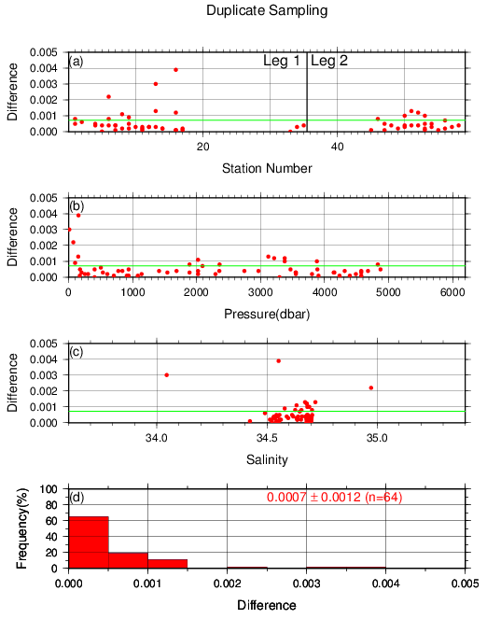
Figure C.2.4. Result of (left) replicate and (right) duplicate analyses during the cruise against (a) station number, (b) pressure and (c) salinity, and (d) histogram of the measurements. Green line indicates the mean of the differences of salinity of replicate/duplicate.

(5.3) Summary of assigned quality control flags
Table C.2.2. Summary of assigned quality control flags
Flag | Definition | Salinity
2 | Good | 1944
3 | Questionable | 0
4 | Bad (Faulty) | 138
6 | Replicate measurements | 271
Total number of samples |  | 2353

References
DOE (1994), Handbook of methods for the analysis of the various parameters of the carbon dioxide system in sea water; version 2. A.G. Dickson and C. Goyet (eds), ORNL/CDIAC-74.
Kawano (2010), The GO-SHIP Repeat Hydrography Manual: A Collection of Expert Reports and Guidelines. IOCCP Report No. 14, ICPO Publication Series No. 134, Version 1.
UNESCO (1981), Tenth report of the Joint Panel on Oceanographic Tables and Standards. UNESCO Tech. Papers in Mar. Sci., 36, 25 pp.

Bottle Oxygen

Personnel
Chihiro KAWAMURA (GEMD/JMA)
Atsushi KOJIMA (GEMD/JMA)
Misaki YAKAWA (GEMD/JMA)

Station occupied
A total of 66 stations (Leg 1: 31, Leg 2: 35) were occupied for dissolved oxygen measurements. Station location and sampling layers of bottle oxygen are shown in Figures C.3.1 and C.3.2, respectively.
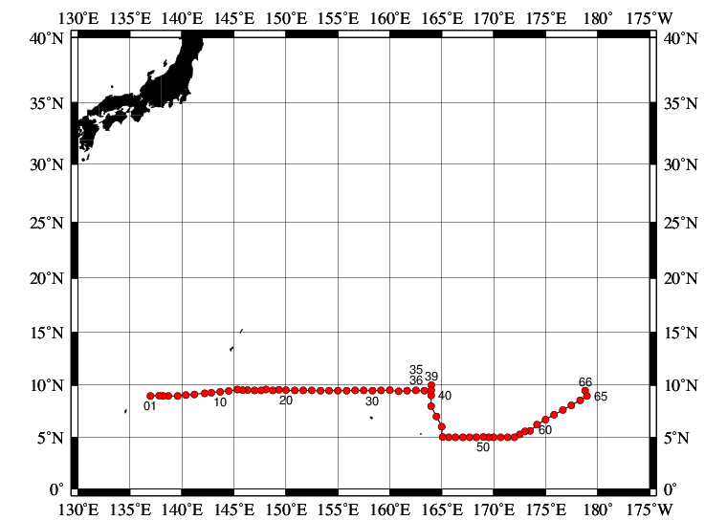
Figure C.3.1. Location of observation stations of bottle oxygen. Closed and open circles indicate sampling and no-sampling stations, respectively.

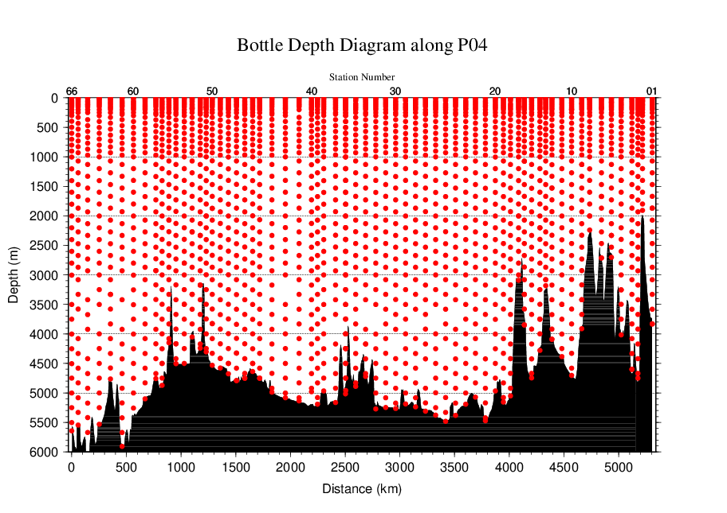
Figure C.3.2. Distance-depth distribution of sampling layers of bottle oxygen.

Instrument
Detector: DOT-01X (Kimoto Electronic, Japan)
Burette: APB-510 (Kyoto Electronic, Japan)

Sampling and measurement
Methods of seawater sampling, measurement, and calculation of dissolved oxygen concentration were based on IOCCP Report (Langdon, 2010). Details of the methods are shown in Appendix A1.
The reagents for the measurement were prepared according to recipes described in Appendix A2. It is noted that standard KIO₃ solutions were prepared gravimetrically using the highest purity standard substance KIO₃ (Lot. No. TLG0272, Wako Pure Chemical, Japan). Batch list of prepared standard KIO₃ solutions is shown in Table C.3.1.

Table C.3.1. Batch list of the standard KIO₃ solutions.
KIO₃ batch | Concentration and uncertainty (k=2) at 20 °C. Unit is normality (N). | Purpose of use
20150501-2 | 0.010003±0.000004 | Standardization (main use)
20150611-2 | 0.010000±0.000004 | Mutual comparison

Standardization
Concentration of Na₂S₂O₃ titrant was determined with the standard KIO₃ solution “20150501-2”, based on the methods of IOCCP Report (Langdon, 2010). The results of standardization during the cruise are shown in Figure C.3.3. Standard deviation of its concentration at 20 °C determined through standardization was used in calculation of an uncertainty.
Figure C.3.3. Calculated concentration of Na₂S₂O₃ solution at 20 °C in standardization during Leg 1 (top) and Leg 2 (bottom). Different colors of plots indicate different batches of Na₂S₂O₃ solution; red (blue) plots correspond to the left (right) y-axis. Error bars of plots show standard deviation of concentration of Na₂S₂O₃ in the measurement. Thick and dashed lines denote the mean and 2 times of standard deviations for the batch measurements, respectively.

Blank

(6.1) Reagent blank
Blank in oxygen measurement (reagent blank; V_{blk}, _{dw}) can be represented as follows;
V_{blk, dw} = V_{blk, ep} + V_{blk, reg} (C3.1)
where V_{blk, ep} represents a blank due to differences between the measured end-point and the equivalence point, and V_{blk, reg} a blank associated with oxidants or reductants in the reagent. The reagent blank V_{blk}, _{dw} was determined by the methods described in IOCCP Report (Langdon, 2010). Because we used two sets (set A and B) of pickling reagent-I and -II, the blanks in each set were determined (Figure C.3.4).

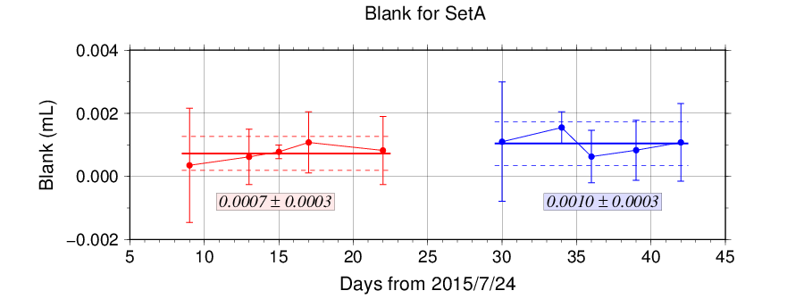
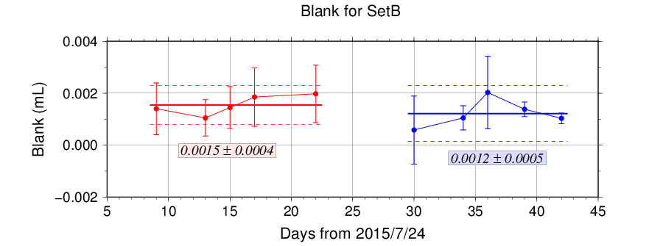
Figure C.3.4. Reagent blank (V_{blk}, _{dw}) determination for set A (top) and set B (bottom). Error bars of plots show standard deviation of the measurement. Thick and dashed lines denote the mean and 2 times of standard deviations for the batch measurement, respectively.

(6.2) Other blanks
We also determined two other blanks related to oxygen measurement; the blank V_{blk, reg} and the seawater blank (V_{blk, sw}). Details are described in Appendix A3.

Quality Control

(7.1) Replicate and duplicate analyses
We took replicate (pair of water samples taken from a single Niskin bottle) and duplicate (pair of water samples taken from different Niskin bottles closed at the same depth) samples of dissolved oxygen through the cruise. Results of the analyses are summarized in Table C.3.2. Detailed results of them are shown in Figure C.3.5. The calculation of the standard deviation from the difference of sets was based on a procedure (SOP 23) in DOE (1994).

Table C.3.2. Summary of replicate and duplicate measurements.
Measurement | Ave. ± S.D. (μmol kg⁻¹)
Replicate | 0.16±0.15 (N=251)
Duplicate | 0.21±0.19 (N=71)

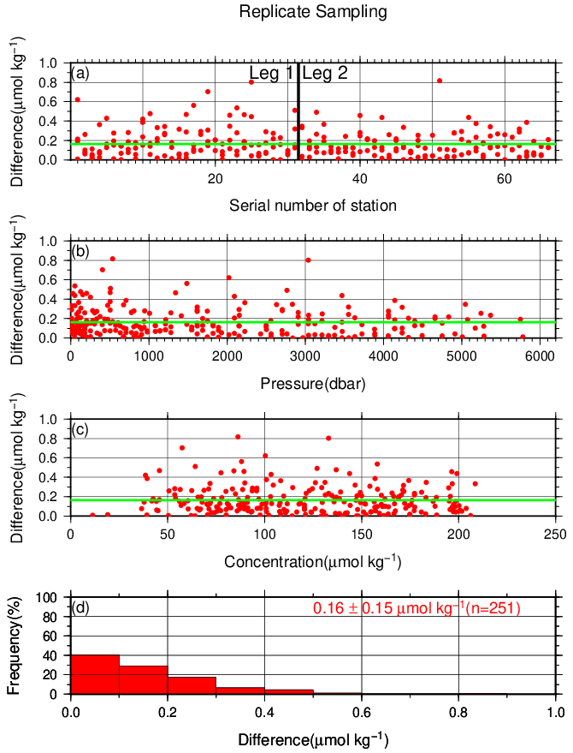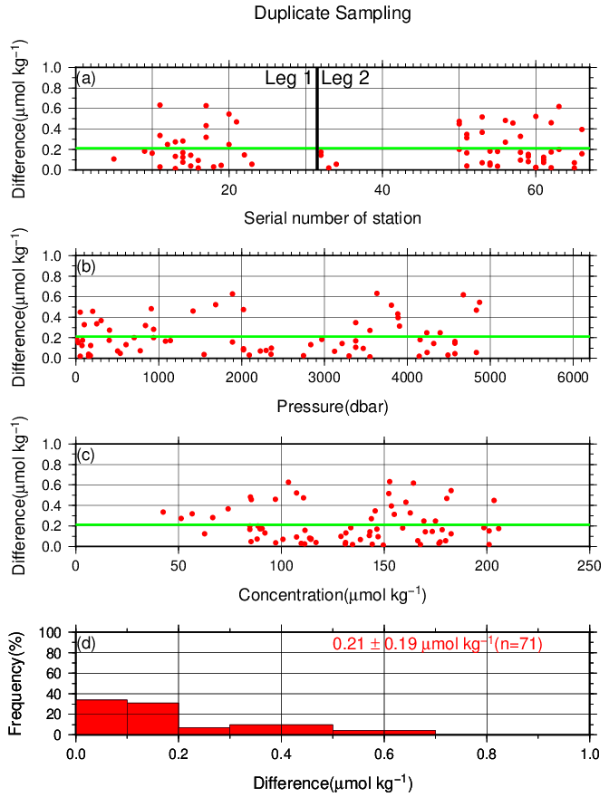
Figure C.3.5. Results of (left) replicate and (right) duplicate measurements during the cruise against (a) station number, (b) pressure and (c) concentration of dissolved oxygen. Green line denotes the average of the measurements. Bottom panels (d) show histogram of the measurements.

(7.2) Mutual comparison between each standard KIO₃ solution
During the cruise, mutual comparison between different lots of standard KIO₃ solution was performed to confirm the accuracy of our oxygen measurement and the bias of a standard KIO₃ solution. A concentration of the standard KIO₃ solution “20150501-2” was determined using Na₂S₂O₃ solution standardized with the KIO₃ solution “20150611-2”, and the difference between measurement value and theoretical one. A good agreement among two standards confirmed that there was no systematic shift in our oxygen measurements during the cruise (Figure C.3.6).

Figure C.3.6. Result of mutual comparison of standard KIO₃ solutions. Circles and error bars show mean of the measurement value and its uncertainty (k=2), respectively. Thick and dashed lines in blue denote the mean and 2 times of standard deviations, respectively, for the measurement through the leg. Green thin line and light green thick line denote nominal concentration and its uncertainty (k=2) of standard KIO₃ solution “20150501-2”.

(7.3) Quality control flag assignment
Quality flag value was assigned to oxygen measurements as shown in Table C.3.3, using the code defined in IOCCP Report No.14 (Swift, 2010).

Table C.3.3. Summary of assigned quality control flags.
Flag | Definition | Number of samples
2 | Good | 2120
3 | Questionable | 11
4 | Bad (Faulty) | 10
5 | Not reported | 0
6 | Replicate measurements | 251
Total number of samples |  | 2392

Uncertainty
Oxygen measurement involves various uncertainties; determination of glass bottles volume, repeatability and systematic error of burette discharge, repeatability of pickling reagents discharge, determination of reagent blank, standardization of Na₂S₂O₃ solution, and uncertainty of KIO₃ concentration. Considering evaluable uncertainties as above, expanded uncertainty of bottle oxygen concentration (T=20, S=34.5) was estimated as shown in Table C.3.4. However, it is difficult to determine a strict uncertainty for oxygen concentration because there is no reference material for oxygen measurement.

Table C.3.4 Expanded uncertainty (k=2) of bottle oxygen in the cruise.
O₂ conc. (μmol kg⁻¹) | Uncertainty (μmol kg⁻¹)
20 | 0.35
30 | 0.36
50 | 0.38
70 | 0.40
100 | 0.45
150 | 0.55
200 | 0.67
250 | 0.80
300 | 0.93
400 | 1.20

Appendix
A1. Methods
(A1.1) Seawater sampling
Following procedure is based on a determination method in IOCCP Report (Langdon, 2010). Seawater samples were collected from 10-liters Niskin bottles attached the CTD-system and a stainless steel bucket for the surface. Seawater for bottle oxygen measurement was transferred from the Niskin bottle and a stainless steel bucket to a volumetrically calibrated dry glass bottles. At least three times the glass volume water was overflowed. Then, pickling reagent-I 1 mL and reagent-II 1mL were added immediately, and sample temperature was measured using a thermometer. After a stopper was inserted carefully into the glass, it was shaken vigorously to mix the content and to disperse the precipitate finely. After the precipitate has settled at least halfway down the glass, the glass was shaken again. The sample glasses containing pickled samples were stored in a laboratory until they were titrated. To prevent air from entering the glass, deionized water (DW) was added to its neck after sampling.

(A1.2) Sample measurement
At least 15 minutes after the re-shaking, the samples were measured on board. Added 1 mL H₂SO₄ solution and a magnetic stirrer bar into the sample glass, samples were titrated with Na₂S₂O₃ solution whose molarity was determined with KIO₃ solution. During the titration, the absorbance of iodine in the solution was monitored using a detector. Also, temperature of Na₂S₂O₃ solution during the titration was recorded using a thermometer. Dissolved oxygen concentration (μmol kg⁻¹) was calculated from sample temperature at the fixation, CTD salinity, glass volume, and titrated volume of the Na₂S₂O₃ solution, and oxygen in the pickling reagents-I (1 mL) and II (1 mL) (7.6 × 10⁻⁸ mol; Murray et al., 1968).

A2. Reagents recipes
Pickling reagent-I; Manganous chloride solution (3 mol L⁻¹)
Dissolve 600 g of MnCl₂·4H₂O in DW, then dilute the solution with DW to a final volume of 1 L.
Pickling reagent-II; Sodium hydroxide (8 mol L⁻¹) / sodium iodide solution (4 mol L⁻¹)
Dissolve 320 g of NaOH in about 500 mL of DW, allow to cool, then add 600 g NaI and dilute with DW to a final volume of 1 L.
H₂SO₄ solution; Sulfuric acid solution (5 mol L⁻¹)
Slowly add 280 mL concentrated H₂SO₄ to roughly 500 mL of DW. After cooling the final volume should be 1 L.
Na₂S₂O₃ solution; Sodium thiosulfate solution (0.04 mol L⁻¹)
Dissolve 50 g of Na₂S₂O₃·5H₂O and 0.4 g of Na₂CO₃ in DW, then dilute the solution with DW to a final volume of 5 L.
KIO₃ solution; Potassium iodate solution (0.001667 mol L⁻¹)
Dry high purity KIO₃ for two hours in an oven at 130 °C. After weight out accurately KIO₃, dissolve it in DW in a 5 L flask. Concentration of potassium iodate is determined by a gravimetric method.

A3. Other blanks in oxygen measurement
(A3.1) Blank associated with oxidants or reductants in the reagents
The blank V_{blk, reg,} associated with oxidants or reductants in the reagent, was determined as follows. Using a calibrated pipette, 1 mL of the standard KIO₃ solution and 100 mL of DW were added to two glasses each. Then, 1 mL H₂SO₄ solution, 1 mL of pickling reagent-II and 1 mL reagent-I were added in sequence into the first glass. Next, added two times volume of the reagents (2 mL of H₂SO₄ solution, pickling reagent-II and I each) into the second one. After that, the sample was titrated to the end-point with Na₂S₂O₃ solution. V_{blk, reg} was determined with difference of titrated volume of Na₂S₂O₃ between the first (total reagents volume is 3 mL) and the second (total reagents volume is 6 mL) one, also, experiments for three times and four times volume of them were carried out. The results are shown in Figure C.3.A1.

Figure C.3.A1. Blank (mL) due to redox species other than oxygen in the reagents.

The relation between difference of the titrant volume and the reagents of the volume (V_{reg}) is expressed as follows;
Difference of the titrant volume = –0.0012 V_{reg}. (C3.A1)
Therefore, V_{blk, reg} was estimated to be +0.004 mL.

(A3.2) Sample blank (V_{blk, spl})
Blank due to redox species other than oxygen in the sample (V_{blk, spl}) can be a potential source of measurement error. Total blank during seawater measurement, seawater blank (V_{blk, sw}), can be represented as follows;
V_{blk, sw} = V_{blk, spl} + V_{blk, dw}. (C3.A2)
If the V_{blk, dw} determined in eq. (C3.1) is identical both in seawater and in pure water, the difference between the seawater and reagent blanks gives the V_{blk, spl}.
Here, V_{blk, spl} was determined by following procedure. Seawater was collected in the calibrated volumetric glass without the pickling solution. Then 1 mL of the standard KIO₃ solution, H₂SO₄ solution, and reagent solution-II and I each were added in sequence into the glass. After that, the sample was titrated to the end-point by Na₂S₂O₃ solution. Similarly, a glass contained 100 mL of DW added with 1 mL of the standard KIO₃ solution, H₂SO₄ solution, pickling reagent solution-II and I were titrated with Na₂S₂O₃ solution. The difference of the titrant volume of the seawater and DW glasses gave V_{blk, spl}.
The sample blank has been reported from 0.4 to 0.8 μmol kg⁻¹ in the previous study (Culberson et al., 1991). Additionally, these errors are expected to be the same to all investigators and not to affect the comparison of results from different investigators (Culberson, 1994). However, the magnitude and variability of the seawater blank have not yet been documented. We believe that understanding of the magnitude and variability may be important to evaluate comparability of computed oxygen concentrations with other groups. The determined sample blanks are shown in Table C.3.A1.

Table C.3.A1. Results of the sample blank determinations.
Station: RF5487  9°-00′N/137°-00′E |  |  | Station: RF5495  8°-59′N/139°-35′E |  |  | Station: RF5547  5°-35′N/173°-00′E |  |  | Station: RF5551  8°-59′N/178°-58′E
Pres. | Blank |  | Pres. | Blank |  | Pres. | Blank |  | Pres. | Blank
(dbar) | (μmol kg⁻¹) |  | (dbar) | (μmol kg⁻¹) |  | (dbar) | (μmol kg⁻¹) |  | (dbar) | (μmol kg⁻¹)
2.6 | 0.42 |  | 25.6 | 0.95 |  | 50.8 | 0.41 |  | 10.8 | 0.61
10.6 | 0.29 |  | 78.3 | 1.21 |  | 75.4 | 0.38 |  | 50.1 | 0.50
25.1 | 0.38 |  | 78.3 | 0.80 |  | 100.7 | 0.48 |  | 50.1 | 0.41
50.9 | 0.42 |  | 252.1 | 0.70 |  | 100.7 | 0.50 |  | 125.2 | 0.58
77.9 | 0.50 |  | 806.8 | 0.62 |  | 126.1 | 0.84 |  | 251.9 | 0.68
77.9 | 0.49 |  | 1412.5 | 1.44 |  | 151.7 | 0.48 |  | 534.3 | 0.72
102.0 | 0.55 |  | 2021.4 | 0.65 |  | 176.9 | 0.55 |  | 736.3 | 0.78
151.8 | 0.71 |  | 2427.0 | 0.91 |  | 202.8 | 0.67 |  | 1080.9 | 0.72
201.7 | 0.72 |  | 2835.4 | 0.65 |  | 606.3 | 0.58 |  | 2297.1 | 0.81
433.3 | 0.71 |  | 3295.6 | 0.69 |  | 1211.2 | 0.50 |  | 3375.6 | 0.58
938.3 | 0.63 |  | 3295.6 | 0.72 |  | 1818.0 | 0.61 |  | 3375.6 | 0.72
1484.3 | 0.66 |  | 4077.6 | 0.54 |  | 2631.1 | 0.53 |  | 4913.8 | 0.76
2296.0 | 0.76 |  |  |  |  | 3293.4 | 0.56
2907.1 | 0.65 |  |  |  |  | 4061.6 | 0.62
3889.4 | 0.71 |  |  |  |  | 4955.6 | 0.68
3889.4 | 0.71 |  |  |  |  | 4955.6 | 0.84

Reference
Culberson, A.H. (1994) Dissolved oxygen, in WHPO Pub. 91-1 Rev. 1, November 1994, Woods Hole, Mass., USA.
Culberson, A.H., G. Knapp, M.C. Stalcup, R.T. Williams, and F. Zemlyak (1991) A comparison of methods for the determination of dissolved oxygen in seawater, WHPO Pub. 91-2, August 1991, Woods Hole, Mass., USA.
DOE (1994), Handbook of methods for the analysis of the various parameters of the carbon dioxide system in sea water; version 2. A.G. Dickson and C. Goyet (eds), ORNL/CDIAC-74.
Langdon, C. (2010), Determination of dissolved oxygen in seawater by Winkler titration using the amperometric technique, IOCCP Report No.14, ICPO Pub. 134, 2010 ver.1
Murray, C. N., J. P. Riley and T. R. S. Wilson (1968), The solubility of oxygen in Winkler reagents used for the determination of dissolved oxygen. Deep-Sea Res. 15, 237–238.
Swift, J. H. (2010), Reference-quality water sample data: Notes on acquisition, record keeping, and evaluation. IOCCP Report No.14, ICPO Pub. 134, 2010 ver.1.

Nutrients

Personnel
Takahiro KITAGAWA (GEMD/JMA)
Kei KONDO (GEMD/JMA)
Ryoma SUZUKI (GEMD/JMA)

Station occupied
A total of 66 stations (Leg 1: 31, Leg 2: 35) were occupied for nutrients measurements. Station location and sampling layers of nutrients are shown in Figures C.4.1 and C.4.2.
Figure C.4.1. Location of observation stations of nutrients. Closed and open circles indicate sampling and no-sampling stations, respectively.

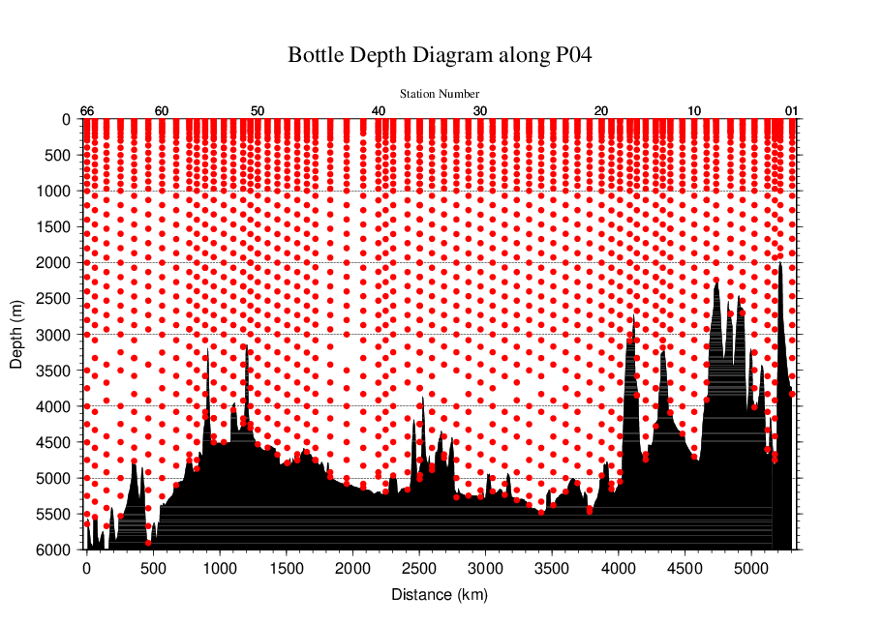
Figure C.4.2. Distance-depth distributions of sampling layers of nutrients.

Instrument
The nutrients analysis was carried out on 4-channel Auto Analyzer III (BL TEC K.K., Japan) for 4 parameters; nitrate+nitrite, nitrite, phosphate, and silicate.

Sampling and measurement
Methods of seawater sampling, measurement, and data processing of nutrient concentration were described in Appendixes A1, A2, and A3, respectively. The reagents for the measurement were prepared according to recipes shown in Appendix A4.

Nutrients standards

(5.1) Volumetric laboratory ware of in-house standards
All volumetric wares were gravimetrically calibrated. The weights obtained in the calibration weighing were corrected for the density of water and for air buoyancy. Polymethylpenten volumetric flasks were gravimetrically calibrated at the temperature of use within 4–6 °C. All pipettes have nominal calibration tolerances of 0.1 % or better. These were gravimetrically calibrated in order to verify and improve upon this nominal tolerance.

(5.2) Reagents of standard
The batches of the reagents used for standard are listed in Table C.4.1.

Table C.4.1. List of reagents of standard used in the cruise.
 | Name | CAS No | Lot. No | Industries
Nitrate | potassium nitrate 99.995 suprapur® | 7757-79-1 | B0771365 | Merck KGaA
Nitrite | sodium nitrite GR for analysis ACS, Reag. Ph Eur | 7632-00-0 | A0723349 | Merck KGaA
Phosphate | potassium dihydrogen phosphate anhydrous 99.995 suprapur® | 7778-77-0 | B1122808 | Merck KGaA
Silicate | Silicon standard solution 1000 mg/l Si* | - | HC382250 | Merck KGaA
* Traceable to NIST-SRM3150

(5.3) Low nutrient seawater (LNSW)
Surface water with sufficiently low nutrient concentration was taken and filtered using 10 μm pore size membrane filter in our previous cruise. This water was stored in 20 liter flexible container with paper box.

(5.4) In-house standard solutions
Nutrient concentrations for A, B and C standards were set as shown in Table C.4.2. A and B standards were prepared with deionized water (DW). C standard (full scale of working standard) was mixture of B-1 and B-2 standards, and was prepared with LNSW. C-1 standard, whose concentrations of nutrient were nearly zero, was prepared as LNSW slightly added with DW to be equal with mixing ratio of LNSW and DW in C standard. The C-2 to -5 standards were prepared with mixture of C-1 and C standards in stages as 1/4, 2/4, 3/4, and 4/4 (i.e., pure “C standard”) concentration for full scale, respectively. The actual concentration of nutrients in each standard was calculated based on the solution temperature and factors of volumetric laboratory wares calibrated prior to use. Nominal zero concentration of nutrient was determined in measurement of DW after refraction error correction. The calibration curves for each run were obtained using 5 levels of C-1 to -5 standards. These standard solutions were periodically renewed as shown in Table C.4.3.

Table C.4.2. Nominal concentrations of nutrients for A, B, and C standards at 20 °C. Unit is μmol L⁻¹.
 | A | B | C
Nitrate | 26250 | 524 | 43.6
Nitrite | 12510 | 250 | 2.0
Phosphate | 2030 | 40.5 | 3.38
Silicate | 35640 | 2134 | 170

Table C.4.3. Schedule of renewal of in-house standards.
Standard | Renewal
A-1 std. (NO₃) | No renewal
A-2 std. (NO₂) | No renewal
A-3 std. (PO₄) | No renewal
A-4 std. (Si) | Commercial prepared solution
B-1 std. (mixture of A-1, A-3, and A-4 stds.) | Maximum 8 days
B-2 std. (diluted A-2 std.) | Maximum 15 days
C-std. (mixture of B-1 and B-2 stds.) | Every measurement
C-1 to -5 stds. | Every measurement

Certified reference material
Certified reference material for nutrients in seawater (hereafter CRM), which was prepared by the General Environmental Technos (KANSO Technos, Japan), was used every analysis at each hydrographic station. Using CRMs for the analysis of seawater, stable comparability and uncertainty of our data are secured.
CRMs used in the cruise are shown in Table C.4.4.

Table C.4.4. Certified concentration and uncertainty (k=2) of CRMs. Unit is μmol kg⁻¹.
 | Nitrate | Nitrite | Phosphate | Silicate
CRM-BY | 0.024±0.019* | 0.019±0.0085* | 0.039±0.010* | 1.763±0.063
CRM-BW | 24.59±0.20 | 0.067±0.010 | 1.541±0.014 | 60.01±0.42
CRM-BV | 35.36±0.35 | 0.047±0.0073 | 2.498±0.023 | 102.2±1.1
CRM-BZ | 43.35±0.33 | 0.215±0.011 | 3.056±0.033 | 161.0±0.93
* Reference value because concentration is under limit of quantitation

The CRM-BY and -BV were analyzed every runs using newly opened CRM bottle at each hydrographic station. The CRM-BW and -BZ were also analyzed every runs but were newly opened every 2 or 3 runs. Although this usage of CRM might be less common, we have confirmed a stability of the opened CRM bottles to be tolerance in our observation. The CRM bottles were stored at a laboratory in the ship, where the temperature was maintained around 25 °C.
It is noted that nutrient data in our report are calibrated not on CRM but on in-house standard solutions. Therefore, to calculate data based on CRM, it is necessary that values of nutrient concentration in our report are correlated with CRM values measured in the same analysis run. The result of CRM measurements is attached as 49UP20150724_P04W_nut_CRM_measurement.csv.

Quality Control

(7.1) Replicate and duplicate analyses
We took replicate (pair of water samples taken from a single Niskin bottle) and duplicate (pair of water samples taken from different Niskin bottles closed at the same depth) samples of nutrient through the cruise. Results of the analyses are summarized in Table C.4.5. Detailed results of them are shown in Figures C.4.3–C.4.5. The calculation of the standard deviation from the difference of sets was based on a procedure (SOP 23) in DOE (1994).

Table C.4.5. Average and standard deviation of difference of replicate and duplicate measurements through the cruise. Unit is μmol kg⁻¹.
Measurement | Nitrate+nitrite | Phosphate | Silicate
Replicate | 0.026±0.024 (N=255) | 0.002±0.002 (N=253) | 0.078±0.077 (N=251)
Duplicate | 0.037±0.033 (N=70) | 0.004±0.004 (N=70) | 0.138±0.125 (N=69)

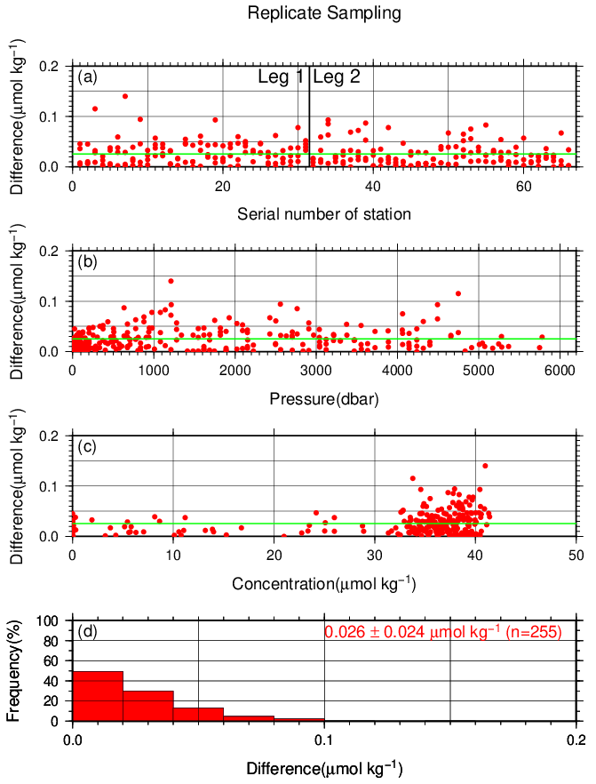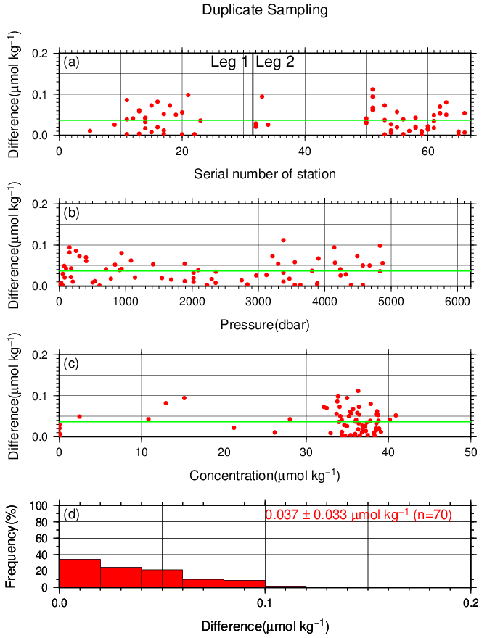
Figure C.4.3. Result of (left) replicate and (right) duplicate measurements of nitrate+nitrite through the cruise versus (a) station number, (b) sampling pressure, (c) concentration, and (d) histogram of the measurements. Green line indicates the mean of the differences of concentration of replicate/duplicate analyses.

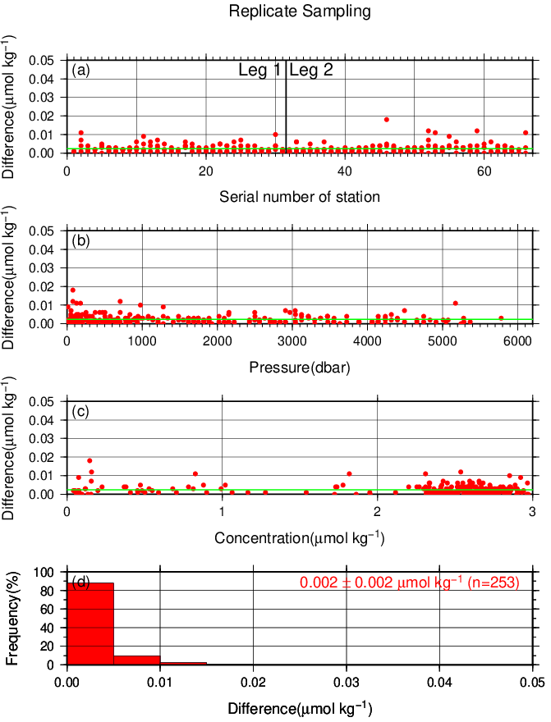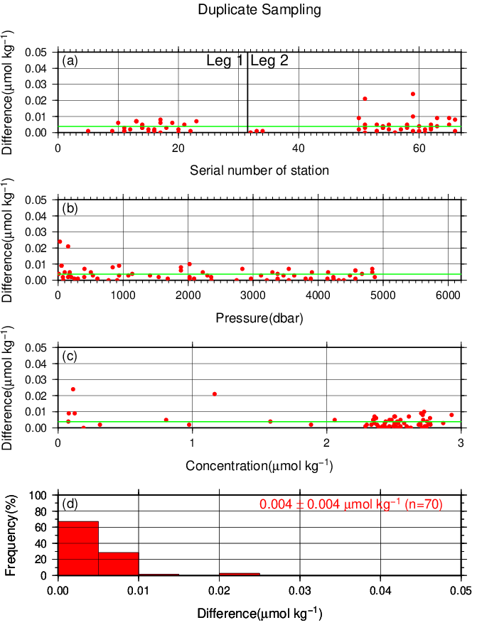
Figure C.4.4. Same as Figure C.4.3 but for phosphate.

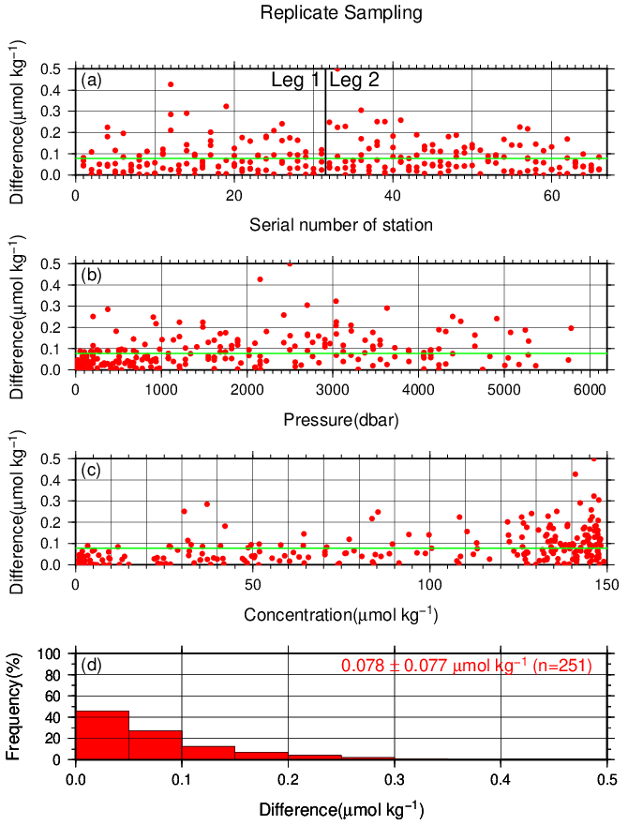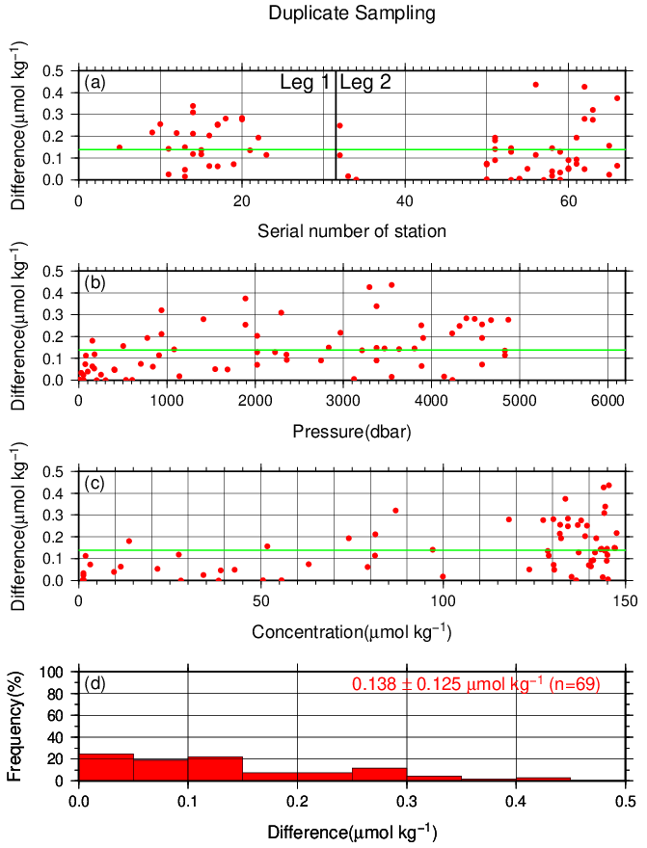
Figure C.4.5. Same as Figure C.4.3 but for silicate.

(7.2) Measurement of CRMs
CRM measurements during the cruise are summarized in Table C.4.6, whose concentrations were assigned with in-house standard solutions. The measured concentrations of CRM-BZ through the cruise are shown in Figures C.4.6–C.4.9.

Table C.4.6. Summary of (upper) mean concentration and its standard deviation (unit: μmol kg⁻¹), (middle) coefficient of variation (%), and (lower) total number of CRMs measurements through the cruise.
 | Nitrate+nitrite | Nitrite | Phosphate | Silicate
CRM-BY | 0.095±0.023  24.30%  (N=132) | 0.022±0.002  10.66%  (N=132) | 0.035±0.004  12.03%  (N=132) | 1.68±0.05  2.76%  (N=131)
CRM-BW | 24.70±0.05  0.20%  (N=99) | 0.073±0.002  2.10%  (N=99) | 1.54±0.01  0.53%  (N=99) | 59.93±0.13  0.22%  (N=95)
CRM-BV | 35.41±0.06  0.17%  (N=132) | 0.049±0.001  2.86%  (N=132) | 2.49±0.01  0.26%  (N=130) | 102.27±0.17  0.16%  (N=128)
CRM-BZ | 43.61±0.06  0.15%  (N=99) | 0.216±0.003  1.52%  (N=99) | 3.05±0.01  0.19%  (N=99) | 160.95±0.26  0.16%  (N=96)

Figure C.4.6. Time-series of measured concentration of nitrate+nitrite of CRM-BZ through the cruise. Closed and open circles indicate the newly and previously opened bottle, respectively. Thick and dashed lines denote the mean and 2 times of standard deviations of the measurements through the cruise, respectively.

Figure C.4.7. Same as Figure C.4.6 but for nitrite.

Figure C.4.8. Same as Figure C.4.6 but for phosphate.

Figure C.4.9. Same as Figure C.4.6 but for silicate.

(7.3) Precision of analysis in a run
To monitor precision of analysis, the same samples were repeatedly measured in a sample array in a run. For this, C-5 standard solutions were randomly arrayed in every 2–10 samples as “check standard” (the number of the standard is about 8–9) in the run. The precision was estimated as coefficient of variation of the measurements. The results are summarized in Table C.4.7. The time series are shown in Figures C.4.10–C.4.13.
Figure C.4.10. Time-series of coefficient of variation of “check standard” measurement of nitrate+nitrite through the cruise. Thick and dashed lines denote the mean and 2 times of standard deviations of the measurements through the cruise, respectively.

Figure C.4.11. Same as Figure C.4.10 but for nitrite.

Figure C.4.12. Same as Figure C.4.10 but for phosphate.

Figure C.4.13. Same as Figure C.4.10 but for silicate.

Table C.4.7. Summary of precisions during the cruise.
 | Nitrate+nitrite | Nitrite | Phosphate | Silicate
Median | 0.08% | 0.08% | 0.09% | 0.08%
Mean | 0.09% | 0.08% | 0.19% | 0.09%
Minimum | 0.02% | 0.02% | 0.03% | 0.03%
Maximum | 0.22% | 0.23% | 0.84% | 0.23%
Number | 66 | 65 | 66 | 66

(7.4) Carryover
Carryover coefficients were determined in each analysis run, using C-5 standard (high standard) followed by two C-1 standards (low standard). Time series of the carryover coefficients are shown in Figures C.4.14–17.
Figure C.4.14. Time-series of carryover coefficients in measurement of nitrate+nitrite through the cruise.

Figure C.4.15. Same as Figure C.4.14 but for nitrite.

Figure C.4.16. Same as Figure C.4.14 but for phosphate.

Figure C.4.17. Same as Figure C.4.14 but for silicate.

(7.5) Limit of detection/quantitation of measurement
Limit of detection (LOD) and quantitation (LOQ) of nutrient measurement were estimated from standard deviation (σ) of repeated measurements of nutrients concentration in C-1 standard as 3σ and 10σ, respectively. Summary of LOD and LOQ are shown in Table C.4.8.

Table C.4.8. Limit of detection (LOD) and quantitation (LOQ) of nutrient measurement in the cruise. Unit is μmol kg⁻¹.
 | LOD | LOQ
Nitrate+nitrite | 0.029 | 0.090
Nitrite | 0.015 | 0.066
Phosphate | 0.016 | 0.068
Silicate | 0.033 | 0.097

(7.6) Quality control flag assignment
Quality flag value was assigned to nutriment measurements as shown in Table C.4.9, using the code defined in IOCCP Report No.14 (Swift, 2010).

Table C.4.9. Summary of assigned quality control flags.
Flag | Definition | Nitrate+nitrite | Nitrite | Phosphate | Silicate
2 | Good | 2126 | 2127 | 2123 | 2116
3 | Questionable | 1 | 0 | 7 | 7
4 | Bad (Faulty) | 10 | 9 | 9 | 18
5 | Not reported | 0 | 0 | 0 | 0
6 | Replicate measurements | 255 | 256 | 253 | 251
Total number of samples |  | 2392 | 2392 | 2392 | 2392

Uncertainty

(8.1) Uncertainty of analysis between runs
Uncertainty of analysis between runs was evaluated from coefficient of variation of measured concentration of CRM-BZ throughout cruise as shown in subsection (7.2).

(8.2) Uncertainty of analysis in a run
Uncertainty of analysis in a run was evaluated from coefficient of variation of repeated measurements of “check standard” solution as shown in subsection (7.3).

(8.3) Uncertainty associated with concentration level
Uncertainty of nutrient measurement associated with concentrations level (U_{c}) was empirically represented as follows;
U_{c} (%) = a + b (1/C_{x}) + c (1/ C_{x})² (C4.1)
where C_{x} is concentration of sample for parameter X.
Using coefficient of variation of CRM measurement through the cruise and CRM concentration, uncertainty associated with concentration level for nitrate+nitrite, phosphate, and silicate were determined as follows;
U_{c} (%) = $0.208+1.804×(1/{C_{n})+}0.0577×{(1/{C_{n})}}^{2}$0.020 + 2.625 × (1/C_{n}) − 0.032 × (1/C_{n})²$0.274+1.779×\left(1/{C_{n}}\right)+0.0497×{\left(1/{C_{n}}\right)}^{2}$ (C4.2)
U_{c} (%) = $0.208+1.804×(1/{C_{n})+}0.0577×{(1/{C_{n})}}^{2}$−$0.208+1.804×(1/{C_{n})+}0.0577×{(1/{C_{n})}}^{2}$0.049 + 0.623 × (1/C_{p}) $0.274+1.779×\left(1/{C_{n}}\right)+0.0497×{\left(1/{C_{n}}\right)}^{2}$− 0.014 × (1/C_{p})² (C4.3)
U_{c} (%) = $0.208+1.804×(1/{C_{n})+}0.0577×{(1/{C_{n})}}^{2}$0.049 + 6.559 × (1/C_{s}) – 0.298 × (1/C_{s})²,$0.274+1.779×\left(1/{C_{n}}\right)+0.0497×{\left(1/{C_{n}}\right)}^{2}$ (C4.4)
where C_{n}, C_{p}, and C_{s} represent concentrations of nitrate+nitrite, phosphate, and silicate, respectively, in μmol kg⁻¹. The determined uncertainty was also represented as graphs in Appendix A5.

(8.4) Combined relative standard uncertainty
Combined relative standard uncertainty (U) is calculated as follows:
U=$\sqrt{U_{c}^{2}+U_{a}^{2}+U_{s}^{2}+U_{r}^{2}}$ (C4.5)
where U_{r} is uncertainty of CRM concentration, U_{s} is uncertainty of in-house standard, U_{a} is uncertainty of analysis, and U_{c} is uncertainty according to concentration level. Here, as representative, the uncertainties obtained from CRM measurement were shown Table C.4.10.

Table C.4.10. Result of concentration and expanded uncertainty (k=2) determined for CRM measurements. Unit is μmol kg⁻¹.
 | Nitrate+nitrite | Phosphate | Silicate
CRM-BY | 0.10±0.05 | 0.035±0.004 | 1.68±0.13
CRM-BW | 24.70±0.24 | 1.54±0.03 | 59.93±0.81
CRM-BV | 35.41±0.34 | 2.49±0.05 | 102.27±1.36
CRM-BZ | 43.61±0.42 | 3.05±0.06 | 160.95±2.13

Appendix
A1. Seawater sampling
Seawater samples were collected from 10-liters Niskin bottle attached CTD-system and a stainless steel bucket for the surface. Samples were drawn into 10 mL polymethylpenten vials using sample drawing tubes. The vials were rinsed three times before water filling and were capped immediately after the drawing.
No transfer was made and the vials were set on an auto sampler tray directly. Samples were analyzed immediately after collection.

A2. Measurement
(A2.1) General
Auto Analyzer III is based on Continuous Flow Analysis method and consists of sampler, pump, manifolds, and colorimeters. As a baseline, we used artificial seawater (ASW).

(A2.2) Nitrate+nitrite and nitrite
Nitrate+nitrite and nitrite were analyzed according to the modification method of Armstrong (1967). The sample nitrate was reduced to nitrite in a glass tube which was filled with granular cadmium coated with copper. The sample stream with its equivalent nitrite was treated with an acidic, sulfanilamide reagent and the nitrite forms nitrous acid which reacts with the sulfanilamide to produce a diazonium ion. N-1-naphthylethylene-diamine was added to the sample stream then coupled with the diazonium ion to produce a red, azo dye. With reduction of the nitrate to nitrite, sum of nitrate and nitrite were measured; without reduction, only nitrite was measured. Thus, for the nitrite analysis, no reduction was performed and the alkaline buffer was not necessary. The flow diagrams for each parameter are shown in Figures C.4.A1 and C.4.A2. If the reduction efficiency of the cadmium column became lower than 95 %, the column was replaced.
ORN/WHT N-1-naphtylethylene-diamine (0.23)
ORN/WHT sample or ASW (0.23)
5T
10T
20T
WHT/WHT debubble (0.60 cc min⁻¹)
YEL/YEL ammonium chloride (buffer) (1.20)
BLK/BLK air (0.32)
BLK/BLK air (0.32)
ORN/WHT sulfanilamide (0.23)
Waste
Waste
Colorimeter
1.5 mm (I.D.) × 15 mm flow cell
530 nm
Cd tube
10T
Waste
GRY/GRY waste (1.00)
Figure C.4.A1. Nitrate+nitrite (1ch.) flow diagram.

GRY/GRY sample or ASW (1.00)
ORN/WHT sulfanilamide (0.23)

ORN/WHT N-1-naphtylethylene-diamine (0.23)

Waste
Colorimeter
1.5 mm (I.D.) × 50 mm flow cell
530 nm
10T
20T
10T
Waste
RED/RED waste (0.80)
Waste
WHT/WHT debubble (0.60)
BLK/BLK air (0.32 cc min⁻¹)
Figure C.4.A2. Nitrite (2ch.) flow diagram.

(A2.3) Phosphate
The phosphate analysis was a modification of the procedure of Murphy and Riley (1962). Molybdic acid was added to the seawater sample to form phosphomolybdic acid which was in turn reduced to phosphomolybdous acid using L-ascorbic acid as the reductant. The flow diagram for phosphate is shown in Figure C.4.A3.
Waste
ORN/ORN debubble (0.42)
BLK/BLK ammonium molybdate (0.32)
YEL/BLU sample or ASW (1.40)
BLK/BLK air (0.32 cc min⁻¹)
ORN/WHT ascolbic acid (0.23)
Waste
Colorimeter
1.5 mm (I.D.) × 50 mm flow cell
880 nm
Heating bath
37°C
10T
Waste
RED/RED waste (0.80)
10T
Figure C.4.A3. Phosphate (3ch.) flow diagram.

(A2.4) Silicate
The silicate was analyzed according to the modification method of Grasshoff et al. (1983), wherein silicomolybdic acid was first formed from the silicate in the sample and added molybdic acid, then the silicomolybdic acid was reduced to silicomolybdous acid, or "molybdenum blue," using L-ascorbic acid as the reductant. The flow diagram for silicate is shown in Figure C.4.A4.
WHT/WHT ammonium molybdate (0.60)
ORN/YEL sample or ASW (0.16)
BLK/BLK air (0.32 cc min⁻¹)
ORN/ORN oxalic acid (0.42)
Waste
Colorimeter
1.5 mm (I.D.) × 15 mm flow cell
820 nm
Heating bath
37°C
10T
Waste
YEL/YEL waste (1.20)
WHT/WHT ascolbic acid (0.60)

10T
10T
Figure C.4.A4. Silicate (4ch.) flow diagram.

A3. Data processing
Raw data from Auto Analyzer III were recorded at 1-second interval and were treated as follows;
- Check the shape of each peak and position of peak values taken, and then change the positions of peak values taken if necessary.
- Baseline correction was done basically using liner regression.
- Reagent blank correction was done basically using liner regression.
- Carryover correction was applied to peak heights of each sample.
- Sensitivity correction was applied to peak heights of each sample.
- Refraction error correction was applied to peak heights of each seawater sample.
- Calibration curves to get nutrients concentration were assumed quadratic expression.
- Concentrations were converted from μmol L⁻¹ to μmol kg⁻¹ using seawater density.

A4. Reagents recipes
(A4.1) Nitrate+nitrite
Ammonium chloride (buffer), 0.7 μmol L⁻¹ (0.04 % w/v);
Dissolve 190 g ammonium chloride, NH₄Cl, in ca. 5 L of DW, add about 5 mL ammonia(aq) to adjust pH of 8.2–8.5.
Sulfanilamide, 0.06 μmol L ⁻¹ (1 % w/v);
Dissolve 5 g sulfanilamide, 4-NH₂C₆H₄SO₃H, in 430 mL DW, add 70 mL concentrated HCl. After mixing, add 1 mL Brij-35 (22 % w/w).
N-1-naphtylethylene-diamine dihydrochloride (NEDA), 0.004 μmol L ⁻¹ (0.1 % w/v);
Dissolve 0.5 g NEDA, C₁₀H₇NH₂CH₂CH₂NH₂·2HCl, in 500 mL DW.

(A4.2) Nitrite
Sulfanilamide, 0.06 μmol L ⁻¹ (1 % w/v); Shared from nitrate reagent.
N-1-naphtylethylene-diamine dihydrochloride (NEDA), 0.004 μmol L ⁻¹ (0.1 % w/v); Shared from nitrate reagent.

(A4.3) Phosphate
Ammonium molybdate, 0.005 μmol L⁻¹ (0.6 % w/v);
Dissolve 3 g ammonium molybdate(VI) tetrahydrate, (NH₄)₆Mo₇O₂₄·4H₂O, and 0.05 g potassium antimonyl tartrate, C₈H₄K₂O₁₂Sb₂·3H₂O, in 400 mL DW and add 40 mL concentrated H₂SO₄. After mixing, dilute the solution with DW to final volume of 500 mL and add 2 mL sodium dodecyl sulfate (15 % solution in water).
L(+)-ascorbic acid, 0.08 μmol L⁻¹ (1.5 % w/v);
Dissolve 4.5 g L(+)-ascorbic acid, C₆H₈O₆, in 300 mL DW. After mixing, add 10 mL acetone. This reagent was freshly prepared before every measurement.

(A4.4) Silicate
Ammonium molydate, 0.005 μmol L⁻¹ (0.6 % w/v);
Dissolve 3 g ammonium molybdate(VI) tetrahydrate, (NH₄)₆Mo₇O₂₄·4H₂O, in 500 mL DW and added concentrated 2 mL H₂SO₄. After mixing, add 2 mL sodium dodecyl sulfate (15 % solution in water).
Oxalic acid, 0.4 μmol L⁻¹ (5 % w/v);
Dissolve 25 g oxalic acid dihydrate, (COOH)₂·2H₂O, in 500 mL DW.
L(+)-ascorbic acid, 0.08 μmol L⁻¹ (1.5 % w/v); Shared from phosphate reagent.

(A4.5) Baseline
Artificial seawater (salinity is ~34.7);
Dissolve 160.6 g sodium chloride, NaCl, 35.6 g magnesium sulfate heptahydrate, MgSO₄·7H₂O, and 0.84 g sodium hydrogen carbonate, NaHCO₃, in 5 L DW.
A5. Uncertainty associated with concentration level
Uncertainty associated with concentration level given by eqs. (C4.2)–(C4.4) are shown in Figures C.4.A5–C.4.A7, respectively.
Figure C.4.A5. Uncertainty of nitrate+nitrite associated with concentration level.

Figure C.4.A6. Same as Figure C.4.A5 but for phosphate.

Figure C.4.A7. Same as Figure C.4.A5 but for silicate.

References
Armstrong, F. A. J., C. R. Stearns and J. D. H. Strickland (1967), The measurement of upwelling and subsequent biological processes by means of the Technicon TM Autoanalyzer TM and associated equipment, Deep-Sea Res., 14(3), 381–389.
DOE (1994), Handbook of methods for the analysis of the various parameters of the carbon dioxide system in sea water; version 2. A.G. Dickson and C. Goyet (eds), ORNL/CDIAC-74.
Grasshoff, K., Ehrhardt, M., Kremling K. et al. (1983), Methods of seawater analysis. 2nd rev, Weinheim: Verlag Chemie, Germany, West.
Murphy, J. and Riley, J.P. (1962), Analytica chimica Acta, 27, 31-36.
Swift, J. H. (2010), Reference-quality water sample data: Notes on acquisition, record keeping, and evaluation. IOCCP Report No.14, ICPO Pub. 134, 2010 ver.1.

Phytopigments (chlorophyll-a and phaeopigment)

Personnel
Takahiro KITAGAWA (GEMD/JMA)
Kei KONDO (GEMD/JMA)

Station occupied
A total of 29 stations (Leg 1: 15, Leg 2: 14) were occupied for phytopigment measurements. Station location and sampling layers of phytopigment are shown in Figures C.5.1 and C.5.2.

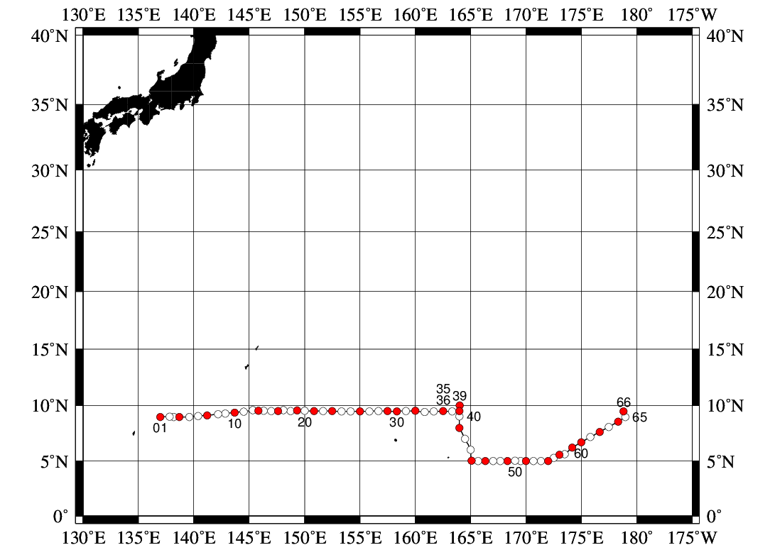
Figure C.5.1. Location of observation stations of chlorophyll-a. Closed and open circles indicate sampling and no-sampling stations, respectively.

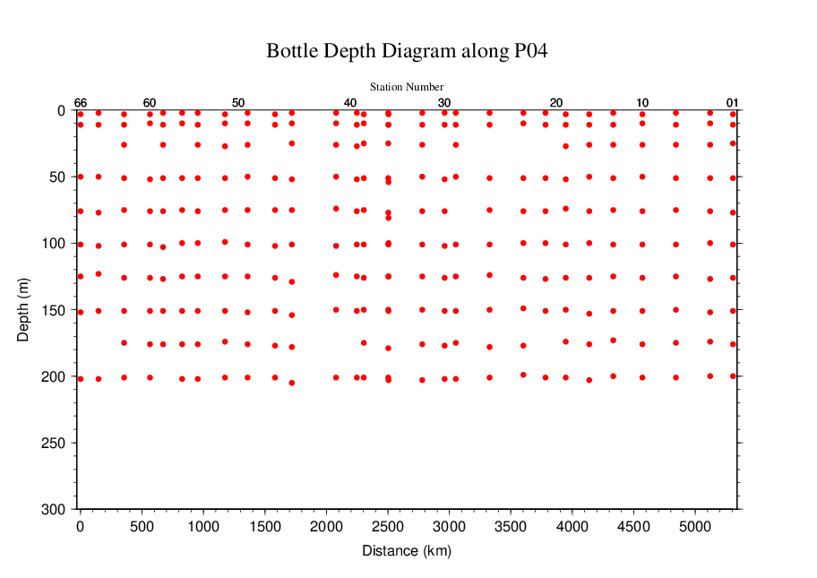
Figure C.5.2. Distance-depth distribution of sampling layers of chlorophyll-a.

Reagents
N,N-dimethylformamide (DMF)
Hydrochloric acid (HCl), 0.5 mol L⁻¹
Chlorophyll-a standard from Anacystis nidulans algae (Sigma-Aldrich, United States)
Rhodamine WT (Turner Designs, United States)

Instruments
Fluorometer: 10-AU (Turner Designs, United States)
Spectrophotometer: UV-1800 (Shimadzu, Japan)

Standardization

(5.1) Determination of chlorophyll-a concentration of standard solution
To prepare the pure chlorophyll-a standard solution, reagent powder of chlorophyll-a standard was dissolved in DMF. A concentration of the chlorophyll-a solution was determined with the spectrophotometer as follows:
chl a concentration (μg mL⁻¹) = A_{chl} / a*_{phy} (C5.1)
where A_{chl} is the difference between absorbance at 663.8 nm and 750 nm, and a*_{phy} is specific absorption coefficient (UNESCO, 1994). The specific absorption coefficient is 88.74 L g⁻¹ cm⁻¹ (Porra et al., 1989).

(5.2) Determination of R and f_{ph}
Before measurements, sensitivity of the fluorometer was calibrated with pure DMF and a rhodamine 1 ppm solution (diluted with deionized water).
The chlorophyll-a standard solution, whose concentration was precisely determined in subsection (5.1), was measured with the fluorometer, and after acidified with 1–2 drops 0.5 mol L⁻¹ HCl the solution was also measured. The acidification coefficient (R) of the fluorometer was also calculated as the ratio of the unacidified and acidified readings of chlorophyll-a standard solution. The linear calibration factor (f_{ph}) of the fluorometer was calculated as the slope of the acidified reading against chlorophyll-a concentration. The R and f_{ph} in the cruise are shown in Table C.5.1.

Table C.5.1. R and f_{ph} in the cruise.
Acidification coefficient (R) | 1.857
Linear calibration factor (f_{ph}) | 6.3099

Seawater sampling and measurement
Water samples were collected from 10-liters Niskin bottle attached the CTD-system and a stainless steel bucket for the surface. A 200 mL seawater sample was immediately filtered through 25 mm GF/F filters by low vacuum pressure below 15 cmHg, the particulate matter collected on the filter. Phytopigments were extracted in vial with 9 mL of DMF. The extracts were stored for 24 hours in the refrigerator at −30 °C until analysis.
After the extracts were put on the room temperature for at least one hour in the dark, the extracts were decanted from the vial to the cuvette. Fluorometer readings for each cuvette were taken before and after acidification with 1–2 drops 0.5 mol L⁻¹ HCl. Chlorophyll-a and phaeopigment concentrations (μg mL⁻¹) in the sample are calculated as follows:
(C5.2)
(C5.3)

F₀: reading before acidification
F_{a}: reading after acidification
R: acidification coefficient (F₀/F_{a}) for pure chlorophyll-a
f_{ph}: linear calibration factor
v: extraction volume
V: sample volume.

Quality control flag assignment
Quality flag value was assigned to oxygen measurements as shown in Table C.5.2, using the code defined in IOCCP Report No.14 (Swift, 2010).

Table C.5.2. Summary of assigned quality control flags.
Flag | Definition | Chl a | Phaeo.
2 | Good | 271 | 271
3 | Questionable | 0 | 0
4 | Bad (Faulty) | 1 | 1
5 | Not reported | 0 | 0
Total number |  | 272 | 272

References
Porra, R. J., W. A. Thompson and P. E. Kriedemann (1989), Determination of accurate coefficients and simultaneous equations for assaying chlorophylls a and b extracted with four different solvents: verification of the concentration of chlorophyll standards by atomic absotption spectroscopy. Biochem. Biophy. Acta, 975, 384-394.
Swift, J. H. (2010), Reference-quality water sample data: Notes on acquisition, record keeping, and evaluation. IOCCP Report No.14, ICPO Pub. 134, 2010 ver.1.
UNESCO (1994), Protocols for the joint global ocean flux study (JGOFS) core measurements: Measurement of chlorophyll a and phaeopigments by fluorometric analysis, IOC manuals and guides 29, Chapter 14.

