Dissolved Calcium (updated 2019/03/12)
PI: Akihiko Murata (JAMSTEC)-not onboard
Sampler: Shinichiro Umeda (JAMSTEC)
Objectives
According to the recent IPCC report, concentrations of CO₂ in the atmosphere have increased by 40% since pre-industrial times, primarily by fossil fuel burning and secondarily by net land use change. The ocean is said to absorb about 30% of the emitted anthropogenic CO₂, accordingly moderating progression of global warming. However, the ocean suffers from ocean acidification by the uptake of anthropogenic CO₂. Ocean acidification is characterized by an increase of H⁺ (i.e., a decrease of pH) and a concurrent decrease of carbonate ion concentration (CO₃^{2–}). The decrease of CO₃^{2–} is unfavorable to marine calcifying organisms, which utilize CO₃^{2–}, together with Ca²⁺, to produce their calcium carbonate (CaCO₃) shells and skeletons. To evaluate dissolution and precipitation of calcium carbonate, we measure the concentration of calcium in water columns in the western part of the Indian Ocean.
Sampling
The samples were collected into 60 mL of HDPE bottles from Niskin bottles attached to the CTD system. The sampling was made at 11 stations, with a few replicates at individual stations (see Figure 25a). In total, 265 samples were collected during the cruise. The samples were stored for 5 months until shipped back to the onshore laboratory for analysis.
Analytical method
The measurement was made in a laboratory on land. The method was based on photometry proposed by Culkin and Cox (1966). We used a modified Dissolved Oxygen Titrator DOT-01 (Kimoto Electronic Co. Ltd.), which bandpass filter is replaced to f0=620nm. Approximately 20 mM of EGTA (Ethylene Glycol Tetraacetic Acid) solution was used as a titrant. The titrant was calibrated several times by in-house Ca-standard solution whose Ca-source was pure CaCO₃ produced by NMIJ (CRM 3013-a).
Results
Results of calibrations are shown in Table 25 and Figure 25b with the concentrations of the titrant. The total number of the replicate sample pairs in good measurement (flagged 2) was 9, and its standard deviation was 0.0177 mmol/kg calculated by a procedure (SOP23) in DOE (1994). For 6 samples, Practical Salinities for the rest of the calcium samples were also measured at 24 ºC by using a salinometer (AUTOSAL 8400B, S/N 60132, Guildline Instruments Ltd., Ontario, Canada) after the calcium measurements. Averaged anomalies from Practical Salinity data measured onboard was +0.03% (+0.0097 +/- 0.0041 psu (standard deviation)), regarded as an effect of evaporation during the shipment to the laboratory. A previous work (Culkin and Cox, 1966) points out that magnesium (Mg) and strontium (Sr) cause positive bias to the titrated volume of Ca because of their interference with the reaction between EGTA and Ca; the bias caused by Mg was 0.729% and by Sr was 0.388%. No correction for the evaporation and interference was given to the data.
References
Culkin, F. and Cox, R.A. (1966). Sodium, potassium, magnesium, calcium and strontium in seawater. Deep Sea Research 13: 789-804.
DOE (1994) Handbook of methods for the analysis of the various parameters of the carbon dioxide system in
sea water; version 2. A.G. Dickson and C. Goyet (eds), ORNL/CDIAC-74.

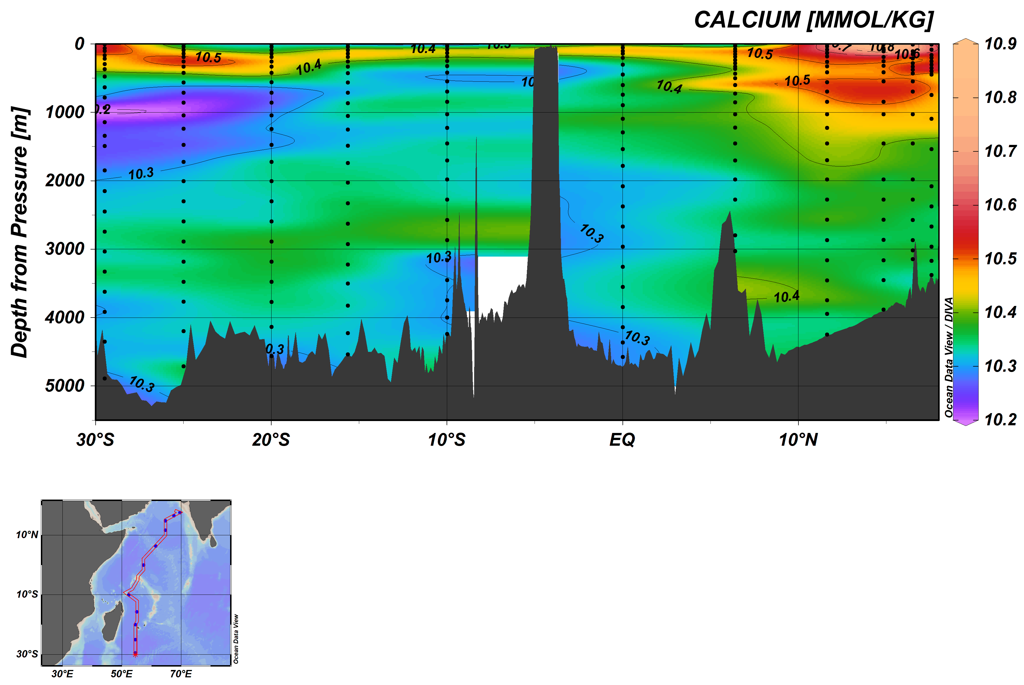
Figure 25a. Section plot of dissolved calcium and sampling layers (top panel).
Map of collected stations (bottom panel).

Table 25. Results of the calibrations during the analysis. %CV means coefficient of variation for the calibrations (S.D. / Average).
EGTA No. | Dates | Average (mM) | S.D. (mM) | N | %CV | Stations
2 | 2018/11/06-08 | 19.9220 | 0.0067 | 11 | 0.03 | 117, 121
3 | 2018/11/08-12 | 19.3451 | 0.0164 | 8 | 0.08 | 105, 111
4 | 2018/11/13 | 19.6633 | 0.0351 | 5 | 0.18 | 76, 93
5 | 2018/11/14-22 | 19.7043 | 0.0252 | 20 | 0.13 | 2, 15, 27, 35, 48

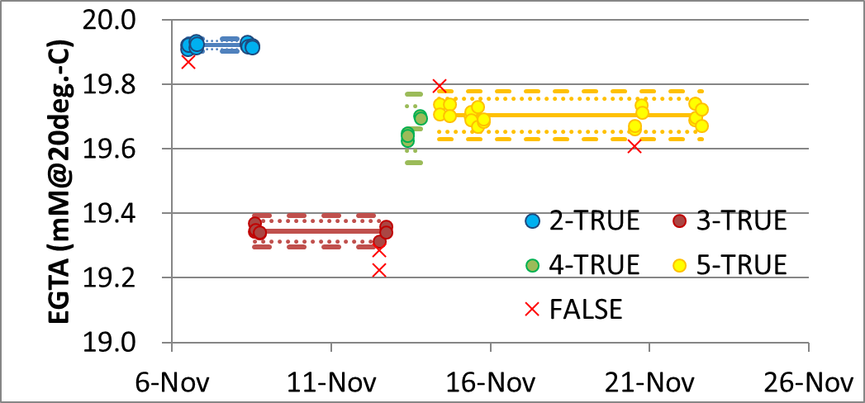
Figure 25b. Results of the calibrations during the analysis. Each result is shown with the average concentration (solid line) with error bar of +/- 2sigma (dotted line), +/- 3sigma (broken line).

