- Cruise narrative

- Highlights
Cruise designation: RF16-06 (WHP-P09 revisit)
- EXPOCODE: 49UP20160703
- Chief scientist: Naoki NAGAI (n-nagai@met.kishou.go.jp)
Marine Division
Global Environment and Marine Department
Japan Meteorological Agency (JMA)
1-3-4, Otemachi, Chiyoda-ku, Tokyo 100-8122, JAPAN
Phone: +81-3-3212-8341 Ext. 4778
- Ship name: R/V Ryofu Maru
- Ports of call: Leg 1: Tokyo–Palau
Leg 2: Palau–Tokyo
- Cruise dates: Leg 1: 3 July 2016–27 July 2016
Leg 2: 31 July 2016–24 August 2016
- Floats and drifters deployed: 1 float
1 drifter

- Cruise Summary Information
RF16-06 cruise was carried out during the period from July 3 to August 24, 2016. The cruise started from the south of Honshu, Japan, and sailed towards south along approximately 137°E meridian. This line (WHP-P9) was observed by JMA in 1994 as WOCE (World Ocean Circulation Experiment) Hydrographic Programme and in 2010 as CLIVAR (Climate Variability and Predictability Project) / GO-SHIP (Global Ocean Ship-based Hydrographic Investigations Program).

A total of 92 stations was occupied using a Sea-Bird Electronics (SBE) 36 position carousel equipped with 10-liter Niskin water sample bottles, a CTD system (SBE911plus) equipped with SBE35 deep ocean standards thermometer, JFE Advantech oxygen sensor (RINKO III), Teledyne Benthos altimeter (PSA-916D), and Teledyne RD Instruments L-ADCP (300kHz). To examine consistency of data, we carried out the observation twice at 8°N, 137°E (Stn.59 and 60). Cruise track and station location are shown in Figure 1.

At each station, full-depth CTDO₂ (temperature, conductivity (salinity) and dissolved oxygen) profile were taken, and at almost all stations except for Stn. 62, up to 36 water samples were taken and analyzed. Water samples were obtained from 10 dbar to approximately 10 m above the bottom. In addition, surface water was sampled by a stainless steel bucket at each station. Sampling layer is designed as so-called staggered mesh as shown in Table 1 (Swift, 2010). The bottle depth diagram is shown in Figure 2.

Water samples were analyzed for salinity, dissolved oxygen, nutrients, dissolved inorganic carbon (DIC), total alkalinity (TA), pH, CFC-11, CFC-12, CFC-113 and phytopigment (chlorophyll-a and phaeopigmens). Underway measurements of partial pressure of carbon dioxide (pCO₂), temperature, salinity, chlorophyll-a, subsurface current, bathymetry and meteorological parameters were conducted along the cruise track.

R/V Ryofu Maru departed Tokyo (Japan) on July 3, 2016. The hydrographic cast of CTDO₂ was started at the first station (Stn.1 (34°10’N, 137°E; RF5802)) on July 4. Leg 1 consisted of 59 stations from Stn.1 to Stn.59 (8°N, 137°E; RF5860). Stn.59 was finished on July 23. She called for Palau (Republic of Palau) on July 27 (Leg 1). She left Palau on July 31, 2016. The hydrographic cast of CTDO₂ was restarted at the station (Stn.60 (8°N, 137°E; RF5861)) on August 1. Leg 2 consisted of 33 stations from Stn.60 (8°N, 137°E; RF5861) to Stn.92 (2°20’S, 141°30’E; RF5893). Stn.92 was finished on August 11. She arrived at Tokyo (Japan) on August 24, 2016 (Leg 2). Location data of stations is shown in Table 2.

One Argo float and one drifting ocean data buoy were deployed along the cruise track. The information of deployed the float and the buoy are listed in Table 3.

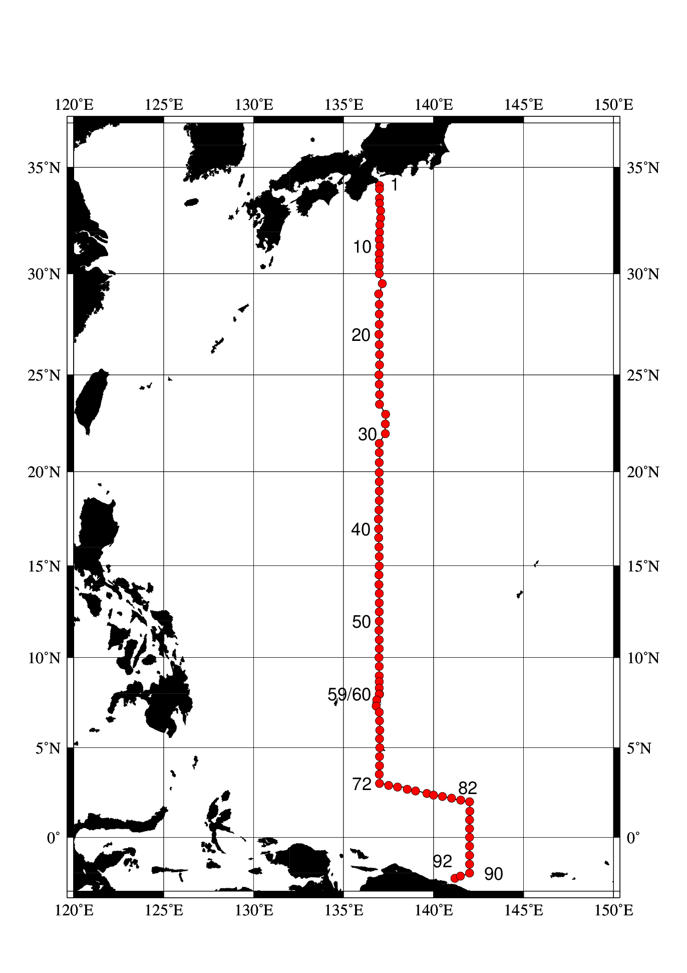 Figure 1. Cruise track of RF16-06.

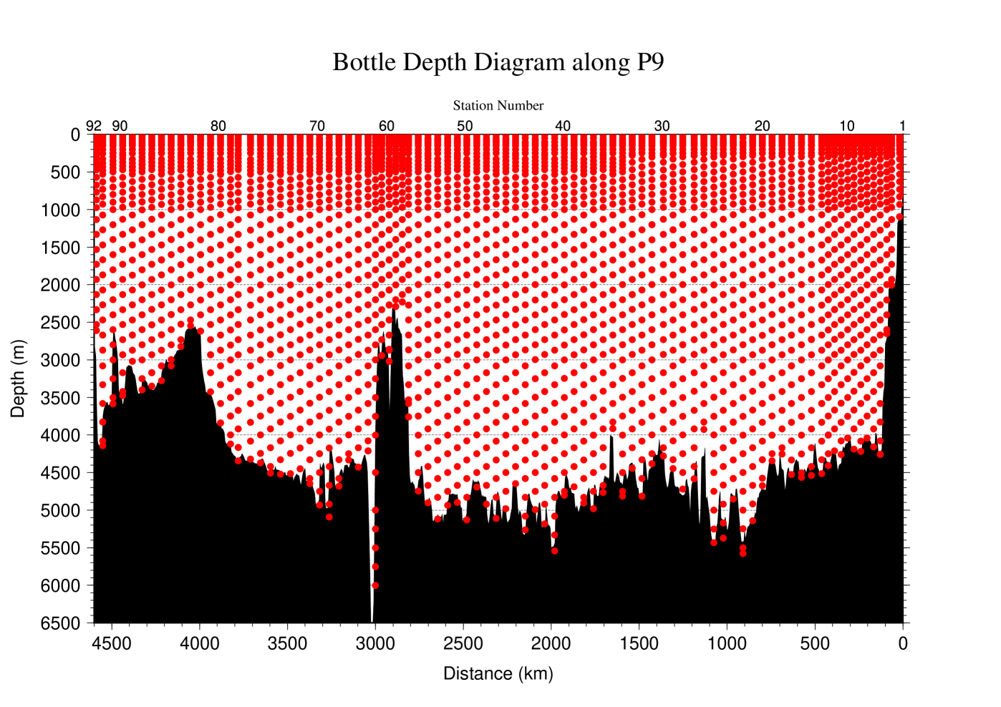
Figure 2. The bottle depth diagram for WHP-P9 revisit.

Table 1. The scheme of sampling layer in meters.
 | North of 20°N (Stn.1–Stn.33) |  |  | South of 20°N (Stn.34–Stn.92)
Bottle count | scheme1 | scheme2 | scheme3 | scheme4 | scheme5 | scheme6
1 | 10 | 10 | 10 | 10 | 10 | 10
2 | 25 | 25 | 25 | 25 | 25 | 25
3 | 50 | 50 | 50 | 50 | 50 | 50
4 | 75 | 75 | 75 | 75 | 75 | 75
5 | 100 | 100 | 100 | 100 | 100 | 100
6 | 125 | 125 | 125 | 125 | 125 | 125
7 | 150 | 150 | 150 | 150 | 150 | 150
8 | 200 | 200 | 200 | 200 | 200 | 200
9 | 250 | 250 | 250 | 250 | 250 | 250
10 | 300 | 330 | 280 | 300 | 330 | 280
11 | 400 | 430 | 370 | 350 | 380 | 320
12 | 500 | 530 | 470 | 400 | 430 | 370
13 | 600 | 630 | 570 | 450 | 480 | 420
14 | 700 | 730 | 670 | 500 | 530 | 470
15 | 800 | 830 | 770 | 600 | 630 | 570
16 | 900 | 930 | 870 | 700 | 730 | 670
17 | 1000 | 1070 | 970 | 800 | 830 | 770
18 | 1200 | 1270 | 1130 | 900 | 930 | 870
19 | 1400 | 1470 | 1330 | 1000 | 1070 | 970
20 | 1600 | 1670 | 1530 | 1200 | 1270 | 1130
21 | 1800 | 1870 | 1730 | 1400 | 1470 | 1330
22 | 2000 | 2070 | 1930 | 1600 | 1670 | 1530
23 | 2200 | 2270 | 2130 | 1800 | 1870 | 1730
24 | 2400 | 2470 | 2330 | 2000 | 2070 | 1930
25 | 2600 | 2670 | 2530 | 2200 | 2270 | 2130
26 | 2800 | 2870 | 2730 | 2400 | 2470 | 2330
27 | 3000 | 3080 | 2930 | 2600 | 2670 | 2530
28 | 3250 | 3330 | 3170 | 2800 | 2870 | 2730
29 | 3500 | 3580 | 3420 | 3000 | 3080 | 2930
30 | 3750 | 3830 | 3670 | 3250 | 3330 | 3170
31 | 4000 | 4080 | 3920 | 3500 | 3580 | 3420
32 | 4250 | 4330 | 4170 | 3750 | 3830 | 3670
33 | 4500 | 4580 | 4420 | 4000 | 4080 | 3920
34 | 4750 | 4830 | 4670 | 4250 | 4330 | 4170
35 | 5000 | 5080 | 4920 | 4500 | 4580 | 4420

Table 1. Continue.
 | North of 20°N (Stn.1–Stn.33) |  |  | South of 20°N (Stn.34–Stn.92)
Bottle count | scheme1 | scheme2 | scheme3 | scheme4 | scheme5 | scheme6
36 | 5250 | 5330 | 5170 | 4750 | 4830 | 4670
37 | 5500 | 5580 | 5420 | 5000 | 5080 | 4920
38 | 5750 | 5830 | 5670 | 5250 | 5330 | 5170
39 | 6000 | 6000 | 6000 | 5500 | 5580 | 5420
40 |  |  |  | 5750 | 5830 | 5670
41 |  |  |  | 6000 | 6000 | 6000

Table 2. Station data of RF16-06 cruise. The ‘RF’ column indicates the JMA station identification number.
Leg | Station |  | Position |  |  | Leg | Station |  | Position
 | Stn. | RF | Latitude | Longitude |  |  | Stn. | RF | Latitude | Longitude
1 | 1 | 5802 | 34-10.49 N | 137-00.02 E |  | 1 | 33 | 5834 | 20-29.25 N | 136-59.38 E
1 | 2 | 5803 | 34-00.26 N | 137-00.04 E |  | 1 | 34 | 5835 | 19-58.33 N | 136-59.74 E
1 | 3 | 5804 | 33-35.10 N | 137-00.32 E |  | 1 | 35 | 5836 | 19-29.61 N | 136-59.86 E
1 | 4 | 5805 | 33-20.36 N | 137-00.73 E |  | 1 | 36 | 5837 | 18-59.87 N | 136-59.31 E
1 | 5 | 5806 | 33-00.42 N | 137-03.29 E |  | 1 | 37 | 5838 | 18-29.90 N | 136-59.51 E
1 | 6 | 5807 | 32-39.77 N | 137-03.32 E |  | 1 | 38 | 5839 | 17-59.19 N | 136-58.61 E
1 | 7 | 5808 | 32-20.44 N | 137-01.63 E |  | 1 | 39 | 5840 | 17-30.27 N | 136-56.65 E
1 | 8 | 5809 | 31-59.45 N | 137-00.82 E |  | 1 | 40 | 5841 | 16-59.80 N | 136-57.92 E
1 | 9 | 5810 | 31-38.69 N | 136-59.83 E |  | 1 | 41 | 5842 | 16-30.21 N | 136-57.90 E
1 | 10 | 5811 | 31-19.13 N | 137-01.13 E |  | 1 | 42 | 5843 | 16-00.19 N | 136-58.60 E
1 | 11 | 5812 | 30-58.80 N | 136-59.55 E |  | 1 | 43 | 5844 | 15-30.09 N | 136-59.00 E
1 | 12 | 5813 | 30-39.47 N | 136-59.83 E |  | 1 | 44 | 5845 | 14-59.50 N | 136-59.35 E
1 | 13 | 5814 | 30-20.04 N | 136-59.20 E |  | 1 | 45 | 5846 | 14-30.08 N | 136-58.88 E
1 | 14 | 5815 | 30-00.70 N | 136-59.29 E |  | 1 | 46 | 5847 | 13-59.79 N | 136-58.40 E
1 | 15 | 5816 | 29-31.59 N | 137-09.03 E |  | 1 | 47 | 5848 | 13-30.33 N | 136-59.25 E
1 | 16 | 5817 | 29-01.52 N | 136-57.97 E |  | 1 | 48 | 5849 | 12-59.99 N | 136-59.33 E
1 | 17 | 5818 | 28-30.27 N | 136-59.73 E |  | 1 | 49 | 5850 | 12-30.39 N | 136-59.39 E
1 | 18 | 5819 | 28-02.64 N | 136-59.38 E |  | 1 | 50 | 5851 | 11-59.12 N | 136-59.61 E
1 | 19 | 5820 | 27-31.32 N | 136-59.83 E |  | 1 | 51 | 5852 | 11-29.12 N | 136-58.77 E
1 | 20 | 5821 | 27-02.23 N | 136-58.87 E |  | 1 | 52 | 5853 | 10-58.76 N | 136-59.38 E
1 | 21 | 5822 | 26-31.86 N | 136-59.52 E |  | 1 | 53 | 5854 | 10-29.23 N | 136-59.52 E
1 | 22 | 5823 | 26-01.18 N | 137-00.69 E |  | 1 | 54 | 5855 | 10-00.11 N | 136-58.67 E
1 | 23 | 5824 | 25-30.16 N | 137-00.72 E |  | 1 | 55 | 5856 | 9-30.04 N | 136-59.13 E
1 | 24 | 5825 | 25-00.33 N | 136-58.55 E |  | 1 | 56 | 5857 | 8-59.69 N | 136-59.36 E
1 | 25 | 5826 | 24-31.44 N | 136-59.38 E |  | 1 | 57 | 5858 | 8-40.01 N | 136-59.64 E
1 | 26 | 5827 | 24-00.38 N | 137-00.96 E |  | 1 | 58 | 5859 | 8-19.94 N | 136-59.87 E
1 | 27 | 5828 | 23-30.16 N | 137-00.34 E |  | 1 | 59 | 5860 | 7-59.75 N | 137-00.12 E
1 | 28 | 5829 | 22-59.78 N | 137-20.39 E |  | 2 | 60 | 5861 | 7-59.61 N | 136-59.17 E
1 | 29 | 5830 | 22-29.37 N | 137-19.64 E |  | 2 | 61 | 5862 | 7-39.02 N | 136-50.51 E
1 | 30 | 5831 | 21-59.88 N | 137-19.31 E |  | 2 | 62 | 5863 | 7-29.24 N | 136-50.68 E
1 | 31 | 5832 | 21-29.68 N | 136-59.35 E |  | 2 | 63 | 5864 | 7-19.40 N | 136-49.06 E
1 | 32 | 5833 | 21-00.15 N | 136-59.86 E |  | 2 | 64 | 5865 | 6-59.16 N | 136-59.90 E

Table 2. Continue.
Leg | Station |  | Position |  |  | Leg | Station |  | Position
 | Stn. | RF | Latitude | Longitude |  |  | Stn. | RF | Latitude | Longitude
2 | 65 | 5866 | 6-30.87 N | 137-00.96 E |  | 2 | 79 | 5880 | 2-17.67 N | 140-29.90 E
2 | 66 | 5867 | 5-59.23 N | 137-01.41 E |  | 2 | 80 | 5881 | 2-11.07 N | 141-00.26 E
2 | 67 | 5868 | 5-30.57 N | 137-00.53 E |  | 2 | 81 | 5882 | 2-05.23 N | 141-30.55 E
2 | 68 | 5869 | 5-00.59 N | 137-01.33 E |  | 2 | 82 | 5883 | 1-59.08 N | 142-00.39 E
2 | 69 | 5870 | 4-31.23 N | 137-00.61 E |  | 2 | 83 | 5884 | 1-28.93 N | 142-01.54 E
2 | 70 | 5871 | 4-00.90 N | 137-00.43 E |  | 2 | 84 | 5885 | 0-59.28 N | 142-00.82 E
2 | 71 | 5872 | 3-31.28 N | 136-59.95 E |  | 2 | 85 | 5886 | 0-29.32 N | 142-00.70 E
2 | 72 | 5873 | 3-01.39 N | 137-00.83 E |  | 2 | 86 | 5887 | 0-00.07 S | 142-00.61 E
2 | 73 | 5874 | 2-54.33 N | 137-30.63 E |  | 2 | 87 | 5888 | 0-29.90 S | 142-00.87 E
2 | 74 | 5875 | 2-49.26 N | 138-00.52 E |  | 2 | 88 | 5889 | 1-00.75 S | 142-00.28 E
2 | 75 | 5876 | 2-41.51 N | 138-32.00 E |  | 2 | 89 | 5890 | 1-30.46 S | 142-00.26 E
2 | 76 | 5877 | 2-36.54 N | 139-00.45 E |  | 2 | 90 | 5891 | 2-00.37 S | 142-00.02 E
2 | 77 | 5878 | 2-27.30 N | 139-38.67 E |  | 2 | 91 | 5893 | 2-10.54 S | 141-29.74 E
2 | 78 | 5879 | 2-22.85 N | 140-00.81 E |  | 2 | 92 | 5892 | 2-17.23 S | 141-11.36 E

Table 3. Information of deployed float and buoy.
Float | Date and Time | Position of deployment |  | PI
WMO number | of Deployment (UTC) | Latitude | Longitude
2902982 | 2016 Aug. 15  23:20 | 21-57.62 N | 139-02.82 E | JMA | ARVOR
Buoy | Date and Time | Position of deployment |  | PI
WMO number | of Deployment (UTC) | Latitude | Longitude
21704 | 2016 July 07  19:11 | 30-00.98 N | 136-59.99 E | JMA | YTSS-2100
ARVOR: nke Instrumentation, France
YTSS-2100: JVC KENWOOD Co., Japan
- List of Principal Investigators for all Measurements
The principal investigator (PI) and the person in charge responsible for major parameters measured on the cruise are listed in Table 4.

Table 4. List of principal investigator and the person in charge on the ship for RF16-06.
Item Principal Investigator（PI） Person in charge on the ship
Hydrography
CTDO₂ / LADCP Toshiya NAKANO Yoshikazu HIGASHI
Salinity Toshiya NAKANO Keizo SHUTTA
Dissolve oxygen Toshiya NAKANO Kazuhiro SAITO
Nutrients Toshiya NAKANO Takahiro KITAGAWA
Phytopigment Toshiya NAKANO Hiroyuki TAKANO
DIC Toshiya NAKANO Shinji MASUDA
Total Alkalinity Toshiya NAKANO Shinji MASUDA
pH Toshiya NAKANO Shinji MASUDA
CFCs Toshiya NAKANO Kazukaka ENYO

Underway
Meteorology Toshiya NAKANO Naoki NAGAI
Thermo-Salinograph Toshiya NAKANO Shinji MASUDA
pCO₂ Toshiya NAKANO Shinji MASUDA
Chlorophyll-a Toshiya NAKANO Hiroyuki TAKANO
ADCP Toshiya NAKANO Yoshikazu HIGASHI
Bathymetry Toshiya NAKANO Yoshikazu HIGASHI

Floats
Argo float Kazuhiro NEMOTO Keizo SHUTTA

Toshiya NAKANO (nakano_t@met.kishou.go.jp)
Marine Division, Global Environment and Marine Department, JMA
1-3-4, Otemachi, Chiyoda-ku, Tokyo 100-8122, JAPAN
Phone: +81-3-3212-8341 Ext. 5131

Kazuhiro NEMOTO (k-nemoto@met.kishou.go.jp)
Marine Division, Global Environment and Marine Department, JMA
1-3-4, Otemachi, Chiyoda-ku, Tokyo 100-8122, JAPAN
Phone: +81-3-3212-8341 Ext. 5128

Reference
Swift, J. H. (2010): Reference-quality water sample data: Notes on acquisition, record keeping, and evaluation. IOCCP Report No.14, ICPO Pub. 134, 2010 ver.1

