- Cruise narrative
- Highlights
Cruise designation: RF13-06 and RF13-07 (WHP-P03W revisit)
- EXPOCODE: 49UP20130619
- Chief scientist: RF13-06 Kazuhiro NEMOTO (k-nemoto@met.kishou.go.jp)
RF13-07 Hitomi KAMIYA
Marine Division
Global Environment and Marine Department
Japan Meteorological Agency (JMA)
1-3-4, Otemachi, Chiyoda-ku, Tokyo 100-8122, JAPAN
Phone: +81-3-3212-8341 Ext. 5128, 5131
- Ship name: R/V Ryofu Maru
- Ports of call: RF13-06 Leg 1: Tokyo–Naha, Leg 2: Naha–Tokyo
RF13-07 Leg 1: Tokyo–Pohnpei, Leg 2: Pohnpei–Tokyo
- Cruise dates: RF13-06 Leg 1: 19 June 2013–1 July 2013
RF13-06 Leg 2: 5 July 2013–24 July 2013
RF13-07 Leg 1: 31 July 2013–21 August 2013
RF13-07 Leg 2: 25 August 2013–18 September 2013
- Floats and drifters deployed: RF13-06: 1 float and 2 drifters
RF13-07: 5 floats

- Cruise Summary Information
RF13-06 and RF13-07 cruises were carried out during the period from June 19 to September 18, 2013. The observation line along approximately 24°N was observed by Scripps Institution of Oceanography (SIO), USA in 1985 and Japan Agency for Marine-Earth Science and Technology (JAMSTEC), Japan in 2005–2006. These cruises were carried out as ‘WHP-P03’, which is a part of WOCE (World Ocean Circulation Experiment) Hydrographic Programme, CLIVAR (Climate Variability and Predictability Project) and GO-SHIP (Global Ocean Ship-based Hydrographic Investigations Program).

A total of 120 stations was occupied using a Sea-Bird Electronics (SBE) 36 position carousel equipped with 10-liter Niskin water sample bottles, a CTD system (SBE911plus) equipped with SBE35 deep ocean standards thermometer, JFE Advantech oxygen sensor (RINKO III), Teledyne Benthos altimeter (PSA-916D), and Teledyne RD Instruments L-ADCP (300kHz). Cruise track and station location are shown in Figure 1.

At each station, full-depth CTDO₂ (temperature, conductivity (salinity) and dissolved oxygen) profile and up to 36 water samples were taken and analyzed. Water samples were obtained from 10 dbar to approximately 10 m above the bottom. In addition, surface water was sampled using a stainless steel bucket at each station. Sampling layer is designed as so-called staggered mesh as shown in Table 1 (Swift, 2010). The bottle depth diagram is shown in Figure 2.

Water samples were analyzed for salinity, dissolved oxygen, nutrients, dissolved inorganic carbon (DIC), total alkalinity (TA), pH, CFC-11, CFC-12 and phytopigment (chlorophyll-a and phaeopigments). Underway measurements of partial pressure of carbon dioxide (pCO₂), temperature, salinity, chlorophyll-a, subsurface current, bathymetry and meteorological parameters were conducted along the cruise track.

RF13-06
RF13-06 cruise was carried out during the period from June 19 to July 24, 2013. Before the observation at the first station, all watch standers were drilled in the method of sample drawing and CTD operations at the point (34°22’N, 138°30’E). At first, the cruise started from Stn.13 (28°42’N, 126°27’E; RF4757) and sailed south-eastward to Stn.26 (27°30’N, 128°15’E; RF4770). After observation of Stn.26 we observed from Stn.1 (30°14’N, 130°50’E; RF4771) to Stn.12 (28°35’N, 129°45’E; RF4782) and from Stn.27 (26°04’N, 127°55’E; RF4783) to Stn.31 (25°39’N, 128°34’E; RF4787). Leg 1 consisted of 31 stations. We finished Stn.31 on June 29. She called for Naha (Japan) on July 1 (Leg 1). She left Naha on July 5, we restarted observation from Stn.32 (25°39’N, 128°34’E; RF4788) that was same the station of Stn.31. Owing to the typhoon (T1307), after observation of Stn.45 (23°43’N, 133°00’E; RF4801), we sailed to Stn.63 (24°15’N, 143°38’E; RF4802). After observation of Stn.63, we sailed to westward, and observed from Stn.59 (24°14’N, 141°34’E; RF4803) to Stn.52 (24°15’N, 137°47’E; RF4810). We gave up at the station of Stn.52 and turned toward Tokyo (Japan). Leg 2 consisted of 23 stations. We arrived at Tokyo on July 24, 2013 (Leg 2).

One float and two drifting ocean data buoy were deployed along the cruise track. The information of deployed the float and the buoy are listed in Table 2a.

RF13-07
RF13-07 cruise was carried out during the period from July 31 to September 18, 2013. Before the observation at the first station, all watch standers were drilled in the method of sample drawing and CTD operations at the point (34°41’N, 139°51’E). We restarted observation from Stn.46 (24°14’N, 133°21’E; RF4812) on August 3 to Stn.51 (24°14’N, 137°49’E; RF4817) that was same the station of Stn.52, and from Stn.60 (24°15’N, 141°46’E; RF4818) and Stn.62 (24°15’N, 143°14’E; RF4820). We continued observation from Stn.64 (24°15’N, 143°39’E; RF4821) that was the same station of Stn.63. We sailed eastward and finished at Stn.89 (24°00’N, 164°59’E; RF4846) on August 15. Leg 1 consisted of 35 stations. She called for Pohnpei (Federated States of Micronesia) on August 21 (Leg 1). She left Pohnpei on August 25, 2013. The hydrographic cast of CTDO₂ was restarted at the same station (Stn.90 (24°00’N, 165°01’E; RF4847)) of Stn.89 on August 28. We observed eastward to Stn.108 (24°00’N, 179°00’E; RF4865), we turned northward and finished Stn.120 (29°58’N, 178°58’E; RF4877). Leg 2 consisted of 31 stations from Stn.90 to Stn.120. Stn.120 was finished on September 7. She arrived at Tokyo (Japan) on September 18, 2013 (Leg 2).

Five Argo floats were deployed along the cruise track. The information of deployed the float and the buoy are listed in Table 2b.

Location data of stations is shown in Table 3.
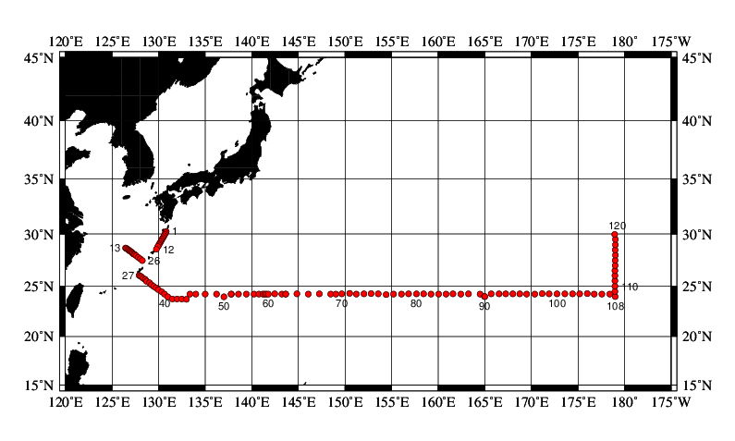
Figure 1. Cruise track of RF13-06 and RF13-07.
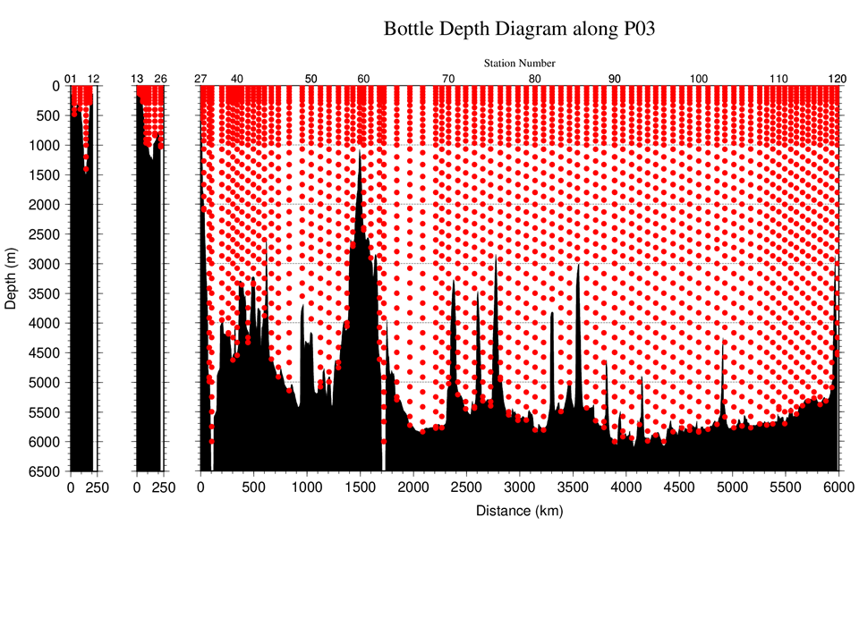

Figure 2. The bottle depth diagram for WHP-P03 revisit.

Table 1. The scheme of sampling layer in meters.
Bottle count | scheme1 | scheme2 | scheme3
1 | 10 | 10 | 10
2 | 50 | 50 | 50
3 | 100 | 100 | 100
4 | 150 | 150 | 150
5 | 200 | 200 | 200
6 | 250 | 250 | 250
7 | 300 | 330 | 280
8 | 400 | 430 | 370
9 | 500 | 530 | 470
10 | 600 | 630 | 570
11 | 700 | 730 | 670
12 | 800 | 830 | 770
13 | 900 | 930 | 870
14 | 1000 | 1070 | 970
15 | 1200 | 1270 | 1130
16 | 1400 | 1470 | 1330
17 | 1600 | 1670 | 1530
18 | 1800 | 1870 | 1730
19 | 2000 | 2070 | 1930
20 | 2200 | 2270 | 2130
21 | 2400 | 2470 | 2330
22 | 2600 | 2670 | 2530
23 | 2800 | 2870 | 2730
24 | 3000 | 3080 | 2930
25 | 3250 | 3330 | 3170
26 | 3500 | 3580 | 3420
27 | 3750 | 3830 | 3670
28 | 4000 | 4080 | 3920
29 | 4250 | 4330 | 4170
30 | 4500 | 4580 | 4420
31 | 4750 | 4830 | 4670
32 | 5000 | 5080 | 4920
33 | 5250 | 5330 | 5170
34 | 5500 | 5580 | 5420
35 | 5750 | 5830 | 5670
36 | 6000 | 6000 | 6000

Table 2a. Information of deployed float and buoy at RF13-06.
Float | Date and Time (UTC) | Position of deployment |  | PI
WMO number | of Deployment | Latitude | Longitude
2902430 | 2013 July 9  01:32 | 23-42.54 N | 132-56.59 E | JMA | APEX
Buoy | Date and Time (UTC) | Position of deployment
WMO number | of Deployment | Latitude | Longitude
21679 | 2013 June 25  01:32 | 28-42.30 N | 126-27.04 E | JMA | YTSS-2100
21704 | 2013 July 6  00:42 | 25-32.74 N | 128-44.72 E | JMA | YTSS-2100
APEX：Teledyne Webb Research (USA)
YTSS-2100: JVC KENWOOD Co., Japan

Table 2b. Information of deployed float and buoy at RF13-07.
Float | Date and Time (UTC) | Position of deployment |  | PI
WMO number | of Deployment | Latitude | Longitude
2902453 | 2013 August 12  05:30 | 24-16.70 N | 157-39.46 E | JAMSTEC | ARVOR
2902461 | 2013 August 29  21:59 | 24-16.84 N | 168-02.16 E | JAMSTEC | ARVOR
2902462 | 2013 August 31  20:45 | 24-18.38 N | 172-47.57 E | JAMSTEC | ARVOR
2902463 | 2013 September 2  11:45 | 24-16.08 N | 176-47.13 E | JAMSTEC | ARVOR
2902464 | 2013 September 3  10:20 | 24-00.89 N | 178-59.85 E | JAMSTEC | ARVOR
ARVOR：nke Instrumentation (France)

Table 3a. Station data of RF13-06 cruise. The ‘RF’ column indicates the JMA station identification number.

EXPOCODE | Leg | Station |  | Position
sub number |  | Stn. | RF | Latitude | Longitude
1 | 1 | 1 | 4771 | 30-14.47 N | 130-50.26 E
1 | 1 | 2 | 4772 | 30-05.87 N | 130-44.66 E
1 | 1 | 3 | 4773 | 29-58.18 N | 130-40.29 E
1 | 1 | 4 | 4774 | 29-48.88 N | 130-34.72 E
1 | 1 | 5 | 4775 | 29-40.04 N | 130-28.82 E
1 | 1 | 6 | 4776 | 29-32.26 N | 130-23.37 E
1 | 1 | 7 | 4777 | 29-23.21 N | 130-17.82 E
1 | 1 | 8 | 4778 | 29-15.26 N | 130-12.34 E
1 | 1 | 9 | 4779 | 29-06.58 N | 130-06.60 E
1 | 1 | 10 | 4780 | 28-58.18 N | 130-01.36 E
1 | 1 | 11 | 4781 | 28-50.25 N | 129-55.28 E
1 | 1 | 12 | 4782 | 28-35.19 N | 129-45.09 E
1 | 1 | 13 | 4757 | 28-42.01 N | 126-26.87 E
1 | 1 | 14 | 4758 | 28-38.37 N | 126-34.13 E
1 | 1 | 15 | 4759 | 28-33.26 N | 126-41.28 E
1 | 1 | 16 | 4760 | 28-29.59 N | 126-48.44 E
1 | 1 | 17 | 4761 | 28-24.62 N | 126-54.41 E
1 | 1 | 18 | 4762 | 28-21.11 N | 127-01.79 E
1 | 1 | 19 | 4763 | 28-16.09 N | 127-08.65 E
1 | 1 | 20 | 4764 | 28-10.72 N | 127-14.80 E
1 | 1 | 21 | 4765 | 28-06.17 N | 127-21.50 E
1 | 1 | 22 | 4766 | 28-02.56 N | 127-28.39 E
1 | 1 | 23 | 4767 | 27-57.76 N | 127-34.77 E
1 | 1 | 24 | 4768 | 27-48.18 N | 127-48.09 E
1 | 1 | 25 | 4769 | 27-38.76 N | 128-02.00 E
1 | 1 | 26 | 4770 | 27-30.08 N | 128-15.29 E
1 | 1 | 27 | 4783 | 26-04.15 N | 127-54.85 E
1 | 1 | 28 | 4784 | 26-00.11 N | 128-02.11 E
1 | 1 | 29 | 4785 | 25-54.71 N | 128-09.77 E
1 | 1 | 30 | 4786 | 25-47.16 N | 128-21.45 E
1 | 1 | 31 | 4787 | 25-39.13 N | 128-33.96 E
2 | 2 | 32 | 4788 | 25-38.74 N | 128-33.71 E
2 | 2 | 33 | 4789 | 25-29.81 N | 128-43.41 E
2 | 2 | 34 | 4790 | 25-20.88 N | 129-00.74 E
2 | 2 | 35 | 4791 | 25-09.31 N | 129-14.70 E
Table 3a. Continue.
EXPOCODE | Leg | Station |  | Position
sub number |  | Stn. | RF | Latitude | Longitude
2 | 2 | 36 | 4792 | 24-59.45 N | 129-29.38 E
2 | 2 | 37 | 4793 | 24-50.65 N | 129-44.33 E
2 | 2 | 38 | 4794 | 24-40.71 N | 129-58.82 E
2 | 2 | 39 | 4795 | 24-28.09 N | 130-19.53 E
2 | 2 | 40 | 4796 | 24-14.71 N | 130-38.28 E
2 | 2 | 41 | 4797 | 23-59.02 N | 130-58.98 E
2 | 2 | 42 | 4798 | 23-45.49 N | 131-28.65 E
2 | 2 | 43 | 4799 | 23-45.05 N | 131-59.11 E
2 | 2 | 44 | 4800 | 23-45.30 N | 132-29.45 E
2 | 2 | 45 | 4801 | 23-43.71 N | 133-00.00 E
2 | 2 | 52 | 4810 | 24-14.55 N | 137-47.36 E
2 | 2 | 53 | 4809 | 24-15.12 N | 138-33.99 E
2 | 2 | 54 | 4808 | 24-14.40 N | 139-26.01 E
2 | 2 | 55 | 4807 | 24-13.83 N | 140-14.17 E
2 | 2 | 56 | 4806 | 24-14.62 N | 140-46.37 E
2 | 2 | 57 | 4805 | 24-14.60 N | 141-11.02 E
2 | 2 | 58 | 4804 | 24-14.47 N | 141-23.34 E
2 | 2 | 59 | 4803 | 24-14.07 N | 141-33.75 E
2 | 2 | 63 | 4802 | 24-15.23 N | 143-37.66 E

Table 3b. Station data of RF13-07 cruise. The ‘RF’ column indicates the JMA station identification number.

EXPOCODE | Leg | Station |  | Position
sub number |  | Stn. | RF | Latitude | Longitude
3 | 1 | 46 | 4812 | 24-13.57 N | 133-21.00 E
3 | 1 | 47 | 4813 | 24-14.06 N | 133-59.75 E
3 | 1 | 48 | 4814 | 24-15.17 N | 134-59.94 E
3 | 1 | 49 | 4815 | 24-15.03 N | 136-12.54 E
3 | 1 | 50 | 4816 | 23-59.27 N | 137-00.24 E
3 | 1 | 51 | 4817 | 24-14.25 N | 137-48.60 E
3 | 1 | 60 | 4818 | 24-15.40 N | 141-45.91 E
3 | 1 | 61 | 4819 | 24-15.84 N | 142-26.98 E
3 | 1 | 62 | 4820 | 24-15.32 N | 143-13.93 E
3 | 1 | 64 | 4821 | 24-15.11 N | 143-38.58 E
3 | 1 | 65 | 4822 | 24-15.63 N | 144-50.93 E
Table 3b. Continue.
EXPOCODE | Leg | Station |  | Position
sub number |  | Stn. | RF | Latitude | Longitude
3 | 1 | 66 | 4823 | 24-14.65 N | 146-03.68 E
3 | 1 | 67 | 4824 | 24-15.78 N | 147-15.35 E
3 | 1 | 68 | 4825 | 24-15.50 N | 148-28.09 E
3 | 1 | 69 | 4826 | 24-14.47 N | 149-01.46 E
3 | 1 | 70 | 4827 | 24-16.36 N | 149-39.23 E
3 | 1 | 71 | 4828 | 24-17.59 N | 150-30.54 E
3 | 1 | 72 | 4829 | 24-14.47 N | 151-14.05 E
3 | 1 | 73 | 4830 | 24-16.08 N | 152-02.72 E
3 | 1 | 74 | 4831 | 24-16.71 N | 152-49.03 E
3 | 1 | 75 | 4832 | 24-16.19 N | 153-33.69 E
3 | 1 | 76 | 4833 | 24-10.97 N | 154-26.25 E
3 | 1 | 77 | 4834 | 24-14.91 N | 155-12.52 E
3 | 1 | 78 | 4835 | 24-14.85 N | 156-03.86 E
3 | 1 | 79 | 4836 | 24-15.89 N | 156-50.46 E
3 | 1 | 80 | 4837 | 24-15.92 N | 157-39.77 E
3 | 1 | 81 | 4838 | 24-15.76 N | 158-27.00 E
3 | 1 | 82 | 4839 | 24-14.67 N | 159-14.71 E
3 | 1 | 83 | 4840 | 24-14.30 N | 160-04.14 E
3 | 1 | 84 | 4841 | 24-14.98 N | 160-50.69 E
3 | 1 | 85 | 4842 | 24-15.82 N | 161-35.29 E
3 | 1 | 86 | 4843 | 24-15.13 N | 162-26.54 E
3 | 1 | 87 | 4844 | 24-15.55 N | 163-16.16 E
3 | 1 | 88 | 4845 | 24-15.36 N | 164-03.30 E
3 | 1 | 89 | 4846 | 24-00.15 N | 164-59.37 E
4 | 2 | 90 | 4847 | 24-00.48 N | 165-00.85 E
4 | 2 | 91 | 4848 | 24-15.67 N | 165-42.12 E
4 | 2 | 92 | 4849 | 24-16.16 N | 166-31.51 E
4 | 2 | 93 | 4850 | 24-15.57 N | 167-15.59 E
4 | 2 | 94 | 4851 | 24-15.88 N | 168-00.59 E
4 | 2 | 95 | 4852 | 24-15.95 N | 168-46.09 E
4 | 2 | 96 | 4853 | 24-14.85 N | 169-30.85 E
4 | 2 | 97 | 4854 | 24-14.74 N | 170-21.82 E
4 | 2 | 98 | 4855 | 24-16.58 N | 171-10.76 E
4 | 2 | 99 | 4856 | 24-15.76 N | 171-55.30 E
4 | 2 | 100 | 4857 | 24-16.08 N | 172-44.98 E
4 | 2 | 101 | 4858 | 24-15.52 N | 173-36.53 E

Table 3b. Continue.
EXPOCODE | Leg | Station |  | Position
sub number |  | Stn. | RF | Latitude | Longitude
4 | 2 | 102 | 4859 | 24-16.26 N | 174-25.87 E
4 | 2 | 103 | 4860 | 24-16.23 N | 175-10.65 E
4 | 2 | 104 | 4861 | 24-16.94 N | 175-59.98 E
4 | 2 | 105 | 4862 | 24-15.37 N | 176-45.70 E
4 | 2 | 106 | 4863 | 24-14.52 N | 177-35.05 E
4 | 2 | 107 | 4864 | 24-15.14 N | 178-24.54 E
4 | 2 | 108 | 4865 | 24-00.31 N | 179-00.35 E
4 | 2 | 109 | 4866 | 24-30.64 N | 178-58.68 E
4 | 2 | 110 | 4867 | 25-01.28 N | 178-58.69 E
4 | 2 | 111 | 4868 | 25-31.64 N | 178-59.31 E
4 | 2 | 112 | 4869 | 26-01.69 N | 178-59.23 E
4 | 2 | 113 | 4870 | 26-30.91 N | 178-58.88 E
4 | 2 | 114 | 4871 | 27-01.13 N | 178-59.51 E
4 | 2 | 115 | 4872 | 27-30.64 N | 179-00.24 E
4 | 2 | 116 | 4873 | 27-59.88 N | 179-00.67 E
4 | 2 | 117 | 4874 | 28-30.42 N | 178-59.89 E
4 | 2 | 118 | 4875 | 29-00.36 N | 179-01.84 E
4 | 2 | 119 | 4876 | 29-29.78 N | 179-01.18 E
4 | 2 | 120 | 4877 | 29-58.17 N | 178-57.70 E

List of Principal Investigators for all Measurements
The principal investigator (PI) and the person in charge responsible for major parameters measured on the cruise are listed in Table 4a (RF13-06) and Table 4b (RF13-07).

Table 4a. List of principal investigator and the person in charge on the ship for RF13-06.
Item Principal Investigator（PI） Person in charge on the ship
Hydrography
CTDO₂ / LADCP Toshiya NAKANO Tomoyuki KITAMURA
Salinity Toshiya NAKANO Sho HIBINO
Dissolve oxygen Toshiya NAKANO Takashi MIYAO
Nutrients Toshiya NAKANO Sonoki IWANO
Phytopigment Toshiya NAKANO Naoshi KUBO
DIC Toshiya NAKANO Kyoichi KAWAHARA
Total Alkalinity Toshiya NAKANO Kyoichi KAWAHARA
pH Toshiya NAKANO Kyoichi KAWAHARA
CFCs Toshiya NAKANO Akira WADA

Underway
Meteorology Toshiya NAKANO Kazuhiro NEMOTO
Thermo-Salinograph Toshiya NAKANO Kyoichi KAWAHARA
pCO₂ Toshiya NAKANO Kyoichi KAWAHARA
Chlorophyll-a Toshiya NAKANO Naoshi KUBO
ADCP Toshiya NAKANO Tomoyuki KITAMURA
Bathymetry Toshiya NAKANO Tomoyuki KITAMURA

Float and Buoy
Argo float (JMA) Kazuhiro NEMOTO Kazuhiro NEMOTO
Buoy (JMA) Kazuhiro NEMOTO Kazuhiro NEMOTO

Table 4b. List of principal investigator and the person in charge on the ship for RF13-07.
Item Principal Investigator（PI） Person in charge on the ship
Hydrography
CTDO₂ / LADCP Toshiya NAKANO Kiyoshi MURAKAMI
Salinity Toshiya NAKANO Keizo SHUTTA
Dissolve oxygen Toshiya NAKANO Hiroyuki FUJIWARA
Nutrients Toshiya NAKANO Chihiro KAWAMURA
Phytopigment Toshiya NAKANO Tomohiro UEHARA
DIC Toshiya NAKANO Shu SAITO
Total Alkalinity Toshiya NAKANO Shu SAITO
pH Toshiya NAKANO Shu SAITO
CFCs Toshiya NAKANO Etsuro ONO

Underway
Meteorology Toshiya NAKANO Hitomi KAMIYA
Thermo-Salinograph Toshiya NAKANO Shu SAITO
pCO₂ Toshiya NAKANO Shu SAITO
Chlorophyll-a Toshiya NAKANO Tomohiro UEHARA
ADCP Toshiya NAKANO Keizo SHUTTA
Bathymetry Toshiya NAKANO Keizo SHUTTA

Float
Argo float (JAMSTEC) Shigeki HOSODA Hitomi KAMIYA

Toshiya NAKANO (nakano_t@met.kishou.go.jp)
Marine Division, Global Environment and Marine Department, JMA
1-3-4, Otemachi, Chiyoda-ku, Tokyo 100-8122, JAPAN
Phone: +81-3-3212-8341 Ext. 5131

Kazuhiro NEMOTO (k-nemoto@met.kishou.go.jp)
Marine Division, Global Environment and Marine Department, JMA
1-3-4, Otemachi, Chiyoda-ku, Tokyo 100-8122, JAPAN
Phone: +81-3-3212-8341 Ext. 5128

Shigeki HOSODA (hosodas@jamstec.go.jp)
Ocean Circulation Research Group,
Research and Development Center for Global Change (RCGC),
Strategic Research and Development area,
Japan Agency for Marine-Earth Science and Technology (JAMSTEC)
2-15 Natsushima, Yokosuka-shi, Kanagawa 237-0061, JAPAN

Reference
Swift, J. H. (2010): Reference-quality water sample data: Notes on acquisition, record keeping, and evaluation. IOCCP Report No.14, ICPO Pub. 134, 2010 ver.1

