- Cruise narrative
- Highlights
Cruise designation: RF12-06 (40N)
- EXPOCODE: 49UP20120726
- Chief scientist: Hitomi KAMIYA
Marine Environment Monitoring and Analysis Center
Marine Division
Global Environment and Marine Department
Japan Meteorological Agency (JMA)
1-3-4, Otemachi, Chiyoda-ku, Tokyo 100-8122, JAPAN
Phone: +81-3-3212-8341 Ext. 5131
- Ship name: R/V Ryofu Maru
- Ports of call: Leg 1: Tokyo - Kushiro, Leg 2: Kushiro–Tokyo
- Cruise dates: Leg 1: 26 July 2012–16 August 2012
Leg 2: 21 August 2012–13 September 2012
f. Floats and drifters deployed: two profiling floats and one drifting ocean data buoy

- Cruise Summary Information
RF12-06 cruise was carried out during the period from July 26 to September 13, 2012. The cruise started from the east of Honshu, Japan, and sailed towards east along 40°N. This line was not observed in the WOCE (World Ocean Circulation Experiment) Hydrographic Programme.

R/V Ryofu Maru departed Tokyo (Japan) on July 26, 2012. Before the observation at the first station, all watch standers were drilled in the method of sample drawing and CTD operations near Izu-Oshima (34°42’N, 139°52’E). The hydrographic cast of CTDO₂ was started at the first station (Stn.1 (40°00’N, 142°19’E; RF4461)) on June 28. Leg 1 consisted of 43 stations from Stn.1 to Stn.43 (40°01’N, 167°40’E; RF4498). She called for Kushiro on August 16, 2012 (Leg 1). She left Kushiro on August 21, 2012 for Tokyo and arrived on September 13, 2012 (Leg 2). Leg 2 consisted of 32 stations from Stn.44 (40°01’N, 167°41’E; RF4504) to Stn.75 (39°59’N, 164°59’E; RF4535). To examine consistency of data, we carried out the observation twice at 40°N, 165°E (Stn.39 and 75), 40°N, 167°40’E (Stn.43 and 44) and 40°N, 169°E (Stn.46 and 47). In order to ensure a controlled spooling of the armored cable, we rewound the cable three times at 37°20’N, 143°35’E (about 7000 m depth), 40°N, 154°20’E (about 5560 m depth) and 41°30’N, 145°35’E (about 6000 m depth). Cruise track and station location are shown in Figure 1.

A total of 75 stations was occupied using a Sea-Bird Electronics (SBE) 36 position carousel equipped with 10-liter Niskin water sample bottles, a CTD system (SBE911plus) equipped with SBE35 deep ocean standards thermometer, JFE Advantech oxygen sensor (RINKO III), Teledyne Benthos altimeter, and Teledyne RD Instruments Lowered Acoustic Doppler Current Profiler (L-ADCP).

At each station, full-depth CTDO₂ (temperature, conductivity (salinity) and dissolved oxygen) profile and up to 36 water samples were taken and analyzed. Water samples were obtained from 10 dbar to approximately 10 m above the bottom. In addition, surface water was sampled by a stainless steel bucket at each station. Sampling layer is designed as so-called staggered mesh as shown in Table 2 (Swift, 2010). The bottle depth diagram is shown in Figure 2.

Water samples were analyzed for salinity, dissolved oxygen, nutrients, dissolved inorganic carbon (DIC), total alkalinity (TA), pH, CFC-11, CFC-12 and phytopigment (chlorophyll-a and phaeopigments). Underway measurements of partial pressure of carbon dioxide (pCO₂), temperature, salinity, chlorophyll-a, subsurface current, bathymetry and meteorological parameters were conducted along the cruise track.

One drifting ocean data buoy (WMO number： 21636) was deployed at 38°45.947’N, 142°50.188’E on June 28, 2012. Two ARGO floats (PROVOR: nke Instrumentation, France) were deployed at the request of JAMSTEC along the cruise track. The information of deployed floats is listed in Table 1.

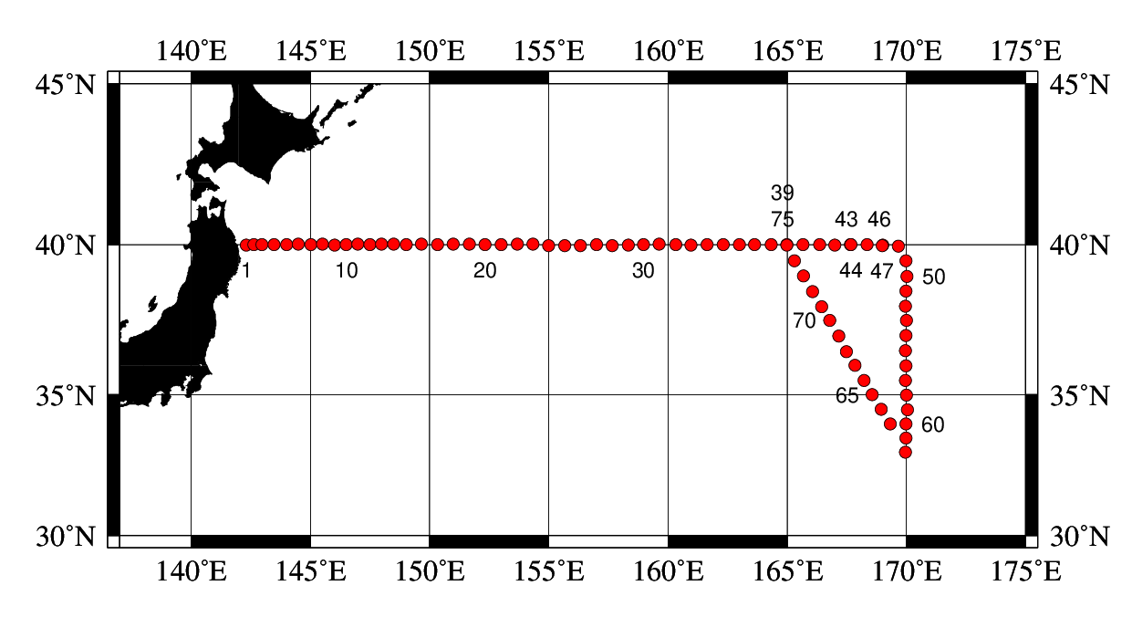

Figure 1. Cruise track of RF13-06 and RF13-07.

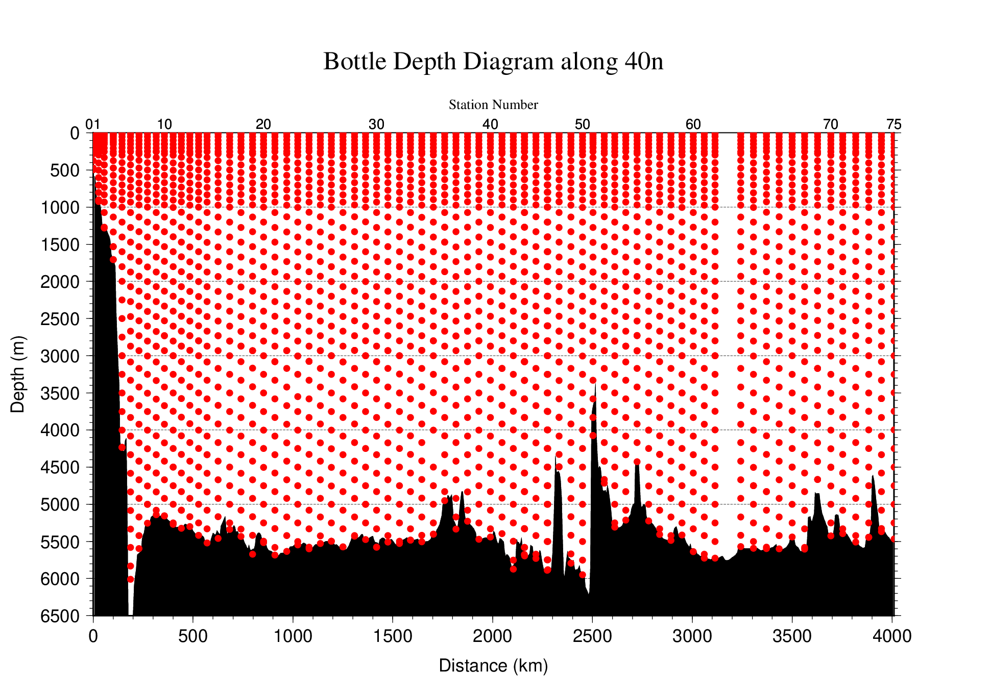
Figure 2. The bottle depth diagram for RF12-06 cruise.
Table 1. Information of deployed floats in RF12-06.
Float | Date and Time | Position of deployment |  | PI
WMO number | of Deployment (UTC) | Latitude | Longitude
2901673 | 2012 August 9  19:00 | 39-58.53 N | 167-01.77 E | JAMSTEC | PROVOR
2901674 | 2012 September 3  18:59 | 37-01.35 N | 167-14.03 E | JAMSTEC | PROVOR
PROVOR：nke Instrumentation (France)

Table 2. The scheme of sampling layer in meters.
Bottle count | scheme1 | scheme2 | scheme3
1 | 10 | 10 | 10
2 | 50 | 50 | 50
3 | 100 | 100 | 100
4 | 150 | 150 | 150
5 | 200 | 200 | 200
6 | 250 | 250 | 250
7 | 300 | 330 | 280
8 | 400 | 430 | 370
9 | 500 | 530 | 470
10 | 600 | 630 | 570
11 | 700 | 730 | 670
12 | 800 | 830 | 770
13 | 900 | 930 | 870
14 | 1000 | 1070 | 970
15 | 1200 | 1270 | 1130
16 | 1400 | 1470 | 1330
17 | 1600 | 1670 | 1530
18 | 1800 | 1870 | 1730
19 | 2000 | 2070 | 1930
20 | 2200 | 2270 | 2130
21 | 2400 | 2470 | 2330
22 | 2600 | 2670 | 2530
23 | 2800 | 2870 | 2730
24 | 3000 | 3080 | 2930
25 | 3250 | 3330 | 3170
26 | 3500 | 3580 | 3420
27 | 3750 | 3830 | 3670
28 | 4000 | 4080 | 3920
29 | 4250 | 4330 | 4170
30 | 4500 | 4580 | 4420
31 | 4750 | 4830 | 4670
32 | 5000 | 5080 | 4920
33 | 5250 | 5330 | 5170
34 | 5500 | 5580 | 5420
35 | 5750 | 5830 | 5670
36 | Bottom | Bottom | Bottom
Table 3. Station data of RF12-06 cruise. The ‘RF’ column indicates the JMA station identification number.
Leg | Station |  | Position |  |  | Leg | Station |  | Position
 | Stn. | RF | Latitude | Longitude |  |  | Stn. | RF | Latitude | Longitude
1 | 1 | 4461 | 39-59.97 N | 142-19.33 E |  | 1 | 35 | 4495 | 40-00.62 N | 162-19.37 E
1 | 2 | 4462 | 40-00.95 N | 142-38.12 E |  | 1 | 36 | 4496 | 40-00.30 N | 162-59.27 E
1 | 3 | 4463 | 40-00.23 N | 142-58.65 E |  | 1 | 37 | 4497 | 40-00.96 N | 163-38.49 E
1 | 4 | 4464 | 40-00.53 N | 143-29.88 E |  | 1 | 38 | 4503 | 40-00.29 N | 164-20.07 E
1 | 5 | 4465 | 40-00.53 N | 144-00.60 E |  | 1 | 39 | 4502 | 40-00.88 N | 164-59.83 E
1 | 6 | 4466 | 40-01.02 N | 144-30.91 E |  | 1 | 40 | 4501 | 40-00.75 N | 165-40.62 E
1 | 7 | 4467 | 40-00.48 N | 145-01.15 E |  | 1 | 41 | 4500 | 40-00.77 N | 166-21.27 E
1 | 8 | 4468 | 40-01.06 N | 145-30.62 E |  | 1 | 42 | 4499 | 39-59.39 N | 167-00.98 E
1 | 9 | 4469 | 39-59.20 N | 146-01.73 E |  | 1 | 43 | 4498 | 40-00.77 N | 167-39.80 E
1 | 10 | 4470 | 40-00.66 N | 146-30.13 E |  | 2 | 44 | 4504 | 40-00.58 N | 167-40.70 E
1 | 11 | 4471 | 40-01.44 N | 147-00.81 E |  | 2 | 45 | 4505 | 40-00.39 N | 168-21.18 E
1 | 12 | 4472 | 40-00.10 N | 147-30.32 E |  | 2 | 46 | 4506 | 39-59.86 N | 169-00.81 E
1 | 13 | 4473 | 40-01.75 N | 147-59.66 E |  | 2 | 47 | 4507 | 39-58.64 N | 168-59.30 E
1 | 14 | 4474 | 40-01.25 N | 148-30.73 E |  | 2 | 48 | 4508 | 39-57.26 N | 169-39.23 E
1 | 15 | 4475 | 40-00.88 N | 149-01.07 E |  | 2 | 49 | 4509 | 39-29.27 N | 169-59.80 E
1 | 16 | 4476 | 40-01.46 N | 149-40.02 E |  | 2 | 50 | 4510 | 38-58.61 N | 170-01.62 E
1 | 17 | 4477 | 40-00.21 N | 150-20.61 E |  | 2 | 51 | 4511 | 38-30.30 N | 169-59.91 E
1 | 18 | 4478 | 40-01.08 N | 151-00.04 E |  | 2 | 52 | 4512 | 37-59.41 N | 169-58.98 E
1 | 19 | 4479 | 40-01.82 N | 151-40.85 E |  | 2 | 53 | 4513 | 37-31.18 N | 170-00.47 E
1 | 20 | 4480 | 40-00.84 N | 152-20.37 E |  | 2 | 54 | 4514 | 37-01.50 N | 169-59.99 E
1 | 21 | 4481 | 40-00.28 N | 153-00.46 E |  | 2 | 55 | 4515 | 36-30.70 N | 169-57.52 E
1 | 22 | 4482 | 40-01.68 N | 153-41.55 E |  | 2 | 56 | 4516 | 35-59.50 N | 169-59.26 E
1 | 23 | 4483 | 40-01.06 N | 154-20.87 E |  | 2 | 57 | 4517 | 35-29.65 N | 169-58.38 E
1 | 24 | 4484 | 39-58.09 N | 155-00.94 E |  | 2 | 58 | 4518 | 34-59.50 N | 170-00.06 E
1 | 25 | 4485 | 39-58.26 N | 155-40.07 E |  | 2 | 59 | 4519 | 34-29.33 N | 170-02.11 E
1 | 26 | 4486 | 39-58.94 N | 156-19.75 E |  | 2 | 60 | 4520 | 33-59.33 N | 169-59.95 E
1 | 27 | 4487 | 40-00.36 N | 157-00.14 E |  | 2 | 61 | 4521 | 33-29.35 N | 169-59.09 E
1 | 28 | 4488 | 39-58.88 N | 157-40.48 E |  | 2 | 62 | 4522 | 33-00.03 N | 169-58.53 E
1 | 29 | 4489 | 39-59.33 N | 158-20.16 E |  | 2 | 63 | 4523 | 33-59.55 N | 169-16.96 E
1 | 30 | 4490 | 40-00.41 N | 158-58.47 E |  | 2 | 64 | 4524 | 34-30.31 N | 168-56.76 E
1 | 31 | 4491 | 40-01.09 N | 159-38.59 E |  | 2 | 65 | 4525 | 35-00.12 N | 168-34.54 E
1 | 32 | 4492 | 40-00.93 N | 160-19.04 E |  | 2 | 66 | 4526 | 35-29.61 N | 168-13.44 E
1 | 33 | 4493 | 39-59.98 N | 160-58.68 E |  | 2 | 67 | 4527 | 36-00.30 N | 167-51.49 E
1 | 34 | 4494 | 40-00.82 N | 161-38.65 E |  | 2 | 68 | 4528 | 36-28.99 N | 167-29.88 E
Leg | Station |  | Position |  |  | Leg | Station |  | Position
 | Stn. | RF | Latitude | Longitude |  |  | Stn. | RF | Latitude | Longitude
2 | 69 | 4529 | 37-00.32 N | 167-10.85 E |  | 2 | 73 | 4533 | 38-59.03 N | 165-41.40 E
2 | 70 | 4530 | 37-31.04 N | 166-47.84 E |  | 2 | 74 | 4534 | 39-29.11 N | 165-18.94 E
2 | 71 | 4531 | 37-58.97 N | 166-27.71 E |  | 2 | 75 | 4535 | 39-59.48 N | 164-59.32 E
2 | 72 | 4532 | 38-29.23 N | 166-04.53 E
List of Principal Investigators for all Measurements
The principal investigator (PI) and the person in charge responsible for major parameters measured on the cruise are listed in Table 4.

Table 4. List of principal investigator and the person in charge on the ship for RF12-06.
Item Principal Investigator（PI） Person in charge on the ship
Hydrography
CTDO₂ / LADCP Toshiya NAKANO Keizo SHUTTA
Salinity Toshiya NAKANO Keizo SHUTTA
Dissolve oxygen Toshiya NAKANO Chihiro KAWAMURA
Nutrients Toshiya NAKANO Takashi MIYAO
Phytopigment Toshiya NAKANO Takashi MIYAO
DIC Toshiya NAKANO Shu SAITO
Total Alkalinity Toshiya NAKANO Shu SAITO
pH Toshiya NAKANO Shu SAITO
CFCs Toshiya NAKANO Etsuro ONO

Underway
Meteorology Toshiya NAKANO Keizo SHUTTA
Thermo-Salinograph Toshiya NAKANO Shu SAITO
pCO₂ Toshiya NAKANO Shu SAITO
Chlorophyll-a Toshiya NAKANO Takashi MIYAO
ADCP Toshiya NAKANO Keizo SHUTTA
Bathymetry Toshiya NAKANO Keizo SHUTTA

Floats
Argo float Toshio SUGA Hitomi KAMIYA

Toshiya NAKANO (nakano_t@met.kishou.go.jp)
Marine Division, Global Environment and Marine Department, JMA
1-3-4, Otemachi, Chiyoda-ku, Tokyo 100-8122, JAPAN
Phone: +81-3-3212-8341 Ext. 5131

Toshio SUGA (sugat@jamstec.go.jp)
Ocean Climate Change Research Program
Research Institute for Global Change (RIGC)
Japan Agency for Marine-Earth Science and Technology (JAMSTEC)
2-15 Natsushima, Yokosuka, Kanagawa, Japan 237-0061
Reference
Swift, J. H. (2010): Reference-quality water sample data: Notes on acquisition, record keeping, and evaluation. IOCCP Report No.14, ICPO Pub. 134, 2010 ver.1

