CRUISE REPORT

Martha L. Black 2012001

LABRADOR SEA,
WOCE LINE AR07W

June 1 – June 17, 2012

A. CRUISE NARRATIVE

1. Highlights

a. WOCE Designation: | WOCE Line AR07W
b. Expedition Designation: | MLB2012001 or 18MF12001 (ISDM format)
c. Chief Scientist: | Igor Yashayaev  Ocean Sciences Division  Department of Fisheries and Oceans  Bedford Institute of Oceanography  PO Box 1006  Dartmouth, NS, Canada B2Y 2A4  Internet Igor.Yashayaev@dfo-mpo.gc.ca
d. Ship: | CCGS Martha L. Black
e. Ports of Call: | June 1, 2012 BIO, Dartmouth, NS, Canada  June 16, 2012 Rimouski, QC, Canada  June 17, 2012 Quebec City, QC, Canada
f. Cruise Dates: | June 1 to June 17, 2012

2. Cruise Summary Information

a. Cruise Track

A cruise track is shown in Figure A.2.1. The ship's position at 0000 UTC on each day of the cruise is indicated with a date label.

The World Ocean Circulation Experiment (WOCE) - format cruise station summary file (SUM) outlines the science operations conducted during the cruise.

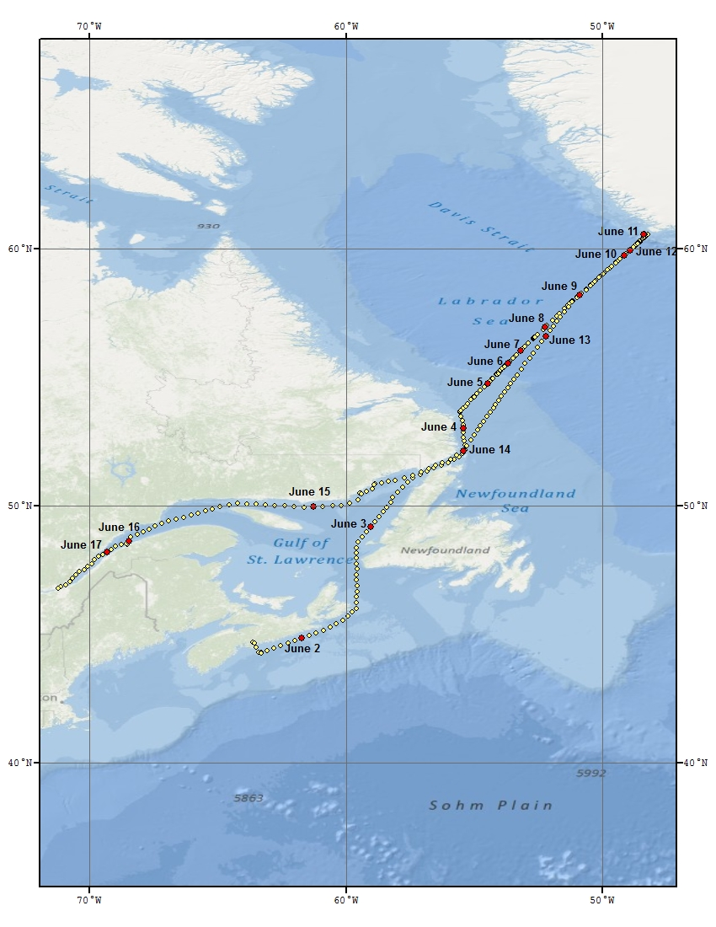
Figure A.2.1 Cruise track for MLB2012001. The yellow dots indicate the ship’s position for each hour of the voyage. The red dots and date labels indicate the ship's position at 0000 UTC for that particular date.
b. Total Number of Stations Occupied

The CTD / ROS station positions are shown in Figure A.2.2. Table A.2.1 lists the science operations for MLB2012001.

Along AR07W, the stations were full-depth WHP small volume rosette casts with up to 24 rosette bottles. Water samples were analyzed for CFC-12, SF6, total inorganic carbon (TIC), total alkalinity, oxygen, salinity, nutrients (nitrate, phosphate, and silicate), pH, and bacterial abundance. Chlorophyll was analyzed at depths less than 200m at most stations. Samples were collected for ¹²⁹I (iodine-129) and O-18 (Oxygen-18) on selected casts.

Cast  Type | Number of  Operations | Operation  Details | Operation  Numbers
Rosette & CTD | 36 | The 28 regular AR07W sites (L3 line) plus some extra occupations: 8.5, 9.5, 10.5, 14.1, 17.4, 23.5, 24.5, and 25.5 | see Table A.2.2
 | 1 | Bedford Basin Test Station | 1
 | 1 | Halifax Line  sites: 2 | 2
 | 4 | Biology Casts | 64, 79, 91, 129
 | 2 | Iceberg Casts | 113, 114
 | 3 | Unsuccessful CTD Operations | 60, 67, 122
Moorings | 3 | Recovery | 33, 48, 127
 | 3  1 | Deployment  Release Test | 34, 38, 108  107
Floats | 8 | APEX floats deployed | 52, 63, 69, 73, 78, 83, 87, 96
Biology | 31 | 200 micron net tows | See Table A.4.2.1. for occupation locations
 | 29 | 76 micron net tows | See Table A.4.2.1. for occupation locations
 | 7 | Egg Production rates | See Table A.4.2.1. for occupation locations
 | 1 | Unusable Net Cast | 57
Chemistry |  | ¹²⁹I surface
 |  | ¹²⁹I bottom
 |  | ¹²⁹I profile
 | 2 | Unused Operation Number | 93, 105

Table A.2.1 Science operations conducted on MLB2012001.

AR07W Site Number | 2012001 Deep Cast Operation Number
1 | 5
2 | 8
3 | 11
4 | 17
5 | 18
6 | 21
7 | 24
8 | 27
8.5 | 32
9 | 37
9.5 | 39
10 | 40
10.5 | 47
11 | 43
12 | 49
13 | 53
14 | 56
14.1 | 61
15 | 68
16 | 70
17 | 74
17.4 | 131
18 | 82
19 | 86
20 | 88
21 | 92
22 | 100
23 | 103
23.5 | 128
24 | 104
24.5 | 126
25 | 123
25.5 | 121
26 | 120
27 | 115
28 | 112

Table A.2.2. AR07W (L3) sites with rosette / CTD operation numbers for MLB2012001.

(Should we add the iceberg stations in here?)
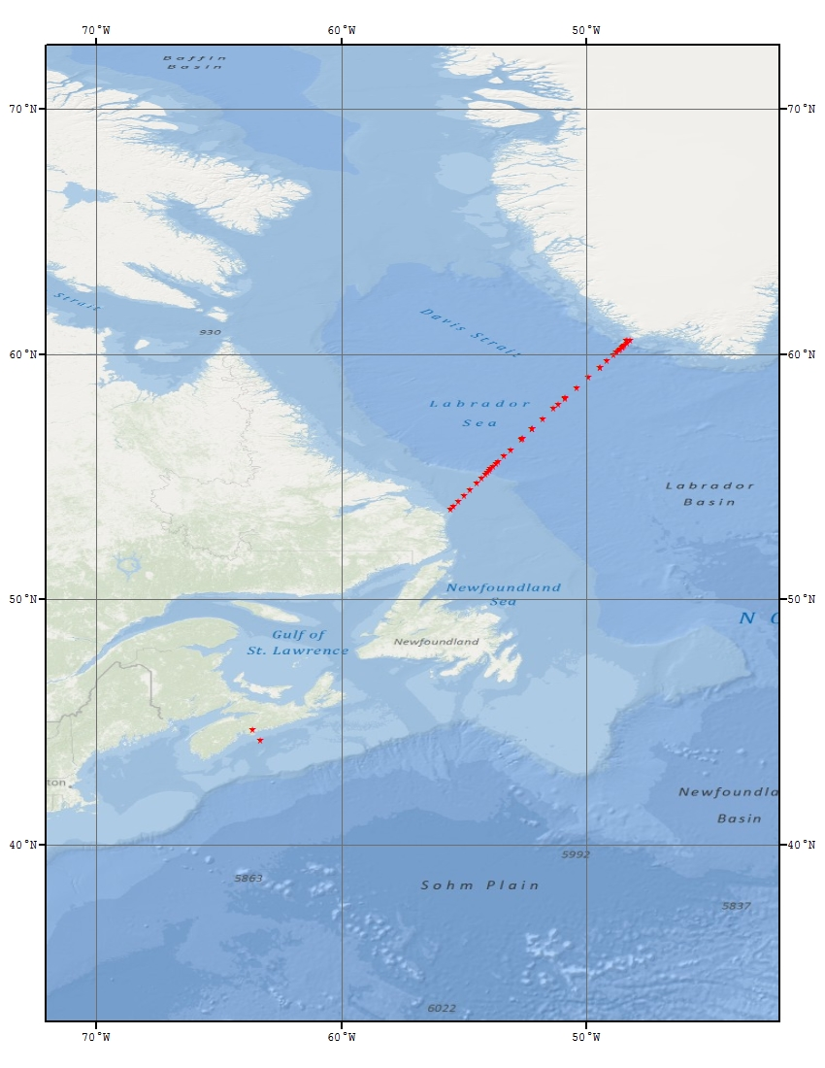

Figure A.2.2 MLB2012001 locations (red-filled stars) for operations involving one or more of the following data collection methods: Rosette, CTD and LADCP.
Stations along the AR07W Labrador Sea section and station HL2 of the Halifax Section (HL) were occupied during the MLB2012001 mission. These survey lines occupied within the same three week period on HUD2009011 provide a comprehensive assessment of the oceanographic conditions in the Canadian sector of the Atlantic Ocean.

c. Floats and Drifters deployed

Eight Argo floats were deployed as a Canadian contribution to the international Argo project along the AR07W line. These were a recently developed profiling float designed and manufactured by MetOcean of Dartmouth, Nova Scotia, Canada. NOVA (New generation Oceanographic Variable buoyancy Autonomous). The floats were equipped with SBE-41CP temperature-conductivity-pressure sensors from Sea-Bird Electronics, Inc., Bellevue, WA. This effort was jointly supported by Fisheries and Oceans Canada and the Canadian Ice Service of Environment Canada. Table A.2.3 gives details of the float deployments.

Six of the eight Argo floats deployed during the mission are still performing flawlessly. They are reporting good temperature and salinity profiles from 2000 db to the surface every 10 days.

Float 37 was a failure. It never returned any data. Reason for its failure is still unknown.

Float 34 returned four good profiles from 2000 db to the surface in the first month after its deployments, but it has never left the surface since July 16, remaining afloat and unable to sink for an unknown reason. This float is still recording and transmitting surface values of temperature and salinity of reasonable quality between two and four times daily. So we may consider this profiling buoy has now become a surface drifting buoy reporting at least twice a day. The GPS positions are good and if it continues functioning for the whole expected lifetime (3-5 years) there may still be a good value in the surface temperature and salinity measurements collected by this float.

IMEI # | Nova S/N | Deployment UTC | Date  (2012) | Latitude | Longitude | Status as of  14-AUG-2012
300034013853530 | 034 | 2239 | June 6 | 55º 50.861' N | -053º 23.560' W | reported 4 profiles before getting stuck at the surface on 16-JUL-2012
300034013854530 | 035 | 2025 | June 7 | 56º 34.751' N | -052º 38.041' W | reporting profiles
300034013856530 | 038 | 0432 | June 8 | 56º 57.390' N | -052º 14.340' W | reporting profiles
300034013857530 | 040 | 1022 | June 8 | 57º 22.536' N | -051º 47.502' W | reporting profiles
300034013859530 | 033 | 1658 | June 8 | 57º 48.014' N | -051º 21.133' W | reporting profiles
300034013850530 | 037 | 0229 | June 9 | 58º 12.940' N | -050º 52.770' W | unknown failure  no data reported
300034013858530 | 032 | 0909 | June 9 | 58º 38.351 N | -050º 25.001' W | reporting profiles
300034013851530 | 042 | 2129 | June 9 | 59º 28.987 N | -049º 28.413' W | reporting profiles

Table A.2.3 APEX float deployments on 2012001MLB.

d. Moorings deployed or recovered

Moorings deployed and recovered

The Aanderaa current meter mooring near station L3_08 on the AR07W line was once again serviced on June 5, 2012. Mooring #1800 was recovered successfully under good sea conditions. The replacement mooring #1824 was deployed successfully on the same day. Two other moorings were replaced; one on the Labrador side and one on the Greenland side of the Labrador Sea. These were recovered and re-deployed successfully (deployment of a new mooring preceded recovery of that deployed in 2011, at each site respectively).

Recoveries:

M 1798 | 60º 14.7114’ N  48º 35.1256’ W | Standard mooring consisting of one current meter and two Microcats. It was positioned within the Labrador Sea on the Greenland Slope for a 12-month deployment at approximately 2800 metres.
M 1799 | 55º 31.1353’ N  53º 43.2353’ W | Standard mooring consisting of one current meter and two Microcats. It was positioned within the Labrador Sea on the Labrador Slope for a 12-month deployment at approximately 2800 metres.
M 1800 | 55º 07.1682’ N  54º 05.2179’ W | Standard mooring consisting of one current meter and one microcat. It was positioned within the Labrador Sea on the Labrador Shelf for a 12-month deployment at approximately 1000 metres.

Deployments:

M 1822 | 60º 13.0014’ N  48º 37.0683’ W | Standard mooring consisting of one current meter and two Microcats. It was positioned within the Labrador Sea on the Greenland Slope for a 12-month deployment at 2786 metres.
M 1823 | 55º 33.4968’ N  53º 41.1712’ W | Standard mooring consisting of one current meter and two Microcats. It was positioned within the Labrador Sea on the Labrador Slope for a 12-month deployment at 2756 metres.
M 1824 | 55º 07.1844’ N  54º 05.5209’ W | Standard mooring consisting of one current meter and one microcat. It was positioned within the Labrador Sea on the Labrador Slope for a 12-month deployment at 1034 metres.

A software package called M-Cal (Mooring Calibrator) V 1.04 was used. M-Cal is a subset of a program called WorkBoat by James Illman of Software Engineering Associates. This enables the user to position the mooring once on the bottom. A computer is linked to the ship’s navigation as well as, in this case, to the Benthos DS7000 deck unit. As the ship travels near the mooring, M-Cal transponds to the acoustic release and measures the time interval between the send and reply pulses. This information combined with the navigation data enables the program to calculate the position of the release. As more and more data is gathered, the position continually updates. M-Cal also calculates a depth for the release.

This software is of great use if a mooring is off location for some reason. M-Cal gives a position so that locating the mooring is much quicker. Transponding to a release only gives a slant range and not a direction. A ship has to randomly travel to minimize this slant range which could be time consuming.

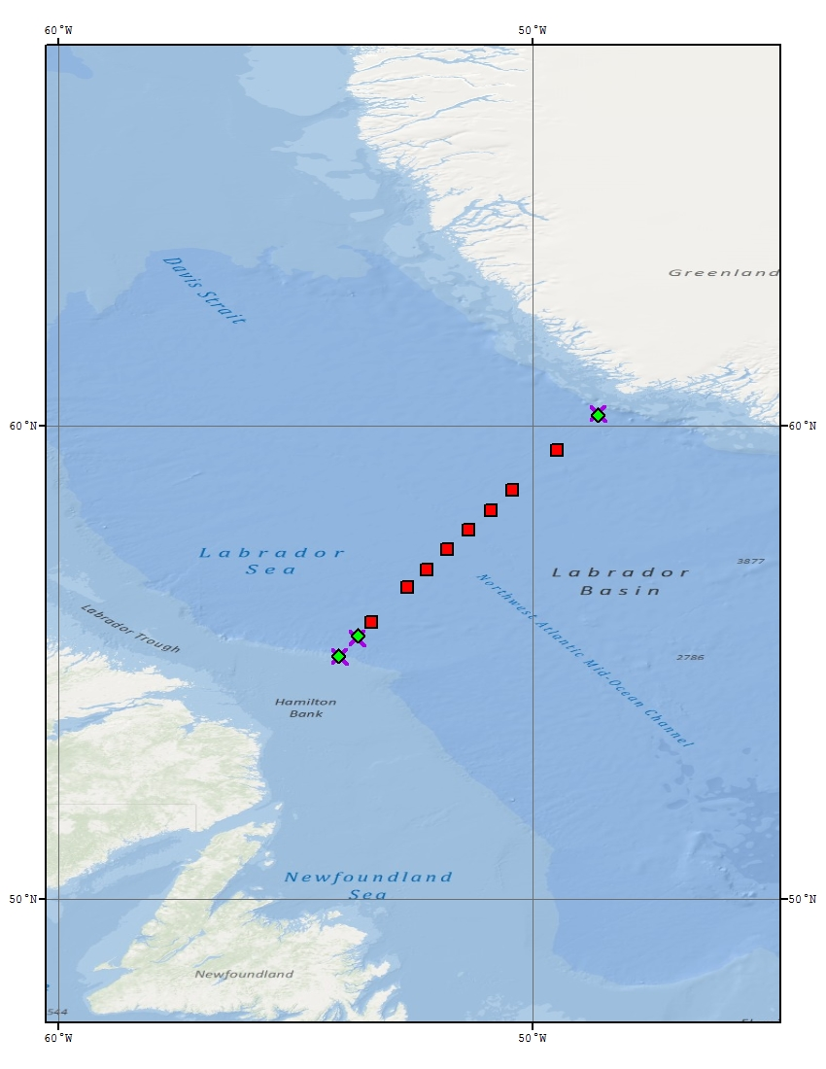

Figure A.2.3 MLB2012001 mooring deployment locations (purple X), mooring recovery locations (green-filled diamonds), and float deployment locations (red-filled squares).
3. List of Principal Investigators

Name | Affiliation | Responsibility
Kumiko Azetsu-Scott | BIO  Azetsu-ScottK@mar.dfo-mpo.gc.ca | Chemistry program coordination, TA, TIC, CFC-12, O¹⁸, SF6, and pH.
Glen Harrison | BIO  HarrisonG@mar.dfo-mpo.gc.ca | Biological program coordination
Erica Head | BIO  HeadE@mar.dfo-mpo.gc.ca | Macrozooplankton distribution, abundance, and metabolism
Bill Li | BIO  LiB@mar.dfo-mpo.gc.ca | Pico-plankton distribution and abundance, bacterial abundance and productivity
John Smith | BIO  SmithJN@mar.dfo-mpo.gc.ca | Radioisotope sampling program
Igor Yashayaev | BIO  YashayaevI@mar.dfo-mpo.gc.ca | Senior Scientist, hydrography, Argo and mooring program coordination, XBTs

Table A.3.1. List of Principal Investigators (see Section 7 for addresses).

4.1 Physical - Chemical Program

a. Narrative

The physical and chemical program on Martha L Black 2012001 continued an annual series of measurements in the Labrador Sea that began in 1990 as a contribution to the World Climate Research Programme and has evolved into a component of a multidisciplinary regional monitoring effort. The broad goals are to investigate interannual and long-term changes in the physical and chemical properties of the Labrador Sea and better understand the mechanisms that cause these changes. A particular focus is on changes in the intensity of winter overturning of surface and intermediate-depth waters and the resulting formation of Labrador Sea Water with varying temperature and salinity properties. This overturning is part of the thermohaline circulation that plays a role in the global climate system. Convection also transfers atmospheric gases such as oxygen and carbon dioxide from the surface layers to intermediate depths. The resulting oceanic storage of anthropogenic carbon reduces the rate of increase of carbon dioxide in the atmosphere but also increases the acidity of oceanic waters.

An occupation of the extended Halifax Line (when feasible) crossing the Scotian shelf, slope and in so-called Slope Water region complements the study of the Labrador Sea and is seen as an important part of the offshore monitoring program. In the 2012 mission we occupied only one station (HL2) on this line (CTD, water sampling and two net tows), where the longest and best temporally resolved series of costal measurements is being collected.

Finally, the mission was also aimed to recover and redeploy three near-bottom moorings over the continental slopes off Labrador (2) and Greenland (1).

The physical-chemical investigations are part of a larger multidisciplinary effort seeking a better understanding of interannual and long-term changes in regional ecosystems.

Hudson 2012001 program elements included:

- CTD profile measurements of pressure, temperature, salinity, dissolved oxygen, pH, fluorescence, and light intensity at a fixed set of stations (AR07W/L3 line) spanning the Labrador Sea from Hamilton Bank on the Labrador Shelf to Cape Desolation Island on the West Greenland Shelf;

- Measurements of salinity, dissolved oxygen, nutrients (nitrate/nitrite, phosphate, silicate), CFC-12, SF6, dissolved inorganic carbon, alkalinity and Iodine-129 from discrete water samples from a rosette sampler on the CTD package;
- Recovery and redeployment of a current meter mooring providing near-bottom current and temperature measurements on the Labrador Slope in 1000 m water depth;
- Recovery and redeployment of two current meter moorings at 2800 m isobath on the western and eastern ends of AR07W;

- Current measurements at CTD stations from a Lowered Acoustic Doppler Current Profiler (LADCP) and Electromagnetic (EM) current meter;
- Temperature profile measurements from eXpendable BathyThermographs (XBTs) at selected points between CTD stations;
- Autonomous float deployments as part of the Canadian Argo Program and the international Argo Project;
- Physical and chemical measurements on station HL2 of the Halifax Line on the Scotian Shelf in support of the Atlantic Zone Monitoring Program (AZMP);

- A phytoplankton biomass/primary productivity program conducted;
- A microbial program;
- A mesozooplankton program.

The Labrador Sea station work went well except for problems with CTD cable termination, instrument cables, bird caging and tearing of CTD cable, problems with the CTD winch and damage of the CTD package and rosette bottles caused by a collision with a huge coral (operation 120). Three additional stations added on the Labrador Sea (western) side and three on the eastern side of AR07W and two in a close proximity of an iceberg on the Greenland shelf. Favourable ice conditions on the eastern and western sides of the Labrador Sea at the time of our survey allowed the occupation of all planned stations on both ends of the line (West Greenland and Labrador shelves).

A number of measures had been taken before the cruise to adapt the CCGS Martha L Black, to install four IML containers of foredeck, design and install supportive parts, and, finally, install our instruments and systems to perform our regular sampling tasks during the mission. This, altogether, came as a new task for the ship and a great challenge for both crew and scientific staff, but owing to professionalism and cooperation of the CCGS and BIO teams involved in preparation and execution of the mission, all of its objectives had been met.

b. Chemical Oceanography

The chemistry program conducted in the GP Lab during MLB2012001 included analysing water samples for dissolved inorganic carbon (DIC), total alkalinity (TA), transient tracers (CFC-12 and SF6), nutrients, and dissolved oxygen. Water samples for pH and oxygen isotope composition were also collected, preserved, and stored for later analysis.

c. Radioisotope Sampling Program

Water samples were collected for ¹²⁹I from a near surface rosette bottle at 14 stations on the L3 (AR07W) line. Samples for ¹²⁹I were collected from near bottom rosette bottle at two L3 stations and one Halifax Line (HL) station. Fuller depth sampling for ¹²⁹I was carried out at six L3 stations and six HL stations. See table A.2.1 for the list of corresponding operation numbers.

4.2 Biological Program

a. Biological Oceanographic Sampling Program

Jeff Anning and Tim Perry

Nearly all stations occupied were sampled for a number of biological parameters. Samples were collected throughout the water column for bacterial identification and enumeration. In the upper 100 m samples were collected for chlorophyll analysis and at the surface samples were taken to measure particulate organic carbon, and determine pigment composition by HPLC and absorption spectra. Duplicate phytoplankton samples, integrated over the upper 50 m., were preserved with Lugols and formalin.

b. Zooplankton Sampling and Experimental Programme

Erica Head and Marc Ringuette

Zooplankton samples for quantitative analysis (identification and enumeration of individuals to species level) were collected by towing ring nets vertically between 100 m and the surface at a total of 30 stations (Table A.4.2.1). The first station sampled was HL2, an AZMP time series station on the Scotian Shelf. The other 29 stations were along the L3 (AR07W) section between Hamilton Bank (Labrador Shelf) and Cape Desolation (Southwest Greenland). Two net mesh sizes, 202 microns and 76 microns, were towed for quantitative analysis at 28 stations, while only one net (202 micron net) was towed at 1 station (L3-24). Samples were preserved in 2% buffered formalin.

Tows to collect animals for experimental purposes were made at 7 stations using the 202 micron mesh ring net towed vertically between 100 m and the surface (Tables A.4.2.1 and A.4.2.2). At one of these stations (L3-23.5), no quantitative tows were taken. The objective of the experiments was to measure egg production rates of female Calanus finmarchicus. These are generally measured by incubating groups of freshly caught females individually for 24 h. At the end of the incubation period, the females are removed, and the eggs they have laid are counted under the microscope. The females’ lengths are measured and they are kept for CHN analysis back in the laboratory. In a variation of this standard procedure, for each group of females incubated individually for 24 h, a second group was incubated individually for 4 sequential 6 h periods. In the second type of incubation at the end of each 6 h period the females were moved to fresh incubation vessels and the eggs were counted. The objectives of carrying out the two types of incubation were (a) to see if egg-laying has a diel periodicity and (b) to see if the same numbers of eggs are laid in the two types of incubation. A preliminary inspection of the data suggests (a) that there is no obvious diel signal in egg-laying and (b) that egg numbers are higher in the second type of incubation, by a factor of between 1.5 and 2.5. The interpretation of the latter observation is that the females are eating their eggs, when they are left with them for a prolonged period: cannibalism has frequently been observed in incubations where steps are not taken to prevent it. In these experiments, even though the incubation method used is supposed to minimise cannibalism, it was apparently still occurring in the 24 h incubations, and (perhaps) at a reduced rate in the incubations where eggs and females were separated at 6 hourly intervals.

One experiment to measure the development rates of C. finmarhicus eggs into the early (non-feeding) naupiar stages was carried out using eggs laid by females collected at station L3-11.

NET | STATION | DATE | START TIME | EVENT | MESH SIZE | EXPERIMENTAL
TOW |  |  | (LOCAL) | NUMBER | (MICRONS) | ANMIALS
NUMBER |  |  |  |  |  | COLLECTED
1-1 | HL2 | 01/06/2012 | 13:45 | 2 | 200
1-2 | HL2 | 01/06/2012 | 13:45 | 3 | 76
2-1 | L301 | 04/06/2012 | 01:30 | 6 | 200
2-2 | L301 | 04/06/2012 | 01:30 | 7 | 76
3-1 | L302 | 04/06/2012 | 03:30 | 9 | 200
3-2 | L302 | 04/06/2012 | 03:30 | 10 | 76
4-1 | L303 | 04/06/2012 | 06:40 | 12 | 200
4-2 | L303 | 04/06/2012 | 06:40 | 13 | 200 | Y
4-3 | L303 | 04/06/2012 | 06:40 | 14 | 76
5-1 | L304 | 04/06/2012 | 09:10 | 15 | 200
5-2 | L304 | 04/06/2012 | 09:10 | 16 | 76
6-1 | L305 | 04/06/2012 | 15:20 | 19 | 200
6-2 | L305 | 04/06/2012 | 15:20 | 20 | 76
7-1 | L306 | 04/06/2012 | 20:00 | 22 | 200
7-2 | L306 | 04/06/2012 | 20:00 | 23 | 76
8-1 | L307 | 04/06/2012 | 23:00 | 25 | 200
8-2 | L307 | 04/06/2012 | 23:00 | 26 | 76
9-1 | L308 | 05/06/2012 | 02:45 | 28 | 200
9-2 | L308 | 05/06/2012 | 02:45 | 29 | 76
10-1 | L308:5 | 05/06/2012 | 03:45 | 30 | 200
10-2 | L308:5 | 05/06/2012 | 03:45 | 31 | 76
11-1 | L309 | 05/06/2012 | 12:07 | 35 | 200
11-2 | L309 | 05/06/2012 | 12:05 | 36 | 76
12-1 | L310 | 06/06/2012 | 03:00 | 41 | 200
12-2 | L310 | 06/06/2012 | 03:00 | 42 | 76
13-1 | L311 | 06/06/2012 | 07:10 | 44 | 200
13-2 | L311 | 06/06/2012 | 07:10 | 45 | 200 | Y
13-3 | L311 | 06/06/2012 | 07:10 | 46 | 76
14-1 | L312 | 06/06/2012 | 18:15 | 50 | 200
14-2 | L312 | 06/06/2012 | 18:15 | 51 | 76
15-1 | L313 | 06/06/2012 | 23:45 | 54 | 200
15-2 | L313 | 06/06/2012 | 23:45 | 55 | 76
16-1 | L314 | 07/06/2012 | 06:54 | 58 | 200
16-2 | L314 | 07/06/2012 | 06:54 | 59 | 76
16-3 | L314 | 07/06/2012 | 06:54 | 62 | 200 | Y
17-1 | L315 | 07/06/2012 | 19:15 | 65 | 200
17-2 | L315 | 07/06/2012 | 19:15 | 66 | 76
18-1 | L316 | 08/06/2012 | 06:00 | 71 | 200
18-2 | L316 | 08/06/2012 | 06:00 | 72 | 76
19-1 | L317 | 08/06/2012 | 12:33 | 75 | 200 | Y
19-2 | L317 | 08/06/2012 | 12:33 | 76 | 200
19-3 | L317 | 08/06/2012 | 12:33 | 77 | 76
20-1 | L318 | 08/06/2012 | 18:45 | 80 | 200
20-2 | L318 | 08/06/2012 | 18:45 | 81 | 76
21-1 | L319 | 09/06/2012 | 01:30 | 84 | 200
21-2 | L319 | 09/06/2012 | 01:30 | 85 | 76
22-1 | L320 | 09/06/2012 | 10:40 | 89 | 200
22-2 | L320 | 09/06/2012 | 10:40 | 90 | 76
23-1 | L321 | 09/06/2012 | 17:08 | 93 | 200
23-2 | L321 | 09/06/2012 | 17:08 | 94 | 76
24-1 | L322 | 09/06/2012 | 19:02 | 97 | 200
24-2 | L322 | 09/06/2012 | 19:02 | 98 | 200 | Y
24-3 | L322 | 09/06/2012 | 19:02 | 99 | 76
25-1 | L323 | 10/06/2012 | 00:15 | 101 | 200
25-2 | L323 | 10/06/2012 | 00:15 | 102 | 76
26-1 | L324 | 10/06/2012 | 07:30 | 106 | 200
27-1 | L328 | 10/06/2012 | 15:00 | 109 | 200
27-2 | L328 | 10/06/2012 | 15:00 | 110 | 200 | Y
27-3 | L328 | 10/06/2012 | 15:00 | 111 | 76
28-1 | L327 | 10/06/2012 | 21:20 | 116 | 200
28-2 | L327 | 10/06/2012 | 21:20 | 117 | 76
29-1 | L326 | 10/06/2012 | 22:45 | 118 | 200
29-2 | L326 | 10/06/2012 | 22:45 | 119 | 76
30-1 | L325 | 11/06/2012 | 09:15 | 124 | 200
30-2 | L325 | 11/06/2012 | 09:15 | 125 | 76
31-1 | L323:5 | 11/06/2012 | 18:55 | 130 | 200 | Y
32-1 |  | 13/06/2012 | 14:36 | 132 | 200

Table A.4.2.1. List of net tows carried out on Labrador Sea monitoring mission MLB2012001.

EXPT. NO. | STATION | DATE | START TIME |  | INCUBATION | TEMPERATURE
 |  |  | (LOCAL) | TYPE |  | (Deg. C)
1A | L303 | 04/06/2012 | 10:00 | 24 h |  | -0.5
1B | L303 | 04/06/2012 | 10:20 | 4 X 6 h |  | -0.5
2B | L311 | 06/06/2012 | 08:45 | 4 x 6 h |  | 3.5
3A | L314 | 07/06/2012 | 17:10 | 24 h |  | 4.0
3B | L314 | 07/06/2012 | 17:40 | 4 X 6 h |  | 4.0
4B | L317 | 09/06/2012 | 14:10 | 4 X 6 h |  | 4.5
5A | L222 | 09/06/2012 | 21:20 | 24 h |  | 5.0
5B | L322 | 09/06/2012 | 21:00 | 4 X 6 h |  | 5.0
6B | L328 | 10/06/2012 | 19:15 | 4 X 6 h |  | 1.0
7A | L323.5 | 11/06/2012 | 21:00 | 24 h |  | 4.5
7B | L323.5 | 11/06/2012 | 20:30 | 4 X 6 h |  | 4.5

Table A.4.2.2. Egg production experiments - List of experimental stations and details.

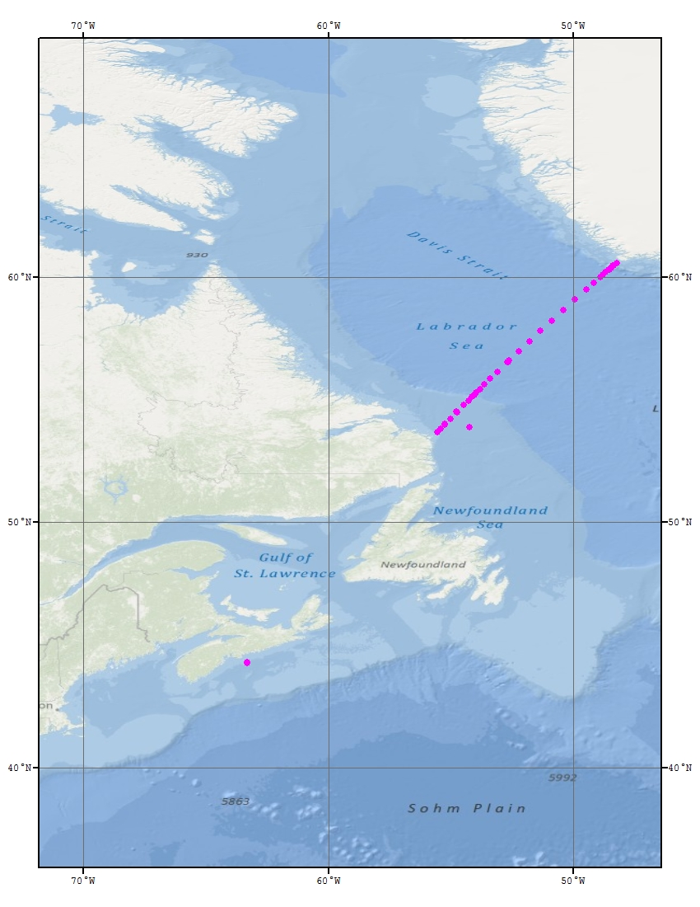

Figure A.4.2.1 MLB2012001 ring net tow (pink-filled circles) locations.

4. Major Problems and Goals Not Achieved

There were none to report.

5. Other Incidents of Note

There were none to report.
7. List of Cruise Participants

Name | Responsibility | Affiliation
Anning, Jeffrey | Biological | OESD, BIO
Anstey, Carol | Nutrients | OESD, BIO
Boyce, Richard | Technical Operations Head, Salts, Moorings, Floats | PCSD, BIO
Burtch, Jason | Winch Room, Moorings, Floats
Childs, Darlene | CFC-12, SF6 | OESD, BIO
Geshelin, Yuri | Oxygens | OESD, BIO
Hartling, Adam | Winch Room, LADCP | PCSD, BIO
Head, Erica | Biological, Net Tows | OESD, BIO
Jackson, Jeffrey | Data management, Computer Room | PCSD, BIO
Perry, Timothy | Biological, Net Tows | OESD, BIO
Punshon, Stephen | CFC-12, SF6 | OESD, BIO
Ringuette, Marc | Biological, Net Tows | OESD, BIO
Ryan, Robert | CTD Tech., Winch Room, Floats | PCSD, BIO
Wartman, Melissa | Carbonate, Alkalinity, pH | OESD, BIO
Wang, Jianing | Computer Room | OESD, BIO
Wang, Zeliang | Computer Room | OESD, BIO
Yashayaev, Igor | Chief Scientist | OESD, BIO

BIO | Bedford Institute of Oceanography  PO Box 1006, Dartmouth, NS, Canada, B2Y 2A4
OESD | Ocean Ecosystem Science Division
PCSD | Program Coordination and Support Division
B. UNDERWAY MEASUREMENTS

1. Navigation and Bathymetry

The differential GPS navigation system was provided onboard by the CCGS Martha L Black. Navigation information was broadcast on the ships network for access in all lab areas.

Mooring locations, station locations and navigation were monitored using the Aldebaran II electronic charting software from CNS Systems.

All navigation data was logged using the Geological Survey of Canada’s (GSC) Survey Suite navigational software. A time and date stamp is added to each navigation string acquired.

The echo sounder system included a Raytheon PTR echo sounder, a Raytheon Line Scan Recorder and an Edo 12kHz transducer. The Edo 12 kHz transducer was mounted on the ram located in the well on the forward deck and remained flush with the hull during the mission.

A Benthos 7000 transducer was also mounted on the ram for use during mooring operations and mooring position and depth calibration.

2. CTD Motion Study

An attitude and heading reference sensor (Xsens MTi) was mounted on the CTD package. Data from the motion sensor was monitored in real-time to provide information on the dynamics of the package during a CTD cast. The Motion Data acquisition software combined each motion sensor sample with CTD and Instrumented Block System data. This information will hopefully aid in the prevention of motion induced failures in the mechanical wire termination on the CTD package. Motion data was logged at 10Hz for almost all CTD casts during this mission.

3. Meteorological observations

The officer of the watch manually logged meteorological variables at regular intervals.

4. Atmospheric Chemistry

There was no atmospheric chemistry program.

C. HYDROGRAPHIC MEASUREMENTS -
DESCRIPTIONS, TECHNIQUES AND CALIBRATIONS

1. Salinity

Richard Boyce

- Description of Equipment and Technique

Approximately 490 salinity samples were analyzed using a Guildline Autosal 8400B salinometer, serial number 69780 and 40 were analysed with serial number 60968. Samples were drawn into 200 ml bottles. Once the sample bottle was rinsed three times and filled to the shoulder, the neck and threads of the bottle were dried using paper towel and a new dry cap was installed. Once the bottles reached room temperature, the caps should be retightened. The drying of the neck of the bottle and installing a dry cap has been a technique used since the HUD2000009 cruise and prevents salt crystals from forming under the cap if samples are left for a long period of time before analysis.

The samples are placed into a constant temperature water bath set to 23.5º C with the Autosal running at 24ºC. The cell of the salinometer was filled and rinsed three times with sample water. A fourth sample was introduced into the cell and readings were averaged over a 10 to 15 second interval until the operator was satisfied that the correct value was attained. If there was any doubt in this value, subsequent refills were performed and readings averaged as above. Once satisfied, a sample ID number and Conductivity Ratio was recorded onto the Salinity Log Sheet. Periodically, the room temperature was recorded constantly.

For the first time, the bath temperature of the Autosal was measured and recorded using a SeaBird SBE-35 temperature probe. This monitored any temperature variations in the bath during the analyses.

- Data Processing Technique

Conductivity ratios, sample ID’s and standards were entered into the ODIN database. Conductivity ratios were used to compute salinities using the water sample conductivity ratio and the standard IAPSO formula applied in an ODIN module. Any changes in the salinometer readings between successive standardizations were assumed to have occurred as a linear drift of the instrument. Thus, the program applied a correction to the ratios, which varied linearly with the samples analyzed. An offset was also applied if the initial standardization was different from the quoted value given on the ampoule label. The computed salinity data was then placed in the water sample database. How the measurements of the Autosal bath temperature measured by the SBE35 will be used will be decided later.

- Laboratory and Sample Temperatures

Full cases of samples were taken from the CTD container to the ship’s technicians working area where the Autosal’s were set-up. Cases of 24 salinity bottles were placed into water baths set at 23.5º C and allowed to equilibrate before analyzing. During this particular Mission, the room temperature in this area ranged between 22º and 24 ºC. The Autosal bath temperature was set to 24ºC for all samples.

- Standards Used

The salinometer was standardized during the mission using IAPSO standard water, Batch P153 with a “USE BY” date of March 8/14 having a K15 value of 0.99979, salinity of 34.992. Typically, standardization checks were performed before a run, then after every 25 to 35 samples and at the end of a run.

e. Performance of the Autosal salinometer
Overall, the Autosal salinometer serial number 69780 worked well during the mission. There was some drift in the standards over the cruise period. The introduction of water baths to bring the samples close to the temperature of the Autosal bath has made the analysis much better. The instrument spends very little time in bringing the sample to the temperature of the bath thus reducing bath fluctuations. The lab temperature was stable during all runs which is an important factor when trying to optimize the performance of the instrument.

- Autosal serial number 60968 did not appear to work consistently during the analysis of samples 380173 - 380211. Over 40 samples, the standard jumped 13 units, the reference number jumped by 5 units and the zero by 3 units. This jump appeared to have happened at sample 380187. Salinities from these samples should be looked at carefully. This salinometer was not used for any further samples.

2. Measuring Dissolved Oxygen Concentration and calibration of Sea-Bird oxygen sensors on the Martha L. Black 2012-001 mission.

Yuri Geshelin

1. Introduction

In June of 2012, the CCGS Martha L. Black carried out the annual field mission: cruise 2012-001 (1-17 June 2012), which included the spring occupation of the ARW7 (WOCE) transect across the Labrador Sea. In this report, the cruise is referred to as MLB2012_001. The Halifax line was not occupied, but measurements were taken on one of its stations: station 2. Samples and standard measurements of dissolved oxygen (DO) were taken at various depths as per cruise program with the use of titration methods and by means of Sea-Bird DO primary and secondary sensors. During the cruise, calibrations of both sensors were made taking into account the experience gained on previous cruises in 2010-2011. We employed the Winkler method of titration implemented with the use of a colorimeter and the BOB software developed at the Maurice Lamontagne Institute, Quebec.

This note describes the methods of collecting samples, data acquisition and processing, presents some preliminary results of the expedition in the form of quantitative estimates and compares those results with some previous cruises.

2. Procedures and methods

Oxygen sub-samples were drawn from 10-L bottles attached to a 24-bottle Rosette Sampler. To reduce air contamination of the samples to a possible minimum the sampling was done immediately after the chlorofluorocarbon samples were taken. Efforts were made to take at least one DO sample from every closed bottle, but in some cases this was not done due to operational constraints. On some oceanographic stations, replicate samples were collected at one or two depths. On the very first station (station 2 on Halifax line), duplicates were taken from each Niskin bottle. Because the detailed analysis of duplicates was carried out on the previous cruises, it had not been the intention to repeat it. Therefore the duplicates were fewer in numbers, and their analysis is not described in the current report.

The oxygen sampling bottles were 125 mL Iodine flasks with matched custom ground stoppers. The volumes of flasks with the corresponding stoppers were predetermined gravimetrically, and volume data were saved to titration program prior to the cruise. The matched flasks and stoppers are etched with identification numbers.

Each oxygen sub-sample was drawn through a silicone tube attached to the spigot of the Rosette bottle. The flask and stopper were thoroughly rinsed. The flow was then allowed to continue until two to three flask volumes overflowed. The sampling tube was then rotated inside the flask and thus rubbed against the neck to prevent bubbles from forming on it. Next, the tube was slowly removed with continuous low flow to ensure that no air was trapped in the flask and the volume kept to the brim until the reagents were added and the stopper inserted.

Samples were immediately oxidized with the addition of 1.0 mL each Alkaline Iodide and Manganous Chloride. The tip of the spout was submerged under the surface of the sample during this procedure. The flask stopper was carefully and tightly inserted to avoid introducing air. The flask was then shaken and turned upside down several times.

The samples were stored immediately after collection for at least 1 hour in a dark place at room temperature.

A piece of post-processing software was written in MATLAB to facilitate the integration of collected data sets into a single database. It allows the user to fix some mistakes made during the titration at sea, add up 2 titrant volumes to determine DO when necessary (see section 3) and merge the titration data with Seabird data for the sake of intercomparisons.

3. Problems

As on the previous cruise, the PC designated for running BOB software often froze. Most often, it happened after it was left idle for an hour or longer. In other words, it happened almost every time I started to titrate a batch of samples or in the beginning of running blanks and standards. As in the past, I was unable to determine which device (or software) was malfunctioning. Therefore I re-booted the PC, colorimeter and Dosimat. This resulted in the loss of some samples.

In two cases, the PC did not freeze, but there was a problem with colorimeter. The titration process stopped before the end point was reached, and the values of NaN were assigned to the volume of consumed titrant and DO concentration. In these cases, with the flask still on the stirrer, I immediately re-started the new titration and used the sum of the two titrant volumes to determine the value of DO. The titrant volume consumed in the course of the first (unsuccessful) titration was read from the bottom of the corresponding TOD file.

4. Sea-Bird – Winkler comparisons

The ultimate goal of the intercomparisons between Sea-Bird and Winkler is to perform the calibration of the Sea-Bird sensors, because the chemical method should provide more accurate values. The comparisons were carried out for both primary and secondary sensors. The total of 581 data points were employed in the analysis, and the results of comparisons are presented in the form of Sea-Bird vs Winkler DO scatter plots in Figure C.2.1. The left panels present the scatter plot of the two concentrations. Plotted on the right panels is the relationship between pressure and the difference between the two concentrations. This was done to ensure that that difference is not dependent on pressure.

Despite some obvious outliers, the correlation coefficients between Sea-Bird and Winkler values are fairly high: 0.90 for the primary and 0.93 for secondary sensor. This is no longer an improvement over the results obtained on the previous cruises (In September-2011, both coefficients were 0.99). As for the correlation coefficients between Sea-Bird – Winkler differences and pressure, they are -0.21 and -0.19 for the primary and secondary sensors respectively. This suggests that the calibration process still undesirably depends on pressure, although the situation has improved since the September-2011 cruise, especially for the secondary sensor, for which the correlation coefficient was -0.63. Despite this improvement, the situation must be addressed. Most likely, the pressure term in the Sea-Bird calibration equation needs to be changed.

As of today, the DO data from 5 cruises have been collected and the scatter plots similar to those in left panels of Figure C.2.1 were produced. The examination of the previous version of this plot (without the MLB2012_001 cruise) is carried out in (1). Here, we will note that in general, with the exception of outliers, the current cruise is in good agreement with the three Hudson cruises: 2010_014, 2011_009, 2011_043.

5. Conclusions

We have summarized the procedures for and results of sampling, measuring and calibrating the DO concentrations on the Martha L. Black cruise in the spring of 2012. Table C.2.1 summarizes the Sea-Bird - Winkler correlation coefficients derived on 5 cruises and suggests that the highest level of our sampling and titration techniques was achieved on the Hudson September 2011 cruise.

Cruise | Ship | Primary Sea-Bird sensor | Secondary Sea-Bird sensor
2010-014 | Hudson | 0.46 | N/A
2010-049 | Hudson | 0.97 | 0.87
2011-009 | Hudson | 0.93 | 0.94
2011-043 | Hudson | 0.99 | 0.99
2012-001 | Martha L. Black | 0.90 | 0.93

Table C.2.1. Correlation coefficients between Winkler- and Sea-Bird-derived values of DO concentration.

It should be noted that we are still not successful in solving the problem of pressure-dependent Sea-Bird values (see the right panels in Figure C.2.1). As mentioned, the Sea-Bird calibration equation needs to be corrected. The CTD data should then be re-processed, and the correlations re-computed.

References

Y.Geshelin, 2011. Measuring Dissolved Oxygen Concentration and calibration of Sea-Bird oxygen sensors on the Hudson 2011-043 cruise. Technical report.

b
a
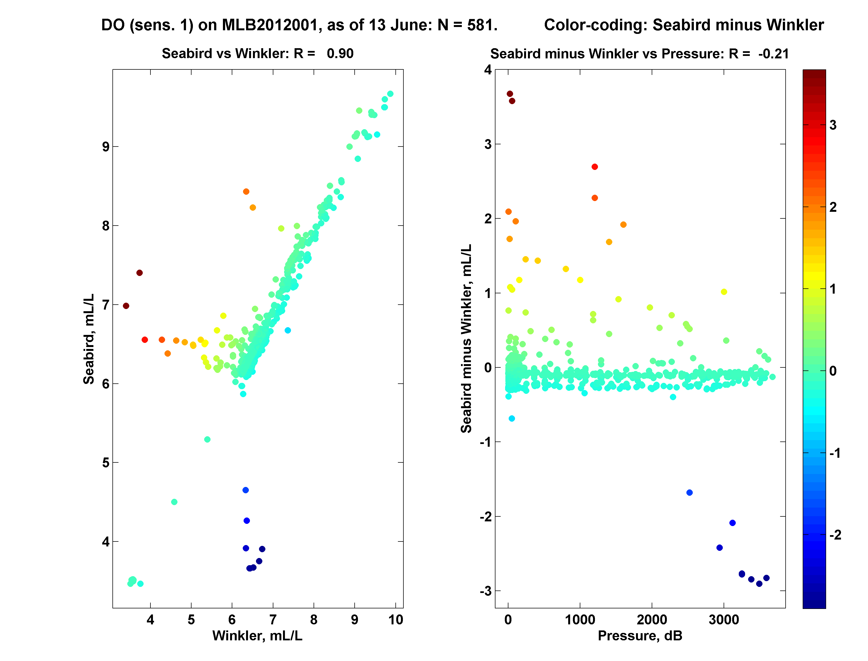
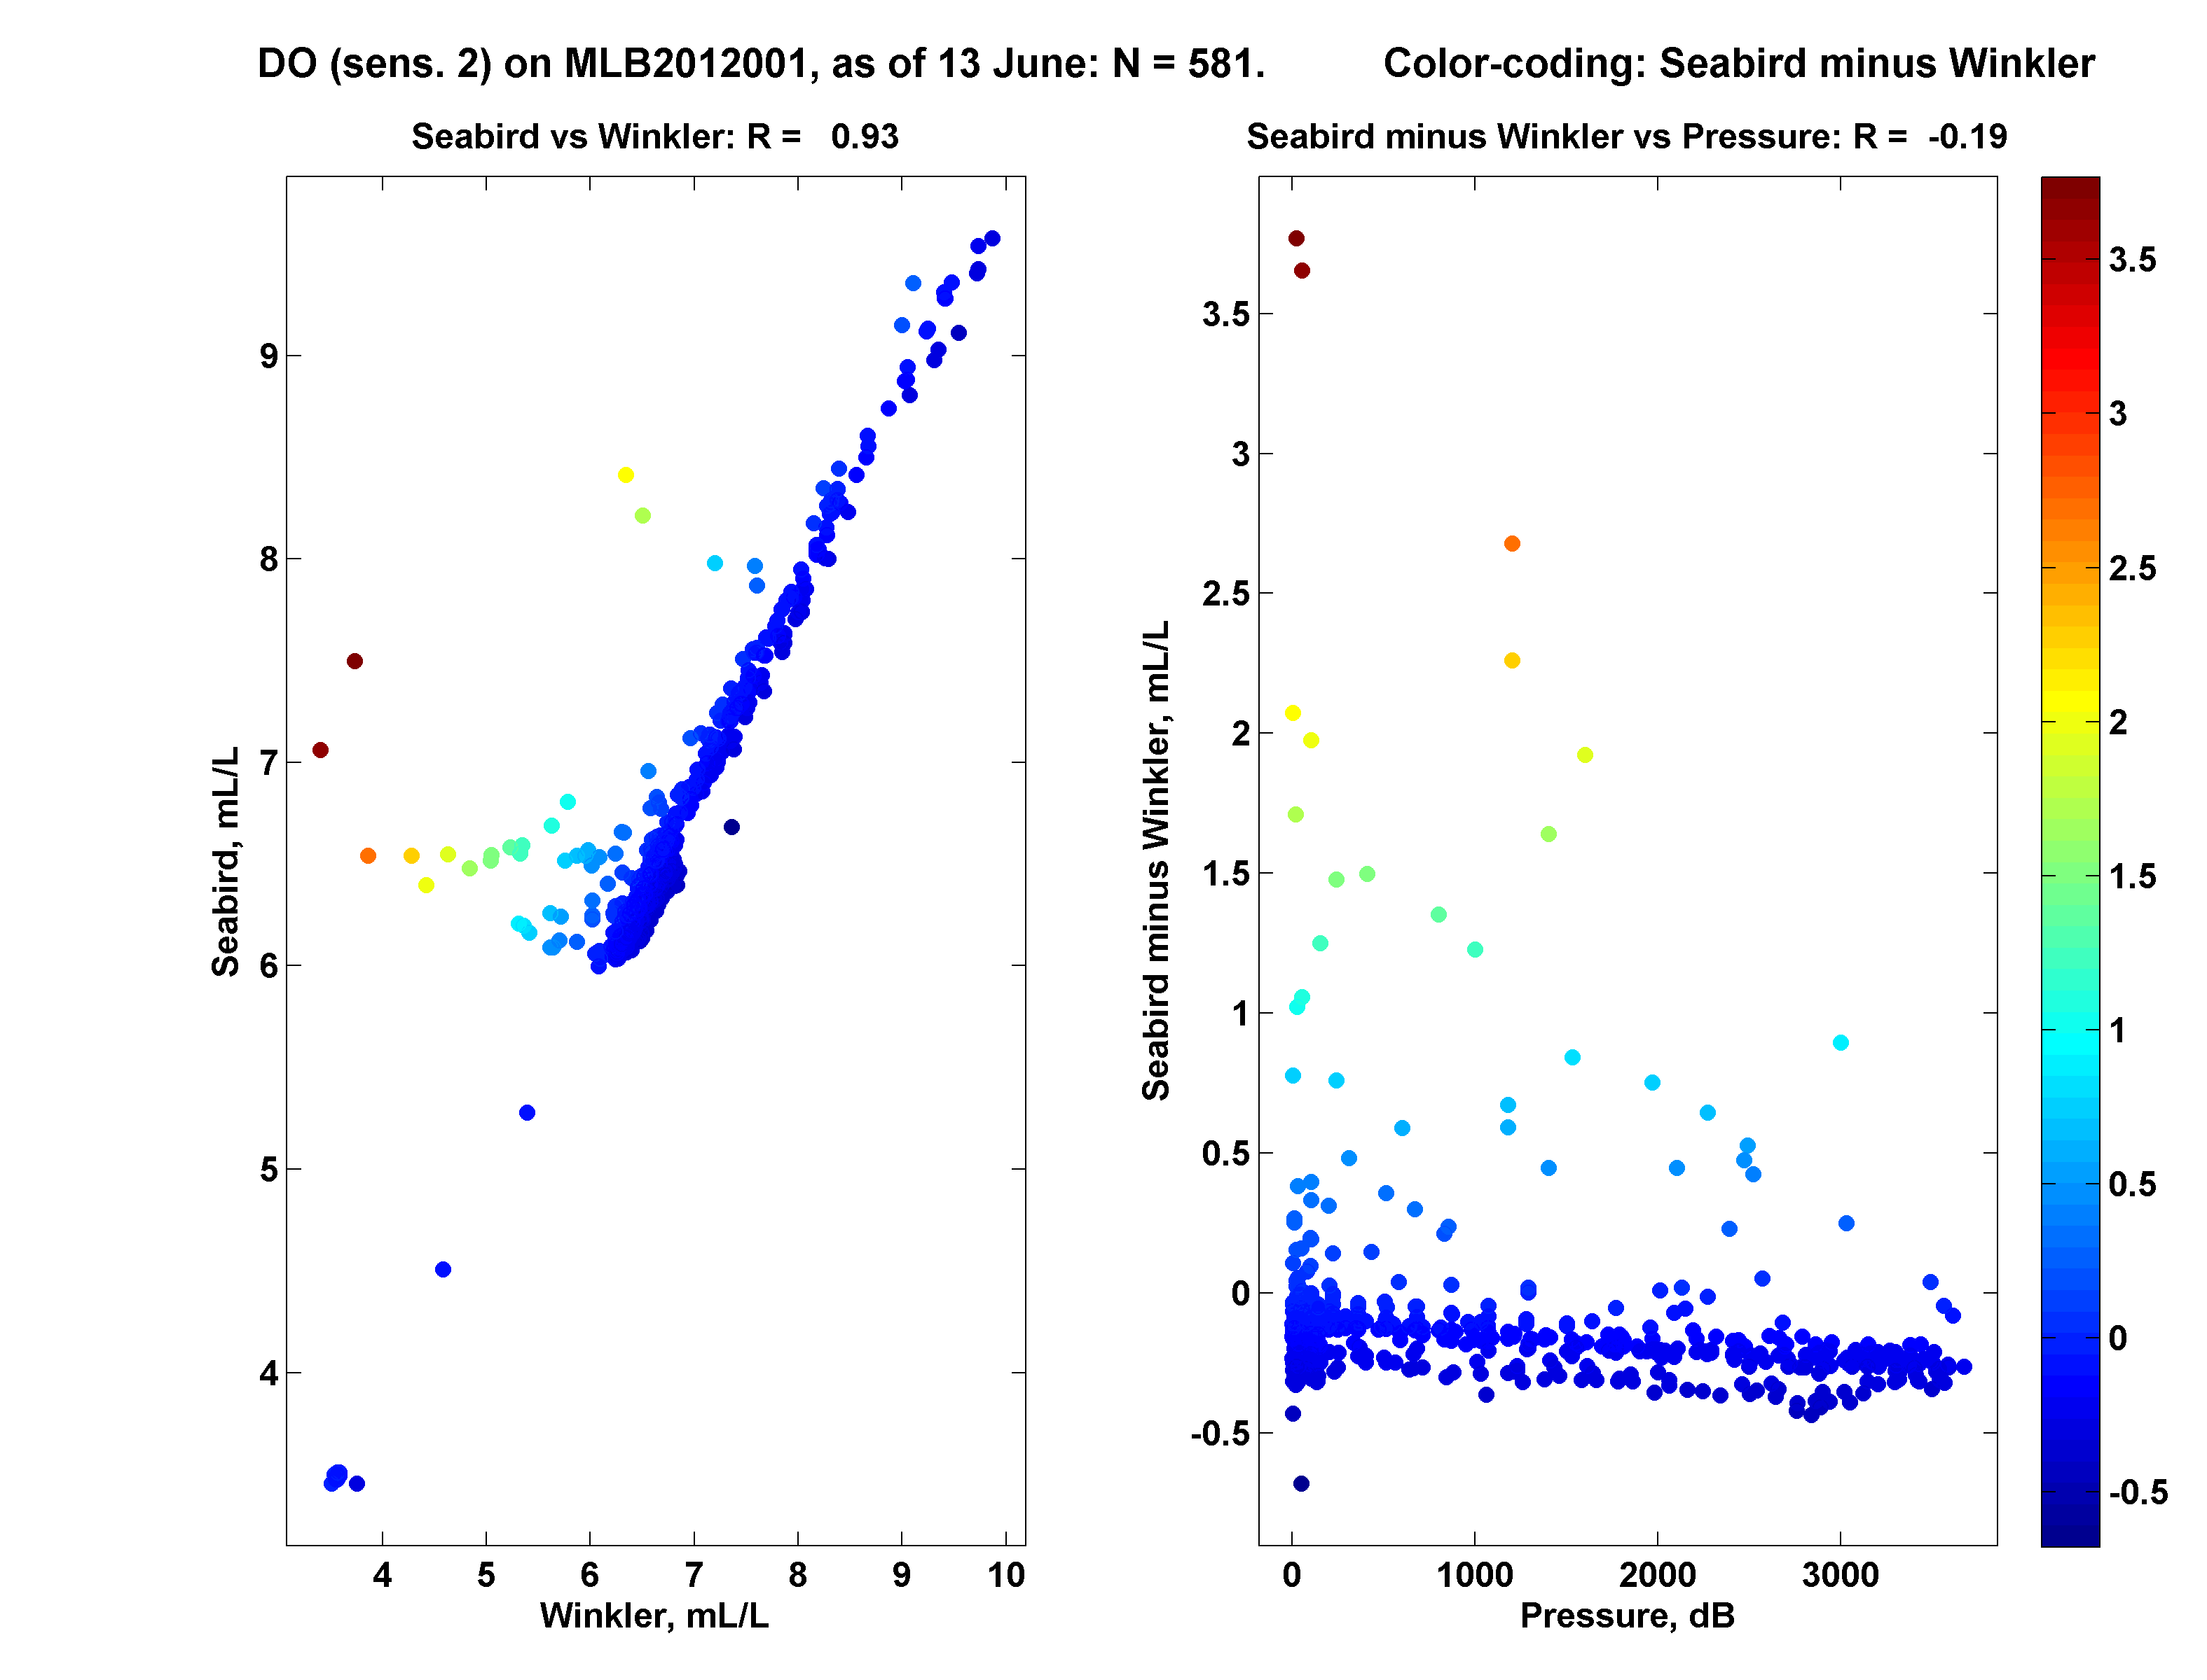

Figure C.2.1. Scatter plot of Sea-Bird vs Winkler DO concentrations (left panels) and Sea-Bird – Winkler difference vs pressure (right panels). (a) Primary Sea-Bird sensor; (b) Secondary Sea-Bird sensor.

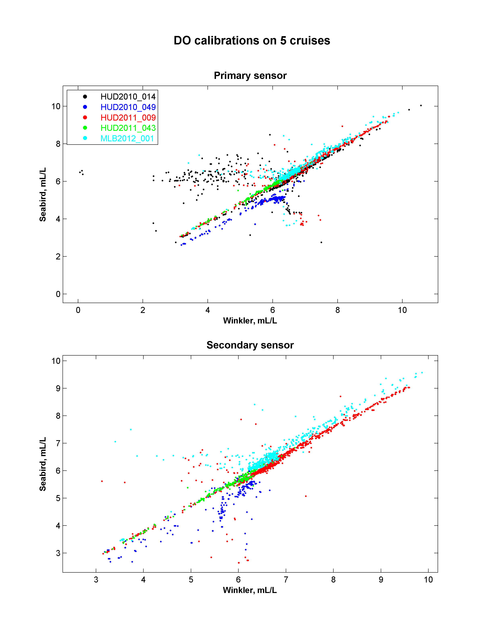

Figure C.2.2: Scatter plot of Sea – Bird versus Winkler DO concentrations from five cruises.

3. Nutrients

Carol Anstey

a. Description of Equipment and Technique

Samples were analyzed for silicate, phosphate, nitrate (nitrate plus nitrite), nitrite and ammonia using a Technicon Autoanalyzer II. The methods were standard Technicon for Seawater Analysis (Silicate 186-72W, Phosphate 155-71W, Nitrate/Nitrite 158-71W), except for ammonia. Ammonia was determined by a method developed by R. Kerouel and A. Aminot; ‘Fluorometric determination of ammonia in sea and estuarine waters by direct segmented flow analysis.’ Marine Chemistry 57 (1997) 265-275. The phosphate method has been modified by separating the Ascorbic Acid (4.0 gm/l) from the Mixed Reagent. The modified Mixed Reagent instead of sample water was introduced at the start of the sample stream (0.23 ml/min.) and the Ascorbic Acid was introduced separately between the two mixing coils (0.32 ml/min.) (Strain and Clement, 1996).

b. Sampling Procedure and Data Processing Technique

Duplicate nutrient samples were drawn into 30 ml HDPE (Nalgene) wide mouth sample bottles from the 10 L Rosette bottles. The sample bottles were pre-washed in 10% HCL, rinsed three times with NANOPure ultra-pure water and oven dried at >100 Degrees F.

A sample run included six Calibration Standards, analyzed in duplicate, at the beginning and end of each shift’s analysis. The standards, wash water and blanks for phosphate, silicate and nitrate/nitrite were made up in 33 ppt NaCl (Sigma, ACS Reagent); for ammonia and nitrite, NANOPure water only. The second most concentrated Calibration Standard was used as a Check Standard every 16 samples, followed by blanks as a baseline check. The quality of analysis was checked by analyzing an Intercalibration Reference Material MOOS-2 for nutrients produced by NRC, Ottawa. There was no existing ammonia Reference Material.

The raw analog data was converted to digital data, processed and concentrations calculated using Michaelis-Menton Regression, including statistics, by an in-house Pascal 7.0 program (AAII) on a PC. This year no common GP lab computer and printer was taken along due to space constraints on the Martha L. Black. The data processing and editing was instead done post cruise as the relevant programs for editing and calculating of raw nutrient data files could not be uploaded at sea. Paper chart recordings, hard copy and disk copies of the data were archived.

c. Shipboard Analysis

The CCGS Hudson was not available this year. Instead CCGS Martha L. Black was outfitted with containers on the forward deck to be used as lab space. Due to time constraints only samples for Halifax Line Station 2 and AR7W Line 03 were collected and analyzed. The total number of duplicate samples analyzed for AR7W Labrador Sea MLB2012-001 was 1226. Any samples collected off watch were kept refrigerated (4ºC) and analyzed within eight hours of collection. Samples collected at Halifax Line Station 2 through the year have been always frozen. To duplicate sample treatment, samples collected at that station were frozen and processed on the last day of analysis.

Again this year, all 5 nutrients were analyzed at sea: nitrate/nitrite, silicate, phosphate, ammonia and nitrite. The ammonia system air supply and reagent bottle head space were both fitted with a homemade gas trap consisting of a 10cc syringe filled with Sicacide® (sulphuric acid coated molecular sieve) to scrub ammonia from the air. As last year, the Barnstead NANOPure system was brought on board along with 220 litres of lab produced NANOPure water in acid washed 20 litre carboys. This water was purified again with the Barnstead system just before making up all reagents, including the 33‰ NaCl wash water. Still, there was some evidence of phosphate and ammonia contaminated washes and reagents even if fresh sieved water was used. If these deck containers are to be used again, a more thorough cleaning of the lab space, protection of glassware and better placement of the NANOPure system may improve matters.

The lab temperatures in the containers remained cool during the first half of the cruise but once the weather remained sunny heat, built up over the day caused degassing of ascorbic acid and molybdate reagents, affecting phosphate analysis particularly. June 5th analysis had a loss of phosphate data for 380146 to 380148 (380148 1 duplicate only) due to air bubbles stubbornly stuck in the flowcell from reagent degassing. Fortunately the door, windows and opening to the hold could be opened allowing much better air flow and reduction of temperatures. Station L3-26 was abandoned due to a very large Coral caught on the Rosette; IDs 380579 to 380598 inclusive.

An Intercalibration Reference Material MOOS-2 produced by NRC, Ottawa was used as a check for data quality (except for Ammonia). Unfortunately, the supply of MOOS-2 is now limited and so was not run daily. Some phosphate results were low, (may have been affected by phosphate contamination of reagents), but not wildly out of range.

QC/QA | SILICATE | PHOSPHATE | NITRATE | NITRITE
MOOS-2 | µM | µM | µM | µM
Accepted Values | 28.8+/-1.0 | 1.58 +/-0.10 | 24.9+/-1.0 | 3.31+/-0.18
 | 27.14 | 1.394 | 24.63 | 3.38
 | 27.11 | 1.410 | 25.11 | 3.44
 | 27.50 | 1.653 | 24.79 | 3.25
 | 28.61 | 1.629 | 24.80 | 3.20
 | 27.06 | 1.610 | 24.62 | 3.35
 | 27.15 | 1.625 | 24.83 | 3.30
 | 27.39 | 1.577 | 25.16 | 3.43
 | 27.53 | 1.550 | 25.00 | 3.37
 | 27.07 | 1.500 | 24.54 | 3.24
 | 26.81 | 1.480 | 24.35 | 3.37
 | 27.26 | 1.422 | 25.49 | 3.39
 | 27.31 | 1.419 | 25.94 | 3.22
 | 27.17 | 1.420 | 25.06 | 3.47
 | 27.66 | 1.427 | 25.19 | 3.43

RMS offset from the predicted calibration curve is a measure of how acceptable the calibration was for a specific analysis run. The acceptable limits for RMS fit were originally determined by averaging 34 runs of data (no data for Nitrite) deemed to be acceptable by peak shape, stability of the baseline and precision between duplicates. There is no firm cut-off for ‘good’ or ‘bad’ data. The data quality parameters, determined with check standards and RMS offset from the calibration curve, came within accepted values except for ammonia.

RMS Offset from Curve:

SILICATE PHOSPHATE NITRATE AMMONIA
Mean (µM) (n=34) 0.115 0.042 0.089 0.080
Std. Deviation (µM) 0.115 0.020 0.043 0.032
Maximum (µM) 0.695 0.111 0.271 0.132

Cruise Average:
MLB2012-001(n=11) 0.098 0.031 0.219 0.183
Std. Deviation (µM) 0.039 0.012 0.110 0.050

The nutrient detection limits (3 * std.dev. of blanks) below were determined as an average of all analytical runs from the cruise where the baseline did not have to be segmented to correct for erratic baseline drift during data processing. This correction had to be done for phosphate for every analysis but one; also for all but two analyses for nitrite.

 | Silicate | Phosphate | Nitrate | Ammonia | Nitrite
Number of Samples | 1226 | 1226 | 1226 | 1226 | 1226
Number of Duplicates | 613 | 613 | 613 | 613 | 613
Detection Limit (μ moles/L) | 0.28 ± 0.12 | 0.21 ± 0.00 | 0.16 ± 0.21 | 0.14 ± 0.09 | 0.06 ± 0.05

Analytical Precision: Standard Deviation of Check Standards

SILICATE | PHOSPHATE | NITRATE | AMMONIA | NITRITE
0.18 | 0.03 | 0.04 | N/A | 0.02
0.79 | 0.04 | 0.13 | 0.18 | 0.026
0.38 | 0.15 | 0.43 | 0.18 | 0.034
0.35 | 0.11 | 0.18 | 0.13 | 0.03
0.51 | 0.03 | 0.26 | 0.13 | 0.063
0.28 | 0.02 | 0.26 | 0.20 | 0.019
0.50 | 0.02 | 0.16 | 0.36 | 0.081
0.86 | 0.04 | 0.79 | 1.12 | 0.025
1.31 | 0.03 | 0.20 | 0.09 | 0.028
0.44 | 0.05 | 0.43 | 0.20 | 0.016
0.04 | 0.02 | 0.20 | 0.04 | 0.019
Average | Average | Average | Average | Average
0.51 | 0.05 | 0.28 | 0.26 | 0.03

4. Ocean Chemistry / Carbon Tracer Group

a. Transient Tracers SF₆ and CFC-12

Stephen Punshon and Darlene Childs

2012 was the second year that measurements of the anthropogenic transient tracer sulphur hexafluoride (SF6) were made in the Labrador Sea. The problems listed in the 2011 Cruise Report had been solved prior to this mission and no further analytical problems were encountered.

Method

Seawater samples were drawn directly from Niskin bottles into 250 mL glass syringes which were then stored at 2 °C in a low-temperature incubator for up to 12 hours. Immediately before analysis, the samples were warmed to around 20 °C in a water bath then injected into the purge vessel of a custom made purge-and trap system where dissolved gases were stripped from the sample in a stream of ultra high purity nitrogen with a flow rate of 120 mL per minute. SF₆ and CFC-12 were quantitatively retained in a trap comprising 30 cm of 1/16" stainless steel tubing packed with 100-120 mesh Carboxen 1000 held at -70 °C over liquid nitrogen. After each 7 minute purge cycle, the trap was heated to ~180 °C with a low voltage electric current and the desorbed gases directed to a Varian gas chromatograph equipped with an electron-capture detector. SF₆ and CFC-12 were separated on a 1 m pre-column packed with Porasil B and a 3 m main column packed with Molecular Sieve 5A held isothermally at 92 °C. Total run-time was 11 minutes and 50 seconds for a water sample. The chromatographic sample peaks were quantified with Varian Galaxie software and the analytical system calibrated at least once each day using an air standard supplied by CMDL/NOAA, Boulder, Colorado. Analytical precision as determined by repeated injections of the gas standard was around ± 2 % for SF6 and ± 0.7 % for CFC-12.

Results

A total of 345 water samples from the AR07W line were analysed for dissolved SF6 and F-12. Fifteen samples were typically collected from each deep cast at pre-selected depths as the limited stock of glass sampling syringes (30 plus 3 spare) precluded sampling every depth at each station. The sample identification numbers ranged between 300025 and 380655 and included profiles from stations 1 to 28 with the exception of Station 26 which was abandoned due to a large piece of coral becoming entangled in the rosette and compromising the integrity of the sample bottles. An additional station, number 17.4, was later sampled during the transit from Greenland to Labrador. A total of 22 samples from this station were analysed for SF₆ and CFC-12 in order to provide higher vertical resolution in the central Labrador Sea. Preliminary section profiles of dissolved concentrations of SF₆ (Figure C.4.1) and CFC-12 (Figure C.4.2) are shown below.

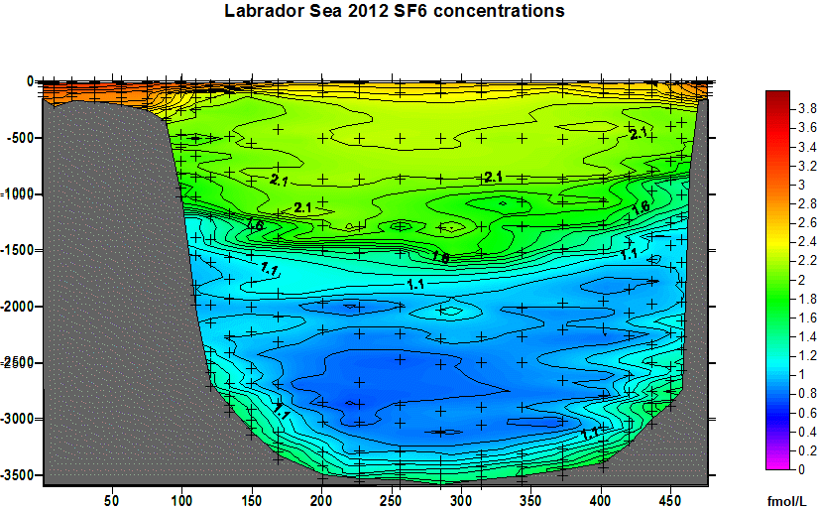

Figure C.4.1

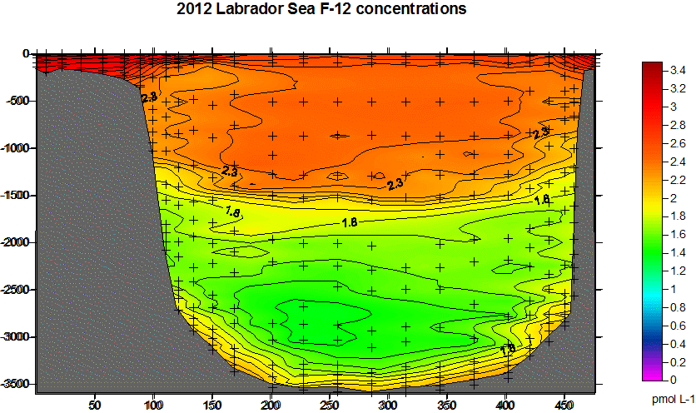

Figure C.4.2

b. Ocean pH

Darlene Childs and Melissa Wartman

Water samples were collected and analysed for pH in 2012 on board the CCGS Martha L Black by Melissa Wartman. Two significant changes were made to the pH sampling protocol for the 2012 Labrador Sea Mission. First, 60 mL borosilicate glass tubes with screw caps were used to collect seawater samples rather than the amber Boston Round soda lime glass bottles used in previous missions as there is evidence to suggest that seawater pH is not stable in samples that are stored in soda lime glass. Second, the samples were analysed fresh or stored for a maximum of around 12 hours before analysis. Mercuric chloride was not used to poison the samples this year as further experiments are required to establish whether the addition of mercuric chloride can affect the pH of seawater. The spectrophotometric analytical method is described in “Guide to best practises for ocean CO₂ measurements” SOP 6B, edited by Andrew Dickson. Briefly, racks of tubes containing seawater samples are placed in a water bath for around 30 minutes to bring the samples to 25 °C. A sample is then introduced into a water-jacketed 10 cm quartz cell and 30 µL of the indicator dye m-cresol purple is added before mixing well. The absorbance of light at the wavelengths 434 and 578 nm is measured with an Agilent photodiode array spectrophotometer and the resulting extinction coefficients at these wavelengths are used to determine the pH of the sample. The sample absorption spectra are referenced to measurements of a Certified Reference Material obtained from Scripps University and consisting of TRIS buffer in synthetic seawater with a known pH accurate to four decimal places. The analytical precision was 0.07% as determined by multiple measurements of seawater drawn from 14 Niskin bottles fired at the same depth.

Results:

A total of 655 pH samples were analysed during the mission. The stations sampled included Station 2 on the Halifax Line and all stations on the AR07W line including all the biological shallow casts and Station number 17.4. Results were converted to in-situ temperature and pressure using the equations from Millero (1979). A section plot (Figure C.4.3) was generated using these results and is shown below.

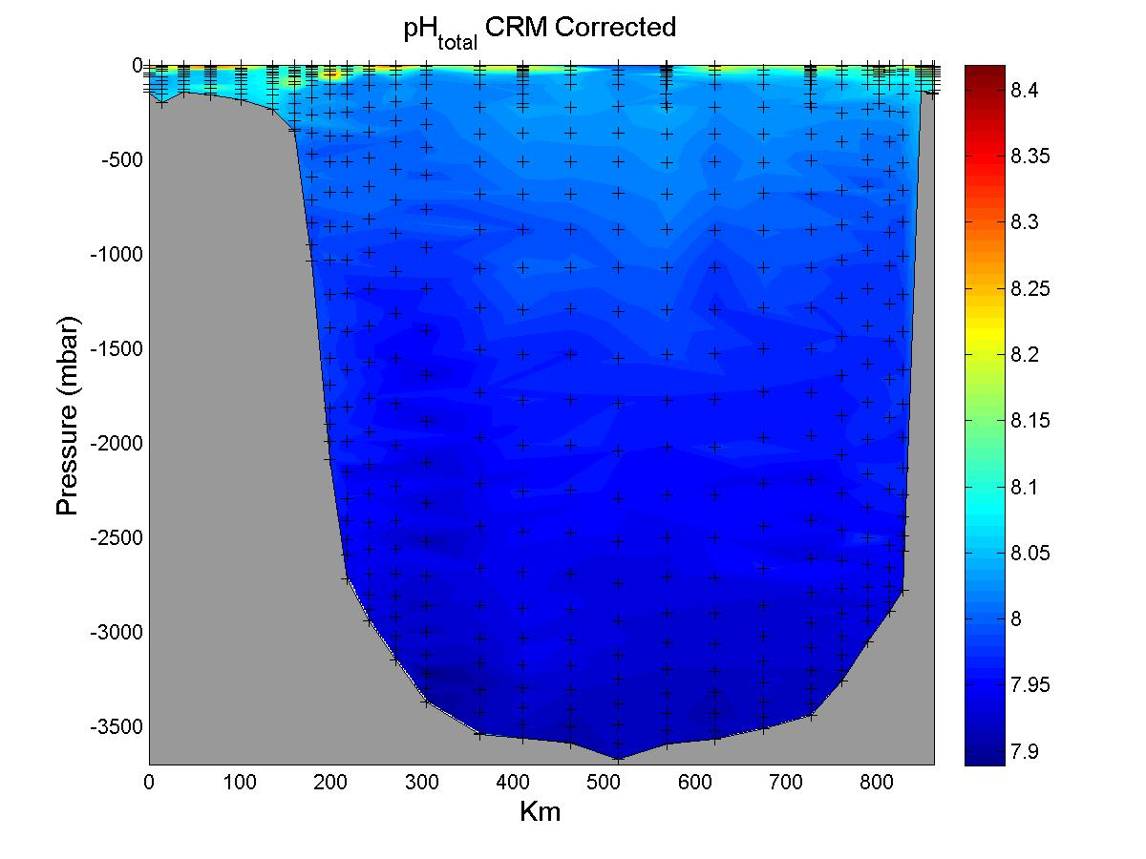
Figure C.4.3

c. Total Inorganic Carbon and Total Alkalinity

Total inorganic carbon (TIC) and total alkalinity (TA) were not measured during the 2012 Labrador Sea Mission because of laboratory space constraints on the CCGS Martha L Black. Instead, water samples for combined TIC and TA analysis were collected in 500 mL borosilicate glass reagent bottles and preserved by the addition of 100 µL of saturated mercuric chloride solution. A 5 mL headspace was created in each sample before sealing the bottles with greased glass stoppers held in place with rubber bands. The samples were transported back to BIO for analysis.

Around 470 water samples for TIC and TA analysis were collected from stations 1 – 28 on the AR07W line with the exclusion of Station 26. The sample identification numbers fell in the range 380025 to 380621.

When the CFC samples are part of cruise program, they are taken prior to sampling any other property.
This includes duplicates.
Such undesirable dependence took place on the previous Hudson cruises.

