- Cruise narrative
- Highlights
Cruise designation: RF12-06（40N）
- EXPOCODE: 49UP20120726
- Chief scientist: Hitomi KAMIYA (hkamiya@met.kishou.go.jp)
Marine Environment Monitoring and Analysis Center
Marine Division
Global Environment and Marine Department
Japan Meteorological Agency (JMA)
1-3-4, Otemachi, Chiyoda-ku, Tokyo 100-8122, JAPAN
Phone: +81-3-3212-8341 Ext. 5131
FAX: +81-3-3211-6908
- Ship name: R/V Ryofu Maru
- Ports of call: Leg 1: Tokyo - Kushiro, Leg 2: Kushiro - Tokyo
- Cruise dates: Leg 1: 26 July 2012 - 16 August 2012
Leg 2: 21 August 2012 - 13 September 2012
f. Floats and drifters deployed: two profiling floats and one drifting ocean data buoy

- Cruise Summary Information
RF12-06 cruise was carried out during the period from July 26 to September 13, 2012. The cruise started from the east of Honshu, Japan, and sailed towards east along 40°N. This line was not observed in the WOCE (World Ocean Circulation Experiment) Hydrographic Programme.

R/V Ryofu Maru departed Tokyo (Japan) on July 26, 2012. Before the observation at the first station, all watch standers were drilled in the method of sample drawing and CTD operations near Izu-Oshima (34°42’N, 139°52’E). The hydrographic cast of CTDO₂ was started at the first station (Stn.1 (40°00’N, 142°19’E; RF4461)) on June 28. Leg 1 consisted of 43 stations from Stn.1 to Stn.43 (40°01’N, 167°40’E; RF4498). She called for Kushiro on August 16, 2012 (Leg 1). She left Kushiro on August 21, 2012 for Tokyo and arrived on September 13, 2012 (Leg 2). Leg 2 consisted of 32 stations from Stn.44 (40°01’N, 167°41’E; RF4504) to Stn.75 (39°59’N, 164°59’E; RF4535). To examine consistency of data, we carried out the observation twice at 40°N, 165°E (Stn.39 and 75), 40°N, 167°40’E (Stn.43 and 44) and 40°N, 169°E (Stn.46 and 47). In order to ensure a controlled spooling of the armored cable, we rewound the cable three times at 37°20’N, 143°35’E (about 7000 m depth), 40°N, 154°20’E (about 5560 m depth) and 41°30’N, 145°35’E (about 6000 m depth). Cruise track and station location are shown in Figure 1.

A total of 75 stations was occupied using a Sea-Bird Electronics (SBE) 36 position carousel equipped with 10-liter Niskin water sample bottles, a CTD system (SBE911plus) equipped with SBE35 deep ocean standards thermometer, JFE Advantech oxygen sensor (RINKO III), Teledyne Benthos altimeter, and Teledyne RD Instruments Lowered Acoustic Doppler Current Profiler (L-ADCP).

At each station, full-depth CTDO₂ (temperature, conductivity (salinity) and dissolved oxygen) profile and up to 36 water samples were taken and analyzed. Water samples were obtained from 10 dbar to approximately 10 m above the bottom. In addition, surface water was sampled by a stainless steel bucket at each station. Sampling layer is designed as so-called staggered mesh as shown in Table 2 (Swift, 2010). The bottle depth diagram is shown in Figure 2.

Water samples were analyzed for salinity, dissolved oxygen, nutrients, dissolved inorganic carbon (DIC), total alkalinity (TA), pH, CFC-11, CFC-12 and phytopigment (chlorophyll-a and phaeopigments). Underway measurements of partial pressure of carbon dioxide (pCO₂), temperature, salinity, chlorophyll-a, subsurface current, bathymetry and meteorological parameters were conducted along the cruise track.

One drifting ocean data buoy (WMO number： 21636) was deployed at 38°45.947’N, 142°50.188’E on June 28, 2012. Two ARGO floats (PROVOR: nke Instrumentation, France) were deployed at the request of JAMSTEC along the cruise track. The information of deployed floats is listed in Table 1.

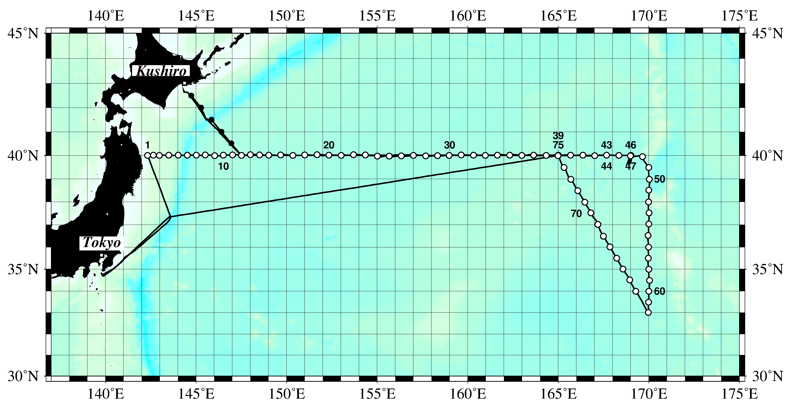
Figure 1. Cruise track of RF12-06. Open and closed circles indicate CTD station and X-BT station, respectively.

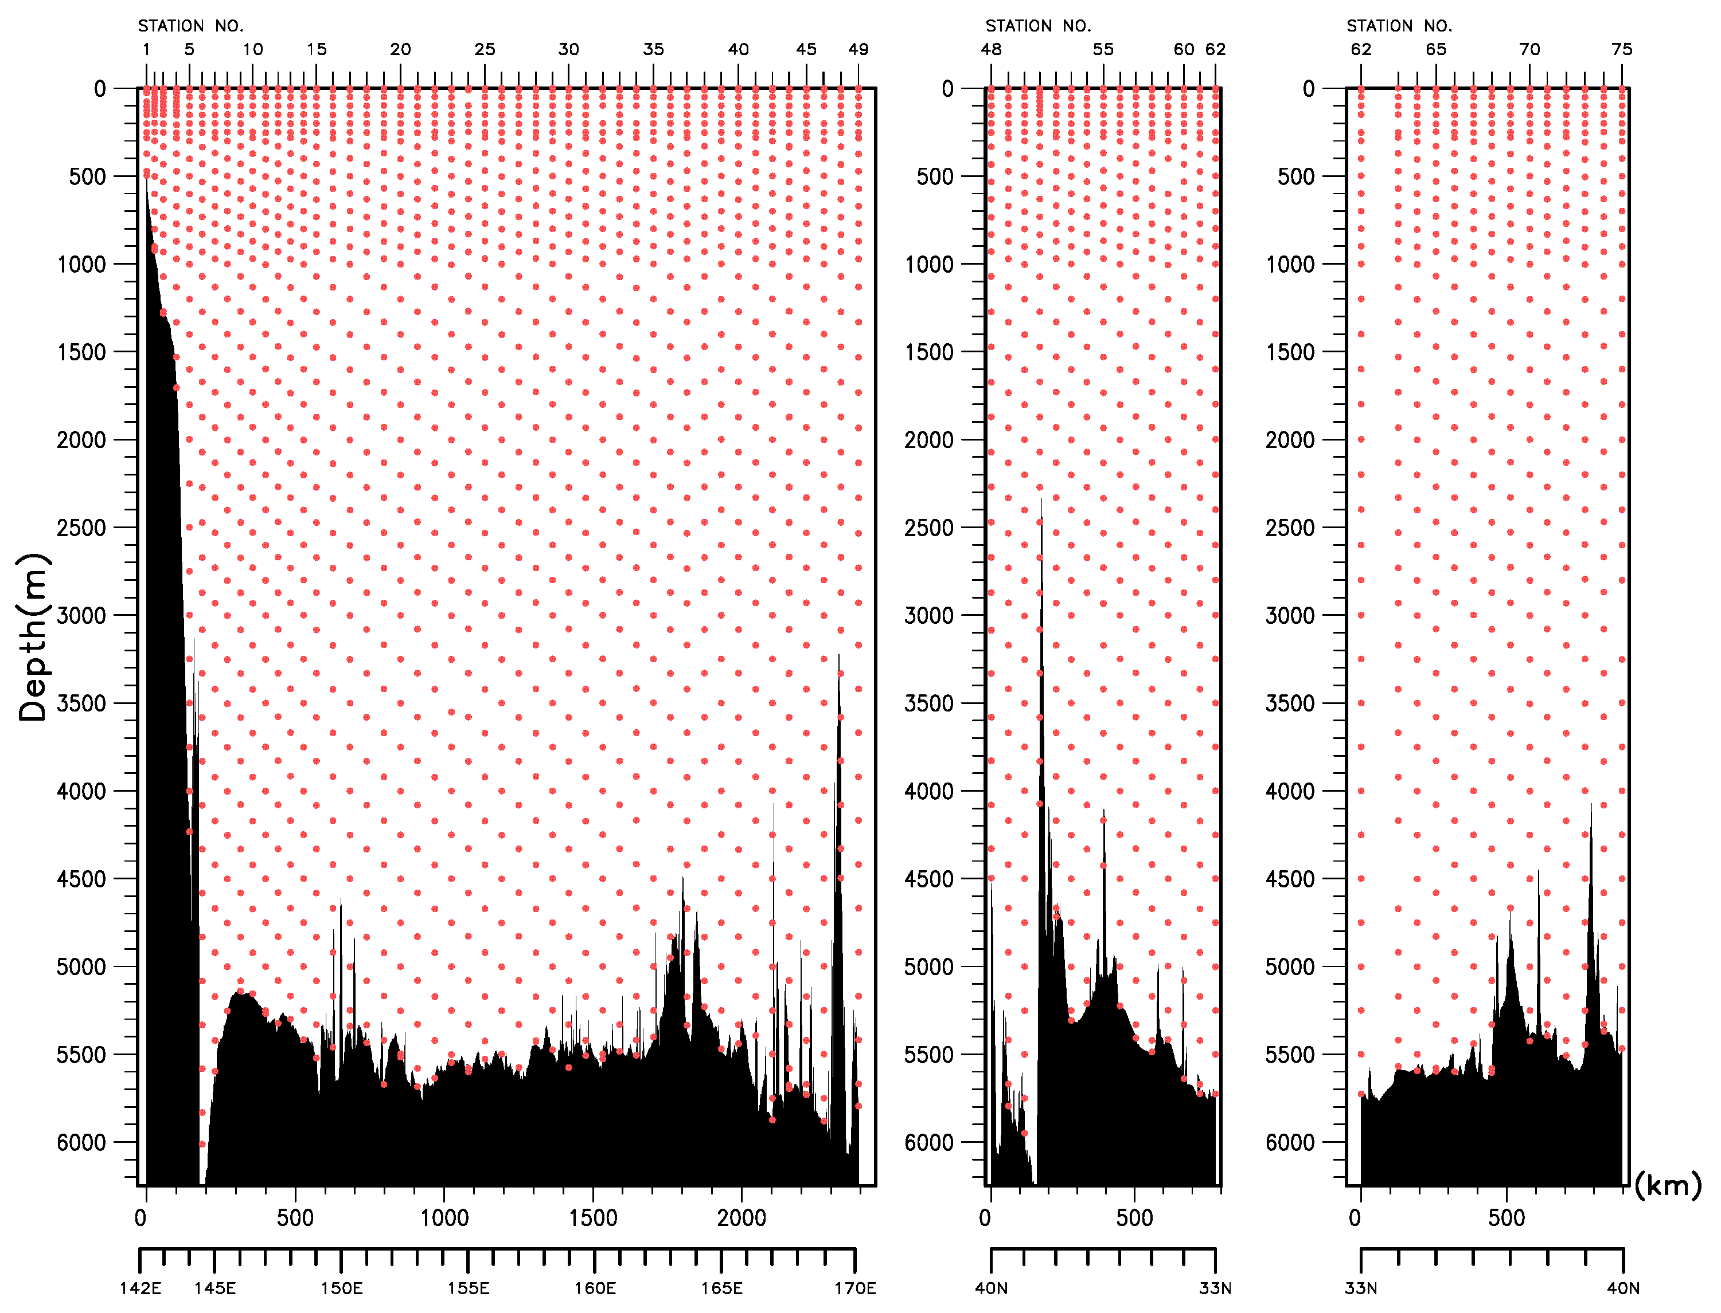
Figure 2. The bottle depth diagram for RF12-06 cruise.
Table 1. Information of deployed floats in RF12-06.

ARGOS ID | Date and Time of System Reset (UTC) | Date and Time of Deployment (UTC) | Position of deployment | PI | Remark
97946 | August 9, 17:53 | August 9, 19:00 | 39-58.531 N, 167-01.768 E | JAMSTEC | Stn. 42 (RF4499)
97912 | Sept. 3, 17:40 | Sept. 3, 18:59 | 37-01.347N, 167-14.029E | JAMSTEC | Stn.69 (RF4529)

Table 2. The scheme of sampling layer in meters.

Bottle  count | scheme1 | scheme2 | scheme3
1 | 10 | 10 | 10
2 | 50 | 50 | 50
3 | 100 | 100 | 100
4 | 150 | 150 | 150
5 | 200 | 200 | 200
6 | 250 | 250 | 250
7 | 300 | 330 | 280
8 | 400 | 430 | 370
9 | 500 | 530 | 470
10 | 600 | 630 | 570
11 | 700 | 730 | 670
12 | 800 | 830 | 770
13 | 900 | 930 | 870
14 | 1000 | 1070 | 970
15 | 1200 | 1270 | 1130
16 | 1400 | 1470 | 1330
17 | 1600 | 1670 | 1530
18 | 1800 | 1870 | 1730
19 | 2000 | 2070 | 1930
20 | 2200 | 2270 | 2130
21 | 2400 | 2470 | 2330
22 | 2600 | 2670 | 2530
23 | 2800 | 2870 | 2730
24 | 3000 | 3080 | 2930
25 | 3250 | 3330 | 3170
26 | 3500 | 3580 | 3420
27 | 3750 | 3830 | 3670
28 | 4000 | 4080 | 3920
29 | 4250 | 4330 | 4170
30 | 4500 | 4580 | 4420
31 | 4750 | 4830 | 4670
32 | 5000 | 5080 | 4920
33 | 5250 | 5330 | 5170
34 | 5500 | 5580 | 5420
35 | 5750 | 5830 | 5670
36 | Bottom | Bottom | Bottom
Table 3. Station data of RF12-06 cruise. The ‘RF’ column indicates the JMA station identification number.
Leg | Station |  | Position |  |  | Leg | Station |  | Position
 | Stn. | RF | Latitude | Longitude |  |  | Stn. | RF | Latitude | Longitude
1 | 1 | 4461 | 39-59.97 N | 142-19.33 E |  | 1 | 39 | 4502 | 40-00.88 N | 164-59.83 E
1 | 2 | 4462 | 40-00.95 N | 142-38.12 E |  | 1 | 40 | 4501 | 40-00.75 N | 165-40.62 E
1 | 3 | 4463 | 40-00.23 N | 142-58.65 E |  | 1 | 41 | 4500 | 40-00.77 N | 166-21.27 E
1 | 4 | 4464 | 40-00.53 N | 143-29.88 E |  | 1 | 42 | 4499 | 39-59.39 N | 167-00.98 E
1 | 5 | 4465 | 40-00.53 N | 144-00.60 E |  | 1 | 43 | 4498 | 40-00.77 N | 167-39.80 E
1 | 6 | 4466 | 40-01.02 N | 144-30.91 E |  | 2 | 44 | 4504 | 40-00.58 N | 167-40.70 E
1 | 7 | 4467 | 40-00.48 N | 145-01.15 E |  | 2 | 45 | 4505 | 40-00.39 N | 168-21.18 E
1 | 8 | 4468 | 40-01.06 N | 145-30.62 E |  | 2 | 46 | 4506 | 39-59.86 N | 169-00.81 E
1 | 9 | 4469 | 39-59.20 N | 146-01.73 E |  | 2 | 47 | 4507 | 39-58.64 N | 168-59.30 E
1 | 10 | 4470 | 40-00.66 N | 146-30.13 E |  | 2 | 48 | 4508 | 39-57.26 N | 169-39.23 E
1 | 11 | 4471 | 40-01.44 N | 147-00.81 E |  | 2 | 49 | 4509 | 39-29.27 N | 169-59.80 E
1 | 12 | 4472 | 40-00.10 N | 147-30.32 E |  | 2 | 50 | 4510 | 38-58.61 N | 170-01.62 E
1 | 13 | 4473 | 40-01.75 N | 147-59.66 E |  | 2 | 51 | 4511 | 38-30.30 N | 169-59.91 E
1 | 14 | 4474 | 40-01.25 N | 148-30.73 E |  | 2 | 52 | 4512 | 37-59.41 N | 169-58.98 E
1 | 15 | 4475 | 40-00.88 N | 149-01.07 E |  | 2 | 53 | 4513 | 37-31.18 N | 170-00.47 E
1 | 16 | 4476 | 40-01.46 N | 149-40.02 E |  | 2 | 54 | 4514 | 37-01.50 N | 169-59.99 E
1 | 17 | 4477 | 40-00.21 N | 150-20.61 E |  | 2 | 55 | 4515 | 36-30.70 N | 169-57.52 E
1 | 18 | 4478 | 40-01.08 N | 151-00.04 E |  | 2 | 56 | 4516 | 35-59.50 N | 169-59.26 E
1 | 19 | 4479 | 40-01.82 N | 151-40.85 E |  | 2 | 57 | 4517 | 35-29.65 N | 169-58.38 E
1 | 20 | 4480 | 40-00.84 N | 152-20.37 E |  | 2 | 58 | 4518 | 34-59.50 N | 170-00.06 E
1 | 21 | 4481 | 40-00.28 N | 153-00.46 E |  | 2 | 59 | 4519 | 34-29.33 N | 170-02.11 E
1 | 22 | 4482 | 40-01.68 N | 153-41.55 E |  | 2 | 60 | 4520 | 33-59.33 N | 169-59.95 E
1 | 23 | 4483 | 40-01.06 N | 154-20.87 E |  | 2 | 61 | 4521 | 33-29.35 N | 169-59.09 E
1 | 24 | 4484 | 39-58.09 N | 155-00.94 E |  | 2 | 62 | 4522 | 33-00.03 N | 169-58.53 E
1 | 25 | 4485 | 39-58.26 N | 155-40.07 E |  | 2 | 63 | 4523 | 33-59.55 N | 169-16.96 E
1 | 26 | 4486 | 39-58.94 N | 156-19.75 E |  | 2 | 64 | 4524 | 34-30.31 N | 168-56.76 E
1 | 27 | 4487 | 40-00.36 N | 157-00.14 E |  | 2 | 65 | 4525 | 35-00.12 N | 168-34.54 E
1 | 28 | 4488 | 39-58.88 N | 157-40.48 E |  | 2 | 66 | 4526 | 35-29.61 N | 168-13.44 E
1 | 29 | 4489 | 39-59.33 N | 158-20.16 E |  | 2 | 67 | 4527 | 36-00.30 N | 167-51.49 E
1 | 30 | 4490 | 40-00.41 N | 158-58.47 E |  | 2 | 68 | 4528 | 36-28.99 N | 167-29.88 E
1 | 31 | 4491 | 40-01.09 N | 159-38.59 E |  | 2 | 69 | 4529 | 37-00.32 N | 167-10.85 E
1 | 32 | 4492 | 40-00.93 N | 160-19.04 E |  | 2 | 70 | 4530 | 37-31.04 N | 166-47.84 E
1 | 33 | 4493 | 39-59.98 N | 160-58.68 E |  | 2 | 71 | 4531 | 37-58.97 N | 166-27.71 E
1 | 34 | 4494 | 40-00.82 N | 161-38.65 E |  | 2 | 72 | 4532 | 38-29.23 N | 166-04.53 E
1 | 35 | 4495 | 40-00.62 N | 162-19.37 E |  | 2 | 73 | 4533 | 38-59.03 N | 165-41.40 E
1 | 36 | 4496 | 40-00.30 N | 162-59.27 E |  | 2 | 74 | 4534 | 39-29.11 N | 165-18.94 E
1 | 37 | 4497 | 40-00.96 N | 163-38.49 E |  | 2 | 75 | 4535 | 39-59.48 N | 164-59.32 E
1 | 38 | 4503 | 40-00.29 N | 164-20.07 E
List of Principal Investigators for all Measurements
The principal investigator (PI) and the person in charge responsible for major parameters measured on the cruise are listed in Table 3.

Table 4. List of principal investigator and the person in charge on the ship for RF12-06.
Item Principal Investigator（PI） Person in charge on the ship
Hydrography
CTDO₂ / LADCP Kazuhiro NEMOTO Keizo SHUTTA
Salinity Kazuhiro NEMOTO Keizo SHUTTA
Dissolve oxygen Kazuhiro NEMOTO Chihiro KAWAMURA
Nutrients Kazuhiro NEMOTO Takashi MIYAO
Phytopigment Kazuhiro NEMOTO Takashi MIYAO
DIC Kazuhiro NEMOTO Shu SAITO
Total Alkalinity Kazuhiro NEMOTO Shu SAITO
pH Kazuhiro NEMOTO Shu SAITO
CFCs Kazuhiro NEMOTO Etsuro ONO

Underway
Meteorology Kazuhiro NEMOTO Keizo SHUTTA
Thermo-Salinograph Kazuhiro NEMOTO Shu SAITO
pCO₂ Kazuhiro NEMOTO Shu SAITO
Chlorophyll-a Kazuhiro NEMOTO Takashi MIYAO
ADCP Kazuhiro NEMOTO Keizo SHUTTA
Bathymetry Kazuhiro NEMOTO Keizo SHUTTA

Floats
ARGO float Toshio SUGA Hitomi KAMIYA

Kazuhiro NEMOTO (k-nemoto@met.kishou.go.jp)
Marine Division, Global Environment and Marine Department, JMA
1-3-4, Otemachi, Chiyoda-ku, Tokyo 100-8122, JAPAN
Phone: +81-3-3212-8341 Ext. 5150 FAX: +81-3-3211-6908

Toshio SUGA (sugat@jamstec.go.jp)
Ocean Climate Change Research Program
Research Institute for Global Change (RIGC)
Japan Agency for Marine-Earth Science and Technology (JAMSTEC)
2-15 Natsushima, Yokosuka, Kanagawa, Japan 237-0061
- Scientific Program and Methods
In recent years, the global environmental issues such as global warming and climate change have become one of the major socio-economic concerns, and it has become apparent that the ocean plays a key role in the climate system. For the better understanding and assessment of global environmental conditions, continuous monitoring of climate variables, concentrations of greenhouse gases both in the ocean and in the atmosphere. To meet those requirements, JMA has been conducting operational oceanographic observations by research vessels in the western North Pacific on a seasonal basis. RF12-06 cruise is one of these activities. The purposes of this cruise are as follows:
(1) To observe profiles of seawater temperature, salinity, dissolved oxygen, nutrients and carbon parameters, as well as upper ocean current;
(2) To observe concentrations of greenhouse gases both in the ocean and in the atmosphere;
(3) To observe bio-geochemical parameters to study carbon cycle in the ocean.

These activities are expected to contribute to international projects related to global environmental issues such as the World Climate Research Programme (WCRP), IOCCP (International Ocean Carbon Coordination Project) and the Global Atmosphere Watch (GAW).

- Major Problems and Goals not Achieved
In order to repair and align of the winch system, she stopped after CTD cast of Stn. 45 (RF4505) on August 25 and after CTD cast of Stn.46 (RF4506) on August 26.

- List of Cruise Participants
The cruise participants of the cruise are listed in Table 5.

Table 5. List of cruise participants for RF12-06.
Name Responsibility Affiliation
Hiroyuki FUJIWARA Nutrients GEMD / JMA
Minoru HAMANA (leg 1) Nutrients GEMD / JMA
Hiroyuki HATAKEYAMA CFCs GEMD / JMA
Sho HIBINO Dissolved Oxygen GEMD / JMA
Hitomi KAMIYA Chief Scientist / Meteorology GEMD / JMA
Nobumi KATO CTDO / ADCP / LADCP GEMD / JMA
Chihiro KAWAMURA Dissolved Oxygen GEMD / JMA
Takashi MIYAO (leg 2) Nutrients GEMD / JMA
Noriyuki OKUNO CTDO / ADCP / LADCP GEMD / JMA
Etsuro ONO CFCs GEMD / JMA
Hisashi ONO Carbon Items GEMD / JMA
Kazuhiro SAITO Nutrients GEMD / JMA
Shu SAITO Carbon Items GEMD / JMA
Naoaki SAKAMOTO Carbon Items GEMD / JMA
Yasunori SASAKI CTDO / ADCP / LADCP GEMD / JMA
Seikou SHIMOJI Salinity GEMD / JMA
Hiroki SHIOZURU Dissolved Oxygen GEMD / JMA
Keizo SHUTTA Salinity / Bathymetry GEMD / JMA
Haruka SUEMATSU CFCs GEMD / JMA
Koichi WADA Salinity GEMD / JMA
GEMD / JMA: Marine Division, Global Environment and Marine Department, JMA
Reference
Swift, J. H. (2010): Reference-quality water sample data: Notes on acquisition, record keeping, and evaluation. IOCCP Report No.14, ICPO Pub. 134, 2010 ver.1

