- Cruise narrative
- Highlights
Cruise designation: RF11-06, RF11-07 and RF11-08 （WHP-P13 revisit）
- EXPOCODE: RF11-06 49UP20110515
RF11-07 49UP20110604
RF11-08 49UP20110705
- Chief scientist: Toshiya NAKANO (nakano_t@met.kishou.go.jp)
Marine Environment Monitoring and Analysis Center
Marine Division
Global Environment and Marine Department
Japan Meteorological Agency (JMA)
1-3-4, Otemachi, Chiyoda-ku, Tokyo 100-8122, JAPAN
Phone: +81-3-3212-8341 Ext. 5163
FAX: +81-3-3211-6908
- Ship name: R/V Ryofu Maru
- Ports of call: RF11-06 Tokyo - Tokyo
RF11-07 Tokyo - Tokyo
RF11-08 Leg1: Tokyo - Pohnpei
Leg 2: Pohnpei - Saipan
- Cruise dates: RF11-06 15 May 2011 - 31 May 2011
RF11-07 4 June 2011 - 27 June 2011
RF11-08 Leg1: 5 July 2011 - 29 July 2011
Leg2: 2 August 2011 - 26 August 2011
f. Floats and drifters deployed: RF11-06 3 floats
RF11-07 5 floats
RF11-08 3 floats
- Cruise Summary Information

RF11-06, RF11-07 and RF11-08 cruises were carried out during the period from May 15 to September 5, 2011. The observation line along approximately 165°E meridian was observed by Ocean Research Institute, University of Tokyo, Japan in 1991 and 1993, and by National Oceanographic and Atmospheric Administration, USA in 1992. These cruises were carried out as ‘WHP-P13’, which is a part of WOCE (World Ocean Circulation Experiment) Hydrographic Programme. The stations from Stn.1 (43°N, 145°30’E; RF3984) to Stn.14 (39°40’N, 147°52’E; RF3997) for RF11-06 cruise and from Stn.23 (39°40’N, 147°52’E; RF4007) to Stn.38 (47°N, 160°E) for RF11-07 cruise had been designed as a re-occupation of the WHP-P1 stations observed by Japan Agency for Marine-Earth Science and Technology (JAMSTEC) in 2007.

RF11-06
RF11-06 cruise was carried out during the period from May 15 to May 31, 2011. Before the observation at the first station, all watch standers were drilled in the method of sample drawing and CTD operations near Izu-Oshima (34°40’N, 139°40’E). The cruise started from the coast near Kushiro, Japan, and sailed southeastward. The hydrographic cast of CTDO₂ was started at the first station (Stn.1 (43°N, 145°30’E; RF3984)) on May 17. RF11-06 cruise consisted of 22 stations from Stn.1 to Stn.22 (37°N, 149°50’E; RF4005). Cruise track and station location are shown in Figure 1(a).

Three sub-surface profiling floats (ARVOR: nke Instrumentation, France) were deployed along the cruise track. The information of deployed the floats are listed in Table 1.

RF11-07
RF11-07 cruise was carried out during the period from June 4 to June 27, 2011. Before the observation at the first station, all watch standers were drilled in the method of sample drawing and CTD operations near Izu-Oshima (34°40’N, 139°40’E). The cruise started from the east of Honshu, Japan, and sailed northeastward along off the Kuril Islands. The hydrographic cast of CTDO₂ was started at the first station (Stn.23 (39°40’N, 147°52’E; RF4007)) on June 6. After observed at Stn.44 (50°N, 165°E; RF4028), she sailed toward south along 165°E meridian. RF11-07 cruise consisted of 33 stations from Stn.23 to Stn.55 (40°N, 165°E; RF4039). Cruise track and station location are shown in Figure 1(b).

Five ARGO floats (PROVOR: nke Instrumentation, France) were deployed at the request of JAMSTEC along the cruise track. The information of deployed floats are listed in Table 1.

RF11-08
RF11-08 cruise was carried out during the period from July 5 to September 5, 2011. In order to ensure a controlled spooling of the armored cable, we rewound the cable at 34°50’N, 142°00’E (about 8000 m depth) before the observation at the first station. The cruise started from 40°N, 165°E, and sailed toward south along approximately 165°E meridian. The hydrographic cast of CTDO₂ was started at the first station (Stn.56 (40°00’N, 165°E; RF4040)) on July 9. Leg 1 consisted of 50 stations from Stn.56 to Stn.105 (9°N, 165°E; RF4089). In order to keep away from the military exercise area, we shifted the nominal longitude of CTDO₂ stations westward between Stn.98 (RF4082) and Stn.111 (RF4095). She called for Pohnpei (Federated States of Micronesia) on July 29, 2011 (Leg 1). She left Pohnpei on August 2, 2011 for Saipan (Commonwealth of the Northern Mariana Islands) and arrived on August 26, 2011 (Leg 2). Leg 2 consisted of 46 stations from Stn.106 (9°N, 164°E; RF4090) to Stn.151 (8°S, 161°E; RF4135). Cruise track and station location are shown in Figure 1(c).

Three ARGO floats (PROVOR: nke Instrumentation, France) were deployed at the request of JAMSTEC along the cruise track. The information of deployed floats are listed in Table 1.

A total of 151 stations (22 for RF11-06, 33 for RF11-07 and 96 for RF11-08) was occupied using a Sea-Bird Electronics (SBE) 36 position carousel equipped with 10-liter Niskin water sample bottles, a CTD system (SBE911plus) equipped with SBE35 deep ocean standards thermometer, JFE Advantech oxygen sensor (RINKO III), Teledyne Benthos altimeter, and Teledyne RD Instruments Lowered Acoustic Doppler Current Profiler (L-ADCP). To examine consistency of data, we carried out the observation twice at 39°40’N, 147°52’E (Stn.14 and Stn.23), 40°N, 165°E (Stn.55 and Stn.56) and 9°N, 165°E (Stn.105 and Stn.106), respectively.

At each station, full-depth CTDO₂ (temperature, conductivity (salinity) and dissolved oxygen) profile and up to 36 water samples were taken and analyzed. Water samples were obtained from 10 dbar to approximately 10 meters above the bottom. In addition, surface water were sampled by stainless steel bucket at each station. Basic sampling layer is designed as so-called staggered mesh as shown in Table 2. We added the sampling layer selected from 25 m/75 m/125 m/350 m/450 m, according as characteristic of ocean structure and water depth. The bottle depth diagram is shown in Figure 2.

Water samples were analyzed for salinity, dissolved oxygen, nutrients, dissolved inorganic carbon (DIC), total alkalinity (TA), pH, CFC-11, -12 and phytopigment (chlorophyll-a and phaeopigments). Samples for ¹⁴C were also collected at the same stations of WHP-P13 in 1992. Underway measurements of partial pressure of carbon dioxide (pCO₂), temperature, salinity, chlorophyll-a, subsurface current, bathymetry and meteorological parameters were conducted along the cruise track.

Table 1. Information of deployed floats in RF11-06, RF11-07 and RF11-08.
ARGOS ID | Date and Time of System Reset (UTC) | Date and Time of Deployment (UTC) | Position of deployment | PI | Remark
RF11-06
064041 | May 21, 09:35 | May 21, 10:07 | 39-26.669N, 148-13.147E | JMA | Stn.15 (RF3998)
064213 | May 21, 09:31 | May 21, 10:08 | 39-26.613N, 148-13.095E | JMA | Stn.15 (RF3998)
064040 | May 22, 00:20 | May 22, 01:14 | 38-43.498N, 148-31.341E | JMA | Stn.17 (RF4000)
RF11-07
97932 | June 4, 16:55 | June 4, 17:43 | 35-10.203N, 141-01.024E | JAMSTEC
97955 | June 5, 04:54 | June 5, 06:00 | 37-08.304N, 144-00.438E | JAMSTEC
97945 | June 17, 21:40 | June 17, 22:57 | 44-00.119N, 165-03.358E | JAMSTEC | Stn.50 (RF4034)
97937 | June 19, 01:27 | June 19, 02:59 | 42-02.514N, 164-54.997E | JAMSTEC | Stn.53 (RF4037)
97913 | June 21, 21:20 | June 21, 22:09 | 40-07.053N, 165-01.610E | JAMSTEC | Stn.55 (RF4039)
RF11-08
97951 | July 13, 20:20 | July 13, 21:31 | 31-55.845N, 164-59.280E | JAMSTEC | Stn.69 (RF4053)
97939 | July 14, 23:12 | July 15, 00:27 | 29-00.311N, 165-00.595E | JAMSTEC | Stn.72 (RF4056)
97943 | July 19, 01:05 | July 19, 02:10 | 20-00.022N, 164-58.151E | JAMSTEC | Stn.83 (RF4067)

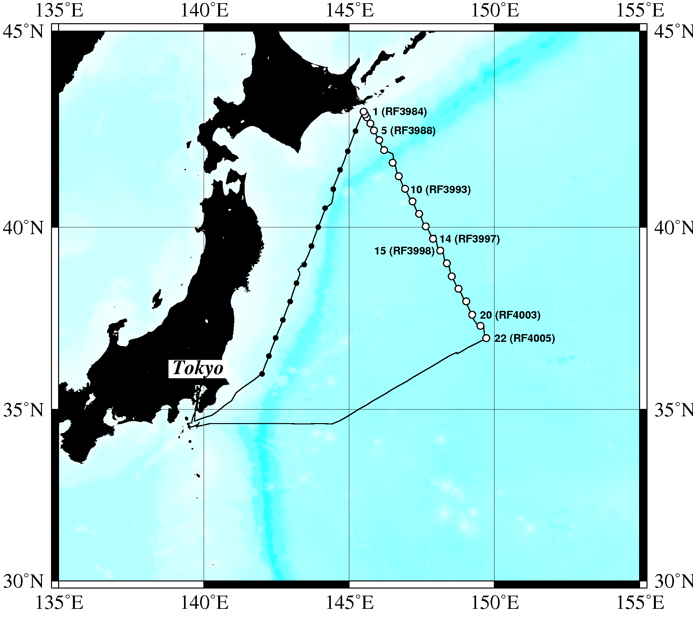
Figure 1(a). Cruise track of RF11-06. Open and closed circles indicate CTD station and X-BT station, respectively.
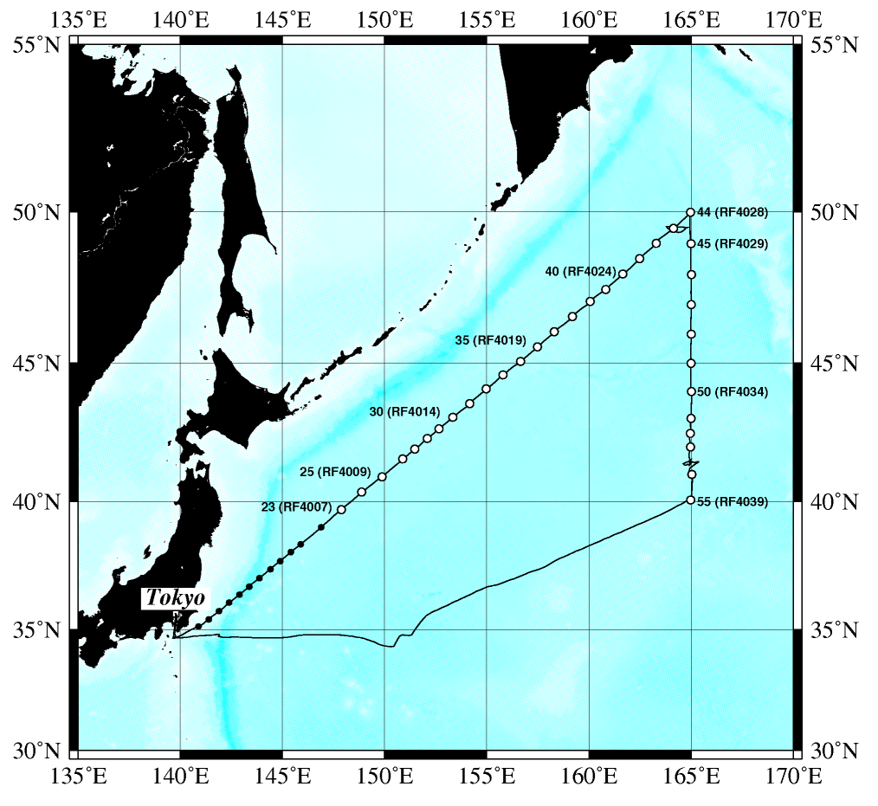
Figure 1(b). Cruise track of RF11-07. Open and closed circles indicate CTD station and X-BT station, respectively.
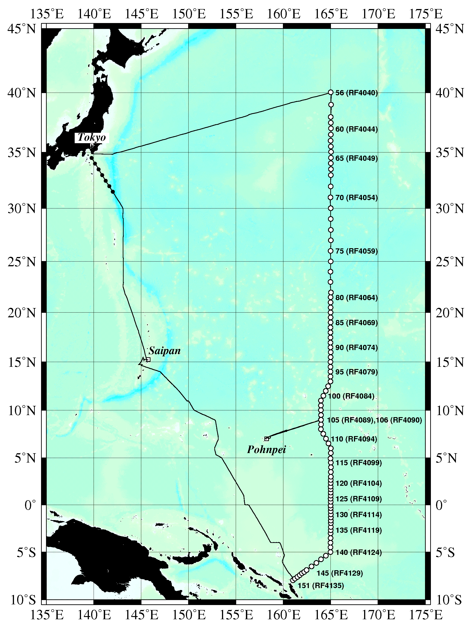
Figure 1(c). Cruise track of RF11-08. Open and closed circles indicate CTD station and X-BT station, respectively.
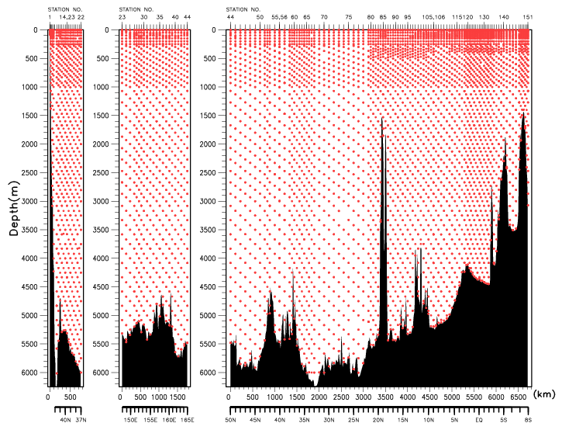
Figure 2. The bottle depth diagram for WHP-P13 revisit.
Table 2. The scheme of sampling layer in meters.

Bottle  count | scheme1 | scheme2 | scheme3
1 | 10 | 10 | 10
2 | 50 | 50 | 50
3 | 100 | 100 | 100
4 | 150 | 150 | 150
5 | 200 | 200 | 200
6 | 250 | 250 | 250
7 | 300 | 330 | 280
8 | 400 | 430 | 370
9 | 500 | 530 | 470
10 | 600 | 630 | 570
11 | 700 | 730 | 670
12 | 800 | 830 | 770
13 | 900 | 930 | 870
14 | 1000 | 1070 | 970
15 | 1200 | 1270 | 1130
16 | 1400 | 1470 | 1330
17 | 1600 | 1670 | 1530
18 | 1800 | 1870 | 1730
19 | 2000 | 2070 | 1930
20 | 2200 | 2270 | 2130
21 | 2400 | 2470 | 2330
22 | 2600 | 2670 | 2530
23 | 2800 | 2870 | 2730
24 | 3000 | 3080 | 2930
25 | 3250 | 3330 | 3170
26 | 3500 | 3580 | 3420
27 | 3750 | 3830 | 3670
28 | 4000 | 4080 | 3920
29 | 4250 | 4330 | 4170
30 | 4500 | 4580 | 4420
31 | 4750 | 4830 | 4670
32 | 5000 | 5080 | 4920
33 | 5250 | 5330 | 5170
34 | 5500 | 5580 | 5420
35 | 5750 | 5830 | 5670
36 | Bottom | Bottom | Bottom

Table 3(a). Station data of RF11-06 cruise. The ‘RF’ column indicates the JMA station identification number.

Leg | Station |  | Position
 | Stn. | RF | Latitude | Longitude
1 | 1 | 3984 | 42-59.53 N | 145-29.82 E
1 | 2 | 3985 | 42-55.25 N | 145-32.72 E
1 | 3 | 3986 | 42-50.85 N | 145-36.45 E
1 | 4 | 3987 | 42-41.38 N | 145-43.70 E
1 | 5 | 3988 | 42-30.90 N | 145-51.01 E
1 | 6 | 3989 | 42-16.00 N | 146-02.06 E
1 | 7 | 3990 | 42-00.75 N | 146-12.13 E
1 | 8 | 3991 | 41-41.35 N | 146-29.80 E
1 | 9 | 3992 | 41-20.14 N | 146-42.38 E
1 | 10 | 3993 | 41-00.56 N | 146-55.31 E
1 | 11 | 3994 | 40-40.84 N | 147-10.72 E
1 | 12 | 3995 | 40-21.13 N | 147-24.26 E
1 | 13 | 3996 | 40-01.21 N | 147-37.85 E
1 | 14 | 3997 | 39-41.56 N | 147-52.96 E
1 | 15 | 3998 | 39-22.74 N | 148-08.12 E
1 | 16 | 3999 | 39-02.30 N | 148-21.66 E
1 | 17 | 4000 | 38-41.11 N | 148-31.75 E
1 | 18 | 4001 | 38-20.97 N | 148-45.65 E
1 | 19 | 4002 | 38-00.47 N | 149-01.63 E
1 | 20 | 4003 | 37-38.34 N | 149-13.98 E
1 | 21 | 4004 | 37-20.09 N | 149-30.97 E
1 | 22 | 4005 | 36-59.71 N | 149-43.09 E

Table 3(b). Station data of RF11-07 cruise. The ‘RF’ column indicates the JMA station identification number.

Leg | Station |  | Position
 | Stn. | RF | Latitude | Longitude
1 | 23 | 4007 | 39-41.20 N | 147-53.53 E
1 | 24 | 4008 | 40-21.01 N | 148-52.73 E
1 | 25 | 4009 | 40-55.05 N | 149-52.79 E
1 | 26 | 4010 | 41-34.59 N | 150-53.38 E
1 | 27 | 4011 | 41-56.44 N | 151-29.15 E
1 | 28 | 4012 | 42-19.40 N | 152-05.32 E
1 | 29 | 4013 | 42-40.36 N | 152-39.91 E
1 | 30 | 4014 | 43-05.50 N | 153-20.34 E
1 | 31 | 4015 | 43-34.66 N | 154-10.27 E
1 | 32 | 4016 | 44-05.77 N | 154-58.35 E
1 | 33 | 4017 | 44-35.31 N | 155-47.96 E
1 | 34 | 4018 | 45-03.62 N | 156-39.25 E
1 | 35 | 4019 | 45-33.64 N | 157-28.74 E
1 | 36 | 4020 | 46-04.60 N | 158-18.39 E
1 | 37 | 4021 | 46-35.35 N | 159-11.81 E
1 | 38 | 4022 | 47-06.13 N | 160-03.89 E
1 | 39 | 4023 | 47-29.69 N | 160-49.18 E
1 | 40 | 4024 | 48-00.58 N | 161-39.39 E
1 | 41 | 4025 | 48-30.44 N | 162-28.67 E
1 | 42 | 4026 | 49-00.23 N | 163-17.79 E
1 | 43 | 4027 | 49-29.08 N | 164-08.39 E
1 | 44 | 4028 | 49-59.80 N | 164-58.50 E
1 | 45 | 4029 | 48-59.46 N | 164-59.89 E
1 | 46 | 4030 | 47-59.45 N | 165-00.88 E
1 | 47 | 4031 | 46-59.64 N | 165-00.51 E
1 | 48 | 4032 | 45-59.68 N | 165-00.70 E
1 | 49 | 4033 | 44-59.41 N | 164-59.94 E
1 | 50 | 4034 | 44-00.16 N | 165-01.11 E
1 | 51 | 4035 | 43-02.99 N | 164-59.98 E
1 | 52 | 4036 | 42-30.36 N | 164-57.80 E
1 | 53 | 4037 | 42-00.81 N | 164-58.36 E
1 | 54 | 4038 | 41-00.33 N | 165-02.37 E
1 | 55 | 4039 | 40-03.07 N | 164-58.78 E

Table 3(c). Station data of RF11-08 cruise. The ‘RF’ column indicates the JMA station identification number.
Leg | Station |  | Position |  |  | Leg | Station |  | Position
 | Stn. | RF | Latitude | Longitude |  |  | Stn. | RF | Latitude | Longitude
1 | 56 | 4040 | 40-02.05 N | 165-00.07 E |  | 1 | 94 | 4078 | 14-29.39 N | 164-58.65 E
1 | 57 | 4041 | 39-01.05 N | 165-02.24 E |  | 1 | 95 | 4079 | 13-59.95 N | 164-58.80 E
1 | 58 | 4042 | 37-59.50 N | 164-59.77 E |  | 1 | 96 | 4080 | 13-29.27 N | 164-58.90 E
1 | 59 | 4043 | 37-30.89 N | 165-00.36 E |  | 1 | 97 | 4081 | 12-59.56 N | 164-58.25 E
1 | 60 | 4044 | 37-02.44 N | 165-01.39 E |  | 1 | 98 | 4082 | 12-29.75 N | 164-43.69 E
1 | 61 | 4045 | 36-30.87 N | 165-00.85 E |  | 1 | 99 | 4083 | 12-00.16 N | 164-28.87 E
1 | 62 | 4046 | 35-59.47 N | 164-59.01 E |  | 1 | 100 | 4084 | 11-30.01 N | 164-13.86 E
1 | 63 | 4047 | 35-29.65 N | 165-00.53 E |  | 1 | 101 | 4085 | 11-00.50 N | 163-57.89 E
1 | 64 | 4048 | 35-01.78 N | 165-01.87 E |  | 1 | 102 | 4086 | 10-29.30 N | 163-58.12 E
1 | 65 | 4049 | 34-30.71 N | 165-01.21 E |  | 1 | 103 | 4087 | 10-00.28 N | 163-57.98 E
1 | 66 | 4050 | 34-02.22 N | 165-01.04 E |  | 1 | 104 | 4088 | 9-29.59 N | 163-58.46 E
1 | 67 | 4051 | 33-31.03 N | 165-01.22 E |  | 1 | 105 | 4089 | 8-59.64 N | 163-58.41 E
1 | 68 | 4052 | 32-59.22 N | 165-00.41 E |  | 2 | 106 | 4090 | 9-00.05 N | 163-58.09 E
1 | 69 | 4053 | 31-58.31 N | 164-59.89 E |  | 2 | 107 | 4091 | 8-30.11 N | 163-58.53 E
1 | 70 | 4054 | 30-59.15 N | 164-58.88 E |  | 2 | 108 | 4092 | 8-00.44 N | 163-58.14 E
1 | 71 | 4055 | 29-59.92 N | 165-00.23 E |  | 2 | 109 | 4093 | 7-31.13 N | 164-12.97 E
1 | 72 | 4056 | 29-00.40 N | 165-00.14 E |  | 2 | 110 | 4094 | 7-00.71 N | 164-30.01 E
1 | 73 | 4057 | 27-59.11 N | 165-00.46 E |  | 2 | 111 | 4095 | 6-30.55 N | 164-45.53 E
1 | 74 | 4058 | 27-00.51 N | 165-00.70 E |  | 2 | 112 | 4096 | 6-00.13 N | 165-00.52 E
1 | 75 | 4059 | 26-00.21 N | 164-59.34 E |  | 2 | 113 | 4097 | 5-30.00 N | 165-00.71 E
1 | 76 | 4060 | 24-59.77 N | 164-59.76 E |  | 2 | 114 | 4098 | 4-55.06 N | 164-58.56 E
1 | 77 | 4061 | 24-00.71 N | 164-58.58 E |  | 2 | 115 | 4099 | 4-29.40 N | 165-00.59 E
1 | 78 | 4062 | 23-00.62 N | 164-58.34 E |  | 2 | 116 | 4100 | 3-59.44 N | 165-01.05 E
1 | 79 | 4063 | 21-58.73 N | 165-01.24 E |  | 2 | 117 | 4101 | 3-29.25 N | 165-00.91 E
1 | 80 | 4064 | 21-30.47 N | 164-59.61 E |  | 2 | 118 | 4102 | 2-58.86 N | 165-00.94 E
1 | 81 | 4065 | 21-00.01 N | 164-59.14 E |  | 2 | 119 | 4103 | 2-38.95 N | 165-00.02 E
1 | 82 | 4066 | 20-30.07 N | 164-59.47 E |  | 2 | 120 | 4104 | 2-18.95 N | 165-00.20 E
1 | 83 | 4067 | 19-59.95 N | 164-59.41 E |  | 2 | 121 | 4105 | 1-56.39 N | 164-59.37 E
1 | 84 | 4068 | 19-30.34 N | 164-59.26 E |  | 2 | 122 | 4106 | 1-39.22 N | 165-00.07 E
1 | 85 | 4069 | 19-00.25 N | 164-59.28 E |  | 2 | 123 | 4107 | 1-18.47 N | 165-00.31 E
1 | 86 | 4070 | 18-30.19 N | 164-58.75 E |  | 2 | 124 | 4108 | 0-59.21 N | 164-59.87 E
1 | 87 | 4071 | 18-00.01 N | 164-58.62 E |  | 2 | 125 | 4109 | 0-39.70 N | 164-59.45 E
1 | 88 | 4072 | 17-29.29 N | 164-58.90 E |  | 2 | 126 | 4110 | 0-19.93 N | 165-00.12 E
1 | 89 | 4073 | 16-58.31 N | 164-58.93 E |  | 2 | 127 | 4111 | 0-04.15 S | 164-59.61 E
1 | 90 | 4074 | 16-29.43 N | 164-58.63 E |  | 2 | 128 | 4112 | 0-20.32 S | 164-59.73 E
1 | 91 | 4075 | 15-59.41 N | 164-59.70 E |  | 2 | 129 | 4113 | 0-39.82 S | 165-00.21 E
1 | 92 | 4076 | 15-28.96 N | 164-59.29 E |  | 2 | 130 | 4114 | 1-00.12 S | 165-00.90 E
1 | 93 | 4077 | 15-00.00 N | 164-58.81 E |  | 2 | 131 | 4115 | 1-19.79 S | 165-00.40 E
Leg | Station |  | Position
 | Stn. | RF | Latitude | Longitude
2 | 132 | 4116 | 1-40.01 S | 165-00.78 E
2 | 133 | 4117 | 1-56.30 S | 165-00.72 E
2 | 134 | 4118 | 2-20.71 S | 165-00.83 E
2 | 135 | 4119 | 2-40.75 S | 165-00.22 E
2 | 136 | 4120 | 3-00.68 S | 164-59.06 E
2 | 137 | 4121 | 3-30.82 S | 164-59.08 E
2 | 138 | 4122 | 4-00.38 S | 164-58.79 E
2 | 139 | 4123 | 4-30.02 S | 164-58.59 E
2 | 140 | 4124 | 5-00.30 S | 164-58.52 E
2 | 141 | 4125 | 5-23.11 S | 164-29.01 E
2 | 142 | 4126 | 5-45.90 S | 163-58.25 E
2 | 143 | 4127 | 6-08.52 S | 163-29.07 E
2 | 144 | 4128 | 6-30.58 S | 162-58.61 E
2 | 145 | 4129 | 6-54.00 S | 162-26.88 E
2 | 146 | 4130 | 7-05.66 S | 162-12.13 E
2 | 147 | 4131 | 7-14.35 S | 161-57.94 E
2 | 148 | 4132 | 7-25.98 S | 161-44.47 E
2 | 149 | 4133 | 7-36.95 S | 161-29.12 E
2 | 150 | 4134 | 7-47.74 S | 161-13.89 E
2 | 151 | 4135 | 7-58.40 S | 161-00.67 E
- List of Principal Investigators for all Measurements
The principal investigator (PI) and the person in charge responsible for major parameters measured on the cruise are listed in Table 4.

Table 4(a). List of principal investigator and the person in charge on the ship for RF11-06.
Item Principal Investigator（PI） Person in charge on the ship
Hydrography
CTDO2 / LADCP Hitomi KAMIYA Tatsuo NAKAMURA
Salinity Hitomi KAMIYA Tatsuo NAKAMURA
Dissolved oxygen Hitomi KAMIYA Yusuke TAKATANI
Nutrients Hitomi KAMIYA Takahiro KITAGAWA
Phytopigment Hitomi KAMIYA Sonoki IWANO
DIC Hitomi KAMIYA Shu SAITO
Total Alkalinity Hitomi KAMIYA Shu SAITO
pH Hitomi KAMIYA Shu SAITO
CFCs Hitomi KAMIYA Kazuki ISHIMARU
Underway
Meteorology Hitomi KAMIYA Tatsuo NAKAMURA
Thermo-Salinograph Hitomi KAMIYA Shu SAITO
pCO₂ Hitomi KAMIYA Shu SAITO
Chlorophyll-a Hitomi KAMIYA Sonoki IWANO
ADCP Hitomi KAMIYA Tatsuo NAKAMURA
Bathymetry Hitomi KAMIYA Tatsuo NAKAMURA
Floats
Sub-surface Profiling float Hitomi KAMIYA Toshiya NAKANO

Hitomi KAMIYA (hkamiya@met.kishou.go.jp)
Marine Division, Global Environment and Marine Department, JMA
1-3-4, Otemachi, Chiyoda-ku, Tokyo 100-8122, JAPAN
Phone: +81-3-3212-8341 Ext. 5150 FAX: +81-3-3211-6908

Table 4(b). List of principal investigator and the person in charge on the ship for RF11-07.
Item Principal Investigator（PI） Person in charge on the ship
Hydrography
CTDO2 / LADCP Hitomi KAMIYA Tetsuya NAKAMURA
Salinity Hitomi KAMIYA Tetsuya NAKAMURA
Dissolved oxygen Hitomi KAMIYA Shinichiro UMEDA
Nutrients Hitomi KAMIYA Naoki NAGAI
phytopigment Hitomi KAMIYA Naoki NAGAI
DIC Hitomi KAMIYA Shinji MASUDA
Total Alkalinity Hitomi KAMIYA Shinji MASUDA
pH Hitomi KAMIYA Shinji MASUDA
CFCs Hitomi KAMIYA Takayuki TOKIEDA
¹⁴C Yuichiro KUMAMOTO Shinji MASUDA
Underway
Meteorology Hitomi KAMIYA Tetsuya NAKAMURA
Thermo-Salinograph Hitomi KAMIYA Takayuki TOKIEDA
pCO₂ Hitomi KAMIYA Takayuki TOKIEDA
Chlorophyll-a Hitomi KAMIYA Naoki NAGAI
ADCP Hitomi KAMIYA Tetsuya NAKAMURA
Bathymetry Hitomi KAMIYA Tetsuya NAKAMURA
Floats
ARGO float Toshio SUGA Toshiya NAKANO

Hitomi KAMIYA (hkamiya@met.kishou.go.jp)
Marine Division, Global Environment and Marine Department, JMA
1-3-4, Otemachi, Chiyoda-ku, Tokyo 100-8122, JAPAN
Phone: +81-3-3212-8341 Ext. 5150 FAX: +81-3-3211-6908
Yuichiro KUMAMOTO (kumamoto@jamstec.go.jp)
Ocean Climate Change Research Program
Research Institute for Global Change (RIGC)
Japan Agency for Marine-Earth Science and Technology (JAMSTEC)
2-15 Natsushima, Yokosuka, Kanagawa, Japan 237-0061
Toshio SUGA (sugat@jamstec.go.jp)
Ocean Climate Change Research Program
Research Institute for Global Change (RIGC)
Japan Agency for Marine-Earth Science and Technology (JAMSTEC)
2-15 Natsushima, Yokosuka, Kanagawa, Japan 237-0061

Table 4(c). List of principal investigator and the person in charge on the ship for RF11-08.
Item Principal Investigator（PI） Person in charge on the ship
Hydrography
CTDO2 / LADCP Hitomi KAMIYA Tetsuya NAKAMURA
Salinity Hitomi KAMIYA Tetsuya NAKAMURA
Dissolved oxygen Hitomi KAMIYA Yusuke TAKATANI
Nutrients Hitomi KAMIYA Naoki NAGAI
Phytopigment Hitomi KAMIYA Naoki NAGAI
DIC Hitomi KAMIYA Shu SAITO
Total Alkalinity Hitomi KAMIYA Shu SAITO
pH Hitomi KAMIYA Shu SAITO
CFCs Hitomi KAMIYA Kazuki ISHIMARU
¹⁴C Yuichiro KUMAMOTO Shu SAITO
Underway
Meteorology Hitomi KAMIYA Tetsuya NAKAMURA
Thermo-Salinograph Hitomi KAMIYA Shu SAITO
pCO₂ Hitomi KAMIYA Shu SAITO
Chlorophyll-a Hitomi KAMIYA Naoki NAGAI
ADCP Hitomi KAMIYA Tetsuya NAKAMURA
Bathymetry Hitomi KAMIYA Tatsuo NAKAMURA
Floats
ARGO float Toshio SUGA Toshiya NAKANO

Hitomi KAMIYA (hkamiya@met.kishou.go.jp)
Marine Division, Global Environment and Marine Department, JMA
1-3-4, Otemachi, Chiyoda-ku, Tokyo 100-8122, JAPAN
Phone: +81-3-3212-8341 Ext. 5150 FAX: +81-3-3211-6908
Yuichiro KUMAMOTO (kumamoto@jamstec.go.jp)
Ocean Climate Change Research Program
Research Institute for Global Change (RIGC)
Japan Agency for Marine-Earth Science and Technology (JAMSTEC)
2-15 Natsushima, Yokosuka, Kanagawa, Japan 237-0061
Toshio SUGA (sugat@jamstec.go.jp)
Ocean Climate Change Research Program
Research Institute for Global Change (RIGC)
Japan Agency for Marine-Earth Science and Technology (JAMSTEC)
2-15 Natsushima, Yokosuka, Kanagawa, Japan 237-0061
- Scientific Program and Methods
In recent years, the global environmental issues such as global warming and climate change have become one of the major socio-economic concerns, and it has become apparent that the ocean plays a key role in the climate system. For the better understanding and assessment of global environmental conditions, continuous monitoring of climate variables, concentrations of greenhouse gases both in the ocean and in the atmosphere. To meet those requirements, JMA has been conducting operational oceanographic observations by research vessels in the western North Pacific on a seasonal basis. RF11-06, RF11-07 and RF11-08 cruises are one of these activities. The purposes of this cruise are as follows:
(1) To observe profiles of seawater temperature, salinity, dissolved oxygen, nutrients and carbon parameters, as well as upper ocean current;
(2) To observe concentrations of greenhouse gases both in the ocean and in the atmosphere;
(3) To observe bio-geochemical parameters to study carbon cycle in the ocean.

These activities are expected to contribute to international projects related to global environmental issues such as the World Climate Research Programme (WCRP), IOCCP (International Ocean Carbon Coordination Project) and the Global Atmosphere Watch (GAW).

- Major Problems and Goals not Achieved
RF11-06
Since there was a lot of debris on the sea surface east of Japan after the Tohoku earthquake on March 11, 2011, we stopped to sail and drifted one night at about 38°40’N, 143°18’E on May 16. During the observation at Stn.7(42°N, 146°12’E), the armored cable hitched a radio buoy with fishing net, so we gave up the observation below 2000 m depth and water sampling at the station.

RF11-07
Owing to the troubles in CTD winch and the unfavorable sea state due to the storms, insufficient time was available to complete the section as planned, and station spacing increased to 60 nautical miles between 50°N and 43°N, and between 42°N and 40°N.

RF11-08
Because of the trouble in the previous cruise, RF11-07, the first station of this cruise was changed from 38°N to 40°N, and station spacing increased to 60 nautical miles between 40°N and 38°N, and between 33°N and 22°N.

- List of Cruise Participants
The cruise participants of the three cruises are listed in Table 5.

Table 5(a). List of cruise participants for RF11-06.
Name Responsibility Affiliation
Ayumi HASHIZUME CTDO / ADCP / LADCP / Salinity GEMD / JMA
Hiroyuki HATAKEYAMA Carbon Items/CFCs GEMD / JMA
Yoshikazu HIGASHI CTDO / ADCP / LADCP / Salinity GEMD / JMA
Masaya IKEDA Dissolved Oxygen GEMD / JMA
Kazuki ISHIMARU Carbon Items /CFCs GEMD / JMA
Sonoki IWANO Nutrients / Phytopigment GEMD / JMA
Takahiro KITAGAWA Nutrients GEMD / JMA
Kiyoshi MURAKAMI CTDO / ADCP / LADCP / Salinity GEMD / JMA
Tatsuo NAKAMURA Meteorology / Bathymetry GEMD / JMA
Toshiya NAKANO Chief Scientist GEMD / JMA
Hidemi OGAHARA Dissolved Oxygen GEMD / JMA
Etsuro ONO Carbon Items/CFCs GEMD / JMA
Shu SAITO Carbon Items/CFCs GEMD / JMA
Ryosuke SAKAKIBARA Nutrients GEMD / JMA
Yusuke TAKATANI Dissolved Oxygen GEMD / JMA
Shinichiro UMEDA Dissolved Oxygen / Phytopigment GEMD / JMA
Koichi WADA CTDO / ADCP / LADCP / Salinity GEMD / JMA

GEMD / JMA: Marine Division, Global Environment and Marine Department, JMA
Table 5(b). List of cruise participants for RF11-07.
Name Responsibility Affiliation
Kazutaka ENYO Carbon Items GEMD / JMA
Hiroyuki FUJIWARA Nutrients GEMD / JMA
Sho HIBINO Dissolved Oxygen GEMD / JMA
Nobumi KATO CTDO / ADCP / LADCP GEMD / JMA
Tomoyuki KITAMURA CTDO / ADCP / LADCP GEMD / JMA
Atsushi KOJIMA Salinity GEMD / JMA
Shinji MASUDA Carbon Items GEMD / JMA
Kiyoshi MURAKAMI CTDO / ADCP / LADCP GEMD / JMA
Tetsuya NAKAMURA Meteorology / Bathymetry GEMD / JMA
Naoki NAGAI Nutrients / Phytopigment GEMD / JMA
Toshiya NAKANO Chief Scientist GEMD / JMA
Ryosuke SAKAKIBARA Dissolved Oxygen GEMD / JMA
Naoaki SAKAMOTO CFCs GEMD / JMA
Daisuke SASANO Carbon Items MRI / JMA
Hiroumi SHIGEOKA Salinity GEMD / JMA
Yoshihiro SHINODA CFCs GEMD / JMA
Takayuki TOKIEDA CFCs GEMD / JMA
Tomohiro UEHARA Nutrients GEMD / JMA
Shinichiro UMEDA Dissolved Oxygen GEMD / JMA
Koichi WADA Salinity GEMD / JMA

GEMD / JMA: Marine Division, Global Environment and Marine Department, JMA
MRI / JMA: Geochemical Research Department, Meteorological Research Institute, JMA
Table 5(c). List of cruise participants for RF11-08.
Name Responsibility Affiliation
Hiroyuki FUJIWARA Nutrients GEMD / JMA
Sho HIBINO Dissolved Oxygen GEMD / JMA
Kazuki ISHIMARU CFCs GEMD / JMA
Nobumi KATO CTDO / ADCP / LADCP GEMD / JMA
Takahiro KITAGAWA Nutrients GEMD / JMA
Tomoyuki KITAMURA CTDO / ADCP / LADCP GEMD / JMA
Atsushi KOJIMA Salinity GEMD / JMA
Shinya MAEDA Carbon Items GEMD / JMA
Shinji MASUDA Carbon Items GEMD / JMA
Tetsuya NAKAMURA Meteorology / Bathymetry GEMD / JMA
Naoki NAGAI Nutrients / Phytopigment GEMD / JMA
Toshiya NAKANO Chief Scientist GEMD / JMA
Hiroumi SHIGEOKA Salinity GEMD / JMA
Etsuro ONO CFCs GEMD / JMA
Hidemi OGAHARA Dissolved Oxygen GEMD / JMA
Shu SAITO Carbon Items GEMD / JMA
Haruka SUEMATSU CFCs GEMD / JMA
Yusuke TAKATANI Dissolved Oxygen GEMD / JMA
Masahiro TANIGUCHI CTDO / ADCP / LADCP GEMD / JMA
Koichi WADA Salinity GEMD / JMA

GEMD / JMA: Marine Division, Global Environment and Marine Department, JMA

