CRUISE REPORT
HUDSON 2009015
LABRADOR SEA
WOCE LINE AR7W
May 17 − June 1, 2009

A. CRUISE NARRATIVE

1. Highlights

a. WOCE Designation: | WOCE Line AR7W
b. Expedition Designation: | HUD2009015 or 18HU09015 (ISDM format)
c. Chief Scientist: | Ross Hendry  Ocean Sciences Division  Department of Fisheries and Oceans  Bedford Institute of Oceanography  PO Box 1006  Dartmouth, NS, Canada B2Y 2A4  Ross.Hendry@dfo-mpo.gc.ca
d. Ship: | CCGS Hudson
e. Ports of Call: | May 17, 2009 St. John’s, NL, Canada  June 1, 2009 BIO, Dartmouth, NS, Canada
f. Cruise Dates: | May 17 to June 1, 2009

2. Cruise Summary Information

a. Cruise Track

A cruise track is shown in Figure A.2.1. The ship's position at 0000 UTC on each day of the cruise is indicated with a date label.

The World Ocean Circulation Experiment (WOCE) - format cruise station summary file (SUM) outlines the science operations conducted during the cruise.

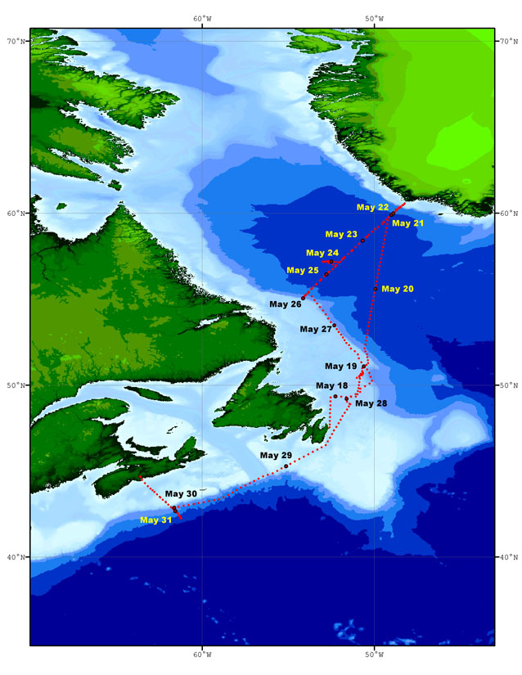
Figure A.2.1 Cruise track for HUD2009015. The pink dots indicate the ship’s position for each hour of the voyage. The green dots and date labels indicate the ship's position at 0000 UTC for that particular date.
b. Total number of stations occupied

The CTD / ROS station positions are shown in Figure A.2.2. Table A.2.1 lists the science operations for HUD2009015.

Along AR7W, the stations were full-depth WHP small volume rosette casts with up to 24 rosette bottles. Water samples were analyzed for CFCs, total inorganic carbon (TIC), total alkalinity, oxygen, salinity, nutrients (nitrate, phosphate, and silicate), total organic carbon (TOC), and bacterial abundance. Chlorophyll was analyzed at depths less than 200 m at most stations. Samples were collected for iodine-129 (¹²⁹I) and Oxygen-18 (¹⁸O) on selected casts.

Cast Type | Number of Operations | Detailed Division | Operation Numbers
Rosette & CTD | 25 | 21 of the 28 regular AR7W Sites (L3 line) plus sites 7.5, 8.5, 25.3 and 25.7 | see Table A.2.2
 | 8 | Halifax Line  Sites 3–9 and 6.5 | 193, 195, 197, 200, 204, 206, 208, 212
 | 5 | Biology Casts not included  in other tables | 72, 111, 122, 162, 187
 | 1 | Station 27 | 3
 | 4 | Transit Stations | 8, 11, 23, 190
 | 4 | Aborted Operations | 5, 6, 7, 9
Moorings | 1 | Recovery | 169
 | 1 | Release Test | 170
 | 1 | Deployment | 171
Floats | 9 | APEX floats deployed | 13, 20, 53, 114, 124, 133, 147, 155, 202
Biology | 30 | 200 micron net tows | 1, 4, 10, 22, 25, 35, 38, 42, 44, 51, 54, 61, 70, 81, 92, 101, 109, 121, 134, 144, 151, 153, 160, 172, 175, 179, 186, 189, 205, 207, 209, 210, 211
 | 14 | 76 micron net tows | 2, 26, 71, 82, 93, 102, 110, 145, 152, 161, 173, 176, 180, 210
 | 4 | Multi-net tows | 194, 196, 201, 203
Chemistry |  | I-129 surface | 27, 36, 43, 45, 112, 123, 146, 154, 181
 |  | I-129 profile | 55, 73, 103, 135, 188, 197, 200
 | 15 | Air Samples | 28, 49, 50, 85, 87, 113, 116, 165, 166, 191, 192, 198, 199, 213, 214
Other |  | 341 Hrs vessel-mounted ADCP | No number assigned
 | 90 | XBT Deployments | 12, 14–19, 21, 24, 29–34, 37, 46–48, 56–60, 63–69, 74–80, 84, 86, 88–91, 95–100, 104–108, 115, 117–120, 125–132, 136–143, 148–150, 156–159, 164, 167, 168, 182 - 185

Table A.2.1 Science operations conducted on HUD2009015.
AR7W Site Number | 2009015 Deep Cast Operation Number
1 | Not sampled due to ice
2 | Not sampled due to ice
3 | Not sampled due to ice
4 | Not sampled due to ice
5 | Not sampled due to ice
6 | Not sampled due to ice
7 | Not sampled due to ice
7.5 | 174
8 | 177
8.5 | 178
9 | 181
10 | 188
11 | 163
12 | 154
13 | 146
14 | 135
15 | 123
16 | 112
17 | 103
18 | 94
19 | 83
20 | 73
21 | 62
22 | 27
23 | 55
24 | 36
25 | 52
25.3 | 40
25.7 | 41
26 | 39
27 | 45
28 | 43

Table A.2.2. AR7W (L3) sites and rosette and CTD operation numbers for HUD2009015.

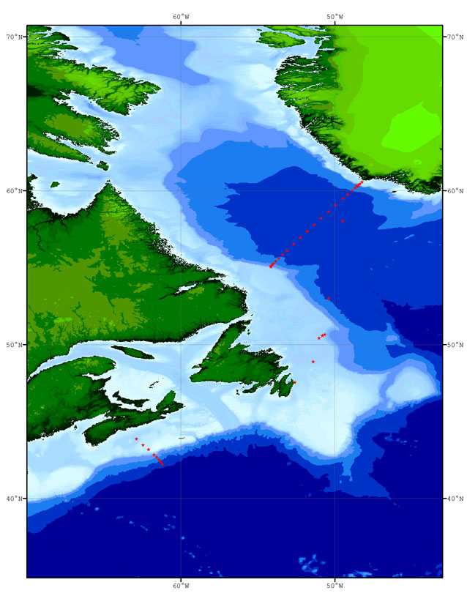
Figure A.2.2 HUD2009015 locations (red-filled stars) for operations involving one or more of the following data collection methods: Rosette, CTD and LADCP.
The AR7W Labrador Sea section and the extended Halifax Section were occupied during the HUD2009015 mission. These survey lines combined with the Orphan Basin lines occupied within the same four week period on HUD2009011 provide a comprehensive assessment of the oceanographic conditions in the Canadian sector of the Atlantic Ocean.

c. Floats and Drifters deployed

Nine APEX profiling floats (Teledyne Webb Research, E. Falmouth, MA) equipped with SBE-41 temperature-conductivity sensors (Sea-Bird Electronics, Inc., Bellevue, WA) were deployed as a Canadian contribution to the international Argo project. This effort was jointly supported by Fisheries and Oceans Canada and the Canadian Ice Service of Environment Canada. Eight floats were deployed in the Labrador Sea and one float was deployed on the offshore Halifax Line. Table A.2.3 gives details of the float deployments.

On 4 May 2009 Sea-Bird issued a notice that there was a problem with the Druck pressure sensors used in SBE-41 CTDs on Argo floats that could cause a progressive negative offset in measured pressure and the eventual failure of these sensors and recommended that float users stop float deployments and return the affected CTDs to Sea-Bird for repair. A considered decision was made to proceed with our planned deployments and accept any resulting premature failures. The time frame for the resolution of this issue was several months at a minimum and it was felt that the benefits of ensuring continued coverage by taking advantage of the deployment opportunities on our annual Labrador Sea mission outweighed the potential costs of reduced float lifetime. All nine floats deployed were equipped with APF9a controller boards which compensate for negative pressure drifts by using atmospheric pressure as a reference. A single float equipped with an older model APF8 controller board originally scheduled for deployment failed pre-launch tests and was replaced with an APF9 float carried as a spare. The APF8 controller truncates negative pressures to zero and the reported pressures are in error by the amount of any negative drift.

Apex Float |  | WMO | Event | Launch Position |  | Start Time | Launch Time
Type | SN |  |  | Latitude | Longitude | UTC | UTC
APEX-SBE APF9A | 4521 | 4901130 | 013 | N53° 59.9' | W050° 14.2' | 19 May 2009 14:45 | 19 May 2009 16:43
APEX-SBE APF9A | 4522 | 4901131 | 020 | N54° 58.8' | W050° 03.9' | 19 May 2009 21:01 | 19 May 2009 21:18
APEX-SBE APF9A | 4524 | 4901133 | 053 | N59° 59.7' | W048° 52.9' | 21 May 2009 22:36 | 21 May 2009 23:27
APEX-SBE APF9A | 4514 | 4901127 | 114 | N57° 22.2' | W051° 44.8' | 23 May 2009 16:35 | 23 May 2009 18:15
APEX-SBE APF9A | 4513 | 4901126 | 124 | N56° 57.4' | W052° 10.6' | 24 May 2009 15:15 | 24 May 2009 16:14
APEX-SBE APF9A | 4512 | 4901125 | 133 | N56° 33.2' | W052° 40.7' | 24 May 2009 18:47 | 24 May 2009 19:28
APEX-SBE APF9A | 4511 | 4901124 | 147 | N56° 06.8' | W053° 05.7' | 25 May 2009 04:17 | 25 May 2009 05:38
APEX-SBE APF9A | 4510 | 4901123 | 155 | N55° 50.4' | W053° 23.4' | 25 May 2009 10:56 | 25 May 2009 11:22
APEX-SBE APF9A | 4516 | 4901129 | 202 | N42° 16.2' | W061° 14.8' | 30 May 2009 16:48 | 30 May 2009 19:27

Table A.2.3 APEX float deployments on HUD2009015.
d. Moorings deployed or recovered

The Aanderaa current meter mooring near station L3-8 on the AR7W line was once again serviced on May 25, 2009. Mooring #1680 was recovered successfully under good sea conditions. The RCM8 appeared to have worked properly and all mooring tackle was in good condition. The replacement mooring #1729 was deployed successfully on the same day.

Recovery:

M 1680 | 55° 07.22' N  54° 05.36' W | Standard mooring consisting of one current meter positioned 20m above bottom along AR7W on the Labrador Slope (12-month deployment) at 1018 m depth.

Deployment:

M 1729  Anchor  Drop  MCal | 55° 07.20' N  54° 05.21' W  55° 07.17' N  54° 05.15' W | Standard mooring consisting of one current meter positioned 20m above bottom along AR7W on the Labrador Slope (12-month deployment) at 1029 m depth.

The M-Cal (Mooring Calibrator) software package V 1.04 again proved useful in our mooring operations. M-Cal is a subset of a program called WorkBoat by James Illman of Software Engineering Associates. This enables the user to position the mooring once on the bottom. A computer is linked to the ship’s navigation as well as, in this case, to the Benthos DS7000 deck unit. As the ship travels near the mooring, M-Cal transponds to the acoustic release and measures the time interval between the send and reply pulses. This information combined with the navigation data enables the program to calculate the position of the release. As more and more data is gathered, the position continually updates. M-Cal also calculates a depth for the release.

This software is of great use if a mooring is off location for some reason. M-Cal gives a position so that locating the mooring is much quicker. Transponding to a release only gives a slant range and not a direction. A ship has to randomly travel to minimize this slant range which could be very time consuming.

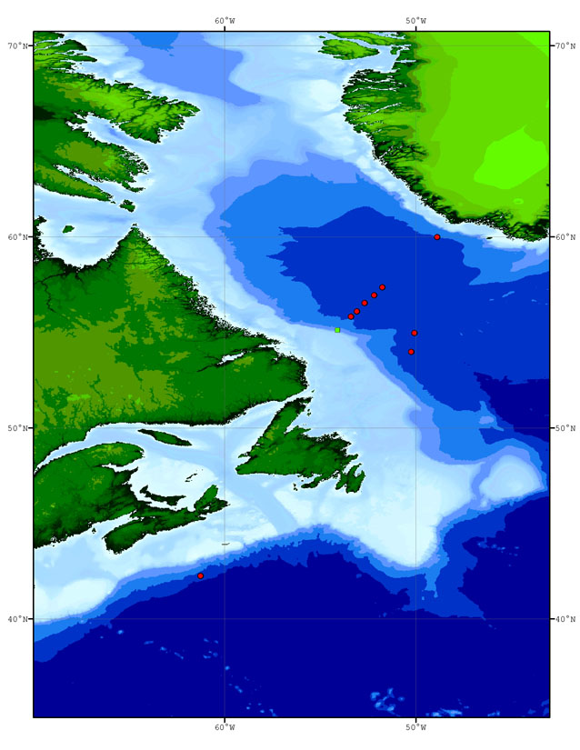
Figure A.2.3 HUD2009015 mooring location (green-filled square - a mooring was recovered and a new one deployed in the same location) and float deployment locations (red-filled circles).
3. List of Principal Investigators

Name | Affiliation | Responsibility
Parisa Ariya | McGill University  parisa.ariya@mcgill.ca | Low molecular weight carbonyls, associated atmospheric sampling
Kumiko Azetsu-Scott | BIO  Kumiko.Azetsu-Scott @dfo-mpo.gc.ca | Chemistry program coordination
Carina Gjerdrum | Canadian Wildlife Service, Environment Canada  Carina.Gjerdrum@ec.gc.ca | Sea bird program
Glen Harrison | BIO  Glen.Harrison@dfo-mpo.gc.ca | Associate Senior Scientist, Biological program coordination
Erica Head | BIO  Erica.Head@dfo-mpo.gc.ca | Macrozooplankton distribution, abundance and metabolism
Ross Hendry | BIO  Ross.Hendry@dfo-mpo.gc.ca | Senior scientist  Overall co-ordination
Paul Kepkay | BIO  Paul.Kepkay@dfo-mpo.gc.ca | Dissolved organic carbon, colloid chemistry, plankton respiration
Bill Li | BIO  Bill.Li@dfo-mpo.gc.ca | Pico-plankton distribution and abundance, bacterial abundance and productivity
Robert Pickart | Woods Hole Oceanographic Institution  rpickart@whoi.edu | Lowered ADCP
John Smith | BIO  John.Smith@dfo-mpo.gc.ca | Radioisotope sampling program
Igor Yashayaev | BIO  Igor.Yashayaev@dfo-mpo.gc.ca | CTD/XBT program coordination

Table A.3.1. List of Principal Investigators (see Section 7 for addresses).

4. Scientific Programme and Methods

4.1 Physical - Chemical Program

a. Narrative

The physical and chemical program on Hudson 2009015 continued an annual series of measurements in the Labrador Sea that began in 1990 as a contribution to the World Climate Research Programme and has evolved into a component of a multidisciplinary regional monitoring effort. The broad goals are to investigate interannual and long-term changes in the physical and chemical properties of the Labrador Sea and better understand the mechanisms that cause these changes. A particular focus is on changes in the intensity of winter overturning of surface and intermediate-depth waters and the resulting formation of Labrador Sea Water with varying temperature and salinity properties. This overturning is part of the thermohaline circulation that plays a role in the global climate system. Convection also transfers atmospheric gases such as oxygen and carbon dioxide from the surface layers to intermediate depths. The resulting oceanic storage of anthropogenic carbon reduces the rate of increase of carbon dioxide in the atmosphere but also increases the acidity of oceanic waters. The physical-chemical investigations are part of a larger multidisciplinary effort seeking a better understanding of interannual and long-term changes in regional ecosystems.

Hudson 2009015 program elements included:

- Full-depth CTD profile measurements of pressure, temperature, salinity, dissolved oxygen, pH, fluorescence, and light intensity at a fixed set of stations (L3 line) spanning the Labrador Sea from Hamilton Bank on the Labrador Shelf to Cape Desolation Island on the West Greenland Shelf;
- Measurements of salinity, dissolved oxygen, nutrients (nitrate/nitrite, phosphate, silicate), CFCs, dissolved inorganic carbon, alkalinity, Oxygen-18, and Iodine-129 from discrete water samples from a rosette sampler on the CTD package;
- Recovery and redeployment of a current meter mooring providing near-bottom current and temperature measurements on the Labrador Slope in 1000 m water depth;
- Current measurements from a ship-mounted acoustic current profiler;
- Current measurements at CTD stations from a lowered acoustic current profiler (Woods Hole Oceanographic Institution);
- Temperature profile measurements from Expendable Bathythermographs (XBTs) at selected points between CTD stations;
- Autonomous float deployments as part of the Canadian Argo Program and the international Argo Project;
- Similar physical and chemical measurements at Station 27 on the Newfoundland Shelf and on the Halifax Line on the Scotian Shelf in support of the Atlantic Zone Monitoring Program (AZMP);
- Similar physical and chemical measurements on the Scotian Slope in support of an expanded offshore monitoring program and a joint study with the UK Proudman Oceanographic Laboratory;
- Measurements of light carbonyl compounds in surface waters and marine air and associated measurements of atmospheric ozone, nitrogen oxides, and non-methane hydrocarbons (McGill University).

The physical-chemical program and the biological program described in Section 4.2 below were tightly coupled and shared water samples from the Rosette sampler. Additional dedicated Biological CTD stations to a maximum depth of 200 m were occupied at selected sites throughout the mission.

Station 27 off St. John's was occupied as a contribution to the AZMP. Problems with the connector on the pH sensor that disrupted the first shallow CTD stations on the outward transit were resolved. Operations on the outward transit to the L3 line included 7 shallow CTD casts, 3 ring net hauls, 9 XBT drops, and 2 float deployments.

The Labrador Sea station work went well except that unusually heavy sea ice on the western side of the Labrador Sea prevented access to stations L3_1 to L3_7 on the Labrador Slope and Shelf. Favourable ice conditions on the eastern side of the Labrador Sea at the time of our survey allowed the occupation of all planned stations on the West Greenland shelf. High winds interrupted over-the-side operations in the western Labrador Sea for approximately 12h. Operations on the L3 line included 25 full-depth CTD casts, 5 shallow CTD casts, 35 ring net hauls, 81 XBT drops, 6 float deployments, and 9 air samples.

A Net haul and CTD cast were carried out near the ice edge on the Newfoundland Shelf in 320 m water depth as a proxy for missed stations on the Labrador Shelf.

Ice conditions made it necessary to return via Cape Race rather than take the shorter route through Belle Isle Strait and the Gulf of St. Lawrence.

The combined Halifax Line/offshore Halifax Line (HL) was surveyed with 8 CTD casts, 4 Multinet hauls with 5 sampling levels down to 1000 m (HL_6–HL_9), and 5 vertical ring net tows (HL_3–HL_5). The offshore survey stopped at HL_9 because of time constraints. HL_6.5 and all AZMP Halifax Line stations except Stations 1 and 2 were occupied. An Apex profiling float was deployed at HL_9.

Researchers from McGill University analyzed 39 water samples from 31 stations for light carbonyl compounds (formaldehydes, acetone, etc.) and collected 13 underway air samples close to 7 of these stations.

Weather and ice presented challenges to time management on this mission. Sea ice on the Labrador Coast was late in withdrawing, necessitating detours on the outbound transit and a longer return via Cape Race. Weather interrupted operations in the western Labrador Sea for approximately 12h. The formal mission plan allowed for a return to BIO as late as 05:00 UTC (08:00 ADT) on 1 June 2009 but nearing the offshore end of the Halifax Line on 29 May 2009 we made a considered commitment to return to BIO late on the afternoon of Sunday, 31 May 2010 to facilitate unloading from HUD2009015 and loading for the following mission, based on a short turnaround time and an assessment that we were in a position to do this and still complete the priority Halifax Line objectives. Arrangements were then made to have a working party and crane on the BIO jetty waiting for our arrival. Subsequently we were obliged to detour inshore to Halifax Line Station 6 to avoid a tropical depression approaching the offshore end of the Extended Halifax Line. This doubled the steaming time to occupy the offshore stations. Persistent fog made it necessary to reduce steaming speed and further cut into our station time. We occupied stations on the Extended Halifax Line out to site HL_9 but time constraints prevented the planned occupation of HL_10. On the return to BIO we occupied Stations 6.5 to 3 on the AZMP Halifax Line, still hampered by persistent fog. We had to bypass the AZMP time series at Halifax Line Station 2 because of poor time management over the final hours of the mission, which we particularly regret.

Summary log (all times are UTC)

17 May 2009 12:40 Depart St. John's harbour.
17 May 2009 13:40 2 Net hauls, CTD at Station 27 about 7 km from St. John’s harbour. Events 1–3. Transit to site L3_22 to start work on the eastern end of the L3 line.
17 May 2009 23:15 Deviated ~60 nm east of planned track near 49°20'N to avoid ice. Ice also prevented an approach to the Notre Dame Trough for a planned brief sub-bottom survey for colleagues in the Atlantic Geosciences Centre with the 3.5 kHz Knudsen Chirp 3260 sounder.
18 May 2009 11:20 Transit_01a Net haul, shallow CTD Event 5. The CTD failed on the downcast. The SBE18 pH sensor installed for the first time on this station had a fault in its connecting cable that was eventually identified as the cause of the problem. Transit_01b shallow CTD Event 6 at same location after removing the depth-limited biological sensors (Licor PAR sensor and WetLabs fluorometer) was also aborted at 58 dbar on the downcast. Trial Transit_02a shallow CTD Event 7 again without the shallow biological sensors was aborted after a partial downcast. Transit_02b shallow CTD Event 8 without the pH sensor was completed without incident. 15:35 Steamed south in response to a SAR call; called off about 3 hours later, resumed steam north. Transit_03 shallow CTD Event 9.
19 May 2009 Transit to L3_22. Transit_04 Net haul, shallow CTD, 2 float deployments, 8 XBT drops. Events 10–21.
20 May 2009 Transit to L3_22. Transit_05 Net haul, shallow CTD including pH measurements with the repaired SBE18 pH sensor, XBT drop. Events 22–24. 20:00 Start L3 line. 2 Net hauls, CTD, 2 XBT drops, air sample. Events 25–30.
21 May 2009 L3 line. 5 Net hauls, 7 CTD casts, float deployment, 8 XBT drops. Events 31–53.
22 May 2009 L3 line. 6 Net hauls, shallow CTD, 4 full-depth CTD casts, 22 XBT drops, 3 air samples. Events 54–88.
23 May 2009 L3 line. 6 Net hauls, shallow CTD, 4 full-depth CTD casts, 19 XBT drops, 2 air samples. Events 89–120. 23 May 2009 20:25 High winds, break off work and run into the wind to the NW and W.
24 May 2009 08:45 Begin steam SE 25 nm to rejoin L3 line at L3_15. 2 Net hauls, shallow CTD, 2 full-depth CTD casts, 2 float deployments, 9 XBT drops. Events 121–136.
25 May 2009 L3 line. Moved from site L3_11 to mooring site on Labrador slope in mid-day to allow recovery in daylight hours. Recovered and redeployed slope mooring. Ice edge approximately 5 nm southwest of mooring site prevented further access to the Labrador Slope and Shelf. Occupied station L3_7.5 at ice edge in approximately 600 m water depth.
9 Net hauls, 5 CTD casts, release test, mooring recovery and redeployment, 2 float deployments, 17 XBT drops, 2 air samples. Events 137–174. It was reported that the hoses connected to the CTD sensors to keep them wet while the CTD is on deck between stations were left on the sensors during Event 174 (L3_7.5).
26 May 2009 L3 line. Occupied stations between ice edge and site L3_10. 5 Net hauls, shallow CTD, 4 full-depth CTD casts, 4 XBT drops. Events 175–188. End of L3 line work
27 May 2009 Transit south along edge of ice edge. Ice conditions at the entrance to Belle Isle Strait blocked the shorter route to the Halifax Line through the Gulf of St. Lawrence.
28 May 2009 02:35 BON_BAY Net haul, CTD in 320 m water depth about 20 nm SE of AZMP Bonavista Line Station 6 at the southern limit of sea ice to sample winter water as a proxy for missed stations on the Labrador Shelf. Events 189–190. Transit around Cape Race to site HL_10 on the extended Halifax Line.
29 May 2009 15:00 Altered course toward site HL_6 to avoid a forecast tropical depression.
30 May 2009 Occupied stations seaward from HL_6 to extended Halifax Line HL_9. 4 Multinet hauls, 4 CTD casts, float deployment, 4 air samples. Events 191–203.
31 May 2009 Occupied Halifax Line stations shoreward HL_6.5 to HL_3. 5 Net hauls, 4 CTD casts. Events 204–212. Final transit to BIO. 19:45 Alongside BIO jetty.
b. Radioisotope Sampling Program | John Smith

Water samples were collected for ¹²⁹I from a near surface rosette bottle at 9 stations on the L3 (AR7W) line. Fuller depth sampling for ¹²⁹I was carried out at five stations on the same section and two on the Halifax line. See table A.2.1 for the list of operations during which ¹²⁹I was sampled.

c. Low molecular weight (LMW) carbonyl compounds in seawater and marine air, and supporting measurements/sampling of ozone, nitrogen oxides (NO_{x}) and non-methane hydrocarbons. | Edward Hudson/ Visahini Kanthasamy

Edward Hudson edward.hudson@mail.mcgill.ca
Visahini Kanthasamy visahini.kanthasamy@mail.mcgill.ca
Departments of Chemistry and Atmospheric and Oceanic Sciences, McGill University

a. Background and Rationale

Low molecular weight (LMW) carbonyl compounds - C₁–C₉ aldehydes and ketones such as formaldehyde, acetone, acetaldehyde, glyoxal, methacrolein - occur in both seawater and the atmosphere. In the surface oceans, they may be produced by photochemical breakdown of dissolved organic matter (DOM), thus being a DOM sink, may be directly produced by certain algae- or may be transferred from the atmosphere. In marine air, where they influence the oxidative capacity of the atmosphere, they may be formed from the oxidation of hydrocarbons, originate via transport from continental sources- or may be transferred from the oceans. Due to a paucity of data, it is not known whether, globally, the surface oceans represent a source or a sink for most of these compounds with respect to the atmosphere. We therefore aimed to measure these compounds in both surface waters and marine air, to better understand the organic contribution to carbon biogeochemistry in this part of the world ocean, and its interaction with the carbon biogeochemistry of the atmosphere. Furthermore, we aimed to test an economical, solventless measurement method not previously used for these compounds in seawater, which could make such measurements more feasible on future cruises.

We therefore sampled surface seawaters at as many sites as possible, and air samples to match a number of these exactly in time and space. In addition, we measured, or sampled for, several substances directly related to the atmospheric chemistry of LMW carbonyl compounds. Discrete air samples were colleted in pre-evacuated canisters to analyze for non-methane hydrocarbons (NMHCs) (2–7 carbons) on shore, since NMHCs may be converted to carbonyl compounds by oxidation and it may be possible to relate any sudden changes in carbonyl composition to changes in NMHC chemistry. Atmospheric ozone (O₃) and oxides of nitrogen (NO_{x}) were measured throughout the cruise, since these substances indicate the oxidative capacity of the atmosphere, which both influences the formation of, and is influenced by, atmospheric carbonyl compounds.

b. Sampling Sites and Procedures

i. Seawater

Seawater was sampled at 32 locations (Table A.4.1.1), on both the Labrador Sea (AR7W) line and Halifax (HL) line, as well as on two casts during steaming from St. John’s to AR7W and a single station near the Bonavista (BON) line. Generally, only the surface Niskin was sampled (2 m nominal depth), except at station L3_14, in the deepest portion of the Labrador Sea, where one Niskin from each layer (presumed water mass) in the thermal structure was sampled.

Seawater samples were drawn from Niskins following the withdrawal of samples for CFCs, dissolved oxygen, TOC, carbonates, alkalinity, and pH. The samples were drawn into pre-combusted 125-mL amber glass bottles with Teflon-lined caps. Tubing was not used since it is not known whether PVC or silicone contaminate the sample, and it was judged that carbonyl exchange would be negligible over the contact time/area with air during sample withdrawal from the spigot. If available, and sufficiently flexible, Teflon tubing may be used in future. The bottle and cap were rinsed three times with sample water, and the bottle filled, with minimal bubble entrainment, to overflowing and capped so as to leave no headspace. Nitrile gloves were used throughout, since latex gloves are believed by some workers to leach contaminating carbonyl compounds.

ii. Air (discrete sampling)

Since discrete air samples needed to be taken while the ship was moving to avoid contamination by ship exhaust, air corresponding to a particular station was sampled immediately on leaving that station, as soon as cruising speed had been reached. Sampling was conducted on the bridge wings, forward of ship exhaust, and port or starboard depending on which was windward of exhaust. Samples taken are indicated in Table A.4.1.2.

For carbonyl compound analysis, 20 L of air (4 min at 5 L min⁻¹) was sampled into a 25 L FEP (fluoropolymer) gas sampling bag. The bag was previously evacuated using an electric pump, and flushed (re-filled and re-evacuated) once with the air mass being sampled before final filling. Air was pumped into the bag using a battery-powered Teflon membrane pump (KNF Neuberger), via stainless steel/Teflon connectors, and through a 0.45 µm PTFE membrane filter to minimize aerosols and sample only the ‘true’ gaseous phase.

For NMHC analysis (conducted on shore), air was sampled into 6 L pre-evacuated (10⁻³ Torr) passivated stainless steel (SUMMA) canisters, using the same Teflon membrane pump and membrane filter as above. Canisters were over-pressurized to 20-25 psig. Each canister sample immediately followed a bag sample.

Meteorological conditions and O₃ and NO_{x} concentrations corresponding to each sample were recorded.

iii. Air (O₃ and NO_{x})

O₃ and NO_{x} were measured continuously using a 49C Photometric Ozone Analyzer and a 42C Chemiluminescence NO-NO₂-NO_{x} Analyzer, respectively (Thermo Environmental Instruments). The instruments were installed in the bridge deck computer-navigation lab, on the forward bench directly opposite the 2 gyroscope units, and sampling was conducted via Teflon tubes (1/4" diameter for ~2 m immediately upstream of the instruments, interfaced to 1/2" for the remaining distance) which were routed through the rearmost of the two starboard windows (re-sealed with clear polyethylene sheeting and secured using rigid construction Styrofoam sheeting lashed to the outside railing) and up to the deck above the bridge. Tubing dimensions are given in detail because care is needed to avoid excessive pressure drops both up and downstream of the instruments.

Exhaust from the NO_{x} analyzers contains significant concentrations of ozone and NO_{x} and must be routed well away from both the sampling inlets and enclosed spaces/work areas. Exhaust was routed through a cartridge packed with activated charcoal followed by another packed with potassium iodide, and then via approx. 2 m of ¼" Tygon tubing, into a sealed connection to 1-1/4" hose, which was routed through the same window as the intake tubes, but from there led aft approx. 4 m, ending downwind from and approx. 8 m from the intake points.

The suggestions and assistance of the Bosun in making these connections and modifications to the window are gratefully noted, as is the robustness of the set-up in some quite severe weather.

Data was logged using TEI for Windows software via a serial/serial-USB interface. Problems with data logging, related mainly to multiple failures of the serial-USB interface hardware and drivers, led to gaps in the data set, but the cruise was nonetheless largely covered.

c. Shipboard analytical procedures

Carbonyl compounds in seawater and marine air were analyzed by, in sequence:

1. derivatization to their pentafluorobenzyl oximes using O-(2,3,4,5,6-pentafluorobenzyl)-hydroxylamine hydrochloride (PFBHA) (Fig. A.4.1.1),
2. extraction and pre-concentration by solid phase microextraction (SPME) on a coated fused silica fibre, and
3. desorption, separation and quantification by gas chromatography, with flame ionization detection (GC-FID).

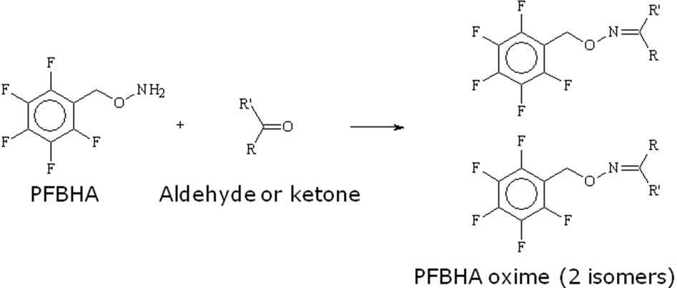
Figure A.4.1.1 PFBHA

For seawater, PFBHA (pre-purified by solid phase extraction, SPE) was added to the sample (20 mL) and the oximes allowed to form (2 hours at ambient temperature, stirring at 550 rpm) prior to extraction (30 min) by SPME. For air, PFBHA was first adsorbed (loaded) onto the fibre (5 min, from the headspace of a 12 mg/mL aqueous PFBHA, at 45-50°C) and the fibre subsequently exposed to the air sample; derivatization occurred simultaneously with extraction (30 min), on the SPME fibre itself. These two different strategies required different SPME adsorbents, both commercially available: 100 µm polydimethylsiloxane (PDMS) for seawater and 65 µm polydimethylsiloxane/ divinylbenzene (PDMS/DVB) for air.

GC separation was effected on a 30 m × 0.25 mm ID × 1 µm film thickness (5% phenyl)-polydimethylsiloxane capillary column.

Optimal spacing of samples allows the analysis of 1 seawater sample every 30 minutes and 1 air sample roughly every hour.

d. Analytical method performance

The derivatization-SPME-GC method for carbonyl compounds was hampered by high and variable signals from laboratory and process blanks, which raised detection limits to levels inadequate for the air & seawater samples. Measures to lower blanks, including preparation and transfer of the samples, standards and blanks under high purity argon and double SPE purification of the PFBHA, proved to be insufficient. Many of the seawater samples, esp. those for which duplicate 125 mL bottles has been taken, were thus spiked with 5 mM sodium azide as a preservative and kept in the dark at ≤ 4°C; they are being transported for analysis on shore.

Conversely, the GC-FID system was robust and experienced few problems, although the FID’s hydrogen-air flame was occasionally extinguished.
Sample  (Niskin)  # | Location | Depth  (m) | Number  Taken | Used | Spiked  with  NaN3 | Comments
351489 | Transit_02b (Event 8) | 2 | 1 | 1
351502 | Transit_04 (Event 11) | 3 | 1 | 1
351540 | L3_22 | 2 | 1 | 1
351563 | L3_24 | 2 | 1 | 1
351584 | L3_26 | 2 | 1 | 1
351596 | L3_28 | 1 | 1 | 1
351607 | L3_27 | 2 | 1 | 1
351629 | L3_25 | 2 | 1 | 1
351653 | L3_23 | 2 | 1 |  | 1
351677 | L3_21 | 1 | 1 | 1
351716 | L3_20 | 2 | 1 | 1
351740 | L3_19 | 2 | 1 |  | 1
351788 | L3_17 | 2 | 1 |  | 1
351825 | L3_16 | 2 | 2 | 1 | 1 | no CTD dry deck sheet
351862 | L3_15 | 2 | 1 |  | 1
351864 | L3_14 | 3460 | 1 |  | 1 | for depth profile
351869 | L3_14 | 2860 | 1 | 1 |  | for depth profile
351873 | L3_14 | 1970 | 1 |  | 1 | for depth profile
351874 | L3_14 | 1730 | 1 |  | 1 | for depth profile
351877 | L3_14 | 1070 | 1 |  | 1 | for depth profile
351880 | L3_14 | 510 | 1 |  | 1 | for depth profile
351884 | L3_14 | 50 | 1 |  | 1 | for depth profile
351886 | L3_14 | 2 | 1 |  | 1 | for depth profile
351910 | L3_13 | 2 | 1 | 1
351934 | L3_12 | 2 | 1 |  | 1
351964 | L3_11 | 510 | 1 |  | 1 | mislabelled?
351971 | L3_11 | 2 | 3 | 1 | 1
351986 | L3_7.5 | 2 | 1 |  | 1
352004 | L3_8 | 2 | 2 | 1 | 1
352028 | L3_09 |  | 1 |  | 1 | Biocast?
352063 | L3_10 |  | 1 |  | 1 | Biocast?
352079 | BON_BAY | 2 | 2 |  | 1 | water temp -1 C
352102 | HL_06 | 2 | 2 |  | 1
352126 | HL_07 | 2 | 2 |  | 1
352150 | HL_08 | 2 | 3 | 1 | 1
352173 | HL_09 | 10 | 2 |  | 1
352183 | HL_05 | 2 | 2 |  | 1
352191 | HL_04 | 1 | 2 |  | 1
352204 | HL_03 | 1 | 2 |  | 1

Table A.4.1.1 Seawater samples drawn during HUD2009015.
Station  No | Event  No | Type | Date  (ADT) | Time  (ADT) | O₃  (ppb) | NO  (ppb) | NO₂  (ppb) | NO_{x}  (ppb)
L3_22 | 28 | FEP bag | 20-May-09 | 20:11 | 47.9 | N/A | N/A | N/A
L3_27 | 49 | FEP bag | 21-May-09 | 15:58 | 45.3 | 0.6 | 2.5 | 3.1
L3_25 | 50 | Canister | 21-May-09 | 16:10 | 44.4 | 0.6 | 2.5 | 3.1
L3_19 | 85 | FEP bag | 22-May-09 | 20:35 | 34 | 0.3 | 1 | 1.2
L3_19 | 87 | Canister | 22-May-09 | 20:45 | 34 | 0.3 | 1 | 1.2
L3_16 | 113 | FEP bag | 23-May-09 | 15:40 | 27.5 | (-0.2) | 0.3 | 0.1
L3_16 | 116 | Canister | 23-May-09 | 16:00 | 27.5 | (-0.2) | 0.3 | 0.1
L3_11 | 165 | FEP bag | 25-May-09 | 14:34 | 29.5 | 0.2 | 1 | 1.1
L3_11 | 166 | Canister | 25-May-09 | 14:50 | 29.5 | 0.2 | 1 | 1.1
HL_06 | 190 | FEP bag | 29-May-09 | 20:57 | 37.5 | 0.3 | 0.9 | 1.1
HL_06 | 191 | Canister | 29-May-09 | 21:10 | 37.5 | 0.3 | 0.9 | 1.1
HL_08 | 198 | FEP bag | 30-May-09 | 11:10 | 27.7 | 0.6 | 0.9 | 1.6
HL_08 | 199 | Canister | 30-May-09 | 11:10 | 27.7 | 0.6 | 0.9 | 1.6

Table A.4.1.2 Air samples taken during HUD2009015.
4.2 Biological Program

a. Narrative

The biological program conducted as part of cruise 2009015, with some modifications, was a continuation of studies began in 1994 to describe the large-scale (spatial and temporal) variability in plankton biomass, productivity and biogenic carbon inventories in the Labrador Sea.

The program has consisted of essentially four elements:
- a phytoplankton biomass/primary productivity program conducted by Jeff Anning (for Glen Harrison),
- a microbial program conducted by Tim Perry (for Bill Li),
- a mesozooplankton program (Erica Head), and
- a dissolved organic carbon program conducted by Jay Bugden (for Paul Kepkay)

The ultimate aim of these studies is twofold:
- to provide a description of the inventories in and export of biogenic carbon from the Labrador Sea, their turnover rates and variability in space and time as part of Ecosystem Research Division’s (ERD) continuing climate studies and
- to provide a description of plankton life-cycles and productivity in the Labrador Sea and its influence or contribution to ecosystems downstream in support of ERD’s ecosystem-related research.

In addition to the Labrador Sea study, phytoplankton, mesozooplankton and nutrient samples were collected along the extended Halifax Section in support of ERD/OSD obligations to the Atlantic Zone Monitoring Program (AZMP) and the new climate component.

A pelagic bird survey was carried out by Rosalind Ford, contractor for Environment Canada’s Canadian Wildlife Service (Dartmouth, NS) supporting CWS work on seabird issues. The goal of this survey was to gather data on the offshore distribution and abundance of marine birds in order to identify and minimize the impacts of human activities at sea on birds. These data will provide critical, and currently unavailable, information for environmental assessments for offshore developments, and will help identify areas where birds are at high risk from oil pollution, and other human activities.

b. Zooplankton Sampling | E. Head

The zooplankton sampling is part of an ongoing program, the aim of which is to investigate the distribution, abundance and life history of the major zooplankton groups found in the Labrador Sea and its associated shelf systems. Particular emphasis is placed on the copepod species of the Calanus genus, which dominate the zooplankton in this region.

Vertical net tows were taken at 30 stations (1 at Station 27, 3 in transit to the L3 line, 22 on the L3 line, 1 on the Newfoundland Shelf and 3 on the Halifax Line). At all stations, tows were made from 100 m to the surface using a ¾ m diameter 200 micron mesh ring net, except at Station 27 and those on the Halifax Line where tows were from the bottom to the surface. An additional tow was made using a using a 30 cm 76 micron mesh ring net at 14 stations (1 at Station 27, 11 on the L3 line and 1 at HL3).

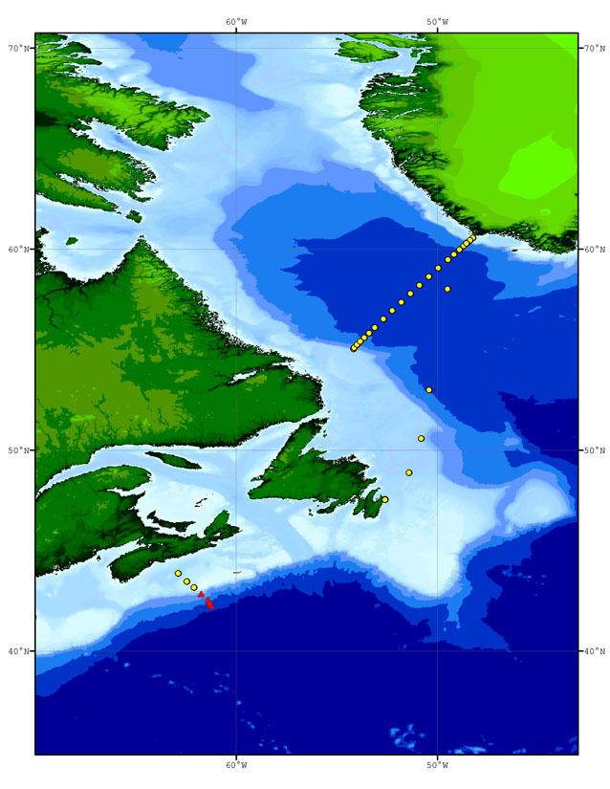
Figure A.4.2.1 HUD2009015 ring net tow (yellow circles) and multi-net tow (red triangles) locations.

c. Depth Distribution of Calanus finmarchicus in the Slope Water off the Scotian Shelf | E. Head

The vertical depth distribution of Calanus finmarchicus in the Slope Water off the Scotian Shelf was investigated. At four stations, HL 6-9, five depth strata (1000-800, 800-600, 600-400, 400-200, 200-0 m) were sampled using a square 0.5 x 0.5 m multi-net fitted with five 200 micron mesh nets. See Table A.4.2.1 below.

Station | Ring Net 200 μ | Ring Net 76 μ | Multi-Net
Station 27 | Y | Y
Transit_01a | Y
Transit_04 | Y
Transit_05 | Y
L3-22 | Y | Y
L3-24 | Y
L3-26 | Y
L3-28 | Y
L3-27 | Y
L3-25 | Y
L3-23 | Y
L3-21 | Y
L3-20 | Y | Y
L3-19 | Y | Y
L3-18 | Y | Y
L3-17 | Y | Y
L3-16 | Y | Y
L3-15 | Y
L3-14 | Y
L3-13 | Y | Y
L3-12 | Y | Y
L3-11 | Y | Y
L3-7.5 | Y | Y
L3-8 | Y | Y
L3-9 | Y | Y
L3-10 | Y
Newfoundland Shelf | Y
HL-6 |  |  | Y
HL-7 |  |  | Y
HL-9 |  |  | Y
HL-8 |  |  | Y
HL-5 | Y
HL-4 | Y
HL-3 | Y | Y

Table A.4.2.1 Net tows performed on HUD2009015.

d. Total Organic Carbon (TOC) | Jay Bugden / Paul Kepkay

In order to better understand the cycling of carbon in the Labrador Sea, it is necessary to examine the pool of total organic carbon (TOC). Obtaining a profile of TOC concentration in the water column can help determine the fate of organic carbon. Elevated concentrations of TOC at depth are indicative of transport of carbon to the deep ocean, which basically removes it from the effects of biological re-mineralization. This can result in the long term storage of organic carbon in the deep ocean. Such information can be applied to models that track the fate of carbon in the environment and its potential effects on climate change.

During CCGS Hudson cruise 2009015 TOC depth profiles were collected from stations of the AR7W line as indicated in the table below.

Station | TOC Profile
AR7W site 1 | Not sampled due to ice
AR7W site 2 | Not sampled due to ice
AR7W site 3 | Not sampled due to ice
AR7W site 4 | Not sampled due to ice
AR7W site 5 | Not sampled due to ice
AR7W site 6 | Not sampled due to ice
AR7W site 7 | Not sampled due to ice
AR7W site 7.5 | X
AR7W site 8 | X
AR7W site 9 | X
AR7W site 10 | X
AR7W site 11 | X
AR7W site 12 | X
AR7W site 13 | X
AR7W site 14 | X
AR7W site 15 | X
AR7W site 16 | X
AR7W site 17 | X
AR7W site 18 | X
AR7W site 19 | X
AR7W site 20 | X
AR7W site 21 | X
AR7W site 22 | X
AR7W site 23 | X
AR7W site 24 | X
AR7W site 25 | X
AR7W site 26 | X
AR7W site 27 | X
AR7W site 28 | X

Table A.4.2.1 TOC sampling on HUD2009015.
e. Primary Production Measurements | Jeff Anning

Water samples for photosynthesis-irradiance (P-I) experiments were collected from the rosette at 10 stations. For each incubation experiment, 33 aliquots were inoculated with ¹⁴C labelled sodium bicarbonate and then incubated at in situ temperatures at 30 light levels (+ 3 dark bottles) for approximately 3 hours. At the end of the incubation period the cells were harvested onto GF/F glass fibre filters for later counting in a scintillation counter. Duplicate chlorophyll, duplicate particulate organic carbon, one particulate inorganic carbon, one HPLC, and one Absorption Spectra sample were collected for each incubation experiment.

Station | Event | Lat. | Long. | Date | Time | Depth | ID
Transit_02b | 8 | 50.6587 | -50.6573 | May 18 2009 | 14:27:24 | 2 | 351489
Transit_02b | 8 | 50.6587 | -50.6573 | May 18 2009 | 14:27:24 | 30 | 351485
Transit_04 | 11 | 53.0037 | -50.4003 | May 19 2009 | 11:49:33 | 2 | 351502
Transit_04 | 11 | 53.0037 | -50.4003 | May 19 2009 | 11:49:33 | 30 | 351498
Transit_05 | 23 | 58.0197 | -49.4933 | May 20 2009 | 11:44:55 | 2 | 351515
Transit_05 | 23 | 58.0197 | -49.4933 | May 20 2009 | 11:44:55 | 30 | 351511
L3-26 | 39 | 60.3673 | -48.456 | May 21 2009 | 07:40:28 | 2 | 351584
L3-28 | 43 | 60.5667 | -48.2282 | May 21 2009 | 16:02:27 | 2 | 351596
L3-28 | 43 | 60.5667 | -48.2282 | May 21 2009 | 16:02:27 | 30 | 351592
L3-20b | 72 | 59.0657 | -49.9487 | May 22 2009 | 13:41:09 | 2 | 351691
L3-20b | 72 | 59.0657 | -49.9487 | May 22 2009 | 13:41:09 | 30 | 351636
L3-16b | 111 | 57.3755 | -51.7828 | May 23 2009 | 14:15:23 | 2 | 351800
L3-16b | 111 | 57.3755 | -51.7828 | May 23 2009 | 14:15:23 | 30 | 351796
L3-15b | 122 | 56.9562 | -52.2357 | May 24 2009 | 12:18:25 | 2 | 351837
L3-15b | 122 | 56.9562 | -52.2357 | May 24 2009 | 12:18:25 | 30 | 351834
L3-11b | 162 | 55.6108 | -53.6315 | May 25 2009 | 13:40:47 | 2 | 351946
L3-11b | 162 | 55.6108 | -53.6315 | May 25 2009 | 13:40:47 | 30 | 351942
L3-10b | 187 | 55.4175 | -53.8308 | May 26 2009 | 11:42:46 | 2 | 352040
L3-10b | 187 | 55.4175 | -53.8308 | May 26 2009 | 11:42:46 | 30 | 352036

Table A.4.2.2 Photosynthesis/Irradiance incubations were conducted at the above stations.
f. Bacterial Abundance and Production of Microbial Plankton | Tim Perry

At every depth at every station sampled on the L3 line and stations sampled on the HL line a sample was collected for bacterial counting by flow cytometry.

Water samples were collected from all depths at 7 stations on the L3 line and incubated for between 3-24 hours after inoculation with ³H labelled leucine. The cells were collected by centrifugation and prepared for scintillation counting back on shore.

Station | Event | Lat. | Long. | Date | Time
L3-24 | 36 | 60.1984 | -48.7379 | May 20 2009 | 04:39:49
L3-27 | 45 | 60.4459 | -48.3736 | May 21 2009 | 18:04:16
L3-18 | 94 | 58.2306 | -50.8711 | May 22 2009 | 04:50:31
L3-14 | 135 | 56.5711 | -52.6720 | May 24 2009 | 22:55:02
L3-11 | 163 | 55.5882 | -53.6434 | May 25 2009 | 16:50:33
L3-7.5 | 174 | 55.0521 | -54.1364 | May 25 2009 | 00:12:19
L3-08 | 177 | 55.0977 | -54.0867 | May 25 2009 | 03:08:20

Table A.4.2.3. Microbial production incubations were conducted at the above stations.

g. Pelagic Bird Survey | Carina Gjerdrum

Carina Gjerdrum, Environment Canada
45 Alderney Drive, Dartmouth, N.S., B2Y 2N6
(902) 426-9641 carina.gjerdrum@ec.gc.ca

SEABIRD OBSERVER: Rosalind Ford

BACKGROUND

Our primary objective for the pelagic monitoring program is to map the relative abundance and distribution of pelagic birds in Atlantic Canada. We rely on ships-of-opportunity to carry seabird observers to offshore areas throughout the region, and prioritise areas that can be surveyed across multiple seasons and years. These data will provide critical, and currently unavailable, information for environmental assessments for offshore developments, help identify areas where birds are at high risk for oil pollution and other human activities, identify critical marine habitat, and allow us to monitor trends in abundance and distribution of marine birds.

Protocol

The main objective of our protocol is to ensure that observers conducting surveys at sea from a moving platform are recording data in a consistent, unbiased fashion that permit subsequent conversion into seabird densities. This protocol is consistent with methods used elsewhere in the world, making these data comparable to other geographic areas.

Surveys are conducted while looking forward from the bridge, scanning ahead to a 90° angle from either the port or starboard side, limiting observations to a transect band 300 m wide from the side of the platform. A survey consists of a series of five-minute observation periods, which are exclusively dedicated to detecting birds at sea. We conduct as many consecutive five-minute observation periods as possible, regardless if birds are present or not, and try to ensure consistent coverage throughout the day.

We scan the transect continuously by eye, to count and identify birds present in air or on water. Binoculars are used to confirm the species identification, and other details, such as age, moult, carrying fish, etc. We continuously record all birds observed on the sea surface and estimate their distance from the platform. Flying birds are not recorded continuously as this would overestimate bird density. Instead, we record flying birds using instantaneous counts, or snapshots, at regular intervals throughout the observation period. The number of snapshots conducted depends on the speed of the platform.

GENERAL RESULTS

From 17 May–1 June, 1602 km of ocean track were surveyed from the bridge of the CCG Hudson. During this time, 2291 birds from 6 different families were counted (Table 1). In general, birds were widely distributed throughout the survey area, although higher densities occurred just outside Halifax Harbour, off the coast of the Avalon Peninsula, and over Newfoundland slope waters (Figure A.4.2.2).

Species from the family Procellariidae were the most abundant group observed (49%), most of which were Northern Fulmar (Table 1). Northern Fulmar were observed throughout the survey area, but were most common over Labrador slope waters and across the Labrador Sea (Figure A.4.2.3a). Observations of both Sooty and Greater Shearwaters were concentrated on the Scotian Shelf (Figure A.4.2.3b). Birds from the family Alcidae accounted for 33% of the total observations (Table 1), most of which were murres. Murres were most common off the coast of Newfoundland, but were observed on both crossings of the Labrador Sea (Figure A.4.2.3c). Dovekie were observed in the Labrador Sea, and Atlantic Puffins were most common in the vicinity of their colonies on the Avalon Peninsula (Figure A.4.2.3d).

Storm-petrels accounted for 7% of the observations, which were especially numerous on the Scotian Shelf (Figure A.4.2.3e). Wilson’s Storm-Petrels were not distinguished from the Leach’s Storm-Petrels. Black-legged Kittiwakes were numerous off the coast of the Avalon Peninsula, but also nearing the coast Greenland (35% of the total observations). Herring and Great Black-backed Gulls were observed in relatively low numbers, and a concentration of terns was sighted on the southern Labrador slope (Figure A.4.2.3f).

ACKNOWLEDGEMENTS

Our work could not occur without the generous support of DFO scientists and staff, and the Coast Guard officers and personnel.
Family | Species |  | Number Observed
Procellariidae | Northern Fulmar | Fulmarus glacialis | 1094
 | Sooty Shearwater | Puffinus griseus | 3
 | Greater Shearwater | P. gravis | 31
 |  | Oceanodroma or
Hydrobatidae | Unknown Storm-Petrels | Oceanites | 154
Sulidae | Northern Gannet | Morus bassanus | 6
Scolopacidae | Red Phalarope | P.fulicaria | 9
Laridae | Pomarine Jaeger | Stercorarius pomarinus | 7
 | Long-tailed Jaeger | S. longicaudus | 2
 | Unknown Jaeger | Stercorarius spp. | 3
 | Great Skua | S. skua | 1
 | Herring Gull | Larus argentatus | 61
 | Great Black-backed Gull | L. marinus | 12
 | Lesser Black-backed Gull | Larus fuscus | 6
 | Glaucous Gull | Larus hyperboreus | 22
 | Iceland Gull | Larus glaucoides | 9
 | Black-legged Kittiwake | Rissa trydactyla | 64
 | Unknown Gull | -- | 10
 | Unknown Tern | Sterna spp. | 34
Alcidae | Dovekie | Alle alle | 166
 | Thick-billed Murre | Uria lomvia | 5
 | Common Murre | U. aalge | 308
 | Unknown Murre | Uria spp. | 104
 | Razorbill | Alca torda | 2
 | Atlantic Puffin | Fratercula arctica | 142
 | Unknown Alcidae | Alcidae | 36
Total number observed within transect |  |  | 2291

Table A.4.2.4. Numbers of birds observed within the 300 m transect during the spring 2009
Labrador Sea survey.
Figure A.4.2.2 Bird densities (number of birds km⁻²) observed during spring 2009 Labrador Sea surveys.
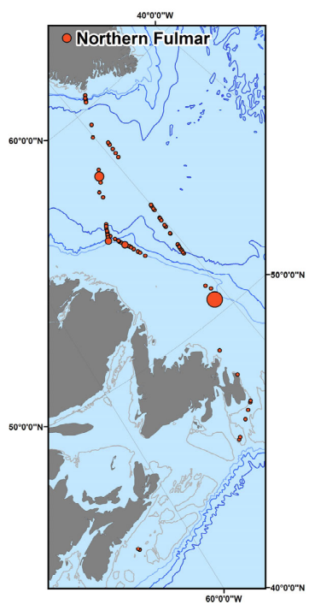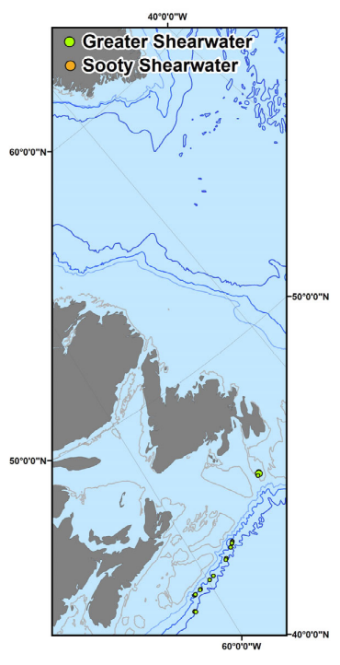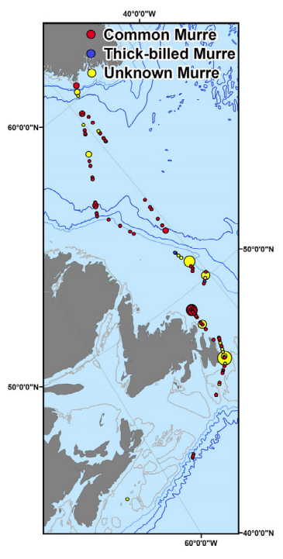

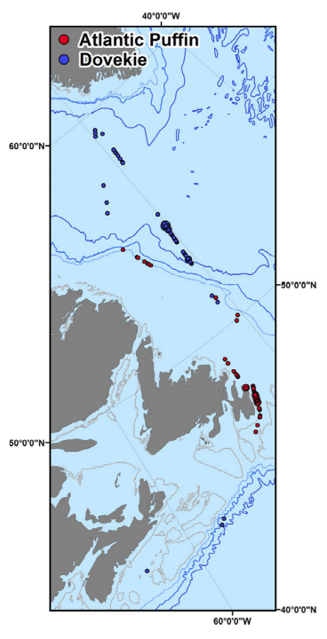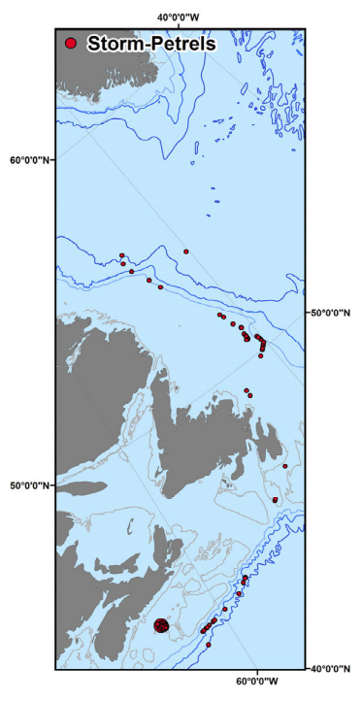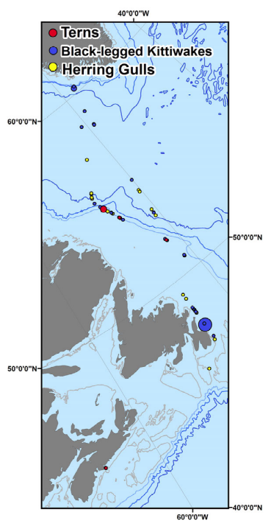

Figure A.4.2.3 Density of various species observed during spring 2009 Labrador Sea surveys.
Density scale is the same as that presented in Figure A.4.2.2.
5. Major Problems and Goals Not Achieved

Weather and ice presented challenges to time management on this mission. Sea ice on the Labrador Coast was late in withdrawing, necessitating detours on transit and a return via Cape Race. A low pressure system passing to the south caused a suspension of over-the-side operations in the western Labrador Sea for approximately 12h. A detour to avoid a forecast tropical depression approaching the offshore end of the Extended Halifax Line cost another 6h. A reduction in steaming speed because of persistent fog during the occupation of the extended Halifax Line and Halifax Line also cut into our station time. We achieved all of the priority Labrador Sea measurements that ice conditions allowed. We achieved good coverage of the Extended Halifax Line out to site HL_9 but had to drop planned stations further offshore. We had to bypass the AZMP time series at Halifax Line Station 2 because of poor time management over the final hours of the mission, which we particularly regret.

6. Other Incidents of Note

It has been noted previously that the extension boom on the North Pacific crane on the foredeck is too short for many operations such as the recovery of the nets during Multinet deployments.

Several persistent issues of concern with winch room operations were discussed with the Commanding Officer and Chief Engineer and during meetings of the Occupational Safety and Health Committee and Safety Management System Review Committee attended by the Senior Scientist:

(1) The Telescopic Boom in the winch room allows for the rapid exchange of metering blocks for the CTD and hydrographic winches. This capability is required to allow alternative CTD and vertical net tows at the same station. After each exchange the blocks must be securely seated in the latching mechanism at the outboard end of the boom. With the present arrangement it is difficult to tell if the block is securely latched in. Although we did not experience any specific problems on HUD2009015, we are aware of two specific incidents during the 2008 and 2009 field seasons where the block fell way from the latching mechanism. This is a potentially hazard. We strongly recommend that a redesign of the latching mechanism be undertaken with the goal of providing a safer system for use in the 2010 field season.

(2) The CTD/Rosette package weighs approximately 2000 lb. It presents a potential hazard to personnel recovering the package in the confined winch room if the ship rolls as the CTD is coming on board during rough weather. Senior technical personnel have suggested that some sort of tethering system might help manage the associated risks. We support the investigation of any practical measures for safer operation of this system.

(3) There does not appear to be a protocol to maintain and test the wire on the hydrographic winch. This wire parted during the previous mission with resultant damage to scientific equipment and potential injury to personnel. This issue needs to be urgently addressed.
7. List of Cruise Participants

Name | Responsibility | Affiliation
Jeffrey Anning | Phytoplankton/primary productivity, CFMP | ERD, BIO
Carol Anstey | Nutrients, Oxygens | ERD, BIO
Kumiko Azetsu-Scott | Scientist, Carbonate, Alkalinity, O-18 | OSD, BIO
Richard Boyce | Salts, Mooring | OSD, BIO
Darlene Brownell | CFCs | BDR
John (Jay) Bugden | Total Organic Carbon | ERD, BIO
Adam Drozdowski | Computer Room, XBTs | OSD, BIO
Rosalind Ford | Sea bird observer | EC, CWS
Glen Harrison | Associate Chief Scientist, Biological | ERD, BIO
Adam Hartling | VMADCP, ADU5, LADCP, Winch Room | OSD, BIO
Erica Head | Zooplankton, Net Tows | ERD, BIO
Ross Hendry | Chief Scientist | OSD, BIO
Yongcun Hu | Computer Room | OSD, BIO
Ed Hudson | Carbonyls, Air Samples | McGill
Jeffrey Jackson | Data management, Computer Room | OSD, BIO
Visahini Kanthasamy | Carbonyls, Air Samples | McGill
Chris L’Esperance | pH | BDR
Darlene Mossman | Carbonate, Alkalinity | MBCO, BIO
Richard Nelson | CFCs | ERD, BIO
Shannon Nudds | Computer Room | RMC
Timothy Perry | Bacterial Abundance, Microbial Plankton | ERD, BIO
Robert Ryan | CTD maintenance, Winch Room, | OSD, BIO
David Slauenwhite | Carbonate, Alkalinity | OSD, BIO
Igor Yashayaev | Scientist, Hydrography, XBTs | OSD, BIO

BIO | Bedford Institute of Oceanography  PO Box 1006, Dartmouth, NS, Canada, B2Y 2A4
BDR | BDR Research Ltd.  Box 652, Station 'M', Halifax, NS, Canada, B3J 2T3
EC, CWS | Environment Canada, Canadian Wildlife Service  45 Alderney Drive, Dartmouth, NS, Canada, B2Y 2N6
ERD | Ecosystem Research Division, BIO
MBCO | Maritimes Biotechnology Coordination Office
McGill | McGill University  801 Sherbrooke Street West  Montreal, QC, Canada H3A 2K6
OSD | Ocean Sciences Division, BIO
RMC | Royal Military College of Canada  PO Box 17000, Station Forces  Kingston, ON, Canada K7K 7B4
B. UNDERWAY MEASUREMENTS

1. Navigation and Bathymetry | Jeff Jackson

The navigation system onboard CCGS Hudson consists of differential GPS receiver and navigation software. The receiver is one of many NMEA feeds into a multiplexer that provides all the NMEA strings to a PC on the bridge. The PC running the navigation software, then rebroadcasts the NMEA strings to distribution units in the computer room, which provide many output lines for the working labs. The resulting broadcast navigation strings are ~ 1 Hz. The navigation data are then logged at specified intervals on a PC. For this cruise the navigation was logged approximately every second.

AGCNAV is a PC-based display and waypoint setting software package, developed at the Atlantic Geoscience Centre [now Geological Survey of Canada (Atlantic)] at BIO. This software graphically displays ship position, waypoints, course, speed, etc. to the various science working areas. This has been the standard software package for years now and we used it again on this mission.

New to the navigation acquisition arena is the Geological Survey of Canada’s (GSC) Survey Suite navigational software. This is a Microsoft Windows based package which grabs every NMEA string broadcast over the network. It adds a date/time stamp to every data record acquired. It was tested on this cruise and it seemed to work very well without any problems. It is easier to configure and operate than AGCNAV. The only negative observation that can be made is that it does not have a waypoint viewer.

The echo sounder system used for collecting bathymetric data at station locations consisted of a 12 KHz Raytheon PTR echo sounder that created an analog trace on a Raytheon Line Scan Recorder located in the forward laboratory. The transducer beam width is 15 degrees. The sweep rate of the recorder was adjusted throughout the course of data collection to aid in identifying the bottom signal. One transducer is positioned on a Ram that can be lowered or raised depending on conditions. When the ram is up, the waterline to transducer offset is 6 m. When the ram is down, the offset is 8 m.

2. Vessel Mounted Acoustic Doppler Current Profiler | Adam Hartling

Hudson is equipped with a Teledyne RDI Ocean Surveyor II vessel mounted acoustic Doppler current profiler (ADCP) system consisting of a 75 kHz phased array transducer assembly mounted in a well in the ship’s hull and a deck unit and computer located in the forward lab.

The transducer assembly is mounted on a ram penetrating the ships hull that can be lowered if necessary. Transducer remained in the retracted position for the duration of the cruise. It was determined during sea acceptance testing that lowering the transducer did not effect the operation of the system. The transducer is located approximately 6m below the waterline.

The system is capable of collecting bottom track data to 1000 m and profile data to 650 m. Setup includes 100-8 m bins. The Ocean Surveyor was set to operate in the narrow band single ping mode with 3 sec ensemble time. Position, heading, pitch and roll data is provided by the ADU5 attitude determination unit at a 1 Hz rate. Ships gyro heading data is connected directly to the OSII deck unit. The Ocean Surveyor also includes a temperature sensor for sound speed calculations.

WinADCP software package used monitor profile data in real time. WinADCP is set to display times series of short-term averaged profile and attitude data. VmDas Software package used to deploy OSII and log raw data, VmDas option files, intermediate and processed files. Data back-up on external hard-drive. Data back-up includes only raw data and VmDas option files.

All NMEA strings are logged during data collection. The gyro heading is included in the raw data. Raw data is processed in real time for a short term average of 30 sec and a long term average of 300 sec.

Data will have to be reprocessed using gyro heading during periods with low quality or no attitude solution. Raw data can be reprocessed using VmDas.

A significant increase in the noise floor is caused by bow thrusters while on station, during high sea states, or during travel at speeds in excess of 12 knots in rough conditions. The increase in noise floor results in a significant decrease in data quality and reduction in profile range.

3. Continuous Flow Multisensor Package (CFMP) | Jeff Anning

Water from approximately 4 m depth was continuously pumped to the forward lab. The temperature, conductivity and fluorescence were measured and logged every 60 sec. The temperature and conductivity were measured with Sea-Bird sensors and the fluorescence by a WET Labs flow through fluorometer. Incident Photosynthetically Active Radiation was measured with a Li-Cor Spherical Quantum Sensor and this data was collected as hourly means. Exact time and positions were provided by the ship's GPS and logged with the other data.

4. XBT measurements | Igor Yashayaev

Expendable Bathythermographs were routinely deployed during the HUD2009015 mission. See Fig. B.4.1 for a map with the XBT drops indicated. We used three different models of XBTs: Sparton T5, Sippican T7 and Sippican T10. T5s are capable of measuring to maximum depths of 1900 m at the cruising speed of 6 knots, T7s record temperature to 800 m at the cruising speed 15 knots and T10s to 200 m. The vertical resolution of the measurements was about 0.6-0.8m. There were 24 T5, 45 T7 and 27 T10 XBTs launched during the cruise (Table A.2.1 lists the operation numbers when these were deployed).

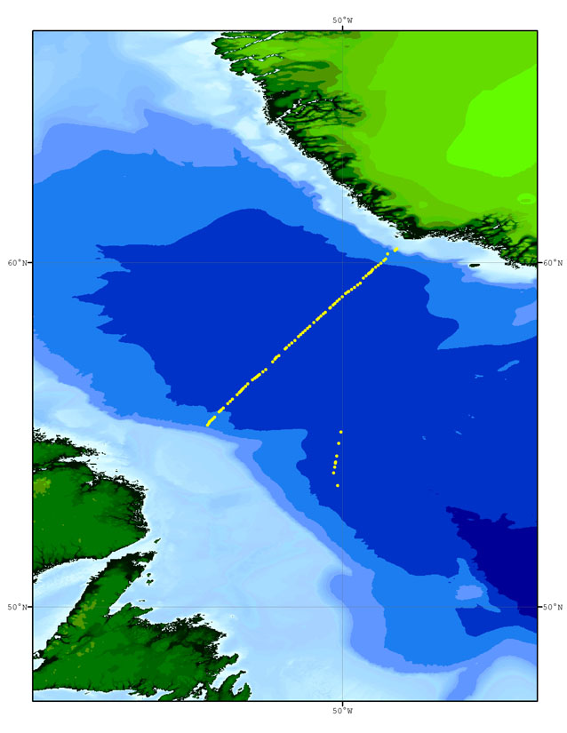
Figure B.4.1 XBT sites (yellow circles) in the Labrador Sea during HUD2009015.

5. Ashtech ADU5 Attitude Determination Unit | Adam Hartling

The Ashtech ADU5 is an attitude determination and real-time DGPS positioning system that provides motion corrections for the Ocean Surveyor II (OS-II) vessel-mounted ADCP.

The ADU5 uses differential carrier phase measurements from an array of four GPS receivers (Antennas) to compute heading, roll, and pitch in real-time at a 5 Hz update rate.

Position and velocities are computed only for Antenna 1. The remaining antennas provide carrier phase data for attitude determination. Antenna 1 is a Beacon antenna providing differential position when in range of a base station. Beacon corrections were available for all but the most northeast portion of the cruise.

Antenna separations in a normal multipath environment determine the level of solution accuracy. The fore-aft antenna separation of 3 m provides potential heading accuracy of 0.2 degrees. The port-starboard antenna separation of 1 m provides potential pitch/roll accuracy of 0.6 degrees.

User configurable data is output on two serial ports. Output Port A is not used. Output Port B, 115200, 1 Hz update rate, provides position and attitude data for the Ocean Surveyor II. NMEA strings used include GGA, VTG, and PASHR, AT2 (heading, pitch, roll)

When the receiver is searching for the ambiguities or when a valid solution has not been found, a code phase estimate of heading appears in the PASHR, AT2 string and pitch and roll are displayed as exactly 0.00. Heading may also be displayed as 0.00 if no estimate is available. The PASHR, AT2 string contains a quality flag which indicated the quality of the solution. When either of these situations exist, the attitude reset flag is set to 1 in the attitude output message (a 0 for the attitude reset flag indicates a good attitude solution).

If noisy or bad satellite measurement data was received by the ADU5 the Kalman filters sometimes get lost. This results in no valid solution. This often is the result of high multipath interference. BRMS and MRMS fields in the PASHR, AT2 string will exceed maximum noise levels, and the PDOP will become large. For a good solution PDOP should be less than 6.

Solution quality was monitored on a daily basis with the aid of the Teledyne RDI VMDAS and WinADCP software packages used to log and monitor the OSII ADCP current profile data.
6. Meteorological measurements | Ross Hendry

The officer of the watch enters standard meteorological data into the ship's log book (not the science log book) at regular intervals. On occasion we have transcribed these logged values for local scientific use but there is no standard protocol for doing this.

Since April 2003 Environment Canada (EC) has maintained an AXYS Technologies Inc. Automated Volunteer Observing Station (AVOS) on board Hudson that measures a suite of meteorological variables. Data are stored on an EC-maintained personal computer on board Hudson. Normally these measurements are automatically forwarded at regular intervals onto the Global Telecommunication System (GTS) of the World Meteorological Organization. The GTS data then become available at
http://www.sailwx.info/shiptrack/shipposition.phtml?call=CGDG but there are significant data gaps which include the entire period of HUD2009015.

Wind speed and direction are operationally monitored with a Young Model 05103 Wind Monitor, (R. M. Young Company, MI, USA) mounted on the starboard side of the upper platform on Hudson's antenna mast at an estimated elevation of 25 m above sea level. The Wind Monitor is connected to a Young Model 06206 Marine Wind Tracker located on the bridge. The Marine Wind Tracker provides NMEA $WIMWV (Wind Speed and Angle) strings which are captured, time-stamped, and logged at 1-second intervals by the Geological Survey of Canada’s (GSC) Survey Suite navigation logging system.

Wind direction reported by the Wind Monitor is the direction relative to the ship's heading from which the wind is blowing, zero degrees when the wind is on the bow and increasing clockwise when viewed from above. The manufacturer of the Model 05103 Wind Monitor notes that the wind direction potentiometer has a 5° dead band between 355 and 360 degrees. In the Hudson installation the NMEA output directions actually show a dead band between approximately 175 and 180 degrees.

Additional information is needed to convert the wind measurements from a ship reference frame to a geographic reference frame. Relative wind direction is converted to geographic direction by adding the ship's heading. Ship's heading information is provided by a Raytheon Marine Standard 20 Gyro Compass System as NMEA $HEHDT (Heading – True) strings. Wind speed and direction in a geographic reference frame are then computed by the vector addition of the wind velocity in the ship reference frame and the ship's velocity. The ship's true course and speed are provided by the Ashtech ADU5 attitude determination and real-time DGPS positioning system (Section B5) as NMEA $GPVTG strings (Track Made Good and Ground Speed). These additional NMEA strings are also captured at 1-second intervals by the Survey Suite system.

The 1-second geographic vector wind values were bin averaged in 60-second bins centred on even minutes to provide a uniform 1-minute time series. A 5-minute time series was then produced by smoothing the 1-minute vector time series with a 5-point convolution filter with relative weights [1 4 6 4 1] and sub-sampling the smoother time series (Fig. B.6.1-2).

Calculated ship winds were verified against Environment Canada hourly winds from Sable Island [http://www.climate.weatheroffice.gc.ca/climateData/hourlydata_e.html] during the period 06:00 UTC 28 May − 18:00 UTC 31 May 2009 when Hudson was within about 150 nm of Sable Island. Winds in the operational area shifted from easterly (100°T) to westerly (260°T) during this period. The mean difference between ship board wind directions from hourly bin averages of the 5-minute vector winds and hourly Sable Island wind directions was about 13 degrees with conventional 95% confidence limits of about 5 degrees and 21 degrees for 62 valid hourly wind readings. Ship board wind speeds showed the same trends as the Sable Island winds but were on average about 1.4 times greater, an expected outcome because the ship board winds were measured at 25 m height compared to the 5 m elevation of the Sable Island wind station.

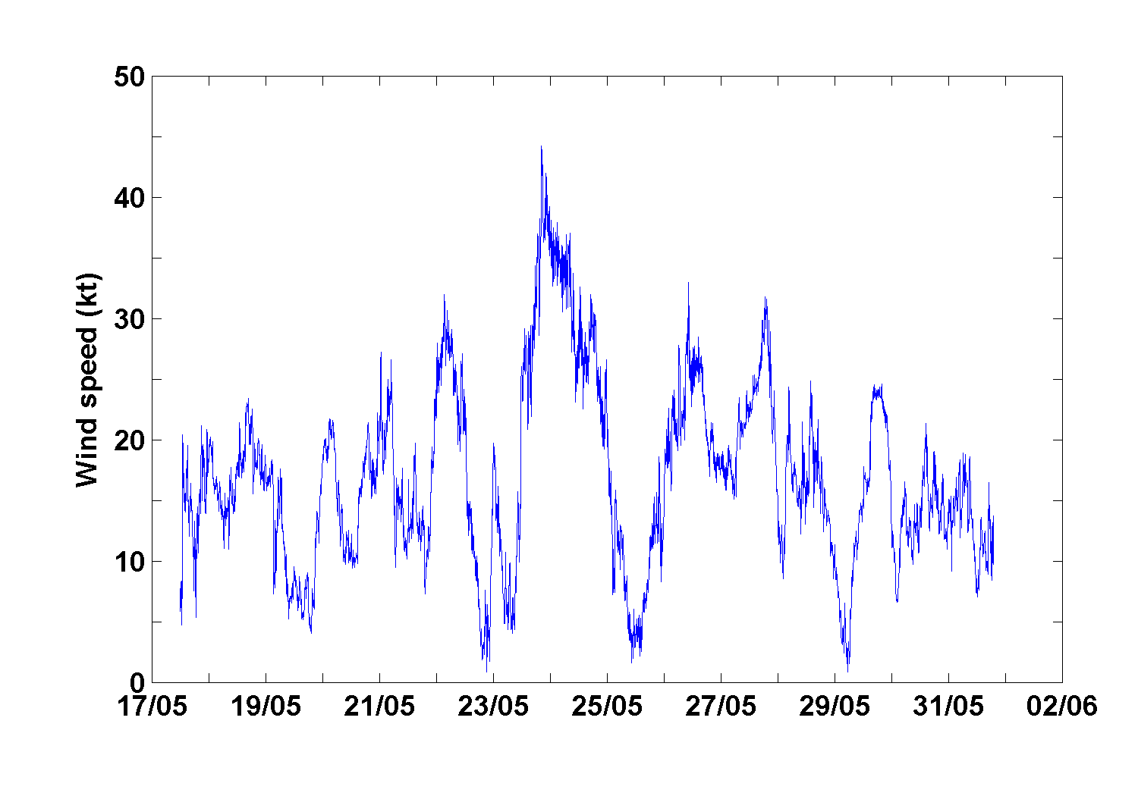 | 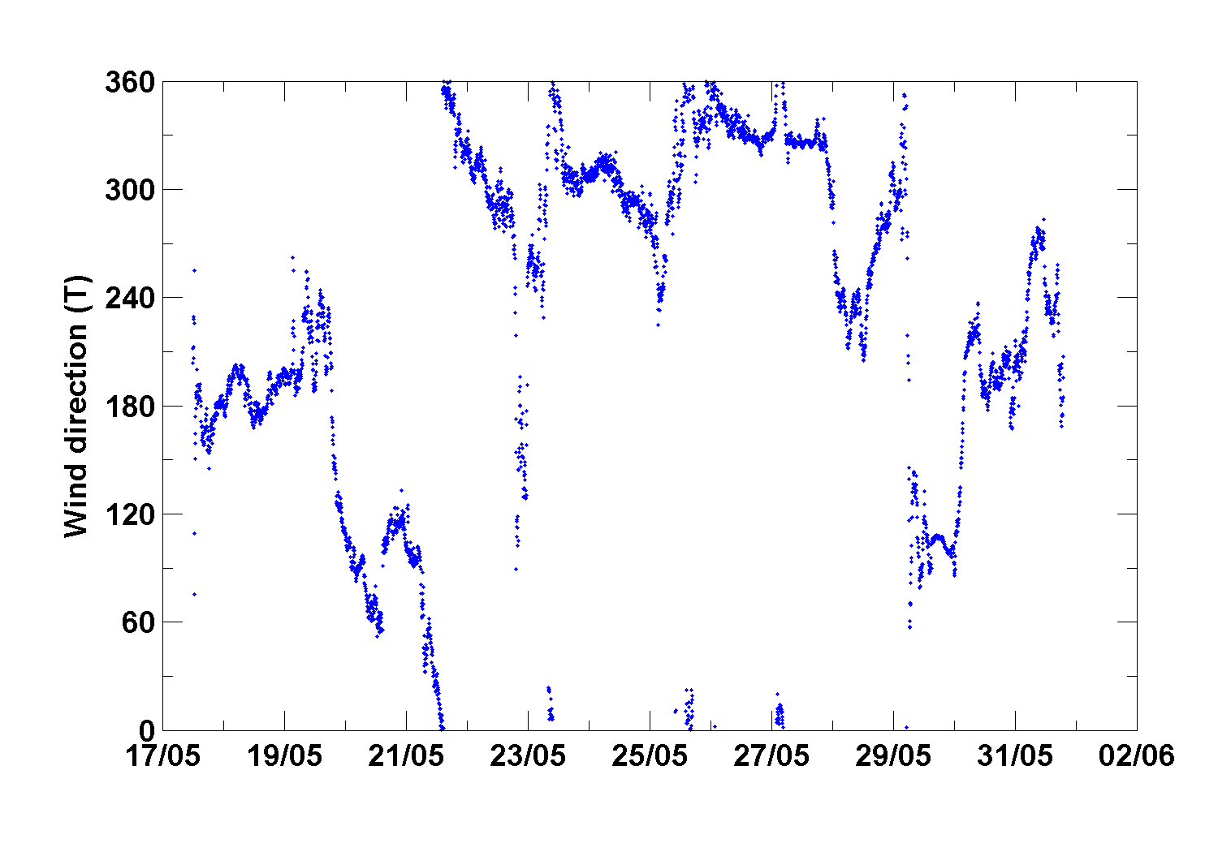
Figure B.6.1 Wind speed from 5-minute vector averaged winds. | Figure B.6.2 Wind direction from 5-minute vector averaged winds.

7. Atmospheric Chemistry

The atmospheric chemistry program carried out by investigators from McGill University is described in Section 4.1.c in Part A above.
C. HYDROGRAPHIC MEASUREMENTS -
DESCRIPTIONS, TECHNIQUES AND CALIBRATIONS

1. CTD Measurements | Ross Hendry/ Bob Ryan/ Igor Yashayaev

a. Description of the Equipment and technique

CTD measurements on HUD2009015 were made with a Sea-Bird Electronics, Inc. 911plus CTD equipped with dual temperature, conductivity, and SBE 43 dissolved oxygen sensors. The SBE 9plus sea unit was mounted vertically within a custom-designed CTD/Rosette frame that accommodates 24 10-L sampling bottles.

Additional analog sensors included a Chelsea Technologies Group Ltd. AquaTracka III Fluorometer, a WET Labs, Inc. CDOM WETStar Fluorometer, a LI-COR Biosciences LI-193SA Irradiance PAR Sensor, and a Sea-Bird SBE 18 pH sensor. A Teledyne Benthos 2110-2 Altimeter was installed in the rosette package and interfaced with the SBE 911plus for bottom detection. Details of the CTD configuration are provided in Appendix 3.

A free-running Teledyne Benthos BFP-312 bottom finding pinger and a self-contained Teledyne RDI 150 kHz Broadband Lowered Acoustic Doppler Current Profiled (LADCP) belonging to the Woods Hole Oceanographic Institute were also installed on the rosette.

All the pressure cases as well as the sample bottles were mounted vertically to improve the package's stability as it descends through the water column. In the centre of the frame is an aluminum tube, which contains at its upper end a 24-position Sea-Bird SBE 32 Carousel Water Sampler. The frame itself is subdivided into four quadrants. One quadrant holds the LADCP in a shortened pressure case. Another quadrant contains the SBE 9plus pressure case and the WetStar fluorometer. The third quadrant contains the battery pack for the LADCP, the altimeter, and the pinger. The last quadrant contains the dual CTD sensors and pumps. The WETStar Fluorometer and LI-COR PAR Sensor have limited depth ranges and are only deployed on shallow casts. They are mounted together in a removable rack to facilitate the change-over from shallow to deep casts. The pH sensor SBE 18 has limited depth range and is also mounted for ease of removal.

The CTD package was deployed from Hudson's enclosed winch room with a Hawboldt Industries Model SPR 43-3640 winch loaded with 7000 m of 0.3125" diameter single-conductor double-armoured cable manufactured by Rochester Wire & Cable. The conductor cable is led out over an 18" diameter ODIM Brooke Ocean Instrumented Metering Sheave (IMS) mounted at the end of a telescoping boom. A quick-change mechanism allows switching blocks between the IMS and a mechanical sheave used for the hydrographic winch located inboard of the CTD winch which is used for vertical net tows. The IMS comprises the sheave block, a computer-based display, and a remote winchroom display. The IMS measures cable tension, scope, speed, and inclination. The Lab Unit and Remote Displays are equipped with inter-system communications features for sending commands and messages to the winch operator.

b. Sampling Procedure and data processing techniques

The rosette frame and CTD were deployed with a lowering rate of 60 m/min (40 m/min in the upper 200 m). The package was recovered at a rate of 75 m/min depending on the wire tension.

Microsoft Windows based Sea-Bird SEASOFT V2 Version 7.14c was used for CTD data acquisition, conversion, and real-time display. IMS software was used for communication with the winch operator and for providing CTD readout to the metering block display.

An in-house JAVA-based CTD Data Acquisition and Processing application (Hum, 2009) provides a wrapper for downloading and processing CTD data from the SBE19plus. Data processing modules from Sea-Bird SBE Data Processing Version 7.14c and in-house BIO processing modules are applied to the raw CTD data files to produce output in several different formats for further analysis. The DATCNV (data conversion) module converts the raw data file to engineering units, and stores the converted data in a .CNV file. DATCNV also creates a water bottle [.ROS] file from the raw [.BL] data file containing CTD scan numbers corresponding to bottle trips. The ROSSUM (bottle summary) module converts the .ROS file to a water bottle summary [.BTL] file. Sea-Bird modules split data in .CNV files into upcast and downcast files, and translate binary data to ASCII format. The in-house SeaODF module reads the final .CNV file, and creates an Ocean Data Format [.ODF] file. ODF_IGOSS appends an IGOSS station record to a [.IGS]. QProBtl creates a [.QAT] file for each [.BTL] file. The [.QAT] file is an ASCII, comma delimited file containing the same data as the [.BTL] file in a different format. Calib appends merged data from the [.ODF] and [.QAT] files to a calib.txt file. All the raw and processed data files associated with the station are then transferred to the ship's file servers for archive and subsequent access and distribution to various users on the vessel.

2. Salinity | Rick Boyce

a. Description of Equipment and Technique

Salinity samples were analyzed using brand new Guildline Autosal 8400B salinometer, serial number 69780. Samples were drawn into 200 mL bottles. Once the sample bottle was rinsed three times and filled to the shoulder, the neck and threads of the bottle were dried using paper towel and a new dry cap was installed. Once the bottles reached room temperature, the caps should be retightened. The drying of the neck of the bottle and installing a dry cap has been a technique used since the HUD2000009 cruise and prevents salt crystals from forming under the cap if samples are left for a long period of time before analysis.

The salinometer cell was filled and rinsed three times with sample water. A fourth sample was introduced into the cell and readings were averaged over a 10 to 15 second interval until the operator was satisfied that the correct value was attained. If there was any doubt in this value, subsequent refills were performed and readings averaged as above. Once satisfied, a sample ID number and Conductivity Ratio was recorded onto the Salinity Log Sheet. Periodically, the room temperature was recorded as well.

b. Data Processing Technique

Conductivity ratios, sample ID’s and standards were entered into the ODIN database (Isenor, 2000). Conductivity ratios were used to compute salinities using the water sample conductivity ratio and the standard IAPSO formula applied in an ODIN module. Any changes in the salinometer readings between successive standardizations were assumed to have occurred as a linear drift of the instrument. Thus, the program applied a correction to the ratios, which varied linearly with the samples analyzed. An offset was also applied if the initial standardization was different from the quoted value given on the ampoule label. The computed salinity data was then placed in the water sample database.

c. Laboratory and Sample Temperatures

Full cases of samples were taken from the Winch Room to the Drawing Office. At least one hour prior to analysis, a case of 24 salinity bottles were placed into a water bath (2) set at 23.5º C. During this particular Mission, the room temperature in this area ranged remained quite stable hovering near 24ºC. The Autosal bath temperature was maintained at 24º for all samples.

d. Replicate Analyses

One or more replicates were drawn from a total of 53 of the 458 rosette bottles sampled for salinity but this figure includes 23 cases where there was a deliberate delay in either running the sample (14 cases) or in drawing the sample (9 cases) to investigate the degradation of samples due to evaporation. Statistics of the signed (first sample minus second sample) differences between the first two replicate salinity samples drawn and processed within the normal time frame are as follows:

Statistic | Value
Number of Points | 30
Median | 0.0000
Mean | 0.0001
Minimum | -0.0010
Maximum | 0.0022
Standard Deviation | 0.0007

Table C.2.1 Salinity replicate statistics

29 of 30 signed differences in salinity lay within the range [-0.001 0.001], with the only exception giving rise to the maximum outlier 0.0022.

9 special replicate salinity samples were drawn from Event 190 after the end of normal sampling to test the effects of head-space evaporation on salinity. The rosette bottles were drained to leave approximately 5 L of water and replicate sample was taken after a delay of about 2 hours. A total of 16 replicates including 3 from the same rosette bottle (Aging Sample) were drawn and set aside and run as a group near the end of the mission to test the effects of sample storage on salinity.

e. Standards Used

The salinometer was standardized during the mission using IAPSO standard water, Batch P149 dated Oct 5/07 having a K15 value of 0.99984 salinity of 34.994 and Batch P150 dated May 22/08 having a K15 value of 0.99978 salinity of 34.991. Typically, standardization checks were performed at the beginning and end of a run not to exceed 60 samples. Batch P149 was used for Run 1 and the initial standardization of Run 2. Batch P150 was used for the final standardization of Run 2 and subsequently. The ODIN software assumes that the same standard is used throughout a particular run so a customized post-cruise procedure was needed to calculate corrected salinities for the Run 2 Autosal analyses.

f. Performance of the Autosal salinometer

Overall the new salinometer worked flawlessly during the mission. There was very little difference between the standards and the Standardize knob on the Autosal did not have to be adjusted. The introduction of water baths to bring the samples close to the temperature of the Autosal bath has made the analysis much better. The instrument spends very little time in bringing the sample to the temperature of the bath thus reducing bath fluctuations. The lab temperature was stable during all runs which is an important factor when trying to optimize the performance of the instrument. Historically the Autosal was setup in the General Purpose (GP) lab onboard Hudson. Air temperature was difficult to control in this area. For this mission the Autosal was installed in the Drawing Office where the operator can control the ambient air temperature much better than in the GP lab.

3. Oxygen | Carol Anstey / Richard Nelson / Darlene Mossman

a. General

This report concerns data from the combined cruises HUD2009011 Orphan Basin and HUD2009015 Labrador Sea. Samples for the determination of dissolved oxygen were collected along transects crisscrossing the Orphan Basin, Newfoundland Monitoring station 27, AR7W-L3 and the Halifax Line on the Scotian Shelf. Samples were drawn from all the depths at each station with few accidental exceptions. Replicate samples were collected at one depth, either bottom or oxygen maximum, for each station.

The samples were analyzed using an automated system developed at the Scripps Institute of Oceanography based on a modified Winkler titration technique.

b. Sampling Procedures

Sub-samples were drawn from 10 L bottles attached to a 24-bottle Rosette Sampler. Oxygen sub-samples were drawn after chlorofluorocarbon (CFC) and total organic carbon (TOC) samples. The oxygen sampling bottles were 125 mL Iodine flasks with matched custom ground stoppers (Levy et al., 1977). The flask volumes were predetermined gravimetrically (volume data saved to titration program). The matched flasks and stoppers are etched with identification numbers.

Each oxygen sub-sample was drawn through a silicone tube attached to the spigot of the Rosette bottle. The flask and stopper were thoroughly rinsed. The flow was then allowed to continue until two to three flask volumes overflowed. The sampling tube was slowly removed with continuous low flow to ensure that no air was trapped in the flask and the volume kept to the brim until the stopper was added. As in the previous year, the draw temperature of each sample was taken by a digital thermometer in the winchroom. There were no problems this year with the thermometer. Samples were oxidized immediately with the addition of 1.0 mL each Alkaline Iodide and Manganous Chloride. The flask stopper was carefully inserted to avoid introducing air and the flask was thoroughly shaken. Beginning this year, the samples were stored immediately after collection for at least 30 minutes to allow the precipitate to settle in a 4°C refrigerator located in the GP lab as per original protocols: store cool and in the dark to prevent undesirable photochemical reactions (Appendix 1 in Codispoti, 1999). This is the routine oxygen protocol followed by the DFO Institute of Ocean Sciences on the West Coast and by the Scripps Institute of Oceanography.

c. Analysis Equipment and Technique

The oxygen samples were analyzed using an automated procedure developed by the Ocean Data Facility of the Scripps Institute of Oceanography (OSD/SIO, 2000). This procedure is a modified Winkler titration from Carritt and Carpenter (1966). On the addition of 1.0 mL each Manganous Chloride and Alkaline Iodide, a manganous hydroxide precipitate forms reacting with the dissolved oxygen to form a hydrated tetravalent oxide of manganese. Once the resulting precipitate has settled, it is dissolved by the addition of 1.5 mL of 5 M sulphuric acid forming acidic MnO(OH)_{2,} which acts as an oxidizing agent liberating free iodine from the iodide solution equivalent to the dissolved oxygen in the water. The free iodine was titrated with standardized thiosulfate solution and the amount of dissolved oxygen calculated. A 350 nm UV detector was used to determine the 100% transmission endpoint. A Potassium Iodate solution was used as the working standard. The temperatures of the samples (taken from the CTD wet deck sheets), potassium iodate and thiosulphate (taken by temperature probe integrated with titration system) were logged in the program for each determination to allow for temperature related volume corrections. Standards, titre, acid and pickling agents were prepared just before the cruise and remained in excellent condition under storage.

d. Replicate Analysis

Replicate samples were drawn from one depth per station, usually at the bottom or oxygen maximum (**Comments). The standard deviations in oxygen concentrations for the replicate pairs are plotted for each day of analysis in Figure C.3.1 below. Average standard deviation (precision) for all replicate samples: ± 0.058 mL/L.

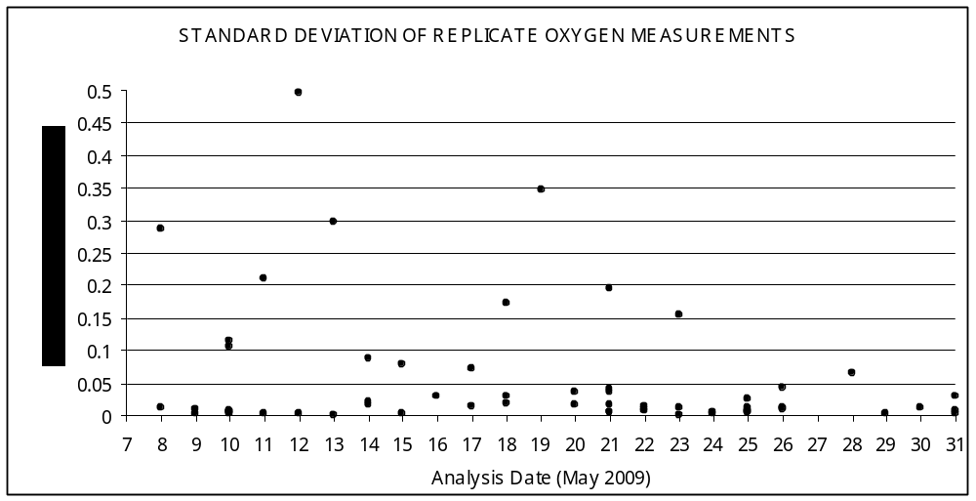
Figure C.3.1 Standard deviation of mean for the analysis of each replicate pair vs. date of analysis.

e. Standards and blanks

Standard calibrations and blanks were done at change of watch when the analysis was taken over by a change of staff. Standards are determined by the titration of 10.0 mL volume of KIO₃ solution. Blanks are determined by titration an initial 1.0 mL volume of potassium iodate followed by addition and titration of a second 1.0 mL volume. The blank is the difference between the two volumes. The protocol begun 2008 was still followed where three to five of each were analyzed and accepted without discarding results outside a set precision limit. The oxygen analysis software does allow the operator to edit out any individual blank or standard titration considered an outlier and this option was used where results were obviously out of line. The average values of valid standards and blanks for each set of titrations were used by the analysis program to compute oxygen concentration. The individual titration volumes and auxiliary information were stored for possible re-processing. The averages of the daily accepted blank and standard values are plotted in Figures C.3.2 and C.3.3 below.

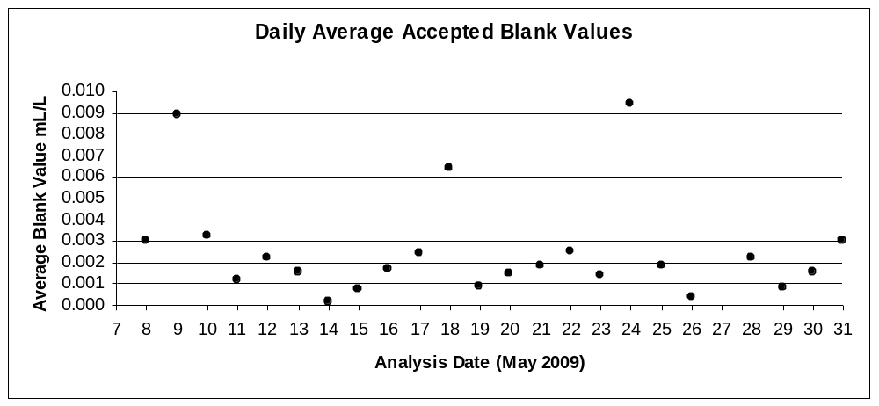
Figure C.3.2 Accepted values for oxygen blanks for each analysis day.

The blank values in Figure C.3.2 have an overall average of 0.003 mL/L and overall average deviation of 0.002 mL/L. Again this year overall blank values were very erratic.
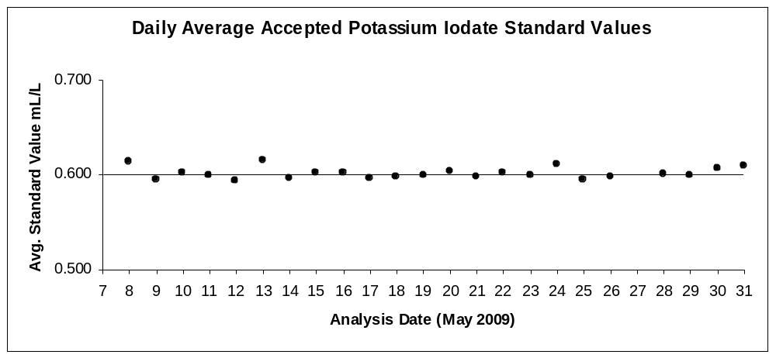
Figure C.3.3 Accepted values for Potassium Iodate standards for each analysis day.

The potassium iodate standard values in Figure C.3.3 have an overall average of 0.602 mL/L and overall average deviation of 0.009 mL/L. Standard values remained pretty much stable over the length of the cruise.

f. Comments

A log book was kept with a daily record of raw data results and any problems encountered. Results were backed up on the Cruise shared drive for all raw and finished data. Analysis of the samples posed few technical problems except for the formation of bubbles in the potassium iodate solution Dosimat especially and the thiosulphate Dosimat to a lesser degree. This may be due to the high temperature in the GP lab although Culberson (1991) does recommend that the reagents be kept at 25.5°C to stabilize the concentration of dissolved oxygen. Results from standard calibrations were relatively stable and precise throughout the cruise. The blank values however, were very erratic with very low precision. There were fewer problems with negative blanks this year than last. It was noticed that the blank values became more erratic once the Dosimat bottle volume of KIO₃ became low (less than 200 mL). At low volumes more air bubbles, especially very fine ones, formed in the plunger assembly faster than they could be removed. Perhaps the erratic results were the result of inaccuracy of volume delivered by the Dosimat caused by air bubble formation which would be much more apparent in 1.0 mL volume blanks than 10 mL standards. The last day’s analysis blank measurements were done using an Eppendorff pipette and the results were much more precise.

A computer or ‘systems’ crash occurred only once during rough weather, probably due to the shaking loose of a board. It is recommended that the computer system be replaced with a new one. This would also involve upgrading the software. Both the Dosimats had problems with air bubble formation; the potassium iodate more severe. The temperature probe connected to the computer allowing temperature data to be uploaded directly into the software for the thiosulfate failed. An extra digital temperature probe was used and the temperature data was entered manually. This may have been a problem with either the connection or a failing board. Problems with switched stoppers or draw bubbles in the samples were not noted. The samples were analyzed usually just after the 30 minute recommended storage time but remained ‘fresh’ looking: no discolouration of the solution or formation of tiny bubbles. This can be contributed to the storage of the samples in the refrigerator. Alkaline Iodide and Manganous Chloride dispensers were kept regularly rinsed out to prevent sticking. Alpha-Q, supplied by the nutrient lab, was used for standard calibrations and blanks. The detector lamp had to be replaced during this cruise. It has been recommended that several more new detector lamps be purchased as spares as only one spare lamp was found.

**Unfortunately, for the most part during the Orphan Basin cruise, replicates were routinely missed for stations sampled by day watch winch room personnel. It was noted that most of these personnel were new. It would be in the program’s best interest to have an overall sampling protocol laid out for everyone at the initial cruise meeting and printed up for the winch room. This would cover what samples are to be taken when and how, including duplicates.
4. Nutrients | Carol Anstey

a. Description of Equipment and Technique

Samples were analyzed for silicate, phosphate, and nitrate (nitrate plus nitrite) using a Technicon Autoanalyzer II. The chemistries were standard Technicon for Seawater Analysis (Silicate 186-72W, Phosphate 155-71W, Nitrate/Nitrite 158-71W) except for Phosphate which has been modified by separating the Ascorbic Acid (4.0 gm/L) from the Mixed Reagent. This modification was achieved by introducing the modified Mixed Reagent instead of water at the start of the sample stream at 0.23 mL/min. and introducing Ascorbic Acid into the stream between the two mixing coils at 0.32 mL/min. (Strain and Clement, 1996).

b. Sampling Procedure and Data Processing Technique

Duplicate nutrient samples were drawn into 30 mL HDPE (Nalge) wide mouth sample bottles from the 10 L Rosette bottles. The sample bottles were pre-washed in 10% HCL, rinsed three times with Alpha-Q (de-ionized water) and oven dried at >100°F.

A sample run included six Calibration Standards, analyzed in duplicate, at the beginning and end of each shift’s analysis. The standards, wash water and blanks were made up in 33 ppt NaCl (Sigma, ACS Reagent). The second most concentrated Calibration Standard was used as a Check Standard every 16 samples, followed by blanks as a baseline check. The quality of analysis was checked by analyzing MOOS-1 Seawater Certified Reference Material for Nutrients produced by NRC, Ottawa [http://www.nrc-cnrc.gc.ca/obj/inms-ienm/doc/crm-mrc/eng/MOOS-1_e.pdf].

The raw analog data was converted to digital data, processed and concentrations calculated using Michaelis-Menton Regression, including statistics, by an in-house Pascal 7.0 program (AAII) on a PC. Chart recordings, hard copy and disk copies of the data were archived.

c. Replicate Analysis

Total number of duplicate samples analyzed for Orphan Basin HUD2009011: 894 and AR7W Labrador Sea HUD 2009015: 1380. Samples were analyzed as soon as possible after collection. Any samples collected off watch were kept refrigerated (4ºC) and analyzed within eight hours of collection.

Rough seas on May 23rd to May 24th caused back flushing of the reagents and samples in the Technicon resulting in very poor peak shape and unintelligible results. The peristaltic pump could not compensate. The instrument was shutdown, the nutrient samples frozen and analyzed the next shift: 351765 to 351825. The ‘air peak’ problems were again avoided by tilting the colorimeters by 20º; except for one run when an air bubble lodged in the phosphate colorimeter. The affected samples were rerun and the affected data edited. Most sample runs were excellent: stable baselines and very good calibration RMS – ‘fit to curve’. This year the GP lab temperature remained very hot: 24°C to 32°C. A fan was used but doors were kept shut to maintain warm temperatures for the pH and alkalinity analysis. It helped that the Autoanalyzer was run at night when the ambient temperatures were cooler preventing degassing of molybdate reagents and build-up of precipitate in the nitrate colour reagent line but the warmer temperatures caused problems with degassing the dissolved oxygen reagents.

The data quality parameters, determined with check standards, MOOS-1 Certified Reference Material and RMS offset from the calibration curve, came well within accepted values. Frequent flushing of the system with 1 N HCl followed by Alpha-Q water helped to prevent sample flow problems and build-up of molybdate coating of the flow cells. A summary of QC/QA MOOS-1 data as follows:

QC/QA |  |  | Silicate | Phosphate | Nitrate
 |  |  | (µM) | (µM) | (µM)
Accepted Values |  | from | 25.00 | 1.490 | 22.80
 |  | to | 27.00 | 1.630 | 24.60
Analytical Results MOOS-1 |  |  | 26.00 | 1.552 | 24.62
 |  |  | 26.03 | 1.534 | 24.54
 |  |  | 26.17 | 1.502 | 24.49
 |  |  | 26.07 | 1.518 | 24.63
 |  |  | 26.62 | 1.680 | 25.52
 |  |  | 26.60 | 1.672 | 25.51
 |  |  | 26.03 | 1.618 | 24.70
 |  |  | 26.09 | 1.603 | 24.89
 |  |  | 26.47 | 1.552 | 24.57
 |  |  | 26.38 | 1.548 | 24.46

Table C.4.1 Analyses of Certified Reference Material

RMS offset from the predicted calibration curve is a measure of how acceptable the calibration was for a specific analysis run. There is no firm cutoff for ‘good’ or ‘bad’ data. The following table lists acceptable limits for RMS fit determined by averaging 34 runs of data deemed to be acceptable by peak shape, stability of the baseline and precision between duplicates.

STATISTIC | SILICATE  (µM) | PHOSPHATE  (µM) | NITRATE  (µM)
Mean | 0.115 | 0.042 | 0.089
Std. Deviation | 0.115 | 0.020 | 0.043
Maximum | 0.695 | 0.111 | 0.271
Cruise Average n=56 | 0.061 | 0.008 | 0.066

Table C.4.2 RMS offset from curve
Analysis Date | SILICATE |  | PHOSPHATE |  | NITRATE
 | Initial | Final | Initial | Final | Initial | Final
MAY0709 | 0.072 | 0.039 | 0.005 | 0.010 | 0.029 | 0.066
MAY0809 | 0.106 | 0.030 | 0.004 | 0.008 | 0.036 | 0.070
MAY0909 | 0.050 | 0.051 | 0.009 | 0.005 | 0.042 | 0.019
MAY1009 | 0.075 | 0.175 | 0.005 | 0.006 | 0.018 | 0.026
MAY1109 | 0.070 | 0.048 | 0.009 | 0.007 | 0.023 | 0.023
MAY11B09 | 0.030 | 0.061 | 0.009 | 0.008 | 0.030 | 0.015
MAY1209 | 0.052 | 0.105 | 0.003 | 0.019 | 0.042 | 0.176
MAY1309 | 0.036 | 0.079 | 0.005 | 0.007 | 0.025 | 0.054
MAY1409 | 0.008 | 0.057 | 0.005 | 0.005 | 0.026 | 0.026
MAY14B09 | 0.036 | 0.037 | 0.007 | 0.009 | 0.035 | 0.031
MAY14C09 | 0.016 | 0.040 | 0.009 | 0.012 | 0.032 | 0.039
MAY1509 | 0.126 | 0.044 | 0.015 | 0.008 | 0.108 | 0.029
MAY1609 | 0.080 | 0.096 | 0.006 | 0.007 | 0.058 | 0.083
MAY1709 | 0.115 | 0.096 | 0.006 | 0.008 | 0.054 | 0.004
MAY1809 | 0.043 | 0.070 | 0.002 | 0.007 | 0.045 | 0.045
May0109 | 0.038 | 0.062 | 0.002 | 0.006 | 0.023 | 0.050
MAY19B09 | 0.055 | 0.026 | 0.004 | 0.009 | 0.042 | 0.033
May0109 | 0.047 | 0.023 | 0.008 | 0.016 | 0.069 | 0.078
May0109 | 0.067 | 0.028 | 0.002 | 0.006 | 0.058 | 0.060
MAY21B09 | 0.100 | 0.026 | 0.010 | 0.010 | 0.200 | 0.028
May0109 | 0.061 | 0.192 | 0.005 | 0.011 | 0.047 | 0.113
May0109 | 0.026 | 0.018 | 0.006 | 0.007 | 0.026 | 0.073
May0109 | 0.054 | 0.075 | 0.007 | 0.012 | 0.052 | 0.113
May0109 | 0.047 | 0.112 | 0.005 | 0.019 | 0.098 | 0.099
May0109 | 0.067 | 0.019 | 0.003 | 0.012 | 0.060 | 0.089
May0109 | 0.042 | 0.048 | 0.003 | 0.014 | 0.126 | 0.124
May0109 | 0.025 | 0.081 | 0.006 | 0.022 | 0.116 | 0.225
May0109 | 0.078 | 0.096 | 0.023 | 0.021 | 0.170 | 0.193

Table C.4.3 RMS values for individual analysis runs

The conversion to mass units for the analytical precision and detection limits used a standard density corresponding to 33 ppt. and 15ºC.

The nutrient detection limits noted in the above table are an average of all analytical runs for the cruise. Individual daily detection limits were applied to the corresponding data set. Duplicate measurements were used to compute the values given in the SEA file.
5. Total Inorganic Carbon in Seawater | David E. Slauenwhite

a. Description of Equipment and Technique

The total dissolved inorganic carbon content of seawater is defined as the total concentration of carbonate ion, bicarbonate ion and unionized species of carbon dioxide. Before analysis, the sample is treated with acid to convert all ionized species to the un-ionized form, which is then separated from the liquid phase by gas purging and subsequently measured using a coulometric titration technique. This involves the reaction of carbon dioxide gas with a dimethysulfoxide solution of ethanolamine to produce hydroxyethylcarbamic acid. The acidic solution is titrated with hydroxide ion formed by the electrolytic decomposition of water. The progress of the titration is followed through colorimetric measurement of the absorbance of a pH indicator dye (thymolphthalein) in the ethanolamine solution.

A known volume of seawater is dispensed into a stripping chamber from a pipette of known volume and temperature controlled to within 0.4°C. It is then acidified with ten percent of its volume of a 10% solution of carbon dioxide-free phosphoric acid. The solution is stripped of carbon dioxide gas by bubbling with a stream of nitrogen gas directed through a glass frit. The carrier gas exiting the stripper passes through a magnesium perchlorate trap to remove water vapour and acidic water droplets. The gas stream is then directed into the coulometric titrator where the total amount of carbon dioxide gas is quantified.

b. Sampling Procedure and Data Processing Technique

Samples for total inorganic carbon were collected and analyzed from all bottles tripped at standard hydrographic depths on all sites on the AR7W and Halifax line except bottles for biological measurements. Samples were analyzed (with the exception of one line, see below) within 4 hours of collection. Because of ice build-up, especially on the Labrador side of the line, many of the shelf stations could not be collected. Station 7.5 was the name given to the station nearest to the ice, the station numbers less than that being uncollected. In order to get a shelf cast, an off-line station, denoted BON_BAY (Bonavista Bay) was collected. This station was pickled with mercuric chloride and analysed at a later day. Because of time constraints, we also missed stations numbered higher than 9 on the Halifax line, as well as Station 2.

Samples were drawn from the rosette immediately following the drawing of the oxygen samples in order to minimize exchange of carbon dioxide gas with the head space in the sampler. This exchange will typically result in a loss of carbon dioxide. It is desirable that the samples be drawn before half the sampler is emptied and within ten minutes of recovery. Clean borosilicate glass bottles are rinsed twice with 30–50 mL of the sample. The bottle is then filled from the bottom using a length of vinyl tubing attached to the spigot of the sampler. The sample is overflowed by at least a half of the volume of the bottle (typically 250 mL). A head space of 1% is left to allow for expansion without leakage.

Theoretically, the coulometer should give a direct measurement of the amount of carbon titrated based on calculations using the Nernst equation. In practice, the coulometer’s calibration is checked using Certified Reference Materials obtained from the Scripps Institute of Oceanography, La Jolla, California. These samples are treated in the same manner as a seawater sample. Values are reported in units of μmol/kg. The overall precision of the analysis was 1.5 μmol/kg or better for samples with concentrations in the range of 1800-2300 μmol/kg.

Our old computer controlling system operated fairly well for this cruise, although we are now in the process of overhauling the command and control of the SOMMA system to better interact with modern computers.

6. Alkalinity | David E. Slauenwhite

a. Description of Equipment and Technique

The total alkalinity of seawater is defined as the number of moles of hydrogen ion equivalent to the excess of proton acceptors (bases formed from weak acids with dissociation constants of less than K=10^{-4.5}) over proton donors (acids with K>10^{-4.5}) in a one kilogram sample. An automated potentiometric titration system is used to determine this quantity. During the course of the titration the pH is measured using a Ross combination electrode standardized using a Hansson seawater buffer. A known volume (~37 mL) of sample is measured in a calibrated, thermostated pipette and dispensed into an open cup. The alkalinity of the sample is estimated from its salinity and acid equivalent to 0.7 of this amount is added and the pH measured. A further three aliquots of acids are added to bring the titration to 90% completion. The Gran Function F3 (Stumm and Morgan, 1996) is then applied to these points to obtain a more refined estimate of the alkalinity. Five additional aliquots are then added to complete the titration.

b. Sampling Procedure and Data Processing Technique

Samples for alkalinity were collected and analyzed from all bottles tripped at standard hydrographic depths on the AR7W and Halifax lines with the exception of bottles for biological measurements. Samples are collected using the same procedure as for Dissolved Inorganic Carbon (see Section 5b). Stations missed in the analysis for total inorganic carbon were also missed for the analysis of alkalinity (see above).

Precision of measurements were less than 0.1% and most of the time less than 0.05%. Precision has improved since 2007. One problem of alkalinity measurements is that of time. Processing time for alkalinity is over 15 minutes per sample, several minutes longer than the DIC system, although this year the alkalinity system kept up very well and rarely fell far behind the DIC system. We did not have any problem in this cruise with our computer, which controls the system and is very old (286). We are currently in the process of upgrading this system as well, by examining a Titrando based titration system with laptop control.

7. Halocarbons | Darlene Brownell / Richard Nelson

Concentrations of chlorofluorocarbons, CFC-12, CFC-11, CFC-113, carbon tetrachloride and methyl chloroform were measured along transect lines, L3 and the Halifax line from May 17th to May 31st 2009. Due to the length of time required for a single sample analysis (approx. 25 min.) and the frequency at which the deep stations were sampled, it was not possible to collect halocarbon samples at all stations during the cruise. Stations missed were, L3-19, L3-16, and L3-11. Overall, 27 stations were sampled and 467 and 18 sea-water and air samples were collected and analysed, respectively.

a. Description of Equipment and Technique

To avoid atmospheric contamination, CFC water samples were drawn first, directly from the spigots of the PVC bottles on the rosette sampler directly into 100 mL glass syringes. Syringes were rinsed three times before they were filled. The samples were stored in a water bath of continuously flowing surface seawater until analysis, less than 24 hours.

Halocarbons were stripped from seawater using an automated purge and trap system. Water samples were injected directly into the system from a 100 mL glass syringe. A measured volume of seawater sample was transferred to a purge chamber, warmed to 80°C, and purged with a stream of UHP Nitrogen (80 mL/min) for 10 minutes. The analytes were trapped on a chromatographic absorbent (Porapak-N) packed in stainless steel tubing (3 mm x 17 cm) maintained at 10°C. The compounds were then desorbed by heating the trap to 170°C. A Varian 3300 Gas Chromatograph equipped with a 75 m DB-624 megabore column and electron capture detection was used for the separation and quantification of the halocarbons.

The purge and trap system was susceptible to contamination whenever it was open for maintenance and repairs. For this reason, blanks are run after the system has been open until a stable baseline is achieved.

b. Calibration

Results were calibrated using working standards prepared gravimetrically at Brookhaven National Laboratories, which were calibrated against a standard air sample certified by CMDL/NOAA, Boulder, Colorado. Analytical precision calculated from replicate measurements for CFCs was 1-3% and for CCl₄ 4%.

c. Problems Encountered

There were a few problems encountered with the instrumentation before and during the cruise. Just before the cruise, the motherboard of one of the computers (486 model) died and needed to be replaced. Another computer was re-built using spare parts and other similar computers here at BIO.

There was a problem with the detector response in system A that was not apparent right away. Some serious time was spent trying to locate the source of the problem. We dissembled the GC and a spare GC, swapped parts, checked voltages, flow rates, put it all back together again, replaced some fuses and finally it worked. We think it may have been an electronics problem, specifically when we changed the fuses we had life again in the GC.

Valve 3 on system B became a problem during the middle of the cruise. The valve came loose on the extraction board and was not able to move the rotor to its proper settings. The valve was set back in place but we needed to keep an eye on it for the remainder of the cruise.

Finally, it looked like there may have been some contamination and/or build up of a compound in system A and to a minor extent system B that interfered with the response of the F-12 peak. The peaks were not as sharp at the end of the cruise as they were in the beginning. There are a few suggestions as to why this is but further work is required solve the problem.

d. Future work

Atmospheric CFCs have stopped increasing as a result of the restrictions enacted in the 1980s on the production and release of CFCs. Using CFCs as tracers to estimate the age of water masses has become more problematic, encouraging the use of new transient tracers. Preliminary investigations suggest that the current system should be modified to incorporate SF₆ as a new chemical tracer as well as upgrading the data acquisition program in order to avoid the system becoming obsolete. This process will tune the instrument in order to maximize the signal to noise ratio for each analyte.

8. Sampling for oxygen isotope composition (O-18) | Kumiko Azetsu-Scott

To identify the freshwater sources contributing to the Labrador Sea, samples for oxygen isotope composition (O-18) analysis were collected. Samples were collected from all bottles tripped at standard hydrographic depths on whole-number sites on the AR7/W; except for sites 1-6 due to ice coverage. No samples were collected from biology stations, the BON-BAY station, or the Halifax Line stations.

Samples were collected in amber glass bottles (60 mL) with poly-seal lined closures. The sampling procedure included:
(1) Rinsing the cap and bottle with sample water three times.
(2) Filling a bottle 90% full by using a silicon tube to smoothly fill it from the bottom.
(3) Tape each cap with black electrical tape (two wraps) to make it air tight.
(4) Re-tighten all caps a day after the samples have been sealed.
These samples were stored at room temperature in a container.
9. pH | Chris L’Esperance

The pH of seawater is a master variable that generically refers to the effective concentration of hydrogen ions in solution. The view that chemical systems have a state defined according to the hydrogen ion concentration is conventionally adopted. This makes pH a convenient variable for measurement.

a. Description of Equipment and Technique

The total scale pH is relevant because it is the only quantity that can be determined analytically. Specifically, pH on the total hydrogen ion scale is defined as the -log10 of the sum of the concentrations of the free hydrogen ion, [H+]F and the monoprotic form of the sulfate ion, [HSO4-]. This is given by the expression

pH_{T} = log10 ([H⁺]_{F} + [HSO₄⁻]) | (1)

pH on the total scale has been measured at 25ºC by the spectrophotometric technique. The blank, or zero, absorption spectrum of a seawater sample alone is initially measured with the Agilent 8453 UV-Vis spectrophotometer. The sulfonephthalein indicator m-cresol purple is added to seawater and thoroughly mixed. The dissociation constant for the added indicator is described by the following reaction:

HI⁻ (aq) ↔ H⁺ (aq) + I²⁻ (aq) | (2)

Only the monoprotic (HI⁻) and unprotonated (I²⁻) forms of the indicator are present at normal seawater pH. The absorption spectrum of the solution in the visible range is measured. The resultant absorption spectrum is a composite of the spectra of the acid (HI⁻) and base (I²⁻) forms of the indicator. The spectrum exhibits peaks at 434 nm and 578 nm corresponding to the absorbance maxima of the acid and base forms of the indicator, respectively. The ratio, R = A578 / A434, of the absorbances at 578 nm to 434 nm is proportional to pH according to:

pH_{T} = pK₂ + log ₁₀ { ( R - c₁ ) / (c₂ - R c₃ ) } | (3)

where c₁ = 0.00691, c₂ = 2.2220 and c₃ = 0.13310. These constants are specific to m-cresol purple and are valid for the temperature range of (24.9 > T > 25.1ºC). The equilibrium constant, K₂, in Eq. (3) has been fitted empirically, and is represented as a function of temperature salinity:

pK₂ = ( 1245.69 / T ) + 3.8275 + 0.00211(35 - S) | (4)

where T is the temperature of measurement (25±0.1ºC) expressed as ºk and S is the salinity determined from the in situ conductivity.

b. Sampling Procedure and Data Processing Technique

Samples intended for the measurement of pH were collected and analyzed from all bottles tripped at standard hydrographic depths on all sites on the AR7W and Halifax Lines excluding most of the stations dedicated to biological sampling. A total of 742 samples were analyzed.

Seawater for pH measurement is to be drawn from the Niskin bottles on the rosette into a 60 mL bottle. A short length of flexible Teflon tubing was used to draw the samples from the Niskin bottles. For at least one depth per station, duplicate samples are drawn from the same bottle. Care was taken to condition the bottle with the sample, filling from the bottom, letting the sample overflow on the last fill and ensuring that all visible air bubbles had flowed out of the bottle. No headspace gas was left in the sample. The cap was also washed and conditioned and was then screwed back on the sample bottle. The bottles were placed in a fridge kept at 4ºC prior to sampling. All samples were analyzed within 5 hours of sampling.

Prior to measurement, sample bottles were taken from the fridge and transferred to a controlled temperature bath that was thermostatted to 25°C. A 10 cm pathlength, quartz-faced optical cell was conditioned with a sample destined for measurement. After approximately three rinses, the optical cell was filled with the seawater leaving a bubble having a volume of approximately 0.5 mL. The overall volume of sample in the optical cell was 25 mL. The Teflon stoppers were inserted into the two spigots of the optical cell in order to eliminate the exchange of gases into or out of the sample. When the seawater sample had been loaded into the optical cell, it was then placed back into the controlled temperature bath in order to come to 25°C.

Once equilibrated to the measurement temperature, the sample-bearing optical cell was loaded into the path of the spectrophotometer and blank, or zero, absorbance was measured. Approximately 70 µL of 2.6 mM∙dm⁻³ of dye (pH not adjusted by addition of HCl) was added to the optical cell. The headspace bubble that was left in the optical cell facilitated the mixing of the sample which was accomplished by gently tipping the cell about its long axis. The cell was re-inserted back into the path of the spectrophotometer and three replicate measurements of absorbance ensued. For each replicate, the Chem Station 32 (accompanies the 8453 spec) software was programmed to log absorbance data at three wavelengths, 434, 578, and 730 nm.

Data were stored in files separated according to event or cast. The event and cruise numbers are found in the filenames. Raw absorbance data were further processed into pH at 25°C and pH at in situ temperature via MATLAB scripts.

Accurate temperature control of the optical cell containing the seawater and indicator solution is a requirement of the technique described above. By placing the optical cells in a thermal bath prior to measurement, temperatures to within 25 ± 0.2°C were obtained. An improvement to the technique, however, would involve thermostatting the optical cell. The precision requirement of the temperature sensor / thermometer (± 0.05°C) was not met by the Fisher Scientific sensor employed which had a precision of ± 0.1°C. The sensor response time (t = 20–40 s) could also be improved.

It is suggested that the controlled temperature bath (Haake A70) be modified to be more seaworthy. Occasionally, when the ship was rolling and pitching, the bath would jump to a random temperature set point. If the set point was not periodically monitored, the bath would begin to heat or cool to this new random set point. Once noticed, the set point had to be adjusted back to 25°C. This represents a cost of the time required for the bath to return to 25°C. The erratic behaviour may have been caused by an electrical short resulting from water somehow making its way into the control box. If the thermal bath is on an angle (for instance, when the ship is rolling), the effective water level in the bath may exceed the recommended level. Under these circumstances it may have been possible for water to splash up into the control electronics. The suggested modification is a plastic splash guard to protect the electronics.

Thermal baths are commonly associated with the types of chemical analyses (e.g. DIC, ALK, pH, CFCs) that are performed in the GP Lab of the CCGS Hudson. Co-incidentally, these devices draw significant electrical currents (Typically rated to 15 A). Attention must be paid to the rating of the sockets through which high current-draw devices are powered.
F. APPENDICES

Appendix 1. Operation Notes Report | Jeff Jackson

Note Number: 1 | Entry Time:  20/May/2009 0:13:05 | Note Made By:  Jeff Jackson | Operation ID:  5
Problem with CTD system. Operation was terminated and the package was brought back on board.

Note Number: 2 | Entry Time:  20/May/2009 0:14:16 | Note Made By:  Jeff Jackson | Operation ID:  6
Problem with CTD system. Operation was terminated and the package was brought back on board.

Note Number: 3 | Entry Time:  20/May/2009 0:14:33 | Note Made By:  Jeff Jackson | Operation ID:  7
Problem with CTD system. Operation was terminated and the package was brought back on board.

Note Number: 4 | Entry Time:  20/May/2009 0:29:00 | Note Made By:  Jeff Jackson | Operation ID:  13
Float #4521 Deployed.

Note Number: 5 | Entry Time:  20/May/2009 0:29:20 | Note Made By:  Jeff Jackson | Operation ID:  20
Float #4522 Deployed.

Note Number: 6 | Entry Time:  26/May/2009 1:59:40 | Note Made By:  Jeff Jackson | Operation ID:  173
The hoses on the CTD were left on the sensors during this operation. This may have affected the CTD values recorded. This was noticed prior to the starting of the next CTD operation 178 as the deck unit indicated that the pump was on when the CTD was not yet in the water.

Appendix 2. Mooring Logs | Rick Boyce

Recovery

Mooring No: | 1680
Ship: | Hudson
Cruise No: | 2009015
Date: | 25 May 2009
Mooring Tech: | Boyce / Hartling
Type of Nav: | DGPS_NOVATEL
Sea State: 2 | Weather Conditions: Front? Half Clear, Half Overcast Wind 11 kt @ 350°T
Cancel Notship: | Yes____No____

Recovery Log

UTC | Instrument | Remarks
 |  | Deck Unit Problem. Switch to Original IC
1928 |  | Move 2 cable south of target – in touch with release.
 |  | Ice edge ~ 4 km away. One large berg nearby. A few growlers nearby.
1939 |  | Mooring Released. Release command registered on Knudsen sounder.
1942 |  | S/R 1031 m. 1948 S/R 687 m.
1951 |  | 2 BB on surface to starboard ~ 2 cables
1953
2000 |  | Hooked on.
2061 |  | Lead on north pacific crane; hauling
 |  | BB out of water. Tangled.
 |  | Release out of water. Transfer.
 |  | BB and release to foredeck.
 |  | Com
2003 | 5002 | Out of water.
 |  | Fuzz on release
 |  | Anodes on BB 90% intact.
 |  | Small amount of fuzz on BB.
 |  | Anodes on CM 50-75% intact; some fuzz on CM & fin; Rotor clean.
 |  | Release 865A S/N 40082
Placement

Mooring No: 1729
Geographic Area: Labrador Sea |  |  |  |  | Intended Duration: 1Year
Ship: Hudson |  |  | Cruise No: 2009015 |  |  | Date: 25May2009
Weather/Sea Conditions: SS2_
Mooring Technician: Boyce/Hartling |  |  |  |  | Type of Navigation: DGPS_NOVATEL
Latitude: 55º07.170 |  |  | Longitude: 54º05.151W |  |  | Time of Fix:
Depth: |  |  | Raw: 550 fm |  |  | Corrected: 1019 m
Main Float: |  |  | Type: Double BB |  |  | Markings:
Beacon: |  |  | Type:N/A |  |  | I.D.#
Mooring Line: |  |  | Type: 3/16 galvanized jacketed |  |  | Colour: Yellow_
Release: | Type: Benthos 865 | S/N: 886 |  | Release Code: C 10KHz |  |  | Enable Code: A

Placement Log

UTC | Instrument | Remarks
2034 | RCM 5569 | Release test - 2 releases. SN 890, 886  On hydro wire to 200 m.
 | Anchor | 886 released (10 kHz); 890 (10.5 kHz) did not release.
 |  | BB turned around from 1680.
2107 |  | Haul on mooring with Arva crane
2109 | Top BB RCM 7013 | Over side in water. Unhooked.
 |  | Hook on ring on top of release.
 |  | Hauling with ...
 |  | Railway wheel over side.
2111 |  | Mooring away.
 |  | Anchor away. N55-07.20
 |  | W 054 – 05.20
 |  | Wind 14 kt @ 354
 |  | Sea state 1-2. Overcast.
 |  | 1048m Knudsen sounder @ 1500 m/s
2127 |  | S/R 1252 m. On bottom?
2214 | GND Survey | Position Survey at 8 kt

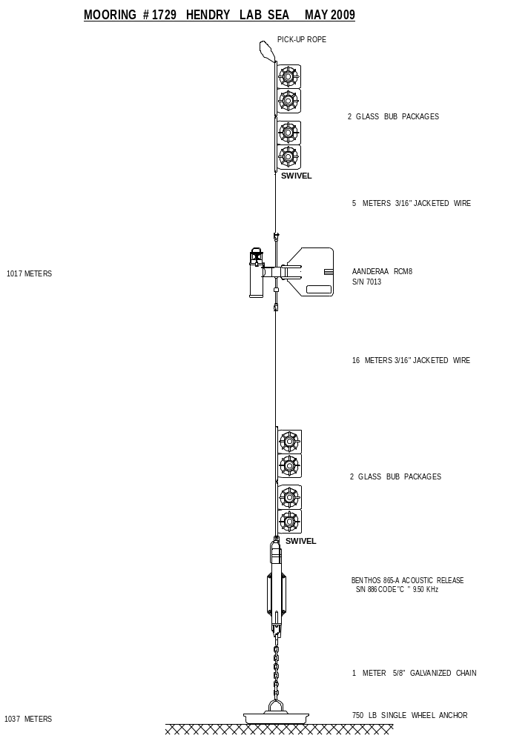

Appendix 3. CTD Initial Setup Information | Bob Ryan

Original Request _X _ Update __ __
Information Supplied By: ____Bob Ryan______
Date: April 30, 2009

Mission: HUD2009-015 Departure Date: 17 May, 2009
Chief Scientist: Hendry

INSTRUMENT CONFIGURATION
Frequency channels suppressed = 0 Pri. Pump Serial Number: 051775
Voltage words Suppressed = 0 Sec. Pump Serial Number: 051776
Computer interface = RS-232 Carousel Serial Number: 3240415-0624
Scans to average = 1
Surface PAR voltage added = No X Yes __
Scan time added= No X Yes __
NMEA position data added = Yes

Channel Designation | Parameter | Model Number | Serial Number | Calibration Date | System Number
Frequency 0 | Temperature - Primary | SBE3 | 035081 | 8 April 2009 | TS13
Frequency 1 | Conductivity - Primary | SBE4 | 043561 | 8 April 2009 | CS13
Frequency 2 | Pressure – SBE9plus  s/n 9P7356-0289 | 410K-105 | 69009 | 25 March 2009 | PP06
Frequency 2 | Pressure – SBE9plus  s/n 9P7356-0289 | Modulo 12P | 0362 | 31 Jan 1997 | PP06
Frequency 3 | Temperature - Secondary | SBE3 | 035083 | 8 April 2009 | TS14
Frequency 4 | Conductivity - Secondary | SBE4 | 043562 | 8 April 2009 | CS14
Voltage 0 | Altimeter | 2110-2 | 222 | 18 May 1999 | AL01
Voltage 1 | Fluorometer Chelsea | AquaTracka Mk 3 | 088172 | 10 February 1997 | FC01
Voltage 2 | Oxygen | SBE43 | 430042 | 06 January 2009 | OX01
Voltage 3 | Oxygen | SBE43 | 431588 | 06 March 2009 | OX03
Voltage 4 | Irradiance (PAR) | LI-193SA | SPQA2711 | 17 June 1999 | IR03
Voltage 4 | Irradiance (PAR) | PN 90310 | 0002-CH1 | 17 April 98 | LA01
Voltage 5 | Fluorometer, WetLabs | CDOM WETStar | WSCD-987P | 18 August 2003 | FL07
Voltage 6 | pH Sensor | SBE18 | 180669 | 5 November 2008 | PH01
Voltage 7 | Free | Free | Free | Free

Additional Configure Information

ASCII Output: Shared File – C:\CTDdata\shared.dat (refer to attached)
Deck Unit Modem COMM Port = COM ___ (selected in ‘Realtime Data : Start Acquisition’)
Water Sampler
Number of Water Bottles = 24
Water Sampler Type = SBE Carousel
Firing Sequence = Sequential
Bottle Positions For Table Driven = < See CTD System Administrator if REQUIRED >

SPARES

Parameter | Model Number | Serial Number | Calibration Date | System Number
Temperature | SBE3 | 031256 | 23 February 2009 | TS06
Temperature | SBE3 | 032303 | 13 March 2009 | TS10
Temperature | SBE3 | 031376 | 9 February 2009 | TS03
Temperature | SBE3 | 032298 | 13 February 2009 | TS09
Conductivity | SBE4 | 040997 | 23 February 2009 | CS06
Conductivity | SBE4 | 041874 | 13 March 2009 | CS10
Conductivity | SBE4 | 041076 | 9 February 2009 | CS03
Conductivity | SBE4 | 041873 | 13 February 2009 | CS09
Pressure – SBE9plus  s/n 9P5676-0249 | 410K-105 | 49258 | 18 March 2009 | PP02
Pressure – SBE9plus  s/n 9P5676-0249 | Modulo 12P | 0084 | 18 March 2009 | PP02
Pressure – SBE9plus  s/n 9P9984-0370 | 410K-105 | 50601 | 18 March 2009 | PP05
Pressure – SBE9plus  s/n 9P9984-0370 | Modulo 12P | 0838 | 18 March 2009 | PP05

ASCII Output Setup (for shared file)

__X__ Generate Shared File

Shared File… C:\Metering Sheave\shared.dat

Number of seconds (data time) between ASCII updates: 0.5
ASCII Output Variables
 | Variable | Dec. Digits |  |  |  | Variable | Dec. Digits
Column #0 | scan number | 0 |  |  | Column #8 | none | 3
Column #1 | pressure | 2 |  |  | Column #9 | none | 3
Column #2 | altimeter | 2 |  |  | Column #10 | none | 3
Column #3 | none | 3 |  |  | Column #11 | none | 3
Column #4 | none | 3 |  |  | Column #12 | none | 3
Column #5 | none | 3 |  |  | Column #13 | none | 3
Column #6 | none | 3 |  |  | Column #14 | none | 3
Column #7 | none | 3

G. REFERENCES

Carritt, D. E. and J. H. Carpenter. 1966. Comparison and evaluation of currently employed modifications of the Winkler method for determining dissolved oxygen in seawater. Journal of Marine Research, 24, 268-318.

Codispoti, L. 1991. On the determination of dissolved oxygen in seawater. Appendix 1 in Frederic, G.E., Codispoti, L.A., and Sakamoto, C.M. 1991. An easy-to-construct automated Winkler titration system. Technical Report 91-6. Monterey Bay Aquarium Research Institute, Monterey, CA.

Culberson, C. H. 1991. WHP Operations and Methods. Dissolved Oxygen. (http://whpo.ucsd.edu/manuals/pdf/91_1/culber2.pdf)

Hum, F. 2009. CTD Data Acquisition and Processing System : CTDDAP Version 1.4.2.

Isenor, A. W. 2000. ODIN The data model of an oceanographic metadata collection and management system.

Levy, E. M., C. C. Cunningham, C. D. W. Conrad and J. D. Moffatt. 1977. The determination of dissolved oxygen in sea water. Bedford Institute of Oceanography Report Series, BI-R-77-9, August 1977.

OSD/SIO, 2000. Ocean Circulation oxygen titration manual. (internal document).

SIO/ODF. 2000. Oxygen titration manual. Scripps Institute of Oceanography, Ocean Data Facility. Version 22-Feb-2000.

Stumm, W. and Morgan, J.J. 1996. Aquatic Chemistry, Chemical Equilibria and Rates in Natural Waters, 3rd ed. John Wiley & Sons, Inc., New York, 1022p.

Strain, P.M. and P.M. Clement. 1996. Nutrient and dissolved oxygen Concentrations in the Letang inlet, New Brunswick, in the summer of 1994. Can. Data Rep. Fish. Aquat. Sci. 1004: iv + 33p.
Ashtech  www.ashtech.com | Rochester Wire & Cable  751 Old Brandy Rd.  Culpeper, VA 22701 USA  http://www.rochestercables.com
Chelsea Technologies Group Ltd  55 Central Avenue  West Molesey, Surrey, KT8 2QZ UK  www.chelsea.co.uk | Teledyne Benthos  49 Edgerton Drive  North Falmouth, MA 02556 USA  www.benthos.com
LI-COR Biosciences  4647 Superior St.  Lincoln, NE 68504 USA  www.licor.com | Teledyne RD Instruments  14020 Stowe Drive  Poway, CA 92064 USA  www.rdinstruments.com
Sea-Bird Electronics, Inc.  1808 136th Place NE  Bellevue, WA 98005 USA  www.seabird.com | Teledyne Webb Research  82 Technology Park Drive E.  Falmouth, MA 02536-4441 USA  www.webbresearch.com
Software Engineering Associates  2316 Delaware Ave Suite #266  Buffalo, NY 14216-2687 USA  www.seanav.com | WET Labs, Inc.  PO Box 518  Philomath, OR 97370 USA  www.wetlabs.com
ODIM Brooke Ocean
461 Windmill Road
Dartmouth, Nova Scotia Canada B3A 1J9
www.brooke-ocean.com

