C. Hydrographic Measurement Techniques and Calibration

CTDO₂ Measurements
Updated 5 March 2020

Personnel
Keizo SHUTTA (GEMD/JMA)
Nobumi KATO (GEMD/JMA)
Seiko SHIMOJI (GEMD/JMA)
Noriyuki OKUNO (GEMD/JMA)
Koichi WADA (GEMD/JMA)
Yasunori SASAKI (GEMD/JMA)

CTDO₂ measurement system
(Software: SEASAVEwin32 ver7.18)
Deck unit | Serial Number | Station
SBE 11plus (SBE) | 0683 | RF4461 – 4535
Under water unit | Serial Number | Station
SBE 9plus (SBE) | 35251 (Pressure: 0760) | RF4461 – 4535
Temperature | Serial Number | Station
SBE 3plus (SBE)  SBE 35 (SBE) | 4923 (primary)  4199 (secondary)  0069 | RF4461 – 4535  RF4461 – 4535  RF4461 – 4535
Conductivity | Serial Number | Station
SBE 4C (SBE) | 3670 (primary)  2842 (secondary) | RF4461 – 4535  RF4461 – 4535
Pump | Serial Number | Station
SBE 5T (SBE) | 5501 (primary)  3887 (secondary) | RF4461 – 4535  RF4461 – 4535
Oxygen | Serial Number | Station
RINKO III (JFE) | 007 (foil number:160002A)  008 (foil numner:160003A) | RF4461 – 4535  RF4461 – 4535
Water sampler (36 position) | Serial Number | Station
SBE 32 (SBE) | 0734 | RF4461 – 4535
Altimeter | Serial Number | Station
PSA-916D (TB) | 43854 | RF4461 – 4535
Water Sampling Bottle |  | Station
Niskin Bottle (GO) |  | RF4461 – 4535

SBE: Sea- Bird Electronics, Inc., USA JFE: JFE Advantech Co., Ltd., Japan
TB: Teledyne Benthos, Inc., USA GO: General Oceanics, Inc., USA

Pre-cruise calibration

(3.1) Pressure
S/N 0760, 25 June 2012
c₁ | = | –4.959020e+004 |  | t₁ | = | 3.006343e+001
c₂ | = | 5.955454e–001 |  | t₂ | = | –1.267270e–004
c₃ | = | 1.521070e–002 |  | t₃ | = | 3.974510e–006
d₁ | = | 3.670600e–002 |  | t₄ | = | 3.613180e–009
d₂ | = | 0.000000e+000 |  | t₅ | = | 0.000000e+000

Formula:
U (degrees Celsius) = M × (12-bit pressure temperature compensation word) + B
U: temperature in degrees Celsius
S/N 0760 coefficients in SEASOFT (configuration sheet dated on 25 June 2012)
M = 1.28452e–002, B = –9.05575e+000

Finally, pressure is computed as
t: pressure period (μsec)

The drift–corrected pressure is computed as
Slope = 0.99985, Offset = –2.1180

(3.2) Temperature (ITS-90): SBE 3plus
S/N 4923(primary), 07 June 2012
g | = | 4.35306753e–003 |  | j | = | 1.77392830e–006
h | = | 6.39201272e–004 |  | f₀ | = | 1000.0
i | = | 2.11553579e–005

S/N 4199(secondary), 07 June 2012
g | = | 4.39477018e–003 |  | j | = | 2.29541975e–006
h | = | 6.50168448e–004 |  | f₀ | = | 1000.0
i | = | 2.42311649e–005

Formula:
f : Instrument freq.[Hz]

(3.3) Deep Ocean Standards Thermometer Temperature (ITS-90): SBE 35
S/N 0069, 23 Oct. 2006
a₀ | = | 4.96812728e–003 |  | a₃ | = | –1.14827915e–005
a₁ | = | –1.39341438e–003 |  | a₄ | = | 2.44200422e–007
a₂ | = | 2.06596098e–004
Formula:
n: instrument output

The slow time drift of the SBE 35
S/N 0069, 11 Sep. 2011 (2nd step: fixed point calibration)
Slope = 1.000003, Offset = –0.000378
Formula:

(3.4) Conductivity: SBE 4C
S/N 3670(primary), 07 June 2012
g | = | –1.01995535e+001 |  | j | = | 2.53978667e–004
h | = | 1.57607652e+000 |  | CP_{cor} | = | –9.5700e–008
i | = | –2.02177497e–003 |  | CT_{cor} | = | 3.2500e–006

S/N 2842(secondary), 07 June 2012
g | = | –1.01277455e+001 |  | j | = | 1.95371413e–005
h | = | 1.38819272e+000 |  | CP_{cor} | = | –9.5700e–008
i | = | 6.13968402e–004 |  | CT_{cor} | = | 3.2500e–006

Conductivity of a fluid in the cell is expressed as:
f: instrument frequency (kHz)
t: water temperature (degrees Celsius)
p: water pressure (dbar).

(3.5) Oxygen (RINKO III)
RINKO III (JFE Advantech Co., Ltd., Japan) is based on the ability of selected substance to act as dynamic fluorescence quenchers. RINKO III model is designed to use with a CTD system which accept an auxiliary analog sensor, and is designed to operate down to 7000 m.

RINKOIII output is expressed in voltage from 0 to 5 V.

Data correction and Post-cruise calibration

(4.1) Temporal change of deck pressure and Post-cruise calibration
The drift-corrected pressure of post-cruise is computed as
S/N 0760, 17 Oct. 2012
Slope = 0.99982，Offset = –2.1059

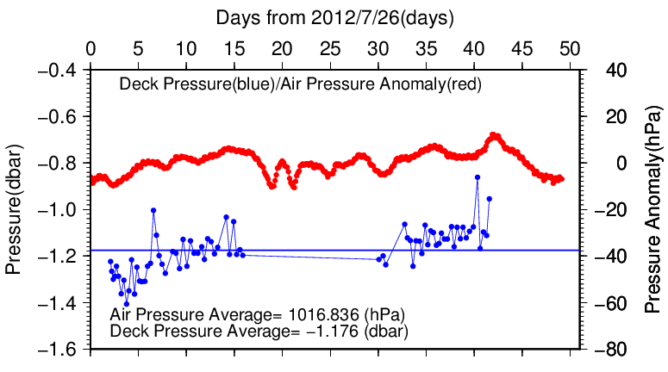
Figure C.1.1. Time series of the CTD deck pressure. Red line indicates atmospheric pressure anomaly. Blue line and dots indicate pre-cast deck pressure and average.

(4.2) Temperature sensor (SBE 3plus)
The practical corrections for CTD temperature data can be made by using a SBE 35, correcting the SBE 3plus to agree with the SBE 35 (McTaggart et al., 2010; Uchida et al., 2007).

CTD temperature is corrected as
T : the CTD temperature (degrees Celsius), P: pressure (dbar) and c₀, c₁, c₂ : coefficients

Table C.1.1. Temperature correction summary (Pressure ≥ 2000dbar). (Bold : selected sensor)
S/N | Num | c₀(K) | c₁(K/dbar) | C₂(K/dbar²) | Stations
4923 | 1116 | 5.7355493e–4 | 1.3373866e–7 | 0.0000000e+0 | RF4461 – 4535
4199 | 1115 | 1.6317968e–3 | –3.2009900e–7 | 7.1930323e–10 | RF4461 – 4535

Table C.1.2. Temperature correction summary for S/N 4923.
Stations | Pressure < 2000dbar |  |  | Pressure ≥ 2000dbar
 | Num | Average  (K) | Std  (K) | Num | Average  (K) | Std  (K)
RF4461 – 4503 | 760 | 0.0008 | 0.0315 | 596 | 0.0000 | 0.0001
RF4504 – 4535 | 576 | 0.0000 | 0.0094 | 520 | 0.0000 | 0.0001

Table C.1.3. Temperature correction summary for S/N 4199.
Stations | Pressure < 2000dbar |  |  | Pressure ≥ 2000dbar
 | Num | Average  (K) | Std  (K) | Num | Average  (K) | Std  (K)
RF4461 – 4503 | 760 | 0.0003 | 0.0145 | 597 | 0.0000 | 0.0002
RF4504 – 4535 | 576 | 0.0001 | 0.0078 | 518 | 0.0000 | 0.0002

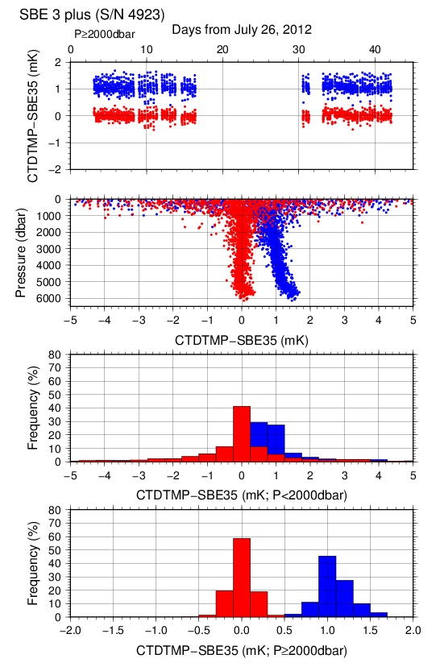
Figure C.1.2. Difference between the CTD temperature (S/N 4923) and the Deep Ocean Standards thermometer (SBE 35) at RF12-06. Blue and red dots indicate before and after the correction using SBE 35 data respectively. Lower two panels show histogram of the difference after correction.

Post-cruise sensor calibration for the SBE 3plus
S/N 4923(primary), 04 Oct. 2012
g | = | 4.35315593e–003 |  | j | = | 1.80068115e–006
h | = | 6.39388379e–004 |  | f₀ | = | 1000.0
i | = | 2.12796459e–005

S/N 4199(secondary), 05 Oct. 2012
g | = | 4.39449032e–003 |  | j | = | 2.19010408e–006
h | = | 6.49542198e–004 |  | f₀ | = | 1000.0
i | = | 2.37799205e–005
Formula:
f : Instrument freq.[Hz]

Post-cruise sensor calibration for the SBE 35
S/N 0069, 12 Oct. 2012 (2nd step: fixed point calibration)
Slope = 1.000002, Offset = 0.000498
Formula:

(4.3) Conductivity sensor (SBE 4C)
The practical corrections for CTD conductivity data can be made by using a bottle salinity data, correcting the SBE 4C to agree with measured conductivity (McTaggart et al., 2010).

CTD conductivity is corrected
C: CTD conductivity, c_{i} and p_{j} : calibration coefficients
i, j: determined by referring to AIC (Akaike, 1974). According to McTaggart et al. (2010), maximum of I and J are 2.

Table C.1.4. Conductivity correction coefficient summary. (Bold : selected sensor)
S/N | Num | c₀(S/m) | c₁ | c₂(m/S) | Stations
 |  |  | p₁(S/m/dbar) | p₂(S/m/dbar²)
3670 | 810 | 1.5903e–4 | 0.0000e+0 | 0.0000e+0 | RF4461 – 4503
 |  |  | 8.4024e–8 | –1.2424e–11
3670 | 616 | 2.2746e–4 | 0.0000e+0 | 0.0000e+0 | RF4504 – 4535
 |  |  | 4.2797e–8 | –4.8510e–12
2842 | 814 | 1.5063e–4 | 0.0000e+0 | 0.0000e+0 | RF4461 – 4503
 |  |  | 9.4583e–8 | –1.2004e–11
2842 | 615 | 2.5754e–4 | 0.0000e+0 | 0.0000e+0 | RF4504 – 4535
 |  |  | 2.9613e–8 | 0.0000e+0

Table C.1.5. Conductivity correction and salinity summary for S/N 3670.
Stations | Pressure < 1900dbar
 | Conductivity |  |  | Salinity
 | Num | Average  (S/m) | Std  (S/m) | Num | Average | Std
RF4461 – 4503 | 446 | 0.0000 | 0.0004 | 446 | 0.0002 | 0.0041
RF4504 – 4535 | 304 | 0.0000 | 0.0001 | 304 | 0.0000 | 0.0013
Stations | Pressure ≥ 1900 dbar
 | Conductivity |  |  | Salinity
 | Num | Average  (S/m) | Std  (S/m) | Num | Average | Std
RF4461 – 4503 | 364 | 0.0000 | 0.0001 | 364 | –0.0001 | 0.0007
RF4504 – 4535 | 312 | 0.0000 | 0.0000 | 312 | 0.0000 | 0.0006

Table C.1.6. Conductivity correction and salinity summary for S/N 2842.
Stations | Pressure < 1900dbar
 | Conductivity |  |  | Salinity
 | Num | Average  (S/m) | Std  (S/m) | Num | Average | Std
RF4461 – 4503 | 446 | 0.0000 | 0.0004 | 446 | 0.0002 | 0.0046
RF4504 – 4535 | 303 | 0.0000 | 0.0001 | 303 | 0.0000 | 0.0013
Stations | Pressure ≥ 1900 dbar
 | Conductivity |  |  | Salinity
 | Num | Average  (S/m) | Std  (S/m) | Num | Average | Std
RF4461 – 4503 | 365 | 0.0000 | 0.0001 | 365 | –0.0001 | 0.0007
RF4504 – 4535 | 312 | 0.0000 | 0.0000 | 312 | 0.0000 | 0.0006

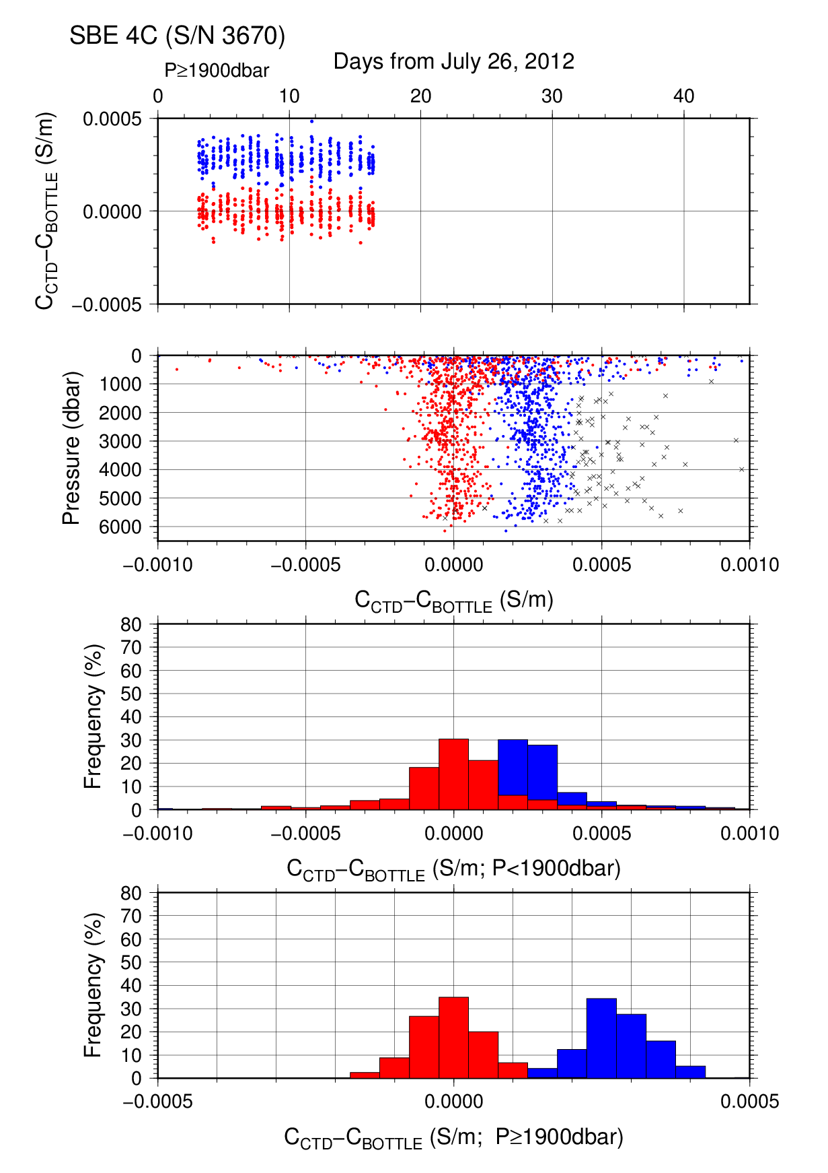
Figure C.1.3. Difference between the CTD conductivity (S/N 3670) and the bottle conductivity at Leg 1. Blue and red dots indicate before and after the calibration using bottle data respectively. Lower two panels show histogram of the difference before and after calibration.
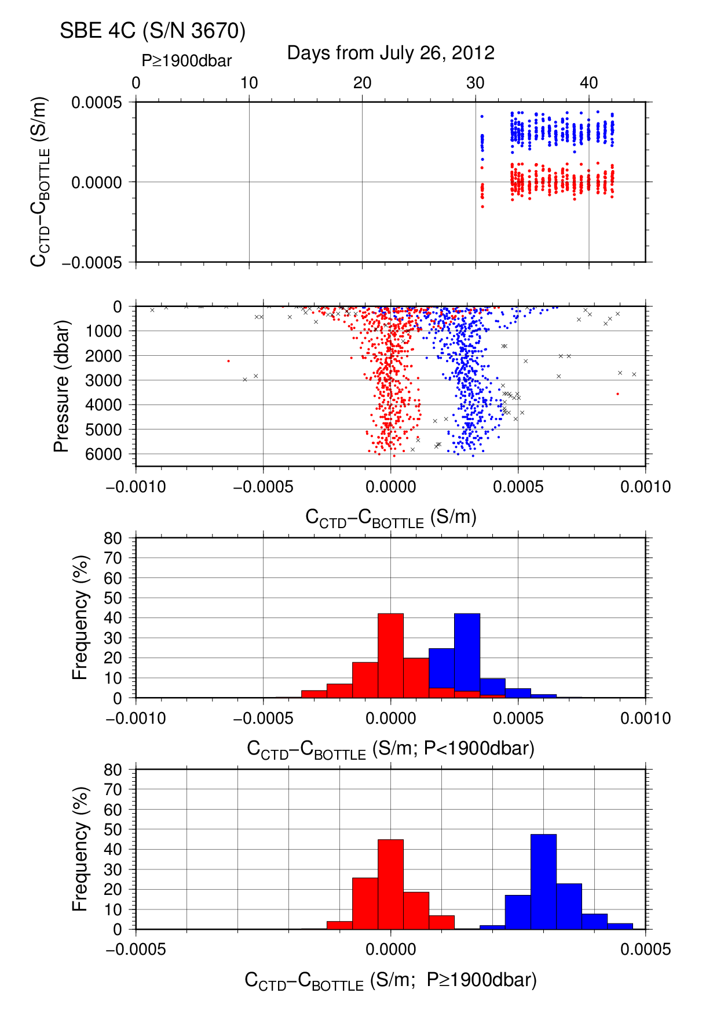
Figure C.1.4. Difference between the CTD conductivity (S/N 3670) and the bottle conductivity at Leg 2. Blue and red dots indicate before and after the calibration using bottle data respectively. Lower two panels show histogram of the difference before and after calibration.

Post-cruise sensor calibration for the SBE 4C
S/N 3670(primary), 04 Oct. 2012
g | = | –1.02008629e+001 |  |  | j | = | 2.65177344e–004
h | = |  | 1.57654876e+000 |  | CP_{cor} | = | –9.5700e–008
i | = |  | –2.16327892e–003 |  | CT_{cor} | = | 3.2500e–006

S/N 2842(secondary), 04 Oct. 2012
g | = | –1.01282248e+001 |  | j | = | 2.44828241e–005
h | = | 1.38836986e+000 |  | CP_{cor} | = | –9.5700e–008
i | = | 5.53283965e–004 |  | CT_{cor} | = | 3.2500e–006

Conductivity of a fluid in the cell is expressed as:
f: instrument frequency (kHz)
t: water temperature (degrees Celsius)
p: water pressure (dbar).

(4.4) Oxygen sensor (RINKO III)
The CTD oxygen is calculated using RINKO III output (voltage) by the Stern-Volmer equation, according to a method by Uchida et al. (2008) and Uchida et al. (2010). The pressure hysteresis for the RINKO III output (voltage) is corrected according to a method by Sea-bird Electornics (2009) and Uchida et al. (2010). The formulas are as follows:$$P_{0}=1.0+c_{4}×t$$
$$P_{c}=c_{5}{+c}_{6}×v+c_{7}×T+c_{8}×T×v$$
$$K_{sv}=c_{1}+c_{2}×t+c_{3}×t^{2}$$
$$coef={\left(1.0+c_{9}×P/{1000}\right)}^{1/3}$$
$$\left[O_{2}\right]=O_{2}^{sat}×\left\{{\left({P_{0}}/{P_{c}-1.0}\right)}/{K_{sv}×coef}\right\}$$
P: pressure (dbar), t: potential temperature, v: RINKO output voltage (volt)
T: elapsed time of the sensor from the beginning of first station in calculation group in day
O₂^{sat}: dissolved oxygen saturation by Garcìa and Gordon (1992) (μmol/kg)
[O₂]: dissolved oxygen concentration (μmol/kg)
c₁–c₉: determined by minimizing difference between CTD oxygen and bottle dissolved oxygen by quasi-newton method (Shanno, 1970).

Table C.1.7. Dissolved oxygen correction coefficient summary. (Bold: selected sensor)
S/N | Stations | c₁ | c₂ | c₃ | c₄ | c₅
 |  | c₆ | c₇ | c₈ | c₉
007 | RF4461 – 4503 | 1.52760e+0 | 2.91968e–2 | 2.86993e–4 | 1.73464e–3 | –2.00194e–1
 |  | 3.24160e–1 | –4.34986e–4 | 7.17883e–4 | 9.34545e–2
007 | RF4504 – 4535 | 1.51865e+0 | 1.78606e–2 | 2.93187e–4 | –6.67446e–4 | –1.77500e–1
 |  | 3.16880e–1 | –6.38358e–4 | 7.30758e–4 | 1.02766e–1
008 | RF4461 – 4503 | 1.65967e+0 | 3.24203e–2 | 1.32570e–4 | 1.41117e–3 | –1.08751e–1
 |  | 3.02507e–1 | –3.75917e–4 | 5.65218e–4 | 8.32538e–2
008 | RF4504 – 4535 | 1.65702e+0 | 2.31065e–2 | 1.89197e–4 | –6.51385e–4 | –1.00474e–1
 |  | 2.99167e–1 | –2.94419e–4 | 5.13555e–4 | 8.74394e–2

Table C.1.8. Dissolved oxygen correction summary for S/N 007.
Stations | Pressure < 950dbar |  |  | Pressure ≥ 950dbar
 | Num | Average  (μmol/kg) | Std  (μmol/kg) | Num | Average  (μmol/kg) | Std  (μmol/kg)
RF4461 – 4503 | 303 | –0.38 | 1.39 | 436 | 0.02 | 0.40
RF4504 – 4535 | 387 | –0.26 | 1.56 | 590 | 0.02 | 0.40

Table C.1.9. Dissolved oxygen correction summary for S/N 008.
Stations | Pressure < 950dbar |  |  | Pressure ≥ 950dbar
 | Num | Average  (μmol/kg) | Std  (μmol/kg) | Num | Average  (μmol/kg) | Std  (μmol/kg)
RF4461 – 4503 | 303 | –0.16 | 1.08 | 436 | 0.01 | 0.35
RF4504 – 4535 | 387 | –0.06 | 1.35 | 590 | 0.01 | 0.35

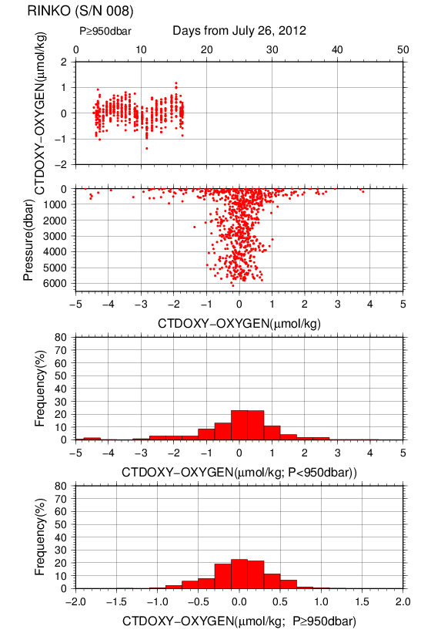
Figure C.1.5. Difference between the CTD oxygen (S/N 008) and bottle dissolved oxygen at Leg 1. Red dots in upper two panels indicate the result of calibration. Lower two panels show histogram of the difference between calibrated oxygen and bottle oxygen.

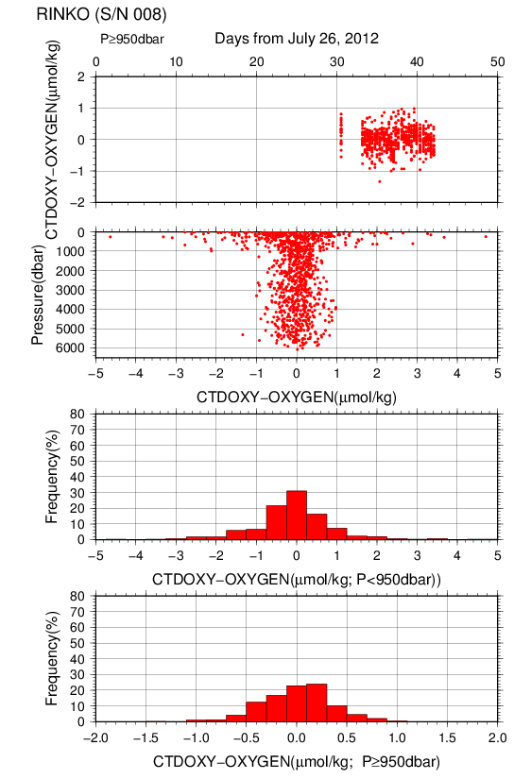
Figure C.1.6. Difference between the CTD oxygen (S/N 008) and bottle dissolved oxygen at Leg 2. Red dots in upper two panels indicate the result of calibration. Lower two panels show histogram of the difference between calibrated oxygen and bottle oxygen.

(4.5) Results of detection of sea floor by the altimeter (PSA-916D)
The altimeter detected the sea floor at 72 of 75 stations, the average distance of beginning detecting the sea floor was 34.1m, and that of final detection of sea floor was 6.0m. The summary of detection of PSA-916D was shown in Figure C.1.8.
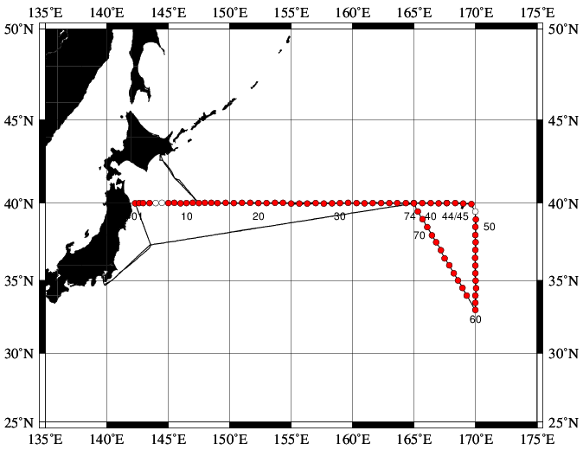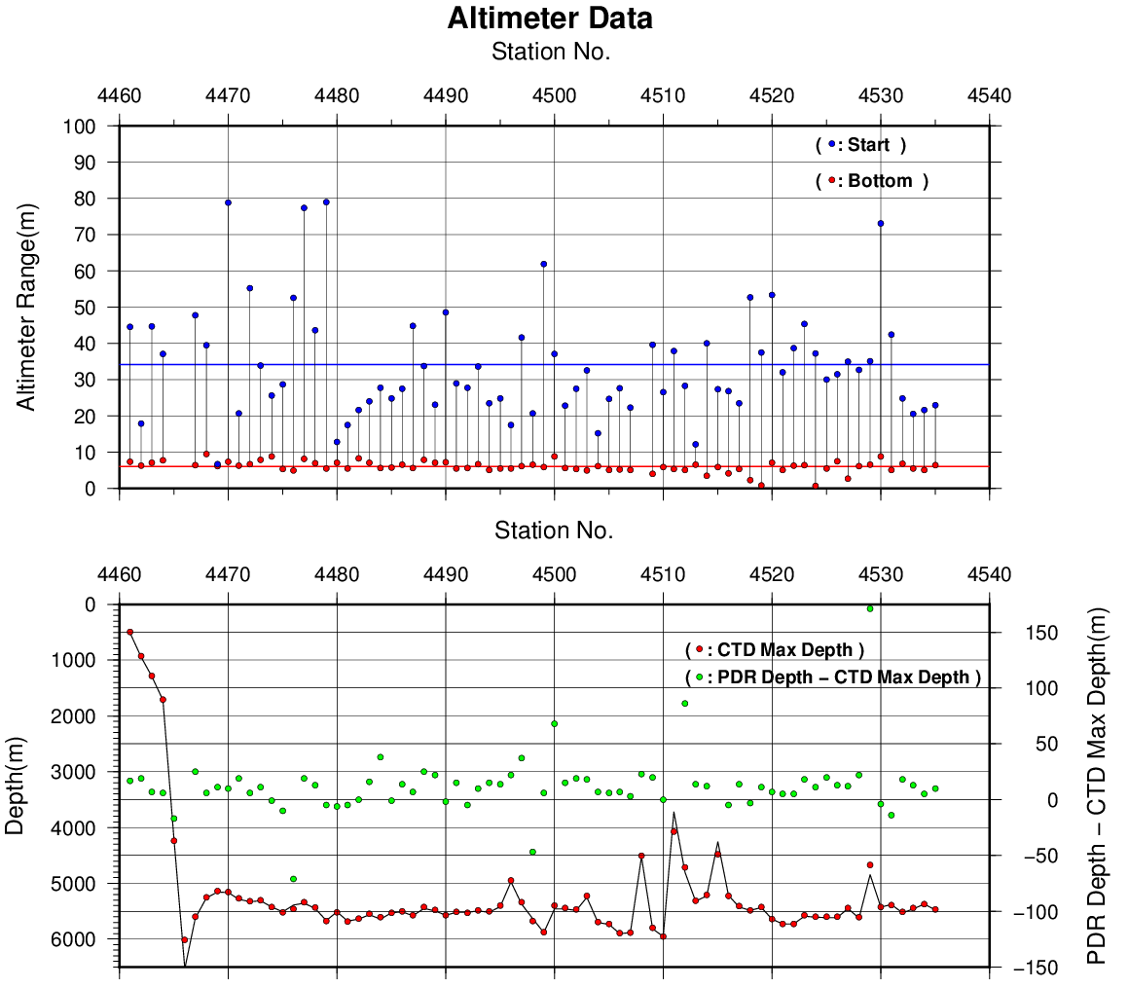
Figure C.1.7. The summary of detection of PSA-916D. The left panel shows the stations of detection, the right panel shows the relationship among PSA-916D, bathymetry and CTD depth. In the left panel, closed and open circles indicate react and no-react stations, respectively.

References
Akaike, H. (1974): A new look at the statistical model identification. IEEE Transactions on Automatic Control, 19:716–722.
Garcìa, H. E., and L. I. Gordon (1992): Oxygen solubility in seawater: Better fitting equations. Limnol. Oceanogr., 37, 1307–1312.
McTaggart, K. E., G. C. Johnson, M. C. Johnson, F. M. Delahoyde, and J. H. Swift (2010): The GO-SHIP Repeat Hydrography Manual: A Collection of Expert Reports and guidelines. IOCCP Report No 14, ICPO Publication Series No. 134, version 1, 2010.
Sea-Bird Electronics (2009): SBE 43 dissolved oxygen (DO) sensor – hysteresis corrections, Application note no. 64-3, 7 pp.
Shanno, David F. (1970): Conditioning of quasi-Newton methods for function minimization. Math. Comput. 24, 647–656. MR 42 #8905.
Uchida, H., G. C. Johnson, McTaggart, K. E. (2010): CTD oxygen sensor calibration procedures. In: The GO-SHIP repeat hydrography manual: A Collection of Expert Reports and guidelines. IOCCP Report No 14, ICPO Publication Series No. 134, version 1, 2010.
Uchida, H., K. Ohyama, S. Ozawa, and M. Fukasawa (2007): In-situ calibration of the Sea-Bird 9plus CTD thermometer. J. Atmos. Oceanic Technol., 24, 1961–1967.
Uchida, H., T. Kawano, I. Kaneko, and M. Fukasawa (2008): In-situ calibration of optode-based oxygen sensors. J. Atmos. Oceanic Technol., 25, 2271–2281.

Bottle Salinity
1 November 2019

Personnel
Keizo SHUTTA (GEMD/JMA)
Nobumi KATO (GEMD/JMA)
Seiko SHIMOJI (GEMD/JMA)
Noriyuki OKUNO (GEMD/JMA)
Koichi WADA (GEMD/JMA)
Yasunori SASAKI (GEMD/JMA)

Salinity measurement
Salinometer: AUTOSAL 8400B (S/N66286 (Leg 1), S/N67642 (Leg 2); Guildline Instruments Ltd., Canada)
Thermometer: Guildline platinum thermometers model 9450 (to monitor an ambient temperature and bath temperature)
IAPSO Standard Sea Water: P154 (K15=0.99990)

Sampling and measurement
The measurement system was almost same as Kawano (2010).
Algorithm for practical salinity scale, 1978 (PSS-78, UNESCO, 1981) was employed to convert the conductivity ratios to salinities.

Station occupied
Figure C.2.1. Location of observation stations of bottle salinity. Closed and open circles indicate sampling and no-sampling station, respectively.

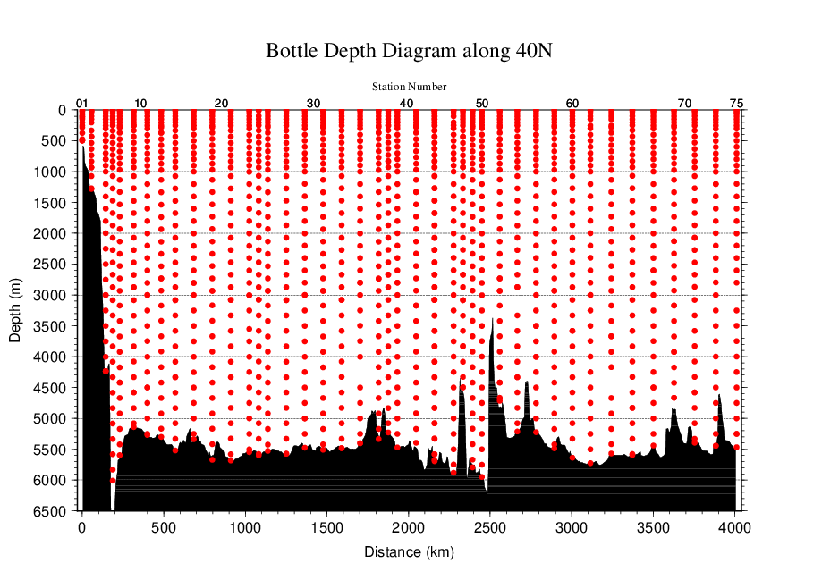
Figure C.2.2. Distance-depth distribution of sampling layers of bottle salinity.

Result

(5.1) Ambient temperature, bath temperature and SSW measurements
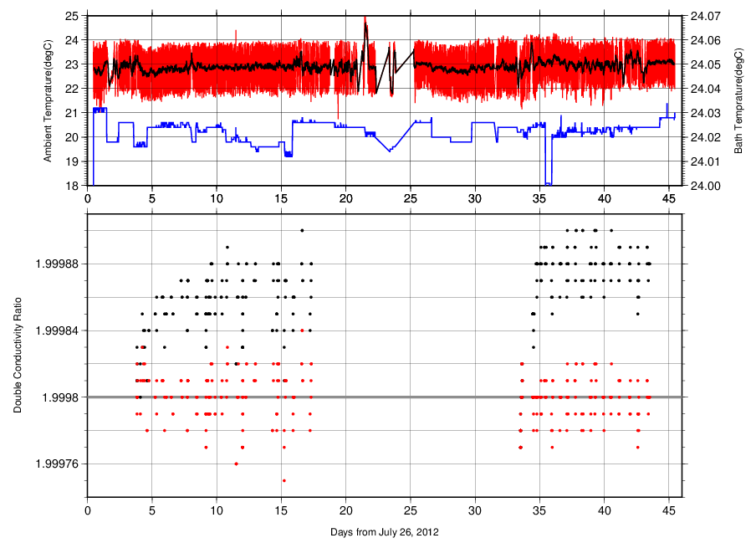
Figure C.2.3. The upper panel, red line, black line and blue line indicate time-series of ambient temperature, ambient temperature average and bath temperature during cruise. The lower panel, black dots and red dots indicate raw and corrected time-series of the double conductivity ratio of the standard sea water (P154).

(5.2) Replicate and Duplicate Samples
We took replicate (pair of water samples taken from a single Niskin bottle) and duplicate (pair of water samples taken from different Niskin bottles closed at the same depth) samples of bottle salinity through the cruise. Results of the analyses are summarized in Table C.2.1. Detailed results of them are shown in Figure C.2.4. The calculation of the standard deviation from the difference of sets was based on a procedure (SOP 23) in DOE (1994).

Table C.2.1. Summary of replicate and duplicate analyses.
Measurement | Ave. ± S.D.
Replicate | 0.0005±0.0005 (N=100)
Duplicate | 0.0007±0.0007 (N=67)

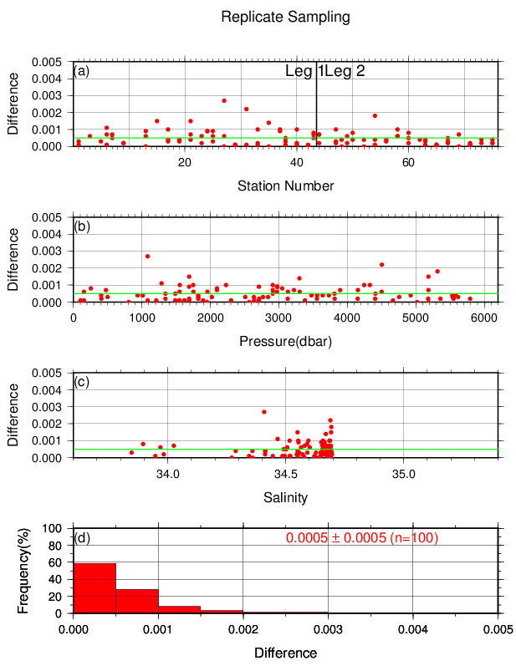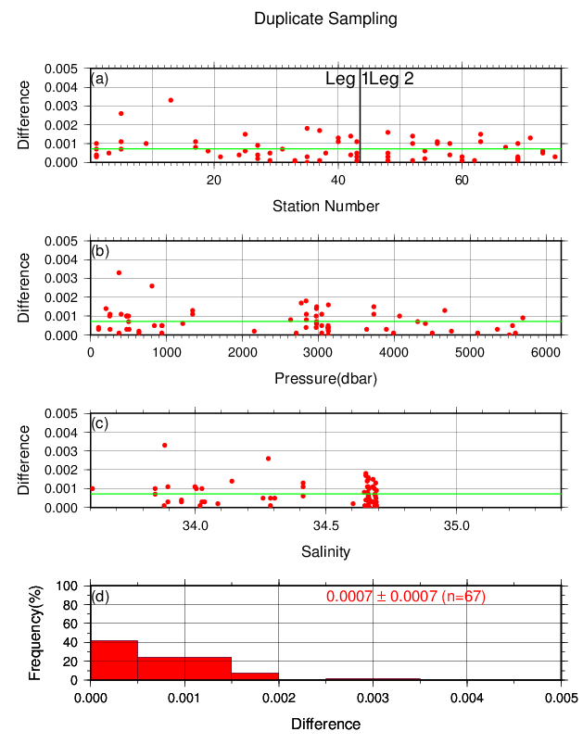
Figure C.2.4. Result of (left) replicate and (right) duplicate analyses during the cruise against (a) station number, (b) pressure and (c) salinity, and (d) histogram of the measurements. Green line indicates the mean of the differences of salinity of replicate/duplicate.

(5.3) Summary of assigned quality control flags
Table C.2.2. Summary of assigned quality control flags
Flag | Definition | Salinity
2 | Good | 1260
3 | Questionable | 0
4 | Bad (Faulty) | 175
6 | Replicate measurements | 105
Total number of samples |  | 1540

References
DOE (1994), Handbook of methods for the analysis of the various parameters of the carbon dioxide system in sea water; version 2. A.G. Dickson and C. Goyet (eds), ORNL/CDIAC-74.
Kawano (2010), The GO-SHIP Repeat Hydrography Manual: A Collection of Expert Reports and Guidelines. IOCCP Report No. 14, ICPO Publication Series No. 134, Version 1.
UNESCO (1981), Tenth report of the Joint Panel on Oceanographic Tables and Standards. UNESCO Tech. Papers in Mar. Sci., 36, 25 pp.

Bottle Oxygen
1 November 2019

Personnel
Chihiro KAWAMURA (GEMD/JMA)
Sho HIBINO (GEMD/JMA)
Hiroki SHIOZURU (GEMD/JMA)

Station occupied
A total of 55 stations (Leg 1: 25, Leg 2: 30) were occupied for dissolved oxygen measurements. Station location and sampling layers of bottle oxygen are shown in Figures C.3.1 and C.3.2, respectively.

Figure C.3.1. Location of observation stations of bottle oxygen. Closed and open circles indicate sampling and no-sampling stations, respectively.

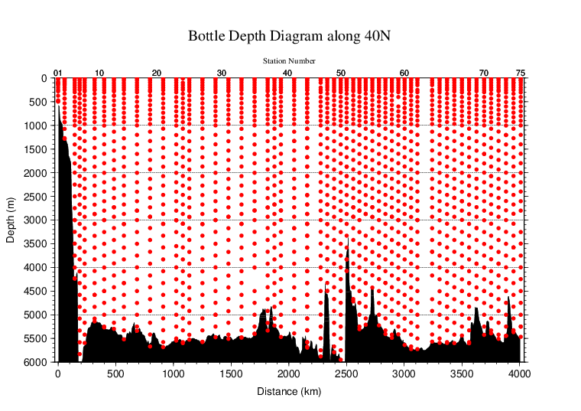
Figure C.3.2. Distance-depth distribution of sampling layers of bottle oxygen.

Instrument
Detector: DOT-01X (Kimoto Electronic, Japan)
Burette: APB-510 (Kyoto Electronic, Japan)

Sampling and measurement
Methods of seawater sampling, measurement, and calculation of dissolved oxygen concentration were based on IOCCP Report (Langdon, 2010). Details of the methods are shown in Appendix A1.
The reagents for the measurement were prepared according to recipes described in Appendix A2. It is noted that standard KIO₃ solutions were prepared gravimetrically using the highest purity standard substance KIO₃ (Lot. No. 92404G, Merck KGaA, Germany). Batch list of prepared standard KIO₃ solutions is shown in Table C.3.1. The normality of the standard potassium iodate solution made by Merck reagent was corrected by the factor as 1.0026 from the result of the inter-laboratory comparison with the standard potassium iodate solution made by National Metrology Institute of Japan reagent (JMA, 2010).

Table C.3.1. Batch list of the standard KIO₃ solutions.
KIO₃ batch | Concentration and uncertainty (k=2) at 20 °C. Unit is normality (N). | Purpose of use
20120222 | 0.010120±0.000005 | Standardization (main use)
20120404-2 | 0.010189±0.000005 | Mutual comparison

Standardization
Concentration of Na₂S₂O₃ titrant was determined with the standard KIO₃ solution “20120222”, based on the methods of IOCCP Report (Langdon, 2010). The results of standardization during the cruise are shown in Figure C.3.3. Standard deviation of its concentration at 20 °C determined through standardization was used in calculation of an uncertainty.
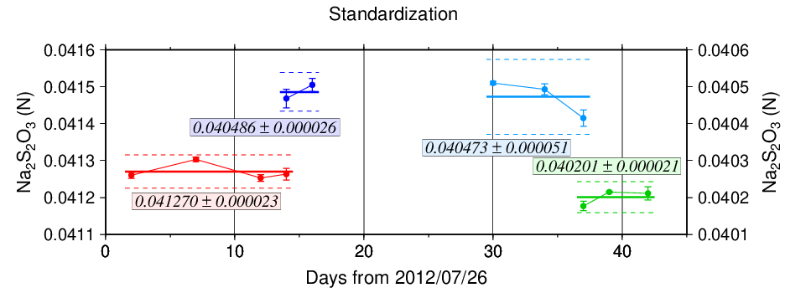
Figure C.3.3. Calculated concentration of Na₂S₂O₃ solution at 20 °C in standardization during the cruise. Different colors of plots indicate different batches of Na₂S₂O₃ solution; red (blue, light blue, and green) plots correspond to the left (right) y-axis. Error bars of plots show standard deviation of concentration of Na₂S₂O₃ in the measurement. Thick and dashed lines denote the mean and 2 times of standard deviations for the batch measurements, respectively.

Blank

(6.1) Reagent blank
Blank in oxygen measurement (reagent blank; V_{blk}, _{dw}) can be represented as follows;
V_{blk, dw} = V_{blk, ep} + V_{blk, reg} (C3.1)
where V_{blk, ep} represents a blank due to differences between the measured end-point and the equivalence point, and V_{blk, reg} a blank associated with oxidants or reductants in the reagent. The reagent blank V_{blk}, _{dw} was determined by the methods described in IOCCP Report (Langdon, 2010). Because we used two sets (set A and B) of pickling reagent-I and -II, the blanks in each set were determined (Figure C.3.4).

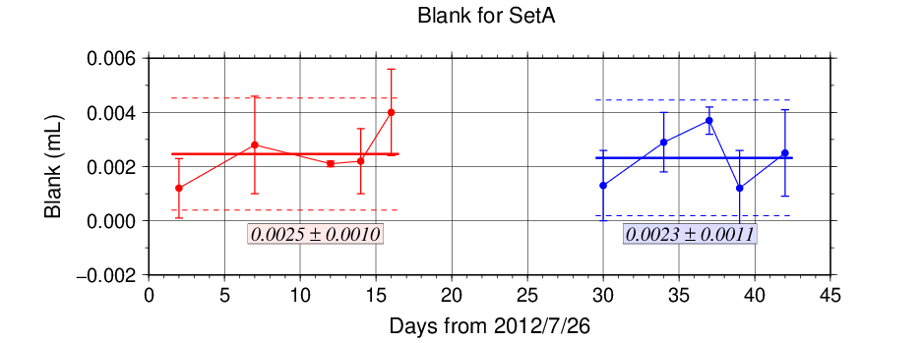
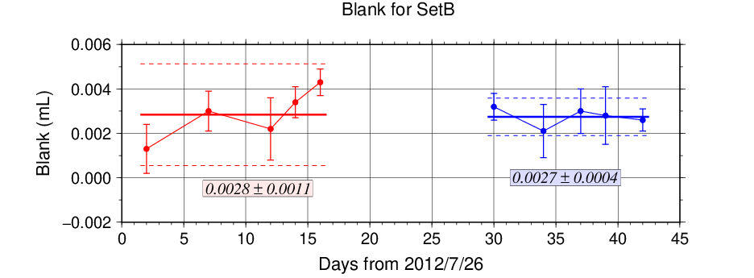
Figure C.3.4. Reagent blank (V_{blk}, _{dw}) determination for set A (top) and set B (bottom). Error bars of plots show standard deviation of the measurement. Thick and dashed lines denote the mean and 2 times of standard deviations for the batch measurement, respectively.

(6.2) Other blanks
We also determined another blanks related to oxygen measurement; the blank V_{blk, reg}. Details are described in Appendix A3.

Quality Control

(7.1) Replicate and duplicate analyses
We took replicate (pair of water samples taken from a single Niskin bottle) and duplicate (pair of water samples taken from different Niskin bottles closed at the same depth) samples of dissolved oxygen through the cruise. Results of the analyses are summarized in Table C.3.2. Detailed results of them are shown in Figure C.3.5. The calculation of the standard deviation from the difference of sets was based on a procedure (SOP 23) in DOE (1994).

Table C.3.2. Summary of replicate and duplicate analyses.
Measurement | Ave. ± S.D. (μmol kg⁻¹)
Replicate | 0.22±0.21 (N=213)
Duplicate | 0.35±0.33 (N=87)

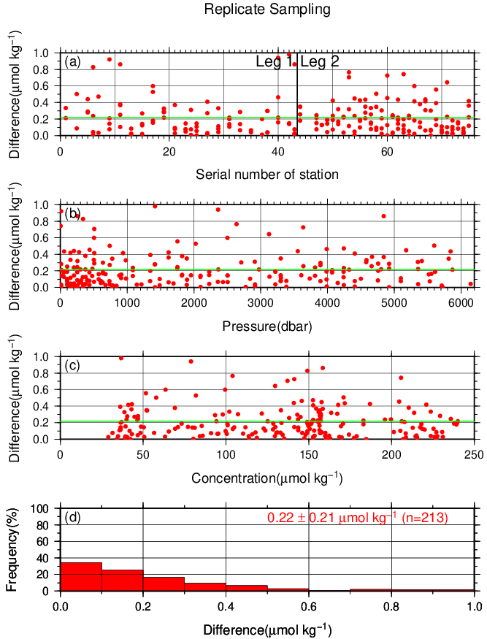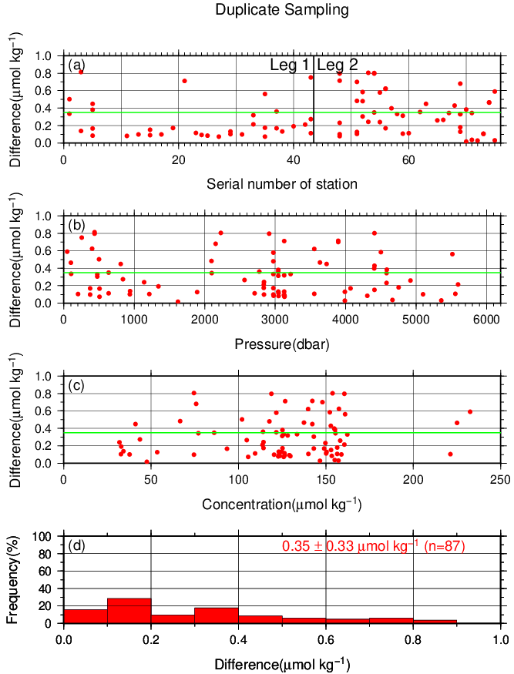
Figure C.3.5. Results of (left) replicate and (right) duplicate analyses during the cruise against (a) station number, (b) pressure and (c) concentration of dissolved oxygen. Green line denotes the average of the measurements. Bottom panels (d) show histogram of the measurements.

(7.2) Mutual comparison between each standard KIO₃ solution
During the cruise, mutual comparison between different lots of standard KIO₃ solution was performed to confirm the accuracy of our oxygen measurement and the bias of a standard KIO₃ solution. A concentration of the standard KIO₃ solution “20120404-2” was determined using Na₂S₂O₃ solution standardized with the KIO₃ solution “20120222”, and the difference between measurement value and theoretical one. A good agreement among two standards confirmed that there was no systematic shift in our oxygen measurements during the cruise (Figure C.3.6).

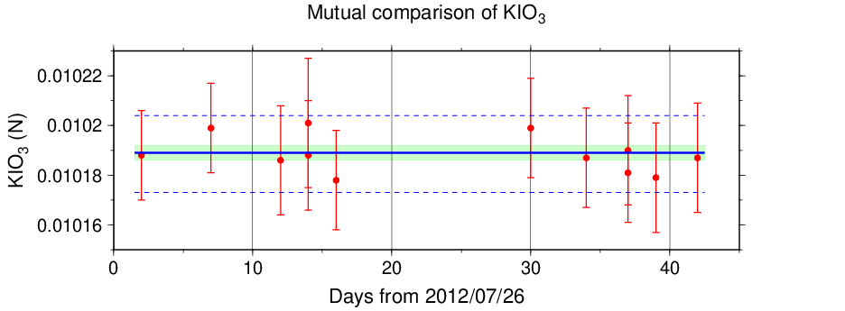
Figure C.3.6. Result of mutual comparison of standard KIO₃ solutions during the cruise. Circles and error bars show mean of the measurement value and its uncertainty (k=2), respectively. Thick and dashed lines in blue denote the mean and 2 times of standard deviations, respectively, for the measurement. Green thin line and light green thick line denote nominal concentration and its uncertainty (k=2) of standard KIO₃ solution “20120404-2”.

(7.3) Quality control flag assignment
Quality flag value was assigned to oxygen measurements as shown in Table C.3.3, using the code defined in IOCCP Report No.14 (Swift, 2010).

Table C.3.3. Summary of assigned quality control flags.
Flag | Definition | Number of samples
2 | Good | 1699
3 | Questionable | 26
4 | Bad (Faulty) | 52
5 | Not reported | 0
6 | Replicate measurements | 204
Total number of samples |  | 1981

Uncertainty
Oxygen measurement involves various uncertainties; determination of glass bottles volume, repeatability and systematic error of burette discharge, repeatability of pickling reagents discharge, determination of reagent blank, standardization of Na₂S₂O₃ solution, and uncertainty of KIO₃ concentration. Considering evaluable uncertainties as above, expanded uncertainty of bottle oxygen concentration (T=20, S=34.5) was estimated as shown in Table C.3.4. However, it is difficult to determine a strict uncertainty for oxygen concentration because there is no reference material for oxygen measurement.

Table C.3.4 Expanded uncertainty (k=2) of bottle oxygen in the cruise.
O₂ conc. (μmol kg⁻¹) | Uncertainty (μmol kg⁻¹)
20 | 0.35
30 | 0.36
50 | 0.39
70 | 0.42
100 | 0.49
150 | 0.62
200 | 0.76
250 | 0.92
300 | 1.07
400 | 1.40

Appendix
A1. Methods
(A1.1) Seawater sampling
Following procedure is based on a determination method in IOCCP Report (Langdon, 2010). Seawater samples were collected from 10-liters Niskin bottles attached the CTD-system and a stainless steel bucket for the surface. Seawater for bottle oxygen measurement was transferred from the Niskin bottle and a stainless steel bucket to a volumetrically calibrated dry glass bottles. At least three times the glass volume water was overflowed. Then, pickling reagent-I 1 mL and reagent-II 1mL were added immediately, and sample temperature was measured using a thermometer. After a stopper was inserted carefully into the glass, it was shaken vigorously to mix the content and to disperse the precipitate finely. After the precipitate has settled at least halfway down the glass, the glass was shaken again. The sample glasses containing pickled samples were stored in a laboratory until they were titrated. To prevent air from entering the glass, deionized water (DW) was added to its neck after sampling.

(A1.2) Sample measurement
At least 15 minutes after the re-shaking, the samples were measured on board. Added 1 mL H₂SO₄ solution and a magnetic stirrer bar into the sample glass, samples were titrated with Na₂S₂O₃ solution whose molarity was determined with KIO₃ solution. During the titration, the absorbance of iodine in the solution was monitored using a detector. Also, temperature of Na₂S₂O₃ solution during the titration was recorded using a thermometer. Dissolved oxygen concentration (μmol kg⁻¹) was calculated from sample temperature at the fixation, CTD salinity, glass volume, and titrated volume of the Na₂S₂O₃ solution, and oxygen in the pickling reagents-I (1 mL) and II (1 mL) (7.6 × 10⁻⁸ mol; Murray et al., 1968).

A2. Reagents recipes
Pickling reagent-I; Manganous chloride solution (3 mol L⁻¹)
Dissolve 600 g of MnCl₂·4H₂O in DW, then dilute the solution with DW to a final volume of 1 L.
Pickling reagent-II; Sodium hydroxide (8 mol L⁻¹) / sodium iodide solution (4 mol L⁻¹)
Dissolve 320 g of NaOH in about 500 mL of DW, allow to cool, then add 600 g NaI and dilute with DW to a final volume of 1 L.
H₂SO₄ solution; Sulfuric acid solution (5 mol L⁻¹)
Slowly add 280 mL concentrated H₂SO₄ to roughly 500 mL of DW. After cooling the final volume should be 1 L.
Na₂S₂O₃ solution; Sodium thiosulfate solution (0.04 mol L⁻¹)
Dissolve 50 g of Na₂S₂O₃·5H₂O and 0.4 g of Na₂CO₃ in DW, then dilute the solution with DW to a final volume of 5 L.
KIO₃ solution; Potassium iodate solution (0.001667 mol L⁻¹)
Dry high purity KIO₃ for two hours in an oven at 130 °C. After weight out accurately KIO₃, dissolve it in DW in a 5 L flask. Concentration of potassium iodate is determined by a gravimetric method.

A3. Other blanks in oxygen measurement
(A3.1) Blank associated with oxidants or reductants in the reagents
The blank V_{blk, reg,} associated with oxidants or reductants in the reagent, was determined as follows. Using a calibrated pipette, 1 mL of the standard KIO₃ solution and 100 mL of DW were added to two glasses each. Then, 1 mL H₂SO₄ solution, 1 mL of pickling reagent-II and 1 mL reagent-I were added in sequence into the first glass. Next, added two times volume of the reagents (2 mL of H₂SO₄ solution, pickling reagent-II and I each) into the second one. After that, the sample was titrated to the end-point with Na₂S₂O₃ solution. V_{blk, reg} was determined with difference of titrated volume of Na₂S₂O₃ between the first (total reagents volume is 3 mL) and the second (total reagents volume is 6 mL) one, also, experiments for three times and four times volume of them were carried out. The results are shown in Figure C.3.A1.

Figure C.3.A1. Blank (mL) due to redox species other than oxygen in the reagents.

The relation between difference of the titrant volume and the reagents of the volume (V_{reg}) is expressed as follows;
Difference of the titrant volume = –0.0012 V_{reg}. (C3.A1)
Therefore, V_{blk, reg} was estimated to be +0.004 mL.

Reference
Culberson, A.H. (1994) Dissolved oxygen, in WHPO Pub. 91-1 Rev. 1, November 1994, Woods Hole, Mass., USA.
Culberson, A.H., G. Knapp, M.C. Stalcup, R.T. Williams, and F. Zemlyak (1991) A comparison of methods for the determination of dissolved oxygen in seawater, WHPO Pub. 91-2, August 1991, Woods Hole, Mass., USA.
DOE (1994), Handbook of methods for the analysis of the various parameters of the carbon dioxide system in sea water; version 2. A.G. Dickson and C. Goyet (eds), ORNL/CDIAC-74.
Japan Meteorological Agency (2010), WHP P09 REVISIT CRUISE REPORT.
Langdon, C. (2010), Determination of dissolved oxygen in seawater by Winkler titration using the amperometric technique, IOCCP Report No.14, ICPO Pub. 134, 2010 ver.1.
Murray, C. N., J. P. Riley and T. R. S. Wilson (1968), The solubility of oxygen in Winkler reagents used for the determination of dissolved oxygen. Deep-Sea Res. 15, 237–238.
Swift, J. H. (2010), Reference-quality water sample data: Notes on acquisition, record keeping, and evaluation. IOCCP Report No.14, ICPO Pub. 134, 2010 ver.1.

Nutrients
Updated 8 July 2020

Personnel
Kazuhiro SAITO (GEMD/JMA)
Hiroyuki FUJIWARA (GEMD/JMA)
(Leg 1) Minoru HAMANA (GEMD/JMA)
(Leg 2) Takashi MIYAO (GEMD/JMA)

Station occupied
A total of 74 stations (Leg 1: 43, Leg 2: 31) were occupied for nutrients measurements. Station location and sampling layers of nutrients are shown in Figures C.4.1 and C.4.2.

Figure C.4.1. Location of observation stations of nutrients. Closed and open circles indicate sampling and no-sampling stations, respectively.

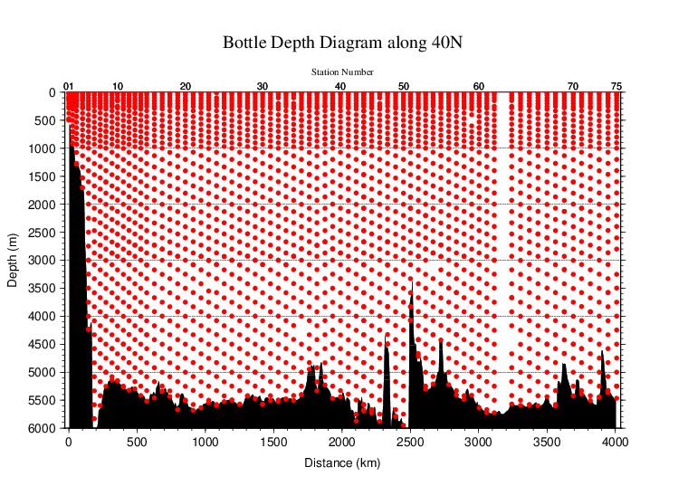
Figure C.4.2. Distance-depth distributions of sampling layers of nutrients.

Instrument
The nutrients analysis was carried out on 4-channel Auto Analyzer III (BL TEC K.K., Japan) for 4 parameters; nitrate+nitrite, nitrite, phosphate, and silicate.

Sampling and measurement
Methods of seawater sampling, measurement, and data processing of nutrient concentration were described in Appendixes A1, A2, and A3, respectively. The reagents for the measurement were prepared according to recipes shown in Appendix A4.

Nutrients standards

(5.1) Volumetric laboratory ware of in-house standards
All volumetric wares were gravimetrically calibrated. The weights obtained in the calibration weighing were corrected for the density of water and for air buoyancy. Polymethylpenten volumetric flasks were gravimetrically calibrated at the temperature of use within 4–6 °C. All pipettes have nominal calibration tolerances of 0.1 % or better. These were gravimetrically calibrated in order to verify and improve upon this nominal tolerance.

(5.2) Reagents of standard
The batches of the reagents used for standard are listed in Table C.4.1.

Table C.4.1. List of reagents of standard used in the cruise.
 | Name | CAS No | Lot. No | Industries
Nitrate | potassium nitrate 99.995 suprapur® | 7757-79-1 | B0158765 | Merck KGaA
Nitrite | sodium nitrite GR for analysis ACS, Reag. Ph Eur | 7632-00-0 | A0113649 | Merck KGaA
Phosphate | potassium dihydrogen phosphate anhydrous 99.995 suprapur® | 7778-77-0 | B0442908 | Merck KGaA
Silicate | Silicon standard solution 1000 mg/l Si* | - | HC122701**  HC247279*** | Merck KGaA
* Traceable to NIST-SRM3150
** Used before Station RF4519
*** Used after Station RF4520

(5.3) Low nutrient seawater (LNSW)
Surface water with sufficiently low nutrient concentration was taken and filtered using 10 μm pore size membrane filter in our previous cruise. This water was stored in 20 liter flexible container with paper box.

(5.4) In-house standard solutions
Nutrient concentrations for A, B and C standards were set as shown in Table C.4.2. A and B standards were prepared with deionized water (DW). C standard (full scale of working standard) was mixture of B-1 and B-2 standards, and was prepared with LNSW. C-1 standard, whose concentrations of nutrient were nearly zero, was prepared as LNSW slightly added with DW to be equal with mixing ratio of LNSW and DW in C standard. The C-2 to -5 standards were prepared with mixture of C-1 and C standards in stages as 1/4, 2/4, 3/4, and 4/4 (i.e., pure “C standard”) concentration for full scale, respectively. The actual concentration of nutrients in each standard was calculated based on the solution temperature and factors of volumetric laboratory wares calibrated prior to use. Nominal zero concentration of nutrient was determined in measurement of DW after refraction error correction. The calibration curves for each run were obtained using 5 levels of C-1 to -5 standards. These standard solutions were periodically renewed as shown in Table C.4.3.

Table C.4.2. Nominal concentrations of nutrients for A, B, and C standards at 20 °C. Unit is μmol L⁻¹.
 | A | B | C
Nitrate | 27480 | 550 | 43.6
Nitrite | 12480 | 250 | 2.0
Phosphate | 2120 | 42.3 | 3.38
Silicate | 35600  35680 | 2300  2310 | 183.9  184.2

Table C.4.3. Schedule of renewal of in-house standards.
Standard | Renewal
A-1 std. (NO₃) | No renewal
A-2 std. (NO₂) | No renewal
A-3 std. (PO₄) | No renewal
A-4 std. (Si) | Commercial prepared solution
B-1 std. (mixture of A-1, A-3, and A-4 stds.) | Maximum 8 days
B-2 std. (diluted A-2 std.) | Maximum 15 days
C-std. (mixture of B-1 and B-2 stds.) | Every measurement
C-1 to -5 stds. | Every measurement

Certified reference material
Certified reference material (CRM) and reference material (RM) for nutrients in seawater, which were prepared by the General Environmental Technos (KANSO Technos, Japan), was used every analysis at each hydrographic station. Using CRM and RMs for the analysis of seawater, stable comparability and uncertainty of our data are secured.
CRM and RMs used in the cruise are shown in Table C.4.4.

Table C.4.4. Certified concentration and uncertainty (k=2) of RMs. Unit is μmol kg⁻¹.
 | Nitrate | Phosphate | Silicate
RM-BS | 0.058±0.028* | 0.054±0.010 | 2.411±0.236
RM-BT | 18.15±0.24 | 1.296±0.027 | 42.02±0.64
CRM-BV | 35.36±0.35 | 2.498±0.023 | 102.2±1.1
RM-BF** | 41.39±0.05 | 2.809±0.06 | 150.61±0.14
* Reference value because concentration is under limit of quantitation
**Assigned by Aoyama et al. (2010)

It is noted that nutrient data in our report are calibrated not on CRM and RM but on in-house standard solutions. Therefore, to calculate data based on CRM and RM, it is necessary that values of nutrient concentration in our report are correlated with CRM and RM values measured in the same analysis run. The result of CRM and RM measurements is attached as 49UP20120726_40N_nut_RM_measurement.csv.

Quality Control

(7.1) Replicate and duplicate analyses
We took replicate (pair of water samples taken from a single Niskin bottle) and duplicate (pair of water samples taken from different Niskin bottles closed at the same depth) samples of nutrient through the cruise. Results of the analyses are summarized in Table C.4.5. Detailed results of them are shown in Figures C.4.3–C.4.5. The calculation of the standard deviation from the difference of sets was based on a procedure (SOP 23) in DOE (1994).

Table C.4.5. Average and standard deviation of difference of replicate and duplicate analyses through the cruise. Unit is μmol kg⁻¹.
Measurement | Nitrate+nitrite | Phosphate | Silicate
Replicate | 0.063±0.064 (N=275) | 0.003±0.003 (N=282) | 0.104±0.098 (N=287)
Duplicate | 0.092±0.086 (N=130) | 0.004±0.005 (N=130) | 0.178±0.193 (N=129)

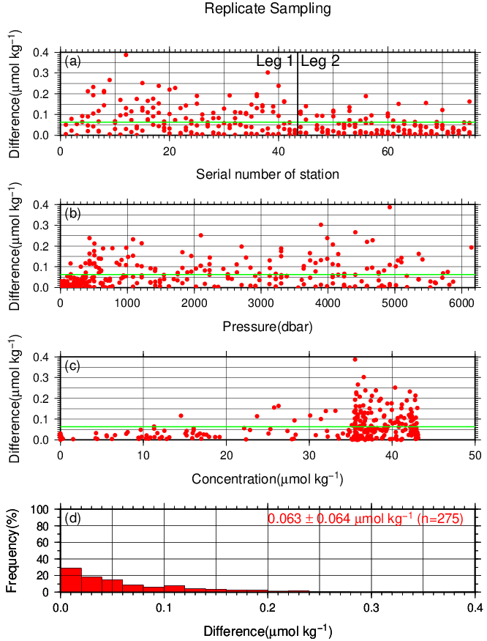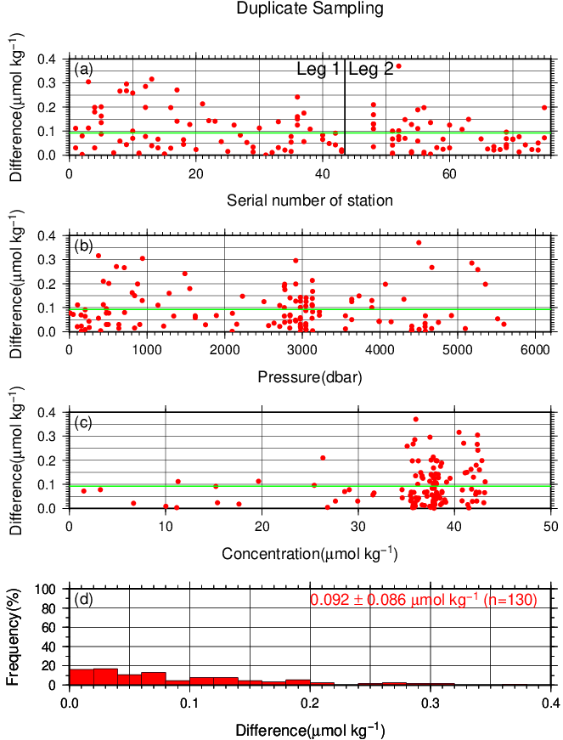
Figure C.4.3. Result of (left) replicate and (right) duplicate analyses of nitrate+nitrite through the cruise versus (a) station number, (b) sampling pressure, (c) concentration, and (d) histogram of the measurements. Green line indicates the mean of the differences of concentration of replicate/duplicate analyses.

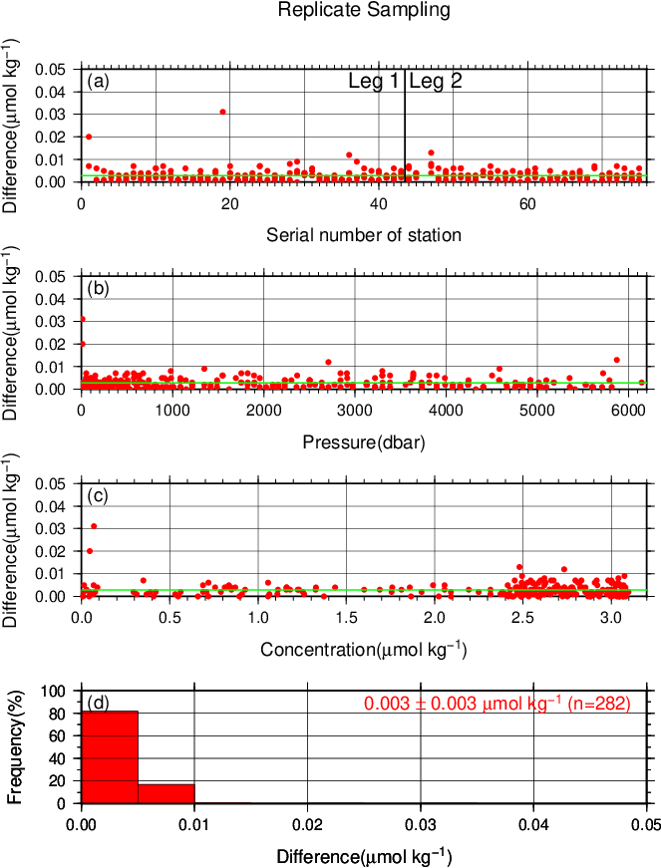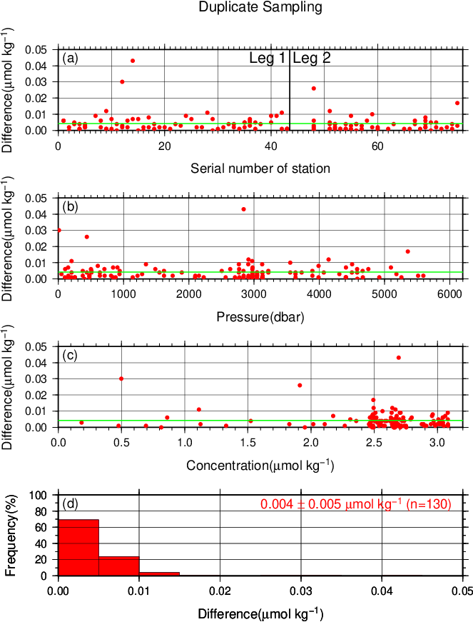
Figure C.4.4. Same as Figure C.4.3 but for phosphate.

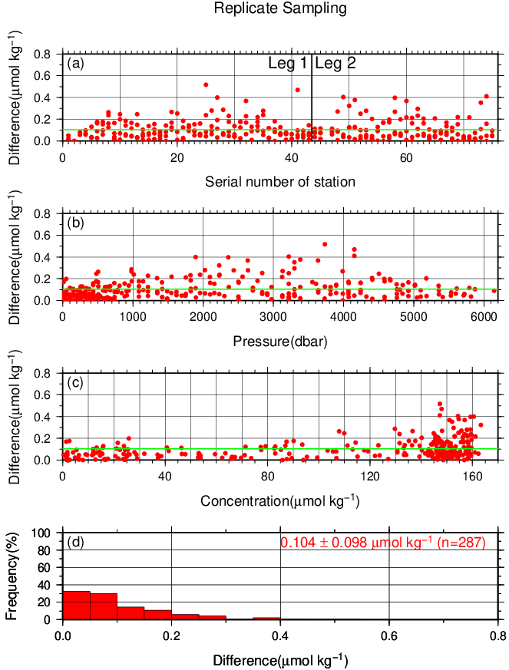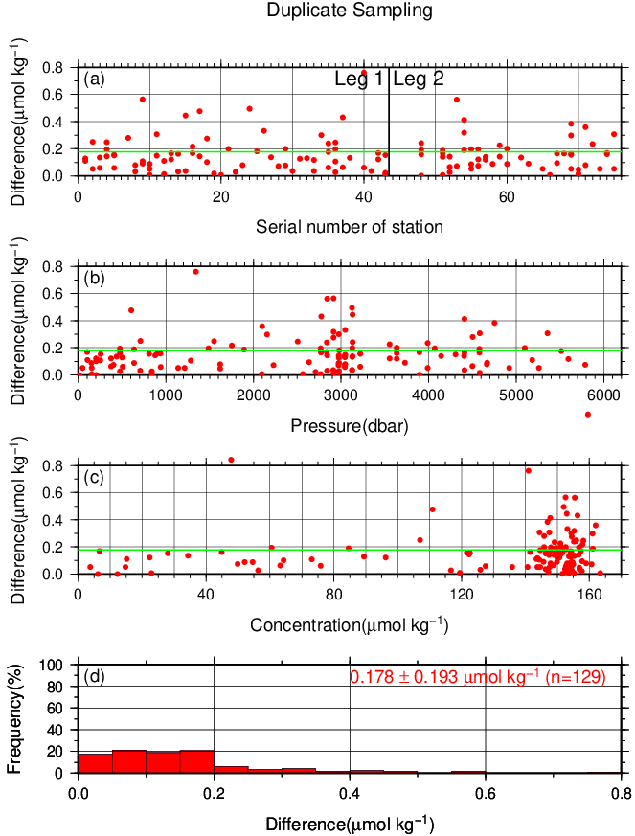
Figure C.4.5. Same as Figure C.4.3 but for silicate.

(7.2) Measurement of CRMs
CRM and RM measurements during the cruise are summarized in Table C.4.6, whose concentrations were assigned with in-house standard solutions. The measured concentrations of CRM-BV through the cruise are shown in Figures C.4.6–C.4.9.

Table C.4.6. Summary of (upper) mean concentration and its standard deviation (unit: μmol kg⁻¹), (middle) coefficient of variation (%), and (lower) total number of CRM and RMs measurements through the cruise.
 | Nitrate+nitrite | Nitrite | Phosphate | Silicate
RM-BS | 0.073±0.037  50.86%  (N=147) | 0.013±0.003  22.42%  (N=144) | 0.029±0.006  19.18%  (N=147) | 1.78±0.10  5.86%  (N=147)
RM-BT | 18.63±0.07  0.39%  (N=112) | 0.046±0.028  6.04%  (N=112) | 1.29±0.01  0.76%  (N=112) | 42.00±0.14  0.34%  (N=112)
CRM-BV | 35.39±0.10  0.28%  (N=147) | 0.040±0.003  6.65%  (N=145) | 2.50±0.01  0.45%  (N=147) | 102.26±0.27  0.26%  (N=147)
RM-BF | 41.38±0.11  0.26%  (N=112) | 0.017±0.003  16.02%  (N=112) | 2.79±0.01  0.37%  (N=112) | 153.73±0.37  0.24%  (N=112)

Figure C.4.6. Time-series of measured concentration of nitrate+nitrite of CRM-BV through the cruise. Closed and open circles indicate the newly and previously opened bottle, respectively. Thick and dashed lines denote the mean and 2 times of standard deviations of the measurements through the cruise, respectively.

Figure C.4.7. Same as Figure C.4.6 but for nitrite.

Figure C.4.8. Same as Figure C.4.6 but for phosphate.

Figure C.4.9. Same as Figure C.4.6 but for silicate.

(7.3) Precision of analysis in a run
To monitor precision of analysis, the same samples were repeatedly measured in a sample array in a run. For this, C-5 standard solutions were randomly arrayed in every 2–10 samples as “check standard” (the number of the standard is about 8–9) in the run. The precision was estimated as coefficient of variation of the measurements. The results are summarized in Table C.4.7. The time series are shown in Figures C.4.10–C.4.13.

Figure C.4.10. Time-series of coefficient of variation of “check standard” measurement of nitrate+nitrite through the cruise. Thick and dashed lines denote the mean and 2 times of standard deviations of the measurements through the cruise, respectively.

Figure C.4.11. Same as Figure C.4.10 but for nitrite.

Figure C.4.12. Same as Figure C.4.10 but for phosphate.

Figure C.4.13. Same as Figure C.4.10 but for silicate.

Table C.4.7. Summary of precisions during the cruise.
 | Nitrate+nitrite | Nitrite | Phosphate | Silicate
Median | 0.19% | 0.08% | 0.13% | 0.14%
Mean | 0.20% | 0.08% | 0.13% | 0.14%
Minimum | 0.04% | 0.02% | 0.02% | 0.04%
Maximum | 0.39% | 0.22% | 0.25% | 0.33%
Number | 74 | 74 | 74 | 74

(7.4) Limit of detection/quantitation of measurement
Limit of detection (LOD) and quantitation (LOQ) of nutrient measurement were estimated from standard deviation (σ) of repeated measurements of nutrients concentration in C-1 standard as 3σ and 10σ, respectively. Summary of LOD and LOQ are shown in Table C.4.8.

Table C.4.8. Limit of detection (LOD) and quantitation (LOQ) of nutrient measurement in the cruise. Unit is μmol kg⁻¹.
 | LOD | LOQ
Nitrate+nitrite | 0.045 | 0.150
Nitrite | 0.002 | 0.005
Phosphate | 0.012 | 0.041
Silicate | 0.130 | 0.435

(7.5) Quality control flag assignment
Quality flag value was assigned to nutriment measurements as shown in Table C.4.9, using the code defined in IOCCP Report No.14 (Swift, 2010).

Table C.4.9. Summary of assigned quality control flags.
Flag | Definition | Nitrate+nitrite | Nitrite | Phosphate | Silicate
2 | Good | 2310 | 2331 | 2315 | 2325
3 | Questionable | 31 | 0 | 19 | 2
4 | Bad (Faulty) | 32 | 30 | 32 | 34
5 | Not reported | 4 | 6 | 4 | 4
6 | Replicate measurements | 275 | 285 | 282 | 287
Total number of samples |  | 2652 | 2652 | 2652 | 2652

Uncertainty

(8.1) Uncertainty associated with concentration level: U_{c}
Generally, an uncertainty of nutrient measurement is expressed as a function of its concentration level which reflects that some components of uncertainty are relatively large in low concentration. Empirically, the uncertainty associated with concentrations level (U_{c}) can be expressed as follows;
$U_{c} (\%)=a+b∙(1/C_{x})+c∙{(1/C_{x})}^{2}$, (C4.1)
where C_{x} is the concentration of sample for parameter X.
Using the coefficients of variation of the CRM measurements throughout the cruise, uncertainty associated with concentrations of nitrate+nitrite, phosphate, and silicate were determined as follows:
U_{c-no3} (%) = $0.208+1.804×(1/{C_{n})+}0.0577×{(1/{C_{n})}}^{2}$0.158 + 4.299 × (1/C_{n}) − 0.043 × (1/C_{n})²$0.274+1.779×\left(1/{C_{n}}\right)+0.0497×{\left(1/{C_{n}}\right)}^{2}$ (C4.2)
U_{c-po4} (%) = $0.208+1.804×(1/{C_{n})+}0.0577×{(1/{C_{n})}}^{2}$0.080 + 0.886 × (1/C_{p}) $0.274+1.779×\left(1/{C_{n}}\right)+0.0497×{\left(1/{C_{n}}\right)}^{2}$− 0.0097 × (1/C_{p})² (C4.3)
U_{c-sil} (%) = $0.208+1.804×(1/{C_{n})+}0.0577×{(1/{C_{n})}}^{2}$0.203 + 5.573 × (1/C_{s}) + 8.073 × (1/C_{s})²,$0.274+1.779×\left(1/{C_{n}}\right)+0.0497×{\left(1/{C_{n}}\right)}^{2}$ (C4.4)
where C_{n}, C_{p}, and C_{s} represent concentrations of nitrate+nitrite, phosphate, and silicate, respectively, in μmol kg⁻¹. Figures C.4.14–C.4.16 show the calculated uncertainty graphically.
Figure C.4.14. Uncertainty of nitrate+nitrite associated with concentration level.

Figure C.4.15. Same as Figure C.4.14 but for phosphate.

Figure C.4.16. Same as Figure C.4.14 but for silicate.

(8.2) Uncertainty of analysis between runs: U_{s}
Uncertainty of analysis among runs (U_{s}) was evaluated based on the coefficient of variation of measured concentrations of CRM-BV with high concentration among the CRM lots throughout the cruise, as shown in subsection (7.2). The reason for using the CRM lot BV to state U_{s} is to exclude the effect of uncertainty associated with lower concentration described previously. As is clear from the definition of U_{c}, U_{s} is equal to U_{c} at nutrients concentrations of lot BV. It is important to note that U_{s} includes all of uncertainties during the measurements throughout stations, namely uncertainties of concentrations of in-house standard solutions prepared for each run, uncertainties of slopes and intercepts of the calibration curve in each run if first order calibration curve applied, precision of measurement in a run (U_{a}), and between-bottle homogeneity of the CRM.

(8.3) Uncertainty of analysis in a run: U_{a}
Uncertainty of analysis in a run (U_{a}) was evaluated based on the coefficient of variation of repeated measurements of the “check standard” solution, as shown in subsection (7.3). The U_{a} reflects the conditions associated with chemistry of colorimetric measurement of nutrients, and stability of electronic and optical parts of the instrument throughout a run. Under a well-controlled condition of the measurements, U_{a} might show Poisson distribution with a mean as shown in Figures C.4.10–C.4.13 and Table C.4.7 and treated as a precision of measurement. U_{a} is a part of U_{c} at the concentration as stated in a previous section for U_{c}.
However, U_{a} may show larger value which was not expected from Poisson distribution of U_{a} due to the malfunction of the instruments, larger ambient temperature change, human errors in handling samples and chemistries and contaminations of samples in a run. In the cruise, we observed that U_{a} of our measurement was usually small and well-controlled in most runs as shown in Figures C.4.10–C.4.13 and Table C.4.7. However, in a few runs, U_{a} showed high values which were over the mean ± twice the standard deviations of U_{a}, suggesting that the measurement system might have some problems.

(8.4) Uncertainty of CRM concentration: U_{r}
In the certification of CRM, the uncertainty of CRM concentrations (U_{r}) was stated by the manufacturer (Table C.4.4) as expanded uncertainty at k=2. This expanded uncertainty reflects the uncertainty of the Japan Calibration Service System (JCSS) solutions, characterization in assignment, between-bottle homogeneity, and long term stability. We have ensured comparability between cruises by ensuring that at least two lots of CRMs overlap between cruises. In comparison of nutrient concentrations between cruises using KANSO CRMs in an organization, it was not necessary to include U_{r} in the conclusive uncertainty of concentration of measured samples because comparability of measurements was ensured in an organization as stated previously.

(8.5) Combined relative standard uncertainty: U
To determine the conclusive uncertainty of nutrient measurements of samples (U), we use two functions depending on U_{a} value acquired at each run as follows:
When U_{a} was small and measurement was well-controlled condition, the conclusive uncertainty of nutrient measurements of samples, U, might be as below:
$U=U_{c}$. (C4.5)
When U_{a} was relative large and the measurement might have some problems, the conclusive uncertainty of nutrient measurements of samples, U, can be expanded as below:
$U=\sqrt{U_{c}^{2}+U_{a}^{2}}$. (C4.6)
When U_{a} was relative large and the measurement might have some problems, the equation of U is defined as to include U_{a} to evaluate U, although U_{a} partly overlaps with U_{c}. It means that the equation overestimates the conclusive uncertainty of samples. On the other hand, for low concentration there is a possibility that the equation not only overestimates but also underestimates the conclusive uncertainty because the functional shape of U_{c} in lower concentration might not be the same and cannot be verified. However, we believe that the applying the above function might be better way to evaluate the conclusive uncertainty of nutrient measurements of samples because we can do realistic evaluation of uncertainties of nutrient concentrations of samples which were obtained under relatively unstable conditions, larger U_{a} as well as the evaluation of them under normal and good conditions of measurements of nutrients.

Appendix
A1. Seawater sampling
Seawater samples were collected from 10-liters Niskin bottle attached CTD-system and a stainless steel bucket for the surface. Samples were drawn into 10 mL polymethylpenten vials using sample drawing tubes. The vials were rinsed three times before water filling and were capped immediately after the drawing.
No transfer was made and the vials were set on an auto sampler tray directly. Samples were analyzed immediately after collection.

A2. Measurement
(A2.1) General
Auto Analyzer III is based on Continuous Flow Analysis method and consists of sampler, pump, manifolds, and colorimeters. As a baseline, we used artificial seawater (ASW).

(A2.2) Nitrate+nitrite and nitrite
Nitrate+nitrite and nitrite were analyzed according to the modification method of Armstrong (1967). The sample nitrate was reduced to nitrite in a glass tube which was filled with granular cadmium coated with copper. The sample stream with its equivalent nitrite was treated with an acidic, sulfanilamide reagent and the nitrite forms nitrous acid which reacts with the sulfanilamide to produce a diazonium ion. N-1-naphthylethylene-diamine was added to the sample stream then coupled with the diazonium ion to produce a red, azo dye. With reduction of the nitrate to nitrite, sum of nitrate and nitrite were measured; without reduction, only nitrite was measured. Thus, for the nitrite analysis, no reduction was performed and the alkaline buffer was not necessary. The flow diagrams for each parameter are shown in Figures C.4.A1 and C.4.A2. If the reduction efficiency of the cadmium column became lower than 95 %, the column was replaced.
ORN/WHT N-1-naphtylethylene-diamine (0.23)
ORN/WHT sample or ASW (0.23)
5T
10T
20T
WHT/WHT debubble (0.60 cc min⁻¹)
YEL/YEL ammonium chloride (buffer) (1.20)
BLK/BLK air (0.32)
BLK/BLK air (0.32)
ORN/WHT sulfanilamide (0.23)
Waste
Waste
Colorimeter
1.5 mm (I.D.) × 15 mm flow cell
530 nm
Cd tube
10T
Waste
GRY/GRY waste (1.00)
Figure C.4.A1. Nitrate+nitrite (1ch.) flow diagram.

GRY/GRY sample or ASW (1.00)
ORN/WHT sulfanilamide (0.23)

ORN/WHT N-1-naphtylethylene-diamine (0.23)

Waste
Colorimeter
1.5 mm (I.D.) × 50 mm flow cell
530 nm
10T
20T
10T
Waste
RED/RED waste (0.80)
Waste
WHT/WHT debubble (0.60)
BLK/BLK air (0.32 cc min⁻¹)
Figure C.4.A2. Nitrite (2ch.) flow diagram.

(A2.3) Phosphate
The phosphate analysis was a modification of the procedure of Murphy and Riley (1962). Molybdic acid was added to the seawater sample to form phosphomolybdic acid which was in turn reduced to phosphomolybdous acid using L-ascorbic acid as the reductant. The flow diagram for phosphate is shown in Figure C.4.A3.
Waste
ORN/ORN debubble (0.42)
BLK/BLK ammonium molybdate (0.32)
YEL/BLU sample or ASW (1.40)
BLK/BLK air (0.32 cc min⁻¹)
ORN/WHT ascolbic acid (0.23)
Waste
Colorimeter
1.5 mm (I.D.) × 50 mm flow cell
880 nm
10T
Waste
RED/RED waste (0.80)
10T
Heating bath
37°C
Figure C.4.A3. Phosphate (3ch.) flow diagram.

(A2.4) Silicate
The silicate was analyzed according to the modification method of Grasshoff et al. (1983), wherein silicomolybdic acid was first formed from the silicate in the sample and added molybdic acid, then the silicomolybdic acid was reduced to silicomolybdous acid, or "molybdenum blue," using L-ascorbic acid as the reductant. The flow diagram for silicate is shown in Figure C.4.A4.
WHT/WHT ammonium molybdate (0.60)
ORN/YEL sample or ASW (0.16)
BLK/BLK air (0.32 cc min⁻¹)
ORN/ORN oxalic acid (0.42)
Waste
Colorimeter
1.5 mm (I.D.) × 15 mm flow cell
820 nm
Heating bath
37°C
10T
Waste
YEL/YEL waste (1.20)
WHT/WHT ascolbic acid (0.60)

10T
10T
Figure C.4.A4. Silicate (4ch.) flow diagram.

A3. Data processing
Raw data from Auto Analyzer III were recorded at 1-second interval and were treated as follows;
- Check the shape of each peak and position of peak values taken, and then change the positions of peak values taken if necessary.
- Baseline correction was done basically using liner regression.
- Reagent blank correction was done basically using liner regression.
- Carryover correction was applied to peak heights of each sample.
- Sensitivity correction was applied to peak heights of each sample.
- Refraction error correction was applied to peak heights of each seawater sample.
- Calibration curves to get nutrients concentration were assumed quadratic expression.
- Concentrations were converted from μmol L⁻¹ to μmol kg⁻¹ using seawater density.

A4. Reagents recipes
(A4.1) Nitrate+nitrite
Ammonium chloride (buffer), 0.7 μmol L⁻¹ (0.04 % w/v);
Dissolve 190 g ammonium chloride, NH₄Cl, in ca. 5 L of DW, add about 5 mL ammonia(aq) to adjust pH of 8.2–8.5.
Sulfanilamide, 0.06 μmol L ⁻¹ (1 % w/v);
Dissolve 5 g sulfanilamide, 4-NH₂C₆H₄SO₃H, in 430 mL DW, add 70 mL concentrated HCl. After mixing, add 1 mL Brij-35 (22 % w/w).
N-1-naphtylethylene-diamine dihydrochloride (NEDA), 0.004 μmol L ⁻¹ (0.1 % w/v);
Dissolve 0.5 g NEDA, C₁₀H₇NH₂CH₂CH₂NH₂·2HCl, in 500 mL DW.

(A4.2) Nitrite
Sulfanilamide, 0.06 μmol L ⁻¹ (1 % w/v); Shared from nitrate reagent.
N-1-naphtylethylene-diamine dihydrochloride (NEDA), 0.004 μmol L ⁻¹ (0.1 % w/v); Shared from nitrate reagent.

(A4.3) Phosphate
Ammonium molybdate, 0.005 μmol L⁻¹ (0.6 % w/v);
Dissolve 3 g ammonium molybdate(VI) tetrahydrate, (NH₄)₆Mo₇O₂₄·4H₂O, and 0.05 g potassium antimonyl tartrate, C₈H₄K₂O₁₂Sb₂·3H₂O, in 400 mL DW and add 40 mL concentrated H₂SO₄. After mixing, dilute the solution with DW to final volume of 500 mL and add 2 mL sodium dodecyl sulfate (15 % solution in water).
L(+)-ascorbic acid, 0.08 μmol L⁻¹ (1.5 % w/v);
Dissolve 4.5 g L(+)-ascorbic acid, C₆H₈O₆, in 300 mL DW. After mixing, add 10 mL acetone. This reagent was freshly prepared before every measurement.

(A4.4) Silicate
Ammonium molydate, 0.005 μmol L⁻¹ (0.6 % w/v);
Dissolve 3 g ammonium molybdate(VI) tetrahydrate, (NH₄)₆Mo₇O₂₄·4H₂O, in 500 mL DW and added concentrated 2 mL H₂SO₄. After mixing, add 2 mL sodium dodecyl sulfate (15 % solution in water).
Oxalic acid, 0.4 μmol L⁻¹ (5 % w/v);
Dissolve 25 g oxalic acid dihydrate, (COOH)₂·2H₂O, in 500 mL DW.
L(+)-ascorbic acid, 0.08 μmol L⁻¹ (1.5 % w/v); Shared from phosphate reagent.

(A4.5) Baseline
Artificial seawater (salinity is ~34.7);
Dissolve 160.6 g sodium chloride, NaCl, 35.6 g magnesium sulfate heptahydrate, MgSO₄·7H₂O, and 0.84 g sodium hydrogen carbonate, NaHCO₃, in 5 L DW.
References
Aoyama, M., A. G. Dickson, D. J. Hydes, A. Murata, J. R. Oh, P. Roose and E. Malcom. S. Woodward (2010), Comparability of nutrients in the world’s ocean, INSS international workshop 10-12 Feb. 2009, Paris
Armstrong, F. A. J., C. R. Stearns and J. D. H. Strickland (1967), The measurement of upwelling and subsequent biological processes by means of the Technicon TM Autoanalyzer TM and associated equipment, Deep-Sea Res., 14(3), 381–389.
DOE (1994), Handbook of methods for the analysis of the various parameters of the carbon dioxide system in sea water; version 2. A.G. Dickson and C. Goyet (eds), ORNL/CDIAC-74.
Grasshoff, K., Ehrhardt, M., Kremling K. et al. (1983), Methods of seawater analysis. 2nd rev, Weinheim: Verlag Chemie, Germany, West.
Murphy, J. and Riley, J.P. (1962), Analytica chimica Acta, 27, 31-36.
Swift, J. H. (2010), Reference-quality water sample data: Notes on acquisition, record keeping, and evaluation. IOCCP Report No.14, ICPO Pub. 134, 2010 ver.1.

Phytopigments (chlorophyll-a and phaeopigment)
1 November 2019

Personnel
Chihiro KAWAMURA (GEMD/JMA)
Takashi MIYAO (GEMD/JMA)

Station occupied
A total of 41 stations (Leg 1: 24, Leg 2: 17) were occupied for phytopigment measurements. Station location and sampling layers of phytopigment are shown in Figures C.5.1 and C.5.2.

Figure C.5.1. Location of observation stations of chlorophyll-a. Closed and open circles indicate sampling and no-sampling stations, respectively.

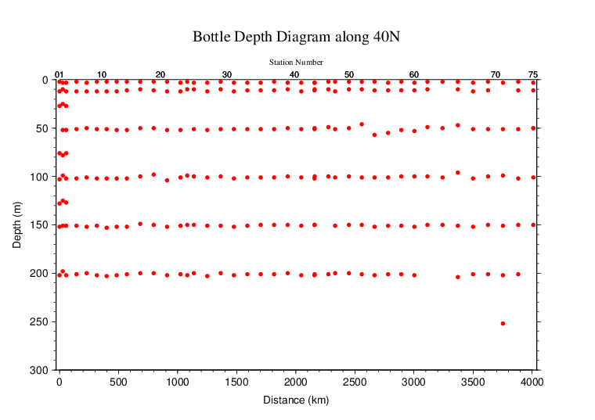
Figure C.5.2. Distance-depth distribution of sampling layers of chlorophyll-a.

Reagents
N,N-dimethylformamide (DMF)
Hydrochloric acid (HCl), 0.5 mol L⁻¹
Chlorophyll-a standard from Anacystis nidulans algae (Sigma-Aldrich, United States)
Rhodamine WT (Turner Designs, United States)

Instruments
Fluorometer: 10-AU (Turner Designs, United States)
Spectrophotometer: UV-1800 (Shimadzu, Japan)

Standardization

(5.1) Determination of chlorophyll-a concentration of standard solution
To prepare the pure chlorophyll-a standard solution, reagent powder of chlorophyll-a standard was dissolved in DMF. A concentration of the chlorophyll-a solution was determined with the spectrophotometer as follows:
chl a concentration (μg mL⁻¹) = A_{chl} / a*_{phy} (C5.1)
where A_{chl} is the difference between absorbance at 663.8 nm and 750 nm, and a*_{phy} is specific absorption coefficient (UNESCO, 1994). The specific absorption coefficient is 88.74 L g⁻¹ cm⁻¹ (Porra et al., 1989).

(5.2) Determination of R and f_{ph}
Before measurements, sensitivity of the fluorometer was calibrated with pure DMF and a rhodamine 1 ppm solution (diluted with deionized water).
The chlorophyll-a standard solution, whose concentration was precisely determined in subsection (5.1), was measured with the fluorometer, and after acidified with 1–2 drops 0.5 mol L⁻¹ HCl the solution was also measured. The acidification coefficient (R) of the fluorometer was also calculated as the ratio of the unacidified and acidified readings of chlorophyll-a standard solution. The linear calibration factor (f_{ph}) of the fluorometer was calculated as the slope of the acidified reading against chlorophyll-a concentration. The R and f_{ph} in the cruise are shown in Table C.5.1.

Table C.5.1. R and f_{ph} in the cruise.
Acidification coefficient (R) | 1.764
Linear calibration factor (f_{ph}) | 7.8333

Seawater sampling and measurement
Water samples were collected from 10-liters Niskin bottle attached the CTD-system and a stainless steel bucket for the surface. A 200 mL seawater sample was immediately filtered through 25 mm GF/F filters by low vacuum pressure below 15 cmHg, the particulate matter collected on the filter. Phytopigments were extracted in vial with 9 mL of DMF. The extracts were stored for 24 hours in the refrigerator at −30 °C until analysis.
After the extracts were put on the room temperature for at least one hour in the dark, the extracts were decanted from the vial to the cuvette. Fluorometer readings for each cuvette were taken before and after acidification with 1–2 drops 0.5 mol L⁻¹ HCl. Chlorophyll-a and phaeopigment concentrations (μg mL⁻¹) in the sample are calculated as follows:
(C5.2)
(C5.3)

F₀: reading before acidification
F_{a}: reading after acidification
R: acidification coefficient (F₀/F_{a}) for pure chlorophyll-a
f_{ph}: linear calibration factor
v: extraction volume
V: sample volume.

Quality control flag assignment
Quality flag value was assigned to oxygen measurements as shown in Table C.5.2, using the code defined in IOCCP Report No.14 (Swift, 2010).

Table C.5.2. Summary of assigned quality control flags.
Flag | Definition | Chl a | Phaeo.
2 | Good | 247 | 247
3 | Questionable | 0 | 0
4 | Bad (Faulty) | 0 | 0
5 | Not reported | 2 | 2
Total number |  | 249 | 249

References
Porra, R. J., W. A. Thompson and P. E. Kriedemann (1989), Determination of accurate coefficients and simultaneous equations for assaying chlorophylls a and b extracted with four different solvents: verification of the concentration of chlorophyll standards by atomic absotption spectroscopy. Biochem. Biophy. Acta, 975, 384-394.
Swift, J. H. (2010), Reference-quality water sample data: Notes on acquisition, record keeping, and evaluation. IOCCP Report No.14, ICPO Pub. 134, 2010 ver.1.
UNESCO (1994), Protocols for the joint global ocean flux study (JGOFS) core measurements: Measurement of chlorophyll a and phaeopigments by fluorometric analysis, IOC manuals and guides 29, Chapter 14.

Total Dissolved Inorganic Carbon (DIC)

2 November 2023

Personnel
ONO Hisashi
SAITO Shu
SAKAMOTO Naoaki

Station occupied
A total of 41 stations (Leg 1: 24, Leg 2: 17) were occupied for total dissolved inorganic carbon (DIC). Station location and sampling layers of them are shown in Figures C.6.1 and C.6.2, respectively.

Figure C.6.1. Location of observation stations of DIC. Closed and open circles indicate sampling and no-sampling stations, respectively.

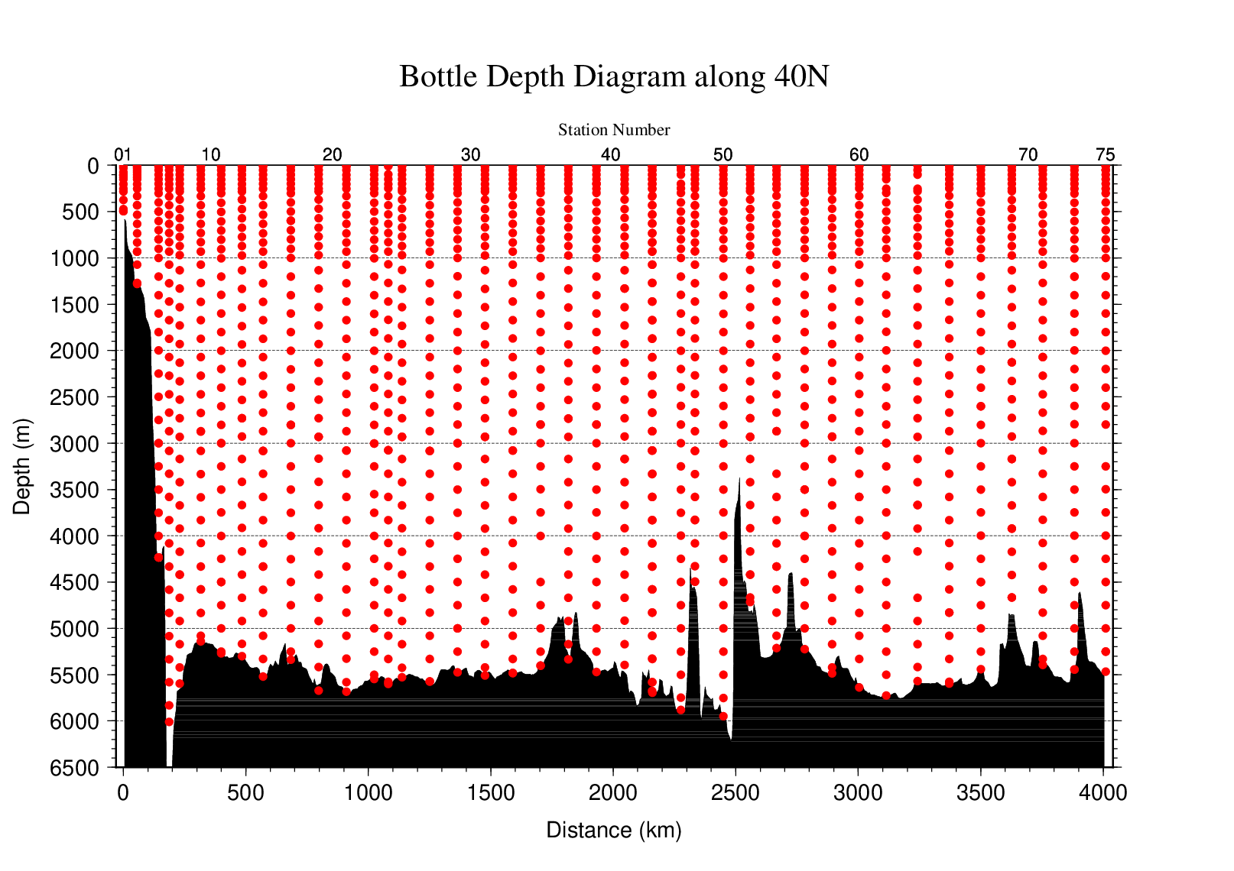
Figure C.6.2. Distance-depth distribution of sampling layers of DIC.

Instrument
The measurement of DIC was carried out with DIC/TA analyzers (Nihon ANS Co. Ltd, Japan). We used two analyzers concurrently. These analyzers are designated as apparatus A and B.

Sampling and measurement
Methods of seawater sampling, measurement and calculation of DIC concentrations were based on the Standard Operating Procedure (SOP) described in PICES Special Publication 3, SOP-2 (Dickson et al., 2007). All samples at four stations (RF-4466, 4475, 4510, 4525) and the sample of surface at station RF-4523 were poisoned with saturated mercury (II) chloride (HgCl₂) solution. DIC was determined by coulometric analysis (Johnson et al., 1985, 1987) using an automated CO₂ extraction unit and a coulometer. Details of sampling and measurement are shown in Appendix A1.

Calibration
The concentration of DIC (C_{T}) in moles per kilogram (mol kg⁻¹) of seawater was calculated from the following equation:
$C_{T}=N_{S}/ (cV ρ_{S})$ (C6.1)
where N_{S} is the counts of the coulometer (gC), cV is the calibration factor (gC (mol L⁻¹)⁻¹), and ρ_{S} is density of seawater (kg L⁻¹), which is calculated from the salinity of the sample and the water temperature of the water-jacket for the sample pipette.
The values of cV were determined by measurements of Certified Reference Materials (CRMs) that were provided by Dr. Andrew G. Dickson of the Scripps Institution of Oceanography. Table C.6.1 provides information about the CRM batches used in this cruise.

Table C.6.1. Certified C_{T} and standard deviation of CRMs. Unit of C_{T} is μmol kg⁻¹. More information is available at the NOAA web site (https://www.ncei.noaa.gov/access/ocean-carbon-acidification-data-system/oceans/Dickson_CRM/batches.html).
Batch number | 118 | 115
C_{T} | 2013.33±0.77 | 2007.45±0.41
Salinity | 33.377 | 33.572

The CRM measurement was carried out at every station. After the cruise, a value of cV was assigned to each apparatus (A, B). Table C.6.2 summarizes the cV values. Figure C.6.3 shows details.

Table C.6.2. Assigned cV and its standard deviation for each apparatus during the cruise. Unit is gC (mol L⁻¹)⁻¹.
Apparatus | cV
A | 0.163815±0.000282 (N=89)
B | 0.133959±0.000179 (N=101)

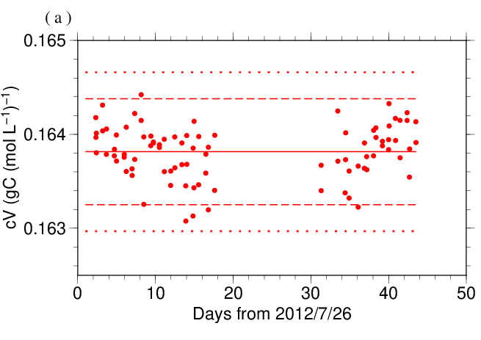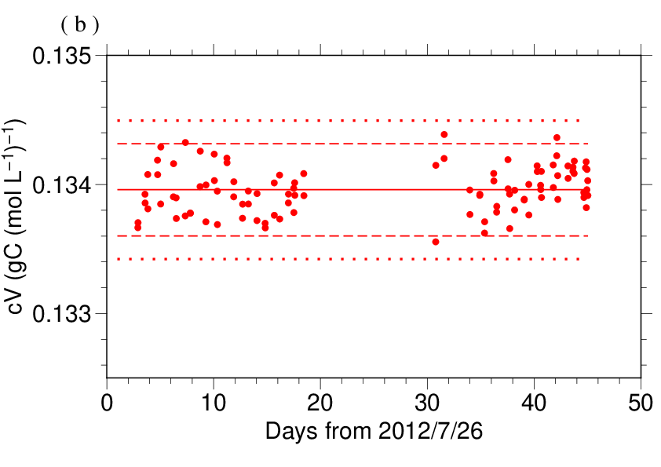
Figure C.6.3. Results of the cV at each station assigned for apparatus (a) A and (b) B. The solid, dashed, and dotted lines denote the mean, the mean ± twice the S.D., and the mean ± thrice the S.D. for all measurements, respectively.

The precisions of the cV is equated to its coefficient of variation (= S.D. / mean). They were 0.172 % for apparatus A and 0.134 % for apparatus B. They correspond to 3.47 μmol kg⁻¹ and 2.69 μmol kg⁻¹ in C_{T} of CRM batch 118, respectively.

The value of C_{T} of some samples which were poisoned with HgCl₂ solution (Appendix A1) was multiplied by 1.00067 (= 300.2 / 300.0) to correct dilution effect induced by addition of 0.2 mL of HgCl₂ solution in a sampling bottle with a volume of ~300 mL.

Quality Control

(6.1) Replicate and duplicate analyses
We took replicate (pair of water samples taken from a single Niskin bottle) and duplicate (pair of water samples taken from different Niskin bottles closed at the same depth) samples of DIC throughout the cruise. Table C.6.3 summarizes the results of the measurements with each apparatus. Figures C.6.4–C.6.5 show details of the results. The calculation of the standard deviation from the difference of sets of measurements was based on a procedure (SOP 23) in DOE (1994).

Table C.6.3. Summary of replicate and duplicate measurements. Unit is μmol kg⁻¹.
 | Apparatus A | Apparatus B
Measurement | Average magnitude of difference ± S.D.
Replicate | 3.1±2.5 (N=58) | 2.0±1.8 (N=78)
Duplicate | 2.6±2.2 (N=31) | 2.5±2.0 (N=34)

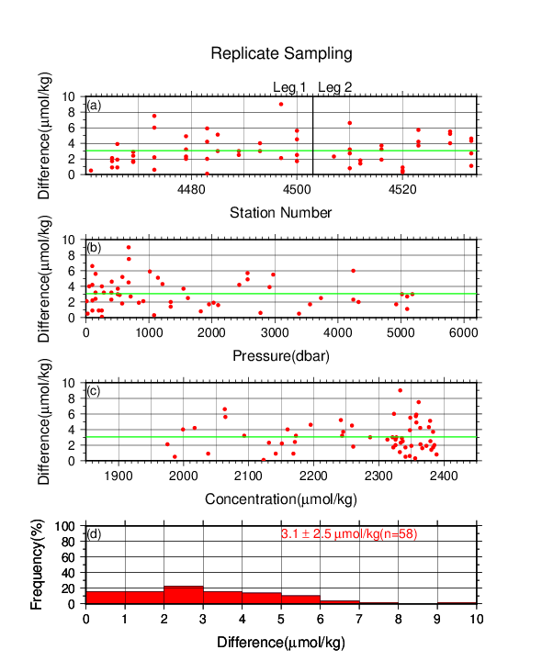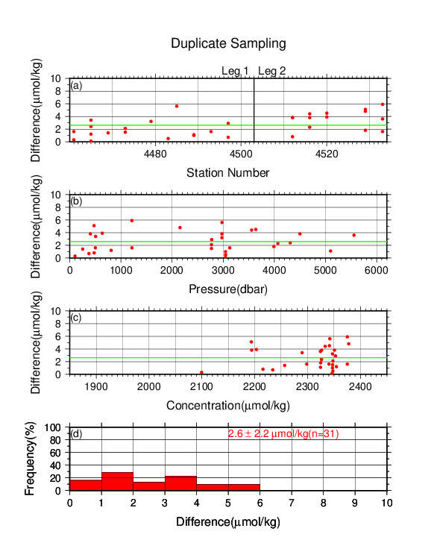
Figure C.6.4. Results of (left) replicate and (right) duplicate measurements during the cruise versus (a) station number, (b) pressure, and (c) C_{T} determined by apparatus A. The green lines denote the averages of the measurements. The bottom panels (d) show histograms of the measurements.

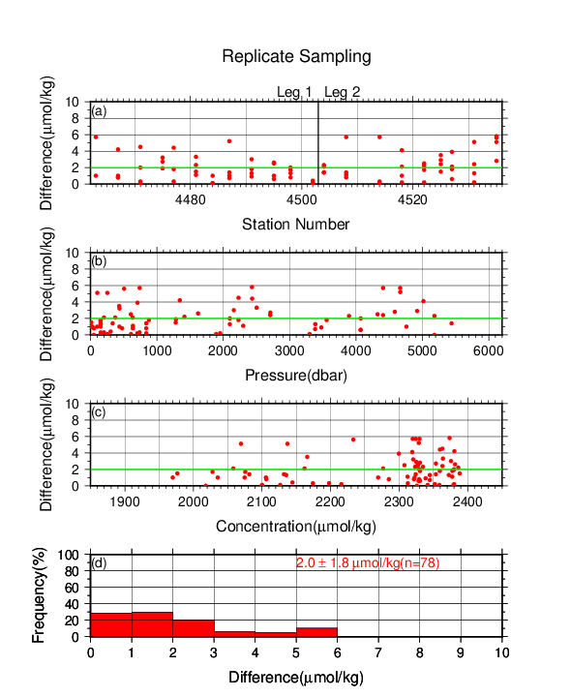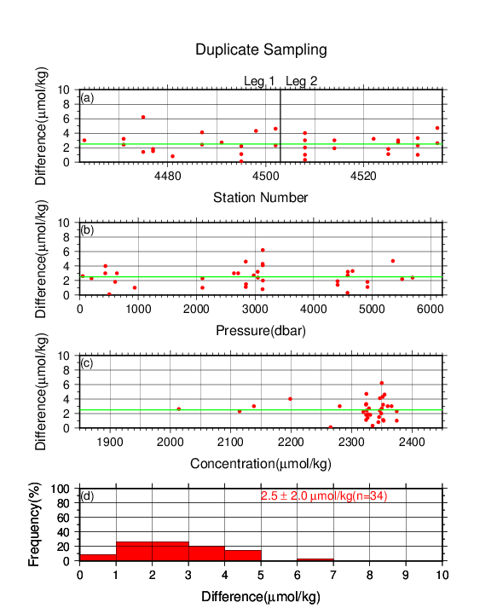
Figure C.6.5. Same as Figure C.6.4, but for apparatus B.

(6.2) Measurements of CRM and working reference materials
The precision of the measurements was monitored by using the CRMs and working reference materials bottled in our laboratory (Appendix A2). The CRM (batch 118) and working reference material measurements were carried out at every station. At the beginning of the measurement of each station, we measured a working reference material and a CRM. If the results of these measurements were confirmed to be good, measurements on seawater samples were begun. At the end of a sequence of measurements at a station, another CRM bottle was measured. A CRM measurement was repeated twice from the same bottle. Table C.6.4 summarizes the differences in the repeated measurements of the CRMs, the mean C_{T} of the CRM measurements, and the mean C_{T} of the working reference material measurements. Figures C.6.6–C.6.8 show detailed results.

Table C.6.4. Summary of difference and mean of C_{T} in the repeated measurements of CRM and the mean C_{T} of the working reference material. These data are based on good measurements. Unit is μmol kg⁻¹.
 | CRM |  | Working reference material
Apparatus | Average magnitude of  difference ± S.D. | Mean  Ave. ± S.D. | Mean  Ave. ± S.D.
A | 3.6±3.0 (N=44) | 2013.4±2.7 (N=44) | 2033.4±4.3 (N=72)
B | 2.2±1.9 (N=46) | 2013.3±2.2 (N=46) | 2033.4±3.0 (N=77)
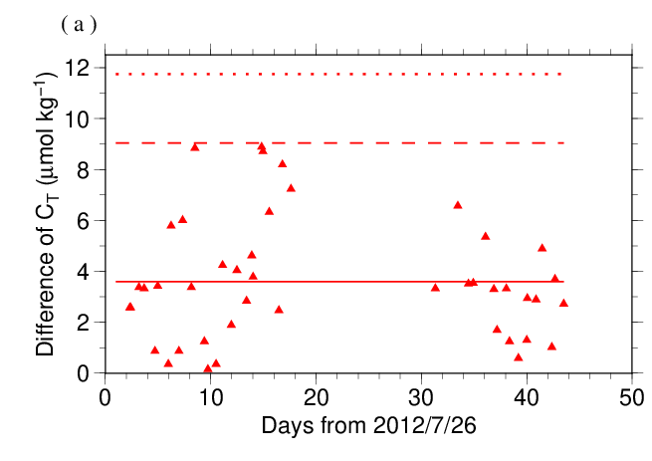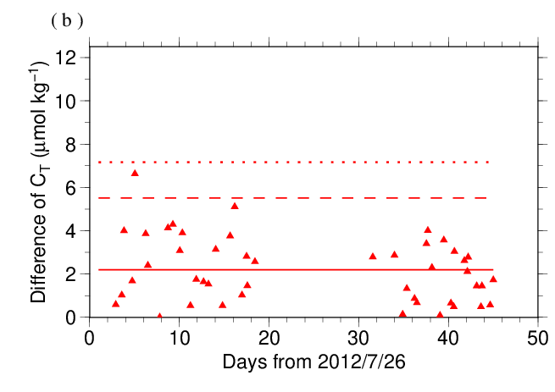
Figure C.6.6. The absolute difference (R) of C_{T} in repeated measurements of CRM determined by apparatus (a) A and (b) B. The solid line indicates the average of R ($\overline{R}$). The dashed and dotted lines denote the upper warning limit (2.512$\overline{R}$) and upper control limit (3.267$\overline{R}$), respectively (see Dickson et al., 2007).

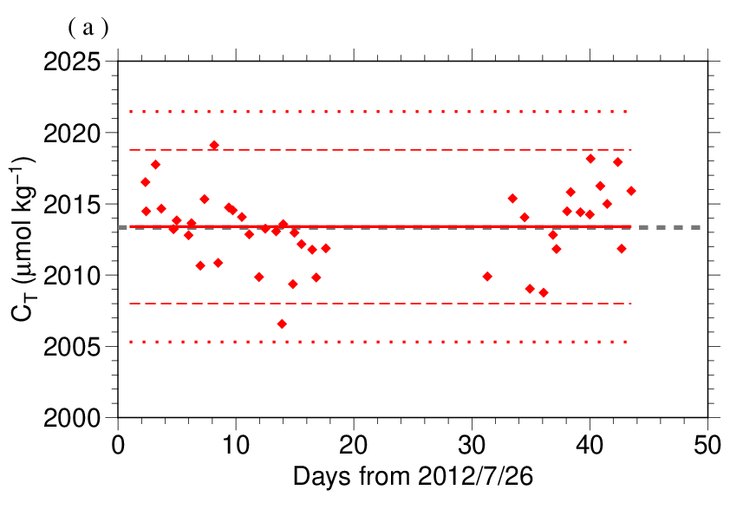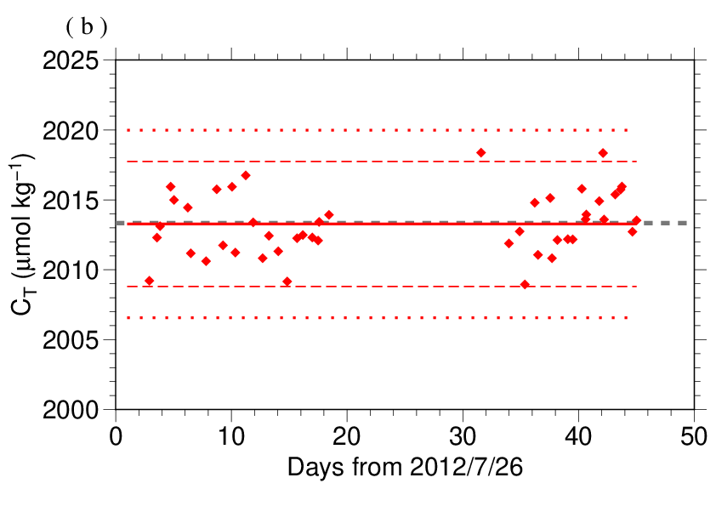
Figure C.6.7. The mean C_{T} of measurements of CRM. The panels show the results for apparatus (a) A and (b) B. The solid line indicates the mean of the measurements throughout the cruise. The dashed and dotted lines denote the upper/lower warning limit (mean ± 2S.D.) and the upper/lower control limit (mean ± 3S.D.), respectively. The gray dashed line denotes certified C_{T} of CRM.

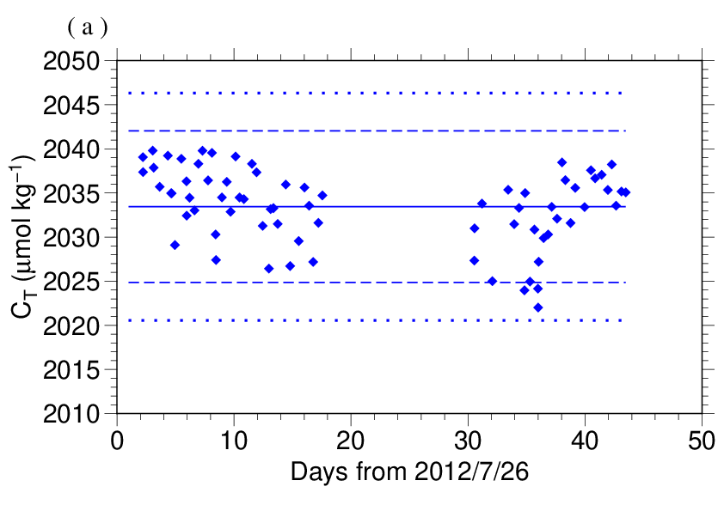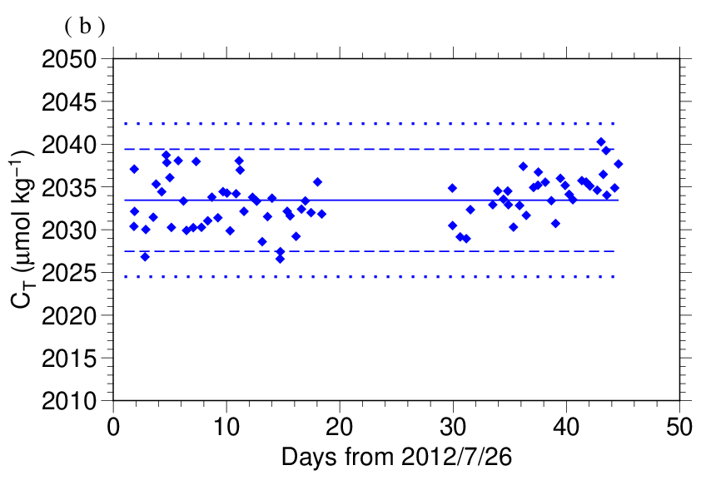
Figure C.6.8. Calculated C_{T} of working reference material measured by apparatus (a) A and (b) B. The solid, dashed and dotted lines are the same as in Figure C.6.7.

(6.3) Comparisons with other CRM batches
At every few stations, other CRM batch (115) was measured by apparatus B to provide comparisons with batch 118 to confirm the determination of C_{T} in our measurements. For these CRM measurements, C_{T} was calculated from the cV determined from batch 118 measurement. Figures C.6.9 show the differences between the calculated and certified C_{T}.

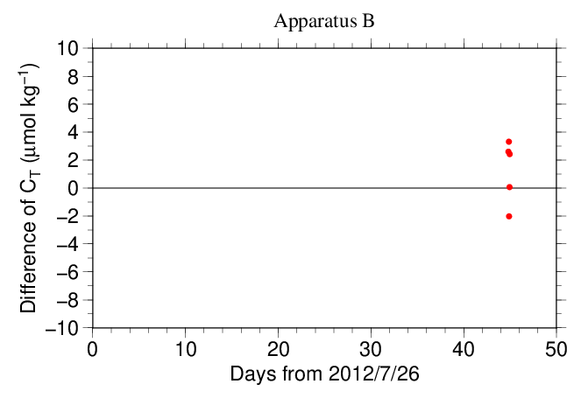
Figure C.6.9. The differences between the calculated C_{T} from batch 118 measurements and the certified C_{T} of CRM batch 115.

(6.4) Quality control flag assignment
A quality control flag value was assigned to the DIC measurements (Table C.6.5) using the code defined in the IOCCP Report No.14 (Swift, 2010).

Table C.6.5. Summary of assigned quality control flags.
Flag | Definition | Number of samples
2 | Good | 1244
3 | Questionable | 71
4 | Bad (Faulty) | 16
5 | Not reported | 0
6 | Replicate measurements | 136
Total number of samples |  | 1467

Appendix
A1. Methods
(A1.1) Seawater sampling
Seawater samples were collected from 10-liters Niskin bottles mounted on CTD-system and a stainless steel bucket for the surface. Samples for DIC/TA were transferred to Schott Duran® glass bottles using sample drawing tubes. Bottles were filled smoothly from the bottom after overflowing double a volume while taking care of not entraining any bubbles, and lid temporarily with ground glass stoppers.
After all sampling finished, 2 mL of sample was removed from each bottle to make a headspace to allow thermal expansion. If we processed poisoning, 0.2 mL of saturated HgCl₂ solution was added to seawater sample. Finally, samples were sealed with ground glass stoppers lubricated with Apiezon® grease (L).

(A1.2) Measurement
The unit for DIC measurement in the coupled DIC/TA analyzer consists of a coulometer with a quartz coulometric titration cell, a CO₂ extraction unit and a reference gas injection unit. The CO₂ extraction unit, which is connected to a bottle of 20 % v/v phosphoric acid and a carrier N₂ gas supply, includes a sample pipette (approx. 12 mL) and a CO₂ extraction chamber, two thermoelectric cooling units and switching valves. The coulometric titration cell and the sample pipette are water-jacketed and are connected to a thermostated (25 °C) water bath. The automated procedures of DIC analysis in seawater were as follows (Ishii et al., 1998):
(a) Approximately 2 mL of 20 % v/v phosphoric acid was injected to an “extraction chamber”, i.e., a glass tube with a course glass frit placed near the bottom. Purified N₂ was then allowed to flow through the extraction chamber to purge CO₂ and other volatile acids dissolved in the phosphoric acid.
(b) A portion of sample seawater was delivered from the sample bottle into the sample pipette of CO₂ extraction unit by pressurizing the headspace in the sample bottle. After temperature of the pipette was recorded, the sample seawater was transferred into the extraction chamber and mixed with phosphoric acid to convert all carbonate species to CO₂ (aq).
(c) The acidified sample seawater was then stripped of CO₂ with a stream of purified N₂. After being dehumidified in a series of two thermoelectric cooling units, the evolved CO₂ in the N₂ stream was introduced into the carbon cathode solution in the coulometric titration cell and then CO₂ was electrically titrated.

A2. Working reference material recipe
The surface seawater in the western North Pacific was taken until at least a half year ago. Seawater was firstly filtered by membrane filter (0.45 μm-mesh) using magnetic pump and transfer into large tank. After first filtration finished, corrected seawater in the tank was processed in cycle filtration again for 3 hours and agitated in clean condition air for 6 hours. On the next day, agitated 5 minutes to remove small bubbles on the tank and transfer to Schott Duran® glass bottles as same method as samples (Appendix A1.1) except for overflowing a half of volume, not double. Created of headspace and poisoned with HgCl₂ was as same as samples, finally, sealed by ground glass stoppers lubricated with Apiezon® grease (L).

References
Dickson, A. G., C. L. Sabine, and J. R. Christian (Eds.) (2007), Guide to best practices for ocean CO₂ measurements. PICES Special Publication 3, 191 pp.
DOE (1994), Handbook of methods for the analysis of the various parameters of the carbon dioxide system in sea water; version 2. A. G. Dickson and C. Goyet (eds), ORNL/CDIAC-74.
Ishii, M., H. Y. Inoue, H. Matsueda, and E. Tanoue (1998), Close coupling between seasonal biological production and dynamics of dissolved inorganic carbon in the Indian Ocean sector and the western Pacific Ocean sector of the Antarctic Ocean, Deep Sea Res. Part I, 45, 1187–1209, doi:10.1016/S0967-0637(98)00010-7.
Johnson, K. M., A. E. King and J. McN. Sieburth (1985), Coulometric TCO2 analyses for marine studies; an introduction. Marine Chemistry, 16, 61–82.
Johnson, K. M., J. M. Sieburth, P. J. L. Williams and L. Brändström (1987), Coulometric total carbon dioxide analysis for marine studies: Automation and calibration. Marine Chemistry, 21, 117–133.
Swift, J. H. (2010): Reference-quality water sample data, Notes on acquisition, record keeping, and evaluation. IOCCP Report No.14, ICPO Pub. 134, 2010 ver.1.

Total Alkalinity (TA)

2 November 2023

Personnel
ONO Hisashi
SAITO Shu
SAKAMOTO Naoaki

Station occupied
A total of 41 stations (Leg 1: 24 Leg 2: 17) were occupied for total alkalinity (TA). Station location and sampling layers of them are shown in Figures C.7.1 and C.7.2, respectively.

Figure C.7.1. Location of observation stations of TA. Closed and open circles indicate sampling and no-sampling stations, respectively.

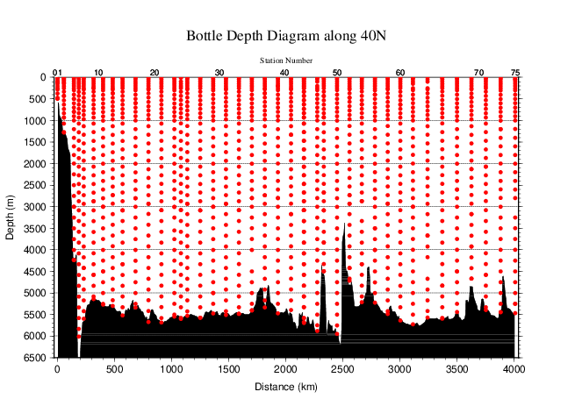
Figure C.7.2. Distance-depth distribution of sampling layers of TA.

Instrument
The measurement of TA was carried out with DIC/TA analyzers (Nihon ANS Co. Ltd., Japan). The methodology that these analyzers use is based on an open titration cell. We used two analyzers concurrently. These analyzers are designated as apparatus A and B.

Sampling and measurement
The procedure of seawater sampling of TA bottles were based on the Standard Operating Procedure (SOP) described in PICES Special Publication 3 (Dickson et al., 2007). All samples at four stations (RF-4466, 4475, 4510, 4525) and the sample of surface at station RF-4523 were poisoned with saturated mercury (II) chloride (HgCl₂) solution. Details are shown in Appendix A1 in C.6.
TA measurement is based on a one-step volumetric addition of hydrochloric acid (HCl) to a known amount of sample seawater with prompt spectrophotometric measurement of excess acid using the sulfonephthalein indicator bromo cresol green sodium salt (BCG) (Breland and Byrne, 1993). We used a mixed solution of HCl, BCG, and sodium chloride (NaCl) as reagent. Details of measurement are shown in Appendix A1.

Calculation

(5.1) Volume of sample seawater
The volumes of pipette V_{S} using in apparatus A and B was calibrated gravimetrically in our laboratory. Table C.7.1 shows the summary.

Table C.7.1. Summary of sample volumes of seawater V_{S} for TA measurements.
Apparatus | Vs / mL
A | 42.0375
B | 42.1978

(5.2) pH_{T} calculation in spectrophotometric measurement
The data of absorbance A and pipette temperature T (in °C) were processed to calculate pH_{T} (in total hydrogen ion scale; details shown in Appendix A1 in C.8) and the concentration of excess acid [H⁺]_{T} (mol kg⁻¹) in the following equations (C7.1)–(C7.3) (Yao and Byrne, 1998),
pH_{T} = − log₁₀([H＋]_{T})
= 4.2699 + 0.02578 (35 − S) + log{(R₂₅ − 0.00131) / (2.3148 − 0.1299 R₂₅)}
− log(1 − 0.001005 S) (C7.1)
R₂₅ = R_{T} {1 + 0.00909 (25 − T)} (C7.2)
$R_{T}={\left(A_{616}^{SA}-A_{616}^{S}-A_{730}^{SA}+A_{730}^{S}\right)}/{\left(A_{444}^{SA}-A_{444}^{S}-A_{730}^{SA}+A_{730}^{S}\right)}$. (C7.3)
In the equation (C7.1), R_{T} is absorbance ratio at temperature T, R₂₅ is absorbance ratio at temperature 25 °C and S is salinity. $A_{λ}^{S}$ and $A_{λ}^{SA}$ denote absorbance of seawater before and after acidification, respectively, at wavelength λ nm.

(5.3) TA calculation
The calculated [H＋]_{T} was then combined with the volume of sample seawater V_{S}, the volume of titrant V_{A} added to the sample, and molarity of hydrochloric acid HCl_{A} (in mmol L⁻¹) in the titrant to determine to TA concentration A_{T} (in μmol kg⁻¹) as follows:
A_{T} = (−[H⁺]_{T} (V_{S} + V_{A}) ρ_{SA} + HCl_{A} V_{A}) / (V_{S} ρ_{S}) (C7.4)
ρ_{S} and ρ_{SA} denote the density of seawater sample before and after the addition of titrant, respectively. Here we assumed that ρ_{SA} is equal to ρ_{S}, since the density of titrant has been adjusted to that of seawater by adding NaCl and the volume of titrant (approx. 2.5 mL) is no more than approx. 6 % of seawater sample.
The value of A_{T} of some samples which were poisoned with saturated HgCl₂ solution (Appendix A1 in C.6) was multiplied by 1.00067 (= 300.2 / 300.0) to correct dilution effect induced by addition of HgCl₂ solution.

Standardization of HCl reagent
HCl reagents were prepared in our laboratory (Appendix A2) and divided into bottles (HCl batches). HCl_{A} in the bottles were determined using measured CRMs provided by Dr. Andrew G. Dickson in Scripps Institution of Oceanography. Table C.7.2 provides information about the CRM batch used during this cruise.

Table C.7.2. Certified A_{T} and standard deviation of CRM. Unit of A_{T} is μmol kg^{–1}. More information is available at the NOAA web site (https://www.ncei.noaa.gov/access/ocean-carbon-acidification-data-system/oceans/Dickson_CRM/batches.html).
Batch number | 118 | 115
A_{T} | 2229.75±0.86 | 2242.84±0.69
Salinity | 33.377 | 33.572

The CRM measurement was carried out at every station. The apparent HCl_{A} of the titrant was determined from CRM using equation (C7.4).
HCl_{A} was assigned for each HCl batches for each apparatus, as summarized in Table C.7.3 and detailed in Figure C.7.3.

Table C.7.3. Summary of assigned HCl_{A} for each HCl batches. The reported values are means and standard deviations. Unit is mmol L⁻¹.
Apparatus | HCl Batch | HCl_{A}
A | A_1 | 49.2287±0.0189 (N=27)
 | A_2 | 49.2396±0.0257 (N=42)
 | A_3 | 49.5365±0.0234 (N=35)
 | A_4 | 49.3226±0.0258 (N=21)
B | B_1 | 49.6787±0.0580 (N=56)
 | B_2 | 49.6690±0.0431 (N=32)
 | B_3 | 49.9854±0.0939 (N=39)
 | B_4 | 50.0617±0.0657 (N=42)

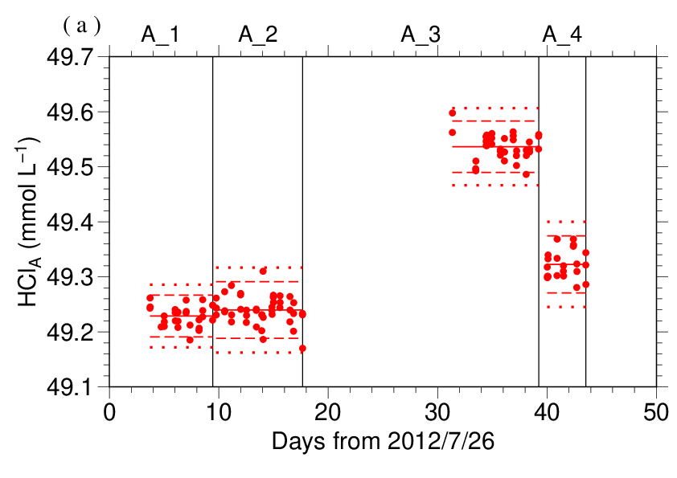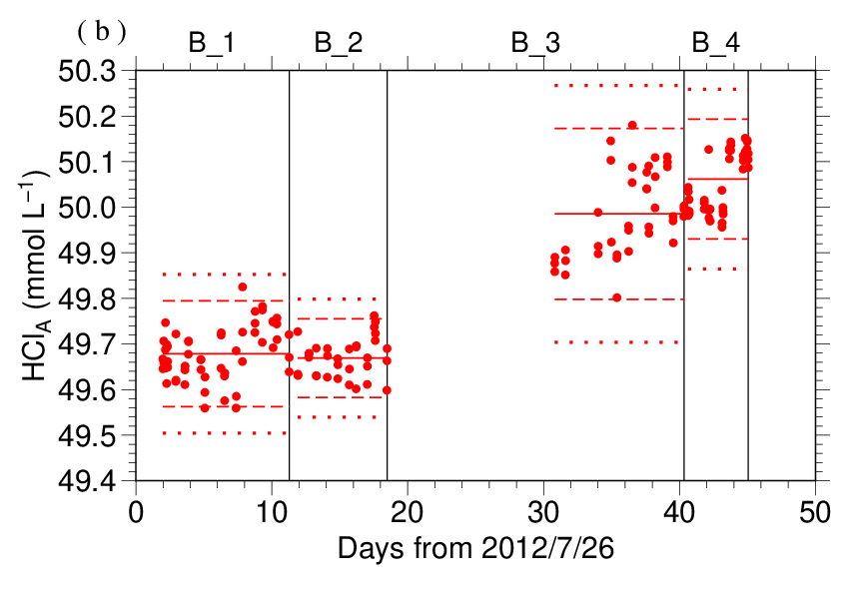
Figure C.7.3. Results of HCl_{A} measured by apparatus (a) A and (b) B. The HCl batch names are indicated at the top of each graph, and vertical lines denote the day when the HCl batch was switched. The red solid, dashed, and dotted lines denote the mean and the mean ± twice the S.D. and thrice the S.D. for each HCl batches, respectively.

The precisions of HCl_{A}, defined as the coefficient of variation (= S.D. / mean), were 0.0384–0.0523 % for apparatus A and 0.0868–0.1879 % for apparatus B. They correspond to 0.86–1.17 μmol kg⁻¹ and 1.94–4.19 μmol kg⁻¹ in A_{T} of CRM batch 118, respectively.

Quality Control

(7.1) Replicate and duplicate analyses
We took replicate (pair of water samples taken from a single Niskin bottle) and duplicate (pair of water samples taken from different Niskin bottles closed at the same depth) samples of TA throughout the cruise. Table C.7.4 summarizes the results of the measurements with each apparatus. Figures C.7.4–C.7.5 show details of the results. The calculation of the standard deviation from the difference of sets of measurements was based on a procedure (SOP 23) in DOE (1994).

Table C.7.4. Summary of replicate and duplicate measurements. Unit is μmol kg⁻¹.
 | Apparatus A | Apparatus B
Measurement | Average magnitude of difference ± S.D.
Replicate | 1.1±1.0 (N=74) | 1.6±1.4 (N=64)
Duplicate | 1.2±1.1 (N=41) | 1.4±1.3 (N=30)

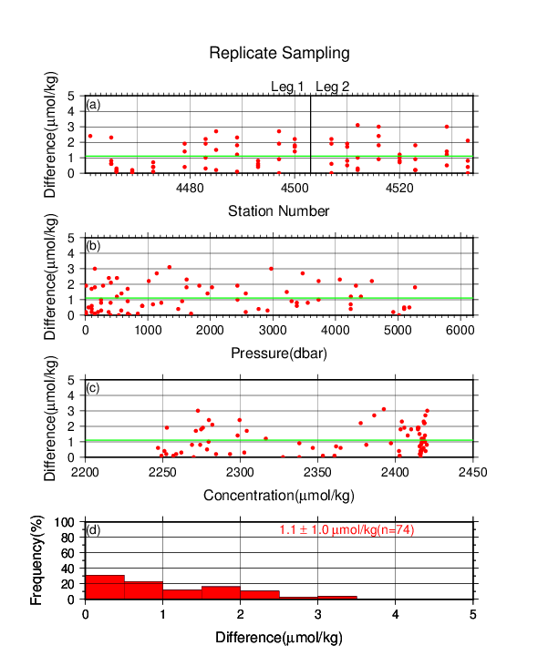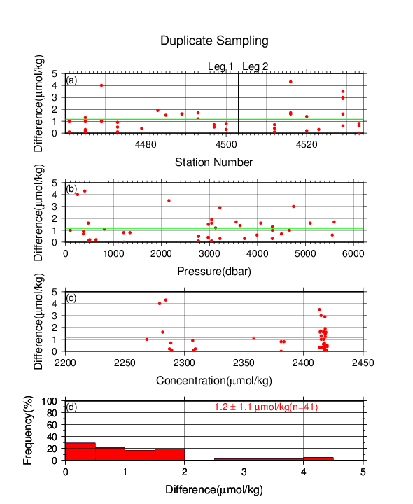
Figure C.7.4. Results of (left) replicate and (right) duplicate measurements during the cruise versus (a) station number, (b) pressure, and (c) A_{T} determined by apparatus A. The green lines denote the averages of the measurements. The bottom panels (d) show histograms of the measurements.
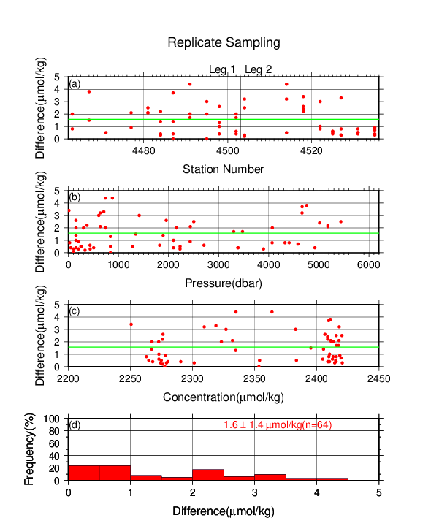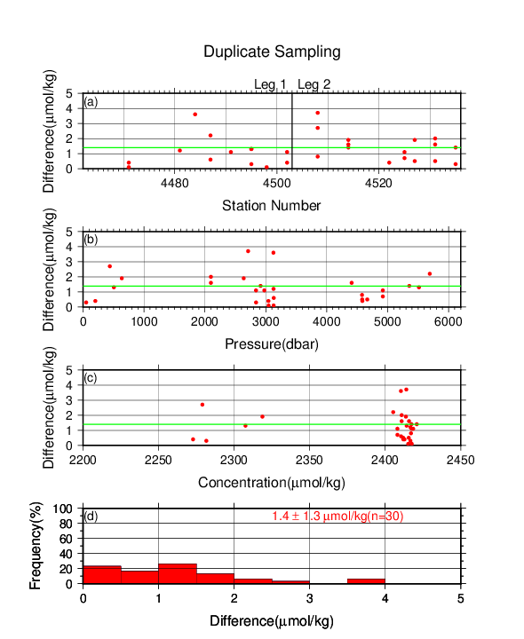
Figure C.7.5. Same as Figure C.7.4, but for apparatus B.

(7.2) Measurements of CRM and working reference materials
The precision of the measurements was monitored by using the CRMs and working reference materials bottled in our laboratory (Appendix A2 in C.6). The measurements of the CRMs and working reference materials were the same those used to measure DIC (see (6.2) in C.6), except that the CRM measurement was repeated 3 times from the same bottle. Table C.7.5 summarizes the differences in the repeated measurements of the CRMs, the mean A_{T} of the CRM measurements, and the mean A_{T} of the working reference material measurements. Figures C.7.6–C.7.8 show detailed results.

Table C.7.5. Summary of difference and mean of A_{T} in the repeated measurements of CRM and the mean A_{T} of the working reference material. These data are based on good measurements. Unit is μmol kg⁻¹.
 | CRM |  | Working reference material
HCl Batches | Average magnitude of difference ± S.D. | Mean  Ave. ± S.D. | Mean  Ave. ± S.D.
A_1 | 0.8±0.6 (N=9) | 2229.8±0.8 (N=9) | 2264.5±1.4 (N=19)
A_2 | 1.3±1.1 (N=14) | 2229.8±0.7 (N=14) | 2265.0±1.0 (N=19)
A_3 | 0.8±0.6 (N=12) | 2229.7±1.0 (N=12) | 2263.4±1.2 (N=24)
A_4 | 1.2±0.9 (N=7) | 2229.8±1.0 (N=7) | 2264.2±1.1 (N=9)
B_1 | 2.2±1.8 (N=16) | 2229.7±2.5 (N=16) | 2263.5±3.7 (N=26)
B_2 | 1.9±1.5 (N=11) | 2229.6±1.6 (N=11) | 2263.9±2.0 (N=15)
B_3 | 2.6±2.2 (N=13) | 2229.8±4.0 (N=13) | 2263.5±3.4 (N=22)
B_4 | 1.4±1.3 (N=11) | 2230.6±2.7 (N=11) | 2262.3±3.1 (N=11)

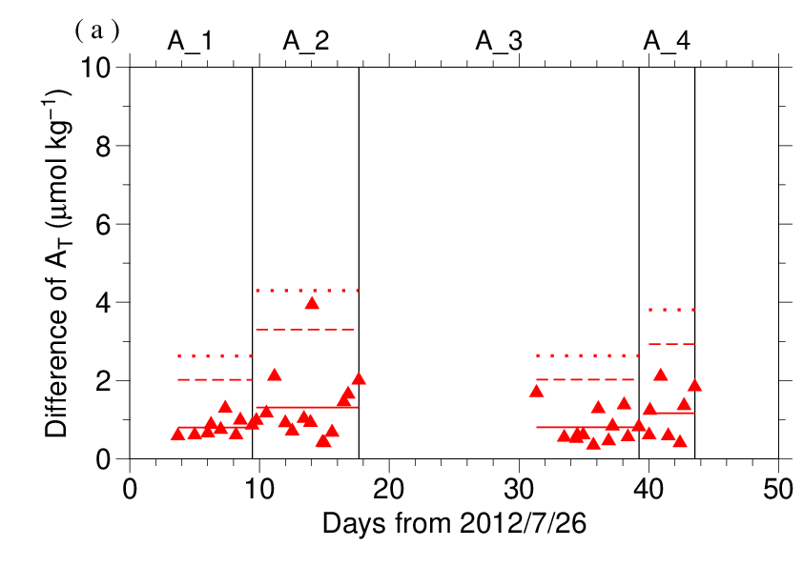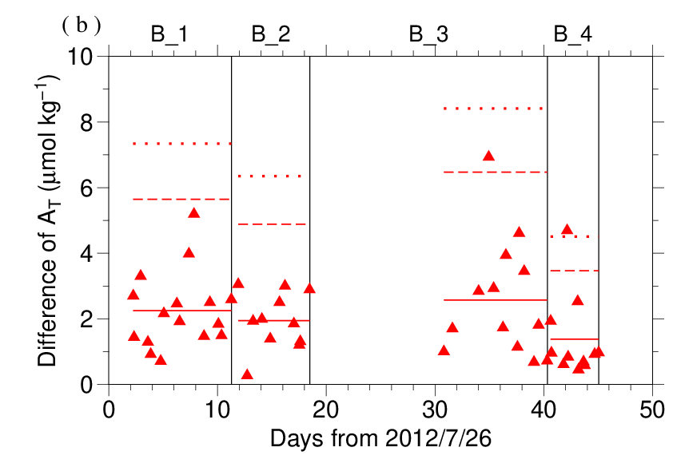
Figure C.7.6. The absolute difference (R) of A_{T} in repeated measurements of CRM determined by apparatus (a) A and (b) B. The solid line indicates the average of R ($\overline{R}$). The dashed and dotted lines denote the upper warning limit (2.512$\overline{R}$) and upper control limit (3.267$\overline{R}$), respectively (see Dickson et al., 2007).

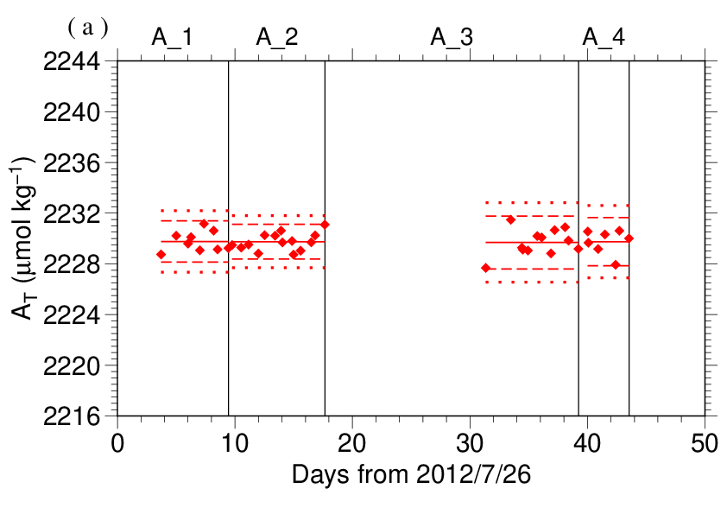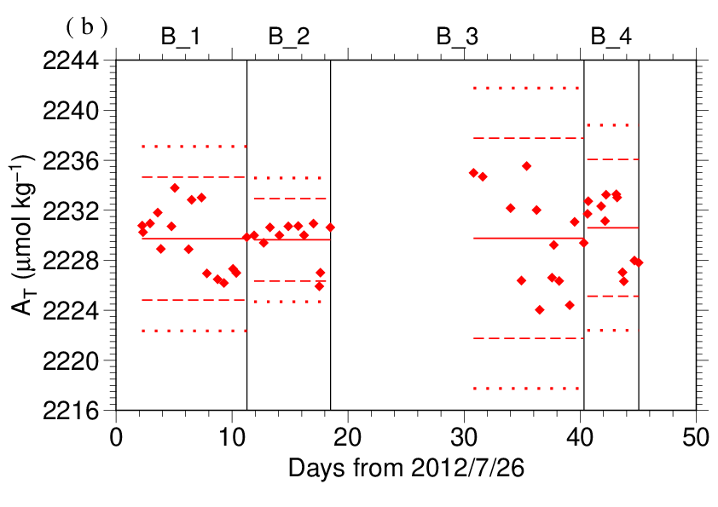
Figure C.7.7. The mean A_{T} of measurements of CRM. The panels show the results for apparatus (a) A and (b) B. The solid line indicates the mean of the measurements. The dashed and dotted lines denote the upper/lower warning limit (mean ± 2S.D.) and the upper/lower control limit (mean ± 3S.D.), respectively. The labels at the top of the graph and vertical lines have the same meaning as in Figure C.7.3.

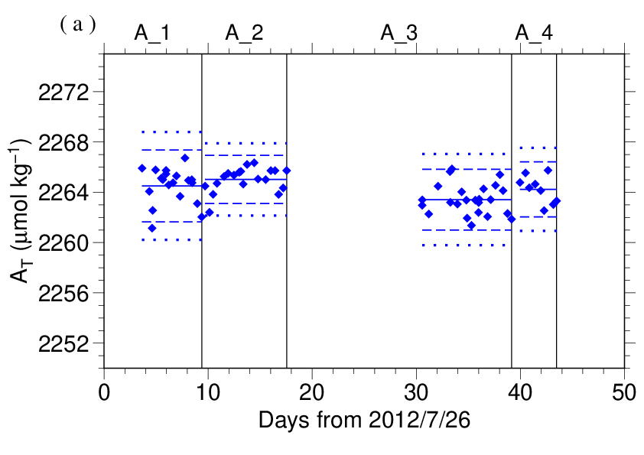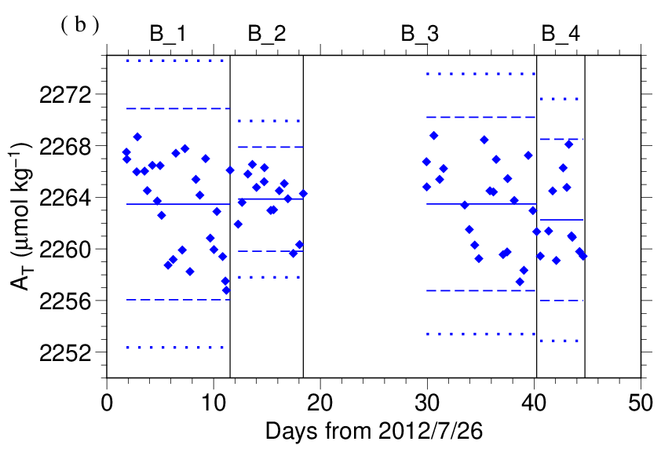
Figure C.7.8. Calculated A_{T} of working reference material measured by apparatus (a) A and (b) B. The solid, dashed and dotted lines have the same meaning as in Figure C.7.7. The labels at the top of the graph and vertical lines have the same meaning as in Figure C.7.3.

(7.3) Comparisons with other CRM batches
At every few stations, other CRM batch (115) was measured by apparatus B to provide comparisons with batch 118 to confirm the determination of A_{T} in our measurements. For these CRM measurements, A_{T} was calculated from HCl_{A} determined from batch 118 measurement. Figures C.7.9 show the differences between the calculated and certified A_{T}.

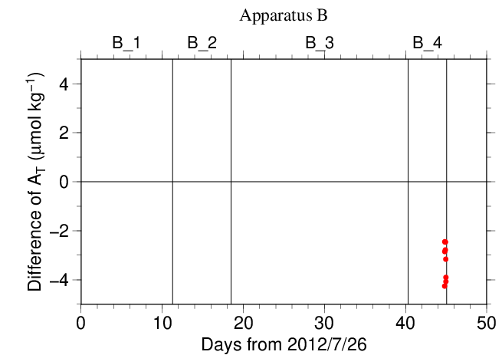
Figure C.7.9. The differences between the calculated A_{T} from batch 118 measurements and the certified A_{T} of CRM batch 115. The labels at the top of the graph and vertical lines have the same meaning as in Figure C.7.3.

(7.4) Quality control flag assignment
A quality control flag value was assigned to the TA measurements (Table C.7.6) using the code defined in the IOCCP Report No.14 (Swift, 2010).

Table C.7.6. Summary of assigned quality control flags.
Flag | Definition | Number of samples
2 | Good | 1243
3 | Questionable | 69
4 | Bad (Faulty) | 16
5 | Not reported | 1
6 | Replicate measurements | 138
Total number of samples |  | 1467

Appendix
A1. Measurement
The unit for TA measurements in the coupled DIC/TA analyzer consists of sample treatment unit with a calibrated sample pipette and an open titration cell that are water-jacketed and connected to a thermostated water bath (25 °C), an auto syringe connected to reagent bottle of titrant stored at 25 °C, and a double-beam spectrophotometric system with two CCD image sensor spectrometers combined with a high power Xenon lamp. The mixture of 0.05 N HCl and 40 μmol L⁻¹ BCG in 0.65 M NaCl solution was used as reagent to automatically titrate the sample as follows:
(a) A portion of sample seawater was delivered into the sample pipette (approx. 42 mL) following sample delivery into the DIC unit for a measurement. After the temperature in the pipette was recorded, the sample was transferred into a cylindrical quartz cell.
(b) An absorption spectrum of sample seawater in the visible light domain was then measured, and the absorbances were recorded at wavelengths of 444 nm, 509 nm, 616 nm, and 730 nm as well as the temperature in the cell.
(c) The titrant that contains HCl was added to the sample seawater by the auto syringe so that pH of sample seawater altered in the range between 3.85 and 4.05.
(d) While the acidified sample was being stirred, the evolved CO₂ was purged with the stream of purified N₂ bubbled into the sample at approx. 200 mL min⁻¹ for 5 minutes.
(e) After the bubbled sample steadied down for 1 minute, the absorbance of BCG in the sample was measured in the same way as described in (b), and pH (in total hydrogen ion scale, pH_{T}) of the acidified seawater was precisely determined spectrophotometrically.

A2. HCl reagents recipes
0.05 N HCl and 40 μmol L⁻¹ BCG in 0.65 M NaCl solution
Dissolve 0.30 g of BCG and 190 g of NaCl in roughly 1.5 L of deionized water (DW) in a 5 L flask, and slowly add 200 mL concentrated HCl. After the powders completely dissolved, dilute with DW to a final volume of 5 L.

References
Breland II, J. A. and R. H. Byrne (1993), Spectrophotometric procedures for determination of sea water alkalinity using bromocresol green, Deep-Sea Res. I, 470, 629–641.
Dickson, A. G., C. L. Sabine, and J. R. Christian (Eds.) (2007), Guide to best practices for ocean CO₂ measurements. PICES Special Publication 3, 191 pp.
DOE (1994), Handbook of methods for the analysis of the various parameters of the carbon dioxide system in sea water; version 2. A. G. Dickson and C. Goyet (eds), ORNL/CDIAC-74.
Yao, W. and R. H. Byrne (1998), Simplified seawater alkalinity analysis: Use of linear array spectrometers. Deep-Sea Res. I, 45, 1383–1392.
Swift, J. H. (2010): Reference-quality water sample data, Notes on acquisition, record keeping, and evaluation. IOCCP Report No.14, ICPO Pub. 134, 2010 ver.1.

pH

2 November 2023

Personnel
ONO Hisashi
SAITO Shu
SAKAMOTO Naoaki

Station occupied
A total of 41 stations (Leg 1: 24, Leg 2: 17) were occupied for pH. Station location and sampling layers of them are shown in Figures C.8.1 and C.8.2, respectively.

Figure C.8.1. Location of observation stations of pH. Closed and open circles indicate sampling and no-sampling stations, respectively.

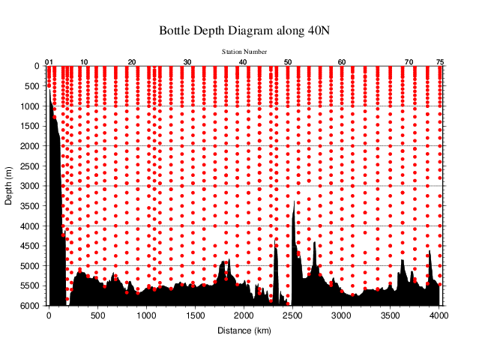
Figure C.8.2. Distance-depth distribution of sampling layers of pH.

Instrument
The measurement of pH was carried out with a pH analyzer (Nihon ANS Co. Ltd, Japan).

Sampling and measurement
Methods of seawater sampling, spectrophotometric measurements using the indicator dye m-cresol purple (hereafter mCP) and calculation of pH_{T} (on the total hydrogen ion scale; Appendix A1) were based on Saito et al. (2008). All samples at four stations (RF-4466, 4475, 4510, 4525) and the sample of surface at station RF-4523 were poisoned with saturated mercury (II) chloride (HgCl₂) solution. Details are shown in Appendix A1 in C.6.
The pH_{T} is calculated from absorbance ratio (R) with the following equations,
${pH}_{T}=pK_{2}+\log_{10}\left\{{\left(R-0.0069\right)}/{\left(2.222-0.1331 R\right)}\right\}$ (C8.1)
$R={\left(A_{578}^{SD}-A_{578}^{S}-A_{730}^{SD}+A_{730}^{S}\right)}/{\left(A_{434}^{SD}-A_{434}^{S}-A_{730}^{SD}+A_{730}^{S}\right)}$ (C8.2)
where pK₂ is the acid dissociation constant of mCP,
$pK_{2}={1245.69}/T+3.8322+0.00211 \left(35-S\right)$ (C8.3)
(293 K ≤ T ≤ 303 K, 30 ≤ S ≤ 37).
$A_{λ}^{S}$ and $A_{λ}^{SD}$ in equation (C8.2) are absorbance of seawater itself and dye plus seawater, respectively, at wavelength λ (nm). The value of pK₂ in equation (C8.3) is expressed as a function of temperature T (in Kelvin) and salinity S (in psu). Finally, pH_{T} is reported as the value at temperature of 25 °C. Details are shown in Appendix A1.
We use two mCP solutions, first batch in Leg 1 (Stns.1-43) and second batch in Leg 2 (Stns.44-75) .

pH perturbation caused by addition of m-cresol purple solution
The mCP solution using as indicator dye was prepared in our laboratory (Appendix A2) and was subdivided into some bottles (mCP batches) that attached to the apparatus. The injection of mCP solution perturbs the sample pH_{T} slightly because the acid-base equilibrium of the seawater is disrupted by the addition of the dye acid-base pair (Dickson et al., 2007).
Before applying R to the equation (C8.1), the measured R in the sample was corrected to that value expected to be unperturbed by the addition of the dye (Dickson et al., 2007; Clayton and Byrne, 1993). The magnitude of the perturbation (ΔR) was calculated empirically from that by the second addition of the dye and absorbance ratio measurement as follows:
ΔR = R₂ − R₁, (C8.4)
where R₁ and R₂ are the absorbance ratio after the initial addition of dye solution in the sample measurement and after the second addition in the experimental measurement, respectively. Because the value of ΔR depends on the pH_{T} of sample, we expressed ΔR as a quadratic function of R₁ based on experimental ΔR measurement obtained at this cruise as follows:
$∆R=C_{2}{×R}_{1}^{2}+C_{1}×R_{1}+C_{0}$. (C8.5)
In each measurement for a station, ΔR was measured for about 10 samples from various depths to obtain wide range of R₁ and experimental ΔR data. For each mCP batch bottle, coefficients (C₀, C₁ and C₂) were calculated by equation (C8.5), and ΔR was evaluated for each R₁. The coefficients for each mCP batch are showed in Table C.8.1. The plots and function curves are illustrated in Figure C.8.3.

Table C.8.1. Summary of coefficients; C_{2,} C₁ and C₀ in $∆R=C_{2}{×R}_{1}^{2}+C_{1}×R_{1}+C_{0}$.
Stations | mCP batch | C₂ | C₁ | C₀
1–43 | 1 | −1.76459E−03 | −5.89115E−03 | 8.47566E−03
44–75 | 2 | 9.79441E−04 | −1.46734E−02 | 1.34916E−02

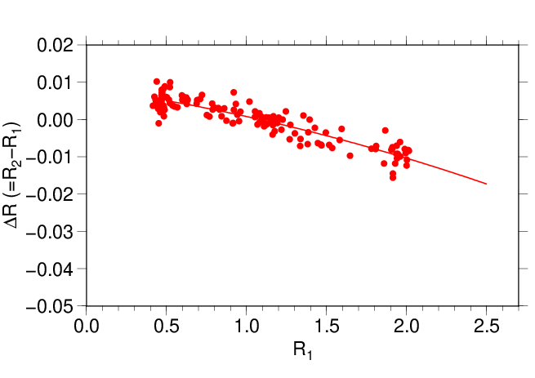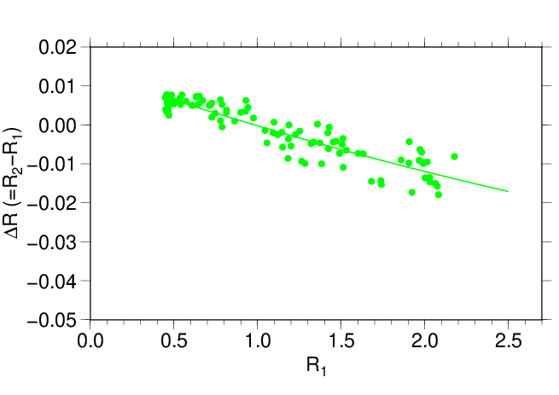
Figure C.8.3. The function curve of the ΔR (= R₂ − R₁) vs R₁ for (upper) first and (lower) second mCP batch of solution shown in Table C.8.1.

Quality Control
(6.1) Replicate and duplicate analyses
We took replicate (pair of water samples taken from a single Niskin bottle) and duplicate (pair of water samples taken from different Niskin bottles closed at the same depth) samples for pH_{T} determination throughout the cruise. In Leg 2, all pH_{T} data were assigned quality control flag only “4” (see section 7). Table C.8.2 summarizes the results of the measurements in Leg 1. Figure C.8.4 shows details of the results in Leg 1. The calculation of the standard deviation from the difference of sets of measurements was based on a procedure (SOP 23) in DOE (1994).

Table C.8.2. Summary of replicate and duplicate measurements of pH_{T} in Leg 1.
Measurement | Average magnitude of difference ± S.D.
Replicate | 0.0019±0.0016 (N=83)
Duplicate | 0.0015±0.0014 (N=42)
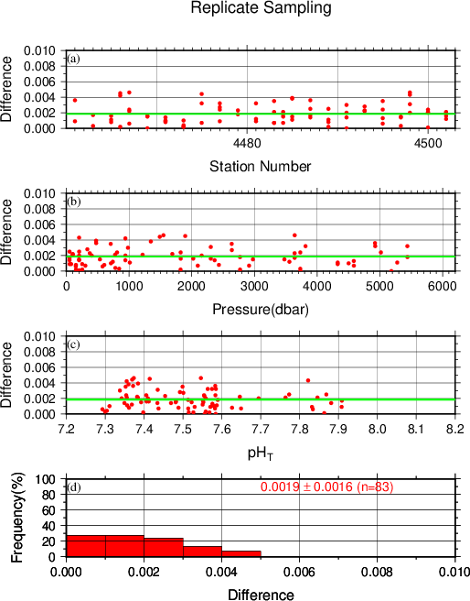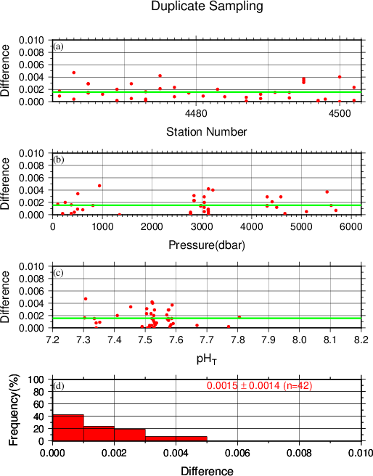
Figure C.8.4. Results of (left) replicate and (right) duplicate measurements during the cruise versus (a) station number, (b) pressure and (c) pH_{T} in Leg 1. The green lines denote the averages of the measurements. The bottom panels (d) show histograms of the measurements.

(6.2) Measurements of CRM and working reference materials
The precision of the measurements was monitored by using the CRMs and working reference materials bottled in our laboratory (Appendix A2 in C.6). Although the pH_{T} value of the CRM was not assigned, it could be calculated from certified parameters of DIC and TA (https://www.ncei.noaa.gov/access/ocean-carbon-acidification-data-system/oceans/Dickson_CRM/batches.html) based on the chemical equilibrium of the carbonate system (Lueker et al., 2000). The pH_{T} of the CRM (batch 118) was calculated to be 7.9200. Working reference material measurements were carried out first at every station. If the results of the measurements were confirmed to be good, measurements on seawater samples were begun. CRM (batch 118) measurements were done at every few (about 3) stations. The measurement for seawater sample and working reference material was made once for a single bottle, and that for CRM was made twice. Table C.8.3 summarizes the means of difference of pH_{T} between two measurements and pH_{T} values for a CRM bottle and the means of the pH_{T} value for a working reference material for each mCP batch. Figures C.8.5–C.8.7 show detailed results. In Leg 2, because apparent drift in pH_{T} measurements was determined (see section 7), standard deviation of the pH_{T} values through the leg was slightly large.

Table C.8.3. Summary of difference and means of the pH_{T} values for two measurements for a CRM bottle, and mean of pH_{T} for a working reference material, which was calculated with data with good measurements.
 | CRM |  | Working reference material
mCP Batches | Magnitude of difference  Ave. ± S.D. | Mean  Ave. ± S.D. | Mean  Ave. ± S.D.
1 | 0.0015±0.0012 (N=9) | 7.9111±0.0023 (N=9) | 7.9236±0.0019 (N=48)
2 | 0.0008±0.0007 (N=8) | 7.9011±0.0040 (N=8) | 7.9132±0.0043 (N=32)

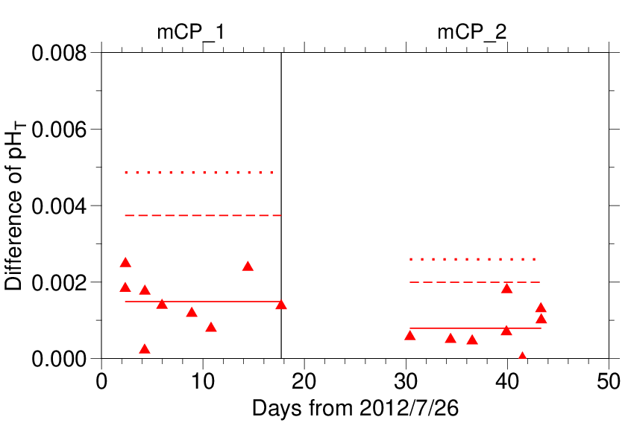
Figure C.8.5. The absolute difference (R) of pH_{T} between two measurements of a CRM bottle. The mCP batch names are shown above the graph, and vertical lines denote the day mCP batches were changed. The solid, dashed and dotted lines denote the average range ($\overline{R}$), upper warning limit (2.512$\overline{R}$) and upper control limit (3.267$\overline{R}$) for each mCP batch bottle, respectively (see Dickson et al., 2007).
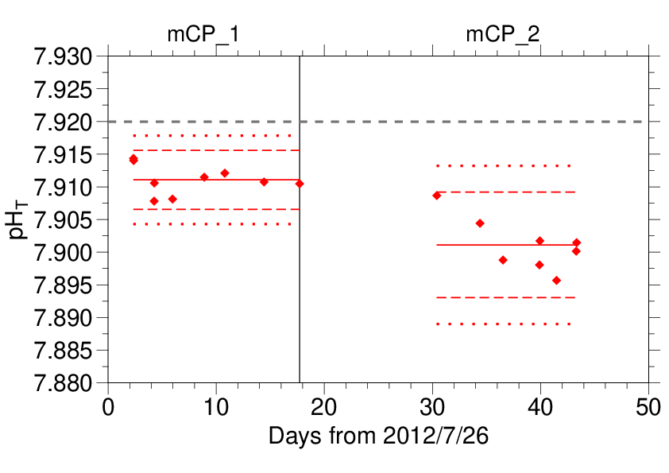
Figure C.8.6. The mean of pH_{T} values between two measurements of a CRM bottle. The mCP batch names are shown above the graph, and vertical lines denote the day when the mCP batch was changed. The solid, dashed, and dotted lines denote the mean of measurements, upper/lower warning limit (mean ± 2S.D.), and upper/lower control limit (mean ± 3S.D.) for each mCP batch bottle, respectively (see Dickson et al., 2007). The gray dashed line denotes pH_{T} of CRM calculated from certified parameters.

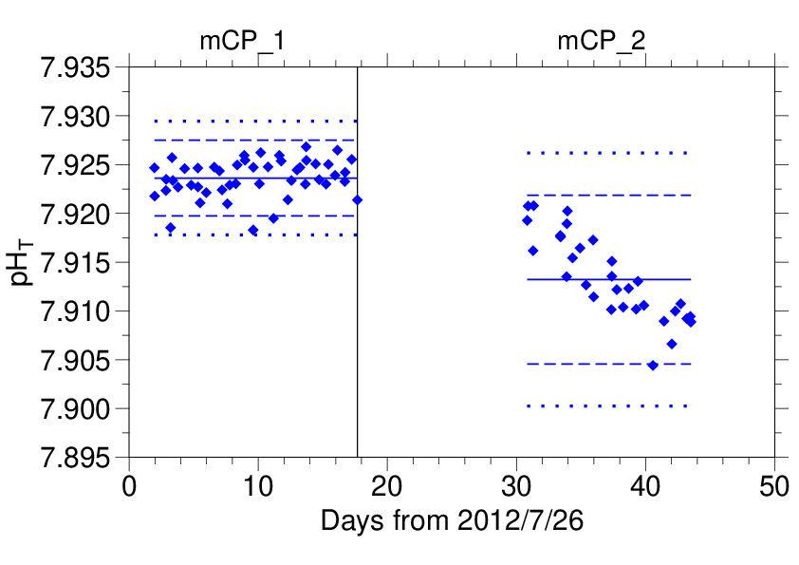
Figure C.8.7. Same as C.8.6, but for working reference material.

(6.3) Quality control flag assignment
A quality control flag value was assigned to the pH measurements (Table C.8.4) using the code defined in the IOCCP Report No.14 (Swift, 2010).

Table C.8.4. Summary of assigned quality control flags.
Flag | Definition | Number of samples
2 | Good | 743
3 | Questionable | 11
4 | Bad (Faulty) | 630
5 | Not reported | 1
6 | Replicate measurements | 83
Total number of samples |  | 1468

(6.4) Comparison at cross-stations during the cruise
There were cross-stations during the cruise located at 40˚N/167˚-40′E and 40˚N/165˚E. At these points, hydrocast sampling for pH_{T} was conducted two times at interval of 16 days (Stns.43 and 44) and 26 days (Stns.39 and 75). These profiles are shown in Figure C.8.8.

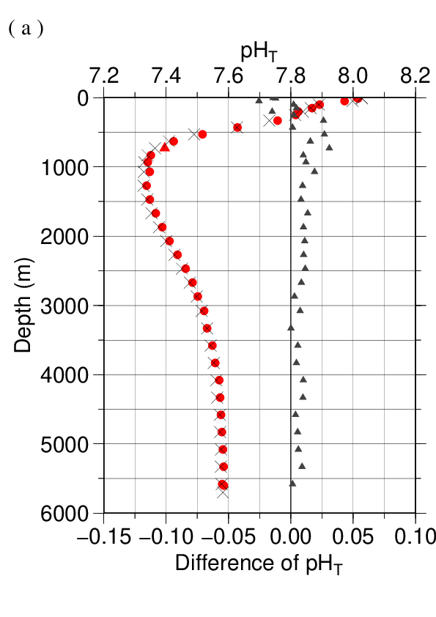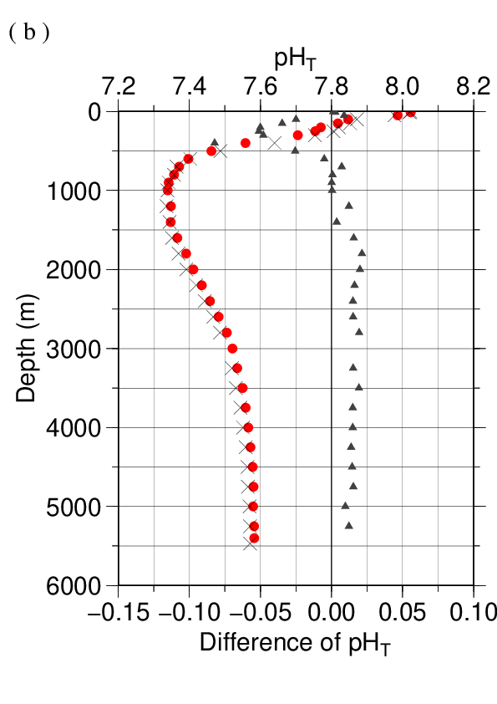
Figure C.8.8. Comparison of pH_{T} profiles observed at the same location in different legs of this cruise: (a) 40˚N/167˚-40′E (Stns.43 and 44) and (b) 40˚N/165˚E (Stns.39 and 75). The red circles denote the profiles observed in Leg 1 (Stns.43 and 39) and gray crosses denote those in Leg 2 (Stns.44 and 75) assigned quality control flag 4 (see section 7). Triangles denote the difference in pH_{T} of them.

(6.5) Comparison at cross-stations of WHP cruises
We compared pH_{T} data of this cruise and other WHP cruises by JMA and Japan Agency for Marine-Earth Science and Technology (JAMSTEC) at cross points. Summary of the comparisons are shown in Figure C.8.9(a) for cross point with WHP-P10 line (around 40˚N/145˚E) and Figure C.8.9(b) for cross point with WHP-P13 line (around 40˚N/165˚E). Data of other cruises are downloaded from the CCHDO web site (https://cchdo.ucsd.edu).

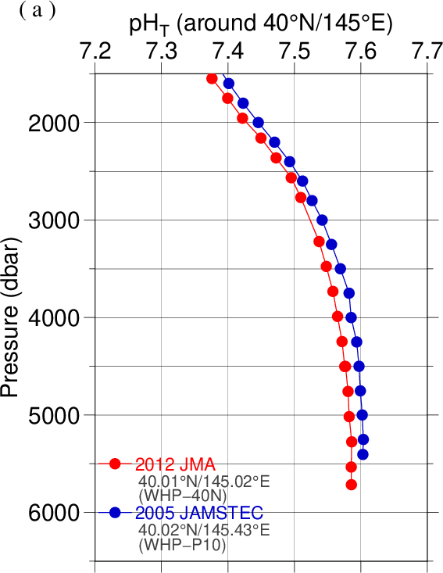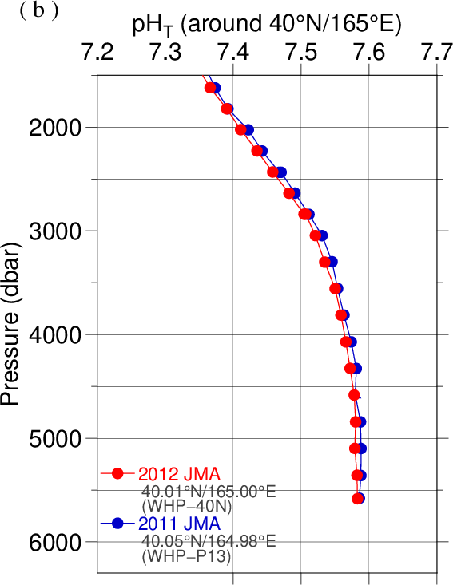

Figure C.8.9. Comparison of pH_{T} profiles at (a) 40˚N/145˚E (cross point with WHP-P10 line) and (b) 40˚N/165˚E (cross point with WHP-P13 line). Circles and triangles denote good and questionable values, respectively. The red ones show this cruise.

Problem
In Leg 2, the results of pH_{T} measurements of CRMs and working reference material were gradually decreased toward the end of Leg 2 (see Figures C.8.6 and C.8.7). The decrease was identified in pH_{T} profiles as about 0.015 below 2000 m at the cross stations between Leg 1 and Leg 2 (see Figures C.8.8). We believe that this unexpected drift was derived from stability of the light source of the instruments. It was difficult to correct these differences, then we assigned quality control flag 4 to all pH_{T} data in Leg 2 of this cruise.

Appendix
A1. Methods
(A1.1) Seawater sampling
Seawater samples were collected from 10-liters Niskin bottles mounted on CTD-system and a stainless steel bucket for the surface. Samples for pH were transferred to Schott Duran® glass bottles using sample drawing tubes. Bottles were filled smoothly from the bottom after overflowing double a volume while taking care of not entraining any bubbles, and lid temporarily with ground glass stoppers.
After all sampling finished, 2 mL of sample is removed from each bottle to make a headspace to allow thermal expansion. If we processed poisoning, 0.2 mL of saturated HgCl₂ solution was added to seawater sample to prevent change in pH_{T} caused by biological activity. Finally, samples were sealed with ground glass stoppers lubricated with Apiezon® grease (L).

(A1.2) Measurement
Custom-made pH analyzer (2009 model; Nihon ANS) was prepared and operated in the cruise. The analyzer comprised of a sample dispensing unit, a pre-treatment unit combined with an automated syringe, and two (sample and reference) spectrophotometers combined with a high power xenon light source. Spectrophotometric cell was made of quartz tube that has figure of “U”. This cell was covered with stainless bellows tube to keep the external surface dry and for total light to reflect in the tube. The temperature of the cell was regulated to 25.0 ± 0.1 °C by means of immersing the cell into the thermostat bath, where the both ends of bellows tube located above the water surface of the bath. Spectrophotometer, cell and light source were connected with optical fiber.
The analysis procedure was as follows:
a) Seawater was ejected from a sample loop.
b) A portion of sample was introduced into a sample loop including spectrophotometric cell. The spectrophotometric cell was flushed two times with sample in order to remove air bubbles.
c) An absorption spectrum of seawater in the visible light range was measured. Absorbance at wavelengths of 434 nm, 488 nm, 578 nm and 730 nm as well as cell temperature were recorded. To eject air bubbles from the cell, the sample was moved four times and the absorbance was recorded at each stop.
d) 10 μl of indicator mCP was injected to the loop.
e) Circulating 2 minutes 40 seconds through the loop tube, seawater sample and indicator dye was mixed together.
f) Absorbance of mCP plus seawater was measured in the same way described above (c).

(A1.3) Calculation
In order to state clearly the scale of pH, we mention “pH_{T}” that is defined by equation (C8.A1.3.1),
${pH}_{T}=-\log_{10}\left({{[H^{+}]}_{T}}/{C^{0}}\right)$ (C8.A1.3.1)
where [H⁺]_{T} denotes the concentration of hydrogen ion expressed in the total hydrogen ion scale. ${[H^{+}]}_{T}={[H^{+}]}_{F}\left(1+{{[{SO}_{4}]}_{T}}/{K_{{HSO}_{4}^{-}}}\right)$, where [H⁺]_{F} is the concentration of free hydrogen ion, [SO₄]_{T} is the total concentration of sulphate ion and $K_{{HSO}_{4}^{-}}$ is acid dissociation constant of hydrogen sulphate ion (Dickson, 1990). C⁰ is the standard value of concentration (1 mole per kilogram of seawater, mol kg⁻¹). The pH_{T} was reported as the value at temperature of 25 °C in “total hydrogen ion scale”.

pH_{T} was calculated from the measured absorbance (A) based on the following equations (C8.A1.3.2) and (C8.A1.3.3), which are the same as (C8.1) and (C8.2), respectively.
$${pH}_{T}=pK_{2}+\log_{10}\left({[I^{2-}]}/{[{HI}^{-}]}\right)$$
$=pK_{2}+\log_{10}\left\{{\left(R-0.0069\right)}/{\left(2.222-0.1331 R\right)}\right\}$ (C8.A1.3.2)
$R={\left(A_{578}^{SD}-A_{578}^{S}-A_{730}^{SD}+A_{730}^{S}\right)}/{\left(A_{434}^{SD}-A_{434}^{S}-A_{730}^{SD}+A_{730}^{S}\right)}$ (C8.A1.3.3)
where pK₂ is the acid dissociation constant of mCP. [I²⁻] / [HI⁻] is the ratio of mCP base form (I²⁻) concentration over acid form (HI⁻) concentration which is calculated from the corrected absorbance ratio (R) shown in the section 8(5) and the ratios of extinction coefficients (Clayton and Byrne, 1993). $A_{λ}^{S}$ and $A_{λ}^{SD}$ in equation (C8.A1.3.3) are absorbance of seawater itself and dye plus seawater, respectively, at wavelength λ (nm). The value of pK₂ (${=-log}_{10}\left({K_{2}}/{k^{0}}\right)$, k⁰ = 1 mol kg⁻¹) had also been expressed as a function of temperature T (in Kelvin) and salinity S (in psu) by Clayton and Byrne (1993), but the calculated value has been subsequently corrected by 0.0047 on the basis of a reported pH_{T} value accounting for “tris” buffer (DelValls and Dickson, 1998):

$$pK_{2}=pK_{2}\left(Clayton \& Byrne, 1993\right)+0.0047$$
$={1245.69}/T+3.8322+0.00211 \left(35-S\right)$. (C8.A1.3.4)
(293 K ≤ T ≤ 303 K, 30 ≤ S ≤ 37)
Finally, pH_{T} determined at a temperature t (pH_{T}(t), with t in °C) was corrected to the pH_{T} at 25.00 °C (pH_{T}(25)) with the following equation (Saito et al., 2008).
$${(pH}_{T}\left(t\right)-{pH}_{T}(25))/(t-25.00)$$
$=(2.00170-0.735594 {pH}_{T}\left(25\right)+{0.0896112 {pH}_{T}\left(25\right)}^{2}-{0.00364656 {pH}_{T}\left(25\right)}^{3})$.
(C8.A1.3.5)
A2. pH indicator
Indicator m-cresol purple (mCP) solution
Add 0.67 g mCP to 500 mL deionized water (DW) in a borosilicate glass flask. Pour DW slowly into flask to weight of 1 kg (mCP + DW), and mix well to dissolve mCP. Regulate the pH (free hydrogen ion scale) of indicator solution to 7.9±0.1 by small amount of diluted NaOH solution (approx. 0.25 mol L⁻¹) if the pH was out of the range. The pH of indicator solution was monitored using glass electrode pH meter. The reagent had not been refining.

References
Clayton T.D. and R.H. Byrne 1993. Spectrophotometric seawater pH measurements: total hydrogen ion concentration scale calibration of m-cresol purple and at-sea results. Deep-Sea Res. I, 40, 2115–2129.
DelValls, T. A and A. G. Dickson, 1998. The pH of buffers based on 2-amino-2-hydroxymethyl-1,3-propanediol (‘tris’) in synthetic sea water. Deep-Sea Res. I, 45, 1541-1554.
Dickson, A.G. 1990. Standard potential of the reaction: AgCl(s) + 1/2 H2(g) = Ag(s) + HCl(aq), and the standard acidity constant of the ion HSO₄⁻ in synthetic sea water from 273.15 to 318.15 K. J. Chem. Thermodynamics, 22, 113–127.
Dickson, A.G., Sabine, C.L. and Christian, J.R. (Eds.) 2007. Guide to best practices for ocean CO₂ measurements. PICES Special Publication 3, 191 pp.
Lueker, T.J, A.G. Dickson and C.D. Keeling, 2000. Ocean pCO₂ calculated from dissolved inorganic carbon, alkalinity, and equations for K₁ and K₂: validation based on laboratory measurements of CO₂ in gas and seawater at equilibrium. Marine Chem., 70, 105-119.
Saito, S., M. Ishii, T. Midorikawa and H.Y. Inoue 2008. Precise Spectrophotometric Measurement of Seawater pH_{T} with an Automated Apparatus using a Flow Cell in a Closed Circuit. Technical Reports of Meteorological Research Institute, 57, 1–28.
Swift, J. H. (2010): Reference-quality water sample data, Notes on acquisition, record keeping, and evaluation. IOCCP Report No.14, ICPO Pub. 134, 2010 ver.1

