B. Underway measurements
1. Navigation and Bathymetry

- Personnel
Takahiro SEGAWA (GEMD/JMA)
Tetsuya NAKAMURA (GEMD/JMA)
Keizo SHUTTA (GEMD/JMA)
Yoshikazu HIGASHI (GEMD/JMA)
Tomoyuki KITAMURA (GEMD/JMA)
Yasuaki BUNGI (GEMD/JMA)

- Navigation
(2.1) Overview of the equipment
The ship's position was measured by navigation system made by FURUNO ELECTRIC CO., LTD. JAPAN. The system has two 3-channels GPS receivers (GP-80, GP-150). GPS antennas was installed at Compass deck. We switched the receivers to choose better receiving state if the number of GPS satellites decreased or HDOP increased. GPS data, gyro heading and log speed were integrated and delivered to two workstations. One workstation works as primary NTP (Network Time Protocol) server and the other works secondary server.

The navigation data were obtained approximately every one second and one minute data were extract from one second data. These one minute data were recorded as "LOG data".

(2.2) Data Period
05:00, 06 Jul. 2010 to 00:00, 1 Sep. 2010(UTC)

- Bathymetry
(3.1) Overview of the equipment
R/V Ryofu Maru equipped a single beam echo sounder, Kongsberg EA 600 (SIMRAD Fisheries Research, Norway). The main objective of the survey is collecting continuous bathymetry data along ship's track. At first we set up system choosing 1500 m/s for sound speed. During the cruise, we used averaged sound velocity data obtained from the nearest CTD cast to get accurate depth data. Data interval was about 8 seconds at 6000m.

(3.2) System Configuration and Performance
System: | Kongsberg EA 600
Frequency: | 12kHz
Transmit power: | 2kW
Transmit pulse interval: | Within 20seconds
Depth range: | 5 to 15,000m
Depth resolution: | 1cm
Depth accuracy: | Within 20cm

(3.3) Data Period
The collecting bathymetry data was carried out during the cruise except for port of Palau and Saipan.
05:00, 06 Jul. 2010 to 00:00, 1 Sep. 2010(UTC)

(3.4) Data Processing
The bathymetry data are obtained using a mean sound velocity calculated from the data of nearest CTD cast. The formula of the sound velocity calculated in SEASAVE, CTD data acquisition software, is Chen and Millero (1977). The system combines bathymetry data with navigation data, so the data file consists of date, time, location, depth and flag of bathymetry data.

If the erroneous data were obtained, the bathymetry data flag was set to '9' and the data was set to '0' automatically.

Reference
Chen, C.-T. and F. J. Millero (1977): Speed of sound in seawater at high pressures. J. Acoust. Soc. Am. 62(5), 1129-1135.
2. Maritime Meteorological Observations

- Personnel
Keizo SHUTTA (GEMD/JMA)
Tetsuya NAKAMURA (GEMD/JMA)
Takahiro SEGAWA (GEMD/JMA)
Yoshikazu HIGASHI (GEMD/JMA)
Yasuaki BUNGI (GEMD/JMA)
Tomoyuki KITAMURA (GEMD/JMA)

- Data Period
09:00, 6 Jul. 2010 to 23:00, 31 Aug. 2010(UTC)

- Methods
The maritime meteorological observation system on R/V Ryofu Maru is Ryofu Maru maritime meteorological measurement station (RMET). Instruments of RMET are listed in Table B.2.1. All RMET data were collected and processed by KOAC-7800 weather data processor made by Koshin Denki Kogyo CO., Ltd. Japan.

Figure B.2.1 and B.2.2 show maritime meteorological observation data.

Table B.2.1. Instruments and locations of RMET.
Sensor | Parameter | Manufacture | Location
 |  | (Type) | (Height from maximum load line)
Thermometer | Air Temperature | Koshin Denki Kogyo  (Electric type) | Compass deck  (13.3m)
Hygrometer | Relative humidity | Koshin Denki Kogyo  (Electrostatic type) | Compass deck  (13.3 m)
Thermometer | Sea Temperature | Koshin Denki Kogyo | Engine Room
 |  | (Electric type) | (–4.7 m)
Aerovane | Wind Speed | Koshin Denki Kogyo | Mast top
 | Wind Direction | (Propellar type) | (19.8 m)
Wave gauge | Wave Height | Tsurumi-Seiki | Ship front
 | Wave period | (Micro wave type) | (6.5 m)
Barometer | Pressure | Koshin Denki Kogyo | Observation room
 |  | (Electrostatic type) | (2.8 m)
Note that there are two set of thermometer and hygrometer at starboard and port sides.
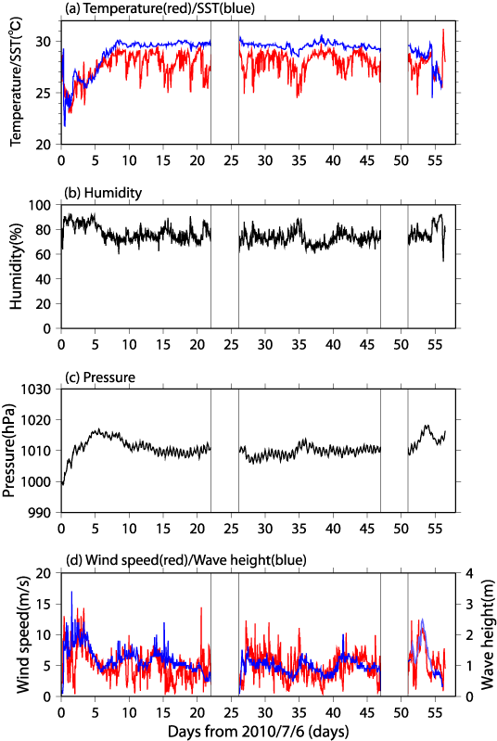
Figure B.2.1. Time series of (a) air and sea surface temperature, (b) relative humidity, (c) pressure, (d) wind speed and wave height. The light blue in (d) panel, light blue line shows the non-instrumental observation of wave height. Day 0 correspond to July 6 (JST), 2010.
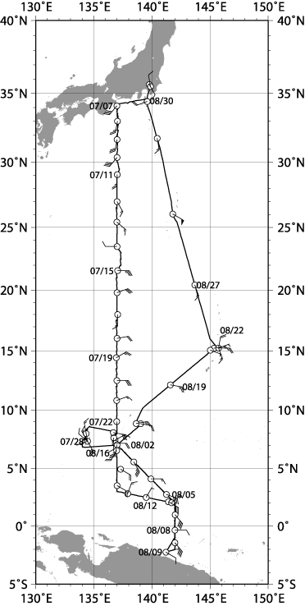
Figure B.2.2. Wind verb along Ryofu Maru at every noon position. Black flag corresponds to 10m/s, long line corresponds to 2m/s and short line corresponds to 1m/s.

- Data processing and Data format
All raw data were recorded every 6-seconds. 1-minute and 10-minute values are averaged from 6-seconds values. 10-minute value of every three hours is available at JMA web site (http://www.data.kishou.go.jp/kaiyou/db/vessel_obs/data-report/html/ship/cruisedata_e.php?id=RF1005).

Since the thermometers and hygrometers are equipped on both starboard/port sides on the Compass deck, we used air temperature/relative humidity data taken at upwind side. Dew point temperature was calculated from relative humidity and air temperature data.

No adjustment to sea level values is applied except for pressure data. During the cruise, fixed value +0.5hPa is used for sea level correction. Data are stored in ASCII format and representative parameters are as follows. Time in UTC, longitude (E), latitude (N), ship speed (knot), ship direction (degrees), sea surface pressure (hPa), air temperature (degrees Celsius), dew point temperature (degrees Celsius), relative humidity (%), sea surface temperature (degrees Celsius), wind direction (degree) and wind speed (m/sec).

Wave height and period are observed twice an hour. The sampling duration is 20 minutes and each sampling starts at 5 minutes and 35 minutes after the hour. In addition to those data, ship’s position and observation time are recorded in ASCII format.

- Data quality
To ensure the data quality, each sensor was checked as follows.
Temperature/Relative humidity sensor:
Temperature and relative humidity (T/RH) sensors were checked by manufacturer and, they were also checked by using calibrated Asman psychrometer before the cruise and arrival at the port. The discrepancy between T/RH sensors and Asman psychrometer were within ±0.4 degrees Celsius and ±4 % respectively at both sides.

Thermometer (Sea Temperature):
Sea temperature sensor was calibrated once per year by the manufacturer. Certificated accuracy of sea temperature sensor is better than ±0.4 degrees Celsius. The values are also compared with bucket samples after the departure.

Pressure sensor:
Using calibrated portable barometer (Vaisala 765-16B, certificated accuracy is better than ± 0.1 hPa), pressure sensor was checked before the cruise. Mean difference of RMET pressure sensor and portable sensor is less than 0.7 hPa.

Aerovane:
Aerovane was checked once per year by the manufacturer and, once per five years by the Meteorological Instrument Center, JMA.

- Ship’s weather observation
Non-instrumental observations such as weather, cloud, visibility, wave direction and wave height were made by the ship crews every three hours. We sent those data together with RMET data to the Global Collecting Centre for Marine Climatological Data in IMMT (International Maritime Meteorological Tape) -III format. The RMET data is available at JMA web site.
(http://www.data.kishou.go.jp/kaiyou/db/vessel_obs/data-report/html/ship/cruisedata_e.php?id=RF1005).
3. CO₂ and Thermo-Salinograph

(1) Personnel
Shinji Masuda (JMA)
Kazutaka Enyo (JMA)
Kazuki Ishimaru (JMA)
Etsuro Ono (JMA)
Naohiro Kosugi (MRI)

(2) Instrument and sampling
Partial pressure of CO₂ (pCO₂) in atmosphere and in surface seawater were measured with the CO₂ measuring system manufactured by Nippon ANS, Inc. based on the method described by Inoue et al. (1999) and Dickson et al. (2007). The system comprises of a non-dispersive infrared gas analyzer (NDIR) (LI-COR LI7000), an air-circulation module and a showerhead-type equilibrator (Figure B3.1). The thermo-salinograph (TSG) (Sea–Bird Electronics, Inc. SBE 38 and SBE 45) was used for measuring temperature and salinity of surface seawater sample; both temperature and salinity were used for calculation of CO₂ concentration of seawater. The measurement system was automatically controlled by using a personal computer equipped with A/D conversion board.
Air sample was taken from the air intake at the bow of the ship, about 8-meters height above the water level. The air sample was transferred to the measurement apparatus through a 3/8-inch diameter fluorinated ethylene-perfluoroalkoxyethylene copolymer (Teflon® PFA) tube.
Surface seawater was pumped from the water intake at about 4-meters depth below the water level and was supplied to shower-type equilibrator and its outer jacket. The flow rate of seawater to equilibrator was adjusted to 3~4 litters per minute. The flow rate to outer jacket of equilibrator was approx. 15 litters per minutes.
Detector (NDIR)
Heatless drier
Drying tube
Perma pure drier
Pump for dry air
Standard gases
STD1
Pump for air sample
Circulation module
Shower type equilibrator
Electronic cooling unit

ポンプ
付属バルブ
刻印
アウトレットキャップ
２次圧ゲージ
１次圧ゲージ
調圧弁
保護キャップ
循環空気用
ポンプ(cH16)
Pump for air circulation
STD5
STD4
STD3
STD2
Electronic cooling unit
Filter
Mass flow controller
Needle valve
Trap
C
NO
NC
Solenoid valve （2 ways）
Solenoid valve （3 ways）

Flow direction
C：Common
NO：Normal Open
NC：Normal Close
NO
NC
C
Figure B3.1 Schematic diagram of CO₂ measuring system.

(3) Analytical procedure
A set of measurement was programmed to 1-hour cycle. Each analytical processes including standard gases calibration (CAL, 20 minutes), seawater samples analyses (SEA, 10 minutes), and air samples analyses (AIR, 5 minutes) were combined as CAL-SEA-AIR-SEA-AIR-SEA.
Air samples and standard gas analyses were made using following procedure;
1) The air sample was dried using electronic cooling unit (dew point of 2ºC) followed by passing through drying tube (magnesium perchlorate desiccant) prior to transfer into the NDIR.
2) NDIR cell was flushed with the air sample for 250 seconds. The flow rate was regulated to 500 cm³/min using mass flow controller.
3) The NDIR inner pressure was let loose by atmospheric pressure for 15 seconds.
4) The outputs of NDIR, temperature of NDIR cell and air pressure at NDIR were recorded for 30 seconds with 1 second interval.
Seawater samples analyses were made using following procedure;
5) The air inside the equilibrator was circulated through the air-circulation module that includes equilibrator for 550 seconds to reach equilibrium with respect to CO₂ exchange between seawater and the air in the circulation module.
6) The air in the circulation module was dried, transferred to NDIR and analysed in the same way described above 2) – 4).

(4) Calibration
The NDIR analyzer was calibrated at interval of 1 hour using a set of CO₂ standard gas cylinders. The concentrations of CO₂ standard gases are listed in Table B3.1, which were pre-calibrated and post-calibrated with the WMO mole-fraction scale.

Table B3.1 CO₂ concentrations of working standards used in RF10-05 cruise.
Cylinder # | Pre-calibrated conc.(ppm) | Pre-calibrated date | Post-calibrated conc.(ppm) | Post-calibrated date
CQB09274 | 280.541 | 2010/06/07 | 280.542 | 2011/01/17
CQB09275 | 340.105 | 2010/06/08 | 340.074 | 2011/01/18
CQB09276 | 384.715 | 2010/06/09 | 384.747 | 2011/01/19
CQB09277 | 435.058 | 2010/06/10 | 435.058 | 2011/01/20

(5) Data and result
CO₂ concentration (in mole fraction, ppm) in the air (xCO₂^{air}) was between 387 ppm and 391 ppm except the coastal area near Japan (Figure B3.1 upper left panel). CO₂ concentration in the sea (xCO₂^{sea}) ranged from 324 ppm to 442 ppm. In the subtropical region (north of 20ºN) sea surface temperature (SST) affects dominantly the xCO₂^{sea} (Figure B3.1 upper right panel). In the tropical region (south of 10ºN), the concentration of total dissolved inorganic carbon in surface seawater affects mainly the xCO₂^{sea}.

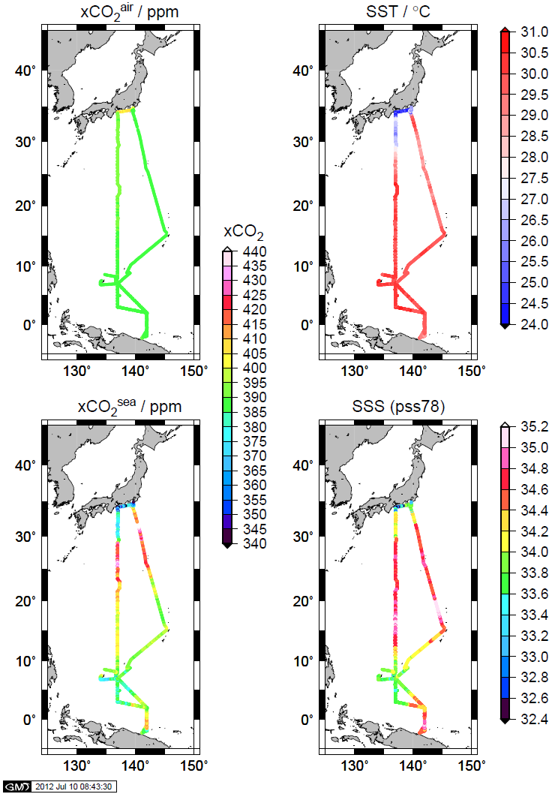
Figure B3.2 Horizontal distributions of CO₂ concentrations (in mole fraction, ppm) in the air (xCO₂^{air}, upper left panel) and in the sea (xCO₂^{sea}, lower left panel). Horizontal distributions of sea surface temperature (SST, upper right panel) and sea surface salinity (SSS, lower right panel).

References
Dickson, A.G., Sabine, C.L. and Christian, J.R. (Eds.) (2007): Guide to best practices for ocean CO₂ measurements. PICES Special Publication 3, 191 pp.
Inoue, Y. H., M. Ishii, H. Matsueda, S. Saito T. Midorikawa and K. Nemoto (1999): MRI measurements of partial pressure of CO2 in surface waters of the Pacific during 1968 to 1970: re-evaluation and comparison of data with those of the 1980s and 1990s, Tellus, 51B, 830-848.

4. Chlorophyll-a

(1) Personnel
Yusuke TAKATANI (GEMD/JMA)
Shinichiro UMEDA (GEMD/JMA)

(2) Method
The Continuous Sea Surface Water Monitoring System of fluorescence (Nippon Kaiyo Co. Ltd.) automatically had been continuously measured seawater which is pumped from a depth of about 4.5 m below the maximum load line to the laboratory. The flow rate of the surface seawater was controlled by several valves and adjusted to about 0.6 L/min. The sensor in this system is a fluorometer (10-AU, S/N:7063) manufactured by Turner Designs. The system measured every one minute.

(3) Measurement
Periods of measurement and problems are listed in Table B.5.1.

(4) Calibration
In order to calibrate the fluorescence sensor, we collected 200 ml of surface seawater from outlet of water line of the system for measuring chlorophyll-a. The seawater samples were collected at nominally 60 N. miles intervals. The seawater sample was gently filtrated by low vacuum pressure through Whatman GF/F filter (diameter 25mm). The filter was immediately transferred into 9 ml of N, N-dimethylformamide (DMF) and then stored at –30ºC to extract chlorophyll-a for more than 24 hours. Concentrations of chlorophyll-a were measured by a fluorometer (10-AU, S/N: 6718, TURNER DESIGNS) that was previously calibrated against a pure chlorophyll-a (Lot.:BCBB4166, Sigma chemical Co.) by the method described in UNESCO (1994). In order to calibrate the fluorometer, fluorometric measurement of chlorophyll-a was performed by the method of Holm-Hansen et al. (1965) and Holm-Hansen and Riemann (1978). The results of the measurements are shown in Table B.5.2. The fluorescence sensor may be contaminated while measuring. Therefore, we calibrated the fluorescence value of the sensor to 0 (deionized water) and 10 (0.1 ppm Rhodamine solution) at the start of a leg, and measured a solution of the same concentration at the end of a leg. The results are shown in Table B.5.3.

The data is calculated by the following procedure;
- The fluorescence value of the sensor is calibrated by deionized water and a Rhodamine solution at the starting and the ending.
- The ratio between a calibrated fluorescence value and a chlorophyll-a concentration of a seawater sample is interpolated by distance.
- The chlorophyll-a concentration is calculated by multiplying a calibrated fluorescence value by an interpolated ratio.

(5) Data and Result
Quality controlled data, those file name is “20120202_p09_in-vivo.txt”, is distributed by JMA format. The record structure of JMA format is shown below.

Column1: observed date [UTC]
Column2: observed time [UTC]
Column3: observed latitude
Column4: observed longitude
Column5: fluorescence value
Column6: fluorescence value calibrated by deionized water and a Rhodamine solution
Column7: ratio between a calibrated fluorescence value and a chlorophyll-a concentration of a seawater sample interpolated by distance
Column8: calculated chlorophyll-a concentration (μg/L)

Result of chlorophyll-a concentration of underway measurement in shown in Figure B.4.1. Chlorophyll-a data on Figure B.4.1 is averaged over 2-hours.

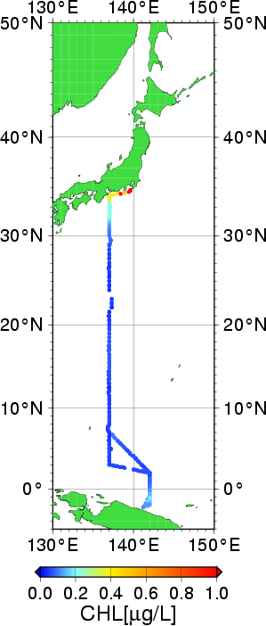
Figure B.4.1. Result of chlorophyll-a concentration of underway measurement.

References
Holm-Hansen, O., and B. Riemann (1978): chlorophyll a determination: improvements in methodology. Oikos, 30, 438-447.
Holm-Hansen, O., C. J. Lorenzen, R. W. Holmes and J. D. H. Strickland (1965): Fluorometric determination of chlorophyll. J. Cons. Perm. Int. Explor. Mer., 30, 3-15.
UNESCO (1994), Protocols for the joint global ocean flux study (JGOFS) core measurements: Measurement of chlorophyll a and phaeopigments by fluorometric analysis, IOC manuals and guides 29, Chapter 14.
Table B.5.1. Events list of the fluorescence sensor.
Date [UTC] | Time [UTC] | Event
6-Jul-10 | 08:51 | The measurement started. (Leg 1 start)
6-Jul-10 | 12:19 | Error data due to the flow line
6-Jul-10 | 22:13 | Error data due to the flow line
7-Jul-10 | 00:21 | Error data due to the flow line
8-Jul-10 | 07:26 | Error data due to the flow line
8-Jul-10 | 12:14 | Error data due to the flow line
9-Jul-10 | 12:46 | Error data due to the flow line
13-Jul-10  -14-Jul-10 | 21:54-09:48 | Error data due to the flow line.
15-Jul-10 | 01:43-02:56 | Failure of data storage due to the PC trouble.
19-Jul-10 | 21:33 | Error data due to the flow line
23-Jul-10 | 14:29 | The measurement stopped. (Leg 1 end)
2-Aug-10 | 02:38 | The measurement started. (Leg 2 start)
2-Aug-10 | 05:16-05:25 | GPS data error.
4-Aug-10 | 21:03 | Error data due to the flow line
4-Aug-10 | 22:18 | Error data due to the flow line
6-Aug-10 | 09:41-10:26 | Failure of data storage due to the PC trouble.
6-Aug-10 | 21:10 | Error data due to the flow line
7-Aug-10 | 02:56-03:03 | Failure of data storage due to the PC trouble.
7-Aug-10 | 14:38 | Error data due to the flow line
8-Aug-10 | 05:49-08:00 | Failure of data storage due to the PC trouble.
9-Aug-10 | 04:32 | Error data due to the flow line
9-Aug-10 | 18:50 | Error data due to the flow line
10-Aug-10 | 08:57 | Error data due to the flow line
10-Aug-10 | 13:52 | Error data due to the flow line
11-Aug-10 | 12:35-13:16 | Failure of data storage due to the PC trouble.
11-Aug-10  -12-Aug-10 | 22:09-11:09 | Error data due to the flow line.
16-Aug-10 | 08:51 | The measurement stopped. (Leg 2 end)

Table B.5.2. Comparison of sensor fluorescence and bottle chlorophyll-a collected from the pump in each sampling point.
Date  [UTC] | Time  [UTC] |  | Latitude | Longitude |  | Sensor Fluorescence |  | Chlorophyll-a  (μg/L)
6-Jul-10 | 08:51 |  | 35˚02.06’N | 139˚41.04’E |  | 1.242 |  | 0.76
7-Jul-10 | 00:23 |  | 34˚14.80’N | 136˚59.37’E |  | 0.632 |  | 0.48
7-Jul-10 | 04:48 |  | 34˚00.97’N | 136˚58.39’E |  | 0.719 |  | 0.40
7-Jul-10 | 15:03 |  | 33˚30.36’N | 137˚01.73’E |  | 0.507 |  | 0.27
8-Jul-10 | 04:05 |  | 33˚03.12’N | 137˚03.42’E |  | 0.240 |  | 0.21
8-Jul-10 | 17:38 |  | 32˚21.66’N | 137˚04.83’E |  | 0.261 |  | 0.18
9-Jul-10 | 05:14 |  | 31˚43.51’N | 136˚58.28’E |  | 0.453 |  | 0.27
9-Jul-10 | 17:49 |  | 30˚58.89’N | 137˚02.15’E |  | 0.157 |  | 0.09
10-Jul-10 | 10:38 |  | 30˚00.04’N | 137˚02.44’E |  | 0.098 |  | 0.08
11-Jul-10 | 03:01 |  | 29˚03.78’N | 137˚00.31’E |  | 0.056 |  | 0.08
11-Jul-10 | 16:00 |  | 27˚59.81’N | 136˚58.89’E |  | 0.050 |  | 0.04
12-Jul-10 | 04:43 |  | 27˚00.72’N | 136˚59.28’E |  | 0.070 |  | 0.04
12-Jul-10 | 19:01 |  | 25˚59.15’N | 136˚58.26’E |  | 0.049 |  | 0.04
13-Jul-10 | 08:27 |  | 25˚01.70’N | 137˚00.67’E |  | 0.038 |  | 0.04
13-Jul-10 | 21:52 |  | 24˚01.35’N | 136˚59.80’E |  | 0.043 |  | 0.05
14-Jul-10 | 12:37 |  | 23˚01.36’N | 137˚17.09’E |  | 0.009 |  | 0.04
15-Jul-10 | 00:14 |  | 21˚59.46’N |  | 137˚16.84’E |  | -0.004 |  | 0.05
15-Jul-10 | 13:39 |  | 21˚00.03’N |  | 136˚55.59’E |  | 0.025 |  | 0.03
16-Jul-10 | 01:15 |  | 19˚57.38’N |  | 136˚59.99’E |  | 0.029 |  | 0.05
16-Jul-10 | 13:25 |  | 18˚59.38’N |  | 136˚58.47’E |  | 0.086 |  | 0.07
17-Jul-10 | 03:10 |  | 18˚00.68’N |  | 137˚02.40’E |  | 0.050 |  | 0.07
17-Jul-10 | 17:16 |  | 17˚00.64’N |  | 136˚55.61’E |  | 0.127 |  | 0.07
18-Jul-10 | 06:56 |  | 16˚00.56’N |  | 136˚57.81’E |  | 0.129 |  | 0.08
18-Jul-10 | 18:48 |  | 14˚58.61’N |  | 136˚58.13’E |  | 0.183 |  | 0.07
19-Jul-10 | 08:19 |  | 13˚59.99’N |  | 136˚57.16’E |  | 0.145 |  | 0.06
19-Jul-10 | 21:45 |  | 12˚59.91’N |  | 136˚57.25’E |  | 0.193 |  | 0.06
20-Jul-10 | 11:13 |  | 12˚00.11’N |  | 136˚56.43’E |  | 0.151 |  | 0.03
21-Jul-10 | 01:28 |  | 11˚00.56’N |  | 136˚56.68’E |  | 0.212 |  | 0.06
21-Jul-10 | 14:50 |  | 10˚00.13’N |  | 136˚58.09’E |  | 0.242 |  | 0.04
22-Jul-10 | 02:57 |  | 9˚00.78’N |  | 136˚57.52’E |  | 0.229 |  | 0.06
22-Jul-10 | 17:19 |  | 7˚59.83’N |  | 136˚58.61’E |  | 0.339 |  | 0.06
23-Jul-10 | 14:29 |  | 7˚00.36’N |  | 136˚58.13’E |  | 0.510 |  | 0.05
2-Aug-10 | 02:38 |  | 7˚01.80’N |  | 136˚59.66’E |  | 0.105 |  | 0.10
4-Aug-10 | 11:23 |  | 3˚45.89’N |  | 140˚14.74’E |  | -0.111 |  | 0.04
5-Aug-10 | 00:09 |  | 3˚00.95’N |  | 140˚57.80’E |  | -0.104 |  | 0.06
5-Aug-10 | 17:49 |  | 1˚59.73’N |  | 141˚58.66’E |  | -0.099 |  | 0.05
7-Aug-10 | 03:43 |  | 0˚59.99’N |  | 141˚58.33’E |  | -0.024 |  | 0.09
7-Aug-10 | 12:11 |  | 0˚29.74’N |  | 141˚57.93’E |  | -0.060 |  | 0.06
7-Aug-10 | 14:37 |  | 0˚14.75’N |  | 141˚59.47’E |  | 0.633 |  | 0.13
7-Aug-10 | 21:35 |  | 0˚00.34’N |  | 141˚57.14’E |  | 0.288 |  | 0.14
8-Aug-10 |  | 14:29 | 0˚59.78’S |  | 141˚57.93’E |  | 0.147 |  | 0.13
9-Aug-10 |  | 16:39 | 2˚00.22’S |  | 141˚57.71’E |  | -0.033 |  | 0.14
10-Aug-10 |  | 22:56 | 1˚58.91’N |  | 141˚59.16’E |  | -0.124 |  | 0.05
11-Aug-10 |  | 09:50 | 2˚11.62’N |  | 140˚57.94’E |  | -0.101 |  | 0.05
11-Aug-10 |  | 22:08 | 2˚24.47’N |  | 139˚58.34’E |  | -0.064 |  | 0.06
12-Aug-10 |  | 11:12 | 2˚35.48’N |  | 138˚59.16’E |  | -0.071 |  | 0.05
13-Aug-10 |  | 01:37 | 2˚47.76’N |  | 137˚59.88’E |  | -0.068 |  | 0.05
13-Aug-10 |  | 17:37 | 2˚59.39’N |  | 136˚59.57’E |  | -0.009 |  | 0.07
14-Aug-10 |  | 09:46 | 4˚00.91’N |  | 136˚57.92’E |  | -0.050 |  | 0.04
15-Aug-10 |  | 00:09 | 4˚59.68’N |  | 136˚59.26’E |  | -0.014 |  | 0.06
15-Aug-10 |  | 18:15 | 5˚58.61’N |  | 136˚56.93’E |  | -0.004 |  | 0.05
16-Aug-10 |  | 08:51 | 6˚59.93’N |  | 136˚58.48’E |  | -0.009 |  | 0.04

Table B.5.3. Results of the fluorescence value of the sensor at the start and end of each leg(0 : deionized water, 10 : 0.1ppm Rhodamine solution).
 | Start |  |  | End
 | Date [UTC] | 0 | 10 | Date [UTC] | 0 | 10
1 Leg | 6-Jul-10 08:30 | 0 | 10.000 | 27-Jul-10 05:00 | 0 | 8.296
2 Leg | 1-Aug-10 04:30 | 0 | 10.000 | 20-Aug-10 01:32 | 0 | 8.438

5. Acoustic Doppler Current Profiler

- Personnel
Tetsuya NAKAMURA (GEMD/JMA)
Yoshikazu HIGASHI (GEMD/JMA)
Tomoyuki KITAMURA (GEMD/JMA)
Keizo SHUTTA (GEMD/JMA)
Takahiro SEGAWA (GEMD/JMA)
Yasuaki BUNGI (GEMD/JMA)

- Instruments and Methods
The instrument used was the hull-mounted 38kHz Ocean Surveyor ADCP (Teledyne RD Instruments, Inc., USA; hereafter TRDI). The transducer of the system was installed in a dome at 3 m left of center and 13 m aft of the bow at the water line. The firmware version was 23.17 and the data acquisition software was TRDI/VMDAS Version. 1.46. The instrument was used in water-tracking mode during the operations, and was recording each ping raw data in 20 m × 60 bin from about 36 m to 1200 m in depth. Sampling interval was variable as short as possible and typically 6.4 seconds. GPS navigation data and ship’s gyrocompass data were recorded with the ADCP data. In addition to the raw data, 60 seconds and 300 seconds averaged data were stored as short time average (STA) and long time average (LTA) data, respectively. Current field based on the gyrocompass was used to check the operation and the performance on board.

- Performance and quick view of the ADCP data on board
The performance of the ADCP instrument was almost good throughout the cruise, and current profiles were usually reached about 1000m. We monitored the profiles and currents based on LTA data in this cruise on board. The ADCP had been installed on the R/V Ryofu Maru just before the cruise, so the scale factor and misalignment angle (Joyce, 1989) to ADCP firmware for Leg 1 were set 1.0 and 0.0, respectively. The scale factor and misalignment for Leg 2 and Leg 3 were set 1.0012 and –1.0627, respectively, based on the calibration constants evaluated by the Leg 1 data.

- Data Processing
LTA data were processed by using CODAS (Common Oceanographic Data Access System) software, developed at the University of Hawaii (http://currents.soest.hawaii.edu/docs/doc/index.html). We use a standard CODAS processing including a PC time correction, a sound-speed correction based on the thermistor temperature at the transducers, and an amplitude and phase calibration constant applied to the measured velocities.

Calibration constants to be applied were evaluated for each leg using the water track data. For Leg 1, the amplitude and phase were 1.0012 and –1.0627, respectively, and for Leg 2 and Leg 3, those were 1.0005 and –0.5528, respectively. Figure B.6.1 shows surface current at the depth of 36 m during the cruise.
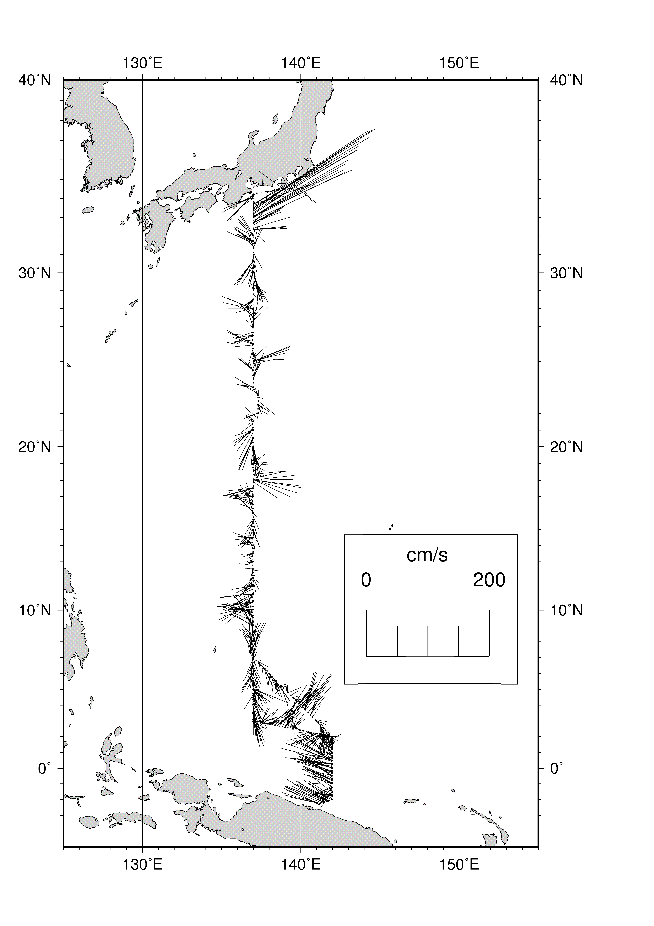
Figure B.6.1. Surface current at the depth of 36 m.

Reference
Joyce, T. M. (1988): On in-situ “calibration” of shipboard ADCPs. J. Atmos. Oceanic Technol., 6, 169-172.

